- Write a program in Prolog that uses following predicates
Write, nl, read, consult,halt,statistics.
CODE:
run():-write("Hello, Name: "), read(N),nl,
write("Hey there "),write(N),nl,
write("Statistics: "),nl,
statistics.

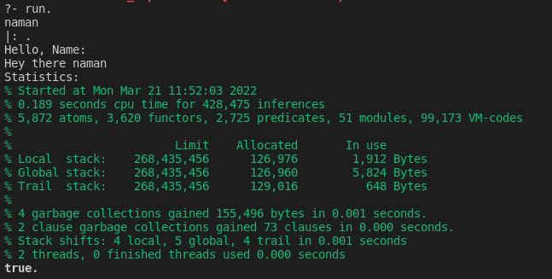
- Try to answer the following questions first “by hand” and then verify your answers using a Prolog interpreter.
(a) Which of the following are valid Prolog atoms?
f, loves(john,mary), Mary, _c1, 'Hello', this_is_it
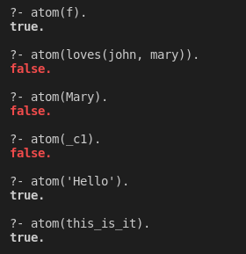
(b) Which of the following are valid names for Prolog variables?
a, A, Paul, 'Hello', a_123, _, _abc, x2

Atom:- a, ’Hello’, a_123, x2
Variables:- A, Paul, _, _abc,
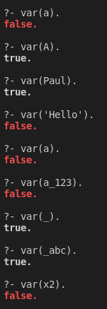
(c) What would a Prolog interpreter reply given the following query?
?- f(a, b) = f(X, Y).

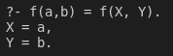
(d) Would the following query succeed?
?- loves(mary, john) = loves(John, Mary).
Why?

Since, John, Mary are variables and does not hold any value. So, mary and john which are atoms, are assigned to John and Mary respectively.
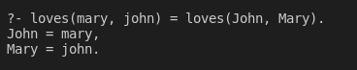
(e) Assume a program consisting only of the fact
a(B, B).
has been consulted by Prolog. How will the system react to the following query? ?- a(1, X), a(X, Y), a(Y, Z), a(Z, 100).
Why?

a(B,B) fact returns true when both arguments are equal. So, after a(1,X), X=1. Then, a(X,Y) assigns Y=1. Now a(Y,Z) assigns Z=1. In last a(Z,100), Since Z has already value which is 1, So it will compare 1 and 100. Since they are not equal, it will result false.
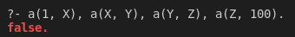

- Read the section on matching again and try to understand what's happening when you submit the following queries to Prolog.
(a) ?- myFunctor(1, 2) = X, X = myFunctor(Y, Y).

Here, X will have value myFunctor(1,2). But when second time X=myFunctor(Y,Y) is called it checks as already x holds value. Now 1 is not equal to 2 hence myFunctor is not equal to myFunctor(Y,Y). So false.
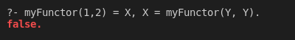
(b) ?- f(a, _, c, d) = f(a, X, Y, _).

Here, f(a, _, c, d) = f(a, X, Y, _) will check first both first variable. Since they are equal it will go for second variable. Here, _ is used which is a universal variable symbol. Hence it will return true and X also doesn’t hold any value it will not show in output. In third variable, one is atom and other is variable which holds no value. Hence it will assign Y=c which will be printed. In fourth variable ‘_’ is used, which is true. Hence, output will be printed as Y=c.
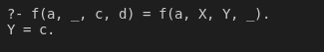
(c) ?- write('One '), X = write('Two ').

So, first write will print One. X= write(‘Two ‘) will assign fact to variable X. Hence it will print X and its value.
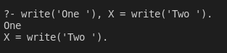
- Draw the family tree corresponding to the following Prolog program:female(mary).
female(sandra).
female(juliet).
female(lisa).
male(peter).
male(paul).
male(dick).
male(bob).
male(harry).
parent(bob, lisa).
parent(bob, paul).
parent(bob, mary).
parent(juliet, lisa).
parent(juliet, paul).
parent(juliet, mary).
parent(peter, harry).
parent(lisa, harry).
parent(mary, dick).
parent(mary, sandra).
After having copied the given program, define new predicates (in terms of rules using male/1, female/1 and parent/2) for the following family relations:
(a) father
(b) sister
(c) grandmother
(d) cousin
You may want to use the operator \=, which is the opposite of =. A goal like X \= Y succeeds, if the two terms X and Y cannot be matched.
Example: X is the brother of Y, if they have a parent Z in common and if X is male and if X and Y don't represent the same person. In Prolog this can be expressed through the following rule:
brother(X, Y) :-
parent(Z, X),
parent(Z, Y),
male(X),
X \= Y.
CODE:
female(mary).
female(sandra).
female(juliet).
female(lisa).
male(peter).
male(paul).
male(dick).
male(bob).
male(harry).
parent(bob, lisa).
parent(bob, paul).
parent(bob, mary).
parent(juliet, lisa).
parent(juliet, paul).
parent(juliet, mary).
parent(peter, harry).
parent(lisa, harry).
parent(mary, dick).
parent(mary, sandra).

% Relationships
father_of(X,Y):-male(X),parent(X,Y).
siblings(X,Y):-parent(Z,X),parent(Z,Y),X\==Y.
sister(X,Y):-siblings(X,Y),female(Y),X\==Y.
grandmother(X,Y):-parent(X,Z),parent(Z,Y),female(X).
cousin(A,B):- parent(X,A),parent(Y,B),siblings(X,Y)

