CODE:

% Program: family.pl

parent(albert, jim).
parent(albert, peter).
parent(jim, brian).
parent(john, darren).
parent(peter, lee).
parent(peter, sandra).
parent(peter, james).
parent(peter, kate).
parent(peter, kyle).
parent(brian, jenny).
parent(irene, jim).
parent(irene, peter).
parent(pat, brian).
parent(pat, darren).
parent(amanda, jenny).

% female(Person)
%
female(irene).
female(pat).
female(lee).
female(sandra).
female(jenny).
female(amanda).
female(kate).

% male(Person)
%
male(albert).
male(jim).
male(peter).
male(brian).
male(john).
male(darren).
male(james).
male(kyle).

% yearOfBirth(Person, Year).
%
yearOfBirth(irene, 1923).
yearOfBirth(pat, 1954).
yearOfBirth(lee, 1970).
yearOfBirth(sandra, 1973).
yearOfBirth(jenny, 2004).
yearOfBirth(amanda, 1979).
yearOfBirth(albert, 1926).
yearOfBirth(jim, 1949).
yearOfBirth(peter, 1945).
yearOfBirth(brian, 1974).
yearOfBirth(john, 1955).
yearOfBirth(darren, 1976).
yearOfBirth(james, 1969).
yearOfBirth(kate, 1975).
yearOfBirth(kyle, 1976).

% Relationships
father_of(X,Y):-male(X),parent(X,Y).
mother_of(X,Y):-female(X),parent(X,Y).
grandparent(X,Y):-parent(X,Z),parent(Z,Y).
siblings(X,Y):-parent(Z,X),parent(Z,Y),X\==Y.
older_brother(X,Y):-siblings(X,Y),older(X,Y),male(X),X\==Y.
sister(X,Y):-siblings(X,Y),female(Y),X\==Y.
predecessor(X, Z) :- parent(X, Z).
predecessor(X, Z) :- parent(X, Y),predecessor(Y, Z).

Questions:
- Is Albert a parent of peter?
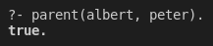
- Who is the child of Jim?
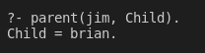
- Who are parents of Brian?
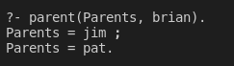
- Is Irene a grandparent of Brian?
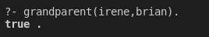

- Find all the grandchildren of Irene.
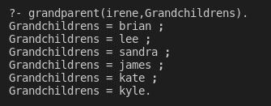
- Now add the following rule to familytree.pl and re-consult:
older(Person1, Person2) :- yearOfBirth(Person1, Year1), yearOfBirth(Person2, Year2), Year2 > Year1.
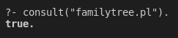
- Who is older than Pat?
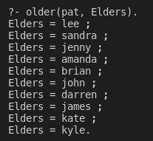
- Who is younger than Daren?
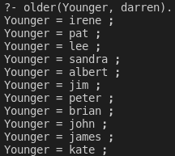

- List the siblings od Sandra.
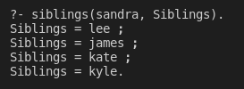
- Who is the older brother of Sandra?
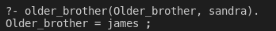
- Find the predecessors of Kyle.
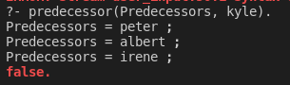
- Does Kate have a sister?
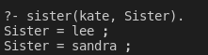
- How many females and males are there in the knowledge base?
