Write a lex program to identify identifiers, constants and keywords (int, float) used in c/c++ from a given
input file.

/*lex code to count the number of lines,
tabs and spaces used in the input*/

%{
#include<stdio.h>
/*Global variables*/
%}

/*Rule Section*/
%%
if|else|while|do|int {printf("Keyword => %s\n", yytext);}
[a-zA-Z_]+[a-zA-Z_0-9]*{30} {printf("Indentifier => %s\n", yytext);}
[0-9]*"."{1}?[0-9]+ {printf("Constant => %s\n", yytext);}
%%
int yywrap(void) {
return 1;
}

int main(int argc, char* argv[])
{
yyin = fopen(argv[1], "r");
// The function that starts the analysis
yylex();
}

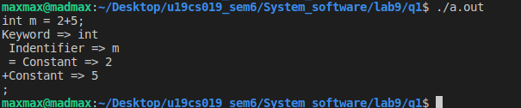

Write a lex Program to find octal and hexadecimal numbers.
/*lex code to count the number of lines,
tabs and spaces used in the input*/

%{
#include<stdio.h>
/*Global variables*/
%}

/*Rule Section*/
%%
"0x"{1}[0-9A-Fa-f]+ {printf("Hexdecimal number => %s\n", yytext);}
[0-7]+ {printf("Octal number => %s\nHexdecimal number => %s\n", yytext, yytext);}
[0-9A-Fa-f]+ {printf("Hexdecimal number => %s\n", yytext);}
%%
int yywrap(void) {
return 1;
}

int main(int argc, char* argv[])
{
yyin = fopen(argv[1], "r");
printf("Enter hex ot octal number: ");
// The function that starts the analysis
yylex();
}
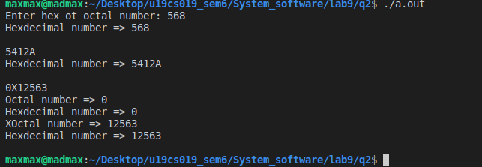

Write a lex program to count and display Single line and multiline comments.
/*lex code to count the number of lines,
tabs and spaces used in the input*/

%{
#include<stdio.h>
/*Global variables*/
%}

/*Rule Section*/
%%
\/\/.{1,} { printf("Single line comment: %s\n", yytext); }
\/\*[.{1,}\n{1,}]*\*\/ { printf("Multi line comment: %s\n", yytext); }
%%
int yywrap(void) {
return 1;
}

int main(int argc, char* argv[])
{
yyin = fopen(argv[1], "r");
yylex();
}

Write a lex program to count no of negative, positive and zero numbers.
/*lex code to count the number of lines,
tabs and spaces used in the input*/

%{
#include<stdio.h>
int n = 0, p = 0, z = 0;
/*Global variables*/
%}

/*Rule Section*/
%%
-[0-9]+ {n++;}
[1-9]+[0-9]* {p++;}
0+ {z++;}
%%
int yywrap(void) {
return 1;
}

int main(int argc, char* argv[])
{
// The function that starts the analysis
yylex();

printf("Negative numbers %d\n", n);
printf("Positive numbers %d\n", p);
printf("Zero numbers %d\n", z);
}
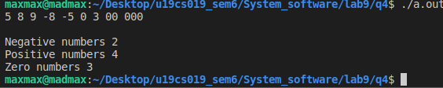

Write a Lex program to accept strings that start with aa and end with bcd .
/*lex code to count the number of lines,
tabs and spaces used in the input*/

%{
#include<stdio.h>
/*Global variables*/
%}

/*Rule Section*/
%%
^aa[a-zA-Z]*bcd$ {printf("Valid string =>\t %s\n", yytext);}
. {}
%%
int yywrap(void) {
return 1;
}

int main(int argc, char* argv[])
{
// The function that starts the analysis
yylex();
}
