Write a C program to recognize strings under ‘a*’, ‘a*b+’, ‘abb’.
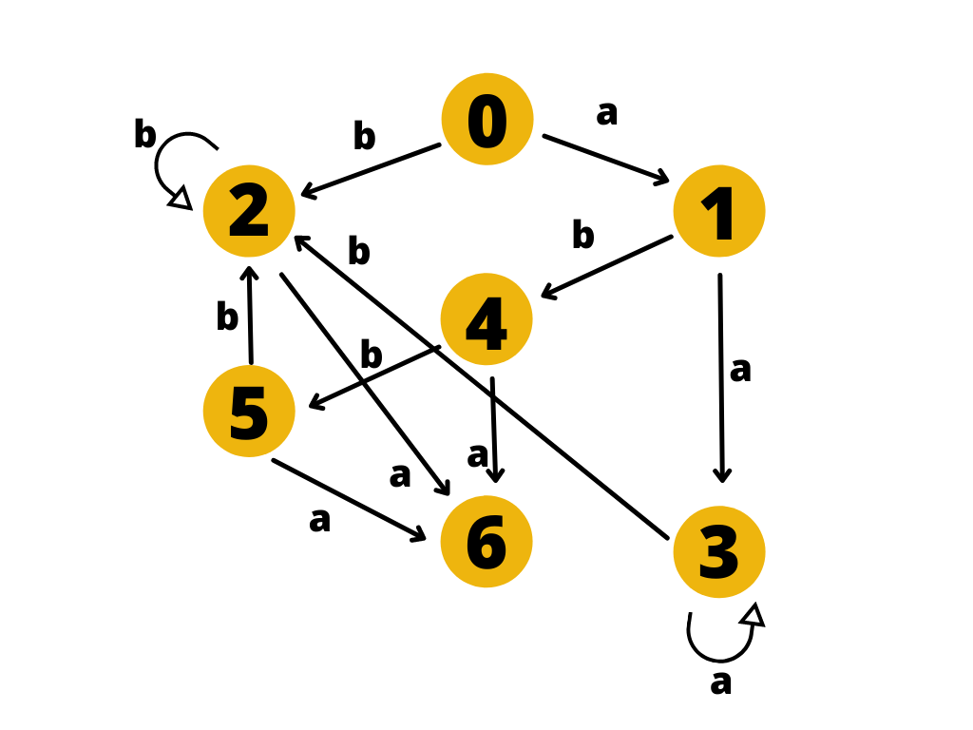
#include <stdio.h>
// #include<conio.h>
#include <string.h>
#include <stdlib.h>
int main()
{
char s[20], c;
int state = 0, i = 0;
system("clear");
printf("\n Enter a string:");
scanf("%s", s);
while (s[i] != '\0')
{
switch (state)
{
case 0:
c = s[i++];
if (c == 'a')
state = 1;
else if (c == 'b')
state = 2;
else
state = 6;
break;
case 1:
c = s[i++];
if (c == 'a')
state = 3;
else if (c == 'b')
state = 4;
else
state = 6;
break;
case 2:
c = s[i++];
if (c == 'a')
state = 6;
else if (c == 'b')
state = 2;
else
state = 6;
break;
case 3:
c = s[i++];
if (c == 'a')
state = 3;
else if (c == 'b')
state = 2;
else
state = 6;
break;
case 4:
c = s[i++];
if (c == 'a')
state = 6;
else if (c == 'b')
state = 5;
else
state = 6;
break;
case 5:
c = s[i++];
if (c == 'a')
state = 6;
else if (c == 'b')
state = 2;
else
state = 6;
break;
case 6:
printf("\n %s is not recognised.", s);
printf("\n");
exit(0);
}
}
if (state == 1 || state == 3)
printf("\n %s is accepted under rule 'a'", s);
else if ((state == 2) || (state == 4))
printf("\n %s is accepted under rule 'a*b+'", s);
else if (state == 5)
printf("\n %s is accepted under rule 'abb'", s);
printf("\n");
return 0;
}

