1) To study the basics of system call and system library.

A system call is the method through which a computer programme asks a service from the kernel of the operating system on which it is running. A system call is a method of interacting with the operating system via programmes. When a computer software makes a request to the kernel of the operating system, it is called a system call. The operating system's services are provided to user programmes via the Application Program Interface (API)

It acts as a link between a process and the operating system, allowing user-level programmes to request operating system services. The kernel system can only be accessed using system calls. System calls are required for any programmes that use resources.

2) Study the following system calls :
Fork, exec, getpid, exit, wait, stat, opendir, readdir,chdir,chmod,kill,read, write, open,
close,lseek,time,mount,chown.

FORK
Fork system call is used for creating a new process, which is called child process, which
runs concurrently with the process that makes the fork() call (parent process). After a new
child process is created, both processes will execute the next instruction following the
fork() system call.
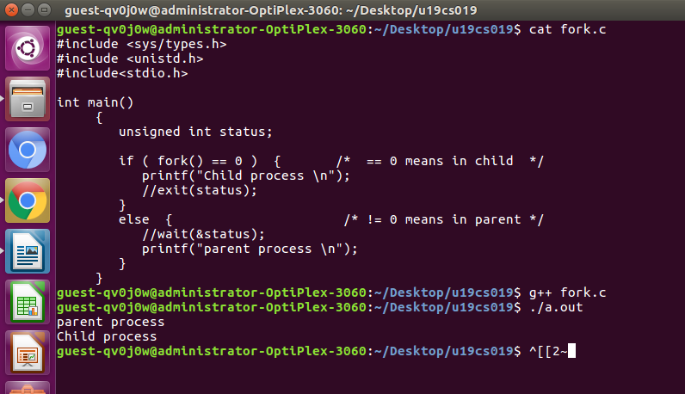

EXEC
The exec family of functions replaces the current running process with a new process. It
can be used to run a C program by using another C program.
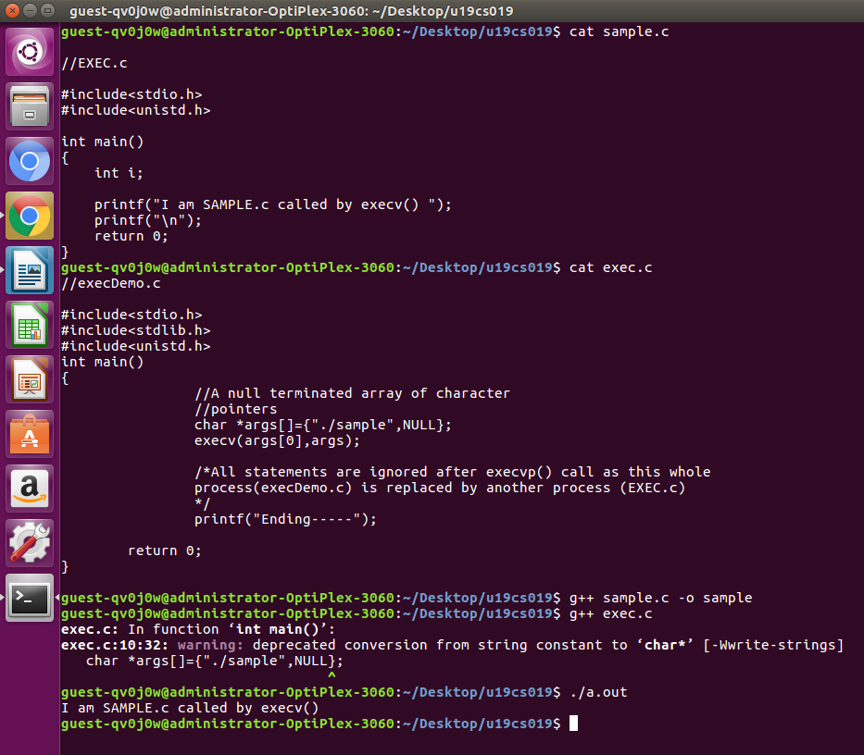

GETPID
getpid() returns the process ID of the calling process. This is often used by routines that
generate unique temporary filenames.
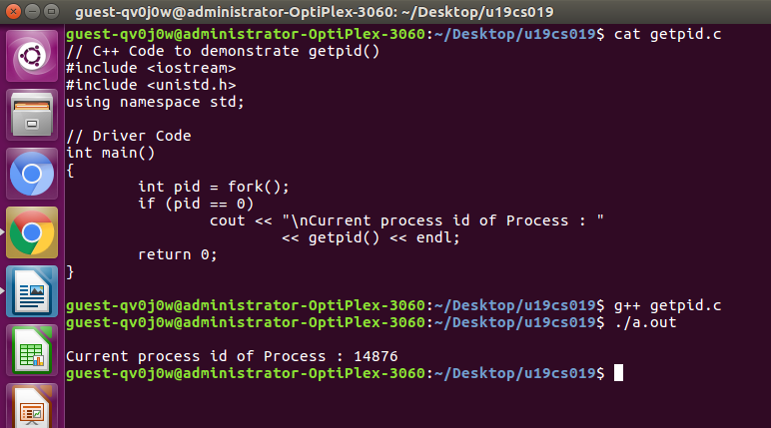
EXIT
exit() terminates the calling process immediately.
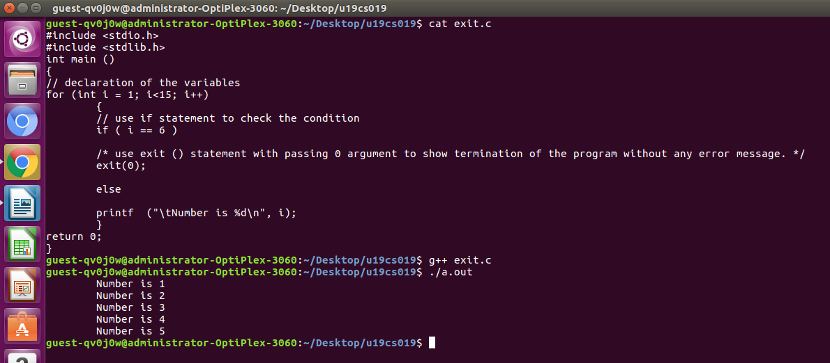

STAT
Stat command gives information such as the size of the file, access permissions and the user
ID and group ID, birth time access time of the file. Stat command has another feature, by
which it can also provide the file system information.

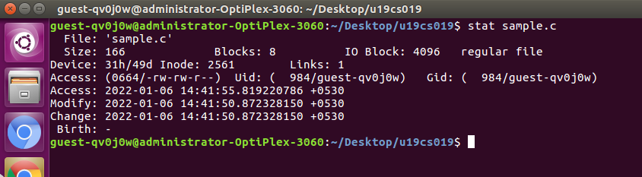
WAIT
A call to wait() blocks the calling process until one of its child processes exits or a signal is
received. After child process terminates, parent continues its execution after wait system
call instruction.

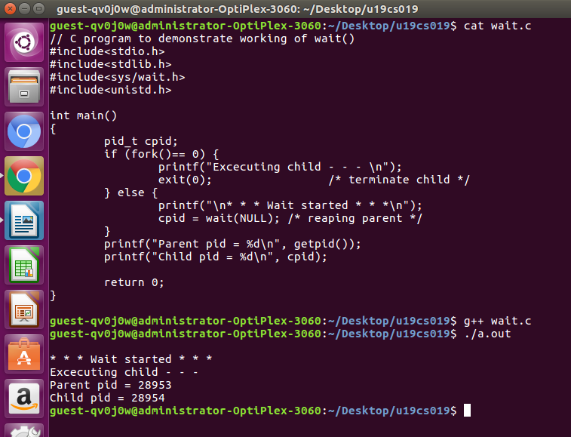
OPENDIR
The opendir() function shall open a directory stream corresponding to the directory named by
the dirname argument.
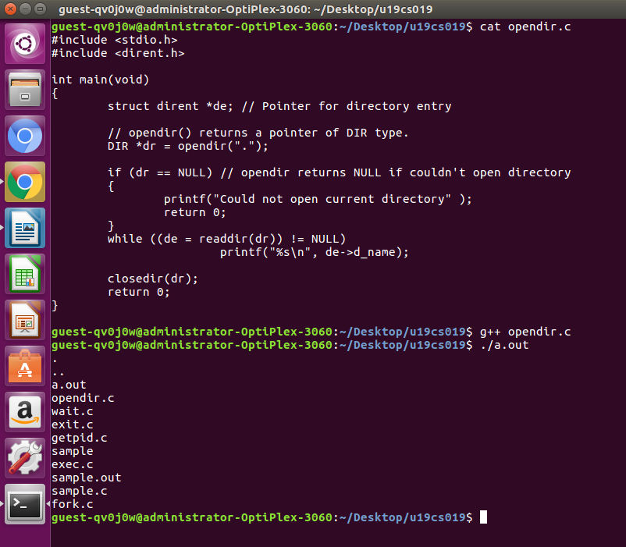
READDIR
The readdir() function returns a pointer to a structure describing the next directory entry in
the directory stream associated with dir.

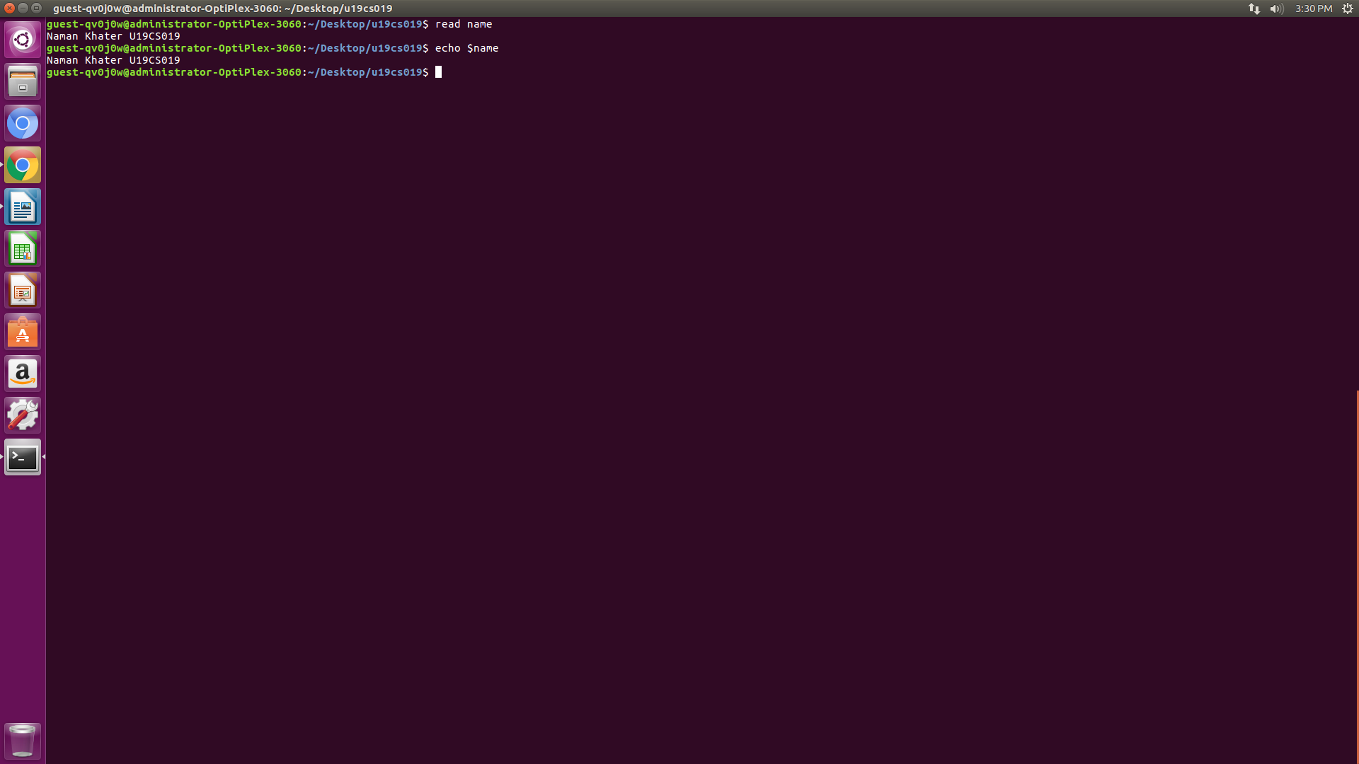
CHDIR
The chdir command is a system function (system call) which is used to change the current
working directory.

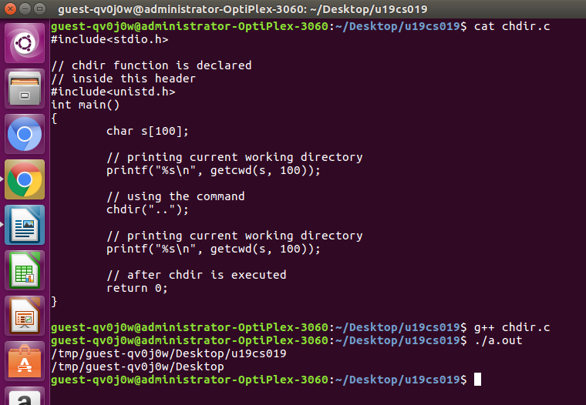

CHMOD
The chmod command is used to change the access mode of a file.

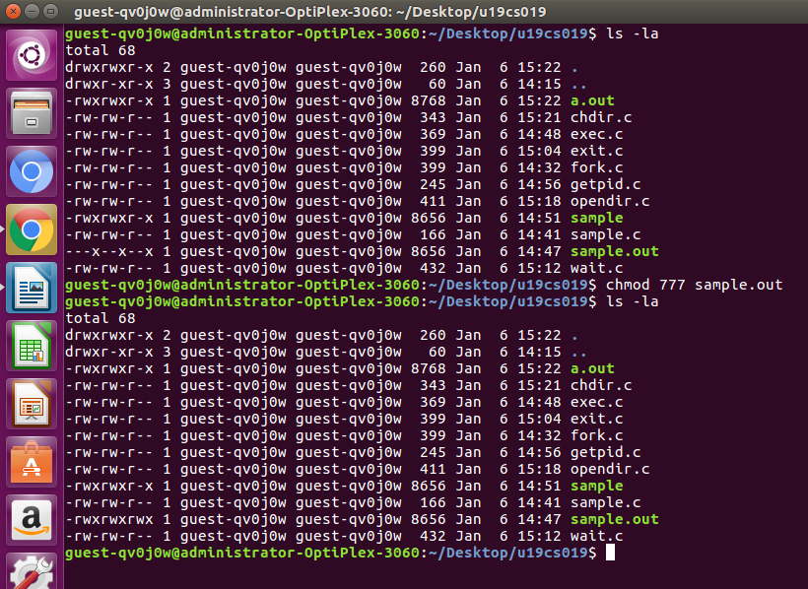

KILL
kill is a built-in command which is used to terminate processes manually.

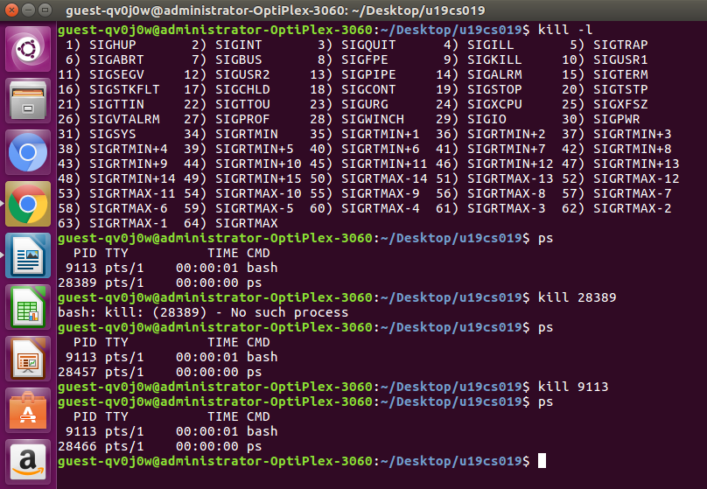
READ
From the file indicated by the file descriptor fd, the read() function reads cnt bytes of input
into the memory area indicated by buf.

TIME
time() returns the time since 00:00:00 UTC, January 1, 1970 (Unix timestamp) in seconds.

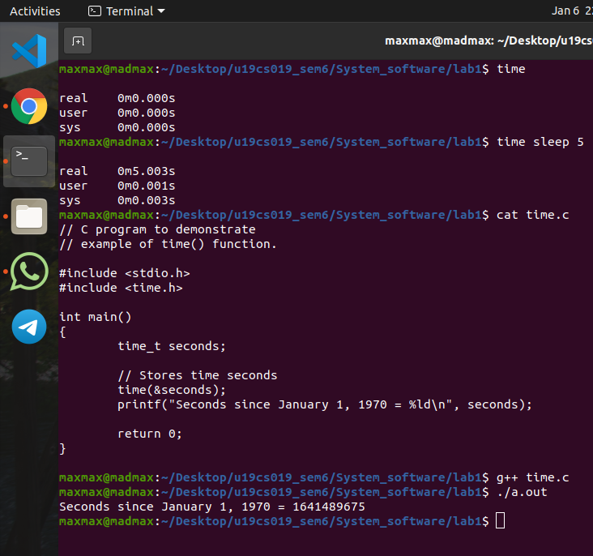

OPEN && CLOSE
open() is used to open the file for reading, writing or both. close() tells the operating system
you are done with a file descriptor and Close the file which pointed by fd.

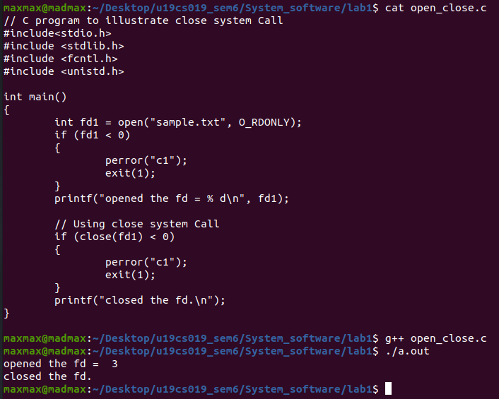

LSEEK
lseek() repositions the file offset of the open file description associated with the file
descriptor fd to the argument offset according to the directive whence as follows

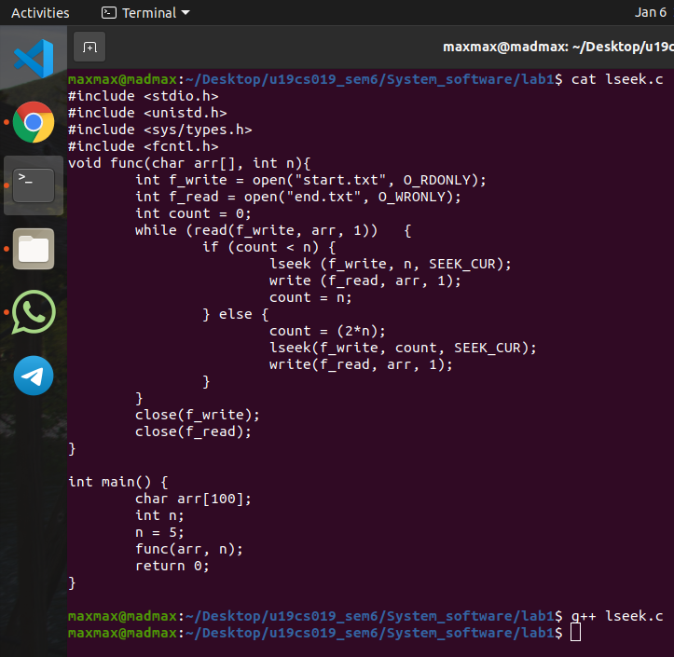

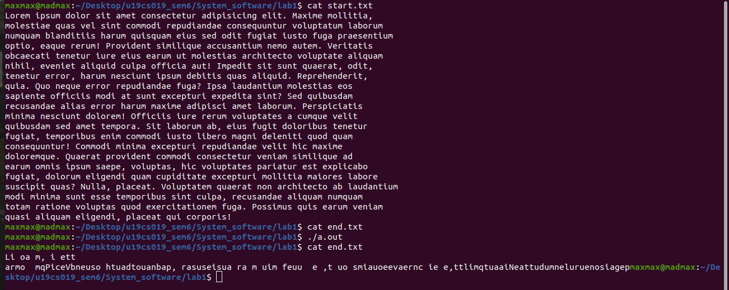

MOUNT
mount() attaches the filesystem specified by source (which is often a pathname referring to a
device, but can also be the pathname of a directory or file, or a dummy string) to the location
(a directory or file) specified by the pathname in target.

CHOWN
chown command is used to change the file owner or group.

