1. Basic Unix/Linux commands:

ls, date, help, info, man, who, pwd, cat, more, mv, rm, chmod, whoami, logout, wc,
grep, sort, mkdir, rmdir, cd, tail, cmp, diff, cp, clear, df, du, uname, apt-get, find, wget,
top, mpstate, netstat, sar, chown

LS
ls is a Linux shell command that lists directory contents of files and directories.
DATE
date command is used to display the system date and time.
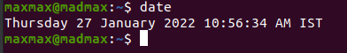
HELP
Displays brief summaries of built-in commands.
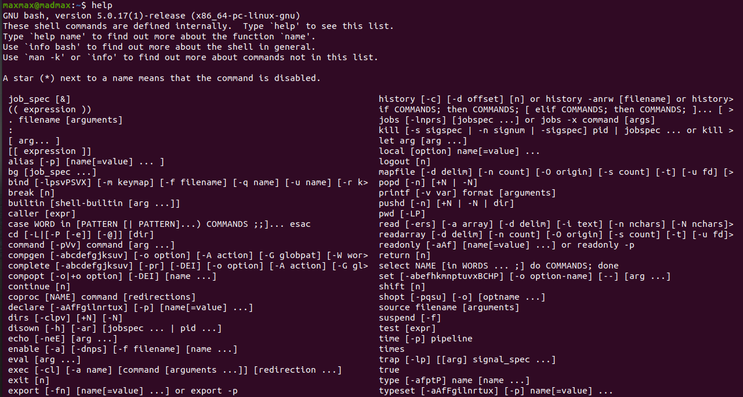
INFO
It will give detailed information for a command when compared with the man page.
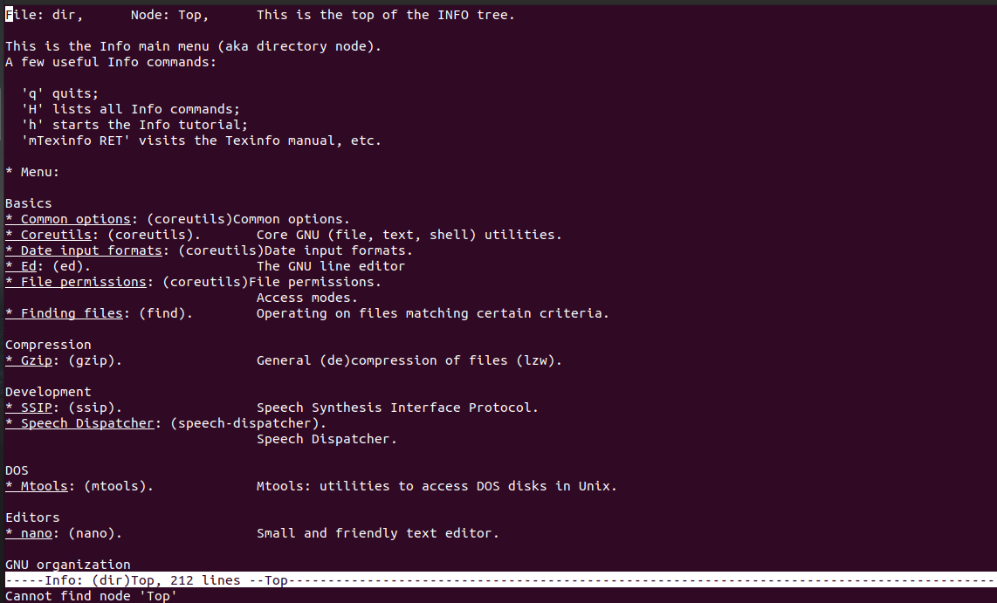
MAN
Used to display the manual of any command.
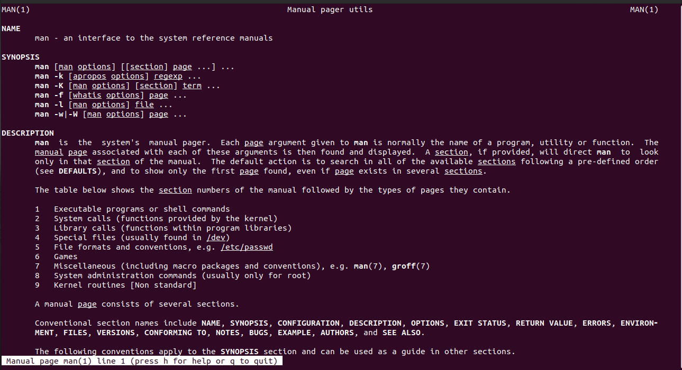
WHO
Displays the users that are currently logged in.
PWD
Prints the current working directory.
CAT
It reads data from the file and gives their content as output. It helps us to create, view,
concatenate files.
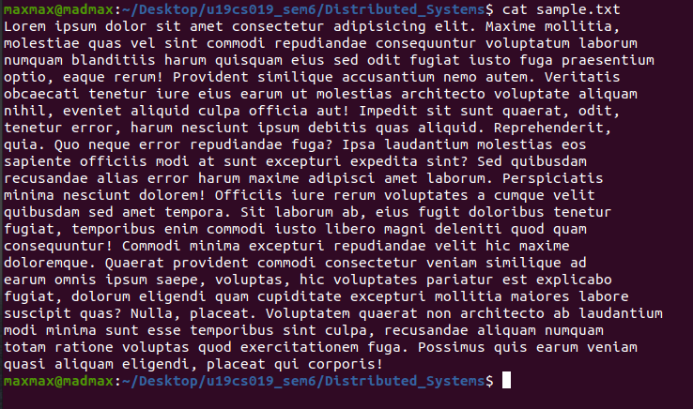
MORE
more command is used to view the text files in the command prompt, displaying one screen
at a time in case the file is large.
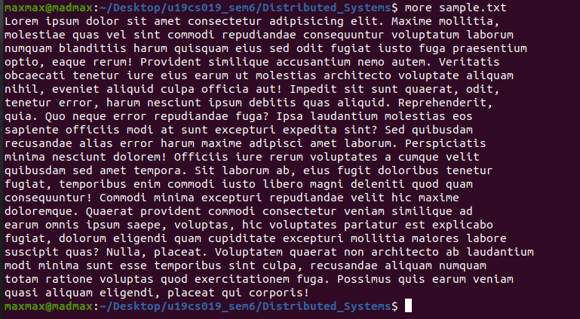
MV
mv is used to move one or more files or directories from one place to another.
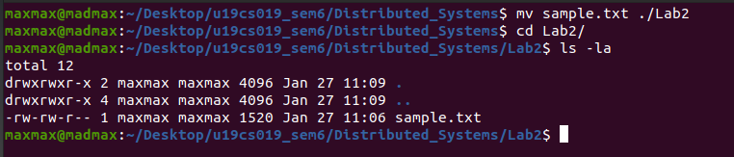
RM
rm command is used to remove objects such as files, directories, symbolic links and so on.
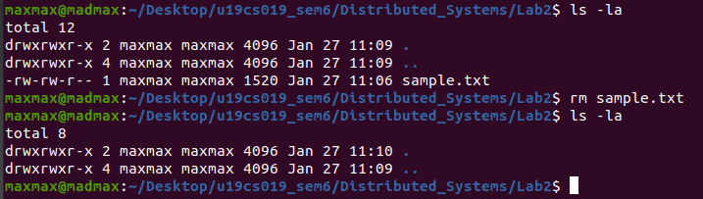
CHMOD
chmod command is used to change the access mode of a file.
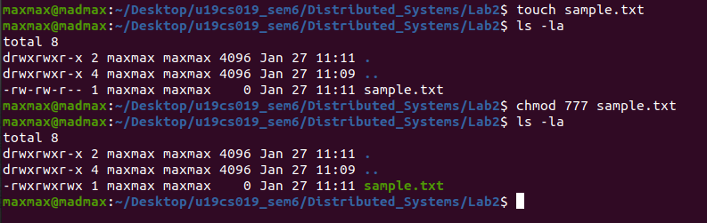
WHOAMI
It displays the username of the current user when this command is invoked.
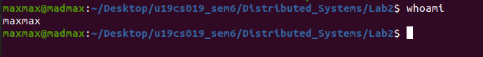
LOGOUT
logout command allows you to programmatically logout from your session.

WC
It is mainly used for counting purpose. It can be run with various options.
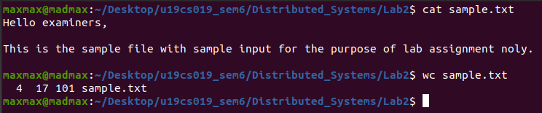
GREP
The grep filter searches a file for a particular pattern of characters, and displays all lines
that contain that pattern. It can be run with various options.
SORT
The grep filter searches a file for a particular pattern of characters, and displays all lines
that contain that pattern. It can be run with various options.
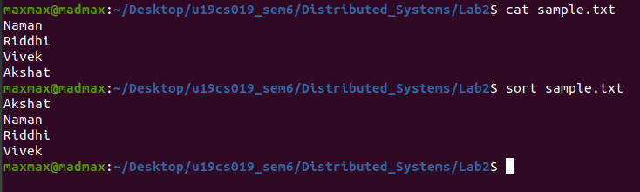
MKDIR
mkdir command in Linux allows the user to create directories.
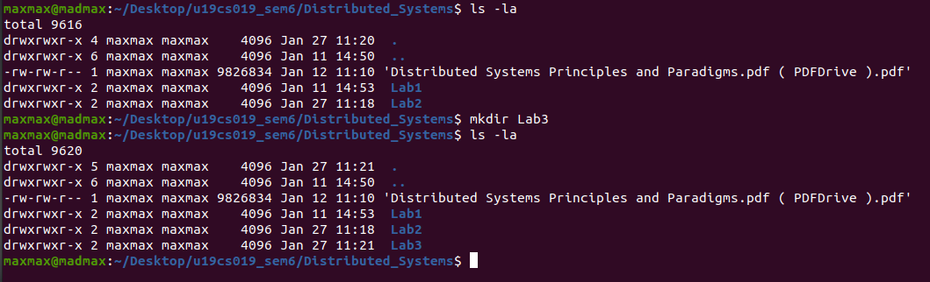
RMDIR
mkdir command in Linux allows the user to delete directories.
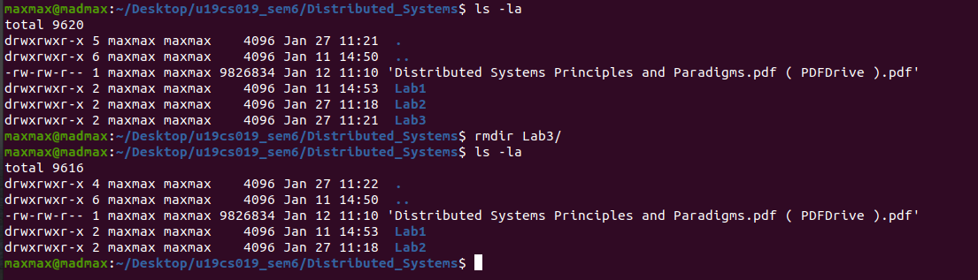
CD
It is used to change current working directory.
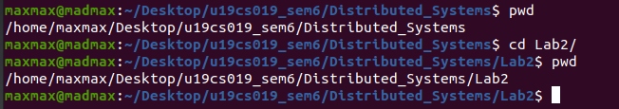
TAIL
It prints the last N number of data of the given input.
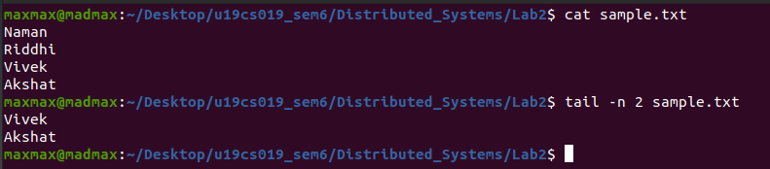
CMP
cmp command is used to compare the two files byte by byte and helps you to find out
whether the two files are identical or not.
DIFF
This command is used to display the differences in the files by comparing the files line by
line
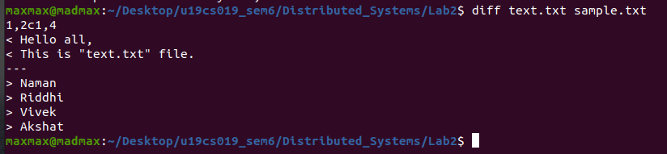
CP
This command is used to copy files or group of files or directory.
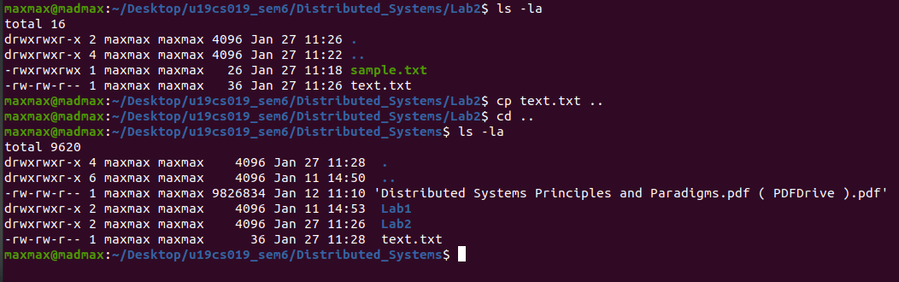
CLEAR
clear is a standard Unix computer operating system command that is used to clear the
terminal screen.

DF
The df command is used to display information related to file systems about total space and
available space.
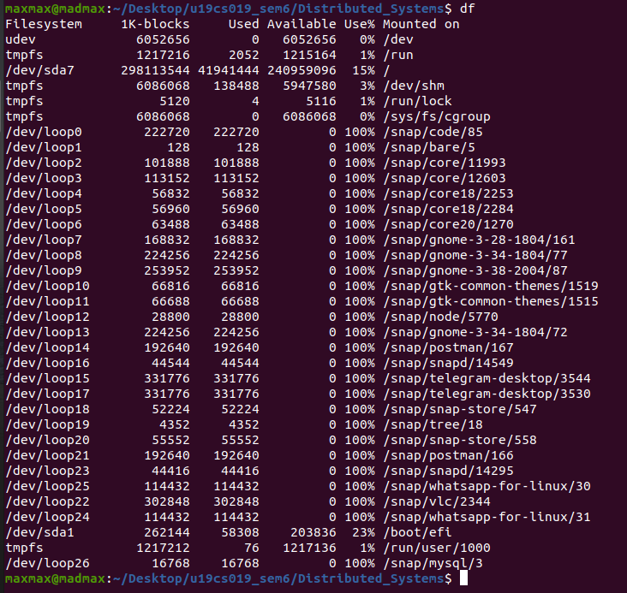
DU
du command, short for disk usage, is used to estimate file space usage.
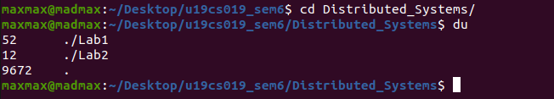
UNAME
The command ‘uname‘ displays the information about the system.
APT-GET
Its main task is to retrieve the information and packages from the authenticated sources for
installation, upgrade and removal of packages along with their dependencies.
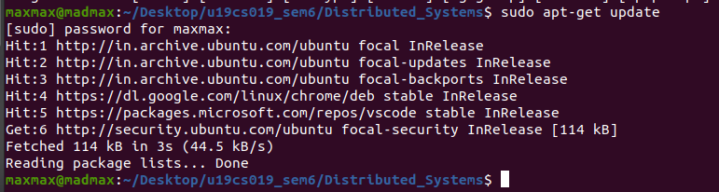
FIND
It can be used to find files and directories and perform subsequent operations on them. It
can be used with other options.
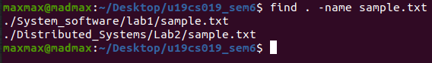
WGET
wget is the non-interactive network downloader which is used to download files from the
server even when the user has not logged on to the system and it can work in the
background without hindering the current process.
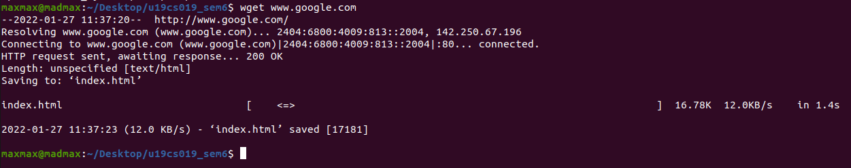

TOP
This command shows the summary information of the system and the list of processes or
threads which are currently managed by the Linux Kernel.
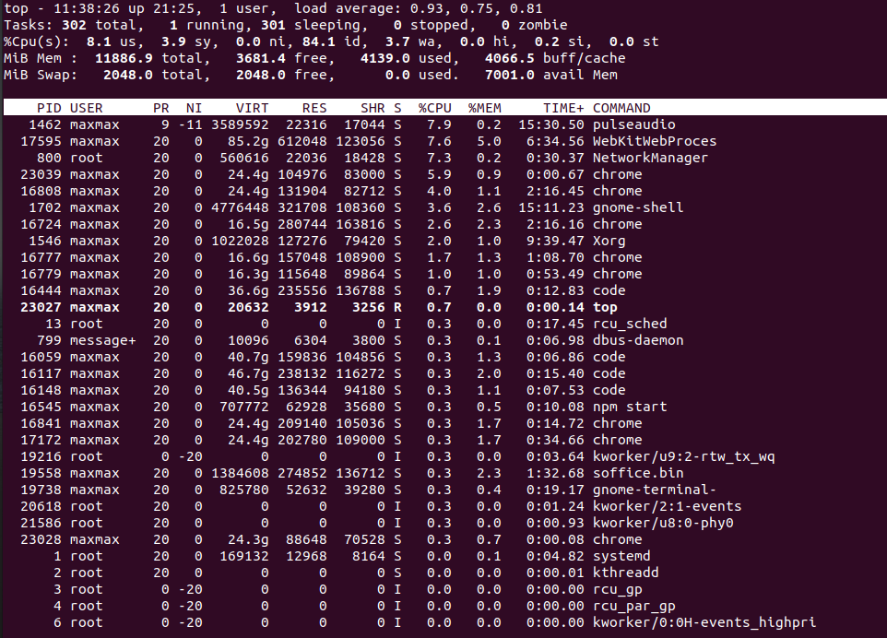
MPSTAT
It accurately displays the statistics of the CPU usage of the system. It displays information
about CPU utilization and performance.
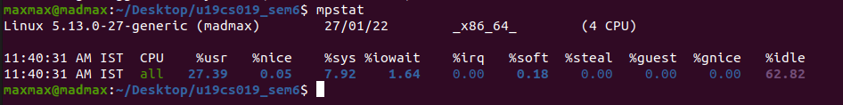
NETSTAT
Netstat command displays various network related information such as network
connections, routing tables, interface statistics, masquerade connections, multicast
memberships etc.
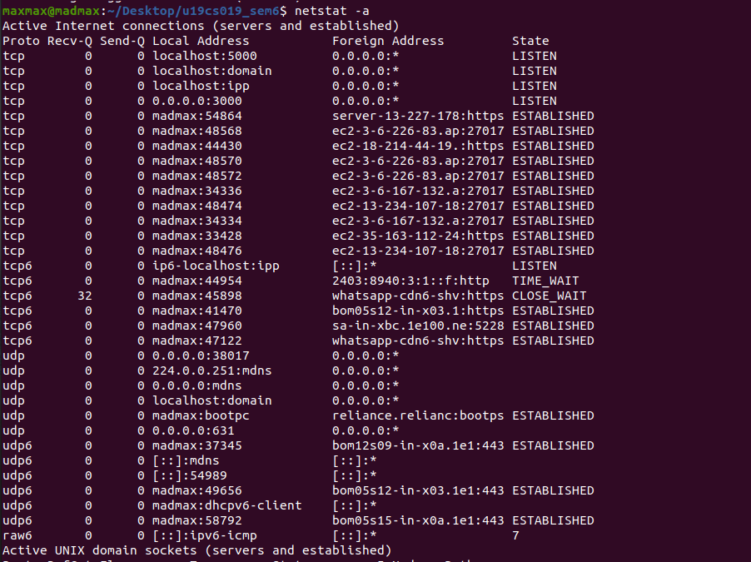
SAR
It can be used to monitor Linux system’s resources like CPU usage, Memory utilization,
I/O devices consumption, Network monitoring, Disk usage, process and thread allocation,
battery performance, Plug and play devices, Processor performance, file system and more.
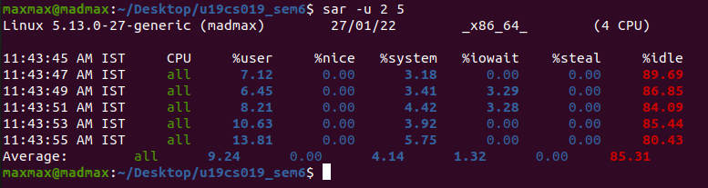
CHOWN
chown command is used to change the file owner or group.

Q2

PS
ps command is used to list the currently running processes and their PIDs along with some
other information depends on different options.
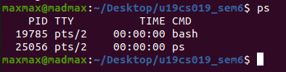

KILL
kill command in Linux is a built-in command which is used to terminate processes
manually.
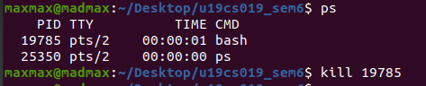

Any process in Linux can be started by adding ‘&’ after the command.
