1) Write a C program to test whether a given identifier is valid or not.

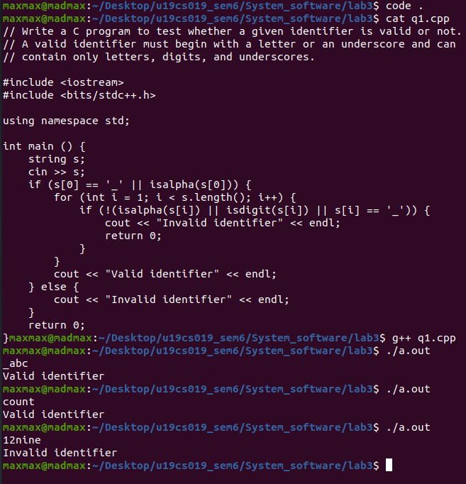

2) Write a C program to identify whether a given line is a comment or not.

