Write a Lex program to count the number of lines, characters and words of the given input file.

/*lex code to count the number of lines,
tabs and spaces used in the input*/

%{
#include<stdio.h>
int lc = 0, wc = 0, ch = 0; /*Global variables*/
%}

/*Rule Section*/
%%
\n lc++; //line counter
[^ \n\t]+ {wc++, ch = ch + yyleng;} // word counter
. ch++; //characters counter
%%

int main()
{
// The function that starts the analysis
yylex();

printf("\nNo. of lines=%d", lc);
printf("\nNo. of words=%d", wc);
printf("\nNo. of other characters=%d\n", ch);

}
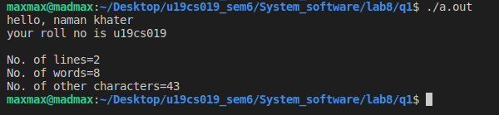

Write a lex program to find out the total number of vowels, and consonants from the given input string.
CODE:
/*lex code to count the number of lines,
tabs and spaces used in the input*/

%{
#include<stdio.h>
int lc = 0, v = 0, ch = 0; /*Global variables*/
%}

/*Rule Section*/
%%
[aeiouAEIOU] v++; // vowels counter
[a-zA-Z] ch++; //characters counter
%%

int main()
{
// The function that starts the analysis
yylex();

printf("\nNo. of lines=%d", lc);
printf("\nNo. of vowels=%d", v);
printf("\nNo. of consonants=%d\n", ch);
}

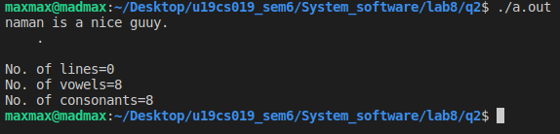

Write a Lex Program to convert Lowercase string to Upper case.
CODE:
/*lex code to count the number of lines,
tabs and spaces used in the input*/

%{
#include<stdio.h>
%}

/*Rule Section*/
%%
[a-z] {printf("%c", yytext[0]-32);}
. {printf("%c", yytext[0]);}
%%

int yywrap(void) {
return 1;
}

int main()
{
// The function that starts the analysis
yylex();
}

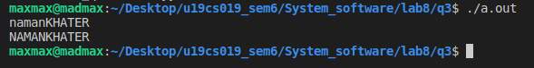

Write a Lex program to check valid/invalid
(a) Mobile number (considering 10-digit mobile number followed by country code +91)
(b) Email address
CODE:
/*lex code to count the number of lines,
tabs and spaces used in the input*/

%{
#include<stdio.h>
%}

/*Rule Section*/
%%
"+91-"+[7-9][0-9]{9} {printf("Valid mobile number: \t%s", yytext);}
.+ {printf("Invalid mobile number \t\t");}
%%

int yywrap(void) {
return 1;
}

int main()
{
// The function that starts the analysis
printf("Enter mobile number: \t");
yylex();
}

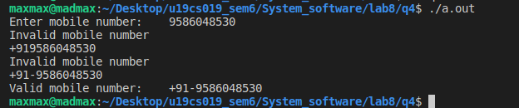

CODE:
/*lex code to count the number of lines,
tabs and spaces used in the input*/

%{
#include<stdio.h>
%}

/*Rule Section*/
%%
[a-z0-9]+@[a-z]+".com"|".in" {printf("Valid email: \t%s", yytext);}
.+ {printf("Invalid email");}
%%

int yywrap(void) {
return 1;
}

int main()
{
// The function that starts the analysis
printf("Enter email: \t");
yylex();
}

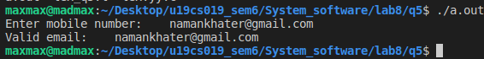

Write a Lex program to implement a simple Calculator.
CODE:
/*lex code to count the number of lines,
tabs and spaces used in the input*/

%{
#include<stdio.h>
#include<string.h>
char *token;
%}

/*Rule Section*/
%%
[0-9]+"+"[0-9]+ {printf("Addition: \t%d", atoi(strtok(yytext, "+")) + atoi(strtok(NULL, "+")));}
[0-9]+"-"[0-9]+ {printf("Subtraction: \t%d", atoi(strtok(yytext, "-")) - atoi(strtok(NULL, "-")));}
[0-9]+"*"[0-9]+ {printf("Multiplication: \t%d", atoi(strtok(yytext, "*")) * atoi(strtok(NULL, "*")));}
[0-9]+"/"[0-9]+ {printf("Division: \t%d", atoi(strtok(yytext, "/")) / atoi(strtok(NULL, "/")));}
.+ {printf("Invalid operation");}
%%

int yywrap(void) {
return 1;
}

int main()
{
// The function that starts the analysis
printf("Enter calculator command: \t");
yylex();
}
