

FAQ – Frequently Asked Questions

udde Instant Messages (uddeIM)

Instant Messages System for

Mambo and Joomla

Version 4.0 rev 1

uddeIM[[1]](#footnote-2) is free software and you may redistribute it under the GPL.

uddeIM comes with absolutely no warranty.

Use at your own risk.

© 2007-2017 Stephan Slabihoud

**Acknowledgements**

I would like to thank all users who made uddeIM the most used Private Messaging System on Joomla. uddeIM becomes in one year only a top rated and popular component.

**Top Rated…**



**… and Popular.**

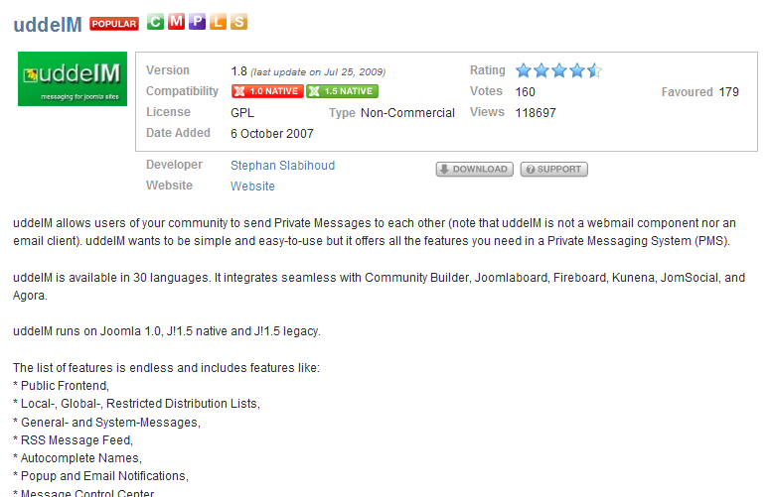

**Table of Contents (overview)**

**Page**

[1 Installation (all supported Joomla versions) 11](#_Toc488826969)

[2 Installation (Joomla 1.5+) 28](#_Toc488826970)

[3 Installation (Joomla 1.6+) 35](#_Toc488826971)

[4 Installation of uddeIM premium plugins (for donators) 40](#_Toc488826972)

[5 uddeIM modules and mambots/plugins 54](#_Toc488826973)

[6 Errors and Warnings 60](#_Toc488826974)

[7 Community Builder 68](#_Toc488826975)

[8 Community Builder Enhanced 76](#_Toc488826976)

[9 Importing PMS data 77](#_Toc488826977)

[10 Configuring uddeIM 79](#_Toc488826978)

[11 Using uddeIM 99](#_Toc488826979)

[12 CSS related questions 104](#_Toc488826980)

[13 3rd party programs 108](#_Toc488826981)

[14 Developer information 116](#_Toc488826982)

**Table of Contents**

**Page**

[1 Installation (all supported Joomla versions) 11](#_Toc488826983)

[1.1 General questions 11](#_Toc488826984)

[1.1.1 What are the requirements for uddeIM? 11](#_Toc488826985)

[1.1.2 What is inside the uddeIM\_x.x\_unzip1st.zip archive? 12](#_Toc488826986)

[1.1.3 Is there something I should know before I install uddeIM? 14](#_Toc488826987)

[1.1.4 Is the Community Builder required for uddeIM? 14](#_Toc488826988)

[1.1.5 How can I link the back end Joomla Message Center to uddeIM? 14](#_Toc488826989)

[1.2 Installation of uddeIM 15](#_Toc488826990)

[1.2.1 “Error! Could not find a Joomla! XML setup file in the package.” 15](#_Toc488826991)

[1.2.2 “Error 500 – Internal server error” during installation 15](#_Toc488826992)

[1.2.3 “Fatal error: Maximum execution time of XX seconds exceeded” during installation 16](#_Toc488826993)

[1.2.4 Plugins cb\_plug\_pms\_xxx cannot be installed 16](#_Toc488826994)

[1.2.5 “Warning: require\_once(var/…/components/com\_uddeim/uddeimlib15.php) failed” message after installation 16](#_Toc488826995)

[1.2.6 “Critical Error: Failed to write to configuration file” during installation 17](#_Toc488826996)

[1.2.7 “Error creating folder: …” or “Error creating file: …” 17](#_Toc488826997)

[1.2.8 How to add more smileys? 18](#_Toc488826998)

[1.3 Upgrading uddeIM 18](#_Toc488826999)

[1.3.1 How to upgrade a very old version of uddeIM (≤ 2.2)? 18](#_Toc488827000)

[1.3.2 How can I upgrade uddeIM? 19](#_Toc488827001)

[1.3.3 How can I upgrade uddeIM’s database tables? 19](#_Toc488827002)

[1.3.4 Installing an uddeIM Hotfix 21](#_Toc488827003)

[1.3.5 How do I upgrade uddeIM modules and plugins? 21](#_Toc488827004)

[1.3.6 “Fatal error: Cannot redeclare uddeIMgetUserTZ() (previously declared in…” 22](#_Toc488827005)

[1.3.7 “Fatal error: Cannot redeclare uddeIMmodCheckCB() (previously declared in…” 22](#_Toc488827006)

[1.3.8 “Fatal error: Cannot redeclare uddeIMcheckJVersion() (previously declared in…” 22](#_Toc488827007)

[1.3.9 “Fatal error: Cannot redeclare class getuddeimTab in…” 22](#_Toc488827008)

[1.4 Configuring Joomla 23](#_Toc488827009)

[1.4.1 How can my users get access to uddeIM? 23](#_Toc488827010)

[1.4.2 Is a published menu link to uddeIM required? 23](#_Toc488827011)

[1.4.3 I have created a menu link to uddeIM but some modules/components do not work correctly? 23](#_Toc488827012)

[1.4.4 Blank screen when uddeIM is called 24](#_Toc488827013)

[1.4.5 “Unsupported operand types in router.php” error 24](#_Toc488827014)

[1.4.6 “You Are Not Allowed To View This Page” error 25](#_Toc488827015)

[1.4.7 “Error 404 – Page not found” when accessing uddeIM 25](#_Toc488827016)

[1.4.8 Wired errors after uddeIM has been installed 25](#_Toc488827017)

[1.4.9 The “Compose” link leads to the inbox instead of the compose form? 26](#_Toc488827018)

[1.5 Deinstallation of uddeIM 26](#_Toc488827019)

[1.5.1 I like to deinstall uddeIM completely. How can I do this? 26](#_Toc488827020)

[2 Installation (Joomla 1.5+) 28](#_Toc488827021)

[2.1 How to install uddeIM on Joomla 1.5+? 28](#_Toc488827022)

[2.2 What is the ftp layer? Is there something I should know about? 28](#_Toc488827023)

[2.3 I have an ownership problem, what can I do? 29](#_Toc488827024)

[2.3.1 How can you avoid using chmod 0777 to enable installs? 30](#_Toc488827025)

[2.3.2 How do you recursively adjust file and directory permissions? 30](#_Toc488827026)

[2.3.3 Why can't you install any extensions? 31](#_Toc488827027)

[2.3.3.1 PHP Version 31](#_Toc488827028)

[2.3.3.2 Tmp and session paths 31](#_Toc488827029)

[2.3.3.3 File ownership advice from ianmac 31](#_Toc488827030)

[2.3.3.4 Web hosting advice from HarryB 32](#_Toc488827031)

[2.4 Does uddeIM run on Joomla 1.5 native? 32](#_Toc488827032)

[2.5 J!1.5 Extension Manager claims that uddeIM modules/plugins are not native 33](#_Toc488827033)

[2.6 How to migrate from Joomla 1.0 to Joomla 1.5+? 33](#_Toc488827034)

[3 Installation (Joomla 1.6+) 35](#_Toc488827035)

[3.1 How to install uddeIM on Joomla 1.6? 35](#_Toc488827036)

[3.2 “Error building admin menus” after installation 38](#_Toc488827037)

[3.3 How to migrate from Joomla 1.5 to Joomla 1.6+? 39](#_Toc488827038)

[4 Installation of uddeIM premium plugins (for donators) 40](#_Toc488827039)

[4.1 How to get premium plugins for donators? 40](#_Toc488827040)

[4.2 How to install premium plugins for donators? 41](#_Toc488827041)

[4.3 Public Frontend plugin 42](#_Toc488827042)

[4.3.1 How to get access to the Public Frontend? 42](#_Toc488827043)

[4.4 RSS Message Feed plugin 43](#_Toc488827044)

[4.4.1 How to get the feed URL to access the mailbox? 43](#_Toc488827045)

[4.4.2 Optional Feed parameters 43](#_Toc488827046)

[4.4.3 How to use RSS Message Feeds in iGoogle? 44](#_Toc488827047)

[4.5 Report Control Center plugin 46](#_Toc488827048)

[4.5.1 How to get access the Report Control Center? 46](#_Toc488827049)

[4.5.2 What actions are available in the Report Control Center? 46](#_Toc488827050)

[4.6 Message Control Center plugin 46](#_Toc488827051)

[4.6.1 How to get access the Message Control Center? 46](#_Toc488827052)

[4.6.2 What actions are available in the Message Control Center? 47](#_Toc488827053)

[4.6.3 Where can I enable the moderation feature for a dedicated user? 47](#_Toc488827054)

[4.6.4 Where can I disable the moderation feature for all users? 48](#_Toc488827055)

[4.7 File attachments plugin 48](#_Toc488827056)

[4.7.1 Installation issues 48](#_Toc488827057)

[4.7.2 How to enable File attachments? 50](#_Toc488827058)

[4.7.3 Unprotected file downloads 50](#_Toc488827059)

[4.7.4 File attachments in Public Frontend 51](#_Toc488827060)

[4.7.5 Sending file attachments in admins only 52](#_Toc488827061)

[4.8 Postbox plugin 52](#_Toc488827062)

[4.8.1 How to enable the Postbox plugin? 52](#_Toc488827063)

[5 uddeIM modules and mambots/plugins 54](#_Toc488827064)

[5.1 General problems 54](#_Toc488827065)

[5.1.1 The module border is different from all other modules 54](#_Toc488827066)

[5.1.2 Fatal error: Cannot redeclare moduddemailboxtime() (previously declared in XY) 54](#_Toc488827067)

[5.1.3 How can I change the module style? 55](#_Toc488827068)

[5.2 MODULE: mod\_uddeIM (aka “uddeIM Notifier Module”) 55](#_Toc488827069)

[5.2.1 What is the purpose of mod\_uddeim? 55](#_Toc488827070)

[5.3 MODULE: mod\_uddeIM\_mailbox (aka “uddeIM Mailbox module”) 55](#_Toc488827071)

[5.3.1 What is the purpose of mod\_uddeim\_mailbox? 55](#_Toc488827072)

[5.4 MODULE: mod\_uddeIM\_statistics (aka “uddeIM Statistics module”) 56](#_Toc488827073)

[5.4.1 What is the purpose of mod\_uddeim\_statistics? 56](#_Toc488827074)

[5.4.2 How are the statistics calculated? 56](#_Toc488827075)

[5.5 PLUGIN: plug\_uddeIM\_contentlink (aka “uddeIM Content Link plugin”) 57](#_Toc488827076)

[5.5.1 What is the purpose of plug\_uddeim\_contentlink? 57](#_Toc488827077)

[5.5.2 How do I use uddeIM Content Link plugin? 57](#_Toc488827078)

[5.6 PLUGIN: plug\_uddeIM\_searchbot (aka “uddeIM Searchbot plugin”) 58](#_Toc488827079)

[5.6.1 What is the purpose of plug\_uddeim\_searchbot? 58](#_Toc488827080)

[5.6.2 How do I use uddeIM Searchbot plugin? 58](#_Toc488827081)

[5.7 PLUGIN: plug\_uddeIM\_hooks (aka “uddeIM Hooks plugin”) 59](#_Toc488827082)

[5.7.1 What is the purpose of plug\_uddeim\_hooks? 59](#_Toc488827083)

[5.7.2 How do I use uddeIM Hooks plugin? 59](#_Toc488827084)

[6 Errors and Warnings 60](#_Toc488827085)

[6.1 SQL errors 60](#_Toc488827086)

[6.1.1 “Unknown column 'xxxxx' in 'field list'” error (SQL error 1054) 60](#_Toc488827087)

[6.1.2 “Unknown column in where clause” error (SQL error 1054) 60](#_Toc488827088)

[6.1.3 “DB function failed with error number 2006” error (SQL error 2006) 60](#_Toc488827089)

[6.1.4 “You have not updated your database! Please refer to the README…” error 61](#_Toc488827090)

[6.2 uddeIM errors 61](#_Toc488827091)

[6.2.1 "There is no user with this username!" error when a message is sent 61](#_Toc488827092)

[6.2.2 “This message cannot be displayed.” when a message is opened 61](#_Toc488827093)

[6.3 Other errors and problems 62](#_Toc488827094)

[6.3.1 Javascript is displayed under the “To” field 62](#_Toc488827095)

[6.3.2 Javascript is displayed in the format menu 63](#_Toc488827096)

[6.3.3 “More smileys” cannot be opened and displays a Javascript error 64](#_Toc488827097)

[6.3.4 "Delete" buttons in inbox, outbox and archive do not work 64](#_Toc488827098)

[6.3.5 uddeIM shows the wrong time 64](#_Toc488827099)

[6.3.6 uddeIM does not display CAPTCHAs 65](#_Toc488827100)

[6.3.7 CAPTCHAs are not displayed on Joomla 1.5 65](#_Toc488827101)

[6.3.8 Performance problems 65](#_Toc488827102)

[6.3.9 Configuration cannot be saved 67](#_Toc488827103)

[6.3.10 UddeIM displays a “Plugin out of date!” error 67](#_Toc488827104)

[7 Community Builder 68](#_Toc488827105)

[7.1 Using uddeIM modules and plugins with CB 1.0 68](#_Toc488827106)

[7.2 Enabling Message notifications 68](#_Toc488827107)

[7.3 Display a Tab in CB profiles 68](#_Toc488827108)

[7.4 “Message from your profile” message 69](#_Toc488827109)

[7.5 Adding a link to uddeIM to the users’ profiles 69](#_Toc488827110)

[7.6 Text “\_UE\_PMSLINK” is displayed in a user’s profile 70](#_Toc488827111)

[7.7 Text “\_UE\_TABINBOX” is displayed in a user’s profile 70](#_Toc488827112)

[7.8 Text “%livesite%” is displayed in an email notification 71](#_Toc488827113)

[7.9 PLUGIN: cb\_plug\_pms\_uddeim (aka “uddeIM CB PMS plugin”) 71](#_Toc488827114)

[7.9.1 What is the purpose of cb\_plug\_pms\_uddeim? 71](#_Toc488827115)

[7.9.2 Difference between cb\_plug\_pms\_uddeim and plug\_pms\_mypmspro? 71](#_Toc488827116)

[7.9.3 I have two links to "Send Private Message"? 72](#_Toc488827117)

[7.9.4 Connection notifications contain “\n” instead of newlines? 72](#_Toc488827118)

[7.10 PLUGIN: cb\_plug\_pms\_uddeim\_inbox (aka “uddeIM CB Inbox plugin”) 73](#_Toc488827119)

[7.10.1 What is the purpose of cb\_plug\_pms\_uddeim\_inbox? 73](#_Toc488827120)

[7.11 PLUGIN: cb\_plug\_pms\_uddeim\_blocking (aka “uddeIM CB Blocking plugin”) 73](#_Toc488827121)

[7.11.1 What is the purpose of cb\_plug\_pms\_uddeim\_blocking? 73](#_Toc488827122)

[7.12 PLUGIN: cb\_plug\_pms\_uddeim\_profilelink (aka “uddeIM CB Profile Link plugin”) 74](#_Toc488827123)

[7.12.1 What is the purpose of cb\_plug\_pms\_uddeim\_profilelink? 74](#_Toc488827124)

[7.13 HACK: Block profile when user is blocked in uddeIM 74](#_Toc488827125)

[7.14 Connection request PMs sent twice 75](#_Toc488827126)

[7.15 cb\_login announces new messages but these are not available in uddeIM component 75](#_Toc488827127)

[8 Community Builder Enhanced 76](#_Toc488827128)

[8.1 Integrating uddeIM in CBE 76](#_Toc488827129)

[8.2 How to enable CBE integration in uddeIM? 76](#_Toc488827130)

[8.3 Do the CB plugins also work with CBE? 76](#_Toc488827131)

[9 Importing PMS data 77](#_Toc488827132)

[9.1 Importing messages from other PM systems 77](#_Toc488827133)

[9.2 Reimport messages from other PM system 77](#_Toc488827134)

[9.3 Importing of messages dies (uddeIM <1.6) 78](#_Toc488827135)

[9.4 Importing of messages dies (uddeIM 1.6+) 78](#_Toc488827136)

[10 Configuring uddeIM 79](#_Toc488827137)

[10.1 General questions 79](#_Toc488827138)

[10.1.1 “System - Used charset”: What character sets are supported? 79](#_Toc488827139)

[10.1.2 “Maintenance – Database maintenance”: Does DB maintenance check the DB structure? 79](#_Toc488827140)

[10.1.3 “Create settings”: There is no effect when clicking "Create settings" button? 80](#_Toc488827141)

[10.1.4 How can I change the language in uddeIM? 80](#_Toc488827142)

[10.1.5 How do I configure welcome messages in uddeIM? 80](#_Toc488827143)

[10.1.6 The Administrator is not shown in the user list? 80](#_Toc488827144)

[10.1.7 UddeIM displays the wrong time. 81](#_Toc488827145)

[10.1.8 Can the userlist be sorted by “lastname firstname”? 81](#_Toc488827146)

[10.1.9 When does uddeIM delete messages from a user’s trash can? 81](#_Toc488827147)

[10.1.10 Why is no “Message sent” message displayed? 82](#_Toc488827148)

[10.2 Popup notifications 82](#_Toc488827149)

[10.2.1 Which uddeIM modules provide popup notifications? 82](#_Toc488827150)

[10.2.2 How to configure popup notifications? 82](#_Toc488827151)

[10.2.3 Popup notifications do not work 83](#_Toc488827152)

[10.2.4 How to enable popup notifications for thousands of site members? 83](#_Toc488827153)

[10.2.5 How to enable popup notifications without a visible module in the frontend? 84](#_Toc488827154)

[10.2.6 How can I change the sound uddeIM is playing? 85](#_Toc488827155)

[10.3 Email notifications 85](#_Toc488827156)

[10.3.1 E-Mail notifications are not sent 85](#_Toc488827157)

[10.3.2 Enabling email notification system 86](#_Toc488827158)

[10.3.3 Where can I change the email notification text? 86](#_Toc488827159)

[10.3.4 What placeholders can be used in notification emails? 86](#_Toc488827160)

[10.3.5 Is it possible for the admin to get a copy of each notification sent by uddeIM? 88](#_Toc488827161)

[10.3.6 Email notification received but no message in Inbox 88](#_Toc488827162)

[10.3.7 uddeIM uses the wrong reply address in a notification email 88](#_Toc488827163)

[10.3.8 Wrong character encoding in email subject 89](#_Toc488827164)

[10.3.9 How to enable e-mail notifications for thousands of site members? 89](#_Toc488827165)

[10.3.10 What does the warning “E-Mail stop” in uddeIM backend mean? 90](#_Toc488827166)

[10.3.11 E-Mail notifications are not accepted by email server for some users. 90](#_Toc488827167)

[10.4 UTF-8 91](#_Toc488827168)

[10.4.1 Receiver gets wired characters 91](#_Toc488827169)

[10.4.2 uddeIM shows wired characters in messages 92](#_Toc488827170)

[10.4.3 uddeIM shows wired characters in the frontend and/or backend 93](#_Toc488827171)

[10.5 Autocompleter and MooTools 93](#_Toc488827172)

[10.5.1 Using MooTools with Joomla and uddeIM 93](#_Toc488827173)

[10.5.2 The Autocompleter does not work 95](#_Toc488827174)

[10.5.3 I cannot select any users with the mouse 96](#_Toc488827175)

[10.5.4 The Autocompleter does only find the first user 96](#_Toc488827176)

[10.6 Blocking 96](#_Toc488827177)

[10.6.1 How to block users? 96](#_Toc488827178)

[10.6.2 Do blocked users receive general messages? 96](#_Toc488827179)

[10.6.3 I cannot send messages to a user list because I am blocked? 97](#_Toc488827180)

[10.6.4 Messages can still be sent to a blocked group? 97](#_Toc488827181)

[10.7 Integration of 3rd party components 97](#_Toc488827182)

[10.7.1 How do I enable gravatars? 97](#_Toc488827183)

[10.7.2 I have enabled gravatars but uddeIM does not display single gravatars? 98](#_Toc488827184)

[10.7.3 UddeIM PM links are not displayed in Kunena Profile? 98](#_Toc488827185)

[11 Using uddeIM 99](#_Toc488827186)

[11.1 General questions 99](#_Toc488827187)

[11.1.1 Two users share the same realname in our community 99](#_Toc488827188)

[11.1.2 Reading of stored messages in the backend 99](#_Toc488827189)

[11.2 Sending messages 99](#_Toc488827190)

[11.2.1 There is no “Subject” field visible 99](#_Toc488827191)

[11.2.2 “Add cc: line” has no effect 99](#_Toc488827192)

[11.2.3 uddeIM shows BBcode in messages 100](#_Toc488827193)

[11.2.4 Double messages from Autowelcome plugin and CB invitations 100](#_Toc488827194)

[11.3 Contact lists 101](#_Toc488827195)

[11.3.1 How can registered users create global or restricted contact lists? 101](#_Toc488827196)

[11.4 System- and General messages 101](#_Toc488827197)

[11.4.1 How to send general or system messages to multiple users 101](#_Toc488827198)

[11.4.2 Blank screen when sending multiple messages 102](#_Toc488827199)

[11.4.3 Why do system messages not appear in the senders outbox? 102](#_Toc488827200)

[11.5 Miscellaneous questions 102](#_Toc488827201)

[11.5.1 Obfuscation and Encryption 102](#_Toc488827202)

[12 CSS related questions 104](#_Toc488827203)

[12.1 Change width of text area 104](#_Toc488827204)

[12.2 How to style the message line above of the uddeIM box 104](#_Toc488827205)

[12.3 “Send” button is not visible 104](#_Toc488827206)

[12.4 Changing of CSS files not possible 105](#_Toc488827207)

[12.5 Using separate CSS files for each browser 105](#_Toc488827208)

[12.6 UddeIM menu displayed as a list 106](#_Toc488827209)

[12.7 UddeIM menu displayed in one row without icons 107](#_Toc488827210)

[13 3rd party programs 108](#_Toc488827211)

[13.1 Calling uddeIM from a 3rd party program 108](#_Toc488827212)

[13.2 Pass a message text to uddeIM from a 3rd party program 109](#_Toc488827213)

[13.3 Joomfish component 109](#_Toc488827214)

[13.4 AdsManager plugin 109](#_Toc488827215)

[13.5 JDirectory component 109](#_Toc488827216)

[13.6 Clickheat & Rokbox plugin 110](#_Toc488827217)

[13.7 yvBBCode plugin 110](#_Toc488827218)

[13.8 IE PNG Fix 110](#_Toc488827219)

[13.9 Joomla template “rt\_refraction\_j1.5” 110](#_Toc488827220)

[13.10 SOBI2 111](#_Toc488827221)

[13.11 sh404SEF 111](#_Toc488827222)

[13.11.1 “item=0” appended to links 111](#_Toc488827223)

[13.11.2 Hot to get the current version of sh404SEF plugin 111](#_Toc488827224)

[13.11.3 How to install the sh404SEF plugin? 111](#_Toc488827225)

[13.12 AceSEF 112](#_Toc488827226)

[13.13 Marketplace 112](#_Toc488827227)

[13.14 JReviews 113](#_Toc488827228)

[13.15 Shoutbox 114](#_Toc488827229)

[13.16 Eventlist 114](#_Toc488827230)

[13.17 myApi (Facebook connector for Joomla) 114](#_Toc488827231)

[13.18 Jomsocial Facebook Connect 114](#_Toc488827232)

[13.19 AlphaUserPoints 114](#_Toc488827233)

[13.19.1 Rule for sending a PM 114](#_Toc488827234)

[13.20 Cobalt - Joomla! CCK component 115](#_Toc488827235)

[14 Developer information 116](#_Toc488827236)

[14.1 How do I write a new message into uddeIM database? 116](#_Toc488827237)

[14.2 What languages and codebases are supported? 117](#_Toc488827238)

[14.3 Where does uddeIM store its language files? 118](#_Toc488827239)

[14.4 What BB code tags are supported? 118](#_Toc488827240)

[14.5 Database tables and fields uddeIM uses 119](#_Toc488827241)

[14.5.1 #\_\_uddeim 119](#_Toc488827242)

[14.5.2 #\_\_uddeim\_emn 121](#_Toc488827243)

[14.5.3 #\_\_uddeim\_blocks 122](#_Toc488827244)

[14.5.4 #\_\_uddeim\_config 122](#_Toc488827245)

[14.5.5 #\_\_uddeim\_userlists 122](#_Toc488827246)

[14.5.6 #\_\_uddeim\_spam 123](#_Toc488827247)

[14.5.7 #\_\_uddeim\_attachment 123](#_Toc488827248)

[14.6 Useful SQL queries 124](#_Toc488827249)

[14.6.1 How many messages have been sent totally? 124](#_Toc488827250)

[14.6.2 How many messages are stored on the server? 124](#_Toc488827251)

[14.7 Description of uddeIM API 124](#_Toc488827252)

[14.7.1 Include the API 124](#_Toc488827253)

[14.7.2 Compatibility 125](#_Toc488827254)

[14.7.3 Create an instance of uddeIM API object 125](#_Toc488827255)

[14.7.3.1 version() 125](#_Toc488827256)

[14.7.3.2 mainVersion() 125](#_Toc488827257)

[14.7.3.3 isInboxLimitReached() 126](#_Toc488827258)

[14.7.3.4 sendNewMessage() 126](#_Toc488827259)

[14.7.3.5 sendNewMessageDelayed() 126](#_Toc488827260)

[14.7.3.6 isAttachmentAvailable() 127](#_Toc488827261)

[14.7.3.7 appendAttachment() 127](#_Toc488827262)

[14.7.3.8 sendNewSysMessage() 127](#_Toc488827263)

[14.7.3.9 getLinkToBox() 128](#_Toc488827264)

[14.7.3.10 getInboxUnreadMessages() 128](#_Toc488827265)

[14.7.3.11 getInboxTotalMessages() 128](#_Toc488827266)

[14.7.3.12 getItemid() 128](#_Toc488827267)

[14.7.3.13 getConfiguration() 128](#_Toc488827268)

[14.7.3.14 registerHook() 129](#_Toc488827269)

[14.7.4 Using Hooks 129](#_Toc488827270)

[14.7.4.1 Event names 129](#_Toc488827271)

[14.8 Usage of uddeIM API 130](#_Toc488827272)

[14.8.1 Sending a simple message 130](#_Toc488827273)

[14.8.2 Sending a message to two users with attachment 131](#_Toc488827274)

[14.8.3 Joomla Hack: Send a new article notification to the admin 131](#_Toc488827275)

# Installation (all supported Joomla versions)

|  |  |
| --- | --- |
| **C:\Users\STEPHA~1\AppData\Local\Temp\messagebox_warning-48.png** | **Joomla 1.5, 1.6, 1.7, and 2.5 users please read:**  Chapter 2 „Installation (Joomla 1.5+)“  **Joomla 1.6, 1.7, 2.5, 3.0 users please also read:**  Chapter 3 „Installation (Joomla 1.6+)“ |

## General questions

### What are the requirements for uddeIM?

*I am interested in installing uddeIM. What are the requirements?*

The requirements are:

* Joomla! 1.0.x or Mambo (>= 4.6.2)
* Joomla! 1.5.x (legacy) or Joomla! 1.5.x (native)
* Joomla! 1.6, 1.7, 2.5, and 3.0
* PHP 4.4.x or above
* MySQL 4.1.2 or above

Optionally uddeIM supports:

* Community Builder (Community Platform)
* Community Builder Enhanced[[2]](#footnote-3) (Community Platform)
* JomSocial (Community Platform)
* Joomlaboard (Forum)
* Fireboard (Forum)
* Agora (Forum)
* Kunena (Forum)
* AlphaUserPoints
* Joo!CM (Community Platform)

### What is inside the uddeIM\_x.x\_unzip1st.zip archive?

|  |  |
| --- | --- |
| **C:\Users\STEPHA~1\AppData\Local\Temp\messagebox_warning-48.png** | When installing uddeIM on **Joomla 1.6** or **Joomla 1.7**, use Components (C), Modules (M), and Plugins (P) that are suffixed with **“\_j16”**.  When installing uddeIM on **Joomla 3.0**, use Components (C), Modules (M), and Plugins (P) that are suffixed with **“\_j30”**.  All other components can be installed on **Joomla 1.0** and **Joomla 1.5**. |

|  |  |  |
| --- | --- | --- |
| **Joomla 1.0 and Joomla 1.5** | | |
| **Package** | **Type** | **Description** |
| com\_uddeim | C | uddeIM - the main component |
| mod\_uddeim | M | A message notifier module. The module provides popup notifications introduced with uddeIM 0.8. |
| mod\_uddeim\_mailbox | M | A mailbox module for uddeIM. The module shows some statistics and links to the inbox, outbox, trashcan, archive, settings, and compose form. |
| mod\_uddeim\_statistics | M | A statistics module for uddeIM. The module shows some statistics about numbers of PMs written with uddeIM (all, last 7/30/365 days). |
| plug\_uddeim\_contentlink | P | A content mambot/plugin which creates a simple link allowing to compose a message to a certain user. |
| plug\_uddeim\_searchbot | P | A search mambot/plugin which integrates uddeIM into Joomla search. |
| **Joomla 1.6 - Joomla 1.7 - Joomla 2.5** | | |
| **Package** | **Type** | **Description** |
| com\_uddeim\_j16 | C | uddeIM - the main component |
| com\_uddeim\_j16\_english\_only | C | uddeIM - the main component (contains only English language files) for sites with PHP upload limit of 2 mbyte. |
| mod\_uddeim\_j16 | M | A message notifier module. The module provides popup notifications introduced with uddeIM 0.8. |
| mod\_uddeim\_mailbox\_j16 | M | A mailbox module for uddeIM. The module shows some statistics and links to the inbox, outbox, trashcan, archive, settings and compose form. |
| mod\_uddeim\_statistics\_j16 | M | A statistics module for uddeIM. The module shows some statistics about numbers of PMs written with uddeIM (all, last 7/30/365 days). |
| plug\_uddeim\_contentlink\_j16 | P | A content mambot/plugin which creates a simple link allowing to compose a message to a certain user. |
| plug\_uddeim\_searchbot\_j16 | P | A search mambot/plugin which integrates uddeIM into Joomla search. |
| **Joomla 3.0** | | |
| **Package** | **Type** | **Description** |
| com\_uddeim\_j30 | C | uddeIM - the main component |
| mod\_uddeim\_j30 | M | A message notifier module. The module provides popup notifications introduced with uddeIM 0.8. |
| mod\_uddeim\_mailbox\_j30 | M | A mailbox module for uddeIM. The module shows some statistics and links to the inbox, outbox, trashcan, archive, settings and compose form. |
| mod\_uddeim\_statistics\_j30 | M | A statistics module for uddeIM. The module shows some statistics about numbers of PMs written with uddeIM (all, last 7/30/365 days). |
| plug\_uddeim\_contentlink\_j30 | P | A content mambot/plugin which creates a simple link allowing to compose a message to a certain user. |
| plug\_uddeim\_searchbot\_j30 | P | A search mambot/plugin which integrates uddeIM into Joomla search. |
| **Community Builder** | | |
| **Package** | **Type** | **Description** |
| cb\_plug\_pms\_uddeim | CB | A plugin for the Community Builder that allows to send a "Quick message" from a user's profile.  Install this with the plugin installer in CB. You have also to publish and configure a tab in CB. |
| cb\_plug\_pms\_uddeim\_inbox | CB | A plugin for the Community Builder that shows the content of the inbox in a profile tab.  Install this with the plugin installer in CB and you have also to publish and configure a tab in CB. |
| cb\_plug\_pms\_uddeim\_blocking | CB | This plugin adds a "Blocking" tab so you can block and unblock users quite easy.  Install this with the plugin installer in CB and you have also to publish and configure a tab in CB. |
| cb\_plug\_pms\_uddeim\_profilelink | CB | This plugin adds a simple link that points to the uddeIM compose page to the users' profile page.  Install this with the plugin installer in CB and you have also to publish and configure a tab in CB. |
| **Miscellaneous** | | |
| **Package** | **Type** | **Description** |
| uddeim\_templates | --- | Templates for uddeIM. Upload these templates into \components\com\_uddeim\templates\ |
| 3rd Party | --- | Miscellaneous files for other projects. |
| LANGUAGES | --- | Outdated language files. |

### Is there something I should know before I install uddeIM?

*Is there something I should know before I install uddeIM?*

Yes, there is: The installation of uddeIM is quite simple and straight forward. Unfortunately Joomla introduced a so called ftp layer in Joomla 1.5+ which could make troubles on some systems. Strictly speaking it is not the ftp layer itself but users become confused because of the different access rights a Joomla installation might have using the ftp layer.

|  |  |
| --- | --- |
| **C:\Users\STEPHA~1\AppData\Local\Temp\messagebox_warning-48.png** | Please check chapter 2 carefully before installing uddeIM with ftp layer enabled.  Please ensure that Joomla has write access to the web root directory since uddeIM 1.9+ tries to create a folder there which is used to store file attachments. |

### Is the Community Builder required for uddeIM?

*Is it required to install the Community Builder in order to run uddeIM?*

No, it isn’t. Even when uddeIM provides integration for common programs like Community Builder, Community Builder Enhanced, Joomlaboard and Fireboard, it is not required to install these programs.

### How can I link the back end Joomla Message Center to uddeIM?

*When logging into the backend (administration) side of Joomla website, there is a message center (com\_message) in upper top right corner. Therefore, what are the settings to allow someone to send me a message on the back end Joomla administration side, the message gets sent to my message box in uddeIM?*

UddeIM works independent from com\_message. There is no link between these components.

## Installation of uddeIM

### “Error! Could not find a Joomla! XML setup file in the package.”

*I get the message “Error! Could not find a Joomla! XML setup file in the package.” when I try to install uddeIM.*

There are a few possible reasons for this error message:

1. When you get this error while installing the plugins

* cb\_plug\_pms\_uddeim\_blocking,
* cb\_plug\_pms\_uddeim\_profilelink,
* cb\_plug\_pms\_uddeim, and
* cb\_plug\_pms\_uddeim\_inbox,

see chapter 1.2.4.

2. When you get this error while installing uddeIM you might have forgotten to unzip the archive uddeIM\_x.x\_unzip1st.zip.

3. Your PHP upload limit is limited to 2 mbyte. Since uddeIM 2.3 package exceeds 2 mbyte a little bit, you will see this message. In that case you can install the “\_english\_only” package and upload the required language files later or upload the package file using ftp and install locally.

Another problem might be that your provider limits the number of files you are allowed to store on the server, e.g. 6000 files and folders altogether. In that case you should check if you can clean up the temp folder in order to get free resources.

### “Error 500 – Internal server error” during installation

*I am getting an "Error 500-Internal server error" when I install uddeIM.*

"Error 500" means a general server (maybe configuration) error. So the server is misconfigured, there is a problem in your .htaccess file(s) or your server has not enough CPU power to complete a script. When it is an overloaded server you can try to remove the template folder from the installation package. Don't forget to remove the corresponding lines from the XML file, too. The Joomla installer needs lots of less CPU power to install the component. When you have installed the component, ftp the missing templates to \components\com\_uddeim\templates.

### “Fatal error: Maximum execution time of XX seconds exceeded” during installation

*I am getting an "Fatal error: Maximum execution time of XX seconds exceeded" when I install uddeIM.*

Your server has not enough CPU power to complete a script. When it is an overloaded server you can try to remove the template folder from the installation package. Don't forget to remove the corresponding lines from the XML file, too. The Joomla installer needs lots of less CPU power to install the component. When you have installed the component, ftp the missing templates to \components\com\_uddeim\templates.

You can ask your server administrator to increase the execution time for PHP scripts but it seems that the server is unsuitable for running Joomla CMS.

### Plugins cb\_plug\_pms\_xxx cannot be installed

*When I try to install the cb\_plugins plug\_pms\_uddeim, cb\_plug\_pms\_uddeim\_inbox, cb\_plug\_pms\_profilelink and* cb\_plug\_pms\_uddeim\_blocking *I always get following error message:*

*Error! Could not find a Joomla! XML setup file in the package.*

These plugins are made for the Community Builder. You have to install the plugins with the Community Builder Plugin Manager.

### “Warning: require\_once(var/…/components/com\_uddeim/uddeimlib15.php) failed” message after installation

*After the installation of uddeIM I get following error message:*

*Warning: require\_once(var/…/components/com\_uddeim/uddeimlib15.php) [function.require-once]: failed to open stream*

It seems that the root path is not set correctly on your Joomla installation:

JPATH\_SITE should be

/var/...

and not

var/...

### “Critical Error: Failed to write to configuration file” during installation

*When I try to install com\_uddeim I get following error message:*

*uddeIM Instant Messages for Mambo/Joomla*   
*Critical Error: Failed to write to configuration file: /home/…/administrator/components/com\_uddeim/config.class.php*

You have installed uddeIM using Joomla’s ftp layer. You can chmod the configuration file and the com\_uddeim folder to 766 using an ftp client so uddeIM can access this file.

### “Error creating folder: …” or “Error creating file: …”

*When I try to install com\_uddeim I get following error message:*

*Error creating folder: /home/…/uddeimfiles   
and/or   
Error creating file: /home/…/uddeimfiles/index.html   
and/or   
Error creating file: /home/…/uddeimfiles/.htaccess*

This error may occur when you install uddeIM using Joomla’s ftp layer.

The folder and files are only needed when you own the File attachments plugin (premium plugin for donators).

You can either ignore this error messages (e.g. when you do not plan to use the plugin) or you can fix it manually (recommended). Just create a folder called “uddeimfiles” in “/images” in Joomla’s root folder (“/images/uddeimfiles”). Other files are not required at this point of time.

A description how to create the required folder (and files) manually please refer to chapter 4.7.1.

|  |  |
| --- | --- |
| **C:\Users\STEPHA~1\AppData\Local\Temp\messagebox_warning-48.png** | Even when you are not using the File attachments plugin you should create the folder “/images/uddeimfiles”. The files “index.html” and “.htaccess” are not required at this point of time. When you install the plugin it is still time to create the missing file.  You will also find these files in the "SUPPORT" folder in the premium plugin package. |

|  |  |
| --- | --- |
| **C:\Users\STEPHA~1\AppData\Local\Temp\messagebox_warning-48.png** | uddeIM 1.9+ has some improvements regarding the ftp layer.  The folder and files should also be created when the ftp layer is enabled during installation. |

### How to add more smileys?

*How can I add additional smileys to uddeIM?*

Additional (animated) emoticons can be stored in folder /templates/~~~theme~~~/animated-extended/

For the default template about 32 animated emoticons are provided. If you need more, you can copy as many emoticons in this folder as you like. The filename is used to identify an emoticon in the message (e.g. "cry.gif" will be entered as ":cry:").

Figure 1.1 – Additional animated emoticons

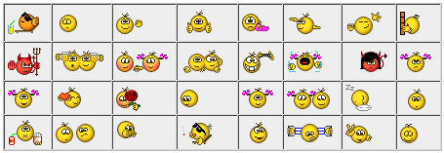

The best source for animated emoticons is <http://www.kolobok.us>

Many thanks to Aiwan who allowed me to use his emoticons in uddeIM.

## Upgrading uddeIM

### How to upgrade a very old version of uddeIM (≤ 2.2)?

*I am still running uddeIM 0.5b. How can I upgrade to the current version?*

Upgrading uddeIM 0.4...1.6 is no longer supported (that means I do not longer describe the process in the README file (located in the README folder)). Please download uddeIM 1.4, and upgrade to this version first (don’t forget to check the README first). Then download uddeIM 1.8 and upgrade to this version. Finally upgrade to the current version of uddeIM.

|  |  |
| --- | --- |
| **C:\Users\STEPHA~1\AppData\Local\Temp\messagebox_warning-48.png** | This process is only necessary when you do not want to lose any data. |

### How can I upgrade uddeIM?

*I want to upgrade uddeIM to the current version. How do I do this?*

Please refer the README enclosed with the package (located in the README folder) you have downloaded. Sometimes you have to upgrade some tables which is explained there. Usually the upgrade process is:

* backup the configuration (e.g. use the internal backup function)
* save your template (in case you do not use the default templates)
* uninstall uddeIM
* update database tables according to the README
* install the current version of uddeIM
* restore the configuration (e.g. use the internal backup function)
* restore your template (in case you do not use the default templates)

|  |  |
| --- | --- |
| **C:\Users\STEPHA~1\AppData\Local\Temp\messagebox_warning-48.png** | Joomla 1.6+:  You can install the newer file over the older one using the Joomla installer. Please don’t forget to update the database since this is not done automatically. |
| **C:\Users\STEPHA~1\AppData\Local\Temp\messagebox_warning-48.png** | Joomla 2.5+:  You can install the newer file over the older one using the Joomla installer. |

### How can I upgrade uddeIM’s database tables?

*The README tells me to upgrade the database tables. I am a complete newbie, how can I do this?*

When you administer Joomla it is very important that you are also familiar how to administer your MySQL database. Joomla does not provide a update mechanism for components, so when a component is updated and its tables has changed, it may have a complex mechanism inside that tries to update your database or it requires to execute some SQL commands. Updating automatically is only good for very view components. uddeIM tables have to be updated manually because with each version uddeIM provides more features, so tables have been updated quite often in past and an automated mechanism would be very complex and may fail on many systems.

To update manually, open phpMyAdmin (or similar program) on your system. If you are using more than on database you have to select the correct database first. Usually there will be a list or a drop-down on the left-hand side showing all your databases, you need to select the one that contains the Joomla database (most likely “joomla” or “j15” but it could also have a completely different name). You can find out which database your Joomla instance is running by logging in to the admin site, going to the global configuration and checking the database name there. Once you have clicked/selected the database, the left-hand side will show all the tables, then select “SQL” icon in the upper left corner (see Figure 1.2).

Figure 1.2 – phpMyAdmin main view

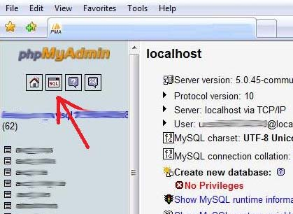

Now you should see a SQL query box (depending on the version of phpMyAdmin you are using maybe in a new window, see Figure 1.3). Now you can copy all required statements from the README file into that box. Execute the statements by pressing “Go”.

|  |  |
| --- | --- |
| **C:\Users\STEPHA~1\AppData\Local\Temp\messagebox_warning-48.png** | You can execute all statements at once but ensure that each line contains one SQL statement only! |

Figure 1.3 – phpMyAdmin SQL query box

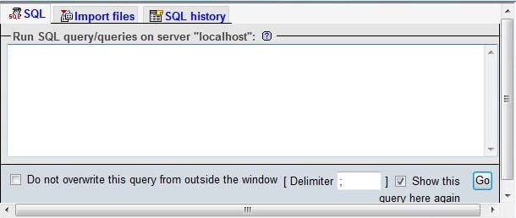

When an error occurs (something similar to the error in Figure 1.4 will be shown), please check the lines carefully and try again. You can also execute all statements line by line.

Figure 1.4 – phpMyAdmin main view

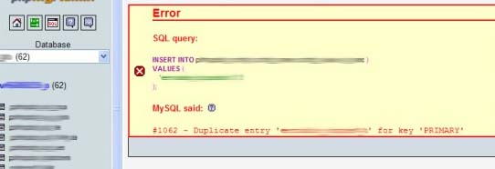

When no error occurs you are done.

### Installing an uddeIM Hotfix

*Hot do I install an uddeIM Hotfix?*

Installing a Hotfix is quite easy:

1. Unpack the ZIP archive
2. Overwrite the existing files on your server with the files found in the archive   
   There are several places you have to check (incl. subfolders):   
   /administrator/components/com\_uddeim   
   /components/com\_uddeim   
   /modules (Joomla 1.0)   
   /modules/<module name> (Joomla 1.5+)   
   /mambots (Joomla 1.0)   
   /plugins (Joomla 1.5+)   
   /components/com\_comprofiler/plugin/user/<plugin name> (CB)

I recommend using Joomla Extplorer to upload the files to the server.

### How do I upgrade uddeIM modules and plugins?

*How do I upgrade uddeIM modules and plugins?*

There are two possibilities:

1. Deinstall the old module/plugin and install the new module/plugin. Since all parameters are lost you have to configure the modules/plugins again.
2. Unpack the installation archive and overwrite the existing files on your server. You will find the modules/plugins on your server in:   
   /modules (Joomla 1.0)   
   /modules/<module name> (Joomla 1.5+)   
   /mambots (Joomla 1.0)   
   /plugins (Joomla 1.5+)   
   /components/com\_comprofiler/plugin/user/<plugin name> (CB)

I recommend using Joomla Extplorer to upload the files to the server.

### “Fatal error: Cannot redeclare uddeIMgetUserTZ() (previously declared in…”

*After upgrading uddeIM I get following error:*

*Fatal error: Cannot redeclare uddeIMgetUserTZ() (previously declared in …/com\_uddeim/uddeimlibXX.php) in …/com\_uddeim/uddeimlibYY.php*

or

*Fatal error: Cannot redeclare uddeIMmodCheckCB() (previously declared in …/mod\_uddeim/mod\_uddeim.php) in …/mod\_uddeim/mod\_uddeim.php*

or

*Fatal error: Cannot redeclare uddeIMcheckJVersion() (previously declared in …/mod\_uddeim/mod\_uddeim.php) in …/administrator/components/com\_uddeim/admin.shared.php*

You have not upgraded all uddeIM modules, plugins or CB plugins (or the component itself). UddeIM uses a compatibility layer to make it compatible to all official Joomla versions (it will change with each Joomla version).

E.g. uddeIM 2.6 on Joomla 2.5 loads the correct compatibility layer for Joomla 2.5. When you have forgotten to update the notifier module (you are using version 2.5 or older), it tries to load the wrong compatibility layer for Joomla 1.7 which will give the conflict above.

### “Fatal error: Cannot redeclare uddeIMmodCheckCB() (previously declared in…”

See chapter 1.3.6.

### “Fatal error: Cannot redeclare uddeIMcheckJVersion() (previously declared in…”

See chapter 1.3.6.

### “Fatal error: Cannot redeclare class getuddeimTab in…”

*After upgrading uddeIM I get following error:*

*Fatal error: Cannot redeclare class getuddeimTab in …/components/com\_comprofiler/plugin/user/plug\_privatemessagingsystem(uddeimpms)/pms.uddeim.php on line 652*

You have installed the uddeIM PMS Plugin for the Community Builder twice. In uddeIM 2.8 the plugin has been renamed so when you have not removed the older one manually, the plugin will be loaded with its old name “uddeIM PMS” and its new name “uddeIM Private Messaging System”. Deinstall the old plugin and you are done.

|  |  |
| --- | --- |
| **C:\Users\STEPHA~1\AppData\Local\Temp\messagebox_warning-48.png** | Do not deactivate the plugin because this will not fix the error. |

## Configuring Joomla

### How can my users get access to uddeIM?

*How do my registered users get access to the component?*

Create a menu link to the component (it is the same procedure you do for all other components, too). When you do not use the "Public Frontend" feature you should set the access rights to "registered" when you publish the link.

Figure 1.5 – Menu link to uddeIM

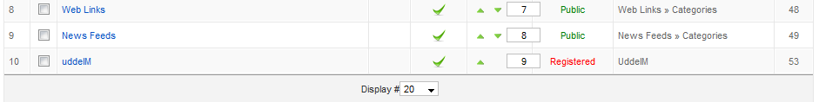

### Is a published menu link to uddeIM required?

*Do I have to create a published menu link to uddeIM?*

Yes, you have to create a published menu link to uddeIM. If this link should not be visible do following:

* Create a new menu which is not displayed.
* Create a published menu link to uddeIM in this menu.

### I have created a menu link to uddeIM but some modules/components do not work correctly?

*I have created a menu link to uddeIM component but some 3rd party modules/components do not work correctly? E.g. I do only get a blank screen when uddeIM is called or a 404 error.*

Usually a module or component tries to find the correct Itemid to another component (e.g. uddeIM) doing a lookup in jos\_menu table (this table stores all menu links to components etc.).

When you uninstall and reinstall uddeIM (e.g. when upgrading) it will get a new Itemid leaving the entry in jos\_menu untouched. When a module or component tries to get a valid Itemid, it may get an orphaned Itemid from jos\_menu, unless you recreate the menu link, so a new jos\_menu entry with an updated Itemid is created.

Unfortunately Joomla does not remove jos\_menu entries from the table when you delete the link in the backend; the links are only marked as deleted. A module or component which does not evaluate this correctly may still get the wrong Itemid because it reads the "deleted" entry.

To avoid this clear the trash (open Joomla Trash Manager) in the backend. Do not forget to switch from "Content Items" to "Menu Items".

|  |  |
| --- | --- |
| **C:\Users\STEPHA~1\AppData\Local\Temp\messagebox_warning-48.png** | Please also check following chapters:  1.4.2, 1.4.4, 1.4.5, 1.4.6, 1.4.7 |

### Blank screen when uddeIM is called

*I do only see a blank screen when I call uddeIM.*

You have to create a menu link to the uddeIM component (when you have upgraded uddeIM check if the menu link is still intact, so that it has the correct Itemid).

If you do not want a visible link in your menu, anyhow you have to create one: create a menu which is not used on your page and create a published link in that menu.

Another problem might be your URL rewriting. When you see URLs like

http://mydomain.com/option,com\_uddeim/

then you should check if you have changed the .htaccess correctly. A correct SEF URL should look like

http://mydomain.com/component/option,com\_uddeim/

or

http://mydomain.com/uddeim.html

### “Unsupported operand types in router.php” error

*Every time I send a PM in uddeim I get this:*

*"Fatal error: Unsupported operand types in /home/mydomain/includes/router.php on line x"*

Check following:

* Have you created a menu link for uddeIM? uddeIM uses this link to get the correct Itemid.
* When creating a menu item, use type “Component”, not type “Link – URL”.
* Is the link to uddeIM published? If not you will get this error when uddeIM redirects after sending/replying a message. If you do not want this link published, create a new menu which is not displayed and create a published link to uddeIM there.
* Is the menu link still pointing to uddeIM component? After updating a component you need to update the menu link, too.
* Has the link the correct access rights? Usually it should be available for “registered users” only. When you have enabled the “Public Frontend” in uddeIM then you have to set the access rights to “public”.
* Have you trashed a menu link to uddeIM and this link is still in the trashcan? Maybe this link is used for the Itemid.
* Have you created two or more menu links to uddeIM? uddeIM uses the first Itemid that can be found. When uddeIM finds the wrong Itemid (and you need two or more menu links to uddeIM) you can overwrite the Itemid in the admin backend (system tab).

|  |  |
| --- | --- |
| **C:\Users\STEPHA~1\AppData\Local\Temp\messagebox_warning-48.png** | Do not overwrite the Itemid before you know what the exact problem is. This feature has been built in to solve the problem with multiple links only! |

### “You Are Not Allowed To View This Page” error

*When I select uddeIM I get a “You Are Not Allowed To View This Page” error.*

Check following:

* UddeIM required a menu link to the component in order to work. The link can be unpublished but must exist.
* Check if the menu link to uddeIM component has the correct access level.
* Open Joomla trash manager. Switch to trashed “menu items”. Check if there are trashed menu items and empty the trash. Clear the Joomla cache if enabled.

### “Error 404 – Page not found” when accessing uddeIM

When I try to access uddeIM I get a 404 error.

The most common reason for that is that the Itemid to access uddeIM is wrong.

|  |  |
| --- | --- |
| **C:\Users\STEPHA~1\AppData\Local\Temp\messagebox_warning-48.png** | Please also check following chapters:  1.4.2, 1.4.3, 1.4.4, 1.4.5, 1.4.6 |

### Wired errors after uddeIM has been installed

*After installing uddeIM I have problems with [fill in your problem here].*

UddeIM component should not interfere with any other component (except another component declares a function that uses the same name which is unlikely). uddeIM component behave passive unless it is called (e.g. MooTools used on the uddeIM compose message page may interfere with another module, mambot/plugin or template that also loads MooTools).

uddeIM modules and mambots/plugins interact with your website. So these components may interfere with other modules, mambots/plugins or templates. To debug problems, first disable all uddeIM modules and mambots/plugins and then sequentially enable them step by step until the problems appear again. When you have identified the problem, changing some parameters may solve your problem (e.g. mod\_uddeIM uses AJAX requests to get the new message status, if this request interferes with another module you can try to switch off AJAX support in mod\_uddeIM).

### The “Compose” link leads to the inbox instead of the compose form?

*The "Compose" link (menu bar) does not lead to the compose form, but to the inbox so I cannot create a new message. The "New Message" Link (mod\_uddeim\_mailbox) is correct.*

The SEF drops "&task=new" from the URL that is used to call the compose form so it shows the inbox instead. Check the SEF settings in Joomla configuration. For a first try disable SEF and mod\_rewrite. When you are using a 3rd party SEF component first check if it requires a special uddeIM plugin in order to work. In some components it is also possible to exclude components from SEF (since uddeIM is only available internally you do not really need search engine friendly links).

## Deinstallation of uddeIM

### I like to deinstall uddeIM completely. How can I do this?

*I like to deinstall uddeIM completely in order to make a clean reinstall. How can I do this?*

Default procedure (this is the same as for all Joomla components):

1. Deinstall uddeIM using the extension manager in Joomla.
2. Use phpMyAdmin and drop all tables that are prefixed uddeIM (plus the standard Joomla prefix), e.g. jos\_uddeim, jos\_uddeim\_userlist etc.

When you have to deinstall uddeIM because of errors (e.g. installation was not finished correctly and uddeIM is not listed in the component manager) then do following:

1. When possible, deinstall uddeIM using the extension manager in Joomla.
2. Check if “/components/com\_uddeim” and “/administrator/components/com\_uddeim” still exist and if delete these folders.
3. Use phpMyAdmin and drop all tables that are prefixed uddeIM (plus the standard Joomla prefix), e.g. jos\_uddeim, jos\_uddeim\_userlist etc.
4. Remove all uddeIM related entries from jos\_menu and jos\_extensions (chance to the prefix used on your system).   
   You can clean up your database tables using following two commands:   
   DELETE FROM `jos\_menu` WHERE `link` LIKE '%uddeim%'   
   DELETE FROM `jos\_extensions` WHERE `element`='com\_uddeim'

# Installation (Joomla 1.5+)

## How to install uddeIM on Joomla 1.5+?

*Is there something I have to know when I install uddeIM on Joomla 1.5+?*

Yes, indeed. Joomla 1.5+ offers an ftp-layer which should make installations easier. Unfortunately this ftp layer does not fix all problems but also introduces new problems.

**First alternative (installing uddeIM without ftp layer enabled):**

**Joomla was installed without ftp mode enabled:** When your .php files are running under different owner rights (e.g. "wwwrun" and "userid") make sure that you do not have ftp mode enabled in global configuration when you install uddeIM. uddeIM creates a new configuration file during installation.

**Joomla was installed with ftp mode enabled:** The existing file will be owned by "userid" and the new created configuration file is owned by "wwwrun". So you will get an error message that the configuration file could not be written. You can chmod the file to “0766” so it becomes writeable.

**Second alternative (installing uddeIM with ftp layer enabled):**

When you install uddeIM you may get a warning that the configuration file config.class.php is not writeable. Ignore this warning and after the installation has finished use your ftp client to chmod this file, so it is writeable for your web server (when you are unsure about the correct access right, try 0766 for a first start).

|  |  |
| --- | --- |
| **C:\Users\STEPHA~1\AppData\Local\Temp\messagebox_warning-48.png** | uddeIM 1.9+ has some improvements regarding the ftp layer.  When the ftp layer is enabled the configuration file should be writeable when Joomla was also installed with the ftp layer. When you mix ftp layer and non ftp layer installations you may chmod the configuration file to “0766” manually. |

## What is the ftp layer? Is there something I should know about?

*What is the ftp layer? Is there something I should know about?*

Yes, indeed. Joomla 1.5+ offers an ftp-layer which should make installations easier. Unfortunately this ftp-layer does not fix all problems but also introduces new problems. The following text has been taken from the Joomla documentation, so read it carefully:

At the heart of the issue is file ownership. There are generally two main server users that end up owning your files - the FTP user, and the Apache/PHP user. Obviously, when you upload files using FTP, the FTP user ends up owning them. Therefore, if you give a file 755 permissions, then ONLY the FTP user can write to that file.

If you install Joomla without the FTP layer, then the files it creates are owned by the Apache/PHP user. If you give the file 755 permissions, then ONLY the Apache/PHP user can write to that file.

Just to emphasize, the fact that these username and passwords happen to be the same has no effect whatsoever on anything. They are different subsystems and are unrelated. It may be convenient, but will not solve your permission issues.

So there are generally two approaches to take:

1. upload all the files via cpanel. This will generally result in all of the files being owned by the Apache/PHP user. Ensure that the root directory that all of your Joomla files are installed in is writable, so that the installer can create the configuration.php file. Then, install Joomla WITHOUT the FTP layer.
2. upload all the files using FTP. This will generally result in all of the files being owned by the FTP user. Make sure that your Joomla! root directory is writable, again, so that the installer can create the configuration.php file. Then install Joomla WITH the FTP layer.

Ensure that your cache folders are owned by the Apache/PHP user, because these files are written by PHP (cache because writing using the PHP user is much faster than via FTP.

If you apply these principles - and choose either the first or the second approach, you should get better results and extension installation should work properly via the admin interface. Mixing the two approaches will cause you no end of grief.

A good way to check that everything is in order is to browse to the Administrator section of your site and browse to Help->System Info from the menu. Click on directory permissions.

If you don't have the FTP layer enabled, it is important that everything show up as Writable. If you do have the FTP layer enabled, then it is important that your two Cache directories show up as writable. It is most likely okay that the rest show up as unwritable, because Joomla can likely write these files using the stored FTP settings.

If you choose to use the FTP layer and you still have trouble, reupload the Joomla 1.5+ package onto your server using your FTP client and the FTP user that you specified in Joomla's global configuration. If your FTP client reports permission problems when trying to do this, contact your host for further assistance.

## I have an ownership problem, what can I do?

*I have the ownership problem described in chapter 2.2. I am running my own server. What can I do?*

Your new hosting service is not a "Joomla Friendly." If they don't have SuExec, the Joomla scripts (like the install components run and install files and directories owned by "Apache" and they should be made with you, the user account as owner.

HarryB in Joomla Documents best said it: "When looking for a (Joomla) host, ask if they implement phpsuexec and php-cgi. if they do, that's a good way to go as the ownership/permission issues in this environment will probably be far more manageable than they are when using the Apache php module (mod\_php)."

The user for your Joomla site should be your user ID. You can't change it or take it away from Apache or the root, so you have to ask your ISP host to change them to your ownership ID.

There are two FAQs available you should read in order to avoid problems:

### How can you avoid using chmod 0777 to enable installs?

From: <http://docs.joomla.org/How_can_you_avoid_using_chmod_0777_to_enable_installs%3F>

On a private server with a small, controlled set of users, there is no need to use a chmod 777 to make the Joomla! folders writable in order to perform installs. You can set the server up so that both Apache and FTP have control of site files.

Directions

1. Edit the Apache user.conf file and tell apache to run under the FTP account.
2. chmod the entire site to 644 or 744. Apache should be able to run just fine that way.

Optional

1. chgrp the entire web space to the FTP group so that only those with FTP access can write to the server.
2. chmod the entire web space to 764 or 664 will be possible giving other users write access as well

### How do you recursively adjust file and directory permissions?

From: <http://docs.joomla.org/How_do_you_recursively_adjust_file_and_directory_permissions%3F>

In the Back-end, go to Site 🡪 Global Configuration 🡪 Server.

Using the UNIX shell:

Note: The find command automatically assumes that it should start from the current directory. To be safe, go to your public\_html directory and specify a path as the first argument. Some shells, such as bash on Apple OS X, must have a path specified in the find command.

find . -type f -exec chmod 644 {} \;

find . -type d -exec chmod 755 {} \;

chmod 707 images

chmod 707 images/stories

chown apache:apache cache

Notes:

1. Test all third party extensions after changing permissions.
2. You may need to reset write permissions to install more extensions.

### Why can't you install any extensions?

From: <http://docs.joomla.org/Why_can%27t_you_install_any_extensions%3F>

#### PHP Version

If your site is using PHP 5.0.4 this problem will occur. You need to ask your host to upgrade to a newer version of php. Joomla! does not work with PHP 5.0.4, there is no work around.

#### Tmp and session paths

One common problem with remote hosts is that they sometimes move sites to different folders on the host server. In general, this does not cause obvious problems in Joomla!. However, when you install an extension, you need to be able to write to the "tmp" directory.

In this case, you might get the error message: "JFolder::create: Could not create directory" and "Warning! Failed to move file." If you have the Joomla! FTP layer enabled, you might get the message "JFTP::mkdir: Bad response, JFTP::chmod: Bad response, JFTP::store: Bad response, Warning! Failed to move file."

**tmp directory:** An incorrect tmp directory can cause this problem. To check this, look in your configuration.php file for the var $tmp\_path value and make certain it matches your actual path. This must be writable to Joomla!.

**Session path:** The session.save\_path directive in your php.ini file must be writable. If it reports *save.session\_path: Not Writable* then there is a problem. Look at your php.ini directives and verify the location and the permissions of the session.save\_path value. It must be a valid location and it must be writable for Joomla!. You may require the assistance of your Web host for this, depending on your Web hosting situation.

**php.ini:** You could also check your php.ini file, main file is generally under /etc directory. If you can edit this file, you can set open\_basedir to include the temp directory: *open\_basedir = /tmp*. If you have another path included, as suggested by security settings for Joomla!, you can add additional paths by adding *:/path*. An example: *open\_basedir = /var/www/html:/tmp*.

#### File ownership advice from ianmac

At the heart of the issue is file ownership. There are generally two main server users that end up owning your files - the FTP user, and the Apache/PHP user. Obviously, when you upload files using FTP, the FTP user ends up owning them. Therefore, if you give a file 755 permissions, then ONLY the FTP user can write to that file.

If you install Joomla! without the FTP layer, then the files it creates are owned by the Apache/PHP user. If you give the file 755 permissions, then ONLY the Apache/PHP user can write to that file.

Just to emphasize, the fact that these username and passwords happen to be the same has no effect whatsoever on anything. They are different subsystems and are unrelated. It may be convenient, but will not solve your permission issues.

So there are generally two approaches to take:

1. upload all the files via cpanel. This will generally result in all of the files being owned by the Apache/PHP user. Ensure that the root directory that all of your Joomla! files are installed in is writable, so that the installer can create the configuration.php file. Then, install Joomla! WITHOUT the FTP layer.
2. upload all the files using FTP. This will generally result in all of the files being owned by the FTP user. Make sure that your Joomla! root directory is writable, again, so that the installer can create the configuration.php file. Then install Joomla! WITH the FTP layer.

Ensure that your cache folders are owned by the Apache/PHP user, because these files are written by PHP. (cache because writing using the PHP user is much faster than via FTP.

If you apply these principles - and choose either the first or the second approach, you should get better results and extension installation should work properly via the admin interface. Mixing the two approaches will cause you no end of grief.

A good way to check that everything is in order is to browse to the Administrator section of your site and browse to Help->System Info from the menu. Click on directory permissions.

If you don't have the FTP layer enabled, it is important that everything show up as Writable. If you do have the FTP layer enabled, then it is important that your two Cache directories show up as writable. It is most likely okay that the rest show up as unwritable, because Joomla! can likely write these files using the stored FTP settings.

If you choose to use the FTP layer and you still have trouble, reupload the Joomla! 1.5+ package onto your server using your FTP client and the FTP user that you specified in Joomla!'s global configuration. If your FTP client reports permission problems when trying to do this, contact your host for further assistance.

#### Web hosting advice from HarryB

There are some techniques used by some Web hosts that make this easier for novices. HarryB, longtime community member, has this advice for those of you who are not experts in security issues, and do not wish to invest time in that learning, and are considering finding a Web host environment that will allow you to avoid these scenarios:

*When looking for a host, ask if they implement phpsuexec and php-cgi. if they do, that's a good way to go as the ownership/permission issues in this environment will probably be far more manageable than they are when using the Apache php module (mod\_php).*

## Does uddeIM run on Joomla 1.5 native?

*Is uddeIM compatible to Joomla 1.5 native mode?*

uddeIM is compatible to Joomla 1.5 in native and legacy mode (i.e. it does not matter if the "System - Legacy" plugin in enabled or not).

## J!1.5 Extension Manager claims that uddeIM modules/plugins are not native

*Joomla 1.5 Extension Manager shows a red X icon under “native compatible” mode. When you go over the X it says "This extension does not function natively with Joomla 1.5. It requires Legacy Mode to be ON. Please contact the extensions author for additional information.” The same happens with a few other modules and/or plugins.*

This is a known flaw in Joomla 1.5. Joomla uses/detects the wrong XML and thinks the module is 1.0 native which is actually wrong. I have reported the bug in August 2008 but the Joomla dev has not reacted up to now:

<http://forum.joomla.org/viewtopic.php?f=231&t=317492>

When you are confused about this you can fix it quite easy (e.g. using Joomla Extplorer):

1. Go to the module folder, e.g. /modules/mod\_uddeim/
2. Remove mod\_uddeim.xml
3. Rename mod\_uddeim.j15.xml to mod\_uddeim.xml

That’s all. Now the extension manager does not claim that the module is not Joomla 1.5 compatible. Do the same for all other installed uddeIM modules and plugins.

|  |  |
| --- | --- |
| **C:\Users\STEPHA~1\AppData\Local\Temp\messagebox_warning-48.png** | In uddeIM 1.7+ there is a maintenance function “Compatibility maintenance” that removes and renames the XML files automatically. |

Figure 2.1 – Red crosses in Extension Manager

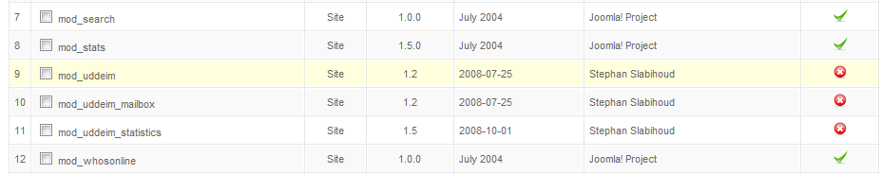

## How to migrate from Joomla 1.0 to Joomla 1.5+?

*Is it possible to migrate from Joomla 1.0 to Joomla 1.5+ without losing all PMs?*

Sure, it is. Create a backup of all tables that are prefixed “uddeim”. Usually you should have a file \*.SQL which contains the content.

Before restoring the data, please ensure that this file is UTF-8 encoded since Joomla 1.5+ saves everything in that encoding.

You can try to restore the file without doing any modifications first (e.g. when you have uddeIM configured to save messages “obfuscated” or “base64 encoded” there is nothing to do since everything is in plain ASCII). When you recognize that special characters are missing after restoring, you have to convert the file into UTF-8 first. I used a text editor (like UltraEdit) for that. Restore the converted file and check if the special characters are ok.

Don’t forget to configure the used character set in uddeIM admin backend to “UTF-8”.

|  |  |
| --- | --- |
| **C:\Users\STEPHA~1\AppData\Local\Temp\messagebox_warning-48.png** | Note:  Migration does only work when you are migrating to the same version of uddeIM. Do not upgrade to a newer version of uddeIM in the same step! |

# Installation (Joomla 1.6+)

|  |  |
| --- | --- |
| **C:\Users\STEPHA~1\AppData\Local\Temp\messagebox_warning-48.png** | Note:  Please also read chapter 2 which is mostly valid for Joomla 1.6 installations, too. In particular when you have problems with the ftp layer you should check this chapter! Additional issues for Joomla 1.6 are listed in this chapter. |

## How to install uddeIM on Joomla 1.6?

*Is there something I have to know when I install uddeIM on Joomla 1.6?*

No, for most users uddeIM installs fine using the Extension Manager in Joomla 1.6 (when you are working with the ftp layer or Joomla gives an ftp error during the installation, please read chapter 2 first).

Figure 3.1 – Installation using the Extension Manager

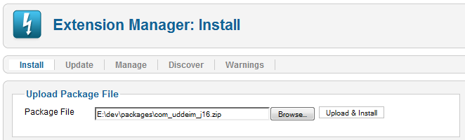

When the installation has finished you should see a message that uddeIM has been installed successfully.

Figure 3.2 – Successful installation of uddeIM

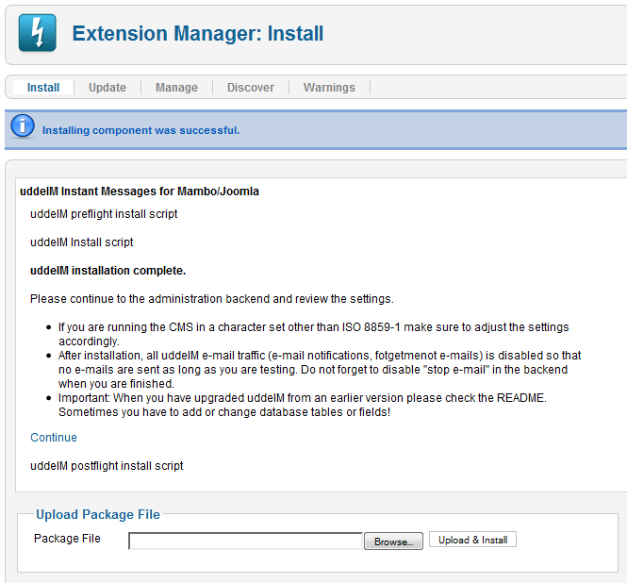

Under “Components” you should be able to access the uddeIM PMS configuration backend.

Figure 3.3 – Accessing the configuration backend of uddeIM

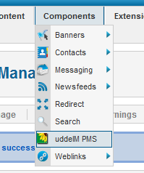

Use the Menu Manager to create a frontend link to uddeIM for your users. First you have to select the Menu Item Type (“uddeIM PMS component”). Then enter a menu title (e.g. “uddeIM” or “Mailbox”) and select the mailbox the user should see by default (usually the “Inbox”).

Figure 3.4 – Creating a menu link to the uddeIM frontend

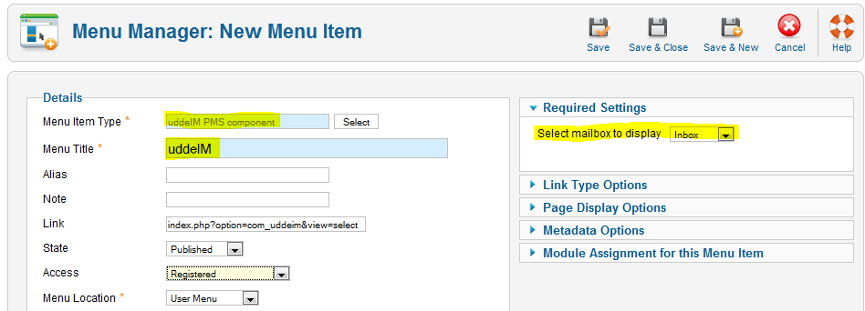

Figure 3.5 – Menu Item Type

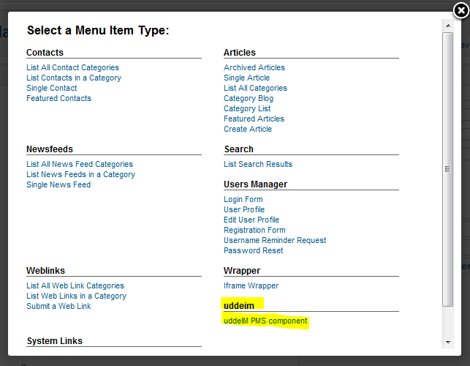

## “Error building admin menus” after installation

*After installation of uddeIM I get the error that the admin menus have not been created.*

It has been reported from a few users that admin menus on Joomla 1.6(.x) have not been created after installation of uddeIM.

This is a known problem that appears on some Joomla 1.6 sites for several components.

There are two possible solutions. The first one has been tested by uddeIM dev and works fine but require some steps, the second one was reported by JimBC@Joomlapolis but not tested by uddeIM dev.

**First solution:**

To avoid or fix this problem:

1. Ensure that you have not upgraded Joomla from version 1.6rc or earlier.  
   Upgrading from 1.6 stable to a newer version is ok.
2. Ensure that you are installing com\_uddeim\_j16.
3. When menu links are not created (Joomla has already created wrong entries), then
   1. Deinstall uddeIM.
   2. Remove all uddeIM related entries from jos\_menu and jos\_extensions (chance to the prefix used on your system).   
      You can clean up your database tables using following two commands:   
      DELETE FROM `jos\_menu` WHERE `link` LIKE '%uddeim%'   
      DELETE FROM `jos\_extensions` WHERE `element`='com\_uddeim'
   3. Reinstall com\_uddeim\_j16.

It seems to be a bug in Joomla 1.6 that it sometimes destroys its own tables.

For more information see <http://www.joomlapolis.com/forum/25-uddeim-plugin-and-component/157512-solved-j16--17-non-created-admin-menus>

**Second solution:**

Do not uninstall uddeIM.

Go to your Joomla backend of your site. Scroll through Extensions/Manage, look for the uddeIM component and then note the ID that Joomla has assigned.

Figure 3.6 – uddeIM ID

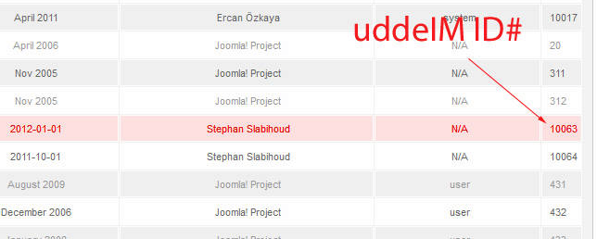

Now open phpMyAdmin, select your Joomla database, open jos\_menu table (with your prefix), search for COM\_UDDEIM\_MENU, and edit the entry. Enter the uddeIM ID in “component\_id”. Save your modification. When you go back in the administrator backend you should see uddeIM PMS.

Figure 3.7 – Set uddeIM in phpMyAdmin

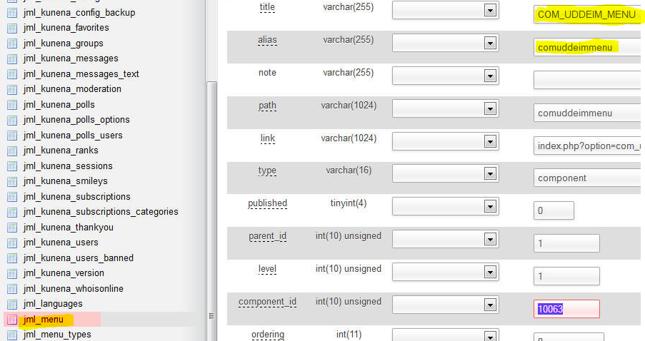

## How to migrate from Joomla 1.5 to Joomla 1.6+?

*Is it possible to migrate from Joomla 1.5 to Joomla 1.6+ without losing all PMs? I imigrated Joomla from 1.5 to 1.6+ using the jUpgrader. But the uddeIM messages have not been imported.*

Create a backup of all tables that are prefixed “uddeim”. Usually you should have a file \*.SQL which contains the content.

There are two ways:

1. Install uddeIM on the new system and after that remove all “uddeIM” tables from the database manually. Then restore the saved data on the new system.
2. Restore the saved data on the new system (so all tables exist), then install uddeIM.

No further modifications are required. When you have backed up the configuration using the internal uddeIM functions you can also restore the configuration after the tables have been imported.

|  |  |
| --- | --- |
| **C:\Users\STEPHA~1\AppData\Local\Temp\messagebox_warning-48.png** | Note:  Migration does only work when you are migrating to the same version of uddeIM. Do not upgrade to a newer version of uddeIM in the same step! |

# Installation of uddeIM premium plugins (for donators)

|  |  |
| --- | --- |
| **C:\Users\STEPHA~1\AppData\Local\Temp\messagebox_warning-48.png** | Note:  A donation does not mean that you have automatically access to all premium plugins. Please check the development site for more information how to get access to a certain plugin.  Currently there is a package available that contains following four plugins:  Public Frontend plugin, RSS Feed plugin, Report Control Center plugin, File Attachment plugin, Postbox plugin. |

## How to get premium plugins for donators?

*How can I get the premium plugins for donators?*

There are currently following premium plugins available exclusively for donators.

Public Frontend plugin

This plugin enables “Public Frontend” functionality. When you enable the Public Frontend unregistered users can send PMs to registered users.

RSS Feed plugin

This plugin publishes your inbox using a RSS feed. So you can display PMs in your favorite RSS reader or on your personalized iGoogle page. There is also a iGoogle gadget available which shows the content of the inbox (you can use any RSS gadget you like).

Report Control Center plugin

This plugin enables the “Report message” feature, so users can report messages (e.g. SPAM) to the Admin. In the backend the Admin can check all reported messages and take appropriate actions.

Message Control Center plugin

This plugin enables the moderation feature, so messages are not delivered immediately. In the backend the Admin can check these delayed messages and deliver/delete them.

File attachments plugin

This plugin enables file attachments, so users can send small files to each other.

Postbox plugin (experimental)

This plugin shows the inbox and outbox content in one single box (postbox).

All plugins can be downloaded from my support web site:

<http://www.slabihoud.de/software/>

When you are interested in these plugins, please make a donation using the donate buttons in uddeIM admin backend or on my support site. Ensure that your email address is submitted by PayPal, so I can send you your personal username/password. With these user credentials you are able to download the files from my webpage.

|  |  |
| --- | --- |
| **C:\Users\STEPHA~1\AppData\Local\Temp\messagebox_warning-48.png** | **Important:**  **Please check the website above for the minimum fee required to get the user credentials for a certain premium plugin package!** |

Figure 4.1 – Donation buttons in uddeIM admin backend

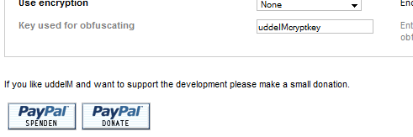

## How to install premium plugins for donators?

*I have downloaded the archive. How do I install the premium plugins?*

Extract the downloaded archive. Depending of the downloaded package you will find one or more files. Please copy the files in the destined folders:

|  |  |  |
| --- | --- | --- |
| **Copy file…** | **To…** | **uddeIM[[3]](#footnote-4)** |
| rss.php | /components/com\_uddeim/ | 1.6+ |
| pfrontend.php | /components/com\_uddeim/ | 1.6+ |
| attachment.php | /components/com\_uddeim/ | 1.9+ |
| postbox.php | /components/com\_uddeim/ | 2.8+ |
| admin.spamcontrol.php | /administrator/components/com\_uddeim/ | 1.7+ |
| admin.mcp.php | /administrator/components/com\_uddeim/ | 2.3+ |

When you enter the uddeIM admin backend you should find (depending on the installed plugins):

* a new tab "Public"
* a new option "Enable RSS" in the "System" tab
* a new option "Enable attachments" in the "System" tab
* a new option "Enable postbox" in the "System" tab
* a new toolbar button “Report Control”
* a new toolbar button “Message Control”

The iGoogle gadget is available here:

http://yoursite/components/com\_uddeim/uddeim\_igoogle.xml

The admin can enable an iGoogle button in the user preferences that can be used to install the gadget.

## Public Frontend plugin

### How to get access to the Public Frontend?

*How do I use the "Public Frontend" feature, so unregistered users can send PMs to my registered users?*

See chapter 1.4.1. Create a menu link to the component, but set the access rights to "public" when you publish the link. Do not forget to enable the "Public Frontend" in uddeIM.

Figure 4.2 – Public Frontend

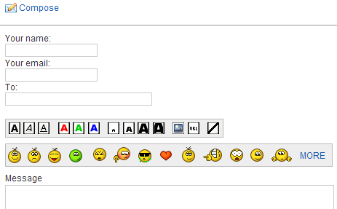

|  |  |
| --- | --- |
| **C:\Users\STEPHA~1\AppData\Local\Temp\messagebox_warning-48.png** | Note:  For security reasons the public frontend does not allow the posting of attachments. Users have to register first and must use the regular frontend. |

## RSS Message Feed plugin

### How to get the feed URL to access the mailbox?

*How do I get the feed URL to access my mailbox?*

When the RSS Message Feed feature in enabled in the backend, the user will see the RSS feed URL in the uddeIM user preferences.

Figure 4.3 – RSS Message Feed URL in uddeIM user preferences

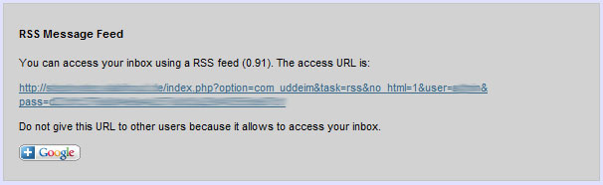

### Optional Feed parameters

*Are there any optional feed parameters available?*

Yes, there are. Currently there are following parameters available. To use them, add the parameters to the Feed URL.

|  |  |
| --- | --- |
| **Parameter** | **Description** |
| showall=n | n=1: Show all messages  n=0: Show new messages (default) |
| type=n | n=1: Return error codes  n=0: Return error messages (default)  Error codes:  code=0: No messages  code=1: No new messages  code=2: Access not allowed  code=3: Wrong username or password  code=4: No object (internal error)  code=5: User blocked |

### How to use RSS Message Feeds in iGoogle?

*I saw that you deliver a special iGoogle gadget. How can I use it on my site?*

Although you can use any RSS reader to display uddeIM message feeds (RSS 0.91) it is very useful to display also feeds on the iGoogle start page.

You can use for this purpose any iGoogle RSS gadget or the enclosed one:

http://yoursite/components/com\_uddeim/uddeim\_igoogle.xml

One advantage of uddeim\_igoogle.xml is that it shows new messages and all messages in separate tabulators without adding additional feed URLs.

To use it, upload uddeim\_igoogle.xml to the root folder of your homepage and use the following code to promote it (you can change the picture of course):

<a href="http://fusion.google.com/add?  
source=atgs&feedurl=http%3A//www.yoursite.com/uddeim.xml">  
<img src="http://gmodules.com/ig/images/plus\_google.gif"   
border="0" alt="Add to Google"></a>

or

<a href="http://fusion.google.com/ig/add?  
synd=open&source=ggyp&moduleurl=http://yoursite/components/  
com\_uddeim/uddeim\_igoogle.xml">  
<img src="http://yoursite/components/com\_uddeim/templates/  
images/igoogle.gif" border="0" alt="Add to Google" width="62"  
height="17"></a>

When installed on the iGoogle start page the user has to enter his personalized feed URL in the gadget preferences.

|  |  |
| --- | --- |
| **C:\Users\STEPHA~1\AppData\Local\Temp\messagebox_warning-48.png** | 1. Do not append showall=n and type=n parameters to the personalized feed URL. These parameters are added automatically by the iGoogle gadget. 2. When the user has installed the iGoogle gadget he may see an “Invalid feed URL” error first. After entering the correct URL in the preferences this error will not disappear immediately since RSS data is cached by Google. It should start working after a few minutes when Google rereads the RSS data. |

|  |  |
| --- | --- |
| **C:\Users\STEPHA~1\AppData\Local\Temp\messagebox_warning-48.png** | Joomla 1.5.14+ added a new rewrite block to the .htaccess file which denies access to XML files globally for your whole site.  When you uncomment following lines  ## Deny access to extension xml files (uncomment out to activate) #<Files ~ "\.xml$"> #Order allow,deny #Deny from all #Satisfy all #</Files> ## End of deny access to extension xml files  iGoogle is no longer able to read uddeim\_igoogle.xml from your server. Better is to block XML files for /administrator/components/ and /components/ folders only!  Or you can also modify your main .htaccess file and add  ## Allow access to XML file used by iGoogle RewriteCond %{REQUEST\_FILENAME} -f RewriteRule ^(components/com\_uddeim/uddeim\_igoogle\.xml)$ $1 [L]  This gives access to uddeim\_igoogle.xml only. |

Figure 4.4 – iGoogle gadget

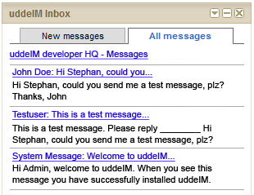

## Report Control Center plugin

### How to get access the Report Control Center?

*How do I call the "Report Control Center" feature?*

There is a new button in the toolbar. This is used to enter the Report Control Center. Don’t forget to enable the “Report message link” in Message tab, so users can report messages.

Figure 4.5 – Message Control Center Button

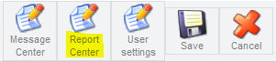

Figure 4.6 – Enable “Report message link”



### What actions are available in the Report Control Center?

*What actions are available in the Report Control Center?*

In the Report Control Center you see a list of all reported messages. When the message has not been encrypted you can also read the message text, so you can control if the message is e.g. SPAM.

Following actions are available:

Remove: Remove the report from the list, the message will not be touched.

Delete: Remove the report from the list and delete the message from the database.

|  |  |
| --- | --- |
| **C:\Users\STEPHA~1\AppData\Local\Temp\messagebox_warning-48.png** | Encrypted messages cannot be displayed! |

## Message Control Center plugin

### How to get access the Message Control Center?

*How do I call the "Message Control Center" feature?*

There is a new button in the toolbar. This is used to enter the Message Control Center. You should also set “Moderate new users” in the System tab and “Moderate public users” in the Public tab (if installed).

Figure 4.7 – Message Control Center Button

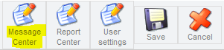

Figure 4.8 – Set moderation default for new registered users



Figure 4.9 – Enable moderation for messages from Public Users



### What actions are available in the Message Control Center?

*What actions are available in the Message Control Center?*

In the Message Control Center you see a list of all new messages from moderated mailboxes. When the message has not been encrypted you can also read the message text.

Following actions are available:

Deliver: Deliver the message to the recipient.

Delete: Delete the message from the database.

|  |  |
| --- | --- |
| **C:\Users\STEPHA~1\AppData\Local\Temp\messagebox_warning-48.png** | Encrypted messages cannot be displayed! |

|  |  |
| --- | --- |
| **C:\Users\STEPHA~1\AppData\Local\Temp\messagebox_warning-48.png** | Message notifications will not work with moderated accounts. Recipients will not be notified about new messages when a message is delivered. |

### Where can I enable the moderation feature for a dedicated user?

*Where can I enable the moderation feature for a dedicated user?*

In the User settings you enable/disable moderation for a dedicated mailbox. All messages written by this user will be delayed until a Moderator or Administrator has confirmed the message.

Figure 4.10 – Enable moderation for a dedicated user

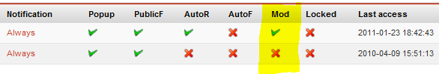

### Where can I disable the moderation feature for all users?

*Where can I disable the moderation feature for all users?*

There is no explicit function for that. You can use a SQL command to disable the moderation feature for all users at one (replace “jos” with the correct prefix):

UPDATE jos\_uddeim\_emn SET `moderated` = 0;

## File attachments plugin

### Installation issues

*How do I install the "File attachments" plugin? Are there any important issues?*

Yes, there are:

1. When you install uddeIM the first time, the installer creates the required folder “/images/uddeimfiles” automatically and also the two additional files “index.html” and “.htaccess”.

The file “index.html” prevents a web server to display the content of the directory (“file index”), the “.htaccess” file denies direct access to all content in that folder.

When your server allows changing the Indexes option, you can also add “Options –Indexes” to the “.htaccess” file.

1. When you upgrade uddeIM you have to create the folder and the content manually. Create a folder "/images/uddeimfiles" and set the access rights that Joomla can access it. When you are unsure use "0777" (usually 0766 should be fine).

To ensure that people do not access this directory directly, you should create following files (you will also find these files in the "SUPPORT" folder in the premium plugin package):

index.html

<!DOCTYPE HTML PUBLIC \"-//W3C//DTD HTML 4.01   
Transitional//EN\">

<html><head></head><body></body></html>

.htaccess

# Having a .htaccess prevents users from directly

# accessing the files in your /images/uddeimfiles folder

#

deny from all

Since uddeIM uses temporary names for file attachments stored in the file system, both files are not explicitely required when the directory is not displayed by default (Options +Indexes).

|  |  |
| --- | --- |
| **C:\Users\STEPHA~1\AppData\Local\Temp\messagebox_warning-48.png** | To improve security you can add "Options -Indexes" to the ".htaccess" file (when your server allows doing this). |

### How to enable File attachments?

*How do I enable the "File attachments" feature, so users can send file attachments with their PMs?*

You have to enable the file attachment feature in the System tab. Please configure the maximum file size allowed (note that there is also an implicit PHP limitation) and the number of files allowed per message (see Figure 4.11 and Figure 4.12).

Files are not purged automatically when a message is deleted (for performance reasons). You can do this manually (recommended), when an admin visits his inbox (recommended on small sites) or whenever a user visits is inbox (not recommended).

Figure 4.11 – File attachments configuration in backend

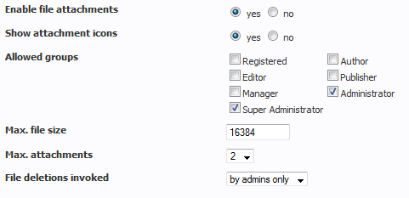

Figure 4.12 – File attachments in the frontend

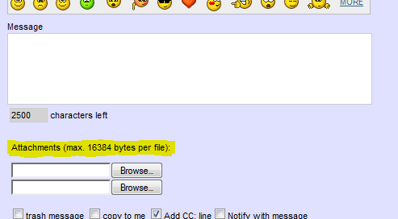

### Unprotected file downloads

*What is the purpose of “Unprotected file downloads”?*

Usually uddeIM does not disclose the path of file attachments on your server and protects your files from direct downloads, so files can only be downloaded from the correct person who is logged on.

By default all files are delivered using the content type application/force-download, which forces all browsers to display a “save file as” dialog instead of displaying the file.

Figure 4.13 – Unprotected file downloads



|  |  |
| --- | --- |
| **C:\Users\STEPHA~1\AppData\Local\Temp\messagebox_warning-48.png** | **Important:**  **When using “Unprotected file downloads”…**   1. Ensure that the folder uddeimfiles is readable so do not use the default .htaccess file (remove deny from all) that uddeIM creates by default. 2. Ensure that scripts in the folder uddeimfiles cannot be executed. This is a serious security risk, e.g. when a user sends a .php file to another user, this file can be executed by the recipient. UddeIM tries to deactivate scripts by adding .txt extensions to some known executable file types but some servers might have more extensions registered for execution.  Several solutions exist to ensure that scripts are not executed (not all are working on every server):    1. You can redefine the content type for all script files, e.g.  AddType text/plain .php .php3 .php4 .php5  in .htaccess so it delivers all php files as plain text files.    2. You can deny to access script files using mod\_rewrite.    3. You can remove the handler for certain file types, e.g.  RemoveHandler .php .php3 .php4 .php5    4. You can deny to execute scripts in the folder, e.g.  Options -ExecCGI |

### File attachments in Public Frontend

*Is it possible to enable File attachments in the Public Frontend?*

No, because of security reasons it is not possible to enable file attachments in the Public Frontend Plugin. Please let users register first in order to allow them sending files to other users.

### Sending file attachments in admins only

*Is it possible to configure file attachments in a way that users can send files to admins only?*

No, this is not possible. You can restrict the group that is allowed to send file attachments but you cannot restrict the recipients to a certain group.

## Postbox plugin

### How to enable the Postbox plugin?

*How do I enable the "Postbox" feature?*

You have to enable the file Postbox feature in the System tab (see Figure 4.14, Figure 4.15 and Figure 4.16).

Figure 4.14 – Postbox configuration in backend



Figure 4.15 – Postbox in the frontend

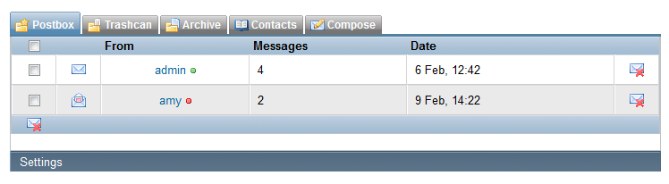

Figure 4.16 – Postbox in the frontend - opened

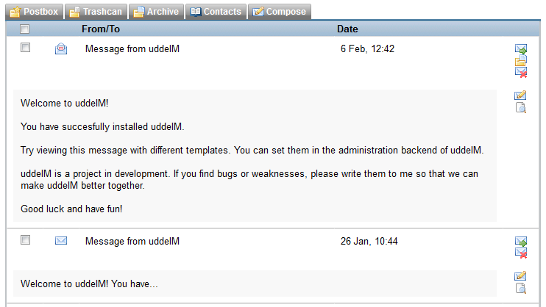

|  |  |
| --- | --- |
| **C:\Users\STEPHA~1\AppData\Local\Temp\messagebox_warning-48.png** | **Important:**  The Postbox plugin is still experimental. Use it on your own risk. |

# uddeIM modules and mambots/plugins

## General problems

### The module border is different from all other modules

*My Joomla template wraps all modules in rounded boxes. Unfortunately this is not working with uddeIM modules.*

You have to configure the “Module Class Suffix” in the module options. Usually uddeIM modules use CSS class “module” for styling. When you template e.g. uses CSS class “module\_menu” you have to enter “\_menu” here.

Figure 5.1 – uddeIM Notifier with and without “Module Class Suffix” set

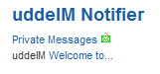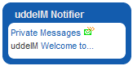

Figure 5.2 – Module Class Suffix” parameter

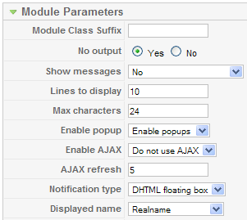

### Fatal error: Cannot redeclare moduddemailboxtime() (previously declared in XY)

*I am getting an error when I publish the mail module in some positions.*

*Fatal error: Cannot redeclare moduddemailboxtime() (previously declared in /home/mydomain/modules/mod\_uddeim\_mailbox/mod\_uddeim\_mailbox.php:213) in /home/mydomain/modules/mod\_uddeim\_mailbox/mod\_uddeim\_mailbox.php on line 217*

It is not possible to use the same uddeIM module twice.

### How can I change the module style?

*I like to change the text styles. How do I do that?*

In

/components/com\_uddeim/templates/<template>/css/uddemodule.css

you will find the CSS styles uddeIM uses for its modules.

## MODULE: mod\_uddeIM (aka “uddeIM Notifier Module”)

### What is the purpose of mod\_uddeim?

*What is the purpose of mod\_uddeim?*

This is a message notifier module. Install this module with the module installer. The module

* shows a box with new messages (optional), and
* provides popup notifications (optional).

Figure 5.3 – uddeIM Notifier (left), Floating Box Notification (right)

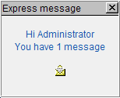

## MODULE: mod\_uddeIM\_mailbox (aka “uddeIM Mailbox module”)

### What is the purpose of mod\_uddeim\_mailbox?

*What is the purpose of mod\_uddeim\_mailbox?*

This is a mailbox module for uddeIM. Install this module with the module installer. The module shows some statistics and links to the inbox, outbox, trashcan, archive, settings, and compose form.

Figure 5.4 – uddeIM Mailbox

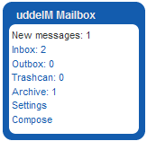

|  |  |
| --- | --- |
| **C:\Users\STEPHA~1\AppData\Local\Temp\messagebox_warning-48.png** | * This module does several database queries. Do not install when you have performance problems on your server. * Even when you have installed this module in order to access uddeIM you still have to create a menu link to the uddeIM component (it can be a “hidden” menu link if you do not want to link the main component). |

## MODULE: mod\_uddeIM\_statistics (aka “uddeIM Statistics module”)

### What is the purpose of mod\_uddeim\_statistics?

*What is the purpose of mod\_uddeim\_statistics?*

This is a statistics module for uddeIM. Install this module with the module installer. The module shows some statistics about sent PMs.

Figure 5.5 – uddeIM Statistics

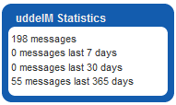

|  |  |
| --- | --- |
| **C:\Users\STEPHA~1\AppData\Local\Temp\messagebox_warning-48.png** | This module does several database queries. Do not install when you have performance problems on your server. |

### How are the statistics calculated?

*How are the statistics calculated? It seems that the values are not 100% accurate?*

uddeIM does not count the number of messages because this would require additional database fields and would cause additional database load. So uddeIM statistics module and the statistics in uddeIM backend do following calculations:

* Message stored

This counts the currently stored database entries.

* Messages trashed by recipient / Messages trashed by sender

All messages carry a trashed by sender and trashed by recipient flag. The database entries having these flags set are counted.

* Messages on hold

Messages having the sender trashed and recipient trashed flag set are counted.

* Number of messages

This returns the highest message index number. Usually MySql starts with 0 and increments this counter by 1 for each message.

* Message in X days

This is done a little bit tricky: First it gets the current time, subtracts X days and queries the message date with the lowest date which is higher than the calculated one. Then it uses the queried date to get the lowest message index with the queried date. The number of written messages is the difference between the maximum message id and the lowest message index incremented by one.

## PLUGIN: plug\_uddeIM\_contentlink (aka “uddeIM Content Link plugin”)

### What is the purpose of plug\_uddeim\_contentlink?

*What is the purpose of plug\_uddeim\_contentlink?*

This content mambot/plugin creates a link which allows composing a message to a certain user. This is a mambot/plugin for uddeIM. Install this mambot/plugin with the plugin installer.

### How do I use uddeIM Content Link plugin?

*How do I use uddeIM Content Link plugin?*

When you have enabled uddeIM Content Link plugin you can use following placeholders in your articles:

Compose a message to user with Id 123:

{pmslink:id=123}

Compose a message to user with realname “John Doe”:

{pmslink:realname=John Doe}

Compose a message to user with username “flubber”:

{pmslink:username=flubber}

Optionally you can enter a text which is displayed instead of the icon:

{pmslink:realname=John Doe,Send John Doe a message}

Example:

Write an email to the author {pmslink:username=flubber}

creates the output shown in Figure 5.6.

Figure 5.6 – uddeIM Content Link plugin



## PLUGIN: plug\_uddeIM\_searchbot (aka “uddeIM Searchbot plugin”)

### What is the purpose of plug\_uddeim\_searchbot?

*What is the purpose of plug\_uddeim\_searchbot?*

This search mambot/plugin integrates uddeIM into Joomla search. When enabled Joomla also searches your inbox. It checks the sender’s name and the message text (see note).

|  |  |
| --- | --- |
| **C:\Users\STEPHA~1\AppData\Local\Temp\messagebox_warning-48.png** | The searchbot does not search inside obfuscated, encrypted or encoded messages! It does search the inbox and archive only. |

### How do I use uddeIM Searchbot plugin?

*How do I use uddeIM Searchbot plugin?*

When you have enabled uddeIM Searchbot plugin, Joomla Search also looks inside your inbox.

## PLUGIN: plug\_uddeIM\_hooks (aka “uddeIM Hooks plugin”)

### What is the purpose of plug\_uddeim\_hooks?

*What is the purpose of plug\_uddeim\_hooks?*

This system plugin enables the hook mechanism in uddeIM. This mechanism allows other components to hook into uddeIM.

Example:

A payment component hooks into uddeIM and registers a “send message” callback. When a user sends a message uddeIM calls the payment component which charges the user for sending the message.

|  |  |
| --- | --- |
| **C:\Users\STEPHA~1\AppData\Local\Temp\messagebox_warning-48.png** | After installing the plugin do not forget to enable it!  See chapter 14.7.4 for more information about hooks. |

### How do I use uddeIM Hooks plugin?

*How do I use uddeIM Hooks plugin?*

When you enable uddeIM Hooks plugin, other components can register callback functions otherwise they are ignored.

|  |  |
| --- | --- |
| **C:\Users\STEPHA~1\AppData\Local\Temp\messagebox_warning-48.png** | See chapter 14.7.4 for more information about hooks. |

# Errors and Warnings

## SQL errors

### “Unknown column 'xxxxx' in 'field list'” error (SQL error 1054)

*I get the following error:*

*SQL errorDB function failed with error number 1054*

*Unknown column 'public' in 'field list' SQL=UPDATE jos\_uddeim\_emn SET public=1 WHERE userid=xx*

*or*

*Unknown column 'flagged' in 'field list' SQL=UPDATE jos\_uddeim SET flagged=1 WHERE toid=xx AND id=yy*

You have upgraded uddeIM. Please refer to the README how to create/update the missing database fields and tables.

### “Unknown column in where clause” error (SQL error 1054)

*I get an*

*Unknown column 'index.php?option=com\_uddeim' in 'where clause' in .../includes/database.php on line 293*

*How do I solve this?*

The error is not coming from uddeIM but from a 3rd party component that tries to find an itemid for uddeIM. Create a menu link for uddeIM (it can be unpublished) and the error should be gone.

### “DB function failed with error number 2006” error (SQL error 2006)

*I tried installing uddeIM on my Joomla system, and while all plugins and other parts of the system where no problem installing, the main component didn't want to install and gave me the following error message:*

*JInstaller::install: SQL fout. DB function failed with error number 2006  
MySQL server has gone away SQL=CREATE TABLE IF NOT EXISTS `jos\_uddeim` […]*

The most common reason for the MySQL server has gone away error:

* Is that the server timed out and closed the connection. By default, the server closes the connection after 8 hours or 28800 seconds if nothing has happened. You can change the time limit by setting the [wait\_timeout](http://www.mysql.com/doc/S/H/SHOW_VARIABLES.html) variable when you start MySQLd via your server's [/etc/my.cnf](http://www.mysql.com/doc/O/p/Option_files.html) as well.
* Another common reason to receive the MySQL server has gone away error is because you have issued a “close”' on your MySQL connection and then tried to run a query on the closed connection. You can check that the MySQL hasn't died by executing MySQLadmin version and examining the uptime, i.e. to check MySQL uptime, in shell as root user type:   
  MySQLadmin -u root -p version
* You can also get these errors if you send a query to the server that is incorrect or too large. If MySQLd gets a packet that is too large or out of order, it assumes that something has gone wrong with the client and closes the connection. If you need big queries (for example, if you are working with big BLOB columns), you can increase the query limit by starting MySQLd with the -O max\_allowed\_packet=# option (default 1M) or via [max\_allowed\_packet](http://max_allowed_packet) variable in your [/etc/my.cnf](http://www.mysql.com/doc/O/p/Option_files.html) file and restarting MySQL after you edited your [/etc/my.cnf](http://www.mysql.com/doc/O/p/Option_files.html) file. The extra memory is allocated on demand, so MySQLd will use more memory only when you issue a big query or when MySQLd must return a big result row

### “You have not updated your database! Please refer to the README…” error

*After updating there is following error displayed in uddeIM admin interface:*

*Important: You have not updated your database! Please refer to the README how to update uddeIM correctly!*

You have not read the README file carefully that have been provided with uddeIM. Please check the README file and also Chapter 1.3 with its subchapters.

## uddeIM errors

### "There is no user with this username!" error when a message is sent

See chapter 13.3 “Joomfish”.

### “This message cannot be displayed.” when a message is opened

When a message is opened this warning appears:

*This message cannot be displayed.*

*Possible reasons:*

* *You have no rights to read this message.*
* *The message has been deleted.*

I checked in the database and the message is still there.

This error may appear when a 3rd party SEF solution is used which is not configured correctly or provides a non-working SEF plugin for uddeIM.

Please turn off the 3rd party SEF completely (when your SEF component allows to switch it off for a certain component you can try this; maybe it also allows to use different SEF modes for a certain component), clear the Joomla cache and try again.

|  |  |
| --- | --- |
| **C:\Users\STEPHA~1\AppData\Local\Temp\messagebox_warning-48.png** | Also see chapter 13.12. |

## Other errors and problems

### Javascript is displayed under the “To” field

*uddeIM shows*

*"); uddeimWindow.document.close(); uddeimWindow.focus(); } -->*

*under the "To:" line.*

Figure 6.1 – Javascript displayed under the “To:” line

*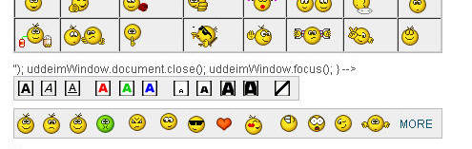*

You are using a plugin/mambot which modifies html code from your site. Unfortunately there are some components/modules/plugins on the market which do not parse the code correctly and modify uddeIM code.

Known components/modules/plugins are:

* com\_clickheat from <http://recly.com>
* yvBBCode plugin from <http://yurivolkov.com>
* Rokbox plugin for Rocket template from <http://rocketwerx.com>
* Woopra plugin from <http://rocketwerx.com>

Remove or disable these components/modules/plugins and the bug is gone.

### Javascript is displayed in the format menu

*uddeIM shows Javascript in the format menu:*

Figure 6.2 – Javascript displayed in format menu

*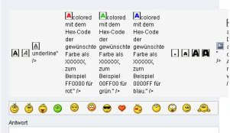*

You are using a plugin which modifies html code from your site. Unfortunately there are some components/modules/plugins on the market which do not parse the code correctly and modify uddeIM code.

Known components/modules/plugins are:

* com\_clickheat from <http://recly.com>
* yvBBCode plugin from <http://yurivolkov.com>
* Rokbox plugin for Rocket template from <http://rocketwerx.com>
* Woopra plugin from <http://rocketwerx.com>

Remove or disable these components/modules/plugins and the bug is gone.

|  |  |
| --- | --- |
| **C:\Users\STEPHA~1\AppData\Local\Temp\messagebox_warning-48.png** | A workaround is to replace all “[“ and “]” in the language file used in BBcodes with “&#91;” for “[“ and “&#93;” for “]”. As an example replace all “[u]” with “&#91;u&#93;”.  Nevertheless this is a workaround to allow the usage of these broken plugins with uddeIM. I will not provide modified language files for that case since no plugin should modify any text in e.g. a title property. Other extensions might also be affected so the better way is to fix these broken plugins that they will not modify text used in tag properties. |

### “More smileys” cannot be opened and displays a Javascript error

*When I try to open the extended smiley window I get following error (IE):*

*Row: 511  
Sign: 1  
Error: object expected  
Url: <the url>*

*or in Firefox that “uddeimWindowOpen()” is not defined.*

You are using a plugin/mambot which modifies html code from your site. Unfortunately there are some components/modules/plugins on the market which do not parse the code correctly and modify uddeIM code.

Known components/modules/plugins are:

* MyApi plugin from <http://www.myapi.co.uk/>
* Jomsocial Facebook Connect

Remove or disable these components/modules/plugins and the bug is gone.

### "Delete" buttons in inbox, outbox and archive do not work

See chapter 13.8 “IE PNG Fix”.

### uddeIM shows the wrong time

*uddeIM shows the wrong time in messages and message lists. How can I fix this?*

In the backend you can adjust the timezone (tab date/time).

Figure 6.3 – Adjust timezone

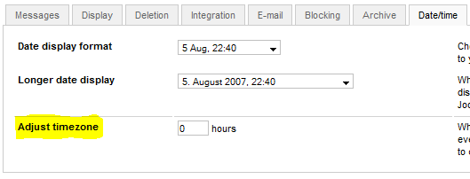

### uddeIM does not display CAPTCHAs

*I have enabled Captcha protection on my system but uddeIM does not display any picture.*

Your server should have GD library installed (http://www.libgd.org). Without this (common) graphics library Captchas cannot be rendered.

Figure 6.4 – uddeIM Captcha

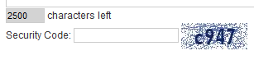

### CAPTCHAs are not displayed on Joomla 1.5

*I have enabled CAPTCHAs in uddeIM backend but they are not displayed.*

Joomla 1.5 comes with a very restrictive .htaccess file which prevents access to captcha15.php on some systems.

In that case you can add following lines to your .htaccess file (below the standard Joomla rewrite rules):

## Allow uddeIM CAPTCHA  
RewriteCond %{REQUEST\_FILENAME} -f  
RewriteRule ^(components/com\_uddeim/captcha15\.php)$ $1 [L]

When this does not work you should try following modified lines:

## Allow uddeIM CAPTCHA  
RewriteRule ^components/com\_uddeim/captcha15\.php$ - [L]

### Performance problems

*I have installed uddeIM on my Community Site with 10.000 users and now my server seems to be much slower.*

When you install a PMS component you should have in mind that each user that visits your site creates server load respectively database load. Without PMS component a registered user visits your sites maybe once or twice a day, with PMS component some users will visit your site regularly (several times a day) in order to check their PM or to write other users. This creates lots of database load and is the number one why your site becomes slower.

Additionally uddeIM does also create some database load. Not very much but on big communities sites this might be noticeable. So when your server is very weak you should not enable all features uddeIM provides on order to save some server load. Features which require additional SQL requests when enabled are:

| **Tab** | **Option** | **Remark** |
| --- | --- | --- |
| ****Blocking**** | **Enable blocking system** | **… requires a few checks if a user or group is blocked.** |
| ****Public**** | **Enable public frontend** | **… creates additional server load when public user write PMs.** |
| **Use autocomplete** | **… creates database queries for each character typed in the recipient field when a message is composed.** |
| ****Display**** | **Use autocomplete** | **… creates database queries for each character typed in the recipient field when a message is composed.** |
| **Behavior of "All users" link** | **… should not be set to “Always show all users” on large sites since this requests a list of all users whenever the compose message dialog is displayed.** |
| Show counters | **…** should be set to “No“ since counters require four additional database query each time the menu bar is drawn. |
| Enable sorting | **… should be set to ‘No’ since additional sort operations create lots of database load.** |
| Enable filtering | **… should be set to ‘No’ since additional filter operations create lots of database load.** |
| **Deletion** | **Restrict trashcan access** | **… set at least to “Special users“ or “Admins”.** |
| ****Integration**** | **Show thumbnails in lists** | **… creates for each entry in the list one additional database request in order to get the filename for the avatar.** |
| ****System**** | **Deletions invoked** | **… set to “by Admins only“. Otherwise each user who visits his inbox creates server load for purging old messages.** |
| **File deletions invoked** | **… set to “by Admins only“. Otherwise each user who visits his inbox creates server load for purging old file attachments.** |

### Configuration cannot be saved

*When pressing the “Save settings” button in uddeIM backend the configuration is not saved.*

Please check following:

1. Check if the configuration file config.class.php is writeable. Usually uddeIM shows a warning in the backend when the file cannot be written. In some cases wrong access rights to the folder that contains the file   
   /administrator/components/com\_uddeim/config.class.php   
   also prevents uddeIM to save its configuration.
2. Check the Javascript console if there is an error listed (see Figure 6.5). In that case try a different Joomla Administration template (e.g. the default template that comes with Joomla).
3. In the case the interface is set to Hathor, changed it back to Isis which usually fixes the problem

Figure 6.5 – Javascript displayed under the “To:” line



### UddeIM displays a “Plugin out of date!” error

*When I visit the uddeIM backend I see the error message “XY Plugin out of date!”*

Please update uddeIM’s plugins. You will find the current versions on the uddeIM development page.

# Community Builder

## Using uddeIM modules and plugins with CB 1.0

*Can I use the uddeIM modules and plugins with CB 1.0?*

Don't know. You should contact *beat* or *nant* according backward compatibility of these modules. Backup the old files and give it a try. Nevertheless I strongly recommend to update to CB 1.1.

## Enabling Message notifications

*I can send messages etc. but I am not notified about new messages.*

You have to configure "cblogin" module (use the patched one when popups are required) or use "mod\_uddeim" module for notifications.

## Display a Tab in CB profiles

*I've been trying to get a tab to show up in user profiles in CB.*

*In the CB plugin manager I've published PMS uddeIM and unpublished PMS MyPMS and Pro. PMS uddeIM access is set to public.*

*In the CB Tab Manager PMS MyPMS and Pro is unpublished. PMS uddeIM is published, position is set to Main Area, type is set to Tab, and access is set to Everybody.*

*UddeIM itself seems to work just fine, when I link to the main component. I just can't get a tab to show up in my user profile.*

*What am I missing?*

You cannot use the "Quick Message" tab (plug\_pms\_uddeim) for public messages. This is an important security feature since the "Quick Message" tab does not provide any anti spam features. Please set the plugin to registered users only, since the boxes do only appear for registered users.

You can use the public frontend feature of uddeIM when you want public users to contact registered users.

## “Message from your profile” message

*Why does plug\_pms\_uddeim add the “Message from your profile” to some PM?*

uddeIM does not add this message. When you send a message from a user’s profile (Quick Message Box) CB adds this line (it is part of the CB language file \_UE\_PM\_PROFILEMSG).

## Adding a link to uddeIM to the users’ profiles

How can I add a “Send Private Message” link to the users’ profiles?

There are two possibilities:

* You can use cb\_plug\_pms\_uddeim\_profilelink (see section 7.12),
* You can use field substitution in Community Builder.

To use field substitution, create a delimiter field with following description (see Figure 7.1):

<a href="index.php?option=com\_uddeim&task=new&recip=[user\_id]">   
PM this user</a>

Then configure the settings as shown in Figure 7.2 to get the result shown in Figure 7.3.

Figure 7.1 – Field substitution

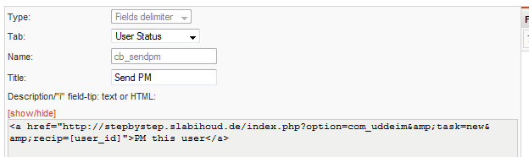

Figure 7.2 – Field substitution (settings)

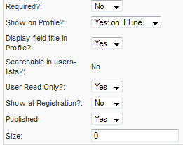

Figure 7.3 – Field substitution (user status tab in profile)

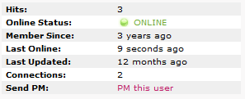

## Text “\_UE\_PMSLINK” is displayed in a user’s profile

*When I view a user's profile, I see the text: \_UE\_PMSLINK just above the Send Private Message link*

Go to CB tab manager, find this tab and rename it (Components 🡪 Community Builder 🡪 Tab Management).

## Text “\_UE\_TABINBOX” is displayed in a user’s profile

*When I view a user's profile, I see the text: \_UE\_TABINBOX just above the Inbox.*

Go to CB tab manager, find this tab and rename it (Components 🡪 Community Builder 🡪 Tab Management).

## Text “%livesite%” is displayed in an email notification

*When a user sends a PM from the profile quick message tab, the email notification contains “%livesite%” instead of the site address.*

Use uddeIM CB PMS plugin instead of the plugin that is delivered within the Community Builder.

## PLUGIN: cb\_plug\_pms\_uddeim (aka “uddeIM CB PMS plugin”)

### What is the purpose of cb\_plug\_pms\_uddeim?

*What is the purpose of cb\_plug\_pms\_uddeim?*

This plugin for the Community Builder allows sending a "Quick message" from a user's profile. Install this with the CB plugin installer (not the Joomla plugin/mambot installer). You have also to publish and configure a tab in CB.

Figure 7.4 – uddeIM CB PMS plugin

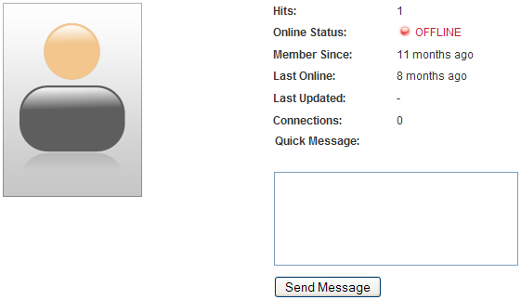

### Difference between cb\_plug\_pms\_uddeim and plug\_pms\_mypmspro?

*What is the difference between cb\_plug\_pms\_uddeim and plug\_pms\_mypmspro?*

plug\_pms\_mypmspro is delivered with CB and supports several PMS. It supports the basic functionality of uddeIM but ignores message obfuscating and a few other uddeIM features.

Note that even cb\_plug\_pms\_uddeim currently does not recognize the timedelay and captcha settings in uddeIM. So do only use the "Quick message" feature when you do not need captcha or timedelay protection.

cb\_plug\_pms\_uddeim is the uddeIM-only (extended) version of plug\_pms\_mypmspro.

### I have two links to "Send Private Message"?

*When I go to someone’s profile and mouse over Messages, I have two links to "Send Private Message."?*

You have enabled both plug\_pms\_mypmspro which is delivered with CB and cb\_plug\_pms\_uddeim that comes with uddeIM. Ensure that only one PMS plugin is enabled.

### Connection notifications contain “\n” instead of newlines?

*When I get a notification message about a new connection it contains “\n” instead of newlines?*

There are two possible fixes for this:

1. Enable message encryption or obfuscating (you can also choose to store messages base64 encoded) in uddeIM settings, or
2. Visit Community Builder Tab Management and select uddeIM PMS plugin. In the parameters box you can set “Double escape” to “no”. When you have problems with double escaped characters (like “\\n”) you can additional set “Unescape ‘\\n’) to “yes”.

Figure 7.5 – uddeIM CB PMS plugin settings

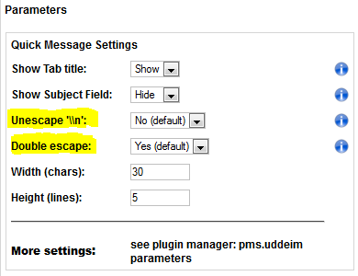

|  |  |
| --- | --- |
| **C:\Users\STEPHA~1\AppData\Local\Temp\messagebox_warning-48.png** | “Unescape ‘\\n’” works with all storing methods.  “Double escape” only works when messages are stored in plain text. |

## PLUGIN: cb\_plug\_pms\_uddeim\_inbox (aka “uddeIM CB Inbox plugin”)

### What is the purpose of cb\_plug\_pms\_uddeim\_inbox?

*What is the purpose of cb\_plug\_pms\_uddeim\_inbox?*

Originally it was a demonstration how to write uddeIM related plugins for CB. Since several people seem to like it, it is now part of the distribution.

It shows the content of the inbox in a profile tab. Install this with the plugin installer in CB and you have also to publish and configure a tab in CB.

Figure 7.6 – uddeIM CB Inbox plugin

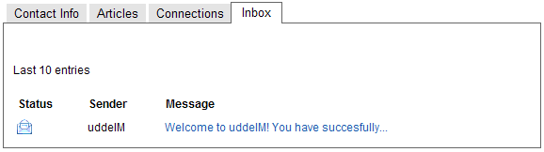

## PLUGIN: cb\_plug\_pms\_uddeim\_blocking (aka “uddeIM CB Blocking plugin”)

### What is the purpose of cb\_plug\_pms\_uddeim\_blocking?

*What is the purpose of cb\_plug\_pms\_uddeim\_blocking?*

This plugin adds a "Blocking" tab so you can block and unblock users quite easy.

Note that the same functionality is already implemented in the uddeIM main component (to block a user open a message and choose “block user”, to unblock users open the user settings and choose the users you want to unblock).

Figure 7.7 – uddeIM CB Blocking plugin

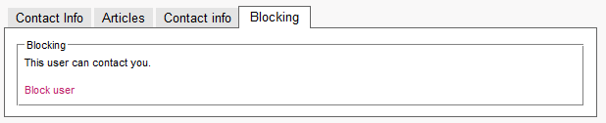

## PLUGIN: cb\_plug\_pms\_uddeim\_profilelink (aka “uddeIM CB Profile Link plugin”)

### What is the purpose of cb\_plug\_pms\_uddeim\_profilelink?

*What is the purpose of cb\_plug\_pms\_uddeim\_profilelink?*

This plugin adds a simple link that points to the uddeIM compose page to the users' profile page. You may also use CB's field substitution feature for that (see section 7.5 “Adding a link to uddeIM to the users’ profiles”).

Figure 7.8 – uddeIM CB Profile Link plugin

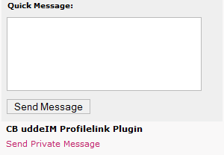

## HACK: Block profile when user is blocked in uddeIM

*I have blocked a user in uddeIM, so he can not send me any private message. Can I also block my profile?*

Yes, that’s possible but requires a hack. You have to modify

/components/com\_comprofiler/comprofiler.html.php

Before the line containing:

if ( $showProfile == 1 ) {

add following code:

// BLOCKING-HACK  
if ( defined( 'JPATH\_ADMINISTRATOR' ) ) {   
 $user =&JFactory::getUser();  
 $myid = $user->id;  
 $db =&JFactory::getDBO();  
} else {  
 global $my, $database;  
 $myid = $my->id;  
 $db = $database;  
}   
if ($myid) {   
 $db->setQuery("SELECT COUNT(id) FROM `#\_\_uddeim\_blocks` WHERE  
 blocker=".(int)$user->id." AND blocked=".(int)$my->id);  
 $is\_blocked = (int)$db->loadResult();  
 if ($is\_blocked) {   
 echo '<fieldset><legend>Ignore</legend>   
    <label for="description">The user has blocked his profile, so  
 you cannot access it</label><br /><br /></fieldset>';   
 $showProfile = 0;   
 }   
}

|  |  |
| --- | --- |
| **C:\Users\STEPHA~1\AppData\Local\Temp\messagebox_warning-48.png** | Warnings:   1. Hacking CB Core Files is not recommended. 2. Do only try this when you exactly know what you are doing! 3. UddeIM HQ does not provide any support for this hack. |

## Connection request PMs sent twice

*I am using uddeIM component with Community Builder. My settings are such that users will be PMed whenever there is a connection request. However, both the connection request PM and the connection acceptance PM are both sent twice to the PM box. How do I fix this?*

Please do either use the uddeIM's CB PMS plugin (cb\_plug\_pms\_uddeim) **OR** CB's PMS plugin (pms.mypmspro), not both.

## cb\_login announces new messages but these are not available in uddeIM component

*One user has "2 private messages" according to cb\_login, but when visiting the inbox, it is empty.*

These messages might be "delayed" messages, i.e. you might have enabled the mailbox moderation for the senders’ mailbox. These messages are not available to the recipient until you have approved them.

cb\_login is not aware of this feature and counts these messages even when the user cannot read them.

Basically it is a missing "AND delayed=0" in a SQL query in cb\_login. Nevertheless this can only be executed when CB is used with a newer version of uddeIM.

You can either

* Deliver all messages using the "message control center" and switch of mailbox moderation generally,
* Patch cb\_login,
* Or use phpMyAdmin to set “delayed=0” for all entries in jos\_uddeim table.

# Community Builder Enhanced

## Integrating uddeIM in CBE

*How can I integrate uddeIM in CBE? I have CBE and uddeIM installed. In CBE uddeIM is set up as PMS system. When I click on the envelope in the login box nothing happens.*

You have to create a menu link to the uddeIM component, which can be "unpublished". In CBE select "PM Notification: uddeIM 0.4 or higher".

## How to enable CBE integration in uddeIM?

*How can I enable CBE integration in uddeIM?*

There are two versions of CBE available. The older version uses #\_\_comprofiler tables while the newer one uses #\_\_cbe tables.

When using the older CBE you can enable “Community Builder” in the Integration tab for links and thumbnails. When you have the newer version installed the drop down lists should show “CB Enhanced” which is the correct setting.

Figure 8.1 – Community Builder (Enhanced) options

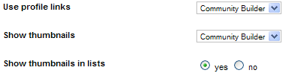

## Do the CB plugins also work with CBE?

*Is it possible to install the CB plugins that come with uddeIM on CBE?*

No. Currently the plugins do not work with CBE. Since I do not use CBE I have no idea how to make them compatible with CBE.

To put the component itself in a tab you have to use following enhanced parameters:

profile=1

tabtype=3

enhancedname=uddeim

# Importing PMS data

## Importing messages from other PM systems

*Is it possible to import messages from PMS xy?*

uddeIM can import messages from following PMS:

|  |  |
| --- | --- |
| **PMS** | **Developer** |
| myPMS OS 2.x | Danial Taherzadeh |
| myPMS II 2.x | Danial Taherzadeh |
| myPMS Pro 1.x | Danial Taherzadeh |
| myPMS Enhanced 1.x | Stefan Klingner |
| myPMS Enhanced 2.x | Stefan Klingner |
| JIM 1.x | Laurent Belloeil |
| JIM Reloaded 1.x | Edi Goetschel |
| Archaic Binary Private Messages 1.x | Wayne Smith |
| JAM - Joomla Advanced Message 1.x | Cas de Vroom |
| Clexus 2.x | Clexus New Media |
| Missus 1.x | Barbara Irene Meclazcke |
| Primezilla 1.x | Achim Fischer |
| JomSocial 1.x | Azrul Rahim |
| Messaging 1.x | Sander Kromwijk |
| CD Pure Messenger 1.x | Daniel Rataj |

When uddeIM finds messages from one of these systems in the database it will show an „Import“ tab in the uddeIM backend. This tab will be removed when no supported PMS has been found.

## Reimport messages from other PM system

*I have already imported messages from another PM system. Now I have to call the importer again, but uddeIM tells me that messages have already been imported and does not longer show the "Import" link.*

Open config.class.php and change $pmsimportdone to 0. After this change uddeIM allows to call the importer again.

## Importing of messages dies (uddeIM <1.6)

*I am moving from another PMS to uddeIM 1.3. All has gone well until I tried to import approx. 22,000 messages. Sometimes I receive a 500 server error. Sometimes the "wait for import" page appears, but no import occurs.*

It seems that the script dies (don't know how long it takes to import 22k messages but I am pretty sure that it will exceed the 30secs most provider allow a PHP script to run).

Another problem might be that PHP has not enough working memory. UddeIM reads all messages at once (22k x 2kb per message = > 44mb memory). So it is also required to increase the working memory.

When you cannot change these values there is a way to import the messages but this requires some script modifications (the following uses JIM as example, see admin.uddeim.php):

$sql="SELECT id, whofrom, username AS whoto, date, message, subject, outbox, readstate FROM #\_\_jim";

change this to

$sql="SELECT id, whofrom, username AS whoto, date, message, subject, outbox, readstate FROM #\_\_jim WHERE id>=0 AND id<5000";

then execute the import.

Change the WHERE clause to 5000 and 10000 and import again, change to 10000 and 15000 and... Not very convenient but it works.

## Importing of messages dies (uddeIM 1.6+)

*I am moving from another PMS to uddeIM 1.6. All has gone well until I tried to import approx. 22,000 messages. Sometimes I receive a 500 server error. Sometimes the "wait for import" page appears, but no import occurs.*

It seems that the script dies (don't know how long it takes to import 22k messages but I am pretty sure that it will exceed the 30secs most provider allow a PHP script to run).

Another problem might be that PHP has not enough working memory. UddeIM reads all messages at once (22k x 2kb per message = > 44mb memory). So it is also required to increase the working memory.

uddeIM 1.6 allows to import messages in parts of 5000 pcs. Just click on the part you want to import. When the script still dies, open admin.uddeim.php and search for $count=5000. Use a smaller value, e.g. 2500, and try again. Note that uddeIM shows twice as much parts to import now.

# Configuring uddeIM

uddeIM offers lots of settings so the administrator can setup uddeIM according to his requirements. Unfortunately more settings also mean more questions so you can find some common questions and answers in this section.

## General questions

### “System - Used charset”: What character sets are supported?

*What character sets are supported by uddeIM?*

The available character sets are limited due to PHP’s “htmlentities” function. You can enter following character set codes:

ISO-8859-1, ISO-8859-15, UTF-8, cp866, cp1251, cp1252, KOI8-R, BIG5, GB2312, BIG5-HKSCS, Shift\_JIS, EUC-JP

Figure 10.1 – System - Used charset

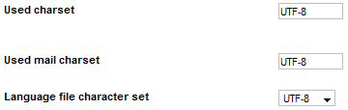

### “Maintenance – Database maintenance”: Does DB maintenance check the DB structure?

*Does the DB maintenance check the DB structure?*

No. The database structure is currently not checked and missing fields are not created. When you upgrade uddeIM you have to create new database manually as described in the README file.

When a user is purged from the database his messages are usually kept in the database. The database maintenance checks if it is necessary to trash orphaned messages. It also checks the database for a few errors which will be corrected.

Figure 10.2 – Maintenance - Database maintenance



### “Create settings”: There is no effect when clicking "Create settings" button?

*When I press “Create settings” there seems to be no effect?*

You have to select a user first then press “Create Settings”. This button creates an entry in the jos\_uddeim\_emn table for the selected user(s) which stores the user settings for each user. As long as no entry exists you are not able to change anything in the user settings backend (the buttons and icons are not selectable).

To remove user settings you can select a user and press “Remove Settings”. When this user visits his inbox the settings are recreated with the default values you have configured in the backend.

### How can I change the language in uddeIM?

*How can I change the language in uddeIM 1.6? In the configuration panel I do not see any language selection?*

uddeIM uses the same language that Joomla uses. So when Joomla uses germani.php, uddeIM also looks for a file named germani.php in uddeIM language folders:

/administrator/component/language/ for ISO and

/administrator/component/language.utf8/ for UTF-8.

### How do I configure welcome messages in uddeIM?

*I want uddeIM to send a welcome message to new users. How do I configure that?*

UddeIM does not send welcome messages to users. To achieve that you must use third party software, e.g. Autowelcome Plugin for CB.

The only welcome message uddeIM creates, is the first message the administrator finds in his inbox after installation.

### The Administrator is not shown in the user list?

*When I try to select the Administrator from the user list on the compose message page I can’t because the Administrator is not listed there?*

By default uddeIM hides the Super Administrator from being listed. When you also want to list the Administrator, remove his user ID from “Hide user from userlist” entry in uddeIM backend (usually #62 on a Joomla 1.0/1.5 system).

### UddeIM displays the wrong time.

*I have configured the correct time zone in Joomla and uddeIM still displays the wrong time.*

Joomla 1.0 users:

Joomla 1.0 does not support user time zones. When the time zone is configured correctly in Joomla’s global configuration uddeIM should display the correct server time. If not you can correct the time zone in uddeIM backend (date/time tab).

Joomla 1.5+ users (supported by uddeIM 2.2+):

First ensure that the time zone is set correctly in Joomla’s global configuration. When a user has not configured a time zone in his profile uddeIM uses this value. When a user has configured a time zone in his profile uddeIM should use this value for new messages.

|  |  |
| --- | --- |
| **C:\Users\STEPHA~1\AppData\Local\Temp\messagebox_warning-48.png** | UddeIM stores the sender’s date/time information as GMT+0 when a message has been written.  Example: A user located in GMT+1 writes a message at 3pm (2pm is stored in the database). Immediately after sending the message the receiver located in GMT-1 will see that the message has been written at 1pm (his local time). |

### Can the userlist be sorted by “lastname firstname”?

*Is there a way to sort the userlist (in the compose form) by “lastname firstname”? Currently it is using “firstname lastname” or the “username”.*

No, since uddeIM uses the “display name” field (which is “firstname lastname”) the list can only be sorted that way.

### When does uddeIM delete messages from a user’s trash can?

*In my users’ trashcan there are lots of messages? How can I delete them? Does uddeIM do that automatically?*

UddeIM stores messages for an admin configurable period of time in the trashcan (“Deletion” tab). When you want to keep the messages for half a day you can configure this time to “0.5 days”. After that time messages are no longer shown in the trash can are still stored in the database. To clean up the database you can configure to do this “Manually”, whenever an “Admin” visits his inbox, or whenever a “User” visits his inbox (“System” tab).

### Why is no “Message sent” message displayed?

*Previous versions of uddeIM show two blue lines in between saying 'message sent' after a PM has been sent, now it is missing?*

The messages are displayed using the standard Joomla framework which requires that the site template supports these messages.

## Popup notifications

### Which uddeIM modules provide popup notifications?

*Which uddeIM module provides provide popup notifications?*

mod\_uddeim contains the code for popup notifications.

When you do not want any display output (only use popup support), switch off the module title and the module output in the preferences.

Figure 10.3 – Maintenance - Database maintenance

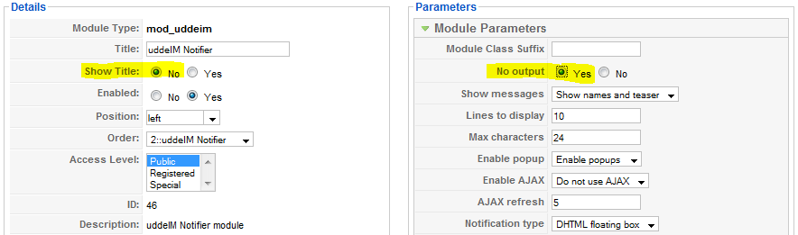

### How to configure popup notifications?

*How do I configure popup notifications?*

First you want to install the uddeIM Notifier module that came with uddeIM. When you do not want to have the notifications on a menu but you still want the user to get some sort of on screen notifications to a new private message do following:

* enable the module (the location of the module does not matter
* open the uddeIM Notifier module configuration
* for "No Output" select yes (so the Notifier module is hidden in its location from the front end and will not affect the menu or contents of the location you enabled the module)
* set “enable popups” = “yes” (now the user will get a popup indication of a new private message when logging in
* set “notification type” = “DHTML Floating box” (if you choose to use java box there is no link to the inbox and every time the user changes the page they will get another aggravating popup box) the other upside to the floating box is that it is nice and small and contains a link to the inbox

Figure 10.4 – Options for popup notifications



### Popup notifications do not work

*I have installed the popup notification module but I do not see any notification?*

There are some issues which could cause this problem:

* Do you have enabled popup notifications in your user settings (you can also check this in the backend "userlist settings")?
* Check the browser’s Javascript error console. It is possible that another module interferes with uddeIM. It might be also possible that there is a Javascript error in another module and the Javascript interpreter stops executing code at all.
* Are popup notifications in mod\_uddeim enabled? There are two options: DHTML and Floating Window. The best choice should be “Floating Window”.
* uddeIM uses a z-index of 10000 so the floating box should be on top on all other elements of your template. Some templates also uses this (or a higher value) e.g. for menus so the floating box will be shown behind these elements.
* Does another module/plugin use the “onload” handler?

### How to enable popup notifications for thousands of site members?

*I have a huge site with thousands of members. How can I enable popup notifications for all of them?*

uddeIM creates an user settings record when a user visits his mailbox the first time. So when you set “Popup notification by default” to “yes” the popup notification will be enabled for those users who visit their mailbox the first time after settings this option.

Figure 10.5 – Options for popup notifications

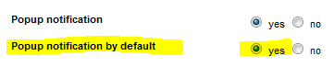

You can also use following SQL command to enable popup notification for all users:

UPDATE jos\_uddeim\_emn SET popup=1

|  |  |
| --- | --- |
| **C:\Users\STEPHA~1\AppData\Local\Temp\messagebox_warning-48.png** | To modify popup notification settings for an individual site member use the “user settings” in uddeIM backend. |

### How to enable popup notifications without a visible module in the frontend?

*I don't want to see the notifier module in the frontend, so I set the "No output" option to Yes and "Show title" in Joomla options to No. Unfortunately I still see some border elements.*

Usually “No Output”=Yes and “Show title”=No are fine for most sites. Some templates that use special effects like rounded borders still show border elements (see Figure 10.6). In that case try to add a "Module Class Suffix". It doesn't matter what you enter here, it should only change "class=module" to something different.

Figure 10.6 – Example source

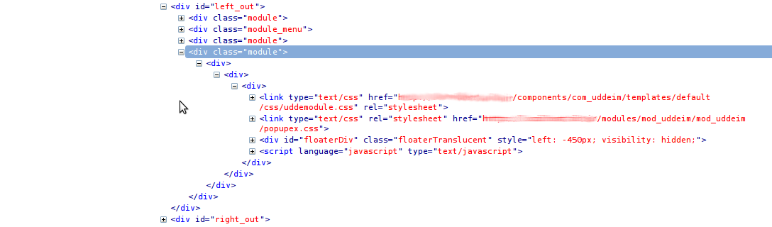

### How can I change the sound uddeIM is playing?

*5.2.2 How can I change the sound uddeIM is playing?*

In the module folder (“/modules/mod\_uddeim/mod\_uddeim” for Joomla 1.5 and better, and “/modules/mod\_uddeim” for Joomla 1.0) you will find two sound files:

* alert.mp3 used for HTML5 and DOM
* alert.ogg used for HTML5

The reason that two files are used for HTML5 is that FF, IE, Safari so not support the same formats. The browser automatically picks the file it can play.

## Email notifications

### E-Mail notifications are not sent

*uddeIM does not send any email notifications, what's wrong?*

There are a lot of issues which could cause this problem:

* Check if "Email stop" is still activated in backend (it is activated by default after a fresh installation of uddeIM).
* Check if you have enabled email notifications in backend (use "yes" when all users should be notified or "admin" when admins should be notified only).
* Check if you have set "Default email notifications" to "always". This is the default for the users’ frontend setting. Existing user settings are not changed; this is used for new users only.
* Check if the user has enabled email notifications in frontend (you can do this using the backend "User settings").
* Check if the emails are not filtered by your or the recipient's ISP. When you are not using a smarthost sometimes it happens that your email server is on a remote blacklist which means the emails are sent but filtered.
* Check the mail settings in uddeIM and Joomla:

Usually "phpMail" should be the correct setting in uddeIM. This requires that PHP is correctly configured so it can send emails using the PHP command "mail". If you have problems you can try "mosMail" which uses a Joomla library function to send emails. This requires that Joomla is correctly installed and the mail system is configured correctly.

* You have to configure “mosMail” when you have configured “SMTP” or “Sendmail” in Joomla.

When “mosMail” is used, check if you have configured the full “**E-mail sender address”. Default is “webmaster” which does not work on most systems, so you have to configure “webmaster@yoursite.com**”. So when your site is “www.myclan.org” use “webmaster@myclan.org” (or another valid email address).

When “phpMail” is used, check if you have entered values for “E-mail sender name” (e.g. “Messaging”) and “E-mail sender address” (e.g. “webmaster”). Without valid settings PHP does not send any emails.

* Some providers require that you use a known email address – an email address that already exists on your web space - when you send messages using phpMail.

### Enabling email notification system

*What is the purpose of “Allow email notification“?*

This setting enables email notification for all users (“yes”), admins only or disables the notification system.

### Where can I change the email notification text?

*Where can I change the text that is used for an email notification?*

Open the language file (ISO and/or UTF-8) and search for following strings:

\_UDDEIM\_EMN\_FORGETMENOT … used for the forgetmenot emails

\_UDDEIM\_EMN\_BODY\_WITHMESSAGE … used for notifications with message

\_UDDEIM\_EMN\_BODY\_NOMESSAGE … used for notifications without message

\_UDDEIM\_EMN\_BODY\_PUBLICWITHMESSAGE

… used for messages to public users

\_UDDEIM\_EMN\_SUBJECT … the subject used in notification emails

You will find the language files in

\administrator\components\com\_uddeim\language

or

\administrator\components\com\_uddeim\language.utf8

### What placeholders can be used in notification emails?

*What are the placeholders that can be used in notification emails?*

Supported placeholders are:

**\_UDDEIM\_EMN\_FORGETMENOT**

|  |  |
| --- | --- |
| %livesite% | url to site |
| %site% | your site name |
| %you% | receiver's name |
| %msglink% | full link to message |

**\_UDDEIM\_EMN\_BODY\_WITHMESSAGE**

|  |  |
| --- | --- |
| %livesite% | url to site |
| %site% | your site name |
| %you% | receiver's name |
| %msglink% | full link to message |
| %user% | sender's name |
| %pmessage% | the message |

**\_UDDEIM\_EMN\_BODY\_NOMESSAGE**

|  |  |
| --- | --- |
| %livesite% | url to site |
| %site% | your site name |
| %you% | receiver's name |
| %msglink% | full link to message |
| %user% | sender's name |

**\_UDDEIM\_EMN\_BODY\_PUBLICWITHMESSAGE**

|  |  |
| --- | --- |
| %livesite% | url to site |
| %site% | your site name |
| %you% | receiver's name |
| %user% | sender's name |
| %pmessage% | the message |

**\_UDDEIM\_EMN\_SUBJECT**

|  |  |
| --- | --- |
| %livesite% | url to site |
| %site% | your site name |
| %you% | receiver's name |
| %user% | sender's name |

**\_UDDEIM\_BODY\_SPAMREPORT**

|  |  |
| --- | --- |
| %livesite% | url to site |
| %site% | your site name |
| %you% | receiver's name |
| %fromuser% | sender’s name of spam message |
| %touser% | receiver's name of spam message |

**\_UDDEIM\_SUBJECT\_SPAMREPORT**

|  |  |
| --- | --- |
| %livesite% | url to site |
| %site% | your site name |
| %you% | receiver's name |
| %fromuser% | sender’s name of spam message |
| %touser% | receiver's name of spam message |

### Is it possible for the admin to get a copy of each notification sent by uddeIM?

*Is it possible for the admin to get a copy of each notification sent by uddeIM?*

This topic is discussed in chapter 11.1.2 “Reading of stored messages in the backend”.

### Email notification received but no message in Inbox

*I have received an email notification but when I visit my Inbox there is no new message?*

There are two issues:

1. Do you have *unread* messages in you inbox? Maybe you have received a “forgetmenot” reminder that you have still unread messages in your inbox.
2. Maybe someone has sent you a message and then has recalled the message. In that case you get an email notification but you will not find the message in your inbox.

### uddeIM uses the wrong reply address in a notification email

*When a message is send the reply address in the email is the own email address instead of the senders email address?*

uddeIM protects the email address of the sender, so this address is never used in email notifications.

Earlier versions of uddeIM used the address of the site admin as sender address only but some people where careless and send a reply so the admin got the message.

Current versions of uddeIM add a reply-to with the address of the recipient(!) so when the recipient tries to send a reply he will receive his own reply and knows that something was wrong.

### Wrong character encoding in email subject

*When a notification is sent the message contains wired characters in the subject line instead of special characters.*

Usually uddeIM sends messages in the encoding specified by “Used mail encoding” on the system tab. Some email readers (mainly Outlook clients) have problems with UTF-8 encoding so when you use special characters in your site name (or when special characters are used in the language string used for the subject) these characters might not be displayed correctly. You can force uddeIM to use RFC 2047 encoding for that (System tab 🡪 Encode mail headers, see Figure 10.7).

Figure 10.7 – Encode mail headers

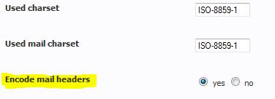

### How to enable e-mail notifications for thousands of site members?

*I have a huge site with thousands of members. How can I enable e-mail notifications for all of them?*

uddeIM creates an user settings record when a user visits his mailbox the first time. So when you set “Default for e-mail notification” to “Always” the email notification will be enabled for those users who visit their mailbox the first time after settings this option.

Figure 10.8 – Options for email notifications

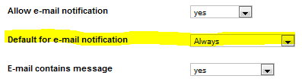

You can also use following SQL command to enable e-mail notification for all users:

UPDATE jos\_uddeim\_emn SET status=1

|  |  |
| --- | --- |
| **C:\Users\STEPHA~1\AppData\Local\Temp\messagebox_warning-48.png** | To modify email notification settings for an individual site member use the “user settings” in uddeIM backend. |

### What does the warning “E-Mail stop” in uddeIM backend mean?

*What does the note “E-Mail stop” in uddeIM backend mean?*

This warning is shown when the option “Stop e-mail” (on e-mail tab) is still active.

After installation, all uddeIM e-mail traffic (e-mail notifications, fotgetmenot e-mails) is disabled so that no e-mails are sent as long as you are testing.

Figure 10.9 – Option “Stop e-mail”



### E-Mail notifications are not accepted by email server for some users.

*Some of my users at Community Builder get no mail notifications from uddeIM. One of them said the reason is that his mail server has not accepted the "envelope" anonymous@123456.xxxxxxserver.net. This should be changed so the mail function uses the correct sender address. My provider says the problem is uddeIM and not Joomla or the server.*

That’s wrong: When a message is delivered by SMTP, there is a so called SMTP envelope (see RFC 2821) which is basically the data from the MAIL FROM: and RCPT TO: commands and the message itself (with the sender and recipient of the mail taken from the message header (From: and To:)). MAIL FROM: and RCPT TO: are SMTP commands you need to communicate with a SMTP server (Joomla does this when you have configured Joomla to use “SMTP server”) otherwise Sendmail or PHP on your server do this. These fields must be a known address when talking to a SMTP server otherwise the connection might be rejected.

When you set up Joomla you can choose between Sendmail, PHPmail and SMTP server. Depending on your choice Joomla uses Sendmail or PHPmail to send messages or uses its own library to connect to a SMTP server (so it "talks" SMTP directly to the MTA). When using Sendmail or PHPmail the server admin is responsible to configure the correct sender address in the Sendmail config or the PHP config.

In your case your provider has configured (I assume it is PHPmail) to use  *anonymous@123456.xxxxxxserver.net* for the SMTP envelope.

To make this clear: That has nothing, absolutely nothing, to do with uddeIM. And it has also nothing to do with Joomla when Joomla is configured to use Sendmail or PHPmail.

In uddeIM you can configure the email(!) header, not the envelope header:

1. When you configure uddeIM to use “mosMail”, it uses the method configured in Joomla to send messages (Sendmail, PHPmail or SMTP server).
2. When you configure uddeIM to use “PHPmail” you are a little bit more flexible and you can specify the sender name and sender email uddeIM should use for its notifications.

## UTF-8

### Receiver gets wired characters

*When I send a message using UTF-8 characters (e.g. Greek, Chinese etc.), the receiver gets "?????" only?*

There are several known issues with UTF-8 encoded characters:

1. The most important issue with UTF-8 encodings is that **you are connected to MySQL using an UTF-8 connection and the database and tables are UTF-8 encoded**.

Check a message in your database: When UTF-8 characters are not stored properly in the database (so the database do only contain "?????") then your Hoster (or you) have not configured the database correctly.

Some hosters have problems with this issue, but you can use uddeIM encryption feature to store messages encoded in the database: "encrypt" and "obfuscate" use a weak algorithm to encrypt a message and store it base64 encoded in the database. "base64" stores it base64 encoded only in the database without any encryption. Because of the base64 encoding only ASCII characters are stored.

Figure 10.10 – Base64 encoding

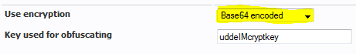

1. When the database contains UTF-8 characters (so the messages are stored correctly), then check the system tab in uddeIM backend. **Check if you have entered "UTF-8" in "Used charset" and you should use the UTF-8 language file (should both be automatically selected on Joomla 1.5+).**

Figure 10.11 – Character set and email character set options

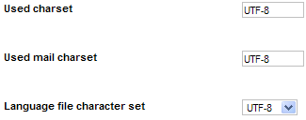

### uddeIM shows wired characters in messages

*When I write a message using UTF-8 characters (e.g. Greek, Chinese etc.) uddeIM shows "?????" or wired characters only? I have previously backup’ed and restored my database and after that this problem occurs.*

This might be a known MySQL / phpMyAdmin problem:

By default MySQL backup will export \*.sql using "ansi as utf-8" that means MySQL backup will export Latin-1 by default no matter if you have already set your server to utf-8.

If you restore this file ("ansi as utf-8") into the database and then install a new component all new installed tables will become Latin-1 and the collation is “latin\_swedish\_ci” (it does not matter if you change it to utf-8, the utf-8 encoded text will not be displayed properly).

You can fix this problem as follows:

Use MySQL administrator to backup the database, then use Notepad++ (or another utf-8 capable editor) to open it. You will see that the encoding is "ansi as utf-8". Change the format to "utf-8 only" and then save the file. Now restore the database using MySQL administrator with default settings. New added component tables should be utf-8 now.

### uddeIM shows wired characters in the frontend and/or backend

*When I call uddeIM the frontend (and/or backend) shows "?????" or other wired characters.*

uddeIM holds two sets of language files: UTF-8 encoded for Joomla 1.5+ and usually ISO encoded for Joomla 1.0.

1. Some people use **Joomla 1.0 with UFT-8 encoding** (which is quite uncommon). In that case you have force uddeIM to use the UTF-8 language file.
2. When you using **Joomla 1.0 with ISO encoding**, please ensure that your language file exists in that encoding (see chapter 14.2). Some language files are only available in UTF-8 encoding, so even on Joomla 1.0 systems (and the selection “Language file character set” = “default”) UTF-8 is used. When you are unsure you can open the language file from

/administrator/components/com\_uddeim/language/<file>.php

and check if it is UTF-8 or ISO encoded. When it is UTF-8 encoded you have to convert it to the character encoding you are using on your site.

## Autocompleter and MooTools

### Using MooTools with Joomla and uddeIM

*How can I use MooTools with Joomla and uddeIM?*

UddeIM basically supports MooTools from version 1.1 up to the current version 1.4. Unfortunately the used Autocompleter(s) are not compatible with each version, so the Admin can choose between the “Autocompleter” (which has been delivered with uddeIM in the past) and “Meio-Autocompleter” which is new in uddeIM 2.7+.

The “Autocompleter” can use MooTools 1.2, which supports multiple selections, or MooTools 1.1 which was delivered within Joomla 1.5 or Joomla 2.5.

UddeIM 2.7+ adds a new autocompleter called “Meio-Autocompleter” that works with Joomla 2.5 and better.

Which autocompleter and setting is the correct one for you depends on your setup. The next paragraph explains the options and a compatibility matrix gives an overview which configuration should work on a certain Joomla version. Nevertheless this matrix is only valid when no other component changes the default configuration of Joomla.

You can specify the version of MooTools which uddeIM should use in the admin backend:

"do not load MooTools":

MooTools is NOT loaded by uddeIM (so when your template loads MooTools, uddeIM does not load it twice). UddeIM assumes that MooTools 1.1 is loaded, so the Autocompleter for MooTools 1.1 is used.

"auto":

UddeIM loads MooTools 1.11 when running under Joomla 1.0 and uses the internal MooTools library when running under Joomla 1.5+. It uses the Autocompleter under Joomla 1.0 and 1.5 and the Meio.Autocompleter under Joomla 2.5.

"force loading MooTools 1.1":

Loads MooTools 1.11 library and uses Autocompleter 1.1. Usually used on Joomla 1.0.

Note that there is no check if MooTools is already loaded!

"force loading MooTools 1.2":

Loads MooTools 1.2 library and uses Autocompleter 1.2 (supports multiple selections). Usually used on Joomla 1.0.

Note that there is no check if MooTools is already loaded!

"do not load MooTools (1.1 is used)":

MooTools is NOT loaded by uddeIM (so when your template loads MooTools, uddeIM does not load it twice). UddeIM assumes that MooTools 1.1 is loaded, so the Autocompleter 1.1 for MooTools 1.1 is used.

"do not load MooTools (1.2 is used)":

MooTools is NOT loaded by uddeIM (so when your template loads MooTools, uddeIM does not load it twice). uddeIM assumes that MooTools 1.2 is loaded, so the Autocompleter 1.2 for MooTools 1.2 is used.

“do not load MooTools (use MEIO)”

MooTools is NOT loaded by uddeIM (so when your template loads MooTools, uddeIM does not load it twice). uddeIM tries to use the Meio-Autocompleter with the installed MooTools.

“force loading MooTools 1.3 (use MEIO)”

Loads MooTools 1.3 library and uses Meio-Autocompleter.

Note that there is no check if MooTools is already loaded and Meio-Autocompleter does not support multiple selection!

**Note:**

**“do not load MooTools” means that uddeIM does not load its own MooTools library but tries to use a built-in one.**

Figure 10.12 – System – Load MooTools



Figure 10.13 – Compatibility Matrix

|  |  |  |  |  |  |  |  |  |
| --- | --- | --- | --- | --- | --- | --- | --- | --- |
|  | **do not load MooTools** | **auto** | **force loading MooTools 1.1** | **force loading MooTools 1.2** | **do not load MooTools (1.1 is used)** | **do not load MooTools (1.2 is used)** | **do not load MooTools (use MEIO)** | **force loading MooTools 1.3 (use MEIO)** |
| **Joomla 1.0** |  | X | X | X |  |  |  | X |
| **Joomla 1.5** | X | X | T | T | X |  |  |  |
| **Joomla 1.6** |  |  |  |  |  | ? |  |  |
| **Joomla 1.7** |  |  |  |  |  | ? |  |  |
| **Joomla 2.5** |  | X |  |  |  |  | X |  |
| **Joomla 3.0** | -- | X | -- | -- | -- | -- | X | X |

X = works with default templates, -- = does not work, T = depends on template, ? = untested

|  |  |
| --- | --- |
| **C:\Users\STEPHA~1\AppData\Local\Temp\messagebox_warning-48.png** | For compatibility reasons "do not load MooTools" and "do not load MooTools (1.1 is used)" are identical. |

### The Autocompleter does not work

*Why does the Autocompleter not work on my site?*

There are several issues that could cause problems with the Autocompleter:

The Autocompleter uses MooTools. Some templates include MooTools, so there are two scripts loaded. Check the javascript error console if functions are double defined.

Sometimes wrong SEF settings or a wrong base path in the .htaccess files prevents the Autocompleter to work. Log into your site and call

http://yoursite.com/index.php?option=com\_uddeim&task=completeUserName&no\_html=1&value=x

(some usernames that start with "x")

This should return a list of persons starting with "x" (example):

[ "xuser1", "xuser2" ]

When no user is found it returns: []

Turn off site debugging. The Autocompleter uses AJAX requests to return values. When another component displays data or an error is displayed (and returned) the Autocompleter fails (see 2. to test it).

Ensure that no mambot/plugin modifies the output or displays additional output.

### I cannot select any users with the mouse

*The Autocompleter works fine, but I cannot select any users with the mouse?*

Do you use the Shoutbox module? It checks new entries very often and so you cannot select any Autocompleter entries with the mouse.

### The Autocompleter does only find the first user

*Why does the Autocompleter do only “autocomplete” the first user typed in?*

This is a limitation of MooTools 1.1 which is used in Joomla 1.5 and also delivered with uddeIM for Joomla 1.0 systems. When you use Joomla 1.0 you can switch uddeIM to MooTools 1.2 which autocompletes multiple users (this is NOT compatible to Joomla 1.5).

## Blocking

### How to block users?

*How do I block users?*

Open a message from a user you like to block. In the header you will find the link “Block user”. You can also install cb\_plug\_pms\_uddeim\_blocking which adds a tab to the CB profile.

### Do blocked users receive general messages?

*Do blocked users receive general messages?*

No, blocked users do not receive general messages, nor system messages.

### I cannot send messages to a user list because I am blocked?

*When I send a message to a user list, it claims that I am blocked. How can I send a message to this list?*

When

* one user has blocked you (by adding you to his personal block list),
* one user on the list is globally blocked (in Joomla), or
* a group is blocked and a user of this list is member of the blocked group,

you are not able to send a message. You will get a warning instead and see the blocked name written in parenthesis in the To:-field. Remove this name and send the message again.

### Messages can still be sent to a blocked group?

*I am trying to stop users of uddeIM on my site from being able to send pm's to a particular group I have set up. I assumed this just meant I had to tick the box in the back end configuration to block users sending messages to that user group. However users are still able to send messages to that particular group?*

Have you checked this feature with a registered user account or with your admin account (or an account with special rights)? Admins and special users can always send messages to all groups.

## Integration of 3rd party components

### How do I enable gravatars?

*How do I enable gravatars?*

When you have enabled the integration of avatars from one of the supported community or forums components (e.g. Community Builder or Agora board) gravatars are used when the user has not specified an avatar for the selected component.

When no supported community or forums component has been selected, gravatars are used for all users.

Figure 10.14 – Integration – Enable gravatars

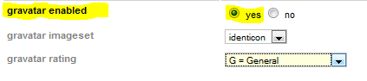

### I have enabled gravatars but uddeIM does not display single gravatars?

*I have enabled gravatars but uddeIM does not display some gravatars?*

uddeIM uses following logic to display avatars (here exemplary for CB and CBE):

Check if CB avatar exists {

yes, use CB avatar

} else check if user has a CB gallery icon selected {

yes, use CB gallery icon

} else check if gravatars are enabled {

yes, use gravatar

} else check if CB default picture exists {

yes, use CB default picture

} else check if CBE default picture exists {

yes, use CBE default picture

} else {

display nothing

}

|  |  |
| --- | --- |
| **C:\Users\STEPHA~1\AppData\Local\Temp\messagebox_warning-48.png** | Please note:  Since AUP and JomSocial provide an API for avatars, uddeIM uses this instead of the above logic. It depends on the component if an gravatar is displayed or not. uddeIM does not display an gravatar for these components when it is not supported by the provided API. |

### UddeIM PM links are not displayed in Kunena Profile?

*Kunena does not display the PM link in the profile pages to send PMs using uddeIM?*

Please ensure that you have installed (and enabled) the uddeIM plugin for Kunena (delivered within Kunena) and that you have installed the uddeIM component itself. Please also check *Kunena 🡪 Plugins* and enable the plugin “Kunena - UddeIM Integration". It might also be necessary to change the access from public to registered users.

# Using uddeIM

This section contains some questions how to use uddeIM.

## General questions

### Two users share the same realname in our community

*We have two users which share the same realname. How it is possible to distinguish between these names?*

There is no way for uddeIM to distinguish between both names. Either you ensure that also the realnames a unique (e.g. the second user can shorten his first name or maybe add a middle name) or you have to switch to usernames only instead.

### Reading of stored messages in the backend

*Is it possible to read messages in the backend?*

No, I do not support this and this is not discussible!

I have been asked several times if I can implement a way to display messages written by users in the backend (some other PMS allow this).

Since uddeIM respects a users' privacy - this is why uddeIM also implements features like message obfuscating, so an admin cannot read messages by accident - I will never support features which allows third persons to read messages without the knowledge of the user.

## Sending messages

### There is no “Subject” field visible

*In uddeIM I don't get the option "subject" when I'm trying to send a PM to another user. Is this correct or is there anything that I miss?*

There is no subject field. In my opinion a PM system should be as easy as possible (like SMS) and that is why uddeIM does not have a subject field (most people do not fill in a subject at all, so why implementing needless ballast?).

### “Add cc: line” has no effect

*I am wondering what I need to do to enable the ”add cc: line checkbox”? It is there but nothing happens when its being checked*

"Add cc: line" adds an additional line to your message containing all recipients when you have entered more than one recipient in the To-box.

Maybe I should rename this to "Add additional line that contains all message recipients" but there is not enough space for that.

Figure 11.1 – CC line in a PM

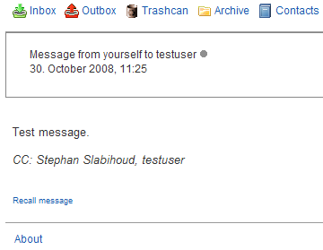

### uddeIM shows BBcode in messages

*When users receive messages from CB (or another component), BBcode tags are displayed. uddeIM seems not to evaluate BBcodes?*

You have to enable BBcodes in uddeIM backend.

### Double messages from Autowelcome plugin and CB invitations

*I receive messages from Autowelcome plugin and CB invitations twice.*

You have enabled cb\_plug\_pms\_uddeim (aka “uddeIM CB PMS plugin”) and plug\_pms\_mypmspro. Ensure that only one of these plugins is enabled (see Chapter 7.9).

## Contact lists

### How can registered users create global or restricted contact lists?

*How can registered users create global or restricted contact lists?*

Only administrators can create "global" or "restricted" contact lists. Registered users can only create "private" contact lists.

All users can see

* his own lists (private lists)
* restricted lists, when he is a list member
* global lists

## System- and General messages

### How to send general or system messages to multiple users

*How can I send a system message to a certain user group?*

When you are admin you can send a general or system messages to certain user groups when going to compose message and selecting “[Create system or general message]”.

Figure 11.2 – Sending a general or system message

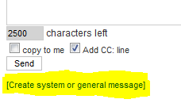

Figure 11.3 – Select recipients

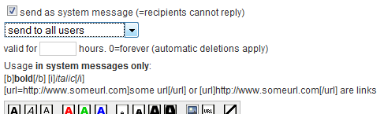

### Blank screen when sending multiple messages

*I do only see a blank screen when I send multiple messages.*

Sending multiple messages need some time. When the list is quite huge the script may die because the execution time of PHP scripts is usually limited. When you are on a shared server there is in most cases no way to increase this limit, when you a operating your own server you can increase this value in your PHP configuration.

### Why do system messages not appear in the senders outbox?

*When I sending a system message to my users this message does not appear in my outbox.*

uddeIM creates multiple messages, one message for each user. Since some communities have lots of users (e.g. 100.000 or more) this would create as many massages in the senders outbox which does not make sense.

## Miscellaneous questions

### Obfuscation and Encryption

*What is "obfuscate messages", and what is the difference between "obfuscate" and "encyption"?*

All known PMS for Joomla store messages as plain text in the database, so when you backup your database or use phpMyAdmin to access it you can read all messages without any problems.

When you "obfuscate" a message, this message is encrypted in the database using a key the admin configures in the backend. It is comparable to ROT13 (see <http://en.wikipedia.org/wiki/Rot13>), so a human user cannot read the massage but since the key is known the admin could decrypt the message with some effort (the PMS user does not recognize the obfuscating of messages).

When you "encrypt" a message, this message is encrypted with a key the PMS user enters in the frontend (it is called "password" in the frontend which is actually wrong because it is a key but users usually do not know the difference so it is easier for them to understand what to do). Since this key is only known by the sender and the receiver the admin cannot decrypt the message (with major effort it is still possible because uddeIM does not use strong encryption in that mode.

When “strong encryption” is chosen uddeIM uses 3-DES algorithm to encrypt the message. The encrypted text cannot be broken without major effort.

"Base64 encoded" is not an encryption at all. This stores messages without using the crypt key base64 encoded in the database. This option has been implemented so help people who have problems with UTF-8 encoded characters because of a wrong database configuration.

Figure 11.4 – Message obfuscating and encryption

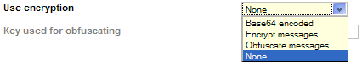

# CSS related questions

## Change width of text area

*How can I change the width of the textarea where the user enters his message?*

Edit the corresponding CSS files. Look for

#uddeim-writeform textarea {

...

width: 450px;

...

}

and change the width.

In uddeIM 1.5+ you can specify the columns, rows and width of the message box in the backend.

Figure 12.1 – Message box options in uddeIM 1.5+ and above



## How to style the message line above of the uddeIM box

*When I send a message or do other operations I see a message line above uddeIM box, e.g. “Message has been sent”. Is there a way to style this message?*

Yes, uddeIM uses standard Joomla messages. So change the CSS class “message” in your site’s CSS file.

## “Send” button is not visible

*I cannot see the "Send" button.*

This happens when the main template CSS sets the text and background to the same color. Check "uddeim.css" (and all corresponding browser CSS files) and set the background (or text color) to e.g. blue:

#uddeim-writeform input.button {

font-family: Arial, Helv, Helvetica, "MS Sans Serif", "Sans Serif";

font-size: 11px;

background: blue;

border: 1px solid #c0c0c0;

}

## Changing of CSS files not possible

*I cannot change uddeIM's CSS files. Seems like I do not have permission to do that. The way I try to this is by downloading the CSS file, mod it, and then upload it again. But then I get the message that I can't overwrite the original CSS file.*

When you upload components using ftp the owner of the file is usually the user (e.g. ftpuser), when you use the Joomla components installer the owner is usually the webserver (e.g. wwwrun). So you cannot change these files using ftp. Use JoomlaXplorer to modify the access rights when the owner is wwwrun.

## Using separate CSS files for each browser

*Can I use separate CSS files for each browser, e.g. I want to use a separate file for Safari browsers?*

Yes, that’s possible.

First check uddeim.css in the default template to see which CSS IDs and classes are used by uddeIM. uddeIM has a browser switch. So you can use specific CSS files for different browsers. If such a specific file is not found, it will try to load uddeim.css from the current template and when this fails uddeIM reverts to uddeim.css from the default template.

Recognized filenames are:

* uddeim-opera.css
* uddeim-ie4.css
* uddeim-ie6.css
* uddeim-ie7.css
* uddeim-ie5win.css
* uddeim-ie5mac.css
* uddeim-ie.css (all Internet Explorer)
* uddeim-safari100.css
* uddeim-safari85.css
* uddeim-safari.css (all Safari)
* uddeim-konq2.css
* uddeim-konq3.css
* uddeim-konq.css (all Konqueror)

The test is cascading. For an Internet Explorer 5.5 on Windows, uddeIM will first search for the file uddeim-ie5win.css, then for the file uddeim-ie.css, then for uddeim.css in the current template, and then for uddeim.css in the default template.

## UddeIM menu displayed as a list

*The menu (navbar) doesn't display 'inline' but just in a list. I tried different standard templates, but they all seem to do this*

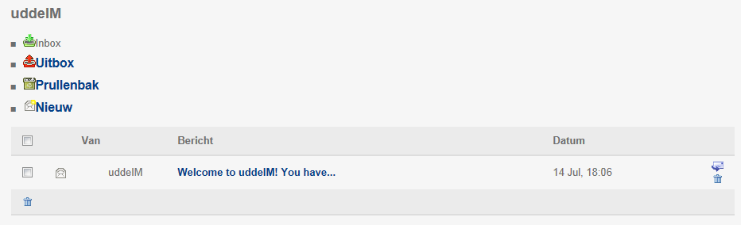

This is a problem with the main site template which overwrites some definitions. There is no real solution for uddeIM: You can use Firebug (Firefox plugin) to inspect the CSS round the menu (navbar) and when you have found the relevant definition you can either fix it in the main site template (recommended) or you can try to add “!important” to the definition in uddeIM’s CSS file in order to give it a higher priority.

## UddeIM menu displayed in one row without icons

*When I change the "Appearance of menu bar" to "icons only" or "text only" then everything is in the first row, the problem is when I change to "text and icons" then icons are not displayed and the menu bar is misaligned like this:*



It seems to be a problem with the site template you are using. The following code may fix the problem:

div.nopad {

float:left;

padding:0 0px 15px 0px;

}

# 3rd party programs

Some of the solutions in this chapter have been collected from several forums and have been edited for this FAQ.

|  |  |
| --- | --- |
| **C:\Users\STEPHA~1\AppData\Local\Temp\messagebox_warning-48.png** | uddeIM development does not offer additional support for programs mentioned in this chapter.  Please contact the author of the component in order to get support! |

## Calling uddeIM from a 3rd party program

*How can I call uddeIM from my own component/module?*

You can use following links to call uddeIM from your component or module:

Call settings dialog when "show settings" is off in backend (no menu link is shown in uddeIM):

http://yoursite/index.php?option=com\_uddeim&task=settings

Open new message dialog to user with userid XX:

http://yoursite/index.php?option=com\_uddeim&task=new&recip=XX [&nouserlist=Y]

Open new message dialog to user with username XX (this is independent from realname/username setting):

http://yoursite/index.php?option=com\_uddeim&task=new&runame=XX [&nouserlist=Y]

when a user with username XX does not exist, XX is used untranslated in the input field, so you can also use "name 1,name 2" or "#userlist" as parameter (note: multiple recipients feature do not work with SEF).

nouserlist parameter (optional):

1 = suppress user list, 2 = suppress connection list, 3 = suppress both lists

add +4 when the TO field should be disabled

e.g. 4 = disable TO field only, 5 = suppress user list AND disable TO field, and so on

## Pass a message text to uddeIM from a 3rd party program

*I want to pass a message along with the "recip" in a URL call that opens a message to that "recip".*

*<a href='/index.php?option=com\_uddeim&task=new&recip=63*

*So something like above, but add*

*&message="this is the message to the recipient"*

I am sorry, this is not possible. There are several issues why I do not implement this feature:

* Spammers might use it to send thousands of emails, and
* It will bypass CSRF and CAPTCHA protections.

## Joomfish component

*I use Joomfish 2.0 Beta. When I compose a message I get following error "There is no user with this username!". It seems that the same problem appears with Fireboard and Joomfish.*

Upgrade to JoomFish 2.0 Beta2. You have to disable the JoomFish Basic Router to make uddeIM and FB work.

## AdsManager plugin

*AdsManager does not send messages/shows error messages (AddManager plugin is installed).*

It seems that the plugin does not work with Joomla 1.5. You can use following fix:

In components/com\_adsmanager/adsmanager.html.php (on line 818) replace

echo '<a href="'.$pmsForm.'">'.$pmsText.'</a><br />';

with

echo '<a href="index.php?option=com\_uddeim&task=new&recip='.

$row->userid.'">'.$pmsText.'</a><br />';

So uddeIM is called without the need to install a plugin.

## JDirectory component

*How can I add uddeIM support to JDirectory?*

Since the existing plugin does work with Joomla 1.0 only, you can use following fix:

In "/components/com\_jdirectory/template/default/content.php" replace:

<?php

if ($this->countFieldsInGroup("GroupDetails1"))

$this->loadFieldsInGroup($content,"GroupDetails1","<br/>");

?>

with

<?php

if ($this->countFieldsInGroup("GroupDetails1"))

$this->loadFieldsInGroup($content,"GroupDetails1",

"<br/>","","",1);

echo '<a href="index.php?option=com\_uddeim&task=new&recip='.

$content->userid.'">'.JDIRECTORY\_CONTACT\_BY\_PMS.'</a>';

?>

So uddeIM is called without the need to install a plugin.

## Clickheat & Rokbox plugin

See chapters

* 6.3.1 “Javascript is displayed under the “To” field” and
* 6.3.2 “Javascript is displayed in the format menu”.

## yvBBCode plugin

See chapters

* 6.3.1 “Javascript is displayed under the “To” field” and
* 6.3.2 “Javascript is displayed in the format menu”.

## IE PNG Fix

*The "delete" buttons in inbox, outbox and archive do not work.*

This problem might be caused by a Javascript plugin. When you use the "IE PNG Fix" try to disable this plugin/mambot.

## Joomla template “rt\_refraction\_j1.5”

*"Delete" checkboxes in inbox, outbox and archive are not shown.*

This template allows to style checkboxes in the admin panel. You need to set it off.

## SOBI2

*Is there any way to contact the entry/listing owner through uddeIM?*

Copy the URL for sending a PMS to a member and replace the recipient member ID with:

<?php echo $mySobi->owner ?>

You can then make a link in SOBI2 to send PMS to the listing owner.

Using uddeIM the link is:

<a href="index.php?option=com\_uddeim&task=new&recip=<?php echo   
$mySobi->owner ?>">Send PM</a>

Put it in the details view template wherever you wish the "Send PM" link to appear.

## sh404SEF

### “item=0” appended to links

*The sh404SEF plugin creates links having always an ItemId=0 afterwards. Is there a way to fix that?*

The “ItemId=0” problem is simply an item ID problem which can be changed in sh404SEF setup. Go to the Advanced tab and open the Item ID management. Set all options to "no" except "Insert default ItemId if none". This will prevent sh404DEF to add the ItemId to links. Don't forget to purge the URL database after changing the configuration.

### Hot to get the current version of sh404SEF plugin

*Where do I get the current version of the sh404SEF plugin?*

Please check this page:

<http://joomlacode.org/gf/project/sh404_plugins>

### How to install the sh404SEF plugin?

*How to install the sh404SEF plugin that comes with uddeIM in the 3rd Party folder?*

Put the "\3rd party\sh404SEF" file to

/components/com\_sh404sef/sef\_ext/ or in /components/com\_uddeim/sef\_ext/

and put the “\3rd party\sh404SEF\language\plugins\com\_uddeim.php” to

/administrator/components/com\_sh404sef/languages/plugins/com\_uddeim.php

## AceSEF

*When a message is opened this warning appears:*

*This message cannot be displayed.*

*Possible reasons:*

* *You have no rights to read this message.*
* *The message has been deleted.*

This issue has been reported with AceSEF and AceSEF uddeIM plugin v1.2.2 . Please configure AceSEF to use the “*Basic SEF rewrite”* with uddeIM component and purged all uddeIM SEF’s.

|  |  |
| --- | --- |
| **C:\Users\STEPHA~1\AppData\Local\Temp\messagebox_warning-48.png** | Also see chapter 6.2.2. |

## Marketplace

*Is there a way to use uddeIM with Marketplace?*

Yes, with a few simple changes (tested with Marketplace 1.4.5):

First, a couple notes: uddeIM does not use a subject, so we are not passing that when creating a new message.

Step 1. decide what graphic you want to use to represent "Send a PM". I used the forward.gif that comes with the default uddeIM template found at /components/com\_uddeim/templates/default/images/forward.gif

Step 2. Make the following changes to /components/com\_marketplace/show\_ad.php

Step 2a) We change the lookup of the menu ID from primezilla to uddeIM. Change line 357 from

$database->setQuery ( "SELECT id FROM #\_\_menu WHERE link   
LIKE '%com\_primezilla%' AND published='1' ");

to

$database->setQuery( "SELECT id FROM #\_\_menu WHERE link   
LIKE '%com\_uddeim%' AND published='1' ");

Step 2b) Modify the linked URL to uddeIM. Change line 368 from

$linkPrimezilla = sefRelToAbs( "index.php?option=com\_primezilla&amp;page=write&amp;uname=".$ad\_user."&amp;subject=".$sSubject.$pzItemidLink);

to

$linkPrimezilla = sefRelToAbs( "index.php?option=com\_uddeim&amp;task=new&amp;runame=".$ad\_user."&amp;lang=en&amp;nouserlist=3".$pzItemidLink);

Remember, we are not including the subject, just send a PM to the creator of the ad.

Step 2c) Change the image to whatever you chose. Change line 370 from

echo "<img src='".$mosConfig\_live\_site."/components/com\_primezilla/images/messagenew.gif' align='center' border='0' alt='$sAltTag $ad\_user' title='$sAltTag $ad\_user' >";

to

echo "<img src='".$mosConfig\_live\_site."/components/com\_uddeim/templates/default/images/forward.gif' align='center' border='0' alt='$sAltTag $ad\_user' title='$sAltTag $ad\_user' >";

Step 2d) Repeat 2b and 2c respectively for lines 709 and 711. These lines are used if you select to sue PM instead of eamil for contact.

Step 3). Change the Marketplace backend configuration to us Primezilla. Keep in mind that the line numbers are for Marketplace 1.4.5.

## JReviews

*Is there a way that members can contact the author by clicking on an uddeIM link.*

Yes, there is:

* Download and publish uddeIM mambot plug\_uddeim\_pms\_contentlink (after JReviews content mambot)
* Insert one of the following code in detail.thtml

For icon link:

{pmslink:id=<?php echo $listing['User']['user\_id'];?>}

For text link (send message):

{pmslink:id=<?php echo $listing['User']['user\_id'];?>,Send Message}

Or regarding a fixed Section ID:

<?php if($listing['Section']['section\_id']==10):?>  
For ICON:  
{pmslink:id=<?php echo $listing['User']['user\_id'];?>}  
For Text (“Send message”):  
{pmslink:id=<?php echo $listing['User']['user\_id'];?>,Send Message}  
<?php endif;?>

## Shoutbox

*When I enable the Shoutbox module I cannot select any users in the Autocompleter with the mouse?*

Shoutbox checks new entries very often and so you cannot select any Autocompleter entries with the mouse. Use a setting which does fewer requests, remove the Shoutbox module or disable the Autocompleter.

## Eventlist

*Is there a way that members can contact the author by clicking on an uddeIM link.*

Yes, add this to views/details/tmpl/default.php:

echo '<a href="index.php?option=com\_uddeim&task=new&recip='.  
(int)$this->row->created\_by.'">Email</a>';

## myApi (Facebook connector for Joomla)

See chapter

* 6.3.3 “More smileys” cannot be opened and displays a Javascript error

## Jomsocial Facebook Connect

See chapter

* 6.3.3 “More smileys” cannot be opened and displays a Javascript error

## AlphaUserPoints

### Rule for sending a PM

*How can users get points for sending messages?*

In /components/com\_uddeim/uddeim.php after the lines

case "save":

uddeIMsaveMessage($userid, $to\_name, $to\_id, $pmessage, $tobedeleted, $tobedeletedsent, $forceembedded, $item\_id, $messageid, $copytome, $addccinfo, $sendeform\_showallusers, $cryptpass, $backto, $config);

add following lines:

//////////////////////////

$api\_AUP = JPATH\_SITE.DS.'components'.DS.'com\_alphauserpoints'.DS.'helper.php';

if ( file\_exists($api\_AUP)) {

require\_once ($api\_AUP);

$date = date("Y-m-d");

AlphaUserPointsHelper::newpoints( 'plgaup\_com\_uddeim\_send','', $date.'|'.$user->id, 'Danke f&uuml;r das senden einer Private Message am "'.$date.'"' );

}

//////////////////////////

Rule for AUP:

INSERT INTO ``.`jos\_alpha\_userpoints\_rules` (`id`, `rule\_name`, `rule\_description`, `rule\_plugin`, `plugin\_function`, `access`, `component`, `calltask`, `taskid`, `points`, `percentage`, `rule\_expire`, `sections`, `categories`, `content\_items`, `exclude\_items`, `published`, `system`, `duplicate`, `blockcopy`, `autoapproved`, `fixedpoints`, `category`) VALUES ('', 'Uddeim Sende Nachricht', 'Sende eine Nachricht und erhalte Punkte', 'com\_uddeim', 'plgaup\_com\_uddeim\_send', '1', '', '', '', '1', '0', '0000-00-00 00:00:00', '', '', '', '', '0', '0', '0', '0', '1', '1', '');

Source:

<http://www.alphaplug.com/index.php/forum.html?func=view&catid=12&id=11181#11181>

## Cobalt - Joomla! CCK component

*How can I use uddeIM in Cobalt templates?*

This is quite simple: open the articles list or article template and add this piece of code anywhere you need it:

<?php if(JComponentHelper::isEnabled('com\_uddeim')):?>

<a href="/<?php echo JRoute::\_('index.php?option=com\_uddeim&task=new&recip='.   
$item->user\_id); ?>">PM</a>

<?php endif;?>

# Developer information

## How do I write a new message into uddeIM database?

Any component can insert messages into the uddeIM database, e.g. to notify about events (example: "Action required, someone wants to save you as buddy"). System messages can have a virtual sender (for example 'Buddy System') and the reply must be disabled.

There are following rules you should know:

* All messages must have a valid user ID as sender (except messages from Public Users which have the user ID set to "0").
* The virtual sender name is stored in the "systemmessage" field and set the "disablereply" should be set to "1" (otherwise the user with the given user ID will get replies).
* The username of the the sender ID will not be displayed when a virtual sender name is set.
* Messages may contain BB codes.
* Messages from invalid user IDs will be show up as "Deleted user" in the system.
* Messages from public users will be show up as "Public user" in the system when no sender name has been given.

Example:

To send the message

*"Someone wants to add you as a buddy. Go to the [url=index.php?option=com\_buddystem] buddy system[/url] and approve this request."*

to user "lonelyboy" with user ID "69" where an admin of the system has "63" as ID but "Buddy System" should be used as virtual sender enter the following:

INSERT INTO #\_\_uddeim (fromid, toid, message, datum, disablereply, systemmessage) VALUES (63, 69, '(message as above)', (timestamp now), 1, 'Buddy System')

If you do not have an admin ID available, you can use the same user ID for fromid and toid. This will change the headline on the 'show message' page from 'Message from Buddy System' to only 'Buddy System' but should otherwise be O.K. if you have "disablereply" set.

The database format has been touched several times since uddeIM 0.5 but old modules and components which have worked with uddeIM 0.5 should still work with the current version of uddeIM.

|  |  |
| --- | --- |
| **C:\Users\STEPHA~1\AppData\Local\Temp\messagebox_warning-48.png** | From uddeIM 1.9+ you should use the API (see 14.7). |

## What languages and codebases are supported?

*What languages are supported by uddeIM and what codebases are used?*

There are two sets of language files (a native language file and a UTF-8 based language file). A few language files are only available in UTF-8 (mentioned under “UTF-8 only” in the table below).

|  |  |  |
| --- | --- | --- |
| **Codebase** | **Language** | **Notes** |
| ISO-8859-1 (Latin-1) |  |  |
|  | brazilian\_portuguese.php |  |
|  | catalan.php |  |
|  | danish.php |  |
|  | dutch.php |  |
|  | english.php |  |
|  | finnish.php |  |
|  | french.php |  |
|  | germanf.php |  |
|  | germani.php |  |
|  | greek.php |  |
|  | indonesian.php |  |
|  | italian.php |  |
|  | norwegian.php |  |
|  | portuguese.php |  |
|  | romanian.php |  |
|  | spanish.php |  |
|  | swedish.php |  |
|  | turkish.php |  |
| ISO-8859-2 (Latin-2) |  |  |
|  | polish.php |  |
|  | hungarian.php |  |
| Windows-1250 (CP1250) |  |  |
|  | hrvatski.php |  |
| Windows-1251 (CP1251) |  |  |
|  | bulgarian.php |  |
|  | russian.php |  |
| Windows-1255 (CP1255) |  |  |
|  | hebrew.php |  |
| UTF-8 only |  | These language files are available |
|  | arabic.php | in UTF-8 only and also used with |
|  | bulgarian.php | Joomla 1.0 |
|  | czech.php | . |
|  | farsi.php |  |
|  | japanese.php |  |
|  | lithuanian.php |  |
|  | serbian.php |  |
|  | serbian\_lat.php |  |
|  | simplified\_chinese.php |  |
|  | traditional\_chinese.php |  |
|  | ukrainian.php |  |
|  | vietnamese.php |  |

## Where does uddeIM store its language files?

*Where does uddeIM store its language files?*

uddeIM stores its language files in following folders:

/administrator/components/com\_uddeim/language/

/administrator/components/com\_uddeim/language.utf8/

## What BB code tags are supported?

*What BB codes does uddeIM support in messages?*

uddeIM supports following BB code tags:

[b]bold[/b]

[i]italic[/i]

[u]underline[/i]

[color=#123456]coloured text[/color]

[size=1][/size]

[size=2][/size]

[size=4][/size]

[size=5][/size]

[ul]unordered list[/ul]

[ol]ordered list[/ol]

[li]list item[/li]

[url=http://www.domain.com]Domain[/url]

[url]http://www.domain.com[/url]

[img]http://www.domain.com/picture.jpg[/img]

[img size=120]http://www.domain.com/picture.jpg[/img]

Additionally following uddeIM specific tags are supported:

[topurl=http://www.domain.com]Domain[/topurl]

[topurl]<http://www.domain.com[/topurl>]

Recognized identifies for url and topurl:

http:// https:// ftp:// mailto:

## Database tables and fields uddeIM uses

The following sections describe the tables uddeIM uses.

|  |  |
| --- | --- |
| **C:\Users\STEPHA~1\AppData\Local\Temp\messagebox_warning-48.png** | When uddeIM development started in 2005 Benjamin specified the database fields using a mixture of German and English field identifiers.  To be compatible to existing modules and mambots I decided to keep these identifier and adding new ones using English field identifier. |

### #\_\_uddeim

#\_\_uddeim stores messages and message flags

`id` int(10) unsigned NOT NULL auto\_increment

primary key

`fromid` int(11) NOT NULL default '0'

UserID (as in #\_\_users) of the person sending the message.

Please note: If the 'systemmessage' field is filled, then the sending user will not be shown regardless of the ID used here.

Might be "0" if the sender is a "public user" (in that case publicname and publicemail are valid).

`toid` int(11) NOT NULL default '0'

UserID of recipient

`replyid` int(11) NOT NULL default '0'

ID of the original message or 0 if this is not a reply to.

`message` text NOT NULL

Contains the message. If replying to a message, uddeIM appends the message history after inserting a linebreak, followed by "\_\_\_\_\_\_\_\_\_\_" and one more linebreak (10 underscores).

`datum` int(11) default NULL,

Unix time stamp when message sent

`toread` int(1) NOT NULL default '0'

1 = Recipient has read the message

`totrash` int(1) NOT NULL default '0'

1 = Recipient has trashed the message

`totrashdate` int(11) default NULL

Unix time stamp when the message was trashed by the recipient

`totrashoutbox` int(1) NOT NULL default '0'

1 = Sender has trashed the message

`totrashdateoutbox` int(11) default NULL

Unix time stamp when the message was trashed by the sender

`expires` int(11) NOT NULL default '0'

Message will expire at this time (unix time stamp) and will be erased from the database next time message pruning is invoked

`disablereply` int(1) NOT NULL default '0'

1 = uddeIM will not display a reply form when the message is displayed

`systemflag` int(1) NOT NULL default '0'

0 = normal message

1 = System message (systemmessage contains valid text)

2 = Copy2me message

`delayed` int(1) NOT NULL default '0'

1 = Message is delayed (sent from a moderated mailbox)

`systemmessage` varchar(60)

System message can contain an inexistent username like "System", "Support" or "Buddy System" etc. If the field `systemmessage` contains a value, the message is presented to the user as an anonymous system message sent from the name mentioned in this field (e.g. the user will see "Support" or "Message from Support").

The user does not know who has send the message.

`archived` int(1) NOT NULL default '0'

Message is stored in archive (but will be deleted if trash set to 1).

`cryptmode` int(1) NOT NULL default '0'

0 = messages is stored unencrypted

1 = message has been obfuscated (key is stored in config->cryptkey, `crypthash` contains a MD5 hash over the key)

2 = message has been encrypted (`crypthash` contains a MD5 hash over the key to ensure that only a valid key is used to encrypt the message)

3 = message is base64 encoded stored in database

`flagged` int(1) NOT NULL default '0'

1 = Message has been flagged by the recipient (inbox and archive only)

`crypthash` varchar(32) default NULL

Contains the MD5 hash over the key used to encrypt/obfuscate the message.

`publicname` text

The name of a public user with has send the message.

`publicemail` text

The email of a public user with has send the message.

### #\_\_uddeim\_emn

#\_\_uddeim\_emn stores user flags

`id` int(11) unsigned NOT NULL auto\_increment

primary key

`userid` int(11) NOT NULL default '0'

UserID of the user

`status` int(1) NOT NULL default '0'

0 = will not receive email notifications

1 = will receive email notifications (notifications must be enabled in the backend)

2 = will receive email notifications when not logged in

10 = like 1, but not on replies

20 = like 2, but not on replies

`popup` int(1) NOT NULL default '0'

User want to see a popup notification

`public` int(1) NOT NULL default '0'

User allows public users to contact him

`remindersent` int(11) NOT NULL default '0'

Used by the forgetmenot feature to check when a reminder hasb een sent to the user. `remindersent` is reset to Now() when a user visits the inbox.

`lastsent` int(11) NOT NULL default '0'

Last time the user has sent a message

`autoresponder` int(1) NOT NULL default '0'

Specifies if the user has enabled the autoresponder.

`autorespondertext` TEXT NOT NULL

The autoresponder text specified by the user.

`autoforward` int(1) NOT NULL default '0'

Specifies if the user has enabled the autoforward feature.

`autoforwardid` int(1) NOT NULL default '0'

Specifies the recipient for the autoforwarder.

`locked` int(1) default '0' NOT NULL

Locks the uddeIM account, so the user cannot access the PMS.

`moderated` int(1) default '0' NOT NULL

This mailbox is moderated and all messages from this user are delayed.

### #\_\_uddeim\_blocks

#\_\_uddeim\_blocks stores information about blocked users

`id` int(10) unsigned NOT NULL auto\_increment

primary key

`blocker` int(11) NOT NULL default '0'

The user with this ID has blocked...

`blocked` int(11) NOT NULL default '0'

...this user. But these blocks will only be used when the admin has enabled the blocking system in the backend

### #\_\_uddeim\_config

#\_\_uddeim\_config stores a backup of uddeIM’s configuration

`varname` tinytext NOT NULL

The name of the configuration field...

`value` tinytext NOT NULL

...and its value. Names starting with the prefix "\_" have only informative character and are not stored in the config class.

### #\_\_uddeim\_userlists

#\_\_uddeim\_userlists stores contact lists off all users

`id` int(11) NOT NULL auto\_increment

primary key

`userid` int(11) NOT NULL default '0'

The owner of the contacts list.

`name` varchar(40) NOT NULL default ''

The name of the list. Must not contain spaces and special characters.

`description` text NOT NULL

A short description.

`userids` text NOT NULL

A comma separated list of userIDs.

`global` int(1) NOT NULL DEFAULT '0'

Specifies if the list is normal (0), global (1) or restricted (2).

### #\_\_uddeim\_spam

#\_\_uddeim\_spam stores reported messages

`id` int(10) unsigned NOT NULL auto\_increment

primary key

`mid` int(11) NOT NULL default '0'

The ID of the reported message.

`datum` int(11) default NULL

The message date (copy from jos\_uddeim).

`reported` int(11) default NULL

The date the message has been reported.

`fromid` int(1) NOT NULL default '0'

The sender of the message that has been reported.

`toid` int(1) NOT NULL default '0'

The recipient of the message that has been reported (this is identical with the reporter) of the message.

`message` TEXT NOT NULL

The message that has been reported (encrypted messages cannot be displayed).

### #\_\_uddeim\_attachment

#\_\_uddeim\_attachment stores references to file attachments

`id` int(10) unsigned NOT NULL auto\_increment

primary key

`mid` int(1) NOT NULL default '0'

Message ID to which this file attachment refers to. Might be “-1” when filenames are temporary stored.

`tempname` TEXT NOT NULL

Temporary filename used to store the file.

`filename` TEXT NOT NULL

Original filename.

`fileid` varchar(32) NOT NULL

Key to access this file (internal use only)

`size` int(1) NOT NULL default '0'

Size of the attachment.

`datum` int(11) default NULL

Date the attachment has been sent.

## Useful SQL queries

*Are there some useful SQL queries when I want to integrate uddeIM in my own component?*

Yes indeed, see the following subchapters or check the mod\_uddeim\_statistics module for more queries.

### How many messages have been sent totally?

SELECT MAX( id ) AS count\_items FROM #\_\_uddeim

### How many messages are stored on the server?

SELECT COUNT( id ) FROM #\_\_uddeim

## Description of uddeIM API

uddeIM 1.9+ comes with an API that can be used by third party components to invoke uddeIM functions.

### Include the API

To use the API in a Joomla 1.0 environment use:

global $mainframe;

require\_once( $mainframe->getCfg('absolute\_path').   
 "/components/com\_uddeim/uddeim.api.php" );

To use the API in a Joomla 1.5+ environment use:

require\_once( JPATH\_SITE."/components/com\_uddeim/uddeim.api.php" );

### Compatibility

The following table states which API version is required for a certain function.

|  |  |
| --- | --- |
| **Function** | **API version** |
| version() | 1+ |
| mainVersion() | 3+ |
| isInboxLimitReached() | 1+ |
| sendNewMessage() | 1+ |
| sendNewMessageDelayed() | 4+ |
| isAttachmentAvailable() | 2+ |
| appendAttachment() | 2+ |
| sendNewSysMessage() | 1+ |
| getLinkToBox() | 1+ |
| getInboxUnreadMessages() | 2+ |
| getInboxTotalMessages() | 2+ |
| getItemid() | 2+ |
| getConfiguration() | 2+ |
| registerHook() | 5+ |

### Create an instance of uddeIM API object

The uddeIMAPI object is used to invoke API functions. To create an instance of the object:

$uddeim = new uddeIMAPI();

#### version()

|  |  |
| --- | --- |
| Method: | bool $uddeim->version(); |
| Description: | Returns the API version number. See chapter 14.7.2. |
| Parameters: | none |
| Returns: | (int) API version |

#### mainVersion()

|  |  |
| --- | --- |
| Method: | bool $uddeim->mainVersion(); |
| Description: | Returns the version number of uddeIM component. |
| Parameters: | none |
| Returns: | (array) [“version”] = “x.x”, [“hotfix”] = “x”, [“text”] = “uddeIM x.x/xxxxxx” |

#### isInboxLimitReached()

|  |  |
| --- | --- |
| Method: | bool $uddeim->isInboxLimitReached($userid); |
| Description: | Tests if the Inbox limit has been reached. You should not create a new message when this limit has been reached. |
| Parameters: | (int) userid of recipient |
| Returns: | (bool) [true: Inbox limit has been reached | false] |

#### sendNewMessage()

|  |  |
| --- | --- |
| Method: | int $uddeim->sendNewMessage($fromid, $toid, $message,  $sendnotification=0, $updatelastsent=0); |
| Description: | Creates a message “message” from sender “fromid” to recipient “toid”.  Special features supported: Autoforward  Special features not supported: Copy2me, Autoresponder |
| Parameters: | (int) fromid (sender)  (int) toid (recipient)  (string) message (may contain BB codes)  (bool) sendnotifications = [true: send email notification | false]  (bool) updatelastsent = [true: update lastsent pointer | false] |
| Returns: | (int) MessageID |

#### sendNewMessageDelayed()

|  |  |
| --- | --- |
| Method: | int $uddeim->sendNewMessageDelayed($fromid,  $toid, $message, $sendnotification=0,  $updatelastsent=0); |
| Description: | Creates a delayed message “message” from sender “fromid” to recipient “toid”, i.e. the message is not delivered immediately to the recipient, so the admin has to approve the message in the Message Control Center Plugin before it is delivered.  Special features supported: Autoforward  Special features not supported: Copy2me, Autoresponder |
| Parameters: | (int) fromid (sender)  (int) toid (recipient)  (string) message (may contain BB codes)  (bool) sendnotifications = [true: send email notification | false]  (bool) updatelastsent = [true: update lastsent pointer | false] |
| Returns: | (int) MessageID |

#### isAttachmentAvailable()

|  |  |
| --- | --- |
| Method: | int isAttachmentAvailable(); |
| Description: | Checks if attachments feature is available. |
| Parameters: | none |
| Returns: | (int) error code = [0: not available | 1: attachments available] |

#### appendAttachment()

|  |  |
| --- | --- |
| Method: | void appendAttachment($messageID, $filename,  $originalname, $id); |
| Description: | Appends attachments to messages.  Before calling this function check if attachments are available. |
| Parameters: | (int) messageID (this is returned by sendNewMessage())  (string) filename (filename of a file stored in “uddeimfiles” folder)  (string) originalname (filename that is used when the file is downloaded)  (string) id (unique id for each file, e.g. use “md5(rand() \* time())”) |
| Returns: | none |

#### sendNewSysMessage()

|  |  |
| --- | --- |
| Method: | int sendNewSysMessage($fromid, $recipients, $message,  $systemmsg=0, $validfor=0, $sendnotification=0,  $forceembedded=0); |
| Description: | Creates a system or general message “message” from sender “fromid” to recipients “sysgm\_universe”. |
| Parameters: | (int) fromid (sender)  (int) recipients = [all: all users | online: all logged in users | special: all special users | admins: all admins | <groupid>: all members of group <groupid> ]  (string) message (may contain BB codes)  (bool) systemmsg = [ true: system message, no replies allowed | false ]  (int) validfor = [ time in hours the message is valid for ]  (bool) sendnotifications = [true: send email notification | false]  (bool) forceembedded = [true: embed message in email notification | false] |
| Returns: | (int) error code = [0: OK | 1: no recipients found] |

#### getLinkToBox()

|  |  |
| --- | --- |
| Method: | bool $uddeim->getLinkToBox($box, $sef=0); |
| Description: | Returns the URL for a given box. This URL can be used, e.g. in a <a href=”URL”> tag.” |
| Parameters: | (string) box = [inbox|outbox|archive|trashcan|settings|compose|contacts]  (bool) sef = [false: no SEF | true: SEF] |
| Returns: | (string) returns URL to given box |

#### getInboxUnreadMessages()

|  |  |
| --- | --- |
| Method: | int $uddeim->getInboxUnreadMessages($userid); |
| Description: | Returns the number of unread messages in the inbox. |
| Parameters: | (int) userid of mailbox |
| Returns: | (int) returns number of messages |

#### getInboxTotalMessages()

|  |  |
| --- | --- |
| Method: | int $uddeim->getInboxTotalMessages($userid); |
| Description: | Returns the number of total messages in the inbox. |
| Parameters: | (int) userid of mailbox |
| Returns: | (int) returns number of messages |

#### getItemid()

|  |  |
| --- | --- |
| Method: | int $uddeim->getItemid(); |
| Description: | Returns the Itemid of uddeIM component. |
| Parameters: | none |
| Returns: | (int) returns Itemid of uddeIM component |

#### getConfiguration()

|  |  |
| --- | --- |
| Method: | int $uddeim->getConfiguration(); |
| Description: | Returns the configuration of uddeIM component. |
| Parameters: | none |
| Returns: | (object) returns configuration object of uddeIM component |

#### registerHook()

|  |  |
| --- | --- |
| Method: | bool $uddeim->registerHook($event, $callback); |
| Description: | Registers a call back function that is called by uddeIM (see Chapter 14.7.4). |
| Parameters: | (string) event name  (string) name of callback function |
| Returns: | (bool) true when the functions has been successfully registered. |

### Using Hooks

uddeIM 3.2+ (API version 5+) supports callback functions. To enable this feature you have to install the system plugin plug\_uddeim\_hooks (see chapter 5.7).

In order to use a callback function you have to register a hook first. Registering a hook is simple; the following example registers a hook that is called whenever a user opens his inbox:

$uddeim->registerHook(‘onInbox’, ‘myFunctionInbox’);

You have to implement a callback function that looks like this:

function myFunctionInbox($params) {

echo "myFunctionInbox";

var\_dump($params);

}

Some hooks return parameters. Generally all parameters are passed by using an array. The array in the example above contains

[ “userid” => userid of user who opens the inbox ]

to myFunctionInbox.

|  |  |
| --- | --- |
| **C:\Users\STEPHA~1\AppData\Local\Temp\messagebox_warning-48.png** | To use hooks you have to install the system plugin plug\_uddeim\_hooks. |

#### Event names

| **Event name** | **API version** | **Description** |
| --- | --- | --- |
| onPostbox | 5+ | User opens the Postbox  Array( "userid" => user id ) |
| onInbox | 5+ | User opens the Inbox  Array( "userid" => user id ) |
| onOutbox | 5+ | User opens the Outbox  Array( "userid" => user id ) |
| onTrashcan | 5+ | User opens the Trashcan  Array( "userid" => user id ) |
| onArchive | 5+ | User opens the Archive  Array( "userid" => user id ) |
| onCompose | 5+ | User opens Compose new message  Array( "userid" => user id ) |
| onSettings | 5+ | User opens the Settings  Array( "userid" => user id ) |
| onAbout | 5+ | User opens About uddeIM  Array( "userid" => user id ) |
| onHelp | 5+ | User opens Help  Array( "userid" => user id ) |
| onSaveMessage | 5+ | User successfully sends a message  Array( "fromid" => from id, "toid" => to id, "replyid" => reply id ) |
| onSaveMessageAttachment | 5+ | User successfully sends an attachment  Array( “num” => number of attachments, "fromid" => from id, "toid" => to id, "replyid" => reply id ) |
| onSavePublicMessage | 5+ | User successfully sends a message to a public user  Array( "fromid" => from id, "toid" => to id, "replyid" => reply id )  Note: “toid” is always “0”. |

## Usage of uddeIM API

### Sending a simple message

To create a message from user 62 to user 97 use following code:

$fromid = 62;

$toid = 97;

$message = "This is the PM that will appear in the uddeIM

inbox\nYou can use [url=index.php]BBcode[/url]";

$uddeim = new uddeIMAPI();

$uddeim->sendNewMessage( $fromid, $toid, $message, 1, 1 );

### Sending a message to two users with attachment

To create messages from user 62 to users 97 and 99 with two attachments use following code:

$message = "This is the PM that will appear in the uddeIM

inbox\nYou can use [url=index.php]BBcode[/url]";

$uddeim = new uddeIMAPI();

$mid1 = $uddeim->sendNewMessage( 62, 97, $message, 1, 1 );

$mid2 = $uddeim->sendNewMessage( 62, 99, $message, 1, 1 );

if (isAttachmentAvailable()) {

// Append first file to each message

$file1 = JPATH\_SITE."/images/uddeimfiles/file\_d961e14106073b.jpg";

$id1 = md5(rand() \* time())

$uddeim->appendAttachment( $mid1, $file1, “picture1.jpg”, $id1 );

$uddeim->appendAttachment( $mid2, $file1, “picture1.jpg”, $id1 );

// Append second file to each message

$file2 = JPATH\_SITE."/images/uddeimfiles/file\_346dd13346223c.jpg";

$id2 = md5(rand() \* time())

$uddeim->appendAttachment( $mid1, $file2, “picture2.jpg”, $id2 );

$uddeim->appendAttachment( $mid2, $file2, “picture2.jpg”, $id2 );

}

### Joomla Hack: Send a new article notification to the admin

This hack was originally announced from user bigbroantonio @joomla.org.

When you want to receive a notification when a new article has been posted you can try following patch:

In \components\com\_content\controller.php add following code just before the send():

if (isNew) {  
 file\_exists(JPATH\_ROOT."/components/com\_uddeim/uddeim.api.php")) {  
 require\_once(JPATH\_ROOT."/components/com\_uddeim/uddeim.api.php");  
 $uddeim = new uddeIMAPI();  
 $user =&JFactory::getUser();  
 $fromid = $user->get('id');  
 $message = JText::\_('New Item')." in ".$section.  
 "\n\n Author: \[size=4\]\[color=#ff4040\]".$user->username.  
 "\[/size\]\[/color\]\nTitel: ".  
 $post['title']."\nSection: ".$section. "\nCategory: ".$category;  
 $query = 'SELECT id FROM #\_\_users WHERE usertype =   
 "Super Administrator" OR usertype = "Administrator"';  
  $db->setQuery($query);  
  $users = $db->loadResultArray();  
  foreach ($users as $toid) {  
  $uddeim->sendNewMessage($fromid, $toid, $message, 1, 0);  
 }  
 }  
}

|  |  |
| --- | --- |
| **C:\Users\STEPHA~1\AppData\Local\Temp\messagebox_warning-48.png** | Warnings:   1. Hacking Joomla Core Files is not recommended. 2. Do only try this when you exactly know what you are doing! 3. UddeIM HQ does not provide any support for this hack. |

1. except any documentation (like this FAQ) and premium plugins [↑](#footnote-ref-2)
2. CBE is supported with com\_profiler (old) and com\_cbe (new) tables and links. [↑](#footnote-ref-3)
3. minimum version required [↑](#footnote-ref-4)