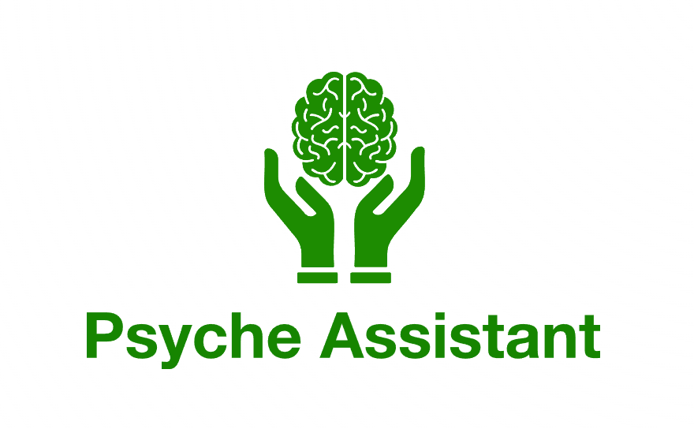
Case Description

Project Summary: Psyche Assistant v2.0
The project will build upon the first iteration of the app ”Psyche Assistant”, programmed by Mads Søndergaard, acting as a proof of concept allowing users (patients/professionals) to track their level of brain fatigue, which currently allows for taking a hard-coded survey for measuring brain fatigue – coded using Kotlin Multiplatform – or rather, Compose Multiplatform (shared UI and Logic) and using a local SQL Delight storage.
This extension will primarily focus on implementing an ”Activity tracker”, using Activities and sub-activities (tasks), as well as user and user-group support (CRUD), for communal tracking and assignation and management of said activities.
This would require an external database (exact tool to be determined), as well as the structuring of new UI/UX, registration and login, for both users and to some extent user groups.
If time permits, the original logic and storage for surveys could then be ported to an external database as well, allowing for more generalized and dynamic serving of different surveys, but implementing CRUD functionality for surveys as well, necessitating an Administrator role to allow and control the creation and publication of vetted surveys only.

Tools and Technologies:
Language: Kotlin Multiplatform (shared UI), specifically Compose Multiplatform (shared UI and Logic)
Database: Currently SQL Delight for local. External tool to be determined.
Platform focus: Android.
Starting point: Psyche Assistant app v0.0.5, as per this commit:
https://github.com/MadSantiak/H6/commit/553a5e5095cf92ff3a6fc5ae50a42746b5ca5bc2

