#Technical Design Document: EthanHalkin_ProgrammingExercise_1

#Name: Ethan Halkin
#Date: August 27, 2026
#Program Description: The program loops until all of the tickets are sold. Then it returns the amount of buyers.

## Function: ticket_sale_loop
Requests how many tickets a buyer wants, then displays how many tickets are left
Loops until sold out

Parameters:
tickets_in_stock (int): The amount of tickets left in stock
tickets_per_buyer (int): The amount of tickets a buyer is allowed to buy
Variables:
buyers (int): The number goes up every time a succesful sale is made
tickets_bought (int): Asks for the amount of tickets bought
Logic:
1. Inits the two main variables
2. Activates while loop that repeats until tickets_in_stock drops to 0
3. Asks for amount of tickets bought and checks if its valid.
4. If valid, then it subtracts from tickets_in_stock and +=1 to accumulator
5. Loop closes upon reaching zero and returns the amount of buyers
Return:
accumulator: The amount of buyers

## Function: display_amount_of_buyers
Displays to user how many buyers bought tickets

Parameters:
amnt_displayed (int): amount of buyers that will be displayed in print statement
Variables:
none
Logic:
1. Formats the parameter into a print statement
Return:
none

#Link to your repository: https://github.com/MadSpinner/COP-2373
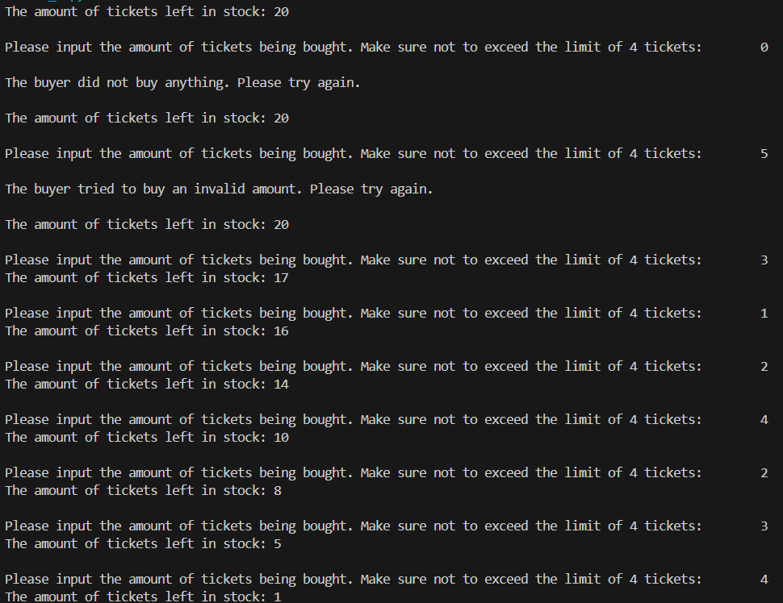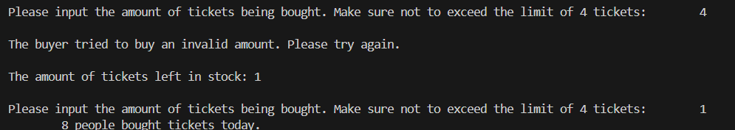
#Comment: I showed off how my program handles invalid inputs inside of the output

