BridgeImport_Visualisation

Guanxu Su

2017/2/4

## Prepare

First, prepare all the packages

if (!require(ggplot2)) install.packages("ggplot2",repos = "http://cran.us.r-project.org")  
if (!require(plyr)) install.packages("plyr",repos = "http://cran.us.r-project.org")  
if (!require(choroplethr)) install.packages("choroplethr",repos =  
 "http://cran.us.r-project.org")  
if (!require(dplyr)) install.packages("dplyr",repos = "http://cran.us.r-project.org")  
if (!require(choroplethrMaps)) install.packages("choroplethrMaps",repos =  
 "http://cran.us.r-project.org")  
if (!require(ggplot2)) install.packages("ggplot2",repos =  
 "http://cran.us.r-project.org")

library(plyr)  
library(choroplethr)

## Warning: package 'choroplethr' was built under R version 3.3.2

## Loading required package: acs

## Loading required package: stringr

## Loading required package: XML

##   
## Attaching package: 'acs'

## The following object is masked from 'package:base':  
##   
## apply

library(dplyr)

##   
## Attaching package: 'dplyr'

## The following object is masked from 'package:acs':  
##   
## combine

## The following objects are masked from 'package:plyr':  
##   
## arrange, count, desc, failwith, id, mutate, rename, summarise,  
## summarize

## The following objects are masked from 'package:stats':  
##   
## filter, lag

## The following objects are masked from 'package:base':  
##   
## intersect, setdiff, setequal, union

library(readr)  
library(data.table)

## Warning: package 'data.table' was built under R version 3.3.2

## -------------------------------------------------------------------------

## data.table + dplyr code now lives in dtplyr.  
## Please library(dtplyr)!

## -------------------------------------------------------------------------

##   
## Attaching package: 'data.table'

## The following objects are masked from 'package:dplyr':  
##   
## between, first, last

library(choroplethrMaps)

## Warning: package 'choroplethrMaps' was built under R version 3.3.2

library(ggplot2)

## Warning: package 'ggplot2' was built under R version 3.3.2

## Download data

step 1: download the bridge data of 2016 into a dataframe, and select some variables of concern. Then convert it into a tibble.

dest = "https://www.fhwa.dot.gov/bridge/nbi/2016/delimited/AK16.txt"  
tmp = fread(dest)   
tmp = as.tbl(tmp)  
classes = sapply(tmp, class)  
  
states= read_csv("http://pages.stat.wisc.edu/~karlrohe/classes/data/stateAbv.txt")  
states=states[-(1:12),]  
states[51,] = c("WashDC", "DC")  
states[52,] = c("Puerto Rico", "PR")  
dat=list()  
dest= rep("", 52)  
for(i in 1:52) dest[i]=paste("https://www.fhwa.dot.gov/bridge/nbi/2016/delimited/",  
 states[i,2],"16.txt", sep = "")   
x16 = ldply(dest, fread, colClasses = classes)   
keep = c("STATE_CODE_001", "STRUCTURE_NUMBER_008", "COUNTY_CODE_003",   
 "LAT_016", "LONG_017", "YEAR_BUILT_027", "FRACTURE_092A",   
 "HISTORY_037", "STRUCTURE_LEN_MT_049")  
M = select(x16,one_of(keep))  
M = as.tbl(M)

## Parsed with column specification:  
## cols(  
## Alberta = col_character(),  
## AB = col_character()  
## )

setp 2: add fips to the tibble and adjust the longitude and latitude by adding decimal point. Then plot the position of the bridges, rule out the out-lying points.

M = mutate(M, fips = STATE_CODE_001*1000+COUNTY_CODE_003)  
min2dec = function(x){  
 n = nchar(x)  
 as.numeric(substr(x,1,n-6)) + as.numeric(substr(x,n-5,n))/6e+05 %>% return  
}  
M = mutate(M,lat = min2dec(LAT_016), lon = -min2dec(LONG_017))  
ggplot(data = M) + geom_point(mapping = aes(y = lat, x = lon))

## Warning: Removed 4029 rows containing missing values (geom_point).

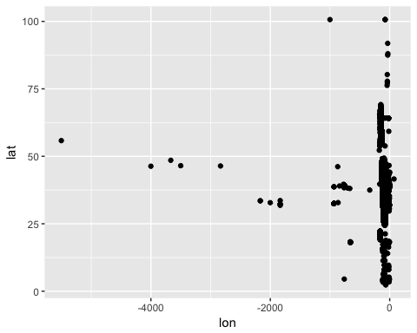

M = M %>% filter(lon>-150,lat<50,lat>24.5)  
ggplot(data = M) + geom_point(mapping = aes(y = lat, x = lon))

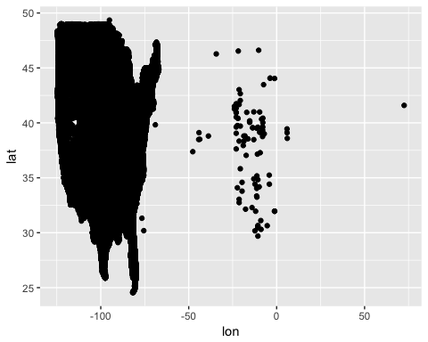

M = M %>% filter(lon< -50)  
ggplot(data = M) + geom_point(mapping = aes(y = lat, x = lon),size=0.1) +  
 ggtitle("BridgeInUS")

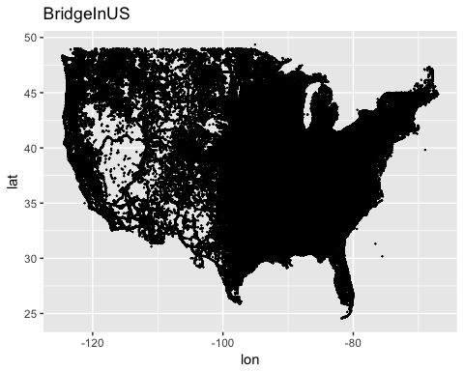

setp 3: Visualization

1. According to "Recording and Coding Guide for the Structure Inventory and Appraisal of ", the variable *HISTORY_037*, historical significance of a bridge, involves a variety of characteristics: the bridge may be a particularly unique example of the history of engineering; the crossing itself might be significant; the bridge might be associated with a historical property or area; or historical significance could be derived from the fact the bridge was associated with significant events or circumstances. Below gives the mean of YEAR_BUILT_027 for each year, which shows that older bridges are more historical significant.

M %>% filter(YEAR_BUILT_027>1900) %>%  
 group_by(YEAR_BUILT_027) %>%   
 summarise(histSign=mean(HISTORY_037)) %>%  
 ggplot(mapping = aes(x=YEAR_BUILT_027,y=histSign)) +  
 geom_point() +  
 ggtitle("Mean of Historical Significance Level")

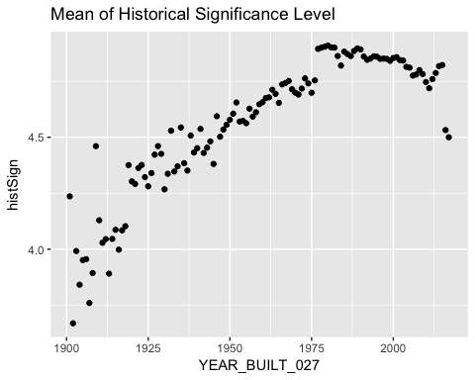

Texas has more historical significant bridges.

a <- c(1,3,4,5,6,7,8,9,10,12,13,14,15,16,17,18,19,20,  
 21,22,23,24,25,26,27,28,29,30,31,32,33,34,35,36,37,38,  
 39,40,41,42,43,44,45,46,47,48,49,50)  
M %>% group_by(fips) %>%  
 summarise(historyBridges = sum(HISTORY_037<=3)) %>%  
 transmute(region = fips, value = historyBridges) %>%   
 county_choropleth(state_zoom = tolower(states$Alberta[a])) +  
 ggtitle("Number Of Historical Bridges")

## Warning in super$initialize(map.df, user.df): Your data.frame contains the  
## following regions which are not mappable: 32025, NA

## Warning in self$bind(): The following regions were missing and are being  
## set to NA: 32510, 31075, 31005, 51620, 48501, 48165, 51735, 31117, 48079

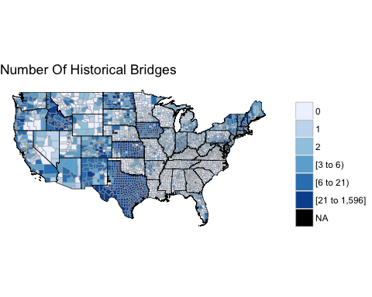

1. The phenomenon in (1) lead me to look at the question that how many bridges are built each year? The bridges are less historical significant maybe result from that more bridges are built in recent years, those historical significant bridges become silent after we take average. Hence, I need to look at the minimum value instead of the mean, and how many bridges are built each year. It turns out that there is almost at least one bridge on the National Register of Historic Places each year execpt some years during the Cold War. There is no bridge on the National Register of Historic Places in 2016 probability because the lastest bulit bridges have not been evaluated.

M %>% filter(YEAR_BUILT_027>1900) %>%  
 group_by(YEAR_BUILT_027) %>%   
 summarise(histSign=min(HISTORY_037)) %>%  
 ggplot(mapping = aes(x=YEAR_BUILT_027,y=histSign)) +  
 geom_point() +  
 ggtitle("Minimum of Historical Significance Level")

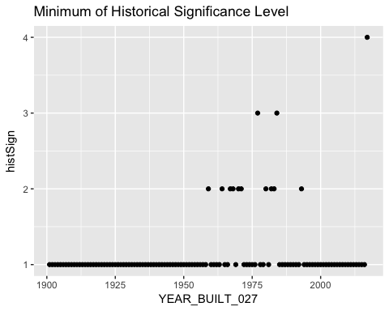

The US began to build more beidges since Franklin D. Roosevelt New Deal, and stopped by the WW2, and rised dramatically right after WW2. The number falls down in recent years, maybe because there are enough bridges and less room for more.

M %>% filter(YEAR_BUILT_027>1900) %>%  
 group_by(YEAR_BUILT_027) %>%   
 summarise(meanLength=sum(STRUCTURE_LEN_MT_049)) %>%  
 ggplot(mapping = aes(x=YEAR_BUILT_027,y=meanLength)) +  
 geom_point() +  
 ggtitle("Total Length Of Bridge Built Each Year From 1900")

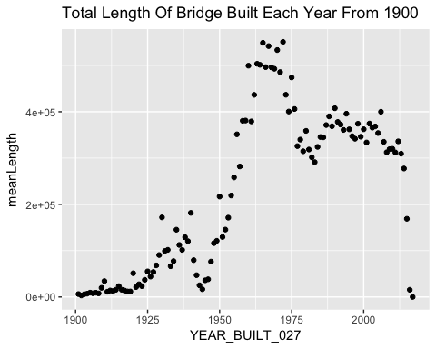

1. I'm curious about which state responsed to Franklin D. Roosevelt New Deal quikly and began to build so many bridges. It turns out that many states did, including New York, Pennsylvania, Connecticut, Massachusetts, New Hampshire, and Vermont. Franklin D. Roosevelt was once governor of New York, which may be the reason that he had more influence in that area.

M %>% mutate(Roosevelt=(YEAR_BUILT_027>1933)&(YEAR_BUILT_027<1939)) %>%   
 group_by(fips) %>%  
 summarise(number = sum(Roosevelt)) %>%  
 transmute(region = fips, value = number) %>%   
 county_choropleth(state_zoom = tolower(states$Alberta[a])) +  
 ggtitle("#Bridges Built Between 1933 and 1939")

## Warning in super$initialize(map.df, user.df): Your data.frame contains the  
## following regions which are not mappable: 32025, NA

## Warning in self$bind(): The following regions were missing and are being  
## set to NA: 32510, 31075, 31005, 51620, 48501, 48165, 51735, 31117, 48079

