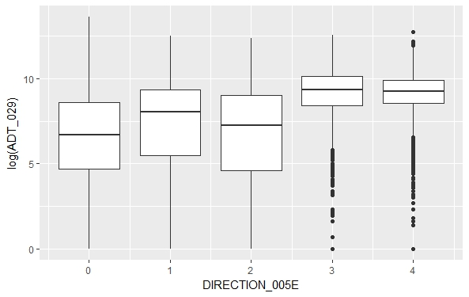

The Boxplot of log(Average Daily Traffic) vs Direction

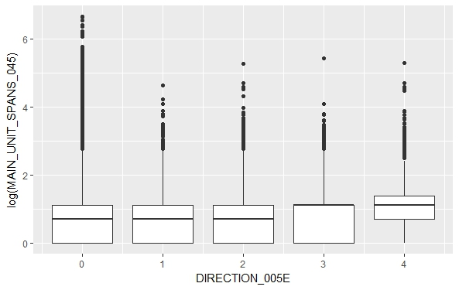

The Boxplot of log(Numbers of Main Unit Spans) VS Direction

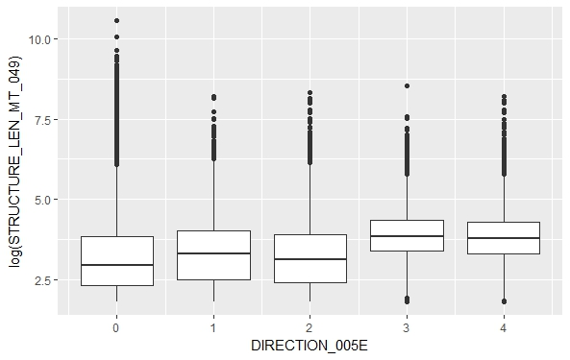

The Boxplot of log(Structure Length) vs Direction

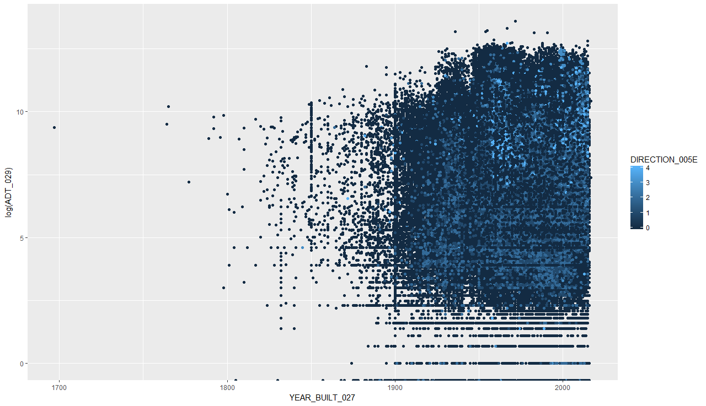

The scatterplot of log(Average Daily Traffic) vs Year

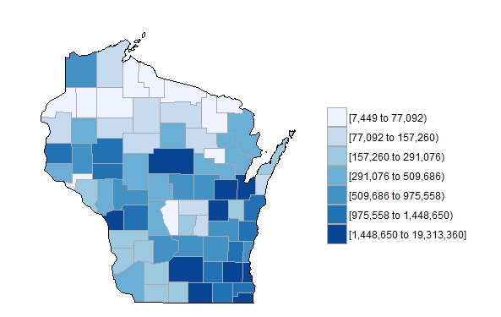

Total Average Daily Traffic in each county with WI map

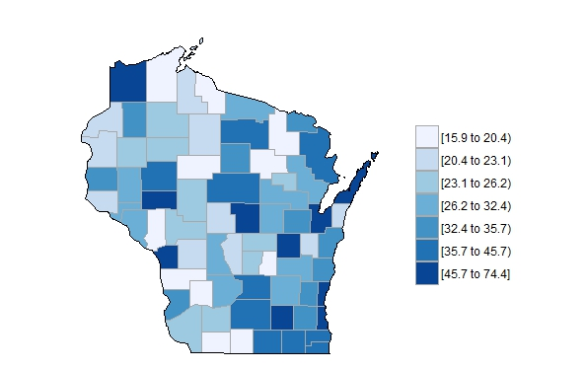

Mean Structure Length in each county with WI map.