CSCI 170Programming Assignment # 4(100 pts)
Due Date: 11/17/2015

- (15 pts) Chapter 7 #6

Sample dialogue:

Test the Vehicle construtors:

No arg constructor: unknown (0 cylinders) owned by nobody
Three arg constructor: Jaguar (12 cylinders) owned by John Doe
Copy constructor: Jaguar (12 cylinders) owned by John Doe

Test the equality tests:

jaguar == otherJaguar ? false
jaguar.equals(otherJaguar) ? true
otherJaguar.equals(jaguar) ? true
jaguar.equals(null) ? false
jaguar.equals(geo) ? false
jaguar.equals("jaguar") ? false

Test the getter and setter methods:

After setters: Geo (2 cylinders) owned by Joe Smith
Geo's manufacturer: Geo
Number of cylinders in a Geo: 2
Geo's owner: Joe Smith

Try changing an owner name:

After changing otherJaguar's owner name:
jaguar: Jaguar (12 cylinders) owned by John Doe
otherJaguar: Jaguar (12 cylinders) owned by Jane Doe
otherJaguar.equals(jaguar): false

Test Trucks:

No arg constructor: unknown (0 cylinders, 0.0 ton load, 0 ton towing capacity) owned by nobody
Five-arg constructor: Ford (8 cylinders, 0.5 ton load, 2 ton towing capacity) owned by John Doe
Create a Vehicle vFord with Manufacuter: "Ford", number of cylinder: 8 Owner: John Doe
Vehicle vFord: Ford (8 cylinders) owned by John Doe

Test equality:

ford.equals(chevy) ? false
ford.equals(otherFord) ? true
ford.equals(vFord) ? false
vFord.equals(ford) ? false
ford.equals(null) ? false

Test getters and setters:

After setting fields, chevy: Chevrolet (6 cylinders, 0.75 ton load, 2 ton towing capacity) owned by nobody
Chevy's towing capacity: 2
Chevy's load capacity: 0.75

Process completed.

- (35 pts) Vectors are math quantities that have both magnitude and direction. This problem involves the use of two-dimensional vectors – here are the math details:
A two-dimensional vector is a directed line segment from the origin of the xy-plane to a point, (a,b). This vector is denoted <a,b>.
Vector addition/subtraction: Two vectors can be added or subtracted resulting in a vector:
<a,b> + <c,d> = <a+c,b+d> or <a,b> – <c,d> = <a–c,b–d>
Vector dot product: Two vectors can be multiplied resulting in a number – this operation is called the dot product of two vectors: <a,b> * <c,d> = ac+bd
Vector/scalar multiplication: A vector can be multiplied by a scalar (a number) resulting in a vector; for any scalar r, <a,b>*r = <ra, rb>
Equality of vectors: <a,b> = <c,d> means a = c and b = d.

you wrote program that modeled complex numbers. Once again, here are the math details:
- A complex number is a number of the form a + bi where a and b are real numbers and i is the imaginary unit, 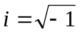.
- Complex number addition/subtraction:
- Complex number multiplication:
- Complex number division: 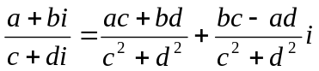
- Equality of complex numbers: 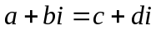 means a = c and b = d.

Notice that both two-dimensional vectors and complex numbers essentially are defined by two numbers. Some of the arithmetic performed on each are the same (addition and subtraction), as is the meaning of equality; the other arithmetic operations are different.

Write a Java program that will model both two-dimensional vectors and complex numbers using derived classes. Start with a base class, Pairs, which should model a pair of floating point numbers and include method addition, subtraction, and equals in addition to appropriate constructors. Then, include two derived classes, Complex and Vect. Both classes will inherit their data from the base Pairs class.

- The Complex class should include methods that perform multiplication and division in addition to appropriate constructors. It should also include overridden methods toString( ). (Note: You can use the Complex class you wrote for the assignment 5 and modify it slightly for this assignment.)
- The Vect class should include methods that perform multiplication in addition to appropriate constructors. Note that it will need two overloaded methods for multiplication – one to handle the dot product and a second to handle scalar multiplication. It should also include overridden methods toString( ).

Note:
- Methods add, subtract, equals() in both Complex and Vect class are inherited from class Pairs. There is no need to rewrite them for those two derived classes.
- You can use Pairs.add(…), or Pairs.subtract(…) to perform Complex and Vect addition or subtraction, but Pairs.add(…) or Pairs.subtract(…) will return an object of Pairs, you need to construct a Complex or Vect object based on the data stored in the Pairs object returned by Pairs.add(…) or Pairs.subtract(...).

To exercise your new collection of classes, use this main program:
public static void main(String[] args)
{
int sel;
do {
System.out.println("Select an option - (1) perform complex number actions ");
System.out.println(" (2) perform vector actions ");
System.out.println(" (3) exit ");
sel = keybrd.nextInt();
if(sel == 1)
cactions();
else if(sel == 2)
vactions();
else if (sel == 3)
System.out.println("Bye...");
else
System.out.println("Invalid input - try again");
} while (sel != 3);
}
You will need to write the static methods cactions and vactions – here is what each does:
- cactions – this function contains an array of 26 complex numbers and will repeatedly prompt the user to select one of four options:
  - Enter a complex number
  - Display a complex number
  - Perform arithmetic or equality comparisons of complex numbers
  - Exit the function
When the user selects options 1 or 2, the function asks where the number is to be stored or read from in the array, and then completes the selected action using that array location.

When the user selects option 3, the function will ask for the operation to be used. If the
operation selected is an arithmetic operator, the function will next ask for the array locations of the numbers to be combined using the operator, as well as the array location of where the result should be stored.

If the operation selected is the is-equal-to operator, the function will only ask for the array locations of the numbers to be compared and will display the result of the comparison.

In all cases, the chosen operation is then performed.

- vactions – this function contains an array of 26 vectors and will repeatedly prompt the user to select one of four options:
- Enter a vector
- Display a vector
- Display a scalar
- Perform arithmetic or equality comparisons of vectors
- Exit the function
When the user selects options 1 or 2, the function asks where the vector is to be stored or read from in the array, and then completes the selected action using that array location.

When the user selects option 3, the function will display the value of a scalar variable that is used to hold the result of a dot product, or the previous value of a scalar used to perform a vector-scalar product.

When the user selects option 4, the function will ask for the operation to be used.

  - If the operation selected is addition or subtraction, the function will next ask for the array locations of the vectors to be combined using the operator, as well as the array location of where the result should be stored.

  - If the operation selected is dot product, the function will next ask for the array locations of the vectors to be combined using the operator, but will not ask for the result location, but will store the result in the scalar variable.

  - If the operator selected is vector-scalar multiplication, the function will ask for the array location of the vector to be multiplied and the scalar value and the location of the result vector.

  - In all cases, the chosen operation is then performed.

A sample dialogue:
Select an option - (1) perform complex number actions
(2) perform vector actions
(3) exit
1
Select an option:
(1) Enter a complex number
(2) Display a complex number
(3) Perform arithmetic or equality check
(4) Exit
1
Enter real:
1
Enter imaginary:
2
Where do you want to store this (enter 1-26):
1
Select an option:
(1) Enter a complex number
(2) Display a complex number
(3) Perform arithmetic or equality check
(4) Exit
2
Which one do you want to display (enter 1-26):
1
1.0 + 2.0 i
Select an option:
(1) Enter a complex number
(2) Display a complex number
(3) Perform arithmetic or equality check
(4) Exit
1
Enter real:
3
Enter imaginary:
4
Where do you want to store this (enter 1-26):
2
Select an option:
(1) Enter a complex number
(2) Display a complex number
(3) Perform arithmetic or equality check
(4) Exit
3
Enter an operation: + - * / =
+
Enter first number (enter 1-26):
1
Enter second number (enter 1-26):
2
Enter result location (enter 1-26):
3
Select an option:
(1) Enter a complex number
(2) Display a complex number
(3) Perform arithmetic or equality check
(4) Exit
2
Which one do you want to display (enter 1-26):
3
4.0 + 6.0 i
Select an option:
(1) Enter a complex number
(2) Display a complex number
(3) Perform arithmetic or equality check
(4) Exit
3
Enter an operation: + - * / =
-
Enter first number (enter 1-26):
1
Enter second number (enter 1-26):
2
Enter result location (enter 1-26):
3
Select an option:
(1) Enter a complex number
(2) Display a complex number
(3) Perform arithmetic or equality check
(4) Exit
2
Which one do you want to display (enter 1-26):
3
-2.0 + -2.0 i
Select an option:
(1) Enter a complex number
(2) Display a complex number
(3) Perform arithmetic or equality check
(4) Exit
3
Enter an operation: + - * / =
*
Enter first number (enter 1-26):
1
Enter second number (enter 1-26):
2
Enter result location (enter 1-26):
3
Select an option:
(1) Enter a complex number
(2) Display a complex number
(3) Perform arithmetic or equality check
(4) Exit
2
Which one do you want to display (enter 1-26):
3
-5.0 + 10.0 i
Select an option:
(1) Enter a complex number
(2) Display a complex number
(3) Perform arithmetic or equality check
(4) Exit
3
Enter an operation: + - * / =
/
Enter first number (enter 1-26):
1
Enter second number (enter 1-26):
2
Enter result location (enter 1-26):
3
Select an option:
(1) Enter a complex number
(2) Display a complex number
(3) Perform arithmetic or equality check
(4) Exit
2
Which one do you want to display (enter 1-26):
3
0.44 + 0.08 i
Select an option:
(1) Enter a complex number
(2) Display a complex number
(3) Perform arithmetic or equality check
(4) Exit
3
Enter an operation: + - * / =
=
Enter first number (enter 1-26):
1
Enter second number (enter 1-26):
2
1.0 + 2.0 i does not equal 3.0 + 4.0 i
Select an option:
(1) Enter a complex number
(2) Display a complex number
(3) Perform arithmetic or equality check
(4) Exit
4
Bye...
Select an option - (1) perform complex number actions
(2) perform vector actions
(3) exit
2
Select an option:
(1) Enter a vector
(2) Display a vector
(3) Display scalar
(4) Perform arithmetic or equality check
(5) Exit
1
Enter first number:
1
Enter second number:
2
Where do you want to store this (enter 1-26):
1
Select an option:
(1) Enter a vector
(2) Display a vector
(3) Display scalar
(4) Perform arithmetic or equality check
(5) Exit
2
Which one do you want to display (enter 1-26):
1
<1.0 , 2.0>
Select an option:
(1) Enter a vector
(2) Display a vector
(3) Display scalar
(4) Perform arithmetic or equality check
(5) Exit
1
Enter first number:
3
Enter second number:
4
Where do you want to store this (enter 1-26):
2
Select an option:
(1) Enter a vector
(2) Display a vector
(3) Display scalar
(4) Perform arithmetic or equality check
(5) Exit
2
Which one do you want to display (enter 1-26):
2
<3.0 , 4.0>
Select an option:
(1) Enter a vector
(2) Display a vector
(3) Display scalar
(4) Perform arithmetic or equality check
(5) Exit
4
Enter an operation: + - . (dot prod) * (scalar prod) =
+
Enter first vector (enter 1-26):
1
Enter second vector (enter 1-26):
2
Enter result location (enter 1-26):
3
Select an option:
(1) Enter a vector
(2) Display a vector
(3) Display scalar
(4) Perform arithmetic or equality check
(5) Exit
2
Which one do you want to display (enter 1-26):
3
<4.0 , 6.0>
Select an option:
(1) Enter a vector
(2) Display a vector
(3) Display scalar
(4) Perform arithmetic or equality check
(5) Exit
4
Enter an operation: + - . (dot prod) * (scalar prod) =
-
Enter first vector (enter 1-26):
1
Enter second vector (enter 1-26):
2
Enter result location (enter 1-26):
3
Select an option:
(1) Enter a vector
(2) Display a vector
(3) Display scalar
(4) Perform arithmetic or equality check
(5) Exit
2
Which one do you want to display (enter 1-26):
3
<-2.0 , -2.0>
Select an option:
(1) Enter a vector
(2) Display a vector
(3) Display scalar
(4) Perform arithmetic or equality check
(5) Exit
4
Enter an operation: + - . (dot prod) * (scalar prod) =
.
Enter first vector (enter 1-26):
1
Enter second vector (enter 1-26):
2
Select an option:
(1) Enter a vector
(2) Display a vector
(3) Display scalar
(4) Perform arithmetic or equality check
(5) Exit
3
Scalar = 11.0
Select an option:
(1) Enter a vector
(2) Display a vector
(3) Display scalar
(4) Perform arithmetic or equality check
(5) Exit
4
Enter an operation: + - . (dot prod) * (scalar prod) =
*
Enter first vector (enter 1-26):
1
Enter scalar to multiply:
13
Enter result location (enter 1-26):
3
Select an option:
(1) Enter a vector
(2) Display a vector
(3) Display scalar
(4) Perform arithmetic or equality check
(5) Exit
2
Which one do you want to display (enter 1-26):
3
<13.0 , 26.0>
Select an option:
(1) Enter a vector
(2) Display a vector
(3) Display scalar
(4) Perform arithmetic or equality check
(5) Exit
4
Enter an operation: + - . (dot prod) * (scalar prod) =
=
Enter first vector (enter 1-26):
1
Enter second vector (enter 1-26):
2
<13.0 , 26.0> does not equal <3.0 , 4.0>
Select an option:
(1) Enter a vector
(2) Display a vector
(3) Display scalar
(4) Perform arithmetic or equality check
(5) Exit
5
Bye...
Select an option - (1) perform complex number actions
(2) perform vector actions
(3) exit
3
Bye...

Process completed.

- (25 pts) Chap 8 #6

sample dialogue:

Testing the draw() methods:
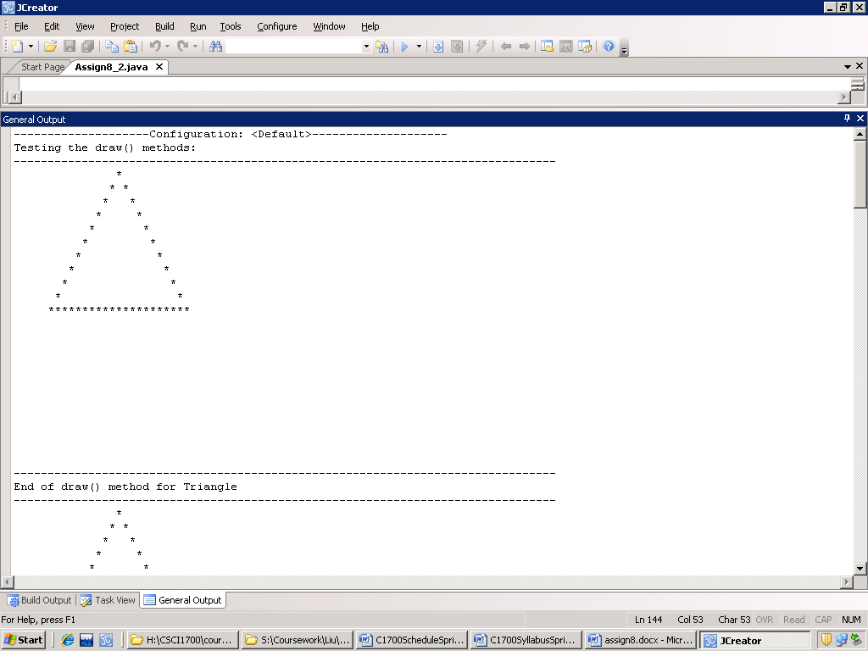
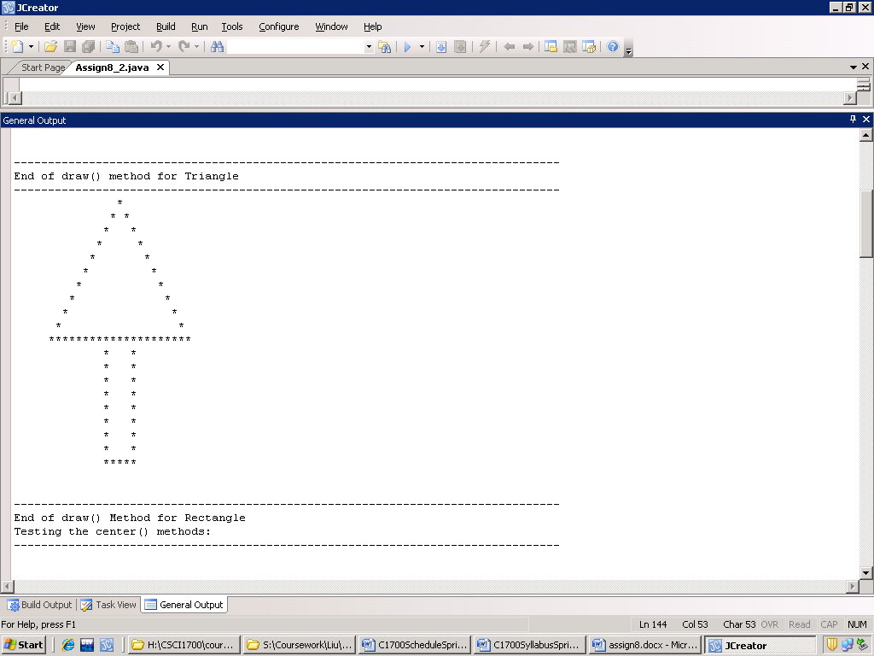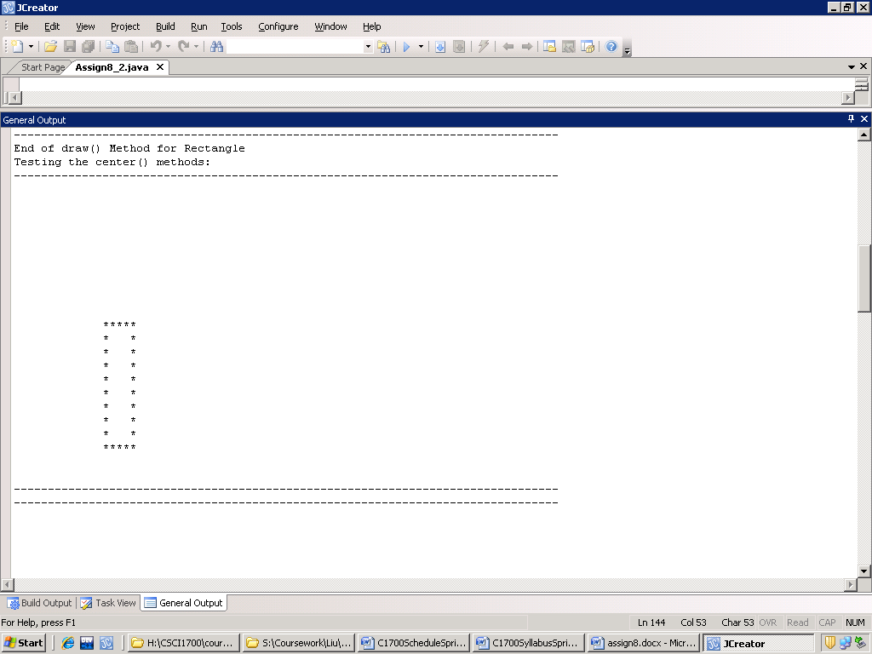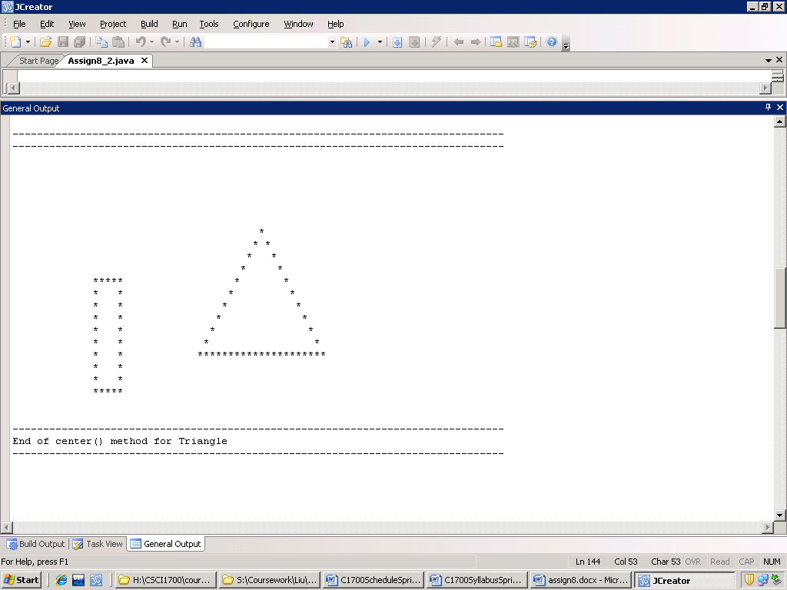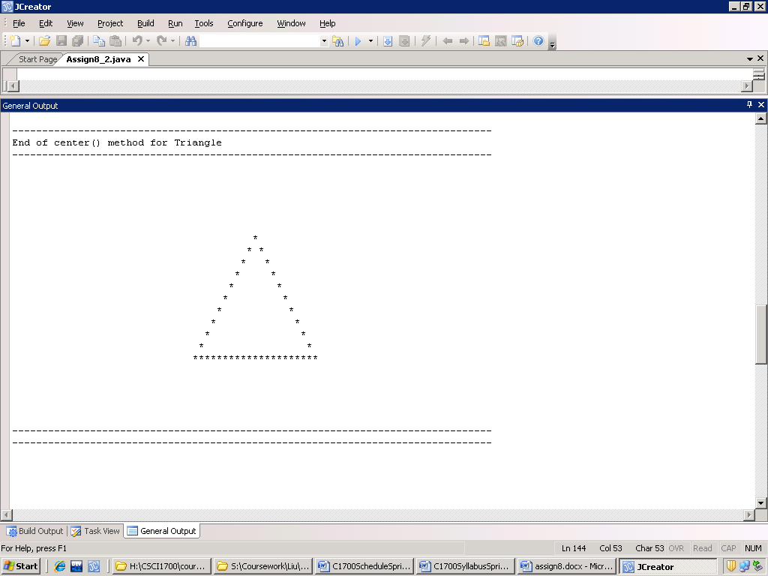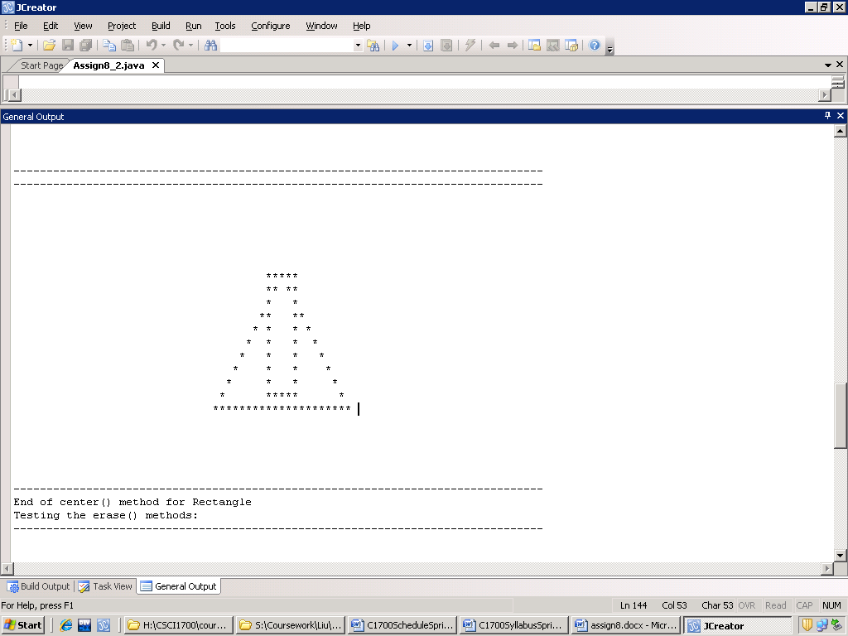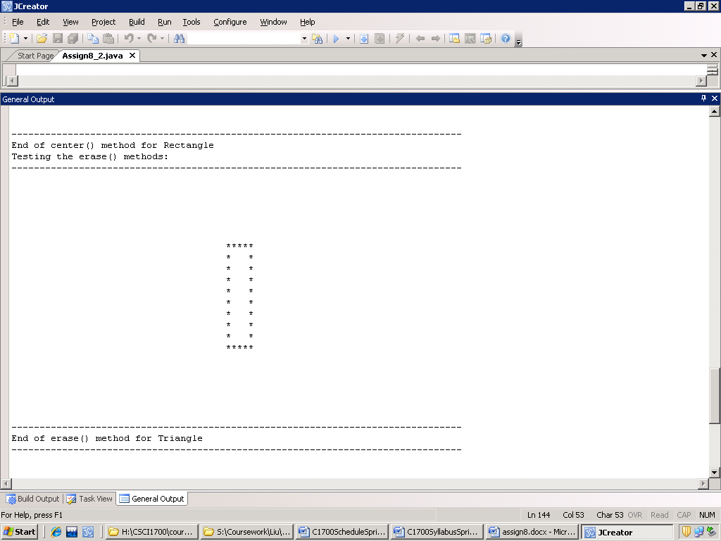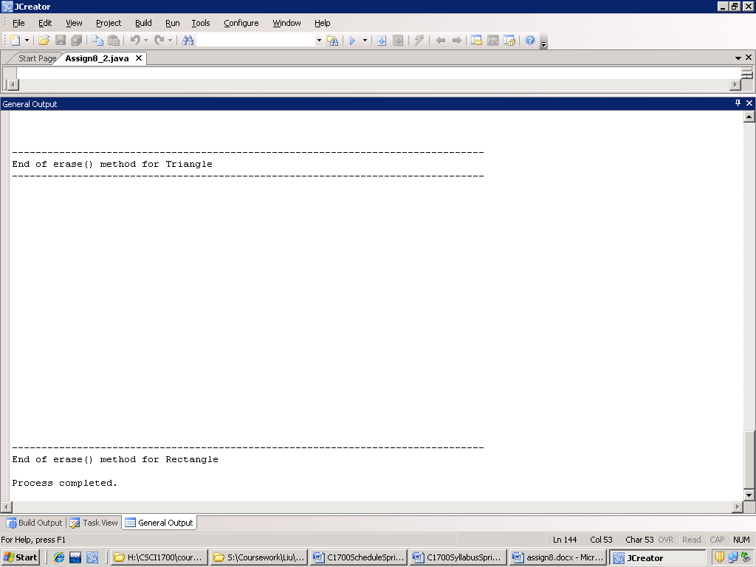

- (25 pts) Write a Java program that uses abstract methods to input, calculate, and display some quantities associated with a variety of 2- and 3-dimensional objects. Design an abstract base class Shape from which you will derive classes Rectangle, Circle, Triangle, Box, Can, Cone, and Ball. The class Shape should contain abstract methods display, getDimensions, area, perimeter, and volume. For each of the derived classes, write methods display, getDimensions, area, perimeter, and volume that will do the following:
- display - output the type and dimensions for an object of the class.
- getDimensions - get the dimensions for an object of the class.
- perimeter - Calculate and display the perimeter of an object of a 2-dimensional shape class; do nothing for an object of a 3-dimensional shape class.
- area - Calculate and display the area of an object of a 2-dimensional shape class; calculate and display the surface area for an object of a 3-dimensional shape class.
- volume - Calculate and display the volume of an object of a 3-dimensional shape class; do nothing for an object of a 2-dimensional shape class.
Include appropriate constructors and any other methods that you think are necessary.

Write a program driver that will allocate an array of 20 elements of class type Shape and then repeatedly prompt the user, up to a maximum 20 times, to enter a shape type, create an object for an appropriate shape type and store the object in the array, and then prompt for and read the appropriate dimensions for the shape. After the input of shapes is complete, the program should then loop through the array elements and display the shape type, dimensions, area, perimeter and/or volume for each of the input shape objects.

Formulas for the cone calculations:
Dimensions: Height and base radius (h and r); Surface area = 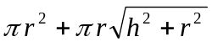; Volume = 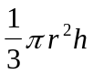.

Formulas for the area of a triangle based on three sides of the triangle:

Area = sqrt(s*(s-a)*(s-b)*(s-c)), where a, b, c are three sides, s = 0.5*(a+b +c)

If you need any other formulas for the other shapes, let me know.

a sample dialogue (user input is in bold):

It is time to enter your shape selection and dimensions.
Enter the number of the shape type:
1 - Rectangle
2 - Circle
3 - Triangle
4 - Box
5 - Can
6 - Cone
7 - Ball
=>
1
Input for Rectangle - enter length and width (separated by space):
1 3

Select another shape? (y or n):
y
It is time to enter your shape selection and dimensions.
Enter the number of the shape type:
1 - Rectangle
2 - Circle
3 - Triangle
4 - Box
5 - Can
6 - Cone
7 - Ball
=>
4
Input for Box - enter length, width, and height (separated by space):
5 2 1

Select another shape? (y or n):
y
It is time to enter your shape selection and dimensions.
Enter the number of the shape type:
1 - Rectangle
2 - Circle
3 - Triangle
4 - Box
5 - Can
6 - Cone
7 - Ball
=>
7
Input for Ball - enter radius:
3

Select another shape? (y or n):
n
Next, a display of your selected shapes, dimensions. and other data

Shape = Rectangle Length = 1.0 Width = 3.0
Area = 3.0
Perimeter = 8.0

Shape = Box Length = 5.0 Width = 2.0
Height = 1.0
Surface area = 34.0
Volume = 10.0

Shape = Ball Radius = 3.0
Surface area = 113.097335544
Volume = 113.097335544

End of the program

Process completed.

What you need to turn in:
- Source code listing: A printed copy of the source code for each problem. Remember to include your name in a comment at the top of your source code. Be sure to follow the “Code Style Guidelines” specified in class.
- Source code files: E-mail me a copy of your source code. Send individual.java files as attachments.
- Working in Pairs: If you want to work with one other student in our class on this assignment, this is acceptable provided that both members of the pair make a contribution to the solution. If you decide to work in a pair, turn in only one copy of the solution – clearly identify the name of each pair member on everything that you turn in.
- Late Assignments: Please note this information given in the “Assignment Information and Guidelines” handout regarding assignments that are turned in late:
“Assignments are due by the end of the day on the specified due date (both the paper copies and the e-mail copies). If you wish to turn in the paper copy of an assignment after class, place them under my office door. Assignments turned in late will be assessed a 20% penalty per class day late.”

