[CS Casual Academic Remuneration and Timesheet Approval Management System]

Progress Report



Information Technology Capstone Project

COMP5703

1. Ziyue Yi (490259641)
2. Yuhao Shi (480454777)
3. Tianyang Yu (500430235)
4. Ziyi Zhang (460446206)

Table of Contents

**Table of Contents 1**

1. Progress Status 2

2. Roles & Responsibilities 3

3. Individual Achievements 3

4. Group Collaboration 4

# Progress Status

|  |  |
| --- | --- |
| **Project Name** | CS Casual Academic Remuneration and Timesheet Approval Management System |
| **Project Start Date** | August 26, 2020 |
| **Project Manager** | Priyanka Magotra /Masahiro Takatsuka/  John Stavrakakis/Xi Wu |
| **Project Name** | CS Casual Academic Remuneration and Timesheet Approval Management System |
| **Project Description** | The aim of this project is to create a portal that manages remuneration and timesheet approval of casual academics for School of Computer Science. |

|  |  |  |
| --- | --- | --- |
| **Project Status Report** | #Week 2 report | Date: September 12, 2020 |

|  |  |  |
| --- | --- | --- |
| **Status Item** | **Status up to last week** | **Planned for this week** |
| **Major deliverables** | 1. Analyze user requirements and design UML use case diagram and class diagram.  2. Build the development environment. Instal php, Apache , MySQL, and other develop IDE.  3. Install php framework Laravel | 1. Design and build the index page and login system for our website.  2. Create the database and create some example data. |
| **Planned delivery date** | September 12, 2020 | September 19, 2020 |
| **Major issues** | 1. Design the database schema | 1. Build the index page and login system.  2. Create our database. |
| **Major risks** | User requirement have not yet been determined, and the structure of the database needs to be relatively flexible to face the needs that may change in the future. | 1.The connection between website page and backend control.  2. The connection between backend and database.  3. The migration of database operation commands from backend to database. |
| **External dependencies** | Wechat | Wechat |
| **Estimated effort (hr)** | 18 | 18 |
| **Recorded effort (hr)** | 18 |  |
| **Status (R, Y, G)** | G | G |

# Roles & Responsibilities

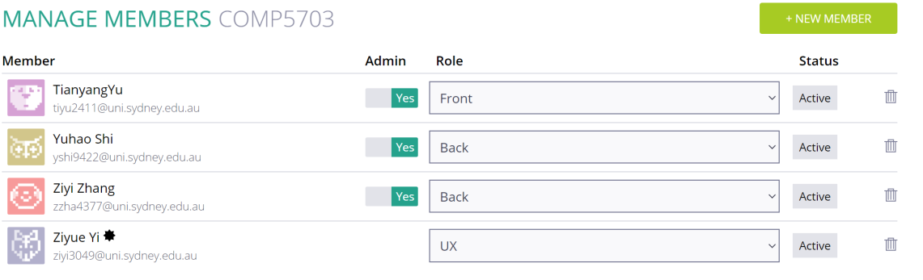

*Figure 1. Roles on Taiga.io*

I am mainly focusing on back-end development. I am responsible for designing the database schema and the back-end functions to meet the requirements of the project. I will also be responsible for testing the developed features to check their integrity and correctness.

Tianyang Yu is responsible for the front-end design. He designed the login page and he is going to design other pages in the future. Ziyue Yi is responsible for the project management, he set up out meetings, made the whole project plan and gathered the clients’ requirements. Yuhao Shi is responsible for the back-end design. He is mainly focusing on the database design. He is going to handle the data within our project system.

# Individual Achievements

This week we started setting up the development environment. I installed PHP, Apache server, MySQL database, Laravel framework, and other IDE such as Navicat, Webstorm, Github Desktop.



*Figure 2. Installed Software*

I have been searching for the JavaScript libraries for the front-end to realize some of the features we are going to need. I found SweetAlert2.js, datatable.js, Bootstrap-notify.js, Bootstrap-datepicker.js, and etc. And I included these JavaScript libraries into our project.

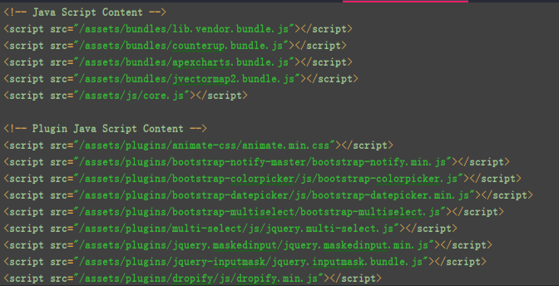

*Figure 3.JavaScript Libraries*

# Group Collaboration

In this week, we also had two group meetings and all the group members were present. In the first meeting we met with out tutor Mr. Johan, we reported our current progress and plan for the next week. And Mr. Johan answered some of our questions.

After the meeting with our tutor, we had a meeting with our clients John Stavrakakis and Xi Wu. John explained the detailed work process of the current timesheet management in our university. And cleared many of our confusions about the timesheet management system.

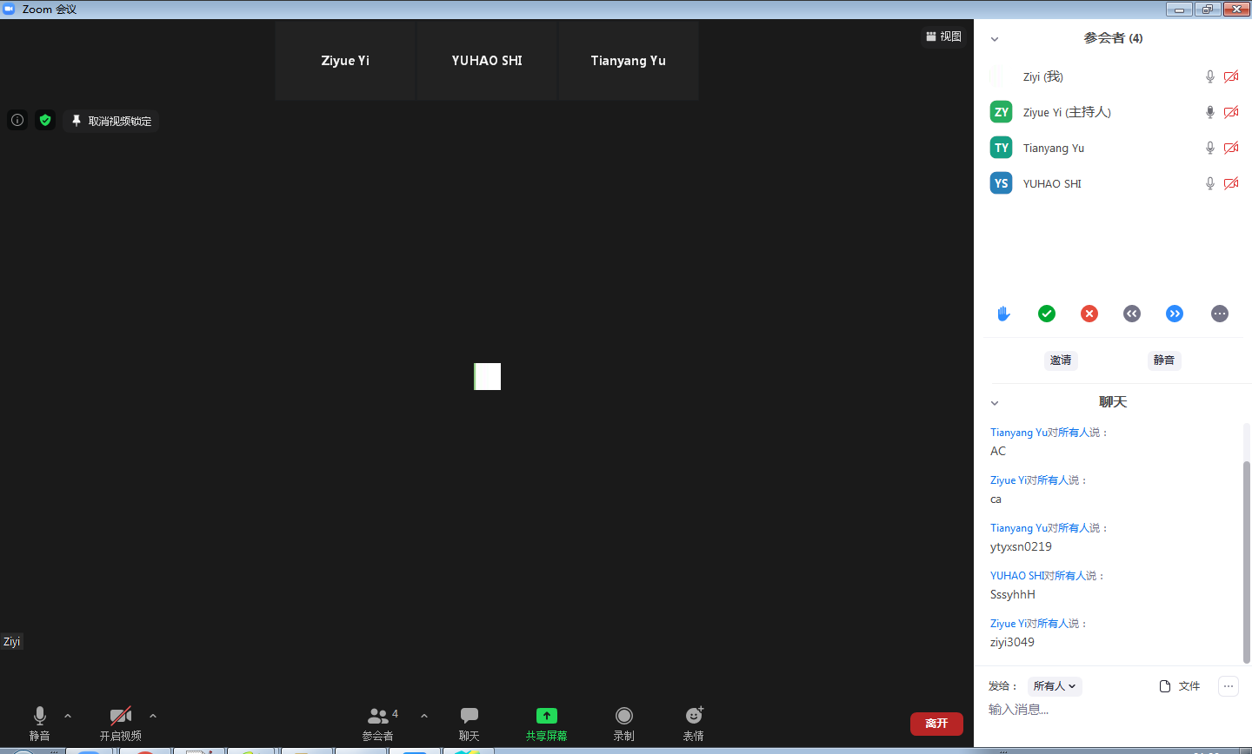

*Figure 4. Meeting with Group Members*

At the rest time of the week, we had two meetings and discussed about our plan for next week, the requirements about our project and the development process of the project. We discussed about how we are going to store our data into the database and how the functions will do when certain under some special circumstances.