**“SleepSense: Unveiling the secrets of sleep and Lifestyle “**

**Using Data Analysis**

Prepared in the partial fulfilment of the Summer Internship

Program on Data Analysis



Under the Guidance Of:

Ms. K. Narmada Mani,APSSDC

Ms. K.Meenakshi,APSSDC

Submitted by:

M. NagaCharitavya

AP21110010027

**ACKNOWLEDGEMENT**

I would like to express my heartfelt gratitude to all those who have contributed to the successful completion of my summer internship project at Andhra Pradesh Skill Development Corporation (APSSDC). This opportunity has been an enriching and transformative experience for me, and I am truly thankful for the support, guidance, and encouragement I have received along the way.

First and foremost, I sincerely thank Ms. K. Meenakshi and Ms. K. Narmada Mani, my supervisors, and mentors, for providing me with valuable insights, constant guidance, and unwavering support throughout the internship. Their expertise and encouragement have been instrumental in shaping the direction of this project.

I would like to thank the entire team at Andhra Pradesh Skill Development Corporation (APSSDC) for fostering a collaborative and innovative environment. The camaraderie, knowledge sharing, and feedback I received from my colleagues significantly contributed to the development and success of this project.

In conclusion, I am honored to have been a part of this internship program, and I look forward to leveraging the skills and knowledge gained to contribute positively to future endeavors.

Thank You.

Sincerely,

Madala.NagaCharitavya

AP21110010027

SRM University AP

nagacharitavya_m@srmap.edu.in

**TABLE OF CONTENTS**

**Abstract 4**

**Introduction 5**

**Methodology 6,7**

**System Requirements 8**

**Uses Of Data Analysis Library 9,10**

**Uses Of Data Set 11,12**

**Visualization 13-21**

**Advantages 22,23**

**Conclusion 24**

**Reference website names or links 25**

**Abstract:**

The "SleepSense: Unveiling the Secrets of Sleep and Lifestyle" dataset provides comprehensive individual data, revealing insights into health attributes, lifestyle choices, and sleep patterns. Columns cover person ID, gender, age, occupation, sleep metrics, physical activity, stress levels, BMI, blood pressure, heart rate, daily steps, and sleep disorder status.

Researchers analyze health and lifestyle's interplay. Sleep duration, quality, physical activity, and stress relate to overall health outcomes.

The dataset uncovers sleep disorders across demographics, revealing trends and risk factors. Attributes like occupation, age, and gender offer insights into population segments facing sleep-related challenges.

Enriched with demographics and health metrics, "SleepSense" supports exploratory analyses, insights for health interventions, and predictive models identifying at-risk individuals.

In conclusion, the "SleepSense" dataset empowers researchers to comprehend connections between lifestyle choices, health markers, and sleep behaviors in health sciences, sleep medicine, and public health policy.

**Introduction:**

Sleep is a fundamental biological process that plays a pivotal role in maintaining overall health and well-being. The quality and quantity of sleep significantly impact various aspects of our lives, including cognitive function, emotional resilience, physical health, and productivity. However, in today's fast-paced and technology-driven world, achieving restful and rejuvenating sleep has become a challenge for many individuals.

"SleepSense: Unveiling the Secrets of Sleep and Lifestyle" is an extensive documentation that delves into the intricate relationship between lifestyle choices and sleep patterns. This project seeks to shed light on how various lifestyle factors, such as nutrition, physical activity, stress management, and technology usage, influence the sleep-wake cycle and, in turn, how sleep behaviors adapt to meet the demands of modern living.

The project's core objective is to provide evidence-based insights and practical recommendations to optimize sleep health and promote overall well-being. By analyzing existing research and leveraging data analysis libraries, "SleepSense" endeavors to empower individuals with the knowledge and tools needed to make informed decisions about their sleep habits and lifestyle choices.

Through longitudinal studies, comparative analyses, and interventional approaches, this documentation aims to uncover critical patterns and correlations between lifestyle choices and sleep quality. By recognizing the significance of individual differences in sleep needs, chronotypes, and adaptability, "SleepSense" advocates for personalized sleep strategies to achieve better sleep outcomes.

In the subsequent sections, we will explore the impact of lifestyle on sleep quality, the importance of stress management in promoting restful sleep, and the role of technology in influencing sleep behaviors. Additionally, "SleepSense" will investigate cross-cultural sleep patterns and highlight the societal implications of improved sleep health.

With its evidence-based approach and comprehensive insights, "SleepSense: Unveiling the Secrets of Sleep and Lifestyle" seeks to contribute to the field of sleep science and empower individuals and healthcare professionals alike in their pursuit of promoting better sleep and overall well-being. By understanding the secrets of sleep and lifestyle, we can unlock the potential for a healthier and more fulfilling life.

**Methodology:**

The project "SleepSense: Unveiling the Secrets of Sleep and Lifestyle" aims to explore the relationships between sleep patterns, lifestyle choices, and health attributes using a comprehensive analysis pipeline. The dataset used for this project is sourced from Kaggle and focuses on various aspects related to sleep, health, and lifestyle. Here's the step-by-step methodology followed in the project:

1. Dataset Loading

The project begins by loading the SleepSense dataset from a CSV file using the pandas library. This dataset contains information about individuals' sleep habits, health metrics, and lifestyle choices.

2. Applying Basic Functions

Basic functions are applied to the dataset to gain a better understanding of its content. The `head()` and `tail()` functions are used to display the initial and final rows of the dataset. The `info()` function provides information about the columns' data types and null values. The `shape` attribute gives the dimensions of the dataset, and the `columns` attribute lists the column names.

3. Data Cleaning

Data cleaning involves handling missing or erroneous data. The project showcases methods such as `isnull()`, `notnull()`, `dropna()`, and `fillna()` to identify, remove, or fill in missing values. This step ensures that the data is prepared for meaningful analysis.

4. Data Filtering and Aggregations

Data is filtered and aggregated to extract insights. For example, the project calculates the average age of individuals, identifies the occupation with the highest average physical activity level, and determines the top individuals with the highest quality of sleep. Aggregation functions like mean, median, and maximum are demonstrated.

5. Grouping and Sorting

The dataset is grouped using the `groupby()` function to analyze specific categories. Sorting is performed to arrange the data based on specific columns, allowing for better visualization of trends and patterns.

6. Data Visualization

Visualization is a crucial aspect of the project. Matplotlib and Seaborn libraries are used to create various types of plots, including bar charts, scatter plots, pie charts, line plots, box plots, violin plots, and more. These visualizations help in representing and understanding relationships between different attributes in the dataset.

7. Exploratory Data Analysis (EDA)

EDA is conducted through visualizations to uncover insights and trends in the data. Different plots help reveal patterns, correlations, and distributions, aiding in forming hypotheses and generating meaningful insights.

8. Conclusion

The methodology concludes with a comprehensive analysis of the SleepSense dataset. Insights derived from visualizations and analytical techniques are summarized to provide a holistic understanding of the relationships between sleep, lifestyle, and health.

By following this methodology, the project "SleepSense: Unveiling the Secrets of Sleep and Lifestyle" provides a practical example of how to approach and analyze datasets related to sleep habits and lifestyle choices. This project empowers researchers, health professionals, and data enthusiasts to gain valuable insights into the complex interplay between sleep patterns, lifestyle decisions, and health attributes.

**System Requirements:**

**Software:**

* Excel Sheet (For CSV Data)
* Jupyter Notebook (For Analysing Data and Visualising Data)

**Hardware:**

* CPU (Intel Core i5 or more)
* Memory (8Gb Ram)
* Storage (500Gb Internal Storage)
* Edition-Windows 11
* Version-22H2 or above

**Uses Of Data Analysis Library:**

I have used this four types of data analysis library in my SleepSense: Unveiling the secrets of sleep and lifestyle:

1. import pandas as pd

2. import numpy as np

3. import matplotlib.pyplot as plt

4. import seaborn as sns

The data analysis library, what I have used in my project. It consisting of Pandas, NumPy, Matplotlib, and Seaborn, offers a powerful toolkit for processing, analyzing, and visualizing data. Here are some common uses of each library in the data analysis process:

**1.** **Pandas:**

- Data Loading: Pandas allows users to import data from various file formats like CSV, Excel, SQL databases, etc.

- Data Cleaning: Pandas provides functions to handle missing data, remove duplicates, and handle inconsistencies.

- Data Manipulation: It enables filtering, sorting, and transforming data, making it easier to extract relevant information.

- Data Aggregation: Pandas facilitates grouping and aggregation operations to summarize data based on specific criteria.

- Merging and Joining: Pandas allows merging multiple datasets based on common columns or indices.

**2. NumPy:**

- Numerical Computations: NumPy provides support for arrays and matrices, enabling efficient numerical computations.

- Mathematical Operations: NumPy includes functions for basic arithmetic, statistical calculations, and linear algebra.

- Broadcasting: It allows performing operations on arrays with different shapes, broadcasting the smaller array to match the larger one.

- Array Indexing and Slicing: NumPy provides powerful indexing and slicing capabilities to access and manipulate array elements.

**3. Matplotlib:**

- Data Visualization: Matplotlib is widely used for creating static, interactive, and publication-quality plots and charts.

- Line Plots: It can generate line plots to visualize trends and relationships in data over time or continuous variables.

- Scatter Plots: Matplotlib is ideal for creating scatter plots to explore relationships between two numerical variables.

- Bar Charts: It enables the creation of bar charts to compare categorical data or show frequency distributions.

- Histograms: Matplotlib is useful for plotting histograms to visualize data distributions and identify patterns.

**4. Seaborn:**

- Enhanced Visualizations: Seaborn builds upon Matplotlib, offering aesthetically pleasing statistical visualizations.

- Heatmaps: Seaborn can create heatmaps to represent the magnitude of numerical data in a 2D format.

- Pair Plots: It facilitates the generation of pair plots for exploring relationships between multiple variables.

- Categorical Plots: Seaborn supports various categorical plots like bar plots, count plots, and box plots for categorical data exploration.

- Regression Plots: Seaborn can plot regression models with confidence intervals to visualize linear relationships.

The data analysis library's collective power lies in their seamless integration, allowing data analysts and scientists to efficiently process data, gain insights, and communicate results through visually appealing and informative plots and charts.

**Uses Of Data Set:**

Based on the given dataset, we have this uses:

1. Person ID: Unique identifier for each person.

2. Gender: The gender of the individual (Male/Female).

3. Age: Age of the person.

4. Occupation: The profession or job of the individual.

5. Sleep Duration: Duration of sleep in hours.

6. Quality of Sleep: Subjective rating of sleep quality (usually on a scale).

7. Physical Activity Level: Level of physical activity (possibly measured in minutes or hours).

8. Stress Level: Subjective rating of stress level (possibly on a scale).

9. BMI Category: Body Mass Index category of the person (Normal, Overweight, Obese).

10. Blood Pressure: Blood pressure readings (Systolic/Diastolic).

11. Heart Rate: Heart rate (beats per minute).

12. Daily Steps: Number of steps taken daily.

13. SleepDisorder: Any sleep disorder the person may have (Sleep Apnea, Insomnia, None).

**Visualization:**

Bar Chart-

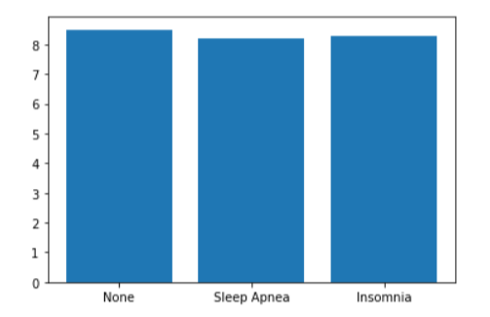

Horizontal Bar Graph-

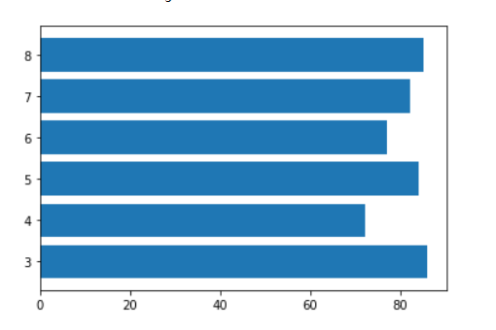

Scatterplot-

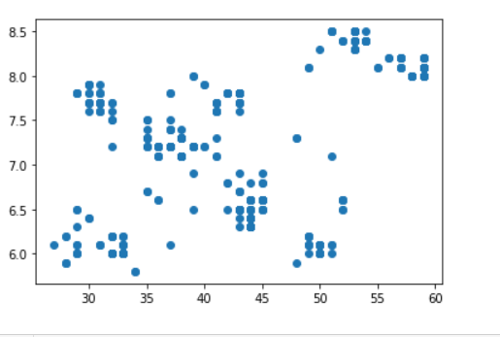

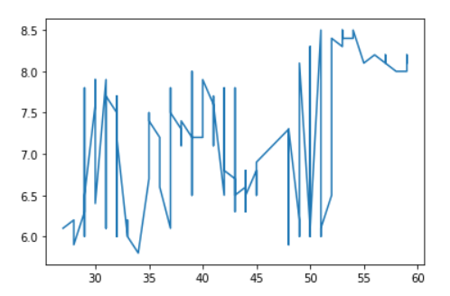

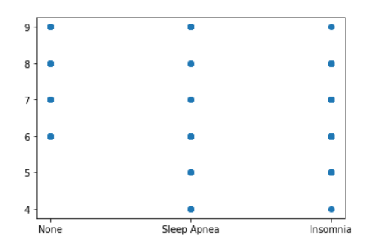

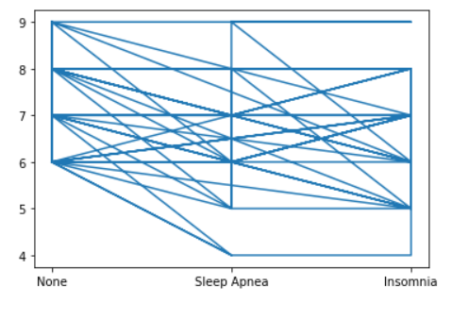

Piechart-

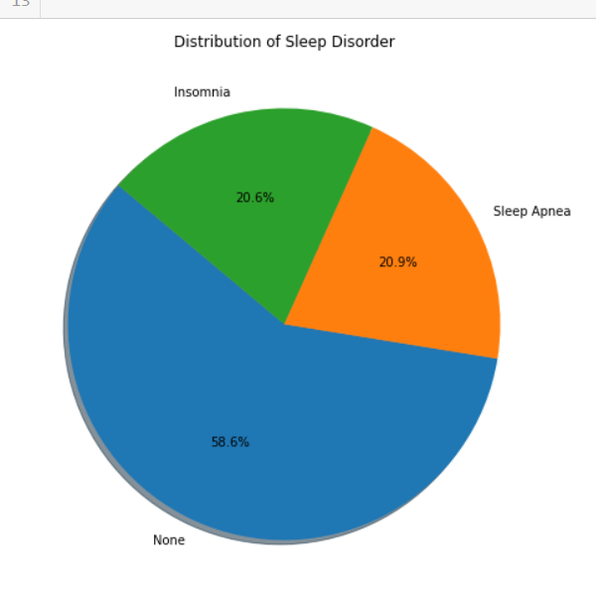

Lineplot-

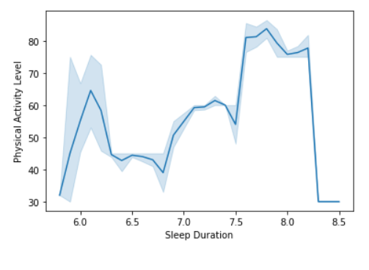

Bar Plot-

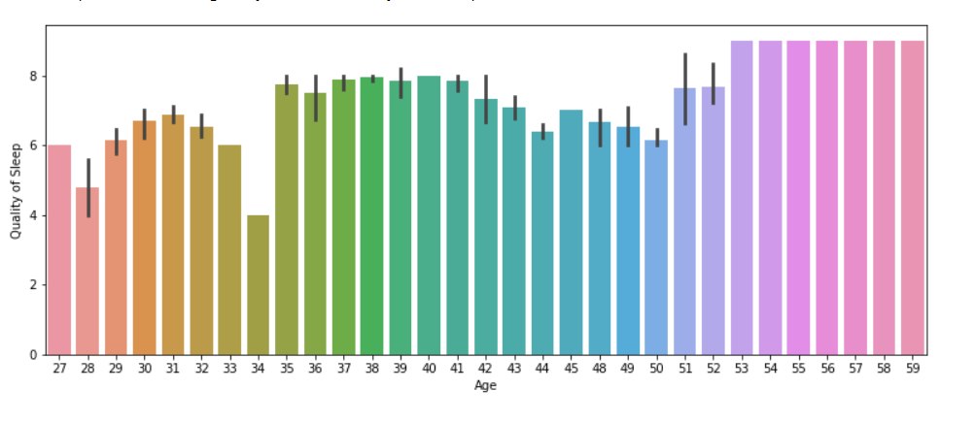

Categorical Distribution Data-

1. Boxplot-

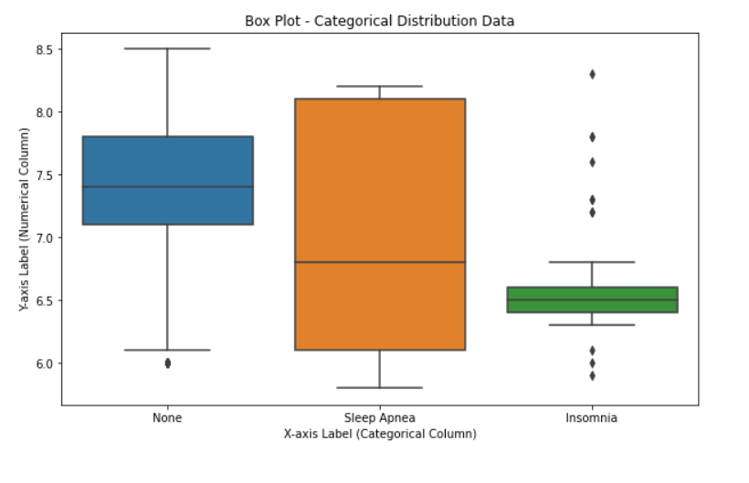

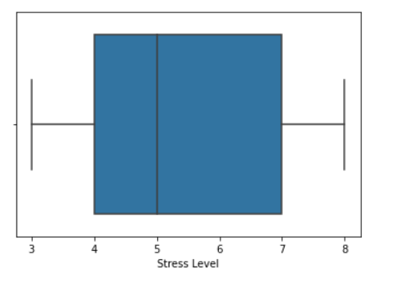

2.Violinplot-

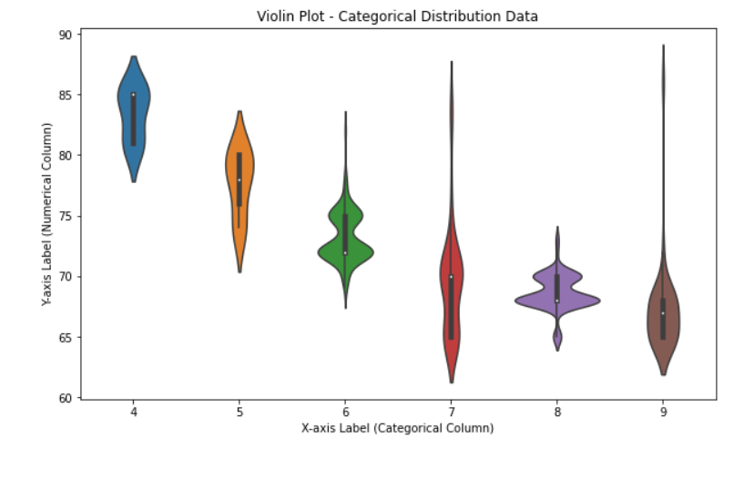

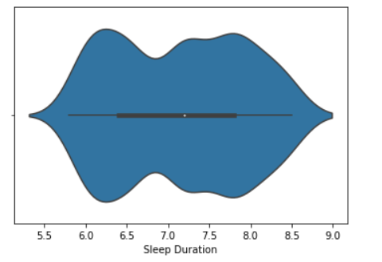

Pairplot-

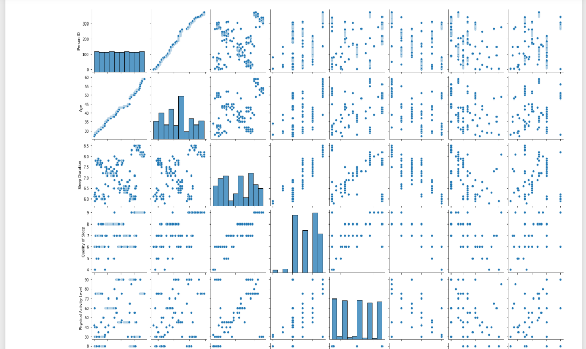

Joint Plot-

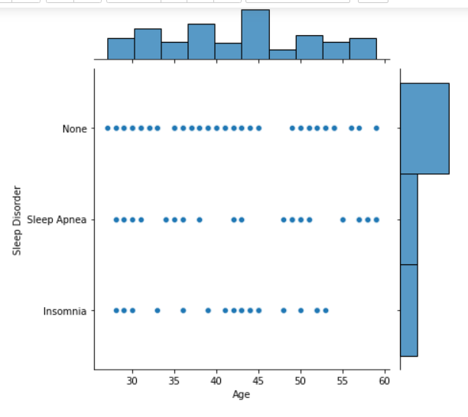

Histogram Plot-

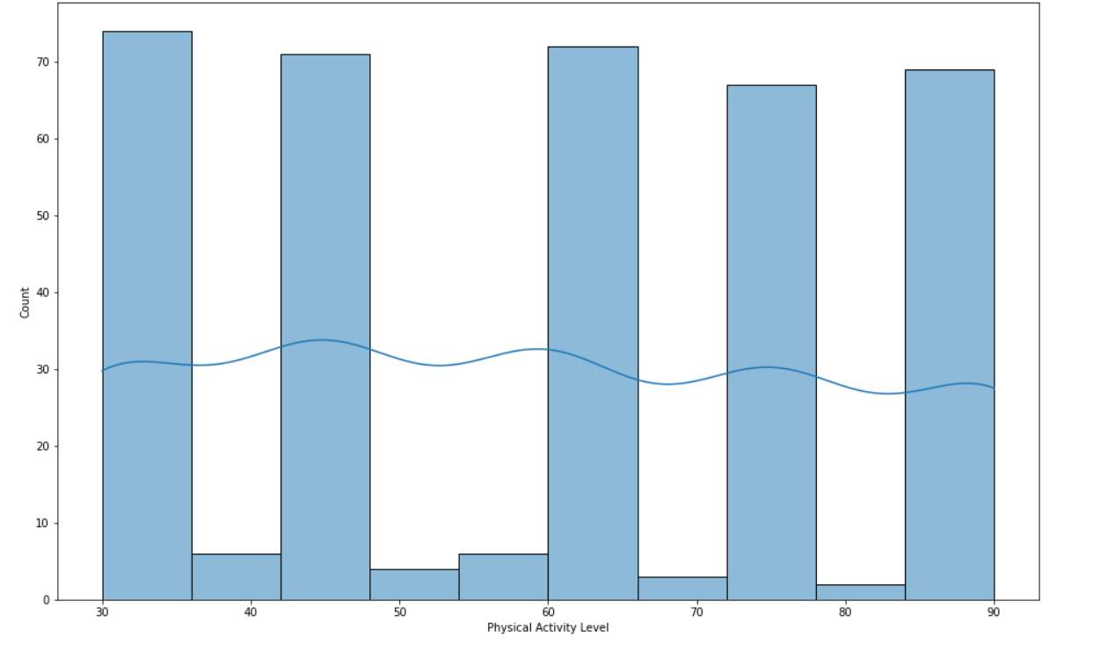

Correlation Heatmap-

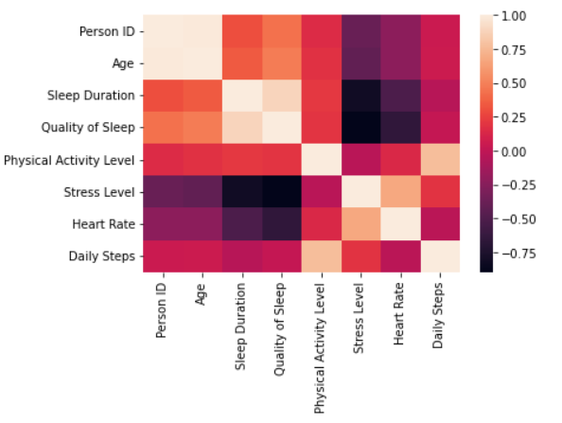

**Advantages:**

The project "SleepSense: Unveiling the Secrets of Sleep and Lifestyle" offers several significant advantages that contribute to the field of sleep science and overall well-being:

1. Improved Sleep Understanding: By delving into the intricate relationship between lifestyle choices and sleep patterns, SleepSense enhances our understanding of the factors influencing sleep quality. This knowledge can lead to better-informed decisions and interventions for improving sleep health.

2. Evidence-Based Recommendations: The project likely provides evidence-based insights and practical recommendations for optimizing sleep habits. This empowers individuals to make informed lifestyle choices that promote restful and rejuvenating sleep.

3. Personalized Sleep Strategies: Recognizing the importance of individual differences in sleep needs and circadian rhythms, SleepSense advocates for personalized sleep strategies. Tailoring sleep routines to individual preferences and chronotypes can lead to better sleep outcomes.

4. Holistic Approach to Well-Being: By addressing the impact of lifestyle on sleep quality, SleepSense highlights the significance of sleep in overall well-being. It promotes a holistic approach to health, considering the interplay between sleep, nutrition, physical activity, and stress management.

5. Stress Reduction Techniques: Understanding the relationship between stress and sleep disturbances, SleepSense likely suggests stress reduction techniques to promote restful sleep. Reducing stress levels can lead to improved sleep quality and emotional well-being.

6. Prevention of Sleep Disorders: Identifying lifestyle factors that contribute to sleep disruptions can aid in recognizing potential risk factors for sleep disorders. Early intervention and lifestyle modifications can help prevent or manage sleep-related issues.

7. Positive Societal Impact: Improved sleep quality among individuals can have broader societal implications. Enhanced sleep health may result in reduced healthcare costs associated with sleep-related problems and improved overall productivity and well-being of the population.

8. Cross-Cultural Insights: Exploring sleep patterns across different cultures can provide valuable insights into cultural factors influencing sleep quality and adaptability. This cross-cultural analysis contributes to a more comprehensive understanding of sleep behaviors worldwide.

9. Healthcare and Research Resource: SleepSense serves as a valuable resource for healthcare professionals and researchers seeking evidence-based information on sleep and lifestyle. It can aid in developing effective interventions and studies related to sleep health.

10. Empowering Individuals: By providing individuals with knowledge about the secrets of sleep and lifestyle, SleepSense empowers them to take an active role in improving their sleep habits. This empowerment can lead to better overall health and a higher quality of life.

"SleepSense: Unveiling the Secrets of Sleep and Lifestyle" offers numerous advantages, including improved sleep understanding, evidence-based recommendations, personalized strategies, and a holistic approach to well-being. By addressing sleep health and lifestyle choices, the project has the potential to positively impact individuals' lives and contribute to the broader field of sleep science and research.

**Conclusion:**

In conclusion, "SleepSense: Unveiling the Secrets of Sleep and Lifestyle" is a significant and comprehensive contribution to the field of sleep science. It offers valuable insights and evidence-based recommendations for optimizing sleep health by understanding the impact of lifestyle choices on sleep patterns.

The project emphasizes the importance of personalized sleep strategies, considering individual differences in sleep needs and circadian rhythms. By empowering individuals to tailor their sleep routines, SleepSense aims to achieve better sleep outcomes and overall well-being.

Additionally, the focus on stress reduction techniques highlights the connection between stress management and sleep quality, enabling individuals to adopt effective coping mechanisms for improved sleep and emotional well-being.

Furthermore, SleepSense's cross-cultural exploration of sleep patterns enriches our understanding of factors influencing sleep quality worldwide, adding depth to sleep research.

As a valuable resource for healthcare professionals and researchers, SleepSense supports the development of targeted interventions and studies related to sleep health, fostering informed decision-making.

Overall, "SleepSense: Unveiling the Secrets of Sleep and Lifestyle" has the potential to positively impact society by promoting better sleep habits and enhancing overall well-being. Improved sleep quality can lead to reduced healthcare costs and increased productivity, contributing to a healthier and more fulfilling life for individuals and communities.

To further progress in sleep science, continued research and collaboration are vital, ensuring a deeper understanding of the intricate connection between lifestyle choices and sleep. Embracing the knowledge from SleepSense can unlock the potential for healthier, happier, and more adaptive lives.

**Reference website names or links:**

* Kaggle.com(<https://www.kaggle.com/>)
* This is the reference website I have used for dataset.