CSS3 | Basic

WarmUp Questions

* You would like to use transitions and transformations in CSS3. What different naming conventions exists?
* Why is it useful to use services like caniuse.com?
* What are two kinds of elements in the flexbox model? What attributes do they have?

Basic exercise | Testing Transition

Create a simple HTML document with multiple links to the developer's resources and tools. Use CSS3 transition effects on hover for these links to change, for example, their font size and color. Try to create your own resource page that you can update easily and use later in this course. Be creative and use as many resources as you can.

## CSS3 | Intermediate

**Before you start with the intermediate exercise, we recommend playing one of the following games, to assist in understanding flexbox:**

[**https://flexboxfroggy.com/**](https://flexboxfroggy.com/#de)

or

[**http://www.flexboxdefense.com/**](http://www.flexboxdefense.com/)

### Intermediate Exercise | Flexitarian

Create a HTML file and try to recreate the following the nutrition table using flex box.

Ein Bild, das Text, Quittung, Screenshot enthält.

## CSS3 | Challenge

### Challenge | Website for a mobile service provider

'BLABSLAB' is a new mobile service provider on the market and are looking for a cool, new website. 'BLABSLAB' offers both a contracted and pay-as-you-go mobile service; for which their customers should be able to check their usage, remaining minutes and purchase more credit over their webpage.

They really love interactive elements on the page and big, bold colors. This must be an active,  bright and happy website. The user's journey to either the pay-as-you-go or contract areas of the website must be shown.

'BLABSLAB' has done some market research which had them conclude that there are too many pages on the current website. You can go to your own service provider's website and consider what you would do to improve the visitor's experience.

Remember, this needs to be, bright and friendly in its interactive elements and the service needs to be clear the minute you land on the homepage

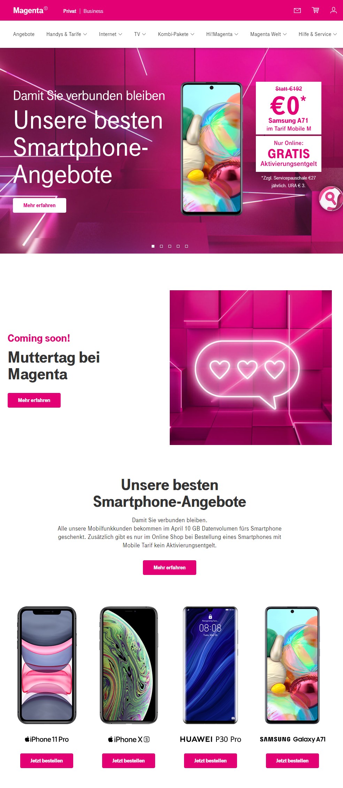Here is some inspiration on how such a website could look like: