***Muhammad al-Xorazmiy nomidagi Toshkent axborot texnologiyalari Universiteti***



**Algoritmlarni Loyihalash Fanidan**

Mustaqil ish

variant-30

Bajardi: Madaminov Samandar

Tekshirdi:Matyakubov Marks

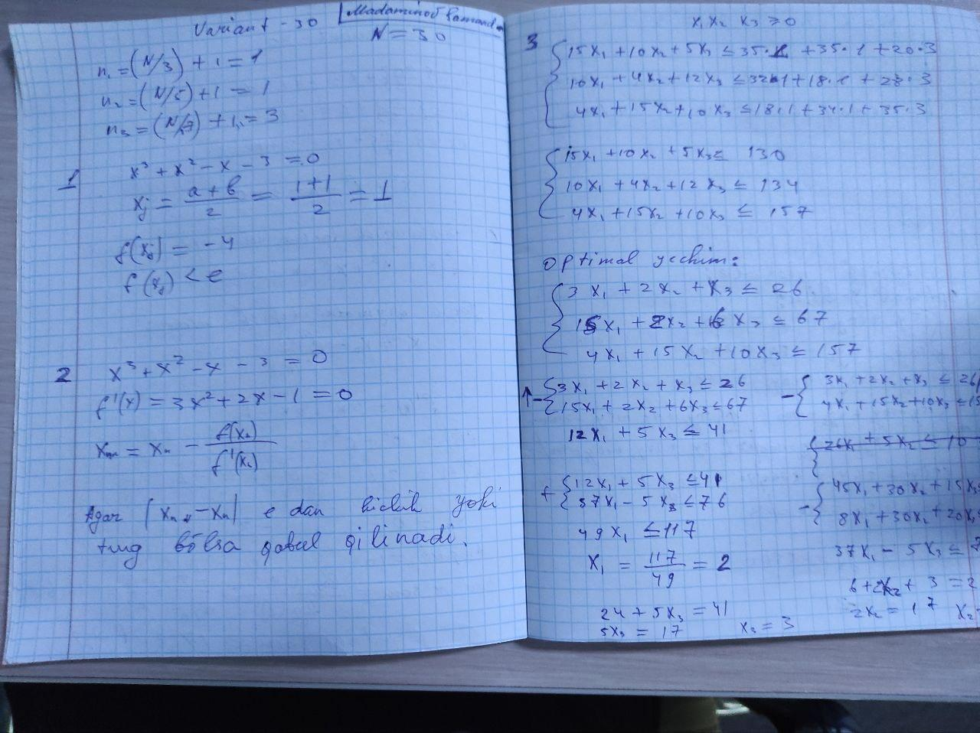

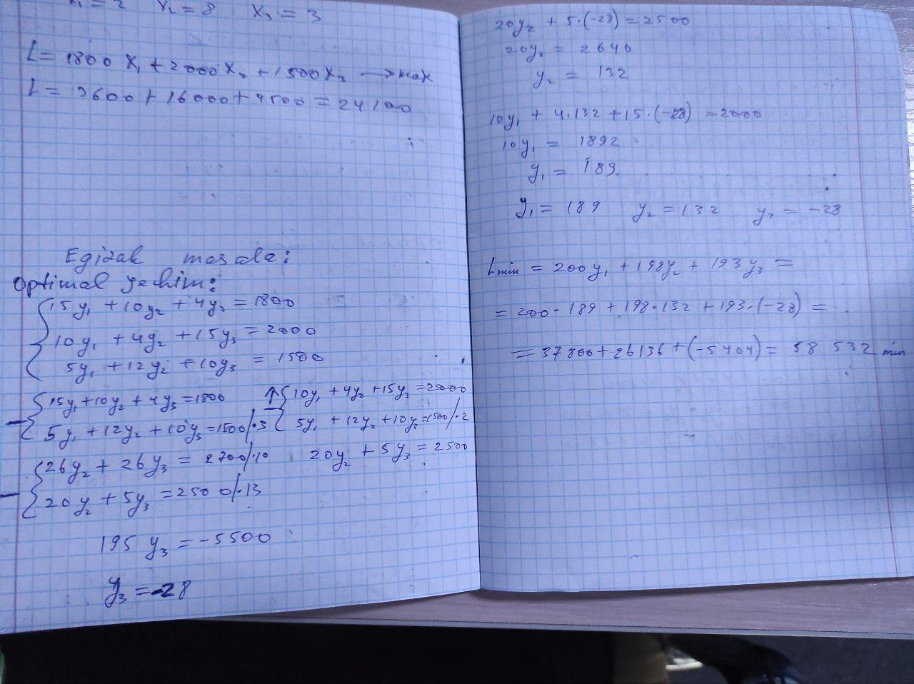

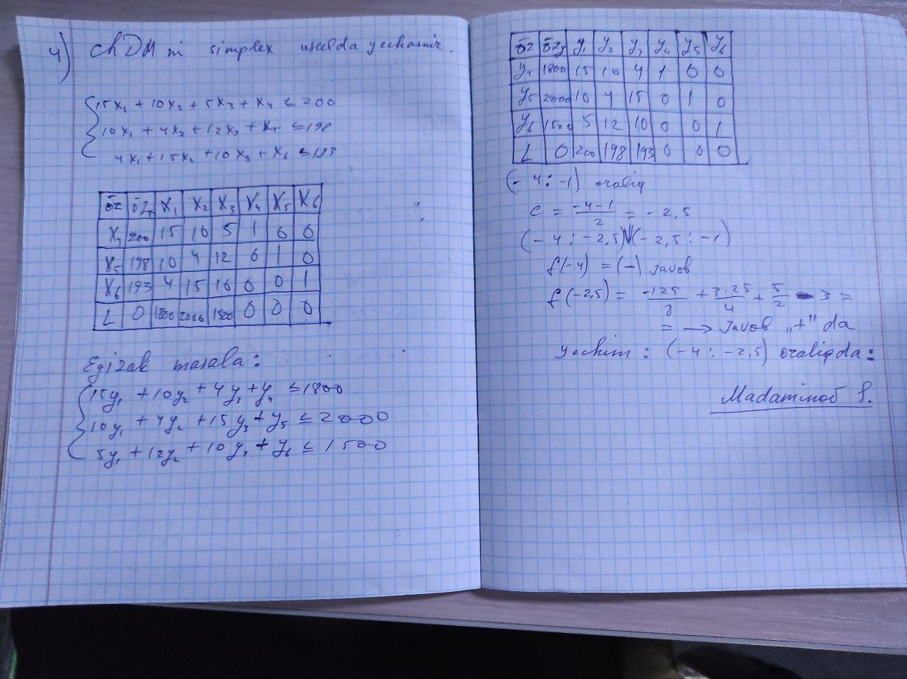

**1- Savolning dastur kodini tuzamiz:**

**def f(x):**

**return x**3 + x**2 - x - 3**

**def bisection_method(a, b, tol):**

**if f(a) * f(b) >= 0:**

**print("Boshlang'ich farazanda x <= a va b, muammosi hal etilmaydi")**

**return None**

**num_iterations = 0**

**while (b - a) / 2 > tol:**

**midpoint = (a + b) / 2**

**if f(midpoint) == 0:**

**return midpoint**

**elif f(a) * f(midpoint) < 0:**

**b = midpoint**

**else:**

**a = midpoint**

**num_iterations += 1**

**return (a + b) / 2, num_iterations**

**a = 1**

**b = 2**

**tolerance = 1e-5**

**result, iterations = bisection_method(a, b, tolerance)**

**print("Yechim: x =", result)**

**print("Zarur qadamlar soni:", iterations)**

**Natija:**

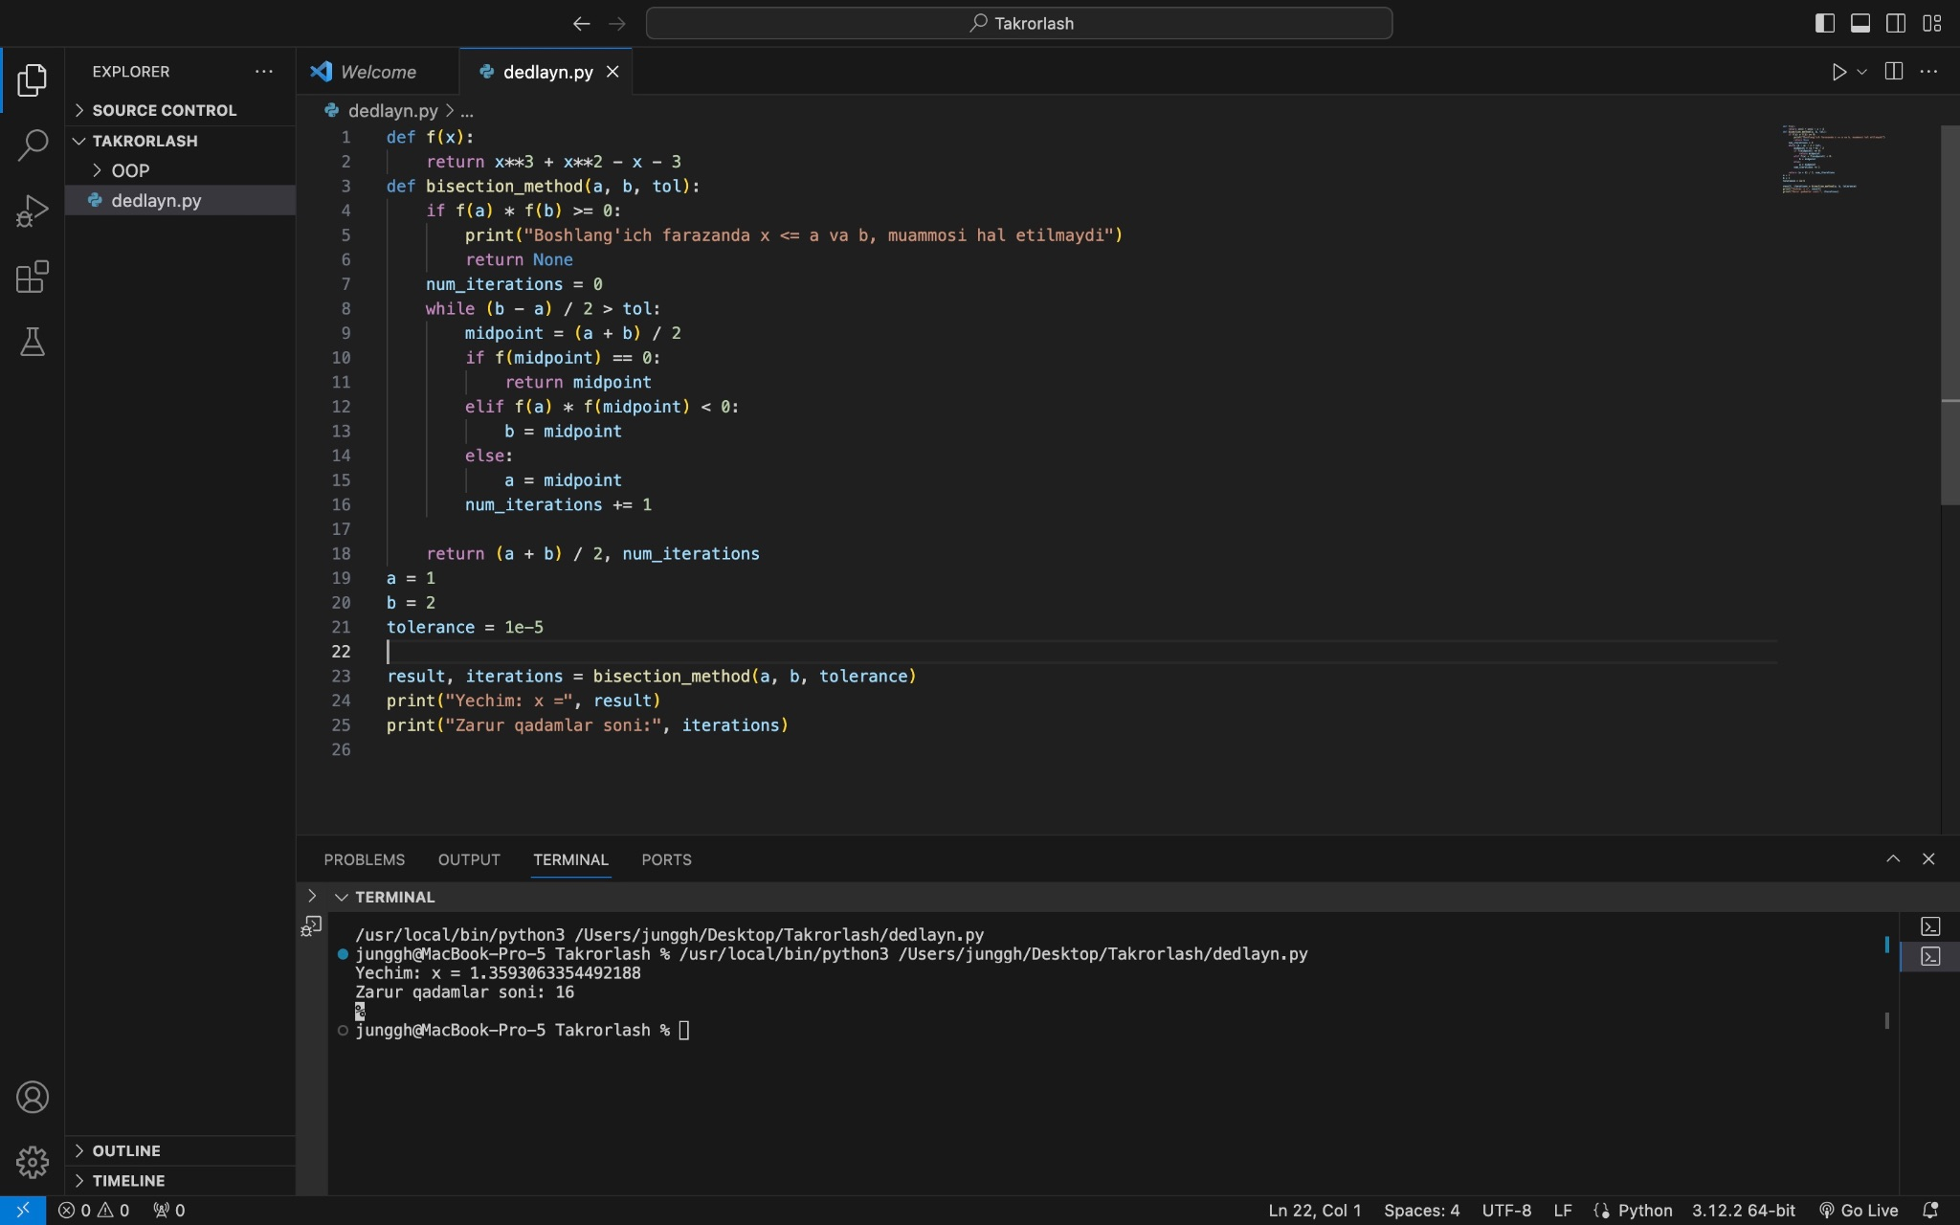

**2-Savolning dastur kodi:**

**def f(x):**

**return x**3 + x**2 - x - 3**

**def f_prime(x):**

**return 3*x**2 + 2*x - 1**

**def newton_method(x0, tol, max_iter):**

**x = x0**

**num_iterations = 0**

**while abs(f(x)) > tol and num_iterations < max_iter:**

**x = x - f(x) / f_prime(x)**

**num_iterations += 1**

**return x, num_iterations**

**def bisection_method(a, b, tol):**

**if f(a) * f(b) >= 0:**

**print("Boshlang'ich farazanda x <= a va b, muammosi hal etilmaydi")**

**return None**

**num_iterations = 0**

**while (b - a) / 2 > tol:**

**midpoint = (a + b) / 2**

**if f(midpoint) == 0:**

**return midpoint**

**elif f(a) * f(midpoint) < 0:**

**b = midpoint**

**else:**

**a = midpoint**

**num_iterations += 1**

**return (a + b) / 2, num_iterations**

**initial_guess = 1.5**

**tolerance = 1e-5**

**max_iterations = 100**

**result_newton, iterations_newton = newton_method(initial_guess, tolerance, max_iterations)**

**print("Nyuton usuli natijasi: x =", result_newton)**

**print("Zarur qadamlar soni:", iterations_newton)**

**a = 1**

**b = 2**

**result_bisection, iterations_bisection = bisection_method(a, b, tolerance)**

**print("\nBisection usuli natijasi: x =", result_bisection)**

**print("Zarur qadamlar soni:", iterations_bisection)**

**dastur natijasi:**

