AiQC Q-Day MiniHackathon
Variational Quantum Optimization Challenge
Weighted Max-Cut for Data-Center Server Partitioning

1. Problem Overview
Data centers must assign servers to network zones. Placing servers that exchange a lot of data in different zones spreads load across independent network spines, improving redundancy and throughput. This is modeled as a Weighted Max-Cut problem: given a graph where each server is a node and each data link is a weighted edge, find a partition of the servers into two groups that maximizes total cross-group traffic.

Scientific Objective: Formulate the problem as a QUBO, map it to an Ising Hamiltonian, and benchmark QAOA vs VQE on the same quantum simulator.

1.1 The Server Network
The toy dataset consists of 5 servers (S1-S5) with 6 data-exchange links. Each link has a weight in GB/s representing the traffic volume between those two servers.

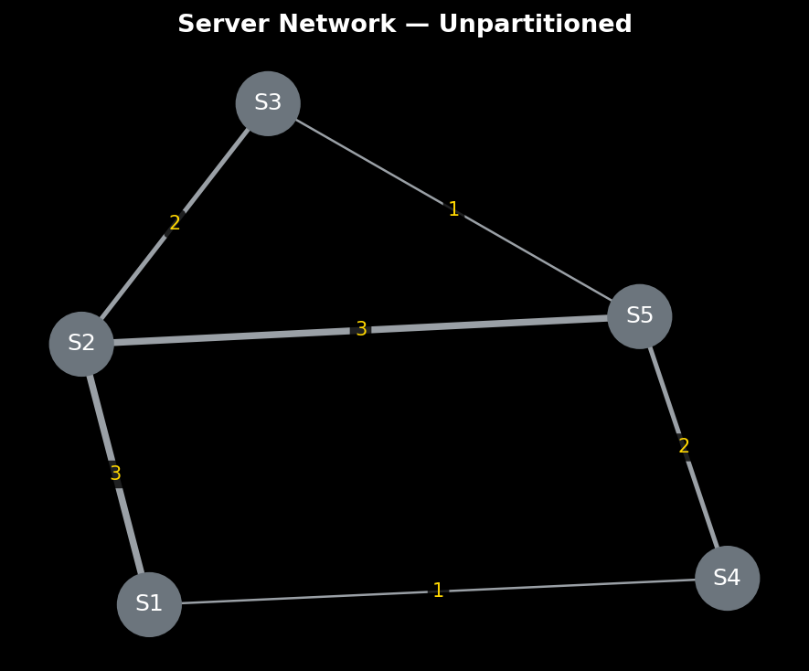

Edge list (from the code):
- S1–S2 (q0–q1) : 3 GB/s
- S2–S3 (q1–q2) : 2 GB/s
- S1–S4 (q0–q3) : 1 GB/s
- S3–S5 (q2–q4) : 1 GB/s
- S4–S5 (q3–q4) : 2 GB/s
- S2–S5 (q1–q4) : 3 GB/s

Brute-force over all 2⁵ = 32 partitions confirms the optimal cut weight is 11 GB/s, achieved by bitstring |01010⟩ (S1,S3,S5 vs S2,S4) or its complement.

2. Mathematical Formulation

2.1 QUBO Formulation
Every edge (i, j) with weight w_ij contributes to the cut when its endpoints are in different groups. With binary variables x_i ∈ {0,1} denoting group membership:

cut(i,j) = x_i + x_j - 2·x_i·x_j

The total weighted cut to maximize is:
E(x) = Σ w_ij · (x_i + x_j - 2·x_i·x_j)

This is already in QUBO form (Eq. 1 of the hackathon spec) with diagonal Q_ii = Σ_j w_ij and off-diagonal Q_ij = −2·w_ij. No penalty terms are needed since any partition is a valid solution.

2.2 Ising Mapping
Quantum computers operate with Pauli-Z operators (eigenvalues +1/−1). Substituting x_i = (1 - Z_i)/2 transforms the cut function:
cut(i,j) = (1 - Z_i·Z_j) / 2
The cost Hamiltonian becomes:
H_C' = -Σ w_ij · Z_i Z_j (constant offset dropped)

Minimizing H_C' is equivalent to maximizing the cut. The constant Σ w_ij/2 shifts all eigenvalues equally and does not affect the optimal bitstring.

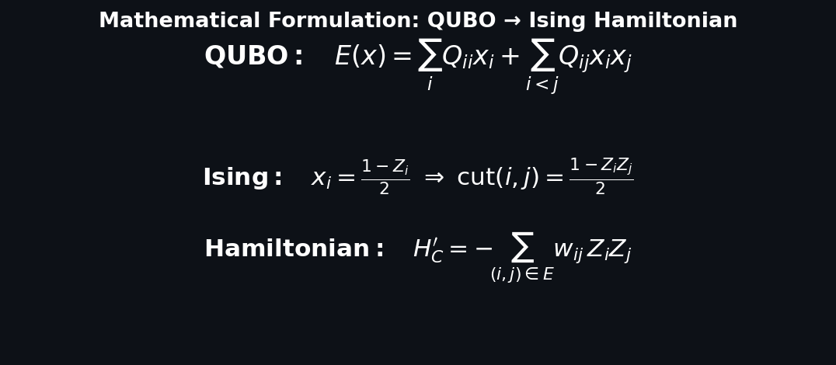
Figure 2 — Summary of the QUBO and Ising formulation used in both quantum algorithms.

3. QAOA — Quantum Approximate Optimization Algorithm

3.1 Algorithmic Mechanics
QAOA constructs a parameterized quantum state by alternating two problem-specific unitaries, repeated p times (p=2 in this project):

- Cost unitary U_C(γ): for each graph edge (i,j) with weight w, applies CNOT(i→j) → RZ(w·γ, j) → CNOT(i→j). This imprints a phase that is proportional to the edge weight whenever qubits i and j disagree, directly encoding the graph structure into the quantum state.

- Mixer unitary U_B(β): applies RX(2β) to every qubit. This transfers amplitude between bitstrings, allowing the optimizer to explore different partitions.

Starting from equal superposition (Hadamard on all qubits), the 2p=4 variational angles (γ₁,β₁,γ₂,β₂) are tuned by the Adagrad optimizer over 500 steps to minimize ⟨H_C'⟩, with 20 shots per step.

3.3 QAOA Solution
After 500 optimization steps, QAOA returns bitstring |10101⟩ with a cut weight of 11 GB/s — matching the brute-force optimal.

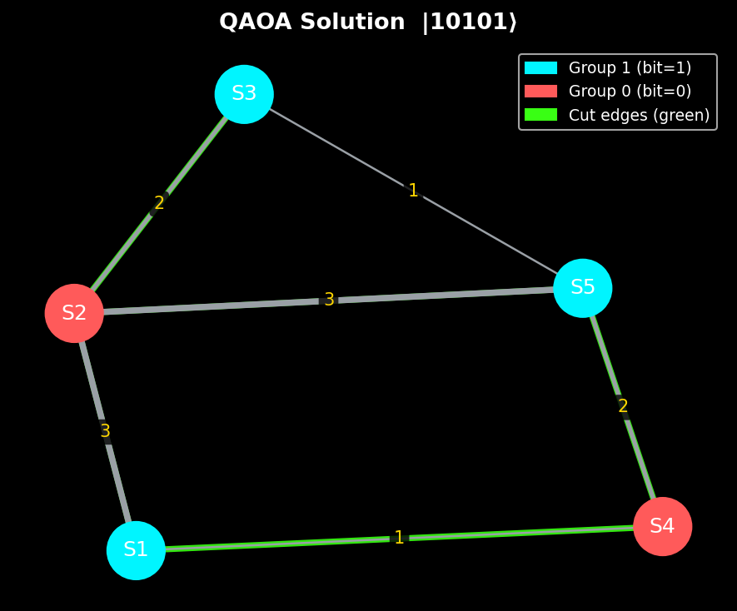

4. VQE — Variational Quantum Eigensolver

4.1 Algorithmic Mechanics
VQE solves the same Hamiltonian H_C' but replaces the graph-aware circuit with a generic, hardware-efficient ansatz (RealAmplitudes, linear entanglement, 1 rep):

- First layer of RY rotations on all 5 qubits (5 tunable parameters).
- Linear CNOT chain: q0→q1→q2→q3→q4 (fixed entangling structure, graph-independent).
- Second layer of RY rotations on all 5 qubits (5 more parameters).

The COBYLA optimizer (derivative-free, via SciPy) tunes the 10 RY angles by calling Qiskit's AerEstimatorV2 to evaluate ⟨H_C'⟩ with exact statevector arithmetic. The ansatz has zero knowledge of the graph — it must discover the optimal partition purely through optimization.

4.3 VQE Solution
VQE converged to bitstring |01010⟩ with a cut weight of 11 GB/s — also optimal. Note that |01010⟩ is the complement of QAOA's |10101⟩; both represent the same partition (group labels are arbitrary).

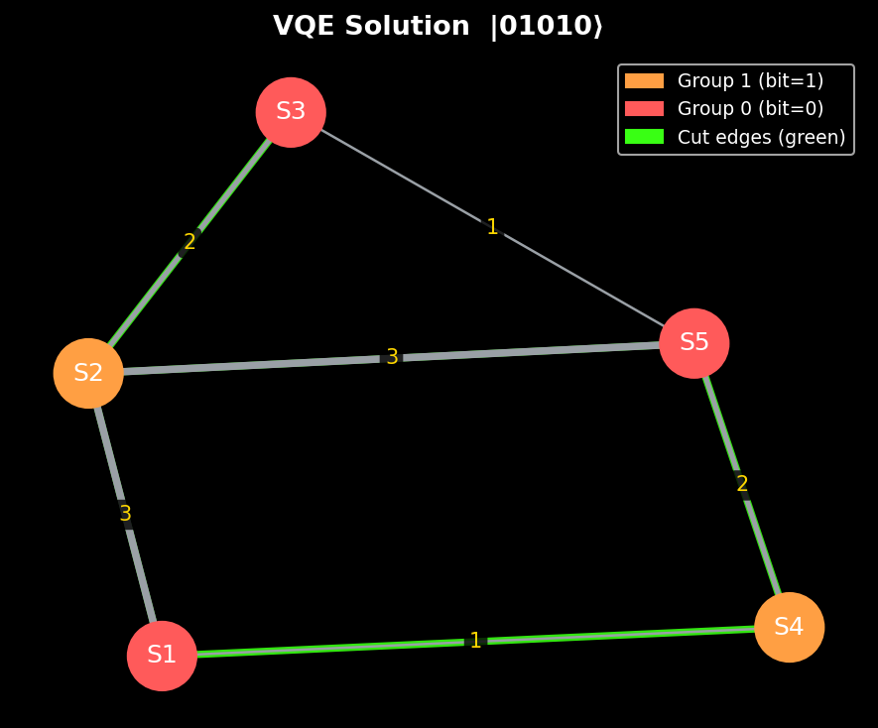

5. Comparative Analysis

5.1 Before vs After: Quantum-Optimized Partitioning
The figure below shows the network before any partitioning (grey), then the QAOA-optimized partition (centre), and the VQE-optimized partition (right). Both algorithms found the global optimum.

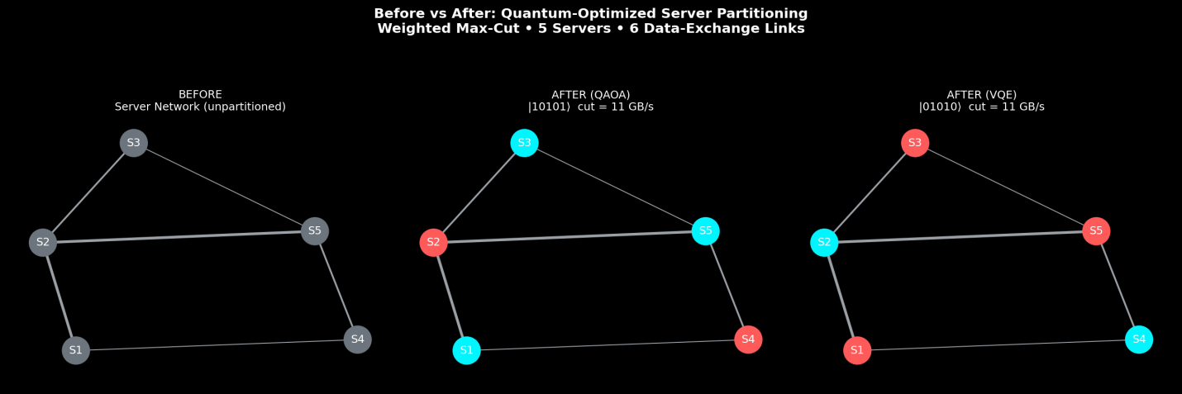

5.3 Algorithm Comparison Table

Aspect | QAOA (PennyLane) | VQE (Qiskit)
Circuit design | Graph-derived: one gate triplet per edge | Generic hardware-efficient ansatz
Gate pattern per edge | CNOT → RZ(w·γ) → CNOT | N/A (no edge encoding)
Tunable parameters | 4 total (γ₁,β₁,γ₂,β₂) for p=2 | 10 RY rotation angles
Classical optimizer | Adagrad (gradient-based) | COBYLA (derivative-free)
Problem encoding | Hard-wired into circuit gates | Learned via optimization
Shots per iteration | 20 (stochastic gradient) | Exact statevector (AerEstimator)
Iterations run | 500 | ~220 (converged early)
Final cut weight | 11 GB/s (optimal) | 11 GB/s (optimal)
Convergence style | Noisy — shot-based variance | Smooth — exact gradients

5.4 Key Architectural Difference
Central insight: QAOA encodes the graph directly into the circuit gates. VQE uses a fixed generic ansatz and discovers the graph structure purely through optimization.

- QAOA circuit IS the problem. Each CNOT-RZ-CNOT triplet maps directly to one graph edge. Remove an edge, remove its gates. This gives QAOA a structural advantage on graph problems: fewer parameters, targeted gates, and built-in physical intuition.

- VQE circuit is problem-agnostic. RealAmplitudes looks identical for any 5-qubit Hamiltonian. It relies on the classical optimizer to discover the problem structure from scratch. More flexible and easier to deploy on real hardware with limited connectivity, but less informed.

Convergence comparison: QAOA's shot-based gradient (20 shots/step) produces a noisy convergence curve that never fully settles, while VQE's exact statevector evaluation gives a perfectly smooth descent that converges in ~220 steps despite having 2.5× more parameters.

6. Implementation Details

6.1 QAOA (PennyLane)
- Device: lightning.qubit (fast CPU simulator, no shots overhead)
- Shots: 20 per optimization step (stochastic gradient); 100 shots for final sampling
- Optimizer: Adagrad, step size 0.1, run for 500 iterations
- Initialization: random angles near zero (0.01 × random) to break symmetry
- Objective: negative cut weight via qp.expval(H_C')
- Graph encoding: weighted_edges list drives the U_C gate loop directly

6.2 VQE (Qiskit)
- Ansatz: RealAmplitudes(n_qubits=5, entanglement="linear", reps=1) → 10 parameters
- Hamiltonian: SparsePauliOp.from_list() with ZZ terms for each weighted edge
- Primitive: AerEstimatorV2 (exact statevector, no shot noise)
- Optimizer: COBYLA via scipy.optimize.minimize, max 380 iterations
- Final sampling: AerSamplerV2, 100 shots on optimized circuit
- VQE converged in ~220 iterations — well before the 380-step limit

6.3 Brute-Force Validation
All 2⁵ = 32 bitstrings were evaluated classically to confirm the optimal cut. Both algorithms matched the optimum of 11 GB/s, giving an approximation ratio of 1.0 (perfect) on this small instance.

7. Conclusion
This project demonstrated two fundamentally different variational quantum strategies on the Weighted Max-Cut problem for a 5-server data-center network:

- QAOA encodes the graph directly into the circuit. Fewer parameters (4 vs 10), more targeted gates, and built-in physical intuition. Convergence is noisy due to shot-based gradients but the algorithm leverages problem structure.

- VQE uses a generic hardware-efficient ansatz with no graph knowledge. More parameters, but smooth exact-gradient convergence. The same circuit can be reused for any Hamiltonian — making it more versatile for real hardware deployment.

Both algorithms found the global optimum (cut = 11 GB/s, approximation ratio = 1.0) on this 5-node toy instance, confirming correct implementation of both QUBO formulation, Ising mapping, and quantum circuit construction.

On larger instances, QAOA's structural advantage is expected to be more pronounced: its circuit depth grows with the number of edges and QAOA layers (O(p×|E|)), while VQE’s generic ansatz may require exponentially more parameters to express the same solution quality.

8. References
[1] https://pennylane.ai/demos/tutorial_qaoa_maxcut
[2] https://quantum.cloud.ibm.com/learning/en/courses/utility-scale-quantum-computing/variational-quantum-algorithms

