### JAVA SWING BASED MINI-CAB-OPERATOR (UBER DATABASE MANAGEMENT SYSTEM) - SQL CONNECTIVITY USING JDBC

*A*

*Report*

*Submitted in partial fulfillment of the Requirements for the award of the Degree of*

#### BACHELOR OF ENGINEERING

IN

**INFORMATION TECHNOLOGY**

By

**M. MADAN KUMAR <1602-19-737-079>**

**Under the Guidance of**

**B. Leelavathy**



#### Department of Information Technology Vasavi College of Engineering (Autonomous) (Affiliated to Osmania University) Ibrahimbagh, Hyderabad-31

**2019-2020**

BONAFIDE CERTIFICATE

This to Certify that the project report titled

“***MINI-CAB-OPERATOR***”

Project work of **M. Madan Kumar** bearing Roll.no:**1602-19-737-079** that carried out this

Project under my supervision in the IV semester for the academic year 2020-2021.

Signature Signature

external examiner internal examiner

ABSTRACT

This project is aimed at developing a Minicab Operator. Here, we mentioned Uber as Company. The Company pays for many advertising companies as shown.

A Driver is identified by Driver Id while driving a car, has a constraint that he can only drive 4 people per ride. The Client includes Rate, Password, CP.no (client phone number), Client Id, Location (The Location of the Client).

The Client adds a request for a ride, which is being sent to the Company. The Company sends back the request, which is being received by the Driver with specific Driver ID. Driver who drives a Car, an Owner or Employee for the car.

A Driver can be a Parttime or Contract Driver. This Driver when he accepts the request gets the trip details. Bill is paid by Client to Driver from Uber wallet, Paytm wallet, by adding Paytm balance to Uber wallet.

**REQUIREMENT ANALYSIS**

LIST OF TABLES:

* Company
* Advertising company
* Driver
* Car
* Client
* Request
* Trip
* Has
* Parttime
* Contract
* Bill
* Paytm wallet
* Uber wallet

LIST OF ATTRIBUTES AND THEIR DOMAIN TYPES:

* Company:
* Address: address_com varchar(20)
* ID of the company: company_id number(10)
* Company name: name_com varchar(10)
* Driver:
* Driver name: name_driver varchar(20),
* Driver phone number: phonenumber_driver varchar(10)
* Driver rating: rate_driver int,
* Driver Gender: gender varchar(6)
* Car:
* Car color: color varchar(10)
* Car model no: modelno number(10)
* Car id: Carid number(5),
* Car name: name_car varchar(10)
* Car model: model varchar(10)
* Client:
* Client rating: rate_client number(10)
* Password: password varchar(15)
* Client phone number: phonenumber_client number(10)
* ID of the client: clientid varchar(6)
* Client location: location_client varchar(20)

**THROUGH THIS PROJECT:** It develops an online application for users. The clients can login into their accounts and search for rides in their location, while on the other hand the drivers can reach out to the passengers for trips. The passengers can either pay money thorough either Pay tm or the Uber money.

**AIM:**

To create a **Java GUI based registration form** which takes the values like: Driver’s and the Client’s name, phone number, password, Location. These values are to be updated in the database using **JDBC connectivity.**

## ARCHITECTURE AND TECHNOLOGY USED:

#### SOFTWARE USED:

Java Eclipse, Oracle 11g Database, Java SE version 8, SQL Plus.

**Java SWING:**

**SWING** is a GUI widget toolkit for Java. It is part of Oracle's Java Foundation Classes (JFC) – an API for providing a graphical user interface (GUI) for Java programs.

Swing was developed to provide a more sophisticated set of GUI components than the earlier AWT. Swing provides a look and feel that emulates the look and feel of several platforms, and also supports a pluggable look and feel that allows applications to have a look and feel unrelated to the underlying platform. It has more powerful and flexible components than AWT. In addition to familiar components such as buttons, check boxes and labels, Swing provides several advanced components such as tabbed panel, scroll panes, trees, tables, and lists.

**SQL:**

Structure Query Language (SQL) is a database query language used for storing and managing data in Relational DBMS. SQL was the first commercial language introduced for E.F Codd's Relational model of database. Today almost all RDBMS (MySql, Oracle, Infomix, Sybase, and MS Access) use SQL as the standard database query language. SQL is used to perform all types of data operations in RDBMS.

**Java-SQL Connectivity using JDBC:**

**Java Database Connectivity** (**JDBC**) is an application programming interface (API) for

the programming language Java, which defines how a client may access a database. It is a Java-based data access technology used for Java database connectivity. It is part of the Java Standard Edition platform, from Oracle Corporation. It provides methods to query and update data in a database and is oriented towards relational databases.

The connection to the database can be performed using Java programming (JDBC API) as:

**public** **class** DBConnection {

**private** **static** DBConnection *driver*;

**private** Connection con;

**private** Statement stmt;

**public** DBConnection() {

**try** {

String username = "madan";

String password = "vasavi";

DriverManager.*registerDriver*(**new** oracle.jdbc.driver.OracleDriver());

con = (Connection) DriverManager.*getConnection*("jdbc:oracle:thin:@localhost:1521:xe", username, password);

System.***out***.println("\nConnected to Oracle DataBase");

stmt = con.createStatement();

} **catch** (SQLException e) {

System.***out***.println("Message: " + e.getMessage());

}

}

**public** **static** DBConnection getInstance() {

**if** (*driver* == **null**)

*driver* = **new** DBConnection();

**return** *driver*;

}

/*

* execute any SQL statements alter the database (update, delete, insert)

*/

**public** **int** executeAlter(String sqlstmt) {

**try** {

**int** a=stmt.executeUpdate(sqlstmt);

con.commit();

**return** a;

} **catch** (Exception e) { **return** 0; }

}

/*

* execute query statements

*/

**public** ResultSet executeQuery(String sqlstmt) {

**try** {

**return** stmt.executeQuery(sqlstmt);

} **catch** (SQLException e) {

System.***out***.println("Message: " + e.getMessage() + "\nUnable to execute: " + sqlstmt);

**return** **null**;

}

}

/*

* disconnect from Oracle database

*/

**public** **void** disconnect() {

**try** {

con.close();

} **catch** (SQLException e) {

System.***out***.println("Message: " + e.getMessage());

System.***out***.println("\nFailed to disconnect from Oracle");

}

}

}

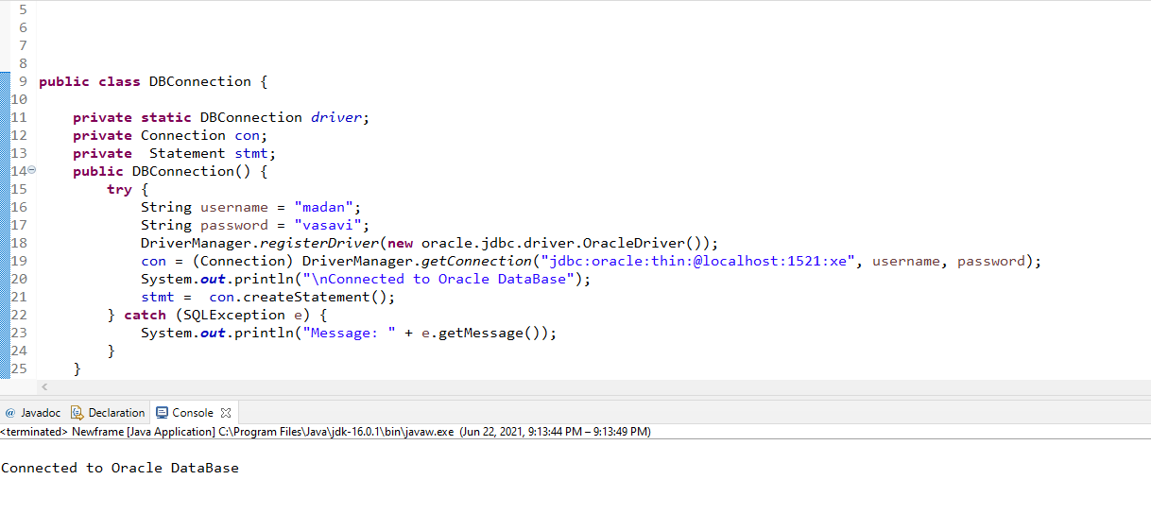 Thus, the connection from Java to Oracle database is performed and therefore, can be used for updating tables in the database directly.

# DESIGN :

**ER DIAGRAM**

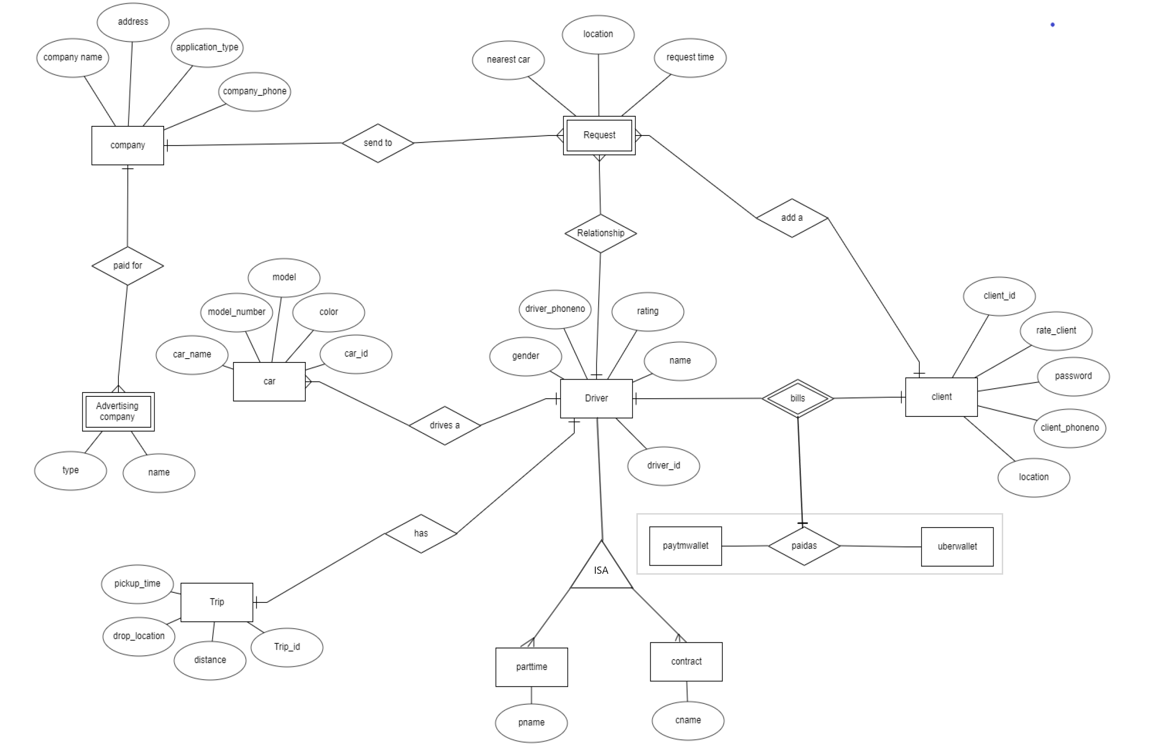

# **DATA DESIGN**

**MAPPING CARDINALITY AND PATISPATION CONSTRAINTS**

Everything is interlinked. Firstly, the company sends a request to the drivers/cars nearby. Depending on the available drivers nearby, there might be multiple requests. So, every company sends many requests, which is one to many participation.

The driver receives a request. If he is an employee, he can choose different cars to drive. So, it is one to many participations. At one time a driver can have only a single trip. So, it is a one-to-one participation.

At one time the driver can display only a single bill and the client can pay only one bill. So, both are one to one participations. The main constraint a driver has is that he can only drive 4 people per a ride.

**DDL COMMANDS**

TABLE CREATED IN SQL:

create table Company (

address_com varchar(20),

company_id number(10) primary key,

name_com varchar(10),

application varchar(4));

create table Advertisingcompany (

type varchar(10),

name_ad number(10) );

create table driver (

did int, name_driver varchar(20),

phonenumber_driver varchar(10)

,rate_driver int,gender varchar(6));

create table client (

rate_client number(10),

password varchar(15) ,

phonenumber_client number(10) primary key

, clientid varchar(6) ,

location_client varchar(20));

create table Request (

location char(20),

request_time varchar(10),

nearest_car varchar(10));

create table trip (

distance number(20),

tripid varchar(10) primary key,

pick_up varchar(5),

drop_off varchar(10));

create table parttime (

paddress varchar(20),

psalary float, did number(6) primary key);

create table contract (

caddress varchar(20),

csalary Float,

did number(6));

create table payfor (

name_ad number(10),

type varchar(10),

company_id number(10), primary key(name_ad,company_id),

foreign key(company_id) references Company(company_id));

create table sendto (

nearest_car varchar(10),

company_id number(10),

request_time varchar(10),

location char(20), primary key(nearest_car,company_id),

foreign key(company_id) references Company(company_id));

create table recieves_a (

didint,

nearest_carvarchar(10),

locationchar(20),

request_timevarchar(10),

primary key(did,nearest_car),

foreign key(did) references driver);

create table drives_a (

did int references driver(did),

carid number(5) references car(carid),

primary key(did,carid));

create table bill (

did int references driver(did),

phonenumber_client number(10) references client(phonenumber_client) ,

pmoney varchar(4) references paytmwallet,

umoney varchar(4) references uberwallet,

primary key(did,phonenumber_client,pmoney,umoney));

create table add_a (

phonenumber_client number(10),

nearest_car varchar(10),

location char(20),

request_time varchar(10),

primary key(nearest_car,phonenumber_client),

foreign key(phonenumber_client) references client);

create table has (

did int,

name_driv varchar(20),

phonenumber_driver number(10),

rate_driver number(5),

gender varchar(4),

tripid varchar(10),

primary key(did),

foreign key(phonenumber_client) references client);

create table drivenby (

owner_carid number(5),

employee_carid number(5),

primary key(owner_carid,employee_carid),

foreign key(owner_carid)references car(carid),

foreign key(employee_carid)references car(carid));

create table paytmwallet (

pmoney varchar(4) primary key);

create table uberwallet (

umoney varchar(4) primary key);

create table paidas (

pmoney varchar(4) references paytmwallet,

umoney varchar(4) references uberwallet,

primary key(pmoney, umoney));

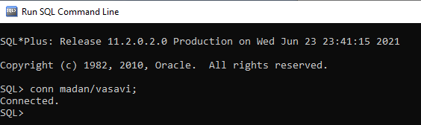

Description of tables:

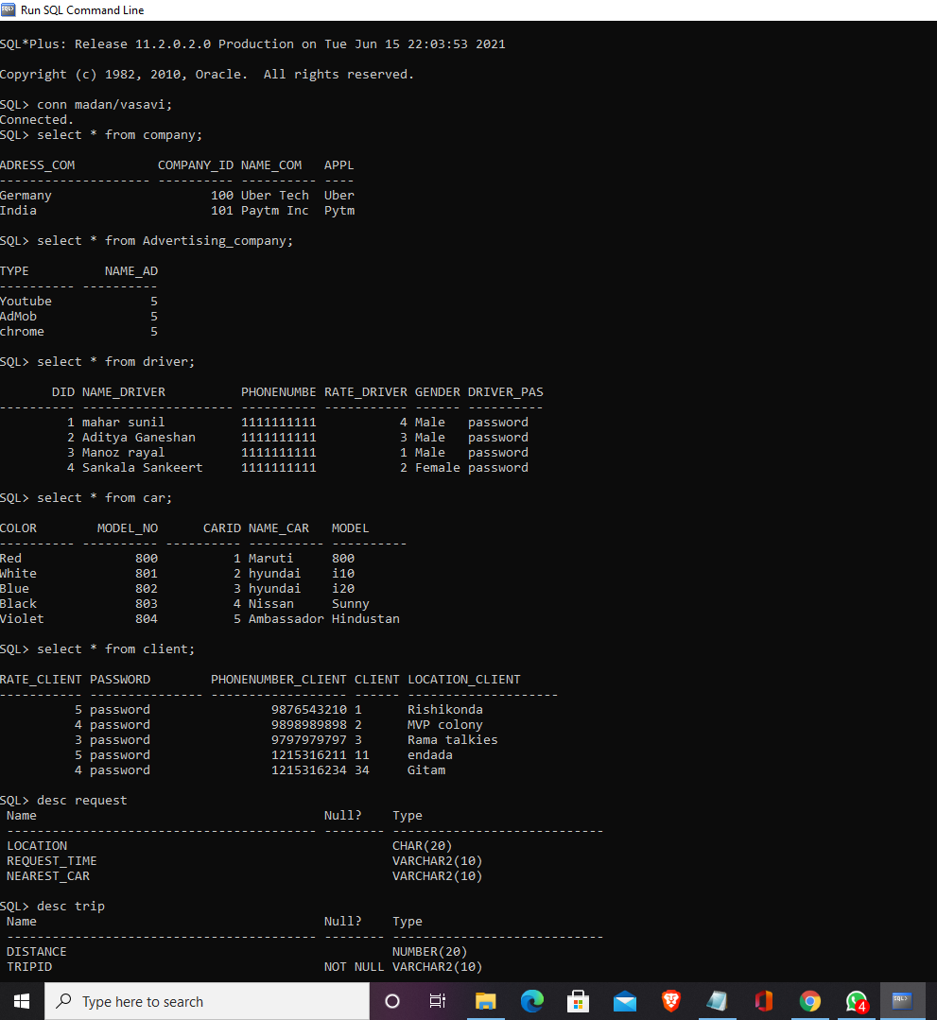

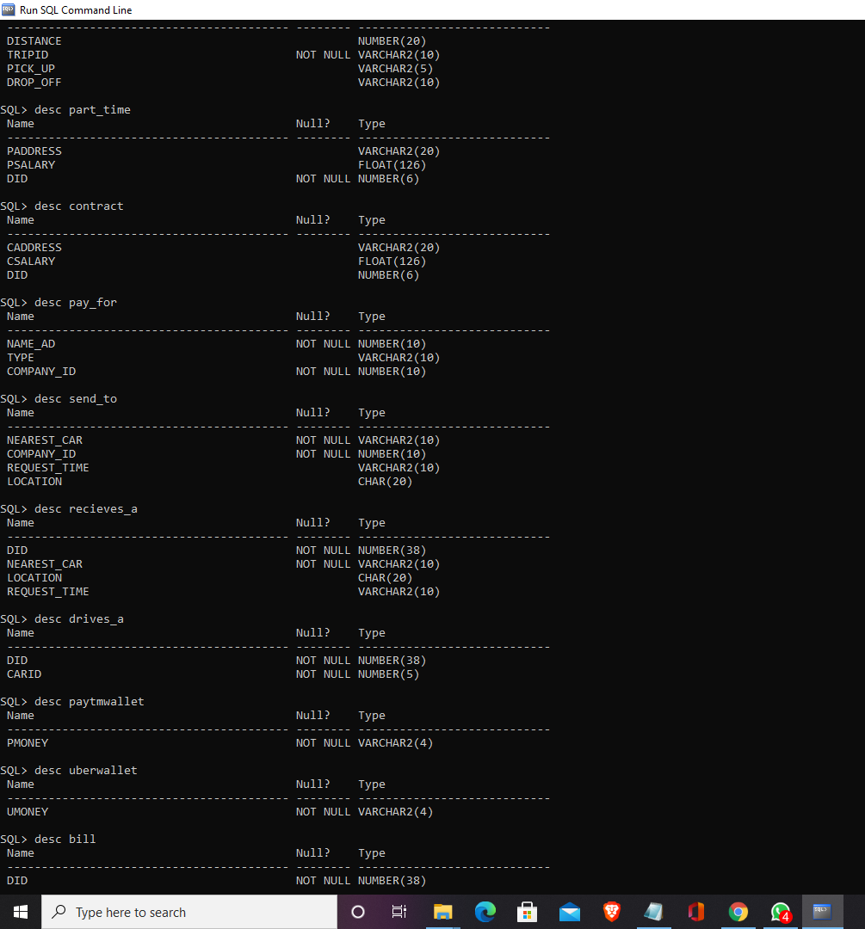

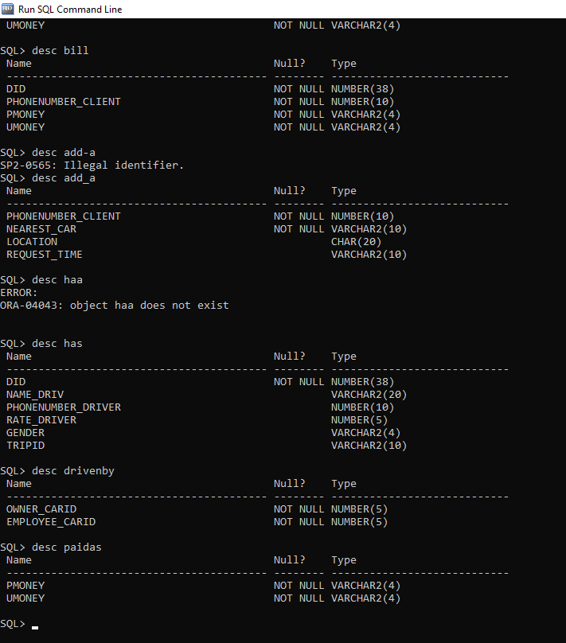

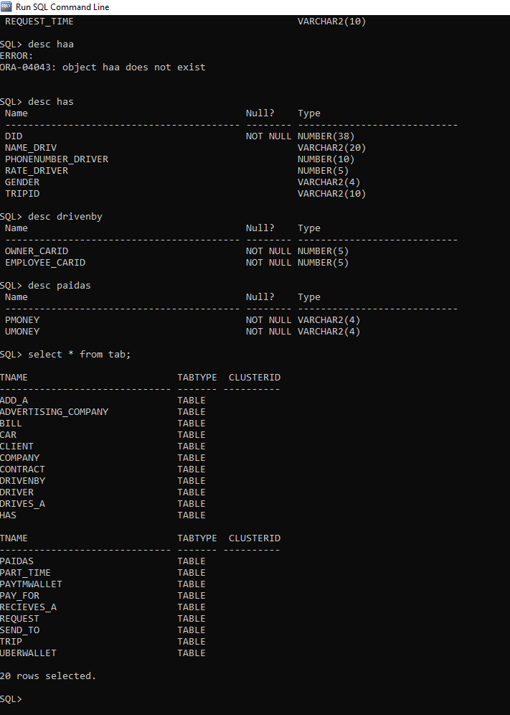

***IMPLEMENTATION:***

**PROGRAM:**

**USER INTERFACE:**

**package** javaapplication1;

**import** java.awt.BorderLayout;

**import** java.awt.EventQueue;

**import** java.awt.Image;

**import** javax.swing.JFrame;

**import** javax.swing.JPanel;

**import** javax.swing.border.EmptyBorder;

**import** java.awt.Color;

**import** javax.swing.AbstractButton;

**import** javax.swing.ImageIcon;

**import** javax.swing.JButton;

**import** javax.swing.JRadioButton;

**import** javax.swing.JTextField;

**import** javax.swing.JPasswordField;

**import** javax.swing.JLabel;

**import** javax.swing.JOptionPane;

**import** java.awt.event.ActionListener;

**import** java.awt.event.ActionEvent;

**import** javax.swing.border.BevelBorder;

**import** java.awt.Font;

**import** java.awt.HeadlessException;

**import** java.awt.Cursor;

**import** java.awt.event.KeyEvent;

**import** java.sql.ResultSet;

**import** java.sql.SQLException;

**import** javax.swing.JCheckBox;

**import** javax.swing.JComboBox;

**import** javax.swing.DefaultComboBoxModel;

**public** **class** Newframe **extends** JFrame {

**private** JPanel contentPane;

**private** DBConnection jdbc;

**private** JButton btnNewButton;

**private** JButton btnNewButton_1;

/**

* Launch the application.

*/

**public** **static** **void** main(String[] args) {

EventQueue.*invokeLater*(**new** Runnable() {

**public** **void** run() {

**try** {

Newframe frame = **new** Newframe();

frame.setVisible(**true**);

} **catch** (Exception e) {

e.printStackTrace();

}

}

});

}

/**

* Create the frame.

*/

**public** Newframe() {

jdbc=**new** DBConnection();

setDefaultCloseOperation(JFrame.***EXIT_ON_CLOSE***);

setBounds(100, 100, 577, 619);

contentPane = **new** JPanel();

contentPane.setForeground(Color.***WHITE***);

contentPane.setBackground(Color.***BLACK***);

contentPane.setBorder(**new** EmptyBorder(5, 5, 5, 5));

setContentPane(contentPane);

contentPane.setLayout(**null**);

JLabel lblNewLabel = **new** JLabel("New label");

lblNewLabel.setIcon(**new** ImageIcon("C:\\Users\\user\\eclipse-workspace\\mini_cab_operator\\bin\\uber.png"));

lblNewLabel.setBounds(-144, 27, 773, 346);

contentPane.add(lblNewLabel);

btnNewButton = **new** JButton("Driver");

btnNewButton.setBorder(**null**);

btnNewButton.addActionListener(**new** ActionListener() {

**public** **void** actionPerformed(ActionEvent e) {

Newframe2 newframe2 = **new** Newframe2();

newframe2.setVisible(**true**);

dispose();

}

});

btnNewButton.setBackground(Color.***WHITE***);

btnNewButton.setFont(**new** Font("Tahoma", Font.***PLAIN***, 13));

btnNewButton.setBounds(99, 476, 147, 32);

contentPane.add(btnNewButton);

btnNewButton_1 = **new** JButton("Passenger");

btnNewButton_1.setBackground(Color.***WHITE***);

btnNewButton_1.setBorder(**null**);

btnNewButton_1.addActionListener(**new** ActionListener() {

**public** **void** actionPerformed(ActionEvent e) {

Newframe3 newframe3 = **new** Newframe3();

newframe3.setVisible(**true**);

dispose();

}

});

btnNewButton_1.setFont(**new** Font("Tahoma", Font.***PLAIN***, 13));

btnNewButton_1.setBounds(332, 477, 141, 32);

contentPane.add(btnNewButton_1);

}

}

**package** javaapplication1;

**import** java.awt.BorderLayout;

**import** java.awt.EventQueue;

**import** javax.swing.JFrame;

**import** javax.swing.JOptionPane;

**import** javax.swing.JPanel;

**import** javax.swing.border.EmptyBorder;

**import** java.awt.Color;

**import** javax.swing.JTextField;

**import** java.awt.Canvas;

**import** javax.swing.JButton;

**import** java.awt.Font;

**import** java.awt.Window;

**import** java.awt.event.ActionListener;

**import** java.sql.PreparedStatement;

**import** java.awt.event.ActionEvent;

**public** **class** Newframe2 **extends** JFrame {

**private** JPanel contentPane;

**private** JTextField txtDriver;

**private** JTextField textField_1;

**private** JTextField textField_2;

**private** JTextField textField_3;

**private** JTextField textField_4;

**private** JTextField txtName;

**private** JTextField txtPhoneNumber;

**private** JTextField txtId;

**private** JTextField txtPassword;

**private** JTextField txtGender;

**private** JTextField textField_6;

**private** DBConnection jdbc;

**private** JTextField textField;

**private** JTextField txtPassword_1;

/**

* Launch the application.

*/

**public** **static** **void** main(String[] args) {

EventQueue.*invokeLater*(**new** Runnable() {

**public** **void** run() {

**try** {

Newframe2 frame = **new** Newframe2();

frame.setVisible(**true**);

} **catch** (Exception e) {

e.printStackTrace();

}

}

});

}

/**

* Create the frame.

*/

**public** Newframe2() {

jdbc = **new** DBConnection();

setDefaultCloseOperation(JFrame.***EXIT_ON_CLOSE***);

setBounds(100, 100, 541, 509);

contentPane = **new** JPanel();

contentPane.setForeground(Color.***WHITE***);

contentPane.setBackground(Color.***BLACK***);

contentPane.setBorder(**new** EmptyBorder(5, 5, 5, 5));

setContentPane(contentPane);

contentPane.setLayout(**null**);

JButton btnNewButton = **new** JButton("Insert");

btnNewButton.addActionListener(**new** ActionListener() {

**public** **void** actionPerformed(ActionEvent e) {

**if**(textField_1.getText()=="")

{

JOptionPane.*showMessageDialog*(**null**,"Driver ID cannot be empty","Alert",JOptionPane.***WARNING_MESSAGE***);

}**else**

{

String res="insert into driver values("+textField_1.getText()+",'"+textField_2.getText()+"','"+textField_3.getText()+"',"+textField_4.getText()+",'"+textField_6.getText()+"','"+textField.getText()+"')";

**int** rs=jdbc.executeAlter(res);

**if**(rs==0)

{

JOptionPane.*showMessageDialog*(**null**,"Invalid details!","Alert",JOptionPane.***WARNING_MESSAGE***);

}**else**

{

JOptionPane.*showMessageDialog*(**null**, "Inserted 1 rows successfully successfully");

}

}

}});

btnNewButton.setBackground(Color.***WHITE***);

btnNewButton.setBounds(24, 419, 89, 23);

contentPane.add(btnNewButton);

txtDriver = **new** JTextField();

txtDriver.setBorder(**null**);

txtDriver.setForeground(Color.***WHITE***);

txtDriver.setBackground(Color.***BLACK***);

txtDriver.setFont(**new** Font("Tahoma", Font.***PLAIN***, 19));

txtDriver.setText(" DRIVER");

txtDriver.setBounds(166, 28, 115, 41);

contentPane.add(txtDriver);

txtDriver.setColumns(10);

JButton btnNewButton_2 = **new** JButton("Update");

btnNewButton_2.setBackground(Color.***WHITE***);

btnNewButton_2.addActionListener(**new** ActionListener() {

**public** **void** actionPerformed(ActionEvent e) {

**if**(textField_1.getText()=="")

{

JOptionPane.*showMessageDialog*(**null**,"Driver ID cannot be empty","Alert",JOptionPane.***WARNING_MESSAGE***);

}**else**

{

String res="update driver set name_driver = '"+textField_2.getText()+"',phonenumber_driver = '"+textField_3.getText()+"',rate_driver = "+textField_4.getText()+",gender = '"+textField_6.getText()+"',driver_password = '"+textField.getText()+"' where did = "+textField_1.getText();

**int** rs=jdbc.executeAlter(res);

**if**(rs==0)

{

JOptionPane.*showMessageDialog*(**null**,"Invalid details!","Alert",JOptionPane.***WARNING_MESSAGE***);

}**else**

{

JOptionPane.*showMessageDialog*(**null**, "Updated 1 rows successfully successfully");

}

}

}});

btnNewButton_2.setBounds(138, 419, 89, 23);

contentPane.add(btnNewButton_2);

textField_1 = **new** JTextField();

textField_1.setBounds(185, 94, 111, 23);

contentPane.add(textField_1);

textField_1.setColumns(10);

textField_2 = **new** JTextField();

textField_2.setBounds(185, 146, 111, 23);

contentPane.add(textField_2);

textField_2.setColumns(10);

textField_3 = **new** JTextField();

textField_3.setBounds(185, 199, 111, 23);

contentPane.add(textField_3);

textField_3.setColumns(10);

textField_4 = **new** JTextField();

textField_4.setBounds(185, 251, 111, 23);

contentPane.add(textField_4);

textField_4.setColumns(10);

txtName = **new** JTextField();

txtName.setText("DID");

txtName.setBorder(**null**);

txtName.setForeground(Color.***WHITE***);

txtName.setBackground(Color.***BLACK***);

txtName.setBounds(39, 95, 86, 20);

contentPane.add(txtName);

txtName.setColumns(10);

txtPhoneNumber = **new** JTextField();

txtPhoneNumber.setText("Name");

txtPhoneNumber.setBorder(**null**);

txtPhoneNumber.setForeground(Color.***WHITE***);

txtPhoneNumber.setBackground(Color.***BLACK***);

txtPhoneNumber.setBounds(39, 147, 86, 20);

contentPane.add(txtPhoneNumber);

txtPhoneNumber.setColumns(10);

txtId = **new** JTextField();

txtId.setText("Phone Number");

txtId.setBorder(**null**);

txtId.setForeground(Color.***WHITE***);

txtId.setBackground(Color.***BLACK***);

txtId.setBounds(39, 200, 86, 20);

contentPane.add(txtId);

txtId.setColumns(10);

txtPassword = **new** JTextField();

txtPassword.setText("Rate");

txtPassword.setBorder(**null**);

txtPassword.setForeground(Color.***WHITE***);

txtPassword.setBackground(Color.***BLACK***);

txtPassword.setBounds(39, 252, 86, 20);

contentPane.add(txtPassword);

txtPassword.setColumns(10);

JButton btnNewButton_1 = **new** JButton("Delete");

btnNewButton_1.setBackground(Color.***WHITE***);

btnNewButton_1.addActionListener(**new** ActionListener() {

**public** **void** actionPerformed(ActionEvent e) {

**if**(textField_1.getText()=="")

{

JOptionPane.*showMessageDialog*(**null**,"Driver ID cannot be empty","Alert",JOptionPane.***WARNING_MESSAGE***);

}**else**

{

String res="delete from driver where did = "+textField_1.getText();

**int** rs=jdbc.executeAlter(res);

**if**(rs==0)

{

JOptionPane.*showMessageDialog*(**null**,"Invalid details!","Alert",JOptionPane.***WARNING_MESSAGE***);

}**else**

{

JOptionPane.*showMessageDialog*(**null**, "Deleted 1 rows successfully successfully");

}

}

} });

btnNewButton_1.setBounds(251, 419, 89, 23);

contentPane.add(btnNewButton_1);

JButton btnNewButton_3 = **new** JButton("Login");

btnNewButton_3.setBackground(Color.***WHITE***);

btnNewButton_3.addActionListener(**new** ActionListener() {

**public** **void** actionPerformed(ActionEvent e) {

Newframe6 newframe6 = **new** Newframe6();

newframe6.setVisible(**true**);

dispose();

}

});

btnNewButton_3.setBounds(366, 419, 89, 23);

contentPane.add(btnNewButton_3);

txtGender = **new** JTextField();

txtGender.setText("Gender");

txtGender.setBorder(**null**);

txtGender.setForeground(Color.***WHITE***);

txtGender.setBackground(Color.***BLACK***);

txtGender.setBounds(39, 303, 86, 20);

contentPane.add(txtGender);

txtGender.setColumns(10);

textField_6 = **new** JTextField();

textField_6.setBounds(185, 303, 111, 20);

contentPane.add(textField_6);

textField_6.setColumns(10);

textField = **new** JTextField();

textField.setBounds(185, 354, 111, 20);

contentPane.add(textField);

textField.setColumns(10);

txtPassword_1 = **new** JTextField();

txtPassword_1.setText("password");

txtPassword_1.setBorder(**null**);

txtPassword_1.setForeground(Color.***WHITE***);

txtPassword_1.setBackground(Color.***BLACK***);

txtPassword_1.setBounds(39, 354, 86, 20);

contentPane.add(txtPassword_1);

txtPassword_1.setColumns(10);

}

}

**package** javaapplication1;

**import** java.awt.BorderLayout;

**import** java.awt.EventQueue;

**import** javax.swing.JFrame;

**import** javax.swing.JOptionPane;

**import** javax.swing.JPanel;

**import** javax.swing.border.EmptyBorder;

**import** java.awt.Color;

**import** javax.swing.JTextField;

**import** java.awt.Font;

**import** java.awt.Window;

**import** javax.swing.JButton;

**import** javax.swing.JRadioButton;

**import** java.awt.event.ActionListener;

**import** java.awt.event.ActionEvent;

**import** javax.swing.SwingConstants;

**public** **class** Newframe3 **extends** JFrame {

**private** JPanel contentPane;

**private** JTextField txtPassenger;

**private** JTextField txtLocaion;

**private** JTextField txtDestination;

**private** JTextField txtTripid;

**private** JTextField textField;

**private** JTextField textField_1;

**private** JTextField textField_2;

**private** JTextField textField_4;

**private** JTextField textField_5;

**private** JTextField txtNumber;

**private** JTextField txtLocation;

**private** JButton btnNewButton;

**private** JButton btnNewButton_1;

**private** JButton btnNewButton_2;

**private** DBConnection jdbc;

/**

* Launch the application.

*/

**public** **static** **void** main(String[] args) {

EventQueue.*invokeLater*(**new** Runnable() {

**public** **void** run() {

**try** {

Newframe3 frame = **new** Newframe3();

frame.setVisible(**true**);

} **catch** (Exception e) {

e.printStackTrace();

}

}

});

}

/**

* Create the frame.

*/

**public** Newframe3() {

jdbc = **new** DBConnection();

setDefaultCloseOperation(JFrame.***EXIT_ON_CLOSE***);

setBounds(100, 100, 509, 489);

contentPane = **new** JPanel();

contentPane.setForeground(Color.***WHITE***);

contentPane.setBackground(Color.***BLACK***);

contentPane.setBorder(**null**);

setContentPane(contentPane);

contentPane.setLayout(**null**);

txtPassenger = **new** JTextField();

txtPassenger.setBorder(**null**);

txtPassenger.setForeground(Color.***WHITE***);

txtPassenger.setBackground(Color.***BLACK***);

txtPassenger.setFont(**new** Font("Tahoma", Font.***PLAIN***, 17));

txtPassenger.setText("PASSENGER");

txtPassenger.setBounds(138, 29, 119, 21);

contentPane.add(txtPassenger);

txtPassenger.setColumns(10);

txtLocaion = **new** JTextField();

txtLocaion.setFont(**new** Font("Tahoma", Font.***PLAIN***, 13));

txtLocaion.setText("Rate");

txtLocaion.setBorder(**null**);

txtLocaion.setForeground(Color.***WHITE***);

txtLocaion.setBackground(Color.***BLACK***);

txtLocaion.setBounds(40, 84, 86, 20);

contentPane.add(txtLocaion);

txtLocaion.setColumns(10);

txtDestination = **new** JTextField();

txtDestination.setText("password");

txtDestination.setBorder(**null**);

txtDestination.setFont(**new** Font("Tahoma", Font.***PLAIN***, 13));

txtDestination.setBackground(Color.***BLACK***);

txtDestination.setSelectedTextColor(**new** Color(255, 255, 255));

txtDestination.setForeground(Color.***WHITE***);

txtDestination.setBounds(40, 140, 86, 20);

contentPane.add(txtDestination);

txtDestination.setColumns(10);

txtTripid = **new** JTextField();

txtTripid.setBorder(**null**);

txtTripid.setText("Phone number");

txtTripid.setForeground(Color.***WHITE***);

txtTripid.setFont(**new** Font("Tahoma", Font.***PLAIN***, 13));

txtTripid.setBackground(Color.***BLACK***);

txtTripid.setBounds(40, 195, 86, 20);

contentPane.add(txtTripid);

txtTripid.setColumns(10);

JButton btnNewButton_3 = **new** JButton("Insert");

btnNewButton_3.setBorder(**null**);

btnNewButton_3.addActionListener(**new** ActionListener() {

**public** **void** actionPerformed(ActionEvent e) {

**if**(textField_2.getText()=="")

{

JOptionPane.*showMessageDialog*(**null**,"Phone number cannot be empty","Alert",JOptionPane.***WARNING_MESSAGE***);

}**else**

{

String res="insert into client values("+textField.getText()+",'"+textField_1.getText()+"',"+textField_2.getText()+",'"+textField_4.getText()+"','"+textField_5.getText()+"')";

**int** rs=jdbc.executeAlter(res);

**if**(rs==0)

{

JOptionPane.*showMessageDialog*(**null**,"Invalid details!","Alert",JOptionPane.***WARNING_MESSAGE***);

}**else**

{

JOptionPane.*showMessageDialog*(**null**, "Inserted 1 rows successfully successfully");

}

}

} });

btnNewButton_3.setFont(**new** Font("Tahoma", Font.***PLAIN***, 12));

btnNewButton_3.setBackground(Color.***WHITE***);

btnNewButton_3.setBounds(40, 386, 96, 21);

contentPane.add(btnNewButton_3);

textField = **new** JTextField();

textField.setBounds(150, 85, 86, 20);

contentPane.add(textField);

textField.setColumns(10);

textField_1 = **new** JTextField();

textField_1.setBounds(150, 141, 86, 20);

contentPane.add(textField_1);

textField_1.setColumns(10);

textField_2 = **new** JTextField();

textField_2.setBounds(150, 196, 86, 20);

contentPane.add(textField_2);

textField_2.setColumns(10);

textField_4 = **new** JTextField();

textField_4.setBounds(150, 248, 86, 20);

contentPane.add(textField_4);

textField_4.setColumns(10);

textField_5 = **new** JTextField();

textField_5.setBounds(150, 292, 86, 20);

contentPane.add(textField_5);

textField_5.setColumns(10);

txtNumber = **new** JTextField();

txtNumber.setHorizontalAlignment(SwingConstants.***CENTER***);

txtNumber.setText("Client ID");

txtNumber.setBorder(**null**);

txtNumber.setForeground(Color.***WHITE***);

txtNumber.setBackground(Color.***BLACK***);

txtNumber.setBounds(40, 248, 86, 20);

contentPane.add(txtNumber);

txtNumber.setColumns(10);

txtLocation = **new** JTextField();

txtLocation.setHorizontalAlignment(SwingConstants.***CENTER***);

txtLocation.setText("Location");

txtLocation.setBorder(**null**);

txtLocation.setForeground(Color.***WHITE***);

txtLocation.setBackground(Color.***BLACK***);

txtLocation.setBounds(40, 292, 86, 20);

contentPane.add(txtLocation);

txtLocation.setColumns(10);

btnNewButton = **new** JButton("Update");

btnNewButton.addActionListener(**new** ActionListener() {

**public** **void** actionPerformed(ActionEvent e) {

**if**(textField_2.getText()=="")

{

JOptionPane.*showMessageDialog*(**null**,"Phone number cannot be empty","Alert",JOptionPane.***WARNING_MESSAGE***);

}**else**

{

String res="update client set rate_client = "+textField.getText()+",password ='"+textField_1.getText()+"',clientid='"+textField_4.getText()+"',location_client='"+textField_5.getText()+"' where phonenumber_client ="+textField_2.getText();

**int** rs=jdbc.executeAlter(res);

**if**(rs==0)

{

JOptionPane.*showMessageDialog*(**null**,"Invalid details!","Alert",JOptionPane.***WARNING_MESSAGE***);

}**else**

{

JOptionPane.*showMessageDialog*(**null**, "Updated 1 rows successfully");

}

}

} });

btnNewButton.setBorder(**null**);

btnNewButton.setBackground(Color.***WHITE***);

btnNewButton.setBounds(160, 386, 89, 23);

contentPane.add(btnNewButton);

btnNewButton_1 = **new** JButton("Delete");

btnNewButton_1.addActionListener(**new** ActionListener() {

**public** **void** actionPerformed(ActionEvent e) {

**if**(textField_2.getText()=="")

{

JOptionPane.*showMessageDialog*(**null**,"Phone number cannot be empty","Alert",JOptionPane.***WARNING_MESSAGE***);

}**else**

{

String res="delete from client where phonenumber_client ="+textField_2.getText();

**int** rs=jdbc.executeAlter(res);

**if**(rs==0)

{

JOptionPane.*showMessageDialog*(**null**,"Invalid details!","Alert",JOptionPane.***WARNING_MESSAGE***);

}**else**

{

JOptionPane.*showMessageDialog*(**null**, "Deleted 1 rows successfully");

}

}

} });

btnNewButton_1.setBorder(**null**);

btnNewButton_1.setBackground(Color.***WHITE***);

btnNewButton_1.setBounds(273, 386, 89, 23);

contentPane.add(btnNewButton_1);

btnNewButton_2 = **new** JButton("Login");

btnNewButton_2.addActionListener(**new** ActionListener() {

**public** **void** actionPerformed(ActionEvent e) {

Newframe5 newframe5 = **new** Newframe5();

newframe5.setVisible(**true**);

dispose();

}

});

btnNewButton_2.setBorder(**null**);

btnNewButton_2.setBackground(Color.***WHITE***);

btnNewButton_2.setBounds(381, 386, 89, 23);

contentPane.add(btnNewButton_2);

}

}

**package** javaapplication1;

**import** java.awt.BorderLayout;

**import** java.awt.EventQueue;

**import** javax.swing.JFrame;

**import** javax.swing.JOptionPane;

**import** javax.swing.JPanel;

**import** javax.swing.border.EmptyBorder;

**import** java.awt.Color;

**import** javax.swing.JTextField;

**import** java.awt.Font;

**import** java.awt.event.ActionEvent;

**import** java.awt.event.ActionListener;

**import** javax.swing.JButton;

**public** **class** Newframe4 **extends** JFrame {

**private** JPanel contentPane;

**private** JTextField txtTrip;

**private** JTextField txtPickupLocation;

**private** JTextField txtClientName;

**private** JButton btnNewButton_3;

**private** JButton btnNewButton_4;

**private** JTextField textField;

**private** JTextField textField_1;

**private** JTextField textField_2;

**private** JTextField textField_3;

**private** JTextField txtPickup;

**private** JTextField txtDropoff;

**private** DBConnection jdbc;

/**

* Launch the application.

*/

**public** **static** **void** main(String[] args) {

EventQueue.*invokeLater*(**new** Runnable() {

**public** **void** run() {

**try** {

Newframe4 frame = **new** Newframe4();

frame.setVisible(**true**);

} **catch** (Exception e) {

e.printStackTrace();

}

}

});

}

/**

* Create the frame.

*/

**public** Newframe4() {

jdbc = **new** DBConnection();

setDefaultCloseOperation(JFrame.***EXIT_ON_CLOSE***);

setBounds(100, 100, 503, 408);

contentPane = **new** JPanel();

contentPane.setForeground(Color.***WHITE***);

contentPane.setToolTipText("");

contentPane.setBackground(Color.***BLACK***);

contentPane.setBorder(**new** EmptyBorder(5, 5, 5, 5));

setContentPane(contentPane);

contentPane.setLayout(**null**);

txtTrip = **new** JTextField();

txtTrip.setBorder(**null**);

txtTrip.setText("Trip");

txtTrip.setFont(**new** Font("Tahoma", Font.***PLAIN***, 19));

txtTrip.setForeground(Color.***WHITE***);

txtTrip.setBackground(Color.***BLACK***);

txtTrip.setBounds(166, 11, 94, 29);

contentPane.add(txtTrip);

txtTrip.setColumns(10);

txtPickupLocation = **new** JTextField();

txtPickupLocation.setFont(**new** Font("Tahoma", Font.***PLAIN***, 12));

txtPickupLocation.setForeground(Color.***WHITE***);

txtPickupLocation.setBackground(Color.***BLACK***);

txtPickupLocation.setBorder(**null**);

txtPickupLocation.setText("Distance");

txtPickupLocation.setBounds(40, 88, 100, 20);

contentPane.add(txtPickupLocation);

txtPickupLocation.setColumns(10);

txtClientName = **new** JTextField();

txtClientName.setBorder(**null**);

txtClientName.setForeground(Color.***WHITE***);

txtClientName.setBackground(Color.***BLACK***);

txtClientName.setFont(**new** Font("Tahoma", Font.***PLAIN***, 12));

txtClientName.setText("TripID");

txtClientName.setBounds(39, 133, 86, 20);

contentPane.add(txtClientName);

txtClientName.setColumns(10);

JButton btnNewButton_2 = **new** JButton("Insert");

btnNewButton_2.setBorder(**null**);

btnNewButton_2.addActionListener(**new** ActionListener() {

**public** **void** actionPerformed(ActionEvent e) {

**if**(textField_1.getText()=="")

{

JOptionPane.*showMessageDialog*(**null**,"TripID cannot be empty","Alert",JOptionPane.***WARNING_MESSAGE***);

}**else**

{

String res="insert into trip values("+textField.getText()+",'"+textField_1.getText()+"','"+textField_2.getText()+"','"+textField_3.getText()+"')";

**int** rs=jdbc.executeAlter(res);

**if**(rs==0)

{

JOptionPane.*showMessageDialog*(**null**,"Invalid details!","Alert",JOptionPane.***WARNING_MESSAGE***);

}**else**

{

JOptionPane.*showMessageDialog*(**null**, "Inserted 1 rows successfully successfully");

}

}

} });

btnNewButton_2.setBackground(Color.***WHITE***);

btnNewButton_2.setFont(**new** Font("Tahoma", Font.***PLAIN***, 12));

btnNewButton_2.setBounds(40, 320, 85, 20);

contentPane.add(btnNewButton_2);

btnNewButton_3 = **new** JButton("Update");

btnNewButton_3.setBorder(**null**);

btnNewButton_3.setBackground(Color.***WHITE***);

btnNewButton_3.addActionListener(**new** ActionListener() {

**public** **void** actionPerformed(ActionEvent e) {

**if**(textField_1.getText()=="")

{

JOptionPane.*showMessageDialog*(**null**,"TripID cannot be empty","Alert",JOptionPane.***WARNING_MESSAGE***);

}**else**

{

String res="update trip set distance = "+textField.getText()+",pick_up='"+textField_2.getText()+"',drop_off='"+textField_3.getText()+"' where tripid="+textField_1.getText();

**int** rs=jdbc.executeAlter(res);

**if**(rs==0)

{

JOptionPane.*showMessageDialog*(**null**,"Invalid details!","Alert",JOptionPane.***WARNING_MESSAGE***);

}**else**

{

JOptionPane.*showMessageDialog*(**null**, "Updated 1 rows successfully successfully");

}

}

} });

btnNewButton_3.setBounds(166, 320, 89, 23);

contentPane.add(btnNewButton_3);

btnNewButton_4 = **new** JButton("Delete");

btnNewButton_4.setBorder(**null**);

btnNewButton_4.setBackground(Color.***WHITE***);

btnNewButton_4.addActionListener(**new** ActionListener() {

**public** **void** actionPerformed(ActionEvent e) {

**if**(textField_1.getText()=="")

{

JOptionPane.*showMessageDialog*(**null**,"TripID cannot be empty","Alert",JOptionPane.***WARNING_MESSAGE***);

}**else**

{

String res="delete from trip where tripid="+textField_1.getText();

**int** rs=jdbc.executeAlter(res);

**if**(rs==0)

{

JOptionPane.*showMessageDialog*(**null**,"Invalid details!","Alert",JOptionPane.***WARNING_MESSAGE***);

}**else**

{

JOptionPane.*showMessageDialog*(**null**, "Deleted 1 rows successfully successfully");

}

}

} });

btnNewButton_4.setBounds(285, 320, 89, 23);

contentPane.add(btnNewButton_4);

textField = **new** JTextField();

textField.setBounds(159, 88, 86, 20);

contentPane.add(textField);

textField.setColumns(10);

textField_1 = **new** JTextField();

textField_1.setBounds(159, 133, 86, 20);

contentPane.add(textField_1);

textField_1.setColumns(10);

textField_2 = **new** JTextField();

textField_2.setBounds(159, 179, 86, 20);

contentPane.add(textField_2);

textField_2.setColumns(10);

textField_3 = **new** JTextField();

textField_3.setBounds(159, 226, 86, 20);

contentPane.add(textField_3);

textField_3.setColumns(10);

txtPickup = **new** JTextField();

txtPickup.setText("pick_up");

txtPickup.setBorder(**null**);

txtPickup.setForeground(Color.***WHITE***);

txtPickup.setBackground(Color.***BLACK***);

txtPickup.setBounds(40, 179, 86, 20);

contentPane.add(txtPickup);

txtPickup.setColumns(10);

txtDropoff = **new** JTextField();

txtDropoff.setText("drop_off");

txtDropoff.setBorder(**null**);

txtDropoff.setForeground(Color.***WHITE***);

txtDropoff.setBackground(Color.***BLACK***);

txtDropoff.setBounds(40, 226, 86, 20);

contentPane.add(txtDropoff);

txtDropoff.setColumns(10);

}

}

package javaapplication1;

import java.awt.BorderLayout;

import java.awt.EventQueue;

import javax.swing.JFrame;

import javax.swing.JOptionPane;

import javax.swing.JPanel;

import javax.swing.border.EmptyBorder;

import java.awt.Color;

import javax.swing.JTextField;

import java.awt.Font;

import javax.swing.JButton;

import javax.swing.JPasswordField;

import javax.swing.JCheckBox;

import java.awt.event.ActionListener;

import java.awt.event.ActionEvent;

public class Newframe5 extends JFrame {

private JPanel contentPane;

private JTextField txtRegister;

private JTextField txtPassworx;

private JTextField txtPhoneNumber;

private JTextField textField_2;

private JTextField textField;

/**

* Launch the application.

*/

public static void main(String[] args) {

EventQueue.invokeLater(new Runnable() {

public void run() {

try {

Newframe5 frame = new Newframe5();

frame.setVisible(true);

} catch (Exception e) {

e.printStackTrace();

}

}

});

}

/**

* Create the frame.

*/

public Newframe5() {

setBackground(Color.BLACK);

setDefaultCloseOperation(JFrame.EXIT_ON_CLOSE);

setBounds(100, 100, 470, 378);

contentPane = new JPanel();

contentPane.setBackground(Color.BLACK);

contentPane.setBorder(new EmptyBorder(5, 5, 5, 5));

setContentPane(contentPane);

contentPane.setLayout(null);

txtRegister = new JTextField();

txtRegister.setBorder(null);

txtRegister.setText("Passenger");

txtRegister.setForeground(Color.WHITE);

txtRegister.setFont(new Font("Tahoma", Font.PLAIN, 21));

txtRegister.setBackground(new Color(0, 0, 0));

txtRegister.setBounds(146, 46, 126, 29);

contentPane.add(txtRegister);

txtRegister.setColumns(10);

txtPassworx = new JTextField();

txtPassworx.setText("Phone number");

txtPassworx.setFont(new Font("Tahoma", Font.PLAIN, 12));

txtPassworx.setForeground(Color.WHITE);

txtPassworx.setBackground(Color.BLACK);

txtPassworx.setBorder(null);

txtPassworx.setBounds(58, 135, 86, 20);

contentPane.add(txtPassworx);

txtPassworx.setColumns(10);

txtPhoneNumber = new JTextField();

txtPhoneNumber.setText("Password");

txtPhoneNumber.setForeground(Color.WHITE);

txtPhoneNumber.setFont(new Font("Tahoma", Font.PLAIN, 12));

txtPhoneNumber.setBackground(Color.BLACK);

txtPhoneNumber.setBorder(null);

txtPhoneNumber.setBounds(58, 186, 89, 20);

contentPane.add(txtPhoneNumber);

txtPhoneNumber.setColumns(10);

textField_2 = new JTextField();

textField_2.setBounds(175, 186, 86, 20);

contentPane.add(textField_2);

textField_2.setColumns(10);

textField = new JTextField();

textField.setBounds(175, 135, 86, 20);

contentPane.add(textField);

textField.setColumns(10);

JButton btnNewButton = new JButton("Login");

btnNewButton.addActionListener(new ActionListener() {

public void actionPerformed(ActionEvent e) {

}

});

btnNewButton.setBackground(Color.WHITE);

btnNewButton.setBounds(172, 278, 89, 23);

contentPane.add(btnNewButton);

}

}

package javaapplication1;

import java.awt.BorderLayout;

import java.awt.EventQueue;

import javax.swing.JFrame;

import javax.swing.JOptionPane;

import javax.swing.JPanel;

import javax.swing.border.EmptyBorder;

import javax.swing.JTextField;

import java.awt.Color;

import java.awt.Font;

import java.awt.HeadlessException;

import javax.swing.JButton;

import javax.swing.SwingConstants;

import javax.swing.border.BevelBorder;

import javax.swing.border.CompoundBorder;

import javax.swing.JPasswordField;

import java.awt.event.ActionListener;

import java.sql.ResultSet;

import java.sql.SQLException;

import java.awt.event.ActionEvent;

import javax.swing.JCheckBox;

public class Newframe6 extends JFrame {

private JPanel contentPane;

private JTextField txtRegister;

private JTextField txtEnterYourLocation;

private JTextField textField_1;

private JButton btnNewButton;

private JTextField textField;

private JTextField txtPassword;

private DBConnection jdbc;

/**

* Launch the application.

*/

public static void main(String[] args) {

EventQueue.invokeLater(new Runnable() {

public void run() {

try {

Newframe6 frame = new Newframe6();

frame.setVisible(true);

} catch (Exception e) {

e.printStackTrace();

}

}

});

}

/**

* Create the frame.

*/

public Newframe6() {

jdbc = new DBConnection();

setDefaultCloseOperation(JFrame.EXIT_ON_CLOSE);

setBounds(100, 100, 528, 364);

contentPane = new JPanel();

contentPane.setBackground(Color.BLACK);

contentPane.setBorder(new EmptyBorder(5, 5, 5, 5));

setContentPane(contentPane);

contentPane.setLayout(null);

txtRegister = new JTextField();

txtRegister.setForeground(Color.WHITE);

txtRegister.setBackground(Color.BLACK);

txtRegister.setText("Driver");

txtRegister.setBorder(null);

txtRegister.setFont(new Font("Tahoma", Font.PLAIN, 21));

txtRegister.setBounds(178, 33, 167, 32);

contentPane.add(txtRegister);

txtRegister.setColumns(10);

txtEnterYourLocation = new JTextField();

txtEnterYourLocation.setHorizontalAlignment(SwingConstants.CENTER);

txtEnterYourLocation.setFont(new Font("Tahoma", Font.PLAIN, 13));

txtEnterYourLocation.setText("phone number");

txtEnterYourLocation.setBorder(null);

txtEnterYourLocation.setForeground(Color.WHITE);

txtEnterYourLocation.setBackground(Color.BLACK);

txtEnterYourLocation.setBounds(59, 134, 133, 20);

contentPane.add(txtEnterYourLocation);

txtEnterYourLocation.setColumns(10);

textField_1 = new JTextField();

textField_1.setBounds(226, 135, 112, 20);

contentPane.add(textField_1);

textField_1.setColumns(10);

btnNewButton = new JButton("Login");

btnNewButton.addActionListener(new ActionListener() {

public void actionPerformed(ActionEvent e) {

Newframe8 newframe8 = new Newframe8();

newframe8.setVisible(true);

dispose();

}

});

btnNewButton.setBorder(null);

btnNewButton.setBackground(Color.WHITE);

btnNewButton.setBounds(149, 266, 175, 23);

contentPane.add(btnNewButton);

textField = new JTextField();

textField.setBounds(226, 177, 112, 20);

contentPane.add(textField);

textField.setColumns(10);

txtPassword = new JTextField();

txtPassword.setText("password");

txtPassword.setBorder(null);

txtPassword.setForeground(Color.WHITE);

txtPassword.setBackground(Color.BLACK);

txtPassword.setBounds(83, 177, 86, 20);

contentPane.add(txtPassword);

txtPassword.setColumns(10);

}

};

package javaapplication1;

import java.awt.BorderLayout;

import java.awt.EventQueue;

import javax.swing.JFrame;

import javax.swing.JOptionPane;

import javax.swing.JPanel;

import javax.swing.border.EmptyBorder;

import java.awt.Color;

import javax.swing.JTextField;

import java.awt.Font;

import javax.swing.JButton;

import java.awt.event.ActionListener;

import java.awt.event.ActionEvent;

public class Newframe7 extends JFrame {

private JPanel contentPane;

private JTextField txtCarRegister;

private JTextField txtColor;

private JTextField txtModelNo;

private JTextField txtCarId;

private JTextField txtCarName;

private JTextField txtModel;

private JTextField textField;

private JTextField textField_1;

private JTextField textField_2;

private JTextField textField_3;

private JTextField textField_4;

private DBConnection jdbc;

/**

* Launch the application.

*/

public static void main(String[] args) {

EventQueue.invokeLater(new Runnable() {

public void run() {

try {

Newframe7 frame = new Newframe7();

frame.setVisible(true);

} catch (Exception e) {

e.printStackTrace();

}

}

});

}

/**

* Create the frame.

*/

public Newframe7() {

jdbc=new DBConnection();

setBackground(Color.BLACK);

setDefaultCloseOperation(JFrame.EXIT_ON_CLOSE);

setBounds(100, 100, 684, 469);

contentPane = new JPanel();

contentPane.setBackground(Color.BLACK);

contentPane.setBorder(null);

setContentPane(contentPane);

contentPane.setLayout(null);

txtCarRegister = new JTextField();

txtCarRegister.setBorder(null);

txtCarRegister.setBackground(Color.BLACK);

txtCarRegister.setForeground(Color.WHITE);

txtCarRegister.setFont(new Font("Tahoma", Font.PLAIN, 26));

txtCarRegister.setText("Car Register");

txtCarRegister.setBounds(262, 25, 234, 68);

contentPane.add(txtCarRegister);

txtCarRegister.setColumns(10);

txtColor = new JTextField();

txtColor.setFont(new Font("Tahoma", Font.PLAIN, 13));

txtColor.setForeground(Color.WHITE);

txtColor.setText("color");

txtColor.setBorder(null);

txtColor.setBackground(new Color(0, 0, 0));

txtColor.setBounds(116, 114, 86, 20);

contentPane.add(txtColor);

txtColor.setColumns(10);

txtModelNo = new JTextField();

txtModelNo.setForeground(Color.WHITE);

txtModelNo.setFont(new Font("Tahoma", Font.PLAIN, 13));

txtModelNo.setText("Model no");

txtModelNo.setBackground(Color.BLACK);

txtModelNo.setBorder(null);

txtModelNo.setBounds(116, 161, 86, 20);

contentPane.add(txtModelNo);

txtModelNo.setColumns(10);

txtCarId = new JTextField();

txtCarId.setFont(new Font("Tahoma", Font.PLAIN, 13));

txtCarId.setForeground(Color.WHITE);

txtCarId.setText("car Id");

txtCarId.setBackground(Color.BLACK);

txtCarId.setBorder(null);

txtCarId.setBounds(116, 205, 86, 20);

contentPane.add(txtCarId);

txtCarId.setColumns(10);

txtCarName = new JTextField();

txtCarName.setText("car name");

txtCarName.setForeground(Color.WHITE);

txtCarName.setFont(new Font("Tahoma", Font.PLAIN, 13));

txtCarName.setBackground(Color.BLACK);

txtCarName.setBorder(null);

txtCarName.setBounds(116, 257, 86, 20);

contentPane.add(txtCarName);

txtCarName.setColumns(10);

txtModel = new JTextField();

txtModel.setForeground(Color.WHITE);

txtModel.setFont(new Font("Tahoma", Font.PLAIN, 13));

txtModel.setText("Model");

txtModel.setBackground(Color.BLACK);

txtModel.setBorder(null);

txtModel.setBounds(116, 308, 86, 20);

contentPane.add(txtModel);

txtModel.setColumns(10);

JButton btnNewButton_5 = new JButton("Register");

btnNewButton_5.setBorder(null);

btnNewButton_5.addActionListener(new ActionListener() {

public void actionPerformed(ActionEvent e) {

if(textField_2.getText()=="")

{

JOptionPane.showMessageDialog(null,"Car ID cannot be empty","Alert",JOptionPane.WARNING_MESSAGE);

}else

{

String res="insert into car values('"+textField.getText()+"',"+textField_1.getText()+","+textField_2.getText()+",'"+textField_3.getText()+"','"+textField_4.getText()+"')";

int rs=jdbc.executeAlter(res);

if(rs==0)

{

JOptionPane.showMessageDialog(null,"Invalid details!","Alert",JOptionPane.WARNING_MESSAGE);

}else

{

JOptionPane.showMessageDialog(null, "Inserted 1 rows successfully successfully");

}

}

}

});

btnNewButton_5.setBackground(Color.WHITE);

btnNewButton_5.setFont(new Font("Tahoma", Font.PLAIN, 12));

btnNewButton_5.setBounds(127, 382, 100, 24);

contentPane.add(btnNewButton_5);

textField = new JTextField();

textField.setBounds(202, 115, 86, 20);

contentPane.add(textField);

textField.setColumns(10);

textField_1 = new JTextField();

textField_1.setBounds(202, 162, 86, 20);

contentPane.add(textField_1);

textField_1.setColumns(10);

textField_2 = new JTextField();

textField_2.setBounds(202, 206, 86, 20);

contentPane.add(textField_2);

textField_2.setColumns(10);

textField_3 = new JTextField();

textField_3.setBounds(202, 258, 86, 20);

contentPane.add(textField_3);

textField_3.setColumns(10);

textField_4 = new JTextField();

textField_4.setBounds(202, 309, 86, 20);

contentPane.add(textField_4);

textField_4.setColumns(10);

JButton btnNewButton = new JButton("Update");

btnNewButton.setBorder(null);

btnNewButton.setBackground(Color.WHITE);

btnNewButton.addActionListener(new ActionListener() {

public void actionPerformed(ActionEvent e) {

if(textField_2.getText()=="")

{

JOptionPane.showMessageDialog(null,"Car ID cannot be empty","Alert",JOptionPane.WARNING_MESSAGE);

}else

{

String res="update car set color = '"+textField.getText()+"',model_no="+textField_1.getText()+",name_car='"+textField_3.getText()+"',model='"+textField_4.getText()+"' where carid="+textField_2.getText();

int rs=jdbc.executeAlter(res);

if(rs==0)

{

JOptionPane.showMessageDialog(null,"Invalid details!","Alert",JOptionPane.WARNING_MESSAGE);

}else

{

JOptionPane.showMessageDialog(null, "updated 1 rows successfully");

}

}

}

});

btnNewButton.setBounds(316, 383, 89, 23);

contentPane.add(btnNewButton);

JButton btnNewButton_1 = new JButton("Delete");

btnNewButton_1.setBorder(null);

btnNewButton_1.setBackground(Color.WHITE);

btnNewButton_1.addActionListener(new ActionListener() {

public void actionPerformed(ActionEvent e) {

if(textField_2.getText()=="")

{

JOptionPane.showMessageDialog(null,"Car ID cannot be empty","Alert",JOptionPane.WARNING_MESSAGE);

}else

{

String res="delete from car where carid="+textField_2.getText();

int rs=jdbc.executeAlter(res);

if(rs==0)

{

JOptionPane.showMessageDialog(null,"Invalid details!","Alert",JOptionPane.WARNING_MESSAGE);

}else

{

JOptionPane.showMessageDialog(null, "Deleted 1 rows successfully");

}

}

}

});

btnNewButton_1.setBounds(515, 383, 89, 23);

contentPane.add(btnNewButton_1);

}

}

package javaapplication1;

import java.awt.BorderLayout;

import java.awt.EventQueue;

import javax.swing.JFrame;

import javax.swing.JPanel;

import javax.swing.border.EmptyBorder;

import java.awt.Color;

import javax.swing.JTextField;

import java.awt.Font;

import javax.swing.JButton;

public class Newframe8 extends JFrame {

private JPanel contentPane;

private JTextField txtDriver;

private JTextField txtEnterYourLocation;

private JTextField textField_1;

/**

* Launch the application.

*/

public static void main(String[] args) {

EventQueue.invokeLater(new Runnable() {

public void run() {

try {

Newframe8 frame = new Newframe8();

frame.setVisible(true);

} catch (Exception e) {

e.printStackTrace();

}

}

});

}

/**

* Create the frame.

*/

public Newframe8() {

setDefaultCloseOperation(JFrame.EXIT_ON_CLOSE);

setBounds(100, 100, 450, 300);

contentPane = new JPanel();

contentPane.setForeground(Color.WHITE);

contentPane.setBackground(Color.BLACK);

contentPane.setBorder(new EmptyBorder(5, 5, 5, 5));

setContentPane(contentPane);

contentPane.setLayout(null);

txtDriver = new JTextField();

txtDriver.setFont(new Font("Tahoma", Font.PLAIN, 22));

txtDriver.setText("Driver");

txtDriver.setBorder(null);

txtDriver.setForeground(Color.WHITE);

txtDriver.setBackground(Color.BLACK);

txtDriver.setBounds(140, 21, 184, 68);

contentPane.add(txtDriver);

txtDriver.setColumns(10);

txtEnterYourLocation = new JTextField();

txtEnterYourLocation.setFont(new Font("Tahoma", Font.PLAIN, 12));

txtEnterYourLocation.setText("Enter your Location");

txtEnterYourLocation.setBorder(null);

txtEnterYourLocation.setForeground(Color.WHITE);

txtEnterYourLocation.setBackground(Color.BLACK);

txtEnterYourLocation.setBounds(41, 118, 121, 20);

contentPane.add(txtEnterYourLocation);

txtEnterYourLocation.setColumns(10);

textField_1 = new JTextField();

textField_1.setBounds(238, 118, 103, 20);

contentPane.add(textField_1);

textField_1.setColumns(10);

JButton btnNewButton = new JButton("Find passengers");

btnNewButton.setBorder(null);

btnNewButton.setBackground(Color.WHITE);

btnNewButton.setBounds(150, 201, 138, 23);

contentPane.add(btnNewButton);

}

}

package javaapplication1;

import java.awt.BorderLayout;

import java.awt.EventQueue;

import javax.swing.JFrame;

import javax.swing.JPanel;

import javax.swing.border.EmptyBorder;

import java.awt.Color;

import javax.swing.JTextField;

import java.awt.Font;

import javax.swing.SwingConstants;

import javax.swing.JRadioButton;

import javax.swing.JButton;

import java.awt.event.ActionListener;

import java.awt.event.ActionEvent;

public class Newframe9 extends JFrame {

private JPanel contentPane;

private JTextField txtPassenger;

private JTextField txtLocation;

private JTextField txtDestination;

private JTextField txtBill;

private JTextField textField_3;

private JTextField textField_4;

private JRadioButton paytm;

private JRadioButton ubermoney;

/**

* Launch the application.

*/

public static void main(String[] args) {

EventQueue.invokeLater(new Runnable() {

public void run() {

try {

Newframe9 frame = new Newframe9();

frame.setVisible(true);

} catch (Exception e) {

e.printStackTrace();

}

}

});

}

/**

* Create the frame.

*/

public Newframe9() {

setDefaultCloseOperation(JFrame.EXIT_ON_CLOSE);

setBounds(100, 100, 573, 416);

contentPane = new JPanel();

contentPane.setForeground(Color.WHITE);

contentPane.setBackground(Color.BLACK);

contentPane.setBorder(new EmptyBorder(5, 5, 5, 5));

setContentPane(contentPane);

contentPane.setLayout(null);

txtPassenger = new JTextField();

txtPassenger.setBorder(null);

txtPassenger.setForeground(Color.WHITE);

txtPassenger.setBackground(Color.BLACK);

txtPassenger.setFont(new Font("Tahoma", Font.PLAIN, 22));

txtPassenger.setText("Passenger");

txtPassenger.setBounds(175, 39, 192, 69);

contentPane.add(txtPassenger);

txtPassenger.setColumns(10);

txtLocation = new JTextField();

txtLocation.setFont(new Font("Tahoma", Font.PLAIN, 13));

txtLocation.setText("Location");

txtLocation.setHorizontalAlignment(SwingConstants.CENTER);

txtLocation.setBorder(null);

txtLocation.setForeground(Color.WHITE);

txtLocation.setBackground(Color.BLACK);

txtLocation.setBounds(52, 133, 86, 20);

contentPane.add(txtLocation);

txtLocation.setColumns(10);

txtDestination = new JTextField();

txtDestination.setHorizontalAlignment(SwingConstants.CENTER);

txtDestination.setFont(new Font("Tahoma", Font.PLAIN, 13));

txtDestination.setText("Destination");

txtDestination.setBorder(null);

txtDestination.setForeground(Color.WHITE);

txtDestination.setBackground(Color.BLACK);

txtDestination.setBounds(52, 186, 86, 20);

contentPane.add(txtDestination);

txtDestination.setColumns(10);

txtBill = new JTextField();

txtBill.setHorizontalAlignment(SwingConstants.CENTER);

txtBill.setFont(new Font("Tahoma", Font.PLAIN, 15));

txtBill.setText("Bill");

txtBill.setBorder(null);

txtBill.setForeground(Color.WHITE);

txtBill.setBackground(Color.BLACK);

txtBill.setBounds(52, 240, 86, 20);

contentPane.add(txtBill);

txtBill.setColumns(10);

textField_3 = new JTextField();

textField_3.setBounds(188, 133, 86, 20);

contentPane.add(textField_3);

textField_3.setColumns(10);

textField_4 = new JTextField();

textField_4.setBounds(188, 186, 86, 20);

contentPane.add(textField_4);

textField_4.setColumns(10);

paytm = new JRadioButton("paytm");

paytm.addActionListener(new ActionListener() {

public void actionPerformed(ActionEvent e) {

if(paytm.isSelected()) {

ubermoney.setSelected(false);

}

}

});

paytm.setBorder(null);

paytm.setHorizontalAlignment(SwingConstants.CENTER);

paytm.setForeground(Color.WHITE);

paytm.setFont(new Font("Tahoma", Font.PLAIN, 12));

paytm.setBackground(Color.BLACK);

paytm.setBounds(52, 278, 109, 23);

contentPane.add(paytm);

ubermoney = new JRadioButton("Ubermoney");

ubermoney.addActionListener(new ActionListener() {

public void actionPerformed(ActionEvent e) {

if(ubermoney.isSelected()) {

paytm.setSelected(false);

}

}

});

ubermoney.setBorder(null);

ubermoney.setBackground(Color.BLACK);

ubermoney.setForeground(Color.WHITE);

ubermoney.setHorizontalAlignment(SwingConstants.CENTER);

ubermoney.setBounds(165, 278, 109, 23);

contentPane.add(ubermoney);

JButton btnNewButton = new JButton("Search for rides");

btnNewButton.setBorder(null);

btnNewButton.setBackground(Color.WHITE);

btnNewButton.setBounds(199, 332, 141, 23);

contentPane.add(btnNewButton);

}

}

**GITHUB LINK:**

<https://github.com/Madankumar15/DBMSminiproject/upload>

# FOLDER STRUCTURE

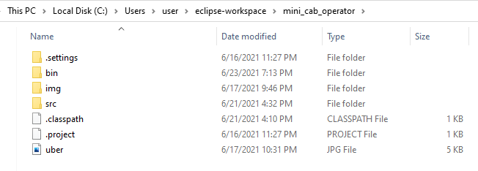

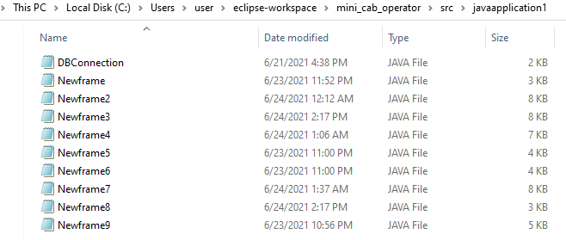

# Testing:

# **OUTPUT SCREENSHOTS:**

**MAIN PAGE:**

It displays the title of the project and it has two JButtons which are named as driver and passenger. The whole system is primarily operated by the admin. When Driver/Passenger Button is selected, he can perform operations such as Update, Delete and Insert, insert incase refers to the registration of new users.

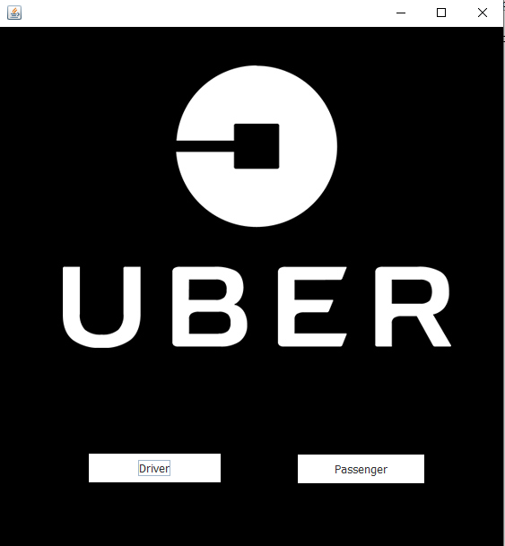

##### **Java GUI Screenshot:**

DRIVER TABLE IN SQL:

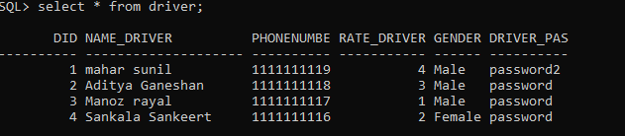

INSERT:

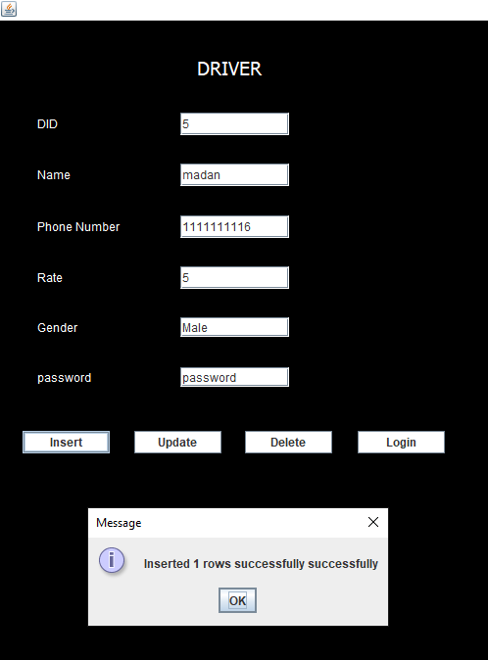

AFTER INSERTION:

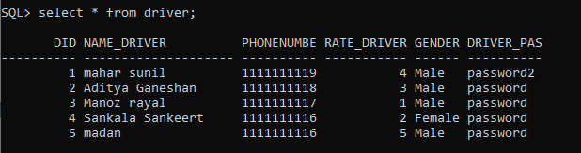

INSERTION ERROR: AS DID IS A NOT-NULL KEY (OR) DID CANNOT BE EMPTY.

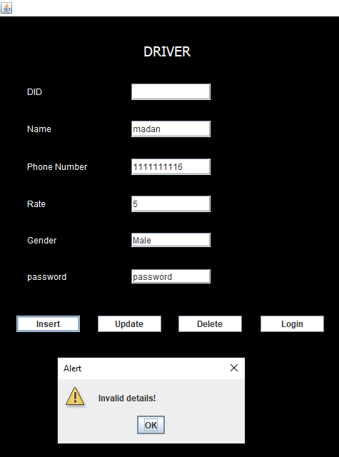

UPDATE:

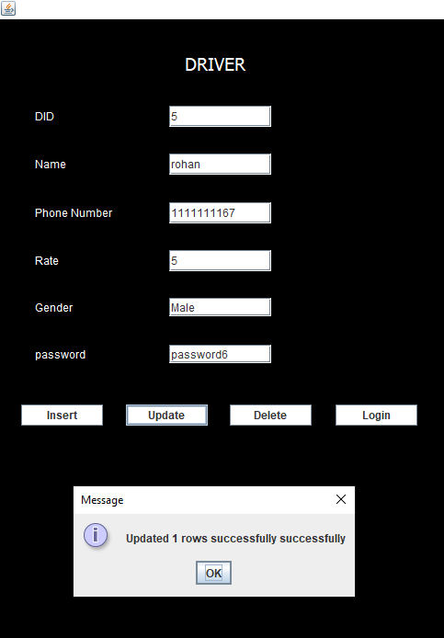

AFTER UPDATION:

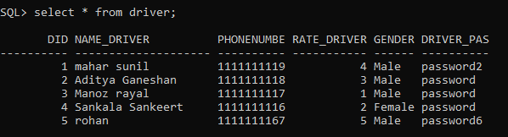

DELETE:

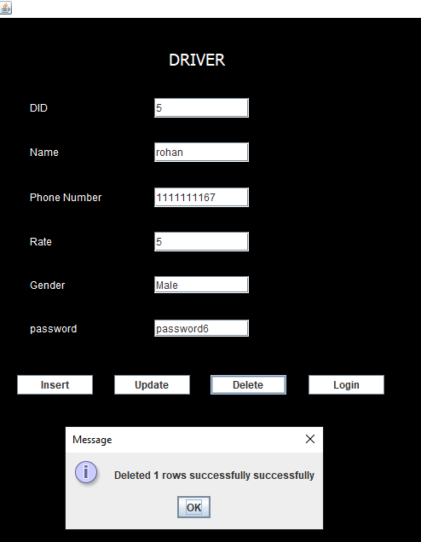

AFTER DELETION:



CLIENT TABLE: IN SQL:

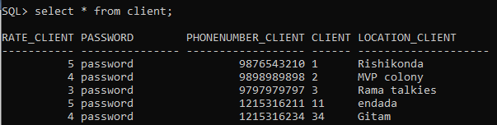

INSERT:

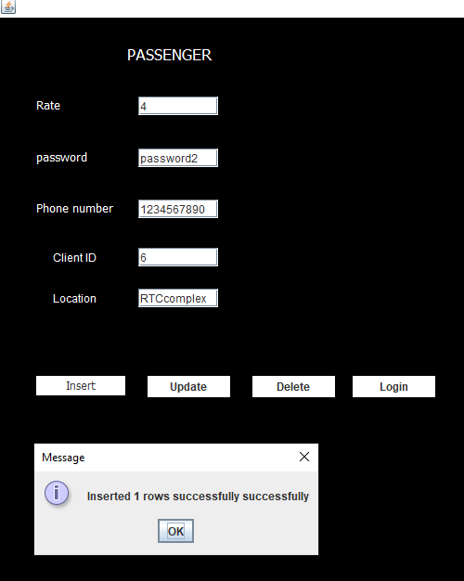\

AFTER INSERTION:

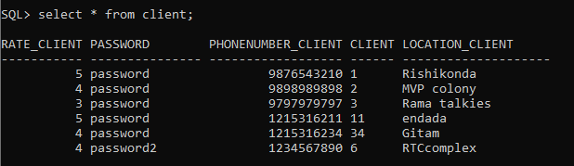

UPDATION:

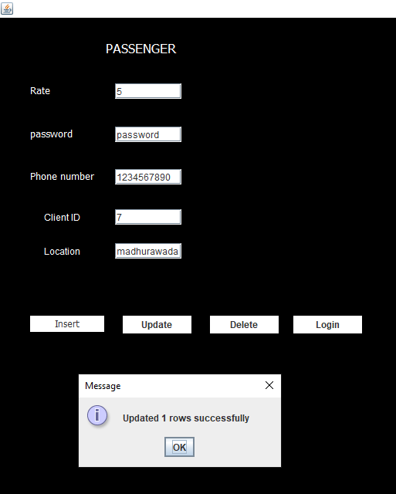

AFTER UPDATION:

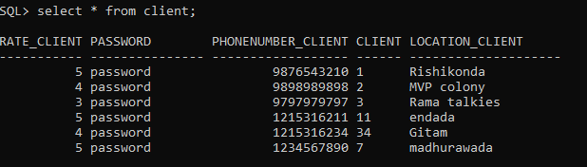

DELETION:

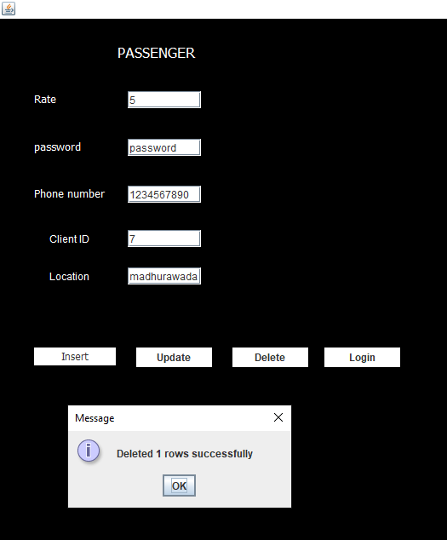

AFTER DELETION:



TRIP TABLE:

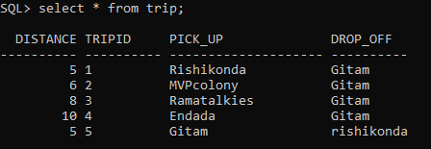

INSERT:

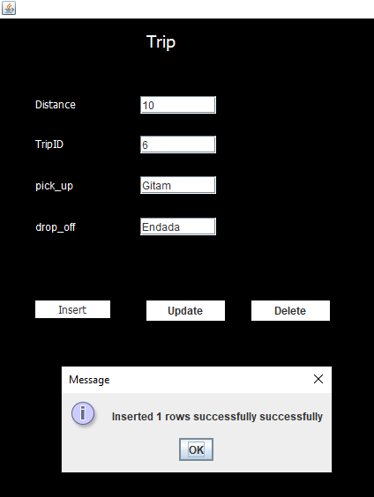

AFTER INSERTION:

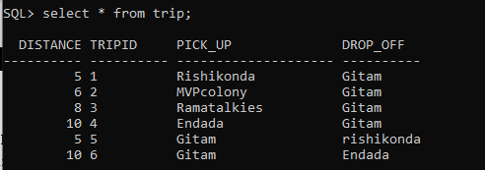

UPDATION:

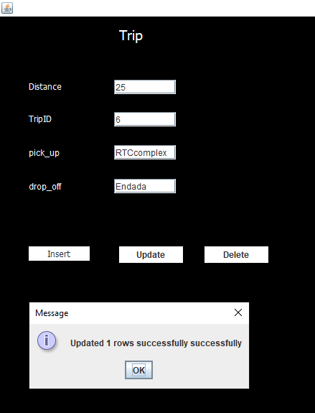

AFTER UPDATION:

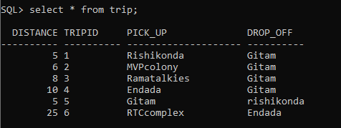

DELETION:

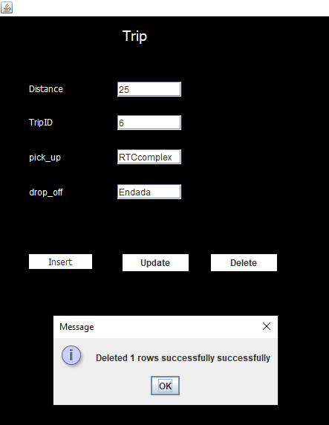

AFTER DELETION:



CAR TABLE:

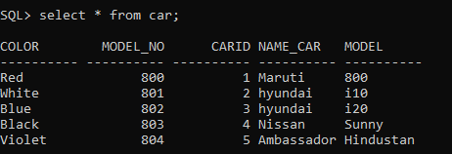

INSERTION:

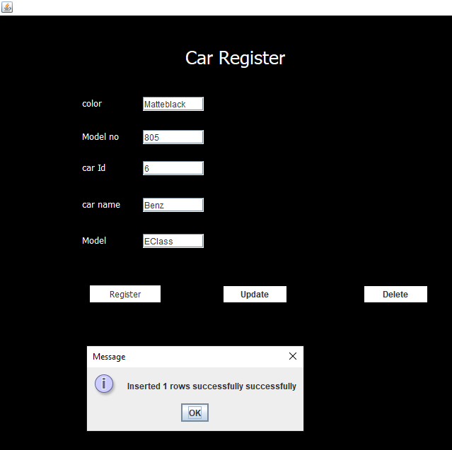

AFTER INSERTION:

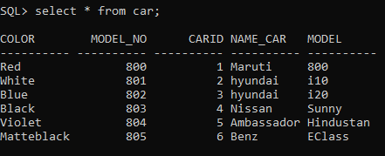

UPDATION:

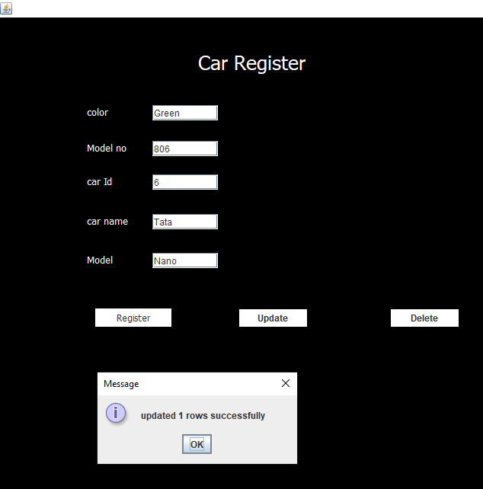

AFTER UPDATION:

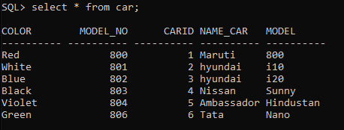

DELETION:

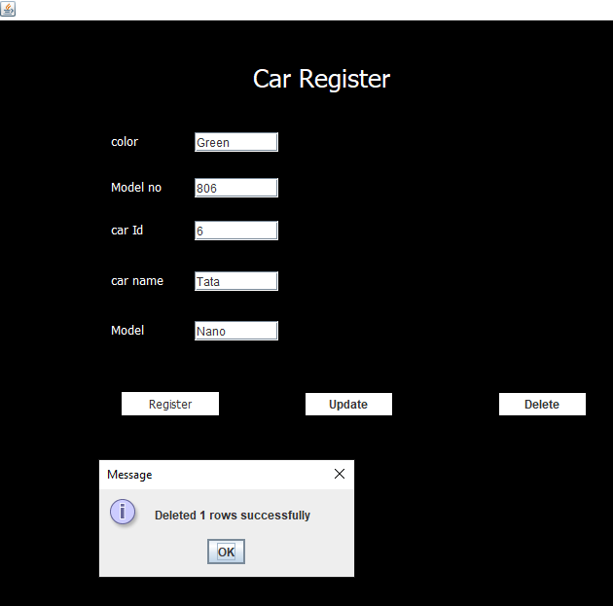

AFTER DELETION:



**RESULTS:**

I had successfully completed MINI PROJECT on “MINI-CAB-OPERATOR” (Uber Database Management System)

**Discussion and future Work:**

This application provides the clients to book a cab and the driver to reach out to the passenger. While working on this project I wanted to extend to make a app which is user friendly and provides accurate information.

**CONCLUSION:**

Thus, a Java SWING based MINI-CAB-OPERATOR is created which is connected to the Oracle 11g database. Therefore, all the entries and details are directly updated on their respective tables created in the database.

REFERENCES:

* <https://docs.oracle.com/javase/7/docs/api/>
* <https://www.javatpoint.com/dbms-tutorial>