**STOCK MANAGEMENT**

*A*

*Mini Project Report*

*Submitted in partial fulfilment of the Requirements for the award of the Degree of*

**BACHELOR OF ENGINEERING**

IN

**INFORMATION TECHNOLOGY**

By

KAMMARI BHARATH – 1602-19-737-069

MOTHKUR MADAN KUMAR – 1602-19-737-079

BADRIGARI MANINDRA– 1602-19-737-081



**Department of Information Technology Vasavi College of Engineering (Autonomous) (Affiliated to Osmania University) Ibrahimbagh, Hyderabad-31 202**

**Vasavi College of Engineering (Autonomous) (Affiliated to OsmaniA**

**University)**

**2020**

**Hyderabad-500 031 Department of Information Technology**

**DECLARATION BY THE CANDIDATE**

We, KAMMARI BHARATH, MOTHKUR MADAN KUMAR and BADRIGARI MANINDRA bearing hall ticket numbers, 1602-19-737-069, 1602-19-737-079 and 1602-19-737-081 respectively, hereby declare that the project report entitled “ STOCK MANAGEMENT ” is submitted in partial fulfilment of the requirement for the award of the degree of Bachelor of Engineering in Information Technology.

This is a record of bonafide work carried out by us and the results embodied in this project report have not been submitted to any other university or institute for the award of any other degree or diploma.

KAMMARI BHARATH – 1602-19-737-069

MOTHKUR MADAN KUMAR – 1602-19-737—079

BADRIGARI MANINDRA – 1602-19-737-081

(Faculty In-Charge) (Head, Dept. of IT)

**AKNOWLEDGEMENTS**

Our Mini Project would not have been successful without the help of several people. We are extremely thankful to our college, Vasavi College of Engineering, for providing the opportunity to implement our project, “STOCK MANAGEMENT”.

We thank our faculty (Prasanna mam) because they clarified our few doubts regarding to the project, gave few suggestions and guided us by which we successfully completed our project.

Last but not the least, we wish to thank our parents for financing our studies in this privileged Vasavi College of Engineering as well as for constantly encouraging us to learn engineering. Their personal sacrifice in providing this opportunity to learn engineering is gratefully acknowledged.

Sincerely,

**KAMMARI BHARATH 1602-19-737-069**

**MOTHKUR MADAN KUMAR 1602-19-737-079**

**BADRIGARI MANINDRA 1602-19-737-081**

**ABSTRACT**

The main aim of out Mini-project “STOCK MANAGEMENT” is to help the owners of the small stores to keep track of the stock they purchased, their sales, profits & losses their store is obtaining. This gives the owner a clear-cut of idea of everything that’s happening with the store like their sales, and many other things. Store Management System is based on the departmental store, which keeps the track of Inventory, Sales, Purchase & personnel. The system is Management Oriented. This system gives the management an efficient way to handle their main operational areas such as customer care, inventory control, point of sales & analysis, Profits.

**TABLE OF CONTENTS**

1. Introduction………………...............................................6
2. Technology………………………………………………9
3. Proposed Work…………………………………………10

3.1 Design………………………………………………..10

3.2 Implementation…………………………………….12

3.3 Testing………………………………………………12

1. Results…………………………………………………13
2. Additional Knowledge Acquired………………………21
3. Conclusion and Future Work………………………….22
4. References…………………………………………….23

# INTRODUCTION

## ABOUT THE PROJECT

“ STOCK MANAGEMENT" is a console-based C Project which keeps the record of sales and maintenance of products in a store . The program is run by the owner who can add products, record sales and feedbacks, modify product list, delete items, and finds the stock available in a store. Admin is the one who modify the users and provide security codes for logins. Sales-man sells the products and takes feedback.

## 1.1 PROJECT DOMAIN

A department store is a retail establishment which specializes in selling a wide range of products without a single predominant merchandise line. Department stores usually sell products including apparel, furniture, appliances, electronics, and additionally select other lines of products such as paint, hardware, toiletries, cosmetics, photographic equipment, jewellery, toys, and sporting goods. Certain department storesare further classified as discount department stores. Discount department stores commonly have central customer checkout areas, generally in the front area of the store. Department stores are usually part of a retail chain of many stores situated around acountry or several Countries. In other words, a departmental store is a large retail storesuffering a variety of merchandise and services and organized in separate departments. The

Departmental Store Management System is based on the departmental store, which keeps the track of Inventory, Sales, Purchase & personnel. The system is Management Oriented.This system gives the management an efficient way to handle their main operational areas such as customer care, inventory control, point of sales & analysis, Profits.

1.2 Problem:

In the departmental stores most of the work is done manually bymaintaining registers. This involves many limitations such as:

⦁ Increases the paper work

⦁ the time to access the data increases

⦁ Chances of Information Leakage or Loss of Information increases

⦁ Maintaining records is not Integrated

⦁ Duplication of data.

**Purpose**

The Main aim of developing this project is to provide any easy way not only automate all functionalities involved managing leaves and Payroll for the employees of Company, but also to provide full functional reports to management of School with necessary details. Nowadays large scale organization are committed to bring the best way of management in the various forms .

**Benefits**

* To improve efficiency.
* Provides security to the data as the cashiers, admin and even the owner has to enter their password everytime they login.
* Quickly find out information of the cashiers.
* Owner has a very easy and faster acccess to the bills, profits & losses, updatind price list and many other options.
* Every time when the cashier forgets their password hebcan contact admin for their password for which the admin provides them with a security which is generated randomnly at that very exact time.
* Very minute chances of information leakage.

# TECHNOLOGY

All computer software needs certain hardware components or other software resources to be present, in order for computers to be used efficiently. These prerequisites are known as System Requirements. Within this, we have two types – Software Requirements and Hardware Requirements.

## SOFTWARE REQUIREMENTS

Software Requirements deal with defining the software resource requirements and prerequisites that need to be installed on a computer to provide optimal functioning of an application. These preconditions are generally not included in the software installation package and need to be installed separately.

In order to use STOCK MANAGEMENT , one should have the following:

* **Operating System:** Windows 7 and above
* **C Compiler: Can be compiled using any c compiler**
* **Editor:** Any text editor .

## HARDWARE REQUIREMENTS

Hardware requirements refer to the common set requirements defined by any operating system or software application and are usually the physical computer resources. In this, we look into the architecture, processing power, memory, secondary memory, display adapter and peripherals.

In order to use this project, one should have the following:

* + - **Processor:** INTELi3 processor and above
    - **Memory:** 2 GB RAM and above

1. **PROPOSED WORK**

**DESIGN**

Our approach in designing the STOCK MANAGEMENT is to reduce the pen and paper work to manage the records in any organization (especially for small store owners).

**USE CASE DIAGRAM**

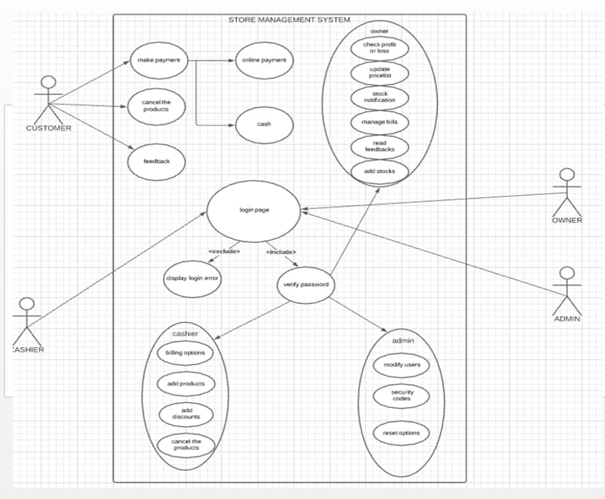

**3.1.1 LOGIN**

The admin has to login with the password. If the password is attempted incorrectly for thrice the it will exit. If the credentials were correct the admin now can start adding the cashiers. When the customer purchases the products, the billing prcess will start, where the user now has to login as one of the cashiers with the correct usernames and passwords as provided by the admin. If the password is incorrectly attempeted for more than thrice then the cashier has to contact the admin. Where the admin will provide the casheir with their password or a security code which is generated randomnly at that very exact amount of time. And now the cashier can start adding new bills. And when the everything’s done with the cashier i.e., like adding new bills now the user can login as the owner with their correct password. If the password is incorrectly entered for more than three

**3.1.2 ADD NEW STOCK/ NEW PRODUCTS.**

The owner has to go through the list of prodcuts available and the amount of stock of left. If the stock left is insufficient to meet the need of the customers, the owner van add the new stock.

**3.1.3 VIEW & MANAGAING BILLS**

The owner has access to each and very bill of customer in that particular day. He can view the bills and can also manage the bills like deleteing them if not needed.

**3.1.4 UPDATE PRICELIST**

The owner can update the price of the products available in his store any time depending upon the ever changing prices in the market inorder to gain the profits .

**3.1.5 READ FEEEDBACKS**

The owner can read the feedbacks provided by the customers.

**3.1.6 MODIFYING THE CASHIERS**

This the work of the admin. He can modify the cashiers. He can provide them with their passwords when forgotten amd also help them in logging into their page with a security code that is generated randomnly at that very exact time.

**3.1.7 ADDDING NEW BILLS**

This is the work of the cashier. He can add any number of bills depending upon the no. of customers purchasing the products.

**3.1.8 EXIT**

The admin on choosing the exit option the program gets terminated.

## 3.2 IMPLEMENTATION

Based on the use cases, we have implemented this project by dividing the work into modules – Start, Login, Adding cashiers, Adding new bills, managing bills, updating the pricelist, adding new stock, modifying the cashiers, reading the feeedbacks, checking upon the profits & losses.

## 3.3 TESTING

## Testing is a method to check whether the actual product matches the expected requirements and to

## ensure that the product is defect-free. This process involves execution of various parts of the

## product either using manual or automated tools. The purpose is to identify errors, gaps or missing

## requirements in contrast to the actual requirements.

## Firstly The admin has to login with the password. If the password is attempted incorrectly

## for thrice the it will exit. If the credentials were correct the admin now can start adding the cashiers

## When the customer purchases the products, the billing prcess will start, where the user now has to

## login as one of the cashiers with the correct usernames and passwords as provided by the admin. If

## the password is incorrectly attempeted for more than thrice then the cashier has to contact the

## admin. Where the admin will provide the casheir with their password or a security code which

## is generated randomnly at that very exact amount of time. And now the cashier can start adding

## new bills. Depending upon the number of purchases the customers make the cashier can add any no

## of bills.

## And when the everything’s done with the cashier i.e., like adding new bills now the user can

## login as the owner with their correct password. If the password is incorrectly entered for more than

## three times then the program will be exited. After logging into the owners page the user now access

## to the options like Adding the stocks, managing the bills, checking upon the profits and losses,

## updating the pricelist and others.

# 4.RESULTS

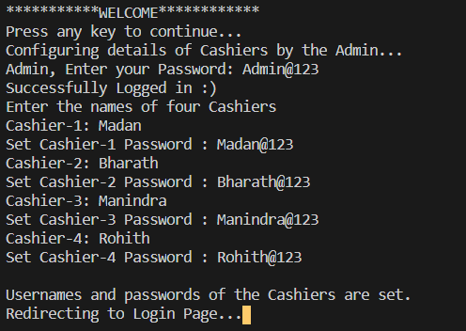

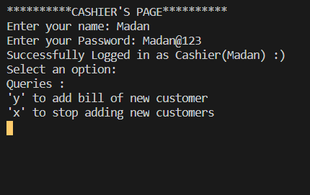

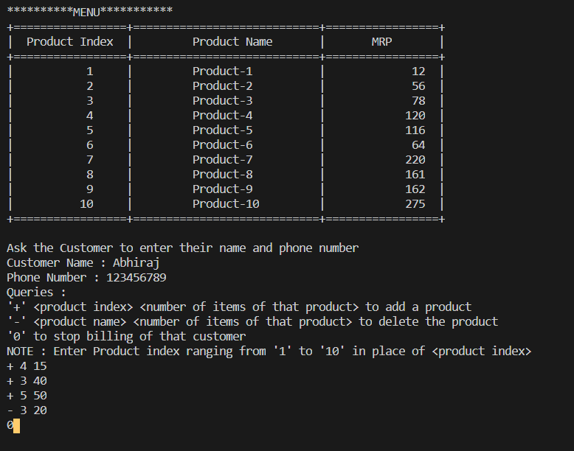

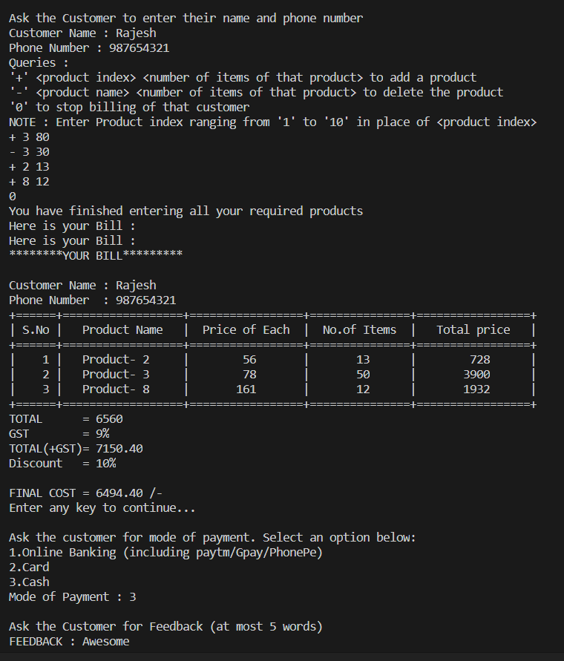

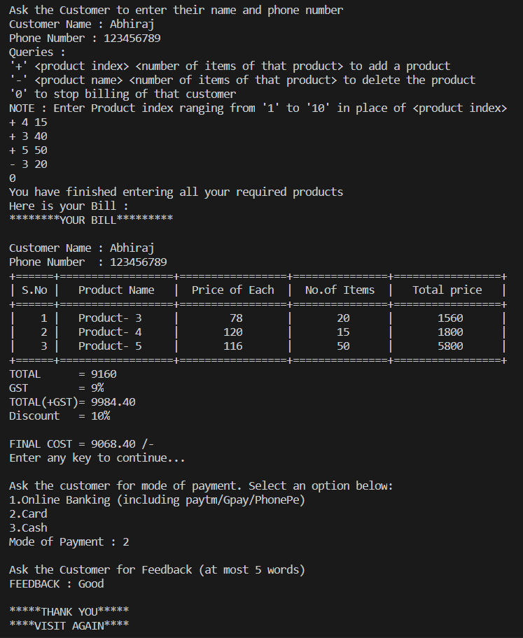

If the password entered by the cashier is incorrect :

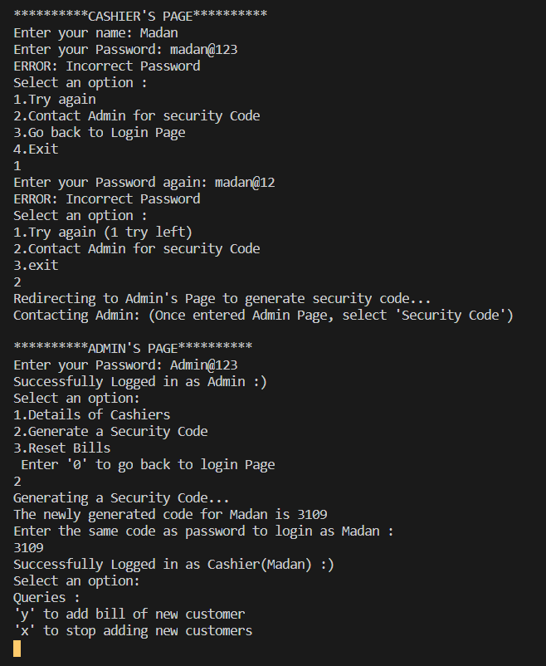

The user can login now as the admin to genertae a security code or can view the details of the cashiers saved.

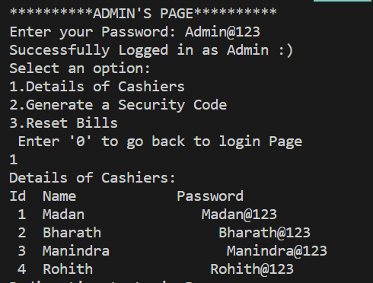

OWNER’s PAGE :

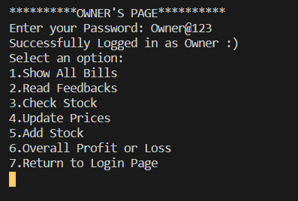

1. BILLS :

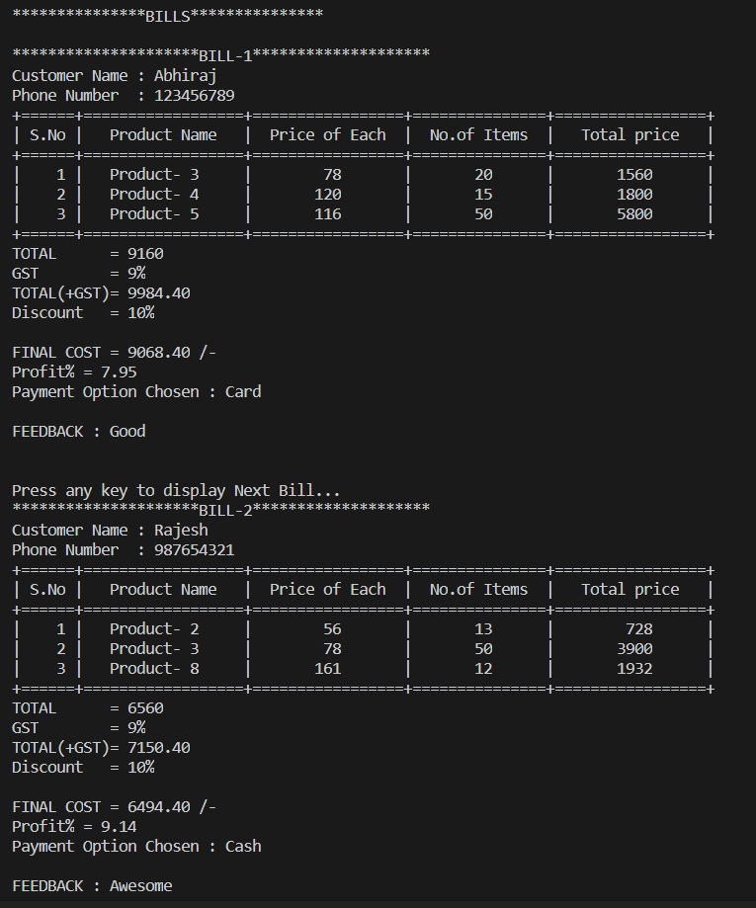

1. Read Feedbacks :

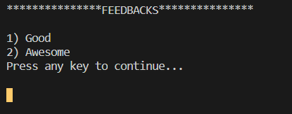

1. Check Stock :

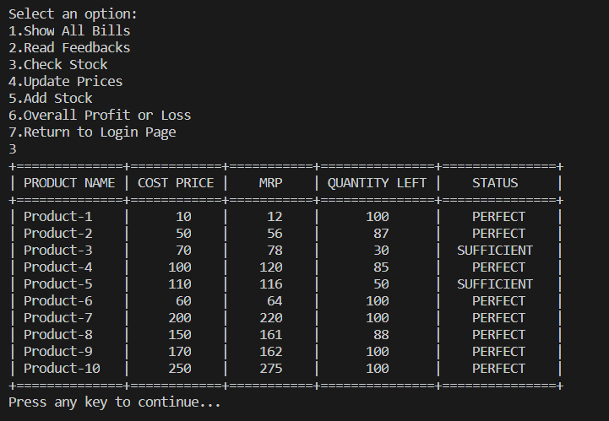

1. Update prices

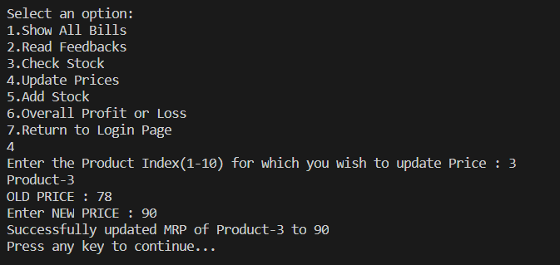

1. Add stock :

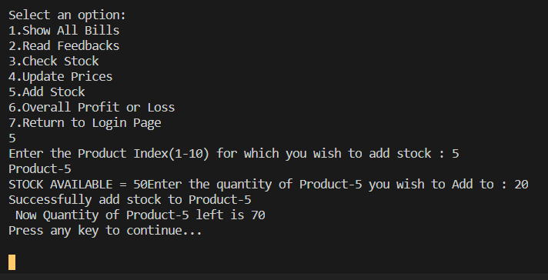

1. Overall profit or loss :

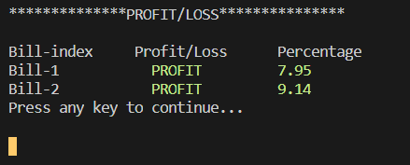

# 5. ADDITIONAL KNOWLEDGE ACQUIRED

Implementing this project in C Language has introduced us to different libraries such as: ‘conio.h’, ‘time.h’ and ‘windows.h’. We were able to use the knowledge we have on the Linked List Data Structure and execute it as a real-time application. We explored the ‘time.h’ and ‘conio.h’ libraries for achieving a look-and-feel of an actual window application by constructing our own time delay function.

Also, we have further improved in our knowledge in file-handling because of the vast amount of data manipulation we have done using text files.

Other than this, we have learnt the value of team spirit and have understood the intention behind working in teams. We have learnt to be team players.

# 

# 6.CONCLUSION AND FUTURE WORK

To conclude, this application is useful for many small store owners who are in a way illiterates. It can be operated very easily.

We develop the application in java Or HTML to make sure that it is user friendly and make real time payments which is saved in the server using htmL.

**7. REFERENCES**

1. C Language Documentation. [language/?view=msvc-160](https://docs.microsoft.com/en-us/cpp/c-language/?view=msvc-160)
2. Visual Studio Code:
3. Stack Overflow (for debugging errors): <https://stackoverflow.com/> 4.