[ ISEN Brest — Yncréa logo ]
ISEN BREST — YNCRÉA
Engineering degree — 4th year
TECHNICAL INTERNSHIP REPORT

Acquisition and standardised publication of NMEA 2000 vessel data
Acquisition node on an ESP32-S3 and publication to an OGC SensorThings database
[ Photograph of the vessel or of the acquisition node ]
Author: [TO COMPLETE: first name and surname]
Host organisation: Universitat Politècnica de Catalunya — SARTI research centre
Rambla de l'Exposició 24, 08800 Vilanova i la Geltrú, Spain
Internship period: [TO COMPLETE] — [TO COMPLETE] (10 weeks)
Industrial tutor: [TO COMPLETE] Academic supervisor: [TO COMPLETE]
Date of writing: [TO COMPLETE]
Review by the industrial tutor
Name and first name of the tutor: ..................................................................
Date of review: ...........................................
Signature of the tutor: Stamp of the organisation:

Acknowledgements
The work presented in this report was carried out at the SARTI research centre of the Universitat Politècnica de Catalunya, in Vilanova i la Geltrú. The quality of the reception given to a visiting student, and the degree of technical autonomy that was granted from the first week, contributed directly to the results described in the following chapters.
Thanks are due to [TO COMPLETE: name of the industrial tutor], who supervised the internship, for the definition of a subject that was both open and precisely bounded, for the access granted to the instrumented vessel and to the laboratory equipment, and for the time spent reviewing the technical choices at each stage of the project.
Thanks are also due to [TO COMPLETE: name of the server administrator], responsible for the OBSEA infrastructure, for the server access, the network configuration and the advice on the deployment constraints of the production environment, and to the members of the SARTI team who assisted with the instrumentation of the vessel and with the sea trials.
Finally, thanks are due to [TO COMPLETE: name of the ISEN academic supervisor] for the academic follow-up of this internship, and to the international relations department of ISEN Brest for making this placement abroad possible.
Table of contents
Acknowledgements 1
Glossary 4
1. Introduction 7
2. Presentation of the host organisation 8
2.1 The Universitat Politècnica de Catalunya 8
2.2 The SARTI research centre 8
2.3 The OBSEA observatory 8
2.4 Position of the internship within the group's activity 9
3. Context 10
3.1 The existing installation 10
3.2 The shore infrastructure 10
3.3 The initial request 10
3.4 Social responsibility and sustainable development 10
4. Technical objectives and specification 13
4.1 Functional requirements 13
4.2 Boundaries of the study 13
5. Technical development 14
5.1 A priori analysis of the problem 14
5.1.1 Alternatives considered 14
5.2 The NMEA 2000 network 15
5.2.1 Physical topology 15
5.2.2 Frame format and parameter groups 16
5.2.3 Encoding conventions 17
5.2.4 Bus load and network management 18
5.3 Hardware implementation 19
5.3.1 Power budget and environmental constraints 19
5.4 Firmware architecture 20
5.4.1 Task organisation and resource usage 20
5.4.2 Reception and decoding 21
5.4.3 Diagnostic instrumentation 22
5.4.4 Source arbitration between parameter groups 23
5.4.5 Time reference 23
5.4.6 Local dashboard 24
5.5 Data model and shore infrastructure 24
5.5.1 Entity model 24
5.5.2 Provisioning of the entities 25
5.5.3 Querying the stored observations 26
5.5.4 Volume of data and retention 26
5.5.5 Server deployment 27
5.6 Security of the chain 27
5.7 Publication chain 28
5.8 Integration and validation 29
5.8.1 Measurement method and sources of uncertainty 31
5.8.2 Interpretation of the results 32
5.9 Critical analysis of the technical choices 32
6. Project management 34
6.1 Organisation of the work 34
6.2 Tooling and configuration management 34
6.3 Initial planning and its evolution 35
6.4 Risk management 36
6.5 Handover 37
7. Conclusion 38
Bibliography 39
Annexes 40
Annexe A — Wiring table of the acquisition node 40
Annexe B — Provisioning of the server entities 40
Annexe C — Publication payload 40
Annexe D — Decoding of a parameter group 41
Annexe E — Bill of materials and indicative cost 41
Annexe F — Photographic record 41

Glossary
The following acronyms and technical terms are used throughout this report. Each one is also expanded at its first occurrence in the text.
AIS Automatic Identification System. Maritime traffic monitoring system that broadcasts the identity, position and course of equipped vessels.
API Application Programming Interface. Set of operations exposed by a software component for use by another component.
CAN Controller Area Network. Serial bus standard (ISO 11898) used as the physical and data-link layer of NMEA 2000.
COG Course Over Ground. Direction of the vessel's movement relative to the seabed.
CSRD Corporate Sustainability Reporting Directive. European directive on the publication of sustainability information.
DDRS Développement Durable et Responsabilité Sociétale. Academic equivalent of corporate social responsibility.
DHCP Dynamic Host Configuration Protocol. Automatic allocation of network addresses.
ESP-IDF Espressif IoT Development Framework. Official development framework for ESP32 microcontrollers.
FROST Fraunhofer Open Source SensorThings. Open-source server implementing the OGC SensorThings API.
GNSS Global Navigation Satellite System. Generic term covering GPS, Galileo, GLONASS and BeiDou.
GPIO General Purpose Input Output. Configurable digital pin of a microcontroller.
HTTP HyperText Transfer Protocol. Application protocol used for the REST interface of the server.
ISR Interrupt Service Routine. Function executed in interrupt context, with strong constraints on execution time.
JSON JavaScript Object Notation. Text format used for the payload of the published observations.
LEN Load Equivalency Number. Unit of electrical load of a device connected to an NMEA 2000 backbone.
MQTT Message Queuing Telemetry Transport. Lightweight publish and subscribe protocol designed for constrained devices.
NMEA 2000 Standard for serial data networking of marine electronic devices, published by the National Marine Electronics Association.
NTP Network Time Protocol. Protocol for clock synchronisation over a network.
OBSEA Expandable Seafloor Observatory operated by SARTI off Vilanova i la Geltrú.
OGC Open Geospatial Consortium. Standards body responsible for the SensorThings API specification.
PGN Parameter Group Number. Identifier that defines the meaning and layout of an NMEA 2000 message.
PostGIS Spatial extension of the PostgreSQL database management system.
REST Representational State Transfer. Architectural style used by the HTTP interface of FROST-Server.
RSE Responsabilité Sociétale des Entreprises. French term for corporate social responsibility.
SARTI Sistemes d'Adquisició Remota i Tractament de la Informació. Research centre of the UPC hosting the internship.
SDG Sustainable Development Goal. One of the seventeen goals defined by the United Nations.
SOG Speed Over Ground. Speed of the vessel relative to the seabed.
STA SensorThings API. OGC standard for the exposure of sensor observations over the web.
TLS Transport Layer Security. Cryptographic protocol securing the HTTP and MQTT transport.
TWAI Two-Wire Automotive Interface. Name given by Espressif to the CAN controller integrated in the ESP32.
UPC Universitat Politècnica de Catalunya. Host university of the internship.
List of figures
Figure 1: Host site: SARTI research centre, UPC Vilanova i la Geltrú campus 8
Figure 2: Architecture of the acquisition chain, from the vessel sensors to the shore clients 14
Figure 3: Trunk-and-drop topology of the instrumented vessel, with the position of the acquisition node 16
Figure 4: M12 five-pin pinout and interface between the acquisition node and the backbone 16
Figure 5: Structure of the 29-bit identifier and parameter groups exploited by the acquisition node 17
Figure 6: Fast-packet reassembly and the buffer defect that was identified and corrected 17
Figure 7: Estimated frame rate per parameter group and resulting load of the backbone 18
Figure 8: Internal organisation of the firmware, from the interrupt service routine to the publication tasks 20
Figure 9: Connectivity state machine of the node, and independence of the acquisition path 23
Figure 10: Layout of the local dashboard served by the node on the on-board network 24
Figure 11: Entity model of the OGC SensorThings API as instantiated for the vessel 25
Figure 12: Deployment of the shore infrastructure on the laboratory server 27
Figure 13: Trust boundaries of the acquisition chain 28
Figure 14: Publication sequence of an observation, from the node to the database 29
Figure 15: Three-level validation strategy applied to the acquisition chain 30
Figure 16: Bench configuration used before installation on board 30
Figure 17: Planning of the ten weeks, with the milestones actually reached 35
Figure 18: Risks identified at the start of the project and their assessed severity 36
Figure 19: Acquisition node: microcontroller module, transceiver and M12 connection 41
Figure 20: Installation of the node on the instrumented vessel 42
Figure 21: Local dashboard displaying live values during a sea trial 42
Figure 22: Observations retrieved from the production database over the REST interface 42

1. Introduction
Marine observation infrastructures rely on two complementary families of sensors. Fixed installations, such as cabled seafloor observatories, deliver long time series at a single point. Mobile platforms, and in particular working vessels, cover a much larger area but rarely contribute their measurements to any scientific database, because the data produced on board remain confined to the navigation instruments that display them.
Every recent vessel carries an NMEA 2000 network, an on-board digital bus on which position, heading, speed, depth, engine parameters and traffic information circulate continuously. That bus is a dense source of georeferenced measurements, already digitised and already timestamped. It is, however, a closed source: the data are broadcast for the benefit of the chart plotter and the engine display, they are not stored, and they are not accessible from shore.
This report describes the design, the implementation and the validation of an acquisition chain that opens that source. An embedded node based on an ESP32-S3 microcontroller listens to the NMEA 2000 backbone of an instrumented vessel, decodes the parameter groups of interest, and publishes the resulting observations to a database hosted by the SARTI research centre of the Universitat Politècnica de Catalunya. The database is a FROST-Server instance implementing the OGC SensorThings API, the same standard already used for the fixed sensors of the OBSEA observatory, so that mobile and fixed measurements can be queried through a single interface. A local web dashboard, served by the node itself, gives the crew an immediate view of the acquired quantities without any dependency on the shore link.
The work was carried out over ten weeks, from [TO COMPLETE: start date] to [TO COMPLETE: end date], within the SARTI research centre in Vilanova i la Geltrú, Spain.
The report is organised as follows. Chapter 2 presents the host organisation and its scientific activity. Chapter 3 sets out the context of the project, the state of the existing installation, the initial request, and a reflection on the social responsibility and sustainable development dimensions of the host laboratory and of the work performed. Chapter 4 formalises the technical objectives and the specification against which the result is assessed. Chapter 5 constitutes the core of the document: it describes the a priori analysis of the problem, the architecture that was derived from it, the hardware and firmware implementation, the data model, the server deployment, the validation campaign, and a critical analysis of the choices that were made. Chapter 6 analyses the management of the project, the evolution of the technical decisions and their effect on the schedule. Chapter 7 concludes and states the perspectives, with an estimate of the effort and the material cost required to extend the work.

2. Presentation of the host organisation

2.1 The Universitat Politècnica de Catalunya
The Universitat Politècnica de Catalunya (UPC), also known as BarcelonaTech, is a public technical university specialised in engineering, architecture, science and technology. Its activity is distributed over several campuses in Catalonia, one of which is located in Vilanova i la Geltrú, a coastal town approximately fifty kilometres south of Barcelona. The Vilanova campus hosts the Escola Politècnica Superior d'Enginyeria de Vilanova i la Geltrú and several research groups attached to the Department of Electronic Engineering.

2.2 The SARTI research centre
The internship took place within SARTI, Sistemes d'Adquisició Remota i Tractament de la Informació, a research centre of the Department of Electronic Engineering located at the Vilanova i la Geltrú technological campus, Rambla de l'Exposició 24. The group is multidisciplinary and specialises in remote data acquisition and information processing systems, with a strong emphasis on marine and Earth sciences applications.
SARTI works in association with the Spanish National Research Council through its Institutes of Earth Sciences and Marine Sciences, is a member of the European Seas Observatory Network, and has been part of the Catalan network of technological innovation centres since 2001. Its activity combines academic research, technology transfer towards industry, and the operation of scientific instrumentation.

[ INSERT: Photograph of the SARTI building or of the Vilanova i la Geltrú campus ]
Figure 1: Host site: SARTI research centre, UPC Vilanova i la Geltrú campus

2.3 The OBSEA observatory
The most visible instrument operated by the group is OBSEA, an expandable cabled seafloor observatory deployed off the coast of Vilanova i la Geltrú. The observatory sits at a depth of twenty metres inside a fishing protected area and is connected to shore by a four-kilometre submarine cable. That cable delivers up to 3.6 kW of power to the seabed station and provides a one-gigabit-per-second communication link, which allows instruments to operate continuously and to transmit data in real time rather than storing them for later recovery.
The seabed station hosts oceanographic and biological instrumentation. A surface buoy moored forty metres away carries a weather station measuring wind speed, air temperature and atmospheric pressure, a satellite positioning receiver and a video camera. The whole installation is a permanent test bench for marine instrumentation as much as it is a scientific observatory, and a substantial part of the group's technical work consists in maintaining, extending and standardising the acquisition chains that feed it.

2.4 Position of the internship within the group's activity
The project described in this report extends that acquisition activity from fixed instrumentation to a mobile platform. The observatory infrastructure already ingests, stores and publishes time series coming from fixed sensors; the vessels operated or used by the group produce comparable quantities but do not feed the same infrastructure. Bridging that gap was the object of the internship. The work was supervised by [TO COMPLETE: name and role of the industrial tutor], and the server-side deployment was carried out in coordination with the administrator responsible for the OBSEA computing infrastructure.
Table 1: Identification of the host organisation
Item | Value
Organisation | Universitat Politècnica de Catalunya (UPC) — SARTI research centre
Address | Rambla de l'Exposició 24, 08800 Vilanova i la Geltrú, Spain
Field of activity | Remote acquisition systems and information processing for marine and Earth sciences
Main infrastructure | OBSEA expandable seafloor observatory
Industrial tutor | [TO COMPLETE]
Duration of the internship | 10 weeks, from [TO COMPLETE] to [TO COMPLETE]
Working languages | Spanish, Catalan, English

3. Context

3.1 The existing installation
The starting point of the project is a working vessel equipped with a standard NMEA 2000 network. Two vessels were involved over the course of the internship: the first was used for development and bench validation, the second for the production deployment. Both carry an equivalent set of devices, which defines the set of quantities that can realistically be acquired.
Table 2: Devices connected to the vessel backbone
Device | Function | Quantities exposed on the bus
Sportnav SPO25F | GNSS receiver | position, speed and course over ground, satellite status
em-trak B921 | AIS class B transponder | own static data, position reports of surrounding traffic
SELVA outboard engine with DLC-Plus display | propulsion | engine speed, coolant temperature, operating hours, alarms
KTD-TM520 | depth and speed transducer | water depth below transducer, speed through water, water temperature

All of these devices are certified for the NMEA 2000 standard and coexist on a single backbone. The information they produce is displayed on board and then discarded: none of the devices stores a history, and none of them exposes an interface towards a shore network. Any subsequent use of the measurements, whether for scientific analysis, for fleet monitoring or for maintenance, is therefore impossible.

3.2 The shore infrastructure
On the shore side, the group operates a data infrastructure built on the OGC SensorThings API. This standard defines a normalised data model and a REST interface for the publication of sensor observations, and it is implemented here by FROST-Server, an open-source server backed by a PostgreSQL database with the PostGIS spatial extension. Choosing the same standard for the vessel data was a constraint of the project rather than an option: any measurement published in another format would have required a dedicated client, a dedicated storage schema and a dedicated maintenance effort.

3.3 The initial request
The request formulated at the beginning of the internship was to establish a continuous, automatic and standardised link between the two, namely to read the NMEA 2000 bus of the vessel, to decode the parameter groups carrying the quantities of interest, and to insert the corresponding observations into the existing database, in real time whenever network coverage allows. Two secondary requirements were expressed: the acquisition must not disturb the operation of the existing navigation devices in any way, and the crew must retain a local view of the acquired data even when the shore link is unavailable.

3.4 Social responsibility and sustainable development
The host laboratory is a public research centre attached to a university, so its social responsibility framework is that of the academic sector rather than that of a commercial company. Its equality and inclusion policy is defined at university level: UPC publishes an equality plan and operates a dedicated unit responsible for gender equality and for the accommodation of students and staff with disabilities. Within the research group, the working languages and the composition of the teams reflect a strong international mobility, and the reception of interns from foreign institutions is a routine part of the group's activity. The internship itself, carried out under a European mobility framework, is a concrete instance of that policy.
The environmental dimension is more directly connected to the scientific object of the laboratory. The group's activity consists in observing the coastal marine environment, and the OBSEA observatory is deployed inside a protected fishing area whose ecosystem it monitors continuously. The prioritised axis is therefore the production of environmental knowledge rather than the reduction of an industrial footprint, which is intrinsically small for a laboratory of this size. The choice of a cabled observatory is itself a sustainability decision: powering instruments from shore avoids the periodic replacement of battery packs at sea and the associated vessel movements, and it removes a recurrent source of waste in a protected area.
The work carried out during the internship contributes to that axis in three measurable ways. First, it increases the observational coverage of the coastal zone at no additional hardware cost, since the sensors being exploited are already installed and already powered on the vessel for navigation purposes. The marginal energy cost of the acquisition chain is limited to that of the acquisition node itself, of the order of one watt, against several hundred watts for the propulsion and the navigation electronics. Second, it makes engine data available, which opens the way to a quantified analysis of fuel consumption as a function of speed and sea state, and therefore to an operational reduction of emissions. Third, publishing the observations through an open standard rather than a proprietary format extends the useful lifetime of the data and allows their reuse by other teams, which is a form of sobriety applied to scientific information: a measurement that can be found and interpreted ten years later does not have to be acquired twice.
Several technical decisions described in the following chapters were taken with those considerations in mind. The node was designed to listen to the bus without drawing power from it and without transmitting on it, which protects the existing installation and avoids any duplication of sensors. Standard, widely available and inexpensive components were preferred to a custom design, which reduces the environmental cost of manufacturing and makes repair and replacement possible without a specific supply chain. The publication format was aligned with an existing open standard rather than defined ad hoc, which avoids the future rewriting of clients and databases. These choices connect the project to the United Nations sustainable development goals 9, industry, innovation and infrastructure, 13, climate action, and 14, life below water, the last of which is the explicit object of the observatory.
The main limitation identified during this analysis concerns the end of life of the electronics and the dependence on a mobile network operator for the transmission. Neither point was addressed within the ten weeks. A recommendation for the continuation of the project is to specify the acquisition node as a repairable module with a documented bill of materials, and to evaluate a store-and-forward mode that would allow the vessel to operate outside network coverage without loss of data, which would reduce both the volume of transmitted data and the energy spent on the radio link.
On a personal level, this experience situated engineering work inside a scientific and environmental purpose that is explicit rather than implied. The engineer's role in ecological and digital transitions appears here as that of an intermediary: the measurement exists, the science exists, and what is missing is the chain that makes one available to the other. That observation is a durable one and is intended to guide subsequent professional choices.

4. Technical objectives and specification

4.1 Functional requirements
The initial request was translated into a set of numbered requirements at the end of the second week, after the first bench experiments had established what the bus could actually deliver. The requirements are stated in verifiable form, so that each of them can be associated with an acceptance test in Chapter 5.
Table 3: Functional requirements
Ref. | Requirement | Verification
F1 | Receive and decode the parameter groups carrying position, course, speed, heading, water depth and engine parameters | Comparison of the decoded value with the reading of the corresponding on-board display
F2 | Decode the position reports of surrounding AIS traffic | Comparison with an independent AIS receiver
F3 | Publish each acquired quantity to the shore database as a normalised observation | Query of the database over its REST interface
F4 | Timestamp every observation with an absolute time reference | Inspection of the phenomenonTime field of the stored observations
F5 | Serve a local web dashboard displaying the current values | Access from a browser connected to the on-board network
F6 | Resume operation automatically after a loss of the radio link or a power cycle | Interruption test on the link and on the supply

Table 4: Non-functional requirements
Ref. | Requirement | Target value
N1 | Publication period per quantity | 1 s
N2 | Electrical load presented to the NMEA 2000 backbone | none, the node is externally powered
N3 | Effect on the existing devices | strictly none, reception only
N4 | Continuous operation without manual intervention | ≥ 24 h
N5 | Compliance of the published data with the OGC SensorThings API | version 1.1
N6 | Transport security between vessel and server | encrypted channel, key-based server administration

4.2 Boundaries of the study
Three points were explicitly excluded from the scope at the start of the project, and are recalled here because they bound the interpretation of the results. The node does not transmit on the NMEA 2000 bus, so no address claiming procedure and no device certification were required. The long-term storage policy, the retention period and the backup of the database are the responsibility of the infrastructure administrator and were not redefined. Finally, the scientific exploitation of the collected data, that is to say their analysis, was not part of the internship: the objective was to make the data exist, to make them accessible and to make them interpretable.

5. Technical development

5.1 A priori analysis of the problem
Before any implementation, the problem was decomposed into four independent questions, each of which can be answered separately and each of which corresponds to a possible point of failure of the complete chain. What is physically present on the bus, and how is it encoded? How can a low-cost microcontroller be connected to that bus without disturbing it? How should a heterogeneous set of instantaneous values be represented so that a standardised database can accept them? How should those values be transported from a moving vessel to a fixed server across an intermittent link?
This decomposition drove the whole schedule. It also determined the order of the work: the first two questions concern the vessel and were answered on a bench reproducing the vessel, the last two concern the shore and were answered on the server, and the two halves were joined only once each of them had been validated in isolation. That sequencing is visible in the planning presented in Chapter 6.
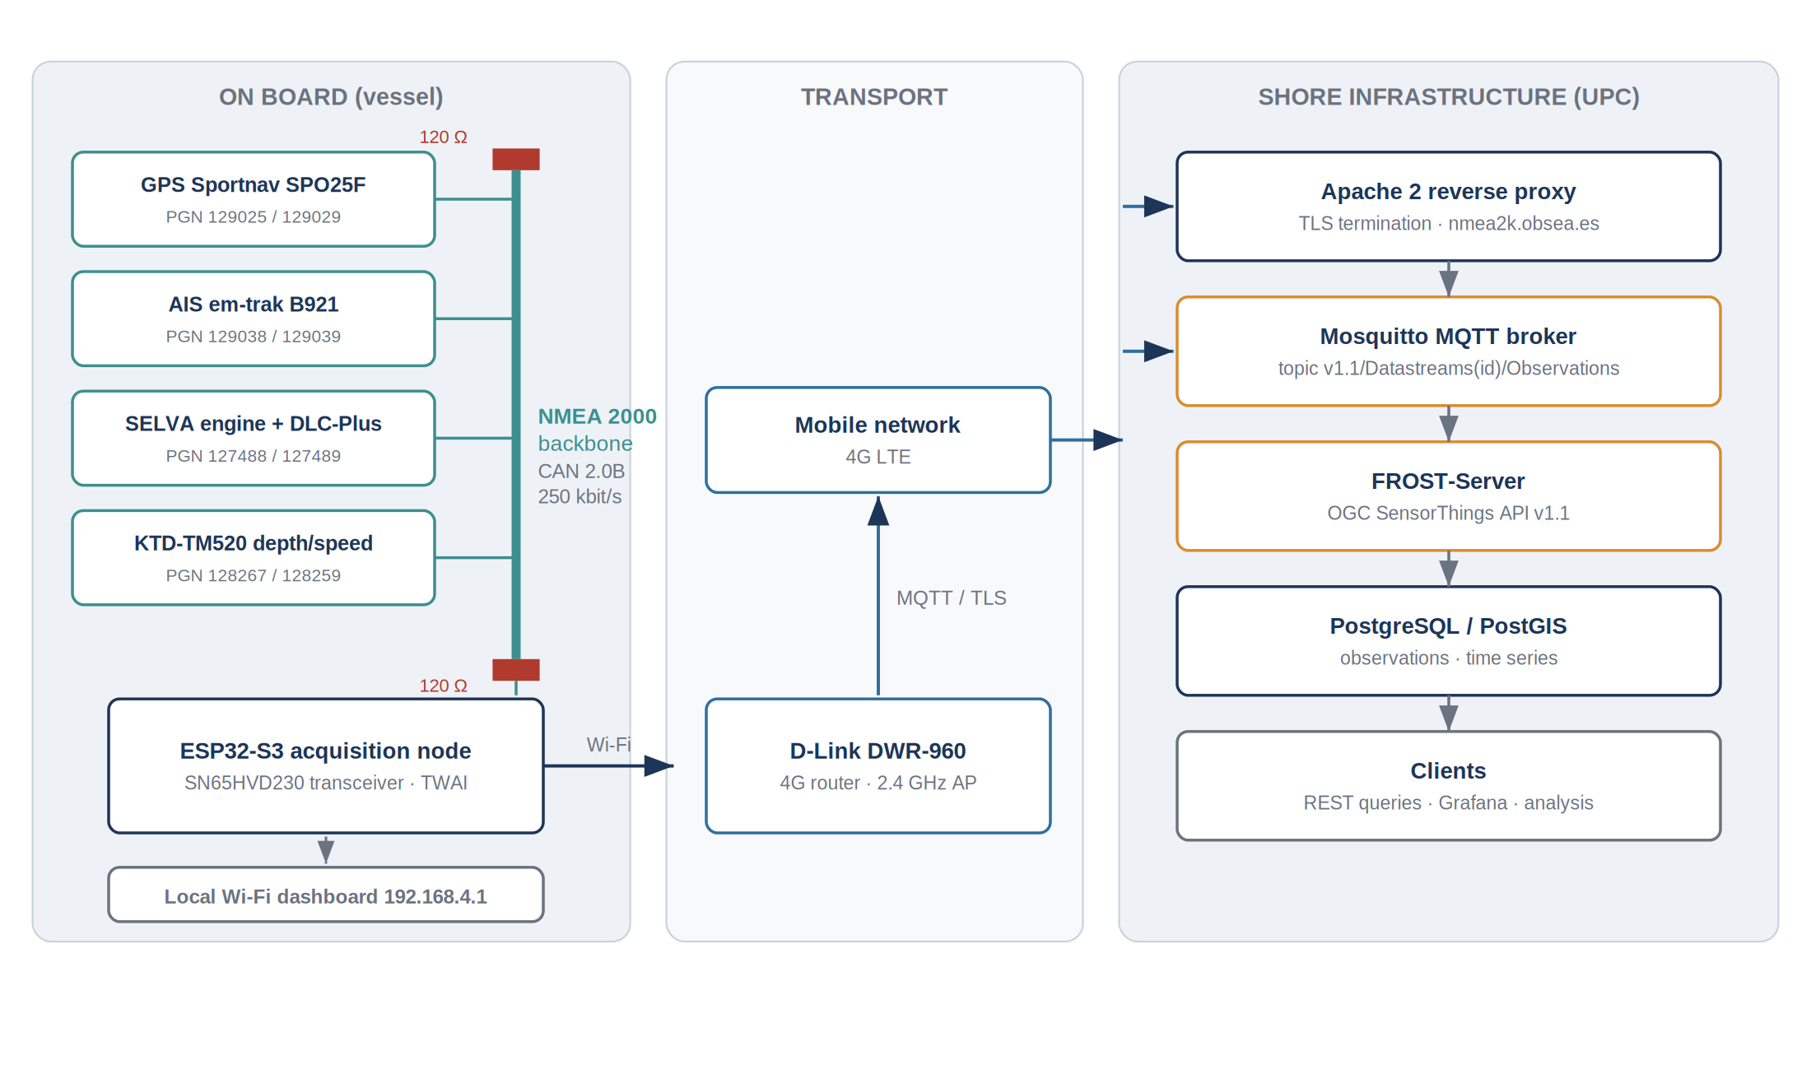
Figure 2: Architecture of the acquisition chain, from the vessel sensors to the shore clients
The architecture that results from the analysis is shown above. It is deliberately linear: each stage transforms the data once and hands them to the next stage, and no stage stores state that another stage needs. Three properties of that arrangement were sought from the beginning. The acquisition stage is passive, so the existing installation is unaffected by any failure downstream. The processing stage holds only the last known value of each quantity, so a restart costs at most one publication period. The publication stage is the only one that depends on the radio link, so an outage degrades the service to a purely local one instead of interrupting it.

5.1.1 Alternatives considered
Three families of solutions were compared before the architecture was fixed. The comparison is reproduced here because the arguments determined several later decisions.
Table 5: Comparison of the candidate architectures
Option | Principle | Advantages | Reasons for rejection or selection
A — Commercial NMEA 2000 gateway | A certified gateway converts the bus to NMEA 0183 or to a proprietary Ethernet protocol, a computer on board forwards the result | No firmware development, immediate certification | Cost per vessel, dependence on a proprietary format, an on-board computer must be powered and maintained, no control over the published data model
B — Raspberry Pi class computer with a CAN interface | A single-board computer runs a Linux system, a CAN interface reads the bus, a Python client publishes the observations | Full software freedom, familiar tooling, easy logging | Power consumption of an order of magnitude higher, sensitivity to unclean power cycles on a vessel, file system corruption risk, oversized for the task
C — Microcontroller with an integrated CAN controller | An ESP32-S3 reads the bus through an external transceiver and publishes over Wi-Fi | Low consumption, immediate start-up, no file system to corrupt, integrated radio, very low unit cost | Requires firmware development and a rigorous approach to real-time constraints

Option C was selected. The determining criteria were the robustness to abrupt power interruptions, which are frequent on a small vessel, and the ability to reach a working state within a second of power-on, which a Linux system cannot guarantee. The cost per node, of the order of a few tens of euros, also makes the replication of the installation on several vessels realistic, which is an explicit objective of the laboratory.

5.2 The NMEA 2000 network
NMEA 2000 is a standard for serial data networking of marine electronic devices published by the National Marine Electronics Association. It is built on the CAN 2.0B physical and data-link layers, operates at 250 kbit/s, and derives its application layer from the ISO 11783 family, itself an extension of the SAE J1939 protocol used in road and agricultural vehicles. That lineage is important in practice: the frame structure, the addressing mechanism and the multi-frame transport are inherited, and the documentation of the underlying protocols is far more accessible than the standard itself, which is not published freely.

5.2.1 Physical topology
The network is organised as a linear trunk terminated at both ends by a 120-ohm resistor, from which short drop cables lead to the individual devices. The trunk carries the two signal conductors, CAN H and CAN L, a shield, and a power pair used by the devices that draw their supply from the bus. Connections use M12 five-pin A-coded connectors, referred to as micro-C in the marine industry. The electrical load of each device is expressed as a load equivalency number, and the sum over the network determines the required supply capacity.
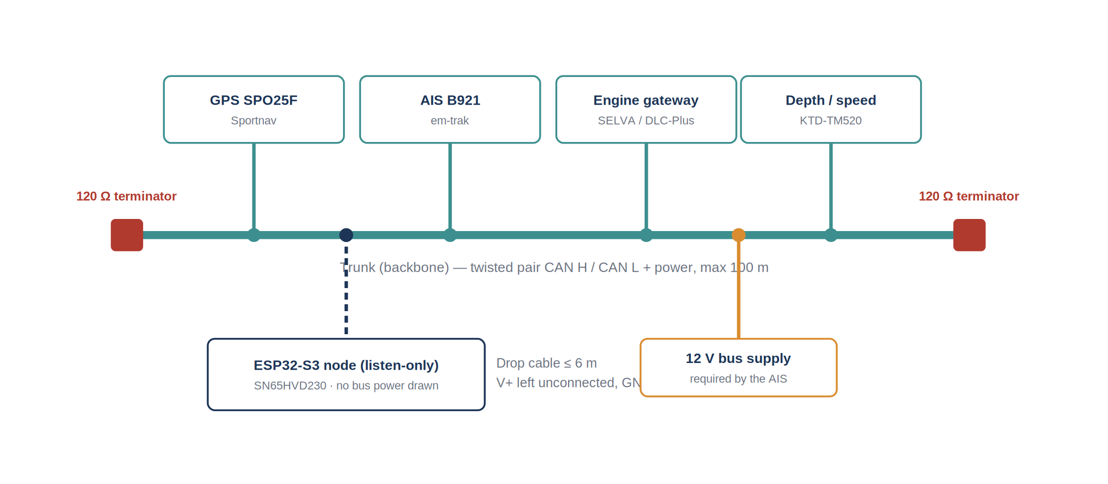
Figure 3: Trunk-and-drop topology of the instrumented vessel, with the position of the acquisition node
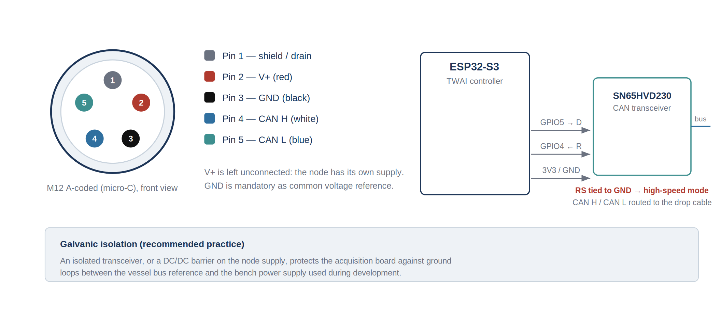
Figure 4: M12 five-pin pinout and interface between the acquisition node and the backbone
The pinout shown above was verified with a multimeter before any connection, because an inversion of CAN H and CAN L is silent: the bus does not communicate, no device reports an error, and the fault is easily attributed to the firmware. Two wiring decisions deserve to be stated explicitly. The power conductor is left unconnected, because the acquisition node has its own supply; connecting it would add a load to the vessel bus for no benefit and would create a second current path. The ground conductor, on the contrary, is connected, and is mandatory: the CAN transceiver interprets a differential voltage, and without a common reference the common-mode voltage can drift beyond the input range of the receiver, which produces intermittent reception faults that are difficult to distinguish from software defects.
A third point concerns the transceiver itself. The SN65HVD230 used here exposes a slope-control pin, RS, whose function depends on the resistance to ground. That pin must be tied directly to ground to select the high-speed mode required at 250 kbit/s; leaving it floating places the device in a low-power state in which frames are not received. Finally, galvanic isolation between the node and the bus is recommended practice on a vessel, where the reference potential of the bus and that of a bench supply are not necessarily identical.

5.2.2 Frame format and parameter groups
Each CAN frame carries a 29-bit identifier and up to eight data bytes. The identifier encodes a priority field, a data page bit, a PDU format field, a PDU specific field and the source address of the transmitting device. The combination of the data page, the PDU format and, when the message is broadcast, the PDU specific field forms the Parameter Group Number, which identifies the meaning and the byte layout of the payload.
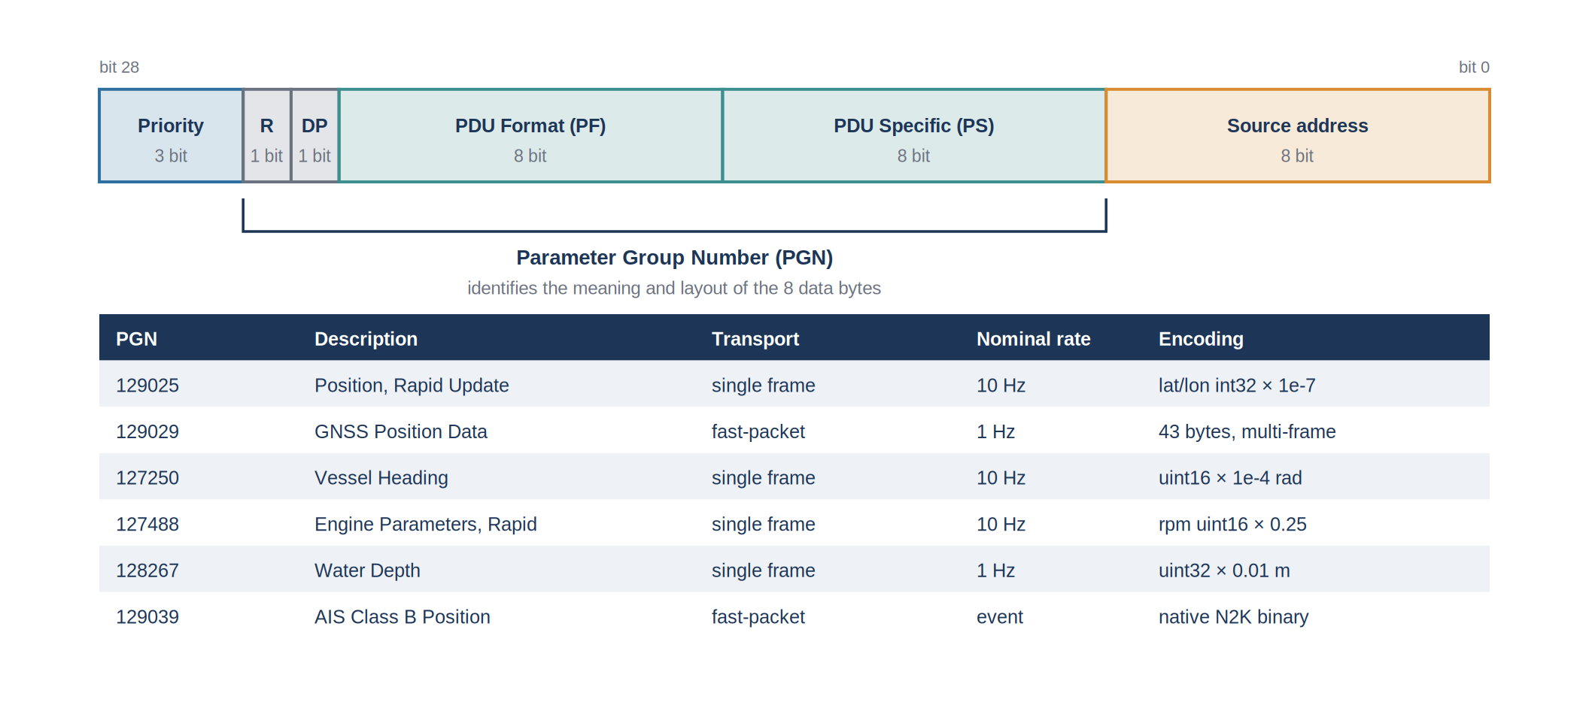
Figure 5: Structure of the 29-bit identifier and parameter groups exploited by the acquisition node
The parameter groups that carry more than eight bytes of payload use a transport mechanism known as fast-packet. The first frame of the sequence carries a sequence counter, the total length of the message and six payload bytes; the following frames carry the sequence counter and seven payload bytes each. The receiver must therefore maintain a reassembly context per message in flight, and must be able to handle the interleaving of several fast-packet sequences coming from different sources.
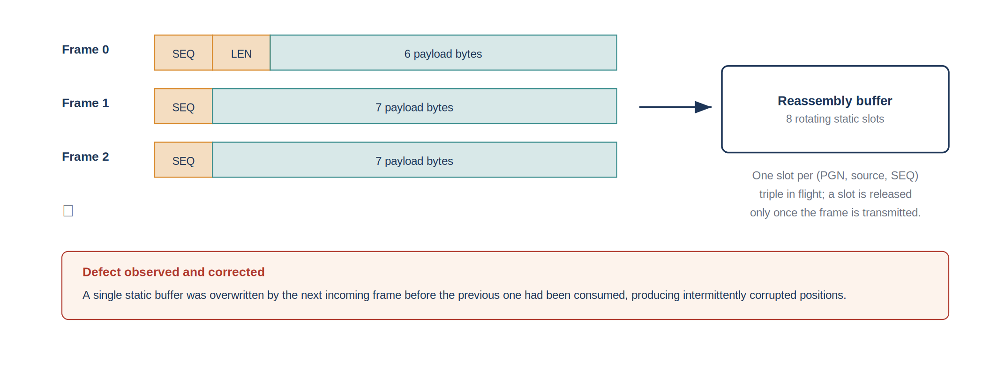
Figure 6: Fast-packet reassembly and the buffer defect that was identified and corrected

5.2.3 Encoding conventions
All numeric fields are transmitted as unsigned or signed integers with a fixed scale factor, in the SI unit of the quantity or in a unit derived from it. Latitude and longitude are transmitted as 32-bit signed integers with a resolution of 10 to the power minus seven degrees; angles are transmitted in radians with a resolution of 10 to the power minus four; engine speed is transmitted in quarter revolutions per minute. Each field also defines reserved values that indicate the absence of a measurement, and those values must be filtered before publication, failing which a missing depth is stored as a depth of several hundred million metres.

5.2.4 Bus load and network management
Two network-level mechanisms deserve a description, because they condition the behaviour of any device added to an existing backbone.
The first is address claiming, inherited from the underlying protocol. Each device selects a source address at power-on and announces it; a collision between two devices is resolved by comparing their unique identifiers, and the loser selects another address. A consequence for this project is that the source address of a device is not a stable identifier between two power cycles, and cannot be used to attribute a measurement to an instrument. Attribution is therefore based on the parameter group and, where several devices emit the same group, on the device instance field carried in the payload.
The second is the load of the bus, which determines whether a new device can be added without degrading the existing traffic. Since the acquisition node never transmits, it adds no traffic at all, but the load had to be estimated in order to size the reception path and to establish that no frame would be lost by lack of processing time.
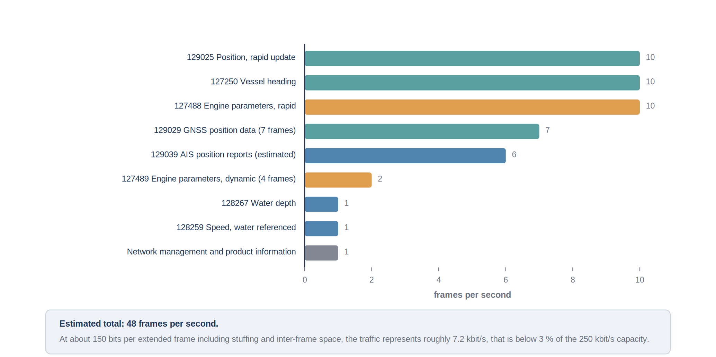
Figure 7: Estimated frame rate per parameter group and resulting load of the backbone
The estimate assumes the nominal transmission rates defined by the standard for each parameter group, a fixed frame length of approximately 150 bits including bit stuffing and the inter-frame space, and a traffic of about twenty AIS targets in the coverage area. The resulting occupation is below three per cent of the capacity of the bus, which leaves a very large margin. That margin is what makes the passive approach viable: the reception task has, on average, more than twenty milliseconds between two frames, whereas the decoding of a frame takes a few tens of microseconds.
The figure also explains why the buffer defect described in Section 5.4 was invisible at first. The mean interval between frames is comfortable, but the frames are not distributed uniformly: the rapid groups of several devices are emitted in bursts, and the interval between two consecutive frames inside a burst falls to the transmission time of a single frame, approximately six hundred microseconds. It is in those bursts, and only in them, that a single reception buffer is overwritten before it is read.

5.3 Hardware implementation
The acquisition node is built around an ESP32-S3 module. The choice of that microcontroller follows from three of its characteristics: it integrates a CAN controller, designated TWAI by the manufacturer, which removes the need for an external controller; it integrates a Wi-Fi radio, which provides the uplink without an additional module; and it is supported by a mature development framework, ESP-IDF, whose version 5.5.4 was used throughout the project.
Table 6: Bill of materials of the acquisition node
Item | Reference | Function
Microcontroller module | ESP32-S3 | CAN reception, processing, Wi-Fi uplink, local web server
CAN transceiver | SN65HVD230 | differential interface with the NMEA 2000 backbone
Connector | M12 five-pin A-coded, female | connection to a drop cable of the vessel backbone
Supply | regulated 5 V, derived from the vessel 12 V network | node supply, independent of the bus power pair
Router | D-Link DWR-960 | on-board Wi-Fi access point and 4G uplink

The transceiver is connected to the microcontroller by two signals, a transmit line on GPIO5 and a receive line on GPIO4, and shares its ground and its 3.3 V supply. The transmit line is configured but never used to send a frame: the firmware installs the TWAI driver in a listening configuration, so that the node cannot acknowledge or disturb the traffic. That decision satisfies requirement N3 by construction rather than by verification, which is the preferable way of satisfying a requirement of that nature.
The radio link deserves one remark. The router installed on board exposes a 2.4 GHz network and a 5 GHz network. The ESP32-S3 supports only the 2.4 GHz band, and the association silently fails if the node is configured with the credentials of the 5 GHz network. That point cost several hours of diagnosis during the integration and is documented here because it is invisible in the logs of the node, which simply reports that the network was not found.

5.3.1 Power budget and environmental constraints
The node is supplied from the twelve-volt network of the vessel through a regulator, and not from the power pair of the backbone. That decision has two justifications: it avoids adding a load to a bus whose supply capacity is dimensioned for the navigation devices, and it makes the node electrically independent of the state of the backbone, so that it can be tested on the bench with a laboratory supply without any modification.
Table 7: Power budget of the acquisition node
Contribution | Typical value | Remark
Microcontroller, radio active | approximately 120 mA at 3.3 V | peak during transmission bursts
Microcontroller, radio idle | approximately 40 mA at 3.3 V | between publications
CAN transceiver in reception | approximately 10 mA at 3.3 V | independent of traffic
Regulator efficiency | approximately 85 % | step-down converter from 12 V
Mean consumption at the vessel supply | of the order of 1 W | negligible against the navigation electronics

Three environmental constraints were identified for a permanent installation and are documented here for the continuation of the project, since the installation carried out during the internship used a provisional enclosure. The first is humidity and salt spray, which impose a sealed enclosure and cable glands even in a sheltered position. The second is vibration, which affects connectors before it affects components, and which argues for screw terminals or locking connectors rather than the header pins used on the bench. The third is temperature: an enclosure exposed to the sun on a deck reaches temperatures well above the ambient value, and the operating range of the components must be verified against that condition rather than against the ambient temperature.

5.4 Firmware architecture
The firmware is organised in three stages, mirroring the architecture of Figure 2: acquisition, processing and publication. The stages communicate through a single shared structure holding the last known value of each quantity together with its acquisition timestamp, which decouples the reception rate of the bus from the publication rate towards the server.
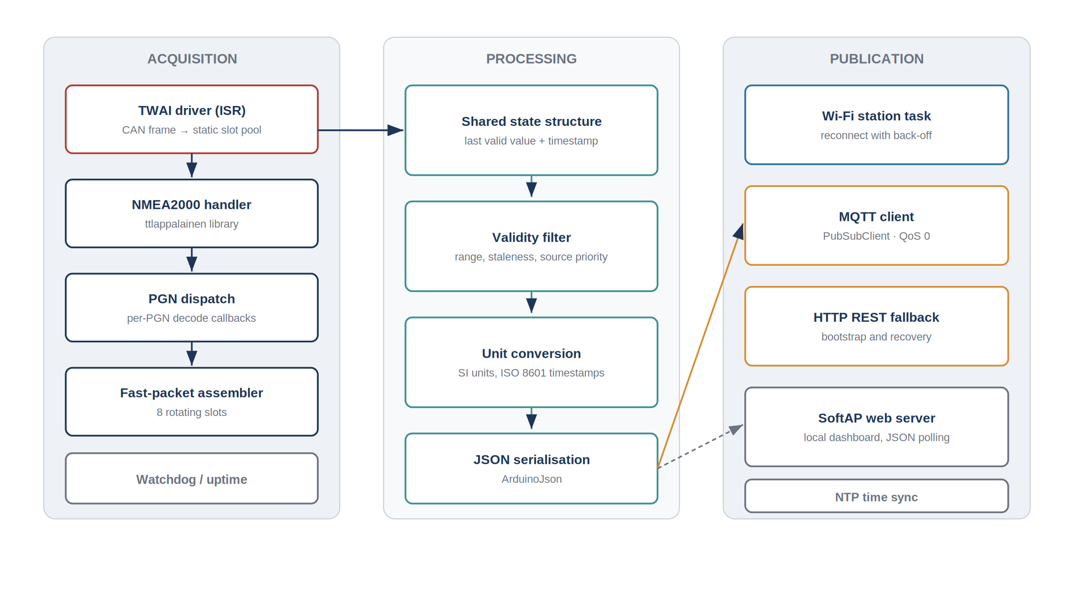
Figure 8: Internal organisation of the firmware, from the interrupt service routine to the publication tasks

5.4.1 Task organisation and resource usage
The firmware runs on the real-time operating system integrated in the framework. Four tasks share the processor, with priorities chosen so that no task can prevent the reception of a frame.
Table 8: Tasks of the firmware and their priorities
Task | Priority | Period or trigger | Function
Reception | highest | interrupt from the CAN controller | copy of the frame into a free slot, no processing
Decoding | high | message queue | parameter group dispatch, decoding, update of the shared state
Publication | medium | 1 s | serialisation and transmission of the observations
Web server | low | on request | local dashboard and configuration interface
Supervision | lowest | 10 s | connectivity state machine, watchdog, diagnostic counters

The rule applied throughout is that interrupt context does only what cannot be deferred, namely the copy of the frame, and that everything else happens in a task. The two defects described below are both violations of that rule, which is why they are treated as a single lesson rather than as two independent bugs.
Memory usage was monitored during the endurance tests, because a leak in an embedded system without a file system manifests itself as a reset rather than as an error message. The free heap is exposed on the diagnostic page together with the uptime and the reset reason, so that a restart can be attributed to a watchdog, to a power cycle or to an exhaustion of memory.
Table 9: Resource usage of the firmware
Resource | Value | Remark
Program memory | [TO COMPLETE: size reported by the build] | reported by the build system
Static memory | [TO COMPLETE] | dominated by the reassembly slot pool and the network stack
Free heap in steady state | [TO COMPLETE] | monitored during the endurance test
Reassembly slots | 4 single frame, 8 fast-packet | sized from the number of devices on the backbone

5.4.2 Reception and decoding
Reception is handled by the TWAI driver, which raises an interrupt on each received frame. The interrupt service routine copies the frame into a buffer and hands it to the NMEA 2000 handler, built on the open-source library maintained by T. Lappalainen, which performs the reassembly of fast-packet sequences and the dispatch towards the per-parameter-group decoding callbacks. Each callback extracts the fields of interest, applies the scale factor, filters the reserved values and updates the shared structure.
Two defects were identified in that path during the bench validation, and both are characteristic of the constraints of interrupt context. The first concerned the buffers used to hand frames from the interrupt to the handler: a single static buffer was reused for every frame, and a frame arriving before the previous one had been consumed overwrote it. On a lightly loaded bus the defect is invisible; on the complete backbone, where several devices transmit simultaneously, it produced positions that were occasionally and unpredictably wrong. The correction consists in a pool of rotating static slots, four for single frames and eight for fast-packet sequences, a slot being released only once its content has been transmitted. Static allocation was preferred to dynamic allocation because allocation in interrupt context is forbidden and because the maximum number of messages in flight is bounded by the number of devices on the bus.
The second defect was a logging call left inside an interrupt callback. The logging function of the framework is not reentrant and takes a lock, which is not permissible in interrupt context; the result was a periodic reset of the microcontroller, attributed at first to a power supply problem. The correction is to remove every logging call from interrupt context and to expose the diagnostic counters through the shared structure instead, where a lower-priority task can read them.
Table 10: Parameter groups decoded by the firmware
PGN | Quantity | Transport | Remark
129025 | Position, rapid update | single frame | primary source of position, highest update rate
129029 | GNSS position data | fast-packet | complete fix, including altitude and satellite count
127250 | Vessel heading | single frame | magnetic or true according to the reference field
127488 | Engine parameters, rapid update | single frame | engine speed, boost pressure
127489 | Engine parameters, dynamic | fast-packet | coolant temperature, operating hours, alarms
128267 | Water depth | single frame | depth below the transducer, offset applied
128259 | Speed, water referenced | single frame | speed through water
129038 / 129039 | AIS class A and class B position reports | fast-packet | surrounding traffic

5.4.3 Diagnostic instrumentation
The diagnosis of the two defects described above relied on external comparison, which is slow. The firmware was therefore instrumented so that a comparable fault would be visible from the inside. The counters listed below are maintained by the decoding and publication tasks and exposed both on the local dashboard and in the periodic log.
Table 11: Diagnostic counters exposed by the firmware
Counter | Meaning | Expected behaviour
Frames received | total frames accepted by the controller | increases at the rate estimated in Section 5.2
Frames dropped, no free slot | reception buffer exhaustion | must remain at zero
Fast-packet sequences aborted | reassembly interrupted or inconsistent | occasional, must not grow steadily
Values rejected as unavailable | reserved pattern filtered before publication | non-zero for quantities absent from the bus
Plausibility rejections | position inconsistent with the elapsed time | rare, indicates a decoding or a source problem
Publications attempted and last publication age | activity of the uplink | age must remain close to the publication period
Free heap, uptime, reset reason | state of the execution environment | stable heap, reset reason consistent with the observed events

A counter that must remain at zero is more useful than a measurement, because it can be checked at a glance and because its first non-zero value dates the beginning of the fault. That principle was applied to the two counters associated with the defects that had been observed.

5.4.4 Source arbitration between parameter groups
Position is available from two parameter groups, 129025 and 129029, which do not have the same properties. The first is a single frame transmitted at a high rate and carries only latitude and longitude. The second is a fast-packet message transmitted once per second and carries the complete fix. Publishing whichever arrives last is the obvious implementation and is incorrect: when a fast-packet sequence is truncated, which occurs when frames are lost or interleaved, the reassembled message may be accepted with inconsistent contents and overwrite a valid position.
The rule that was implemented gives priority to the rapid update for latitude and longitude, and uses the complete message only for the fields that the rapid update does not carry. A validity test on the reassembled message, comparing the position it contains with the last position accepted from the rapid group, rejects any deviation incompatible with the elapsed time. This is a form of plausibility filtering, applied at the decoding stage rather than in the database, where it would arrive too late.

5.4.5 Time reference
The SensorThings data model requires an absolute timestamp for every observation. The natural source is the parameter group 129033, which carries date and time from the GNSS receiver. That group turned out never to be transmitted by the receiver installed on the vessel, a behaviour that is permitted by the standard, since a device is required to transmit only the groups it declares. The initial implementation, which waited for that group, therefore never reached a valid time state.
The solution retained is to synchronise the clock of the microcontroller over the network, using the Network Time Protocol against a public pool of servers, at start-up and then periodically. Since the uplink is required for publication in any case, that dependency introduces no new point of failure. The timestamp associated with an observation is the acquisition time recorded by the node, not the publication time, so that a delayed transmission does not distort the time series. When the parameter group carrying GNSS time is available, it remains the preferred source; the network protocol is a fallback, and the origin of the time reference is exposed in the diagnostic page of the local dashboard.
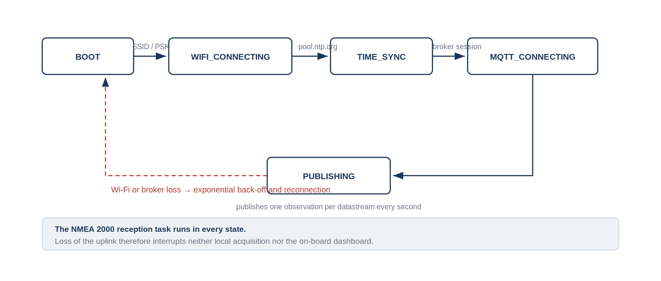
Figure 9: Connectivity state machine of the node, and independence of the acquisition path

5.4.6 Local dashboard
Requirement F5 asks for a local view of the acquired quantities that does not depend on the shore link. The node therefore runs a web server on the on-board network and serves a single page that polls a JSON endpoint exposing the shared structure. The page displays the navigation quantities, the engine parameters and a table of the AIS targets currently tracked, together with the age of each value, so that a stale quantity is immediately visible as such.
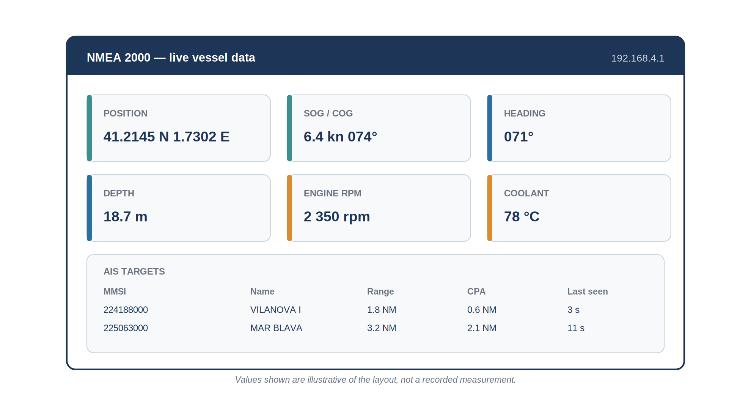
Figure 10: Layout of the local dashboard served by the node on the on-board network
The implementation keeps the page deliberately small and free of external dependencies, because it must load on a device that has no internet access at the time it is used. The refresh is a periodic request rather than a persistent connection, which costs a little more traffic but survives the transient disconnections that are frequent on a vessel moving around its own access point.
A configuration mode is also served on the same interface. It exposes the network credentials, the address of the broker and the identifiers of the datastreams, so that the node can be redeployed on another vessel without recompiling the firmware. The credentials are stored in the non-volatile memory of the microcontroller.

5.5 Data model and shore infrastructure
The shore side of the chain is built on the OGC SensorThings API, an Open Geospatial Consortium standard that defines a data model for sensor observations and a REST interface for their manipulation. The implementation used is FROST-Server, an open-source server developed by the Fraunhofer Institute of Optronics, System Technologies and Image Exploitation, backed by a PostgreSQL database with the PostGIS extension.

5.5.1 Entity model
The standard organises the data as a graph of entities. A Thing represents a physical object carrying sensors, here the vessel. A Location gives the position of that object. A Sensor describes the device performing a measurement, an ObservedProperty describes the quantity being measured, and a Datastream binds a Thing, a Sensor and an ObservedProperty together with a unit of measurement. Observations belong to a Datastream and carry a result and a phenomenonTime. Each Observation also references a FeatureOfInterest, which describes what was actually observed.
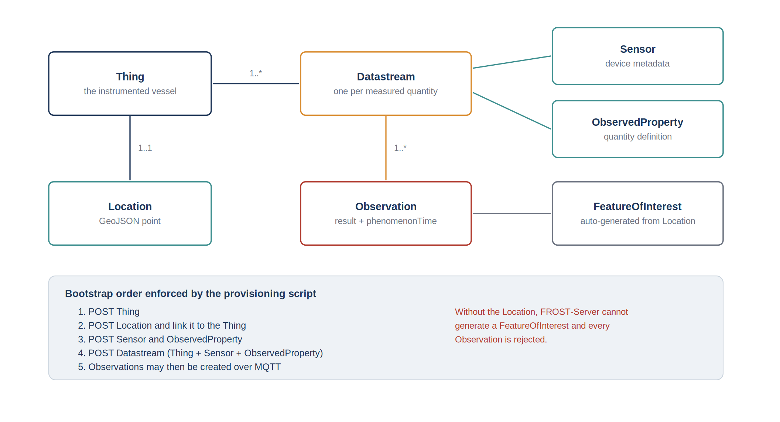
Figure 11: Entity model of the OGC SensorThings API as instantiated for the vessel
The mapping of the vessel onto that model required one decision that is not dictated by the standard. A Datastream binds exactly one quantity, so a vessel producing eight quantities requires eight Datastreams, all attached to the same Thing. The alternative, which is to declare one Thing per instrument, was rejected: the quantities are consumed together, they share a position, and the vessel, not the instrument, is the object that moves.
Table 12: Datastreams declared for the instrumented vessel
Datastream | Observed property | Unit | Source PGN
Position | latitude and longitude | degree | 129025
Speed over ground | speed | metre per second | 129026
Course over ground | direction | degree | 129026
Heading | direction | degree | 127250
Water depth | depth | metre | 128267
Speed through water | speed | metre per second | 128259
Engine speed | rotational speed | revolution per minute | 127488
Coolant temperature | temperature | kelvin | 127489

5.5.2 Provisioning of the entities
A property of the server that determined the whole provisioning procedure is that the MQTT interface of FROST-Server can create Observations and nothing else. Every other entity of the graph must exist before the first observation is published, and must be created over the HTTP REST interface. A provisioning script was therefore written; it creates the entities in dependency order and records the identifiers assigned by the server, which are then written into the configuration of the node.
A second property caused a failure that is worth documenting, because the error message does not point to its cause. An Observation is rejected if the server cannot associate it with a FeatureOfInterest, and the server generates that entity automatically from the Location of the Thing. If the Thing has been created without a Location, or if the Location has been created but not linked, every observation is refused. The provisioning script therefore creates the Location and verifies the link before declaring the bootstrap successful.

5.5.3 Querying the stored observations
The interest of publishing to a standardised interface is that the retrieval of the data requires no specific client. The following requests, issued against the deployed server, illustrate the three operations that are used in practice: the verification that the chain is alive, the extraction of a time window for analysis, and the enumeration of what a vessel exposes.
GET /FROST-Server/v1.1/Datastreams(3)/Observations
?$orderby=phenomenonTime desc&$top=1
-> most recent observation of the datastream: liveness check

GET /FROST-Server/v1.1/Datastreams(3)/Observations
?$filter=phenomenonTime gt 2026-07-14T08:00:00Z
and phenomenonTime lt 2026-07-14T12:00:00Z
-> time window, paginated, for analysis

GET /FROST-Server/v1.1/Things(1)?$expand=Datastreams($select=name,unitOfMeasurement)
-> enumeration of the quantities published by the vessel
The same filtering and expansion syntax applies to the observations of the fixed observatory, which is the practical benefit of the alignment on the standard: a client written for one source works on the other without modification.

5.5.4 Volume of data and retention
An estimate of the volume produced was required by the infrastructure administrator before the node was authorised to publish to the production server. The calculation is elementary but it conditions the retention policy.
Table 13: Estimated volume of data produced by one vessel
Quantity | Value
Datastreams published | 8
Publication period | 1 s
Observations per hour | approximately 29 000
Observations per day of operation, 8 hours under way | approximately 230 000
Stored size per observation, including indexes | of the order of 100 bytes
Volume per day of operation | of the order of 25 MB
Volume per year at 100 days of operation | of the order of 2.5 GB

The order of magnitude is modest for a database server, but it is not negligible for a fleet, and it grows linearly with the number of instrumented vessels. Two levers are available and are recommended for the continuation. The first is to adapt the publication period to the quantity rather than to publish everything at one hertz: the coolant temperature does not vary at that rate, and publishing it every ten seconds divides its contribution by ten without any loss of information. The second is to publish only on significant variation for the slowly varying quantities, with a periodic refresh to distinguish a stable value from a node that has stopped.

5.5.5 Server deployment
The server runs on an Ubuntu Server 22.04 host provided by the laboratory. FROST-Server, the message broker and the database run as containers orchestrated by Docker Compose, and an Apache 2 instance acts as a reverse proxy, terminating the encrypted connection and exposing the service under the name of the observatory domain. Administrative access to the host is restricted to key-based authentication on a non-standard port, in accordance with the policy of the infrastructure administrator.
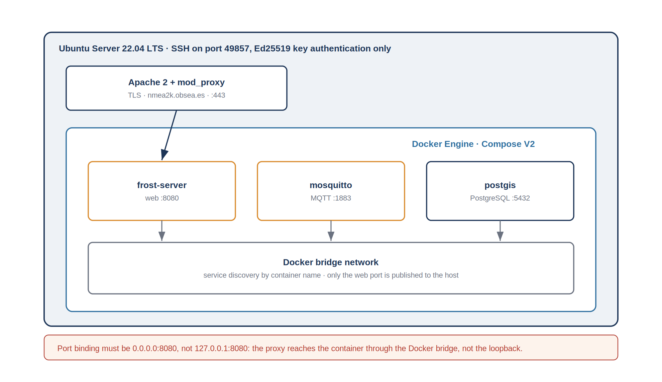
Figure 12: Deployment of the shore infrastructure on the laboratory server
One deployment detail cost a full afternoon and is representative of the class of problem encountered at this stage. The container publishing the web interface was initially bound to the loopback address of the host, which is the prudent default when a reverse proxy is present. The proxy, however, does not reach the container through the loopback interface of the host but through the internal bridge network created by the container engine, so the binding must be made on all interfaces of the host. The symptom was a proxy returning a connection error while the service answered correctly when tested from inside the host.
The service was then verified from outside the laboratory network, over the encrypted interface, using the catalogue endpoint of the API, which lists the available entity collections and constitutes the simplest end-to-end test of the deployment.

5.6 Security of the chain
The node publishes to a server exposed on the public network, so the security of the chain was treated as a requirement and not as a finishing touch. The analysis was carried out by identifying the trust boundaries and, for each of them, what an attacker on the wrong side of it could do.
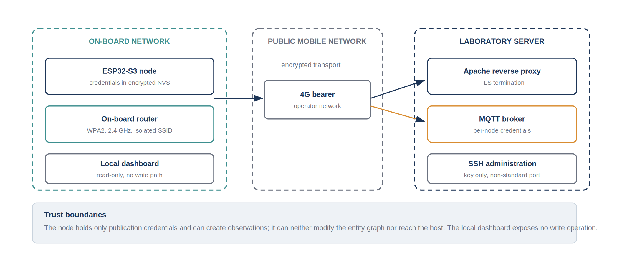
Figure 13: Trust boundaries of the acquisition chain
On the vessel side, the node holds the credentials of the on-board wireless network and of the message broker. They are stored in the non-volatile memory of the microcontroller rather than compiled into the firmware, which allows a node to be reconfigured without a rebuild and prevents the credentials from being extracted from a firmware image circulating between machines. The local dashboard exposes no write operation other than the configuration interface, so a device connected to the on-board network can read the current values but cannot alter the published data.
On the transport side, the exchanges between the vessel and the server pass through the network of a mobile operator, which is not trusted. The transport is therefore encrypted, and the certificate presented by the server is verified by the node.
On the server side, the exposure surface is reduced to what the service requires. The reverse proxy is the only component reachable from the outside, administrative access uses key-based authentication on a non-standard port, and the containers communicate on an internal network of which only the web port is published. The broker requires per-node credentials, so a node cannot impersonate another one.
Two residual weaknesses are identified. The publication credentials are stored in the node, and physical access to the vessel therefore gives access to them; the mitigation is to issue one credential per node so that a compromise can be revoked individually. The observations themselves are not signed, so the server accepts as authentic any observation published with valid credentials; signing the payload would close that gap but was judged disproportionate for data of this nature, which are neither confidential nor used for a regulatory purpose.

5.7 Publication chain
The last stage of the chain transports the observations from the node to the server. Two mechanisms are available and both were implemented, with different roles.
The HTTP REST interface is the reference mechanism defined by the standard. It is used by the provisioning script and by the recovery path of the node, because it returns an explicit status for every request. It is, however, expensive for a periodic publication: each observation requires the establishment of an encrypted session, a set of headers of a size comparable to the payload, and a response that the node must parse.
The MQTT interface is used for the nominal publication. The node opens a single session with the broker and publishes each observation on the topic associated with its datastream. The payload is a small JSON document carrying the result and the acquisition timestamp. The cost per observation is reduced to the payload and a few bytes of protocol overhead, which matters on a metered mobile link.
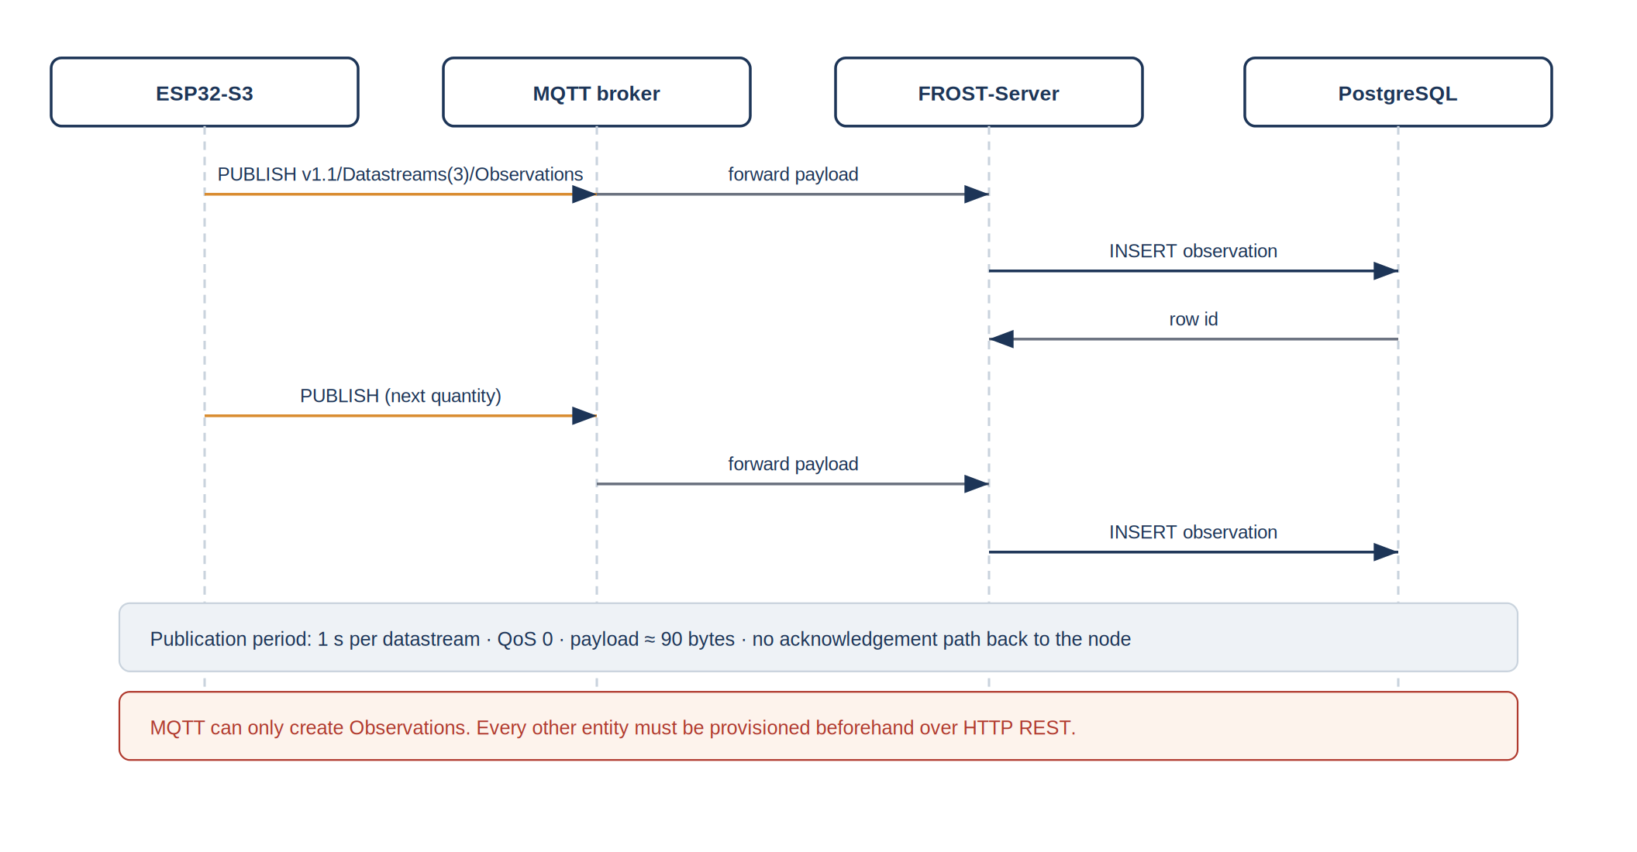
Figure 14: Publication sequence of an observation, from the node to the database
Table 14: Comparison of the two publication mechanisms
Criterion | HTTP REST | MQTT
Overhead per observation | several hundred bytes | a few tens of bytes
Acknowledgement of the application-level result | explicit status code | none at quality of service 0
Session establishment | per request, unless connection reuse is implemented | once per connection
Entities that can be created | all | Observations only
Role in the project | provisioning, diagnostics, recovery | nominal periodic publication

The absence of an application-level acknowledgement on the nominal path is a deliberate compromise, and it is the main weakness of the chain as it stands. At quality of service 0, the node cannot distinguish between an observation that was stored and one that was discarded by the broker. The mitigation implemented is a periodic verification: the node queries, over the REST interface and at a low rate, the timestamp of the last observation stored for one of its datastreams, and reports a discrepancy on the diagnostic page. That mechanism detects a persistent loss but not an isolated one.

5.8 Integration and validation
Validation was organised in three levels of increasing realism, each of which is a prerequisite for the next. The purpose of that staging is to ensure that a fault observed at a given level can be attributed to what was added at that level.
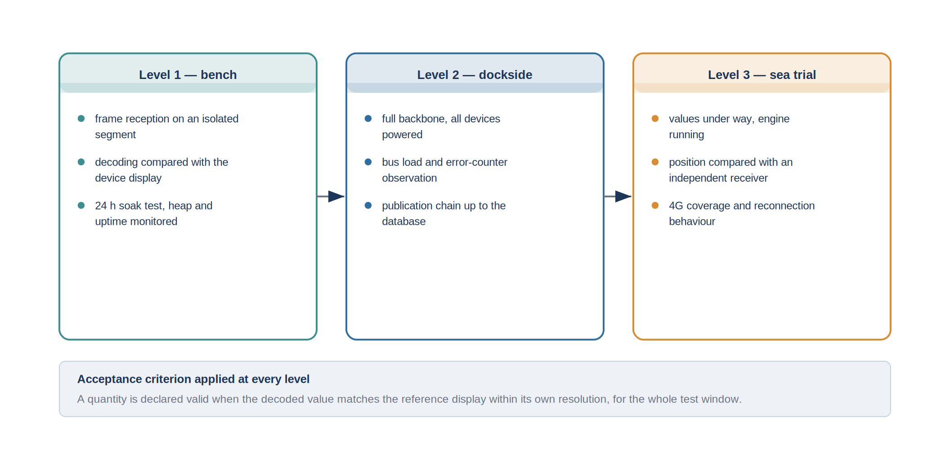
Figure 15: Three-level validation strategy applied to the acquisition chain
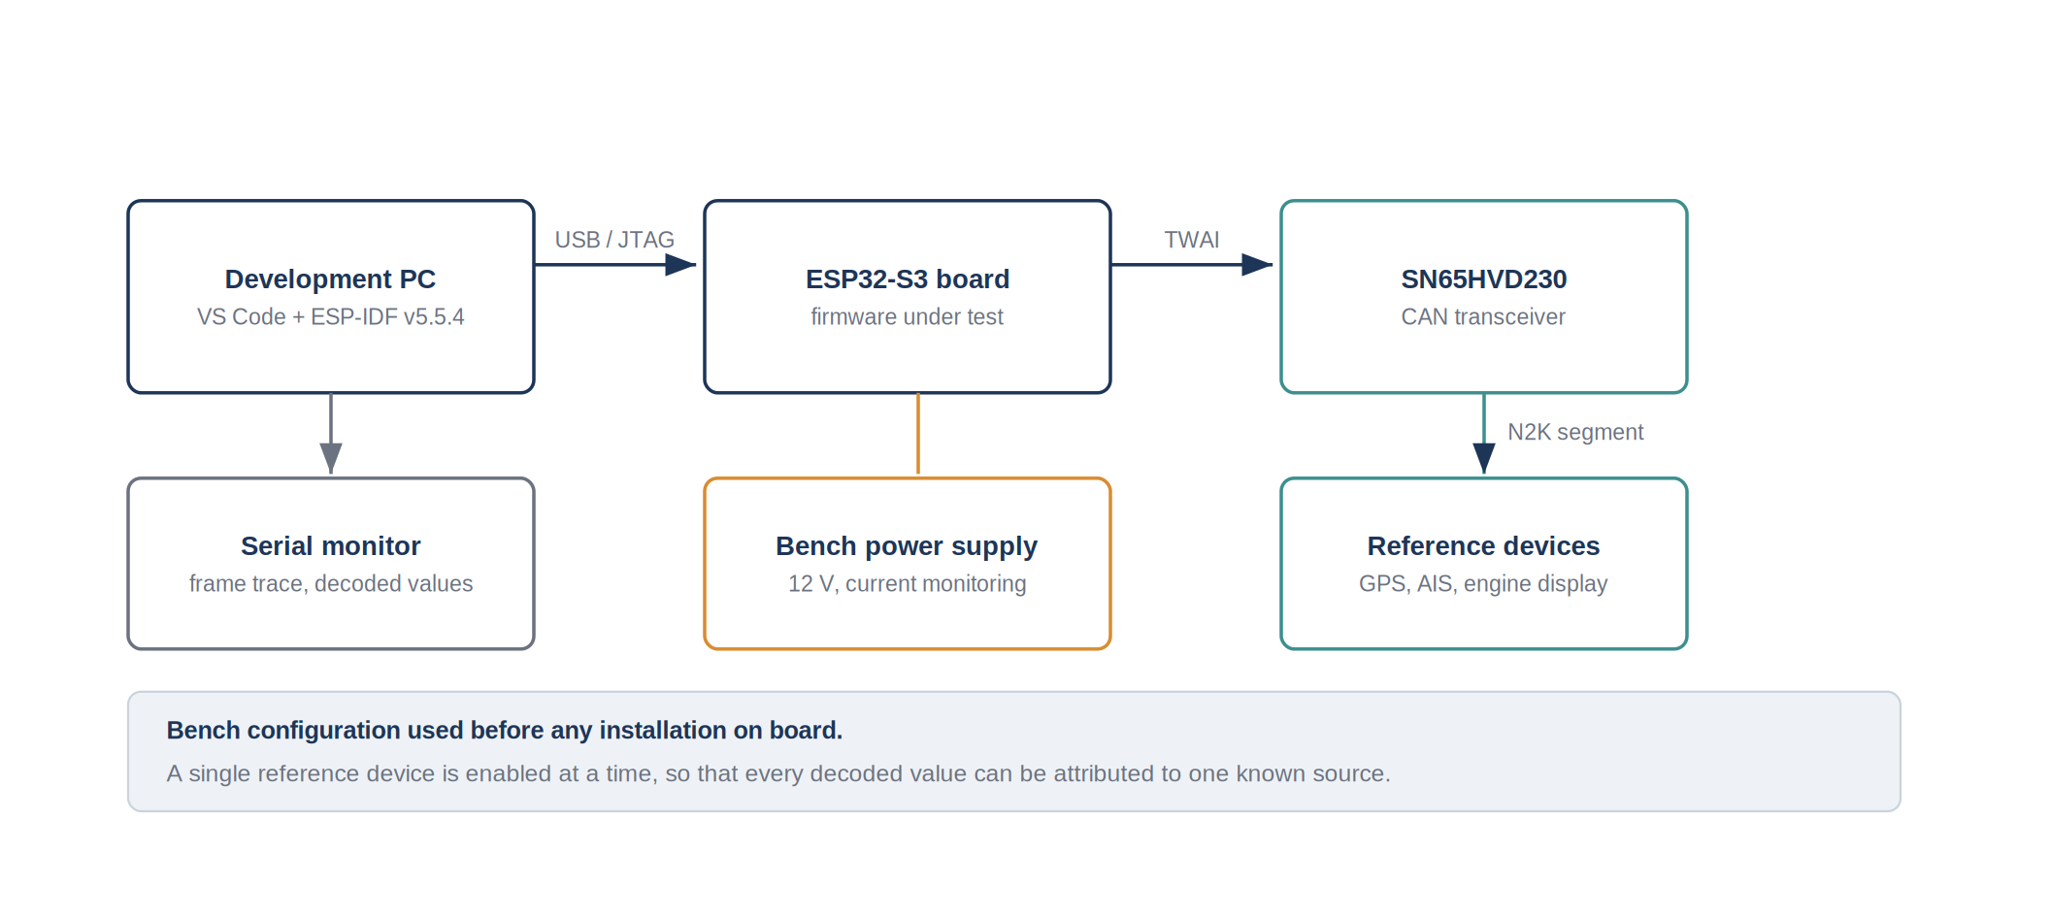
Figure 16: Bench configuration used before installation on board
At bench level, a single reference device is connected to an isolated segment at a time, and the decoded value is compared with the reading of the display of that device. Working with one device at a time makes every decoded value attributable to a known source, which is what allowed the buffer defect described earlier to be characterised: the fault appeared only when a second device was added to the segment.
At dockside level, the node is connected to the complete backbone with every device powered. Two additional observations become possible at that stage: the load of the bus, and the behaviour of the reassembly when several fast-packet sequences interleave. The AIS transponder, in particular, only becomes active when the backbone is powered at twelve volts, so its parameter groups cannot be observed at bench level with a laboratory supply alone.
At sea trial level, the vessel is under way and the engine is running. This is the only level at which the engine parameters take non-trivial values, at which the position changes, and at which the behaviour of the mobile link can be assessed. It is also the level at which the acceptance tests of the requirements of Chapter 4 were executed.

5.8.1 Measurement method and sources of uncertainty
The comparison of a decoded value with the reading of an on-board display is a method whose limitations must be stated, because it determines what the results of the acceptance tests actually establish.
The reference is not an instrument of higher accuracy but the same instrument read through a different path. The comparison therefore validates the decoding and the transmission, not the accuracy of the sensor. A systematic error of the depth transducer, for example, is invisible to this method, since both the display and the node receive the same erroneous value.
The two readings are not simultaneous. The display refreshes at its own rate, the node publishes at one hertz, and the operator reads the two with a delay of at least a second. For a quantity that varies quickly, such as the position of a moving vessel or the engine speed during a transient, the observed deviation is dominated by that delay and not by the decoding. The comparisons were therefore performed in stable conditions, at rest for the position and at a constant operating point for the engine, and the deviation is expressed against the resolution of the quantity rather than as an accuracy figure.
Table 15: Sources of uncertainty in the validation and their treatment
Source | Effect | Treatment
Non-simultaneity of the readings | apparent deviation on varying quantities | comparison performed in stable conditions
Resolution of the display | deviation bounded from below by the display step | acceptance expressed against the display resolution
Shared sensor error | systematic error invisible | explicitly outside the scope, validation of the chain only
Time reference of the node | offset of the timestamps | synchronisation verified against the network reference, origin exposed in the diagnostics
Position reference | deviation between two receivers | independent receiver used for the order of magnitude only

Table 16: Results of the acceptance tests
Ref. | Test | Result | Comment
F1 | Decoded navigation quantities compared with the on-board displays | [TO COMPLETE: pass or fail] | [TO COMPLETE: observed deviation per quantity]
F2 | AIS targets compared with an independent receiver | [TO COMPLETE] | [TO COMPLETE: number of targets compared]
F3 | Observations retrieved from the database over the REST interface | verified | position observations confirmed present in the production database
F4 | Absolute timestamp present and consistent | verified | time reference obtained by network synchronisation
F5 | Local dashboard accessible on the on-board network | verified | access from a browser on the node access point
F6 | Recovery after link interruption and after power cycle | [TO COMPLETE] | [TO COMPLETE: measured recovery time]
N1 | Publication period per quantity | verified | publication at one hertz confirmed on the production database
N4 | Continuous operation without intervention | [TO COMPLETE: duration of the endurance test] | [TO COMPLETE: uptime and free heap at the end of the test]

The table above is to be completed with the measurements recorded during the final campaign. The entries marked as verified correspond to results established during the internship; the remaining entries correspond to quantitative values that must be reported from the measurement log rather than estimated.

5.8.2 Interpretation of the results
The chain was brought to an operational state within the ten weeks: observations produced by the vessel are stored in the production database at the nominal rate, and the local dashboard is served independently of the shore link. Measured against the specification of Chapter 4, the functional requirements are satisfied, with the reservation that the quantitative characterisation of the recovery time and of the long-duration behaviour is to be completed from the campaign log.
Three limitations are known and are stated here rather than in the conclusion, because they follow directly from the design choices analysed above. The publication path has no application-level acknowledgement, so an isolated loss is not detected. The node has no local buffer, so an observation produced while the link is down is lost rather than deferred. Finally, the decoding of the engine parameters relies on the standard interpretation of the corresponding parameter groups, and a manufacturer-specific field, if present, would be silently ignored.

5.9 Critical analysis of the technical choices
This section examines the principal decisions against the alternatives that were available, including those that were rejected, and identifies what would be done differently with the benefit of the completed work.
The choice of a microcontroller rather than a single-board computer is confirmed by the outcome. The robustness to abrupt power cycles was tested involuntarily and repeatedly during the integration, and no corruption ever followed. The cost of that choice is the absence of a file system, which is precisely what prevents the implementation of a local buffer without additional hardware; the two properties are two faces of the same decision.
The choice of a listening-only node is likewise confirmed, and would be made again. It removes an entire class of risk, namely the disturbance of a navigation installation on a working vessel, at the cost of a capability that the specification did not require. It also removes the need for a device certification, which would have been incompatible with a ten-week schedule.
The choice of MQTT for the nominal publication is the one that would be revisited. Publishing at quality of service 1 rather than 0 would provide a transport-level acknowledgement for a modest additional cost, and would allow the node to distinguish between a message that reached the broker and one that did not. That change alone does not guarantee that the observation was stored, but it closes the most probable failure mode, which is the loss of the radio link during the transmission.
The alignment of the data model on the SensorThings standard is the choice with the highest long-term value and the highest short-term cost. The provisioning constraints described above, the ordering of the entities and the generation of the feature of interest represent a real overhead compared with the insertion of rows into a dedicated table. In exchange, the observations produced by the vessel are queried through the same interface and the same tooling as those of the fixed observatory, without any adaptation.
Finally, the diagnostic strategy would be strengthened. Both firmware defects described in Section 5.4 were found by comparison with an external reference, not by an internal indicator. Exposing the error counters of the CAN controller, the number of rejected reassemblies and the number of filtered reserved values from the first version of the firmware would have shortened that diagnosis considerably, and this is the practice that will be retained from this project.

6. Project management

6.1 Organisation of the work
The internship was conducted as a single-developer project inside a research team, which sets the management framework: there is no task allocation to arbitrate, but there is a dependency on shared resources, principally the vessel, the laboratory equipment and the server, whose availability is not controlled by the project. The organisation adopted consists of a weekly review with the industrial tutor, a written technical log kept daily, and a version-controlled repository in which the firmware, the provisioning scripts and the deployment files are held.
The technical log proved to be the most useful of those three instruments. Several of the findings reported in Chapter 5, in particular the behaviour of the transceiver slope-control pin and the binding address of the container, are the kind of detail that is obvious for a day and lost within a week. The log was structured by symptom rather than by date, so that a recurring fault could be recognised as such.

6.2 Tooling and configuration management
The firmware, the provisioning scripts and the deployment files are held in a version-controlled repository, with one commit per identified change and a message stating the observed symptom rather than the modified file. That practice was adopted after the first debugging episode, when it became necessary to determine which of several simultaneous modifications had actually corrected the behaviour.
Two practical constraints shaped the use of the repository. Binary artefacts produced by the build, and the media files used for documentation, are excluded, so that the history remains small enough to be transferred over the connection available on site. Large transfers are performed directory by directory rather than in a single operation, which avoids the timeouts observed on the shared connection.
The environment itself is documented as part of the deliverable: the exact version of the development framework, the versions of the third-party libraries, and the composition file describing the server services. An environment that cannot be reproduced makes a firmware unmaintainable, and this project depends on a framework whose behaviour differs noticeably between minor versions.
Table 17: Development and deployment environment
Element | Version or reference
Development framework | ESP-IDF v5.5.4
Development environment | Visual Studio Code with the framework extension
NMEA 2000 library | open-source library maintained by T. Lappalainen
Serialisation library | ArduinoJson
Messaging client | PubSubClient
Server | FROST-Server, OGC SensorThings API v1.1
Database | PostgreSQL with the PostGIS extension
Host system | Ubuntu Server 22.04 LTS with Docker Compose V2

6.3 Initial planning and its evolution
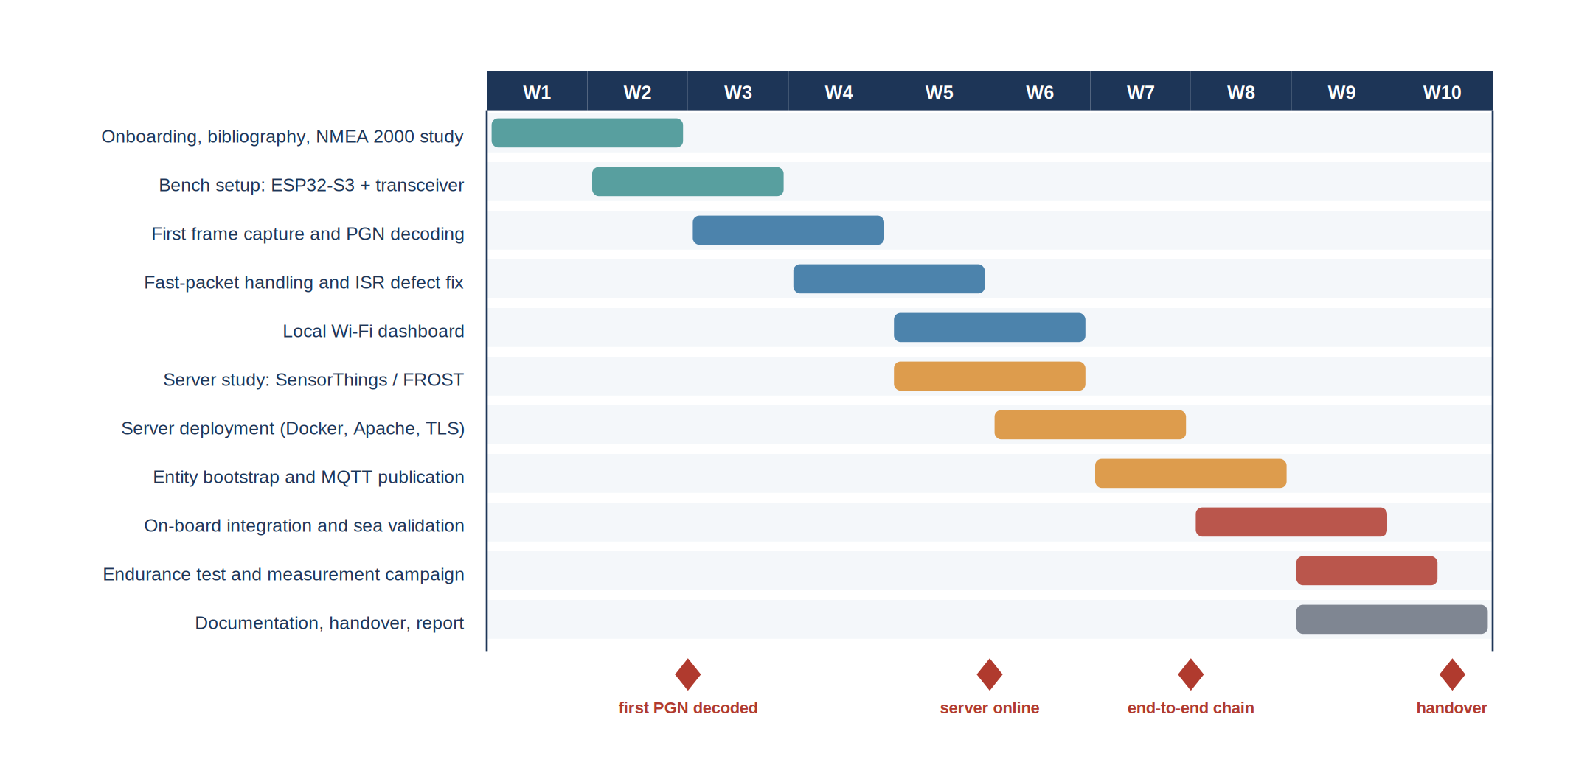
Figure 17: Planning of the ten weeks, with the milestones actually reached
The initial planning followed the decomposition presented in Section 5.1: two weeks of study and bench setup, four weeks on the vessel side, three weeks on the shore side, and one week of integration and documentation. That sequence was modified twice.
The first modification concerns the shore side, which was brought forward by approximately one week. The reason is a dependency that had been underestimated: obtaining the server access, the domain name and the firewall configuration involves an administrator whose availability is not aligned with the project schedule. Starting the request early, and working on the local components while waiting, converted a potential blocking point into a period of parallel work. The general form of that lesson, namely that a task whose duration depends on a third party should be started as early as its inputs allow rather than as late as its outputs permit, is the principal project management outcome of the internship.
The second modification concerns the debugging of the reception path, which consumed about a week more than planned. That overrun was absorbed by reducing the scope of the local dashboard, which was initially intended to include a chart of the recent history of each quantity and was reduced to the display of the instantaneous values and their age. The arbitration was made explicitly with the tutor, on the grounds that the dashboard is a convenience for the crew whereas the integrity of the decoded data conditions everything downstream.
Table 18: Deviations from the initial plan and their treatment
Event | Effect on the schedule | Decision taken
Server access granted later than requested | potential blocking of the shore-side work | shore-side tasks brought forward, request issued in week 3 rather than week 5
Intermittent corruption of positions on the complete backbone | approximately one week of additional debugging | scope of the local dashboard reduced, history chart deferred
GNSS time parameter group never transmitted | two days lost on a component assumed to be available | fallback on network time synchronisation, origin of the time reference made visible in the diagnostics
AIS transponder inactive at bench level | validation of two parameter groups deferred | corresponding tests moved from level 1 to level 2, dockside

6.4 Risk management
Seven risks were identified at the beginning of the project and reassessed at each weekly review. Their position in a probability and impact plane is given below, together with the mitigation that was applied.
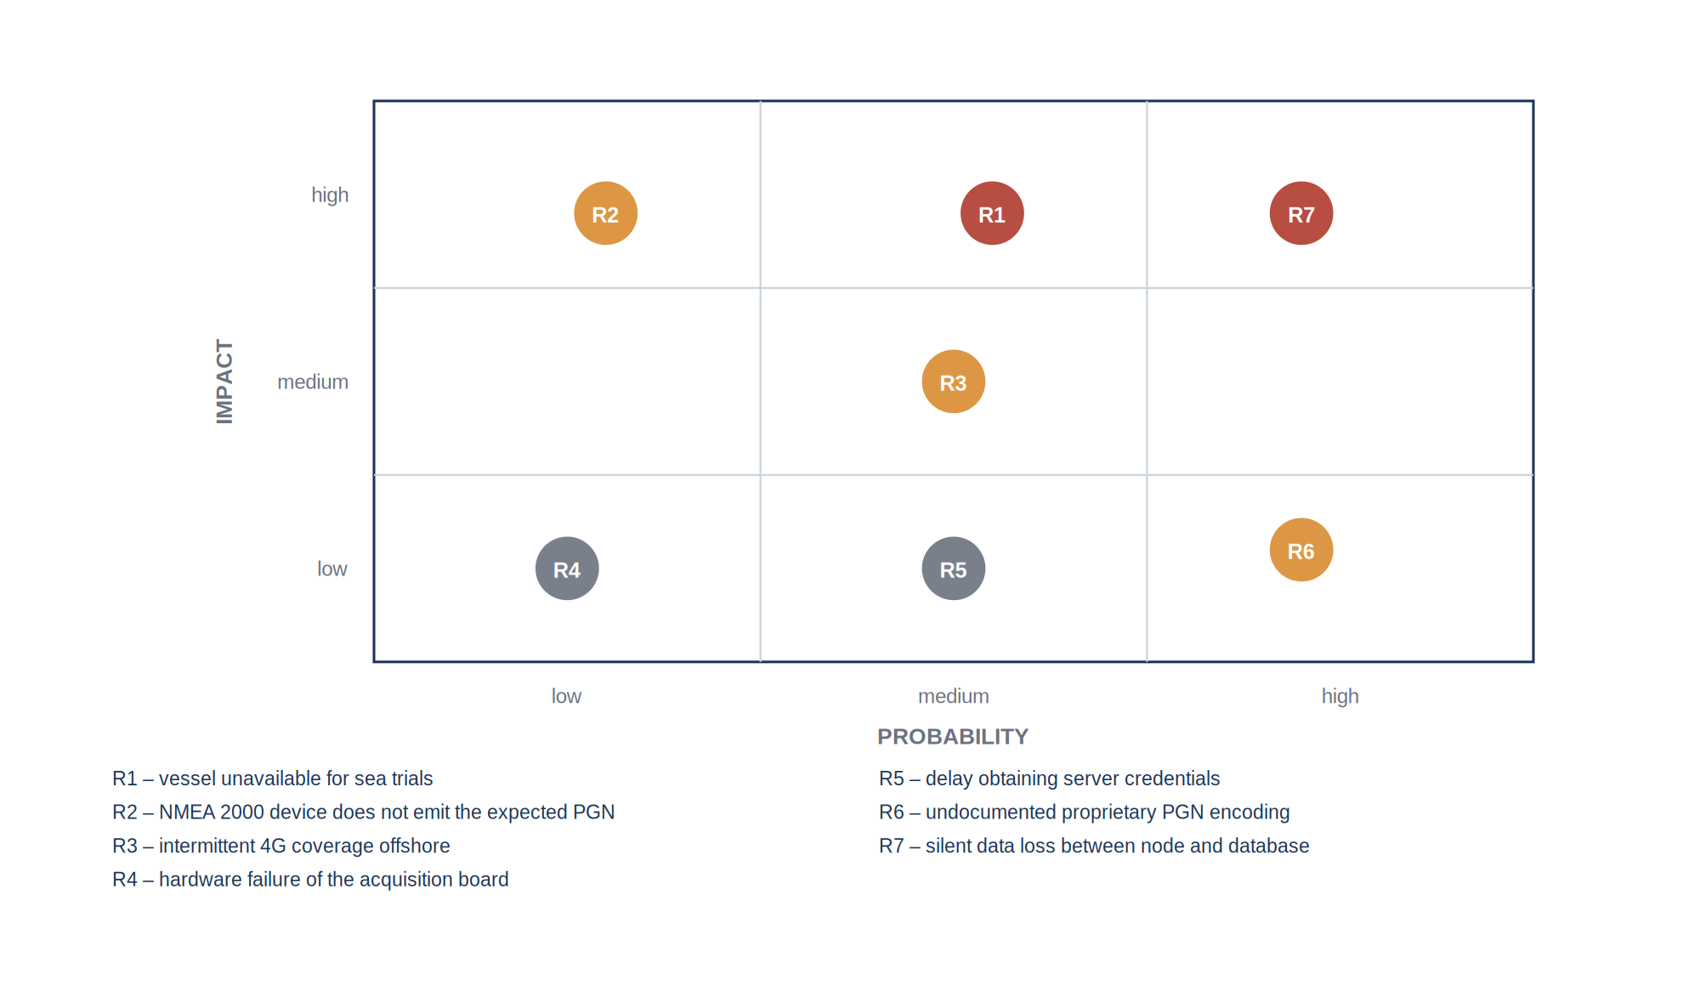
Figure 18: Risks identified at the start of the project and their assessed severity
Table 19: Risk register and mitigation
Ref. | Risk | Mitigation applied
R1 | The vessel is unavailable during the window planned for the sea trials | bench and dockside levels defined so that they validate everything that does not require movement, sea trial reduced to the irreducible tests
R2 | A device does not emit the parameter group expected from it | early inventory of the groups actually observed on the bus, before any decoding work
R3 | Intermittent mobile coverage offshore | acquisition and local dashboard made independent of the uplink
R4 | Hardware failure of the acquisition node | second board assembled and kept configured as a spare
R5 | Delay in obtaining the server credentials | request issued early, local development environment used in the meantime
R6 | Proprietary encoding of a manufacturer-specific field | scope limited to the standard parameter groups, deviation documented
R7 | Silent loss of data between the node and the database | periodic verification of the last stored timestamp, reported in the diagnostics

Two of these risks materialised. Risk R5 was anticipated and its mitigation is the schedule change described above. Risk R7 materialised in the form of the missing feature of interest, which caused every observation to be rejected while the node reported a successful publication; that is precisely the failure mode that the mitigation was designed to detect, and it was detected by it.

6.5 Handover
A project carried out during an internship is only useful to the host laboratory if it survives the departure of its author. Three deliverables were prepared for that purpose: the version-controlled repository containing the firmware, the provisioning scripts and the deployment files; a written procedure describing the installation of the node on a new vessel, from the wiring to the declaration of the datastreams; and the present report. The identifiers of the entities created on the production server, and the correspondence between each datastream and its source parameter group, are recorded in the annexes so that the installation can be reproduced or extended without reading the firmware.

7. Conclusion
The object of this work was to make the measurements circulating on the NMEA 2000 network of a working vessel available in a standardised scientific database. That objective was reached: an acquisition node based on an ESP32-S3 microcontroller reads the vessel backbone in a strictly passive way, decodes the parameter groups carrying position, course, speed, heading, water depth, engine parameters and surrounding traffic, and publishes the corresponding observations to a FROST-Server instance implementing the OGC SensorThings API, hosted on the infrastructure of the laboratory. Position observations were confirmed present in the production database at the nominal rate of one hertz. A local web dashboard, served by the node on the on-board network, gives the crew the current values independently of the availability of the shore link.
The work also produced results that are reusable beyond this particular installation. The reception path was corrected on two defects characteristic of interrupt-driven acquisition, namely the reuse of a static buffer between frames and the presence of a non-reentrant call in interrupt context, and the corresponding solutions, a pool of rotating slots and the exposure of diagnostic counters outside interrupt context, are applicable to any acquisition of that class. The provisioning constraints of the server, and in particular the necessity of a location entity before any observation can be accepted, are documented in a script that reproduces the bootstrap in the correct order. The wiring conventions of the marine bus, and the pitfalls attached to them, are recorded in the annexes.
Three limitations bound the result. The nominal publication path carries no application-level acknowledgement, so an isolated loss of an observation is not detected. The node holds no local buffer, so measurements produced outside network coverage are lost rather than deferred. The decoding covers the standard parameter groups only, so any manufacturer-specific extension present on the bus is ignored.
The perspectives follow from those limitations, and are ordered here by the ratio of their value to their cost. Publishing at quality of service 1 rather than 0 would close the most probable loss mode; the change is confined to the publication task and is estimated at one to two days of work, with no material cost. Adding a local store-and-forward buffer would allow operation outside coverage; a serial flash memory of a few megabytes, of the order of two euros, is sufficient to hold several days of observations at the current rate, and the firmware work is estimated at one to two weeks, the difficulty lying in the reconciliation of deferred observations with the real-time stream rather than in the storage itself. Extending the decoding to the engine parameter groups specific to the manufacturer would require access to the corresponding documentation and is estimated at one week once that documentation is available. Finally, the replication of the installation on other vessels of the laboratory is now essentially a matter of assembly and configuration: the material cost per node is of the order of fifty euros excluding the router, and the installation procedure prepared during the handover is designed to be executed without reading the firmware.
A fourth direction, of a different nature, is opened by the availability of these data. The joint exploitation of the engine parameters, the speed over ground and the speed through water gives access to the fuel consumption of the vessel as a function of its operating point, and therefore to a quantified basis for reducing it. That analysis is outside the scope of the internship, but it is the first use of the acquired data that the laboratory identified once the chain became operational.

Bibliography
[1] National Marine Electronics Association, "NMEA 2000 Standard for Serial-Data Networking of Marine Electronic Devices", version 1.301, NMEA, Severna Park, MD, USA, 2010.
[2] International Organization for Standardization, "ISO 11783-3: Tractors and machinery for agriculture and forestry — Serial control and communications data network — Part 3: Data link layer", ISO, Geneva, Switzerland, 2018.
[3] Open Geospatial Consortium, "OGC SensorThings API Part 1: Sensing Version 1.1", OGC 18-088, 2021. [Online]. Available: https://docs.ogc.org/is/18-088/18-088.html
[4] Fraunhofer IOSB, "FROST-Server documentation", 2024. [Online]. Available: https://fraunhoferiosb.github.io/FROST-Server/
[5] Espressif Systems, "ESP-IDF Programming Guide, Two-Wire Automotive Interface (TWAI)", version 5.5, 2024. [Online]. Available: https://docs.espressif.com/projects/esp-idf/
[6] T. Lappalainen, "NMEA2000 library for Arduino and ESP32", GitHub repository, 2024. [Online]. Available: https://github.com/ttlappalainen/NMEA2000
[7] Texas Instruments, "SN65HVD23x 3.3-V CAN Bus Transceivers", datasheet SLOS346R, 2019.
[8] OASIS, "MQTT Version 3.1.1 — OASIS Standard", 2014. [Online]. Available: https://docs.oasis-open.org/mqtt/mqtt/v3.1.1/os/mqtt-v3.1.1-os.html
[9] J. del Río et al., "The New Seafloor Observatory (OBSEA) for Remote and Long-Term Coastal Ecosystem Monitoring", Sensors, vol. 11, no. 6, pp. 5850–5872, 2011.
[10] SARTI, "Remote Acquisition and Data Processing Systems — research group presentation", Universitat Politècnica de Catalunya. [Online]. Available: https://eel.upc.edu/en/research/folder-groups/sarti-remote-acquisition-and-data-processing-systems
[11] OBSEA, "Expandable Seafloor Observatory — overview", Universitat Politècnica de Catalunya. [Online]. Available: https://obsea.es/about/overview.php
[12] Kvaser, "NMEA 2000 higher layer protocol description". [Online]. Available: https://kvaser.com/about-can/higher-layer-protocols/nmea-2000/
[13] United Nations, "Transforming our world: the 2030 Agenda for Sustainable Development", resolution A/RES/70/1, 2015.
[14] Universitat Politècnica de Catalunya, "Pla d'igualtat de la UPC", Barcelona, Spain. [Online]. Available: https://www.upc.edu/igualtat

Annexes

Annexe A — Wiring table of the acquisition node
Table 20: Connections of the acquisition node
Signal | M12 pin | Node terminal | Remark
Shield | 1 | chassis | connected at one end only
Bus power positive | 2 | not connected | the node has its own supply
Bus ground | 3 | node ground | mandatory common reference
CAN H | 4 | transceiver CAN H | white conductor
CAN L | 5 | transceiver CAN L | blue conductor
Transceiver transmit | — | GPIO5 | configured but unused, reception only
Transceiver receive | — | GPIO4 | —
Transceiver mode | — | RS to ground | selects the high-speed mode

Annexe B — Provisioning of the server entities
The following commands create the entity graph in dependency order. The identifiers returned by the server are substituted into the subsequent requests and then written into the configuration of the node.
POST /FROST-Server/v1.1/Things
{ "name": "Vessel <name>", "description": "Instrumented working vessel" }

POST /FROST-Server/v1.1/Things(1)/Locations
{ "name": "Berth", "encodingType": "application/geo+json",
"location": { "type": "Point", "coordinates": [1.7302, 41.2145] } }

POST /FROST-Server/v1.1/Sensors
{ "name": "Sportnav SPO25F", "encodingType": "text/html",
"metadata": "GNSS receiver, NMEA 2000" }

POST /FROST-Server/v1.1/ObservedProperties
{ "name": "Latitude", "definition": "http://...", "description": "Geodetic latitude" }

POST /FROST-Server/v1.1/Datastreams
{ "name": "Vessel latitude",
"observationType": "http://.../OM_Measurement",
"unitOfMeasurement": { "name": "degree", "symbol": "deg" },
"Thing": { "@iot.id": 1 }, "Sensor": { "@iot.id": 1 },
"ObservedProperty": { "@iot.id": 1 } }
The Location must exist and be linked to the Thing before any observation is published. Without it the server cannot generate the FeatureOfInterest and every observation is rejected.

Annexe C — Publication payload
Each observation is published on the topic associated with its datastream, with the following payload. The timestamp is the acquisition time recorded by the node, not the publication time.
topic: v1.1/Datastreams(3)/Observations
payload: { "result": 41.21453, "phenomenonTime": "2026-07-14T09:31:22Z" }

Annexe D — Decoding of a parameter group
The following extract illustrates the decoding of the position rapid update group. The reserved value test rejects the pattern that the standard defines as "data not available", which would otherwise be published as a valid coordinate.
/* PGN 129025 - Position, Rapid Update - single frame, 8 bytes */
static void decode_129025(const n2k_frame_t *f, vessel_state_t *st)
{
int32_t lat_raw = le32(&f->data[0]); /* 1e-7 degree units */
int32_t lon_raw = le32(&f->data[4]);

/* reserved pattern: quantity not available on this device */
if (lat_raw == INT32_MAX || lon_raw == INT32_MAX) {
st->pos.rejected++;
return;
}

st->pos.latitude = lat_raw * 1e-7;
st->pos.longitude = lon_raw * 1e-7;
st->pos.timestamp = now_utc(); /* NTP-disciplined clock */
st->pos.valid = true;
}

Annexe E — Bill of materials and indicative cost
Table 21: Indicative cost of one acquisition node
Item | Quantity | Indicative unit cost
ESP32-S3 development module | 1 | [TO COMPLETE]
SN65HVD230 transceiver board | 1 | [TO COMPLETE]
M12 five-pin drop cable | 1 | [TO COMPLETE]
Enclosure and mounting | 1 | [TO COMPLETE]
12 V to 5 V regulator | 1 | [TO COMPLETE]
Total per node, excluding the on-board router | — | [TO COMPLETE]

Annexe F — Photographic record

[ INSERT: Photograph of the acquisition node, enclosure open ]
Figure 19: Acquisition node: microcontroller module, transceiver and M12 connection

[ INSERT: Photograph of the installation on board ]
Figure 20: Installation of the node on the instrumented vessel

[ INSERT: Screenshot of the local dashboard in operation ]
Figure 21: Local dashboard displaying live values during a sea trial

[ INSERT: Screenshot of the database response to a REST query ]
Figure 22: Observations retrieved from the production database over the REST interface
Abstract
Recent working vessels carry an NMEA 2000 network on which position, heading, speed, water depth, engine parameters and surrounding traffic circulate continuously. These measurements are displayed on board and then discarded. This report describes an acquisition chain that makes them available in a scientific database. An embedded node based on an ESP32-S3 microcontroller listens passively to the vessel backbone through a CAN transceiver, decodes the parameter groups of interest, filters the values declared unavailable by the standard, and publishes the resulting observations to a FROST-Server instance implementing the OGC SensorThings API and operated by the SARTI research centre of the Universitat Politècnica de Catalunya. Publication uses a lightweight messaging protocol over a mobile link, while the reference web interface of the server is used for provisioning and diagnostics. A local dashboard served by the node gives the crew the current values independently of the shore link. The chain was validated on a bench, at the dockside and at sea; position observations are stored in the production database at the nominal rate. The report also documents two defects of the interrupt-driven reception path and the provisioning constraints of the server, and states the limitations of the result together with the perspectives for its extension.
Résumé
Les navires de travail récents embarquent un réseau NMEA 2000 sur lequel circulent en permanence la position, le cap, la vitesse, la profondeur, les paramètres moteur et le trafic environnant. Ces mesures sont affichées à bord puis perdues. Ce rapport décrit une chaîne d'acquisition qui les rend disponibles dans une base de données scientifique. Un nœud embarqué fondé sur un microcontrôleur ESP32-S3 écoute passivement le bus du navire au travers d'un émetteur-récepteur CAN, décode les groupes de paramètres utiles, filtre les valeurs déclarées indisponibles par la norme, et publie les observations obtenues vers un serveur FROST mettant en œuvre l'API OGC SensorThings, exploité par le centre de recherche SARTI de l'Universitat Politècnica de Catalunya. La publication emprunte un protocole de messagerie léger sur liaison mobile, l'interface web de référence du serveur étant réservée au provisionnement et au diagnostic. Un tableau de bord local servi par le nœud restitue à l'équipage les valeurs courantes indépendamment de la liaison vers la terre. La chaîne a été validée au banc, à quai et en mer ; les observations de position sont enregistrées dans la base de production à la cadence nominale. Le rapport documente également deux défauts du chemin de réception sous interruption ainsi que les contraintes de provisionnement du serveur, et énonce les limites du résultat et les perspectives de son extension.
Keywords / Mots-clés
NMEA 2000, CAN bus, ESP32-S3, marine instrumentation, OGC SensorThings API, FROST-Server, MQTT, embedded acquisition, OBSEA.

