Madarang, Jan Willia,

BSIT32E3

Part 1: C# (30 points)

(10 points) Write a C# program that calculates the area of a triangle given its base and height. Include user input for both values and display the calculated area.

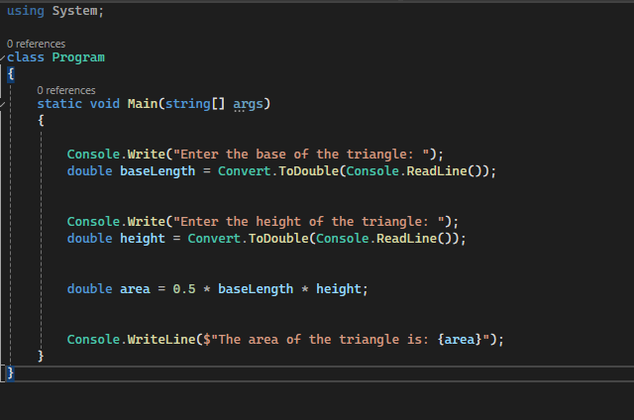



(10 points) Declare an array of 5 integers and fill it with values based on a user-defined formula (e.g., n^2). Then, print the largest element in the array.

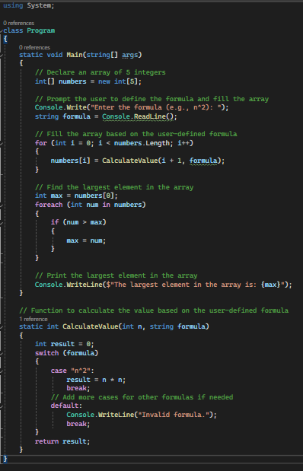



(10 points) Implement a simple for loop that iterates from 1 to 10 and prints each number along with its square root.

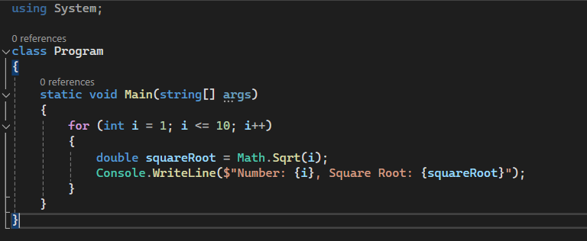

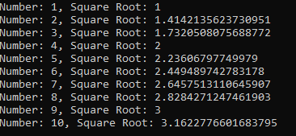

Part 2: HTML, CSS, and JavaScript (30 points)

HTML (10 points): You are provided with the following incomplete HTML code snippet:

HTML

<!DOCTYPE html>

<html>

<head>

<title>My Website</title>

</head>

<body>

<h1>Welcome to...</h1>

<p>This is a paragraph...</p>

<ul>

<li>Item 1</li>

<li>Item 2</li>

</ul>

</body>

</html>

Complete the code snippet by adding the following elements:

An image within the <body> tag with a relevant src attribute.

An ordered list (<ol>) with three items.

A hyperlink within a <p> tag that points to an external website.

A CSS styling rule using an inline style attribute to change the font color of the <h3> heading.

CSS (10 points): Create a CSS stylesheet that defines the following styles:

Change the background color of the body element to light blue.

Apply a padding of 20px to all headings (h1, h2, h3).

Set the font size of the <p> tag to 14px.

Make the list items (li) have a bullet point style instead of the default numbers.

JavaScript (10 points): Write a JavaScript function that takes a number as input and returns a string indicating whether the number is even or odd. Then, add a button to your HTML page that, when clicked, calls this function and displays the result (even or odd) in a paragraph element below the button.

Part 3: Essay Question (40 points)

Discuss the importance of object-oriented programming (OOP) concepts in software development. Explain the key principles of OOP (encapsulation, inheritance, polymorphism, abstraction) and provide examples of how they can be used to create more efficient, maintainable, and reusable code. Include real-world scenarios or cases where OOP is particularly valuable.

Answer:

In software engineering, object-oriented programming (OOP) serves as a foundational framework, offering systematic organization and enhanced maintainability for codebases. Encapsulation acts as a safeguard, shielding data from unwarranted access, while inheritance streamlines code development by facilitating the inheritance of properties and behaviors across class hierarchies. Polymorphism fosters versatility by enabling disparate objects to conform to a common interface, akin to interchangeable components in a system. Abstraction, akin to wearing noise-canceling headphones, filters out extraneous complexities, allowing developers to focus on essential aspects of their designs. OOP's versatility extends across diverse industries, from finance and healthcare to gaming and e-commerce, where its principles underpin the development of scalable, adaptable software solutions.

Points Distribution:

Each part carries equal weight (30 points).

Code clarity, functionality, and explanations will be considered in grading.

The essay question focuses on understanding and application of OOP concepts.