AIAC
ASSIGNMENT -8.1
Name: M.Anjali
HT. No: 230351025
Batch: 01

Task Description #1 (Password Strength Validator – Apply AI in Security Context)
- Task: Apply AI to generate at least 3 assert test cases for is_strong_password(password) and implement the validator function.
- Requirements:
  - Password must have at least 8 characters. o Must include uppercase, lowercase, digit, and special character.
  - Must not contain spaces.
Example Assert Test Cases:
assert is_strong_password("Abcd@123") == True assert is_strong_password("abcd123") == False assert is_strong_password("ABCD@1234") == True
Expected Output #1:
Password validation logic passing all AI-generated test cases
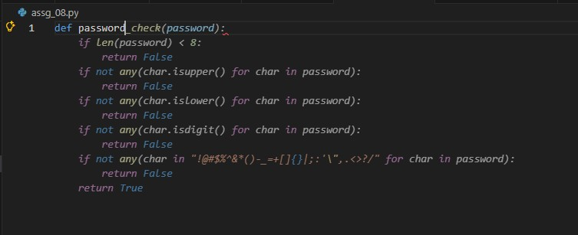
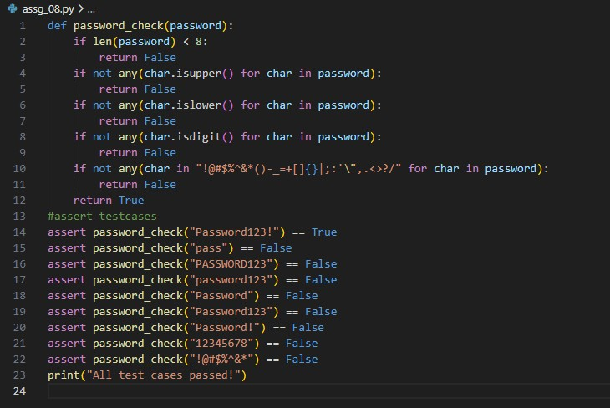
OUTPUT:

Task Description #2 (Number Classification with Loops – Apply AI for Edge Case Handling)
- Task: Use AI to generate at least 3 assert test cases for a classify_number(n) function. Implement using loops.
- Requirements:
  - Classify numbers as Positive, Negative, or Zero. o Handle invalid inputs like strings and None.
  - Include boundary conditions (-1, 0, 1).
Example Assert Test Cases:
assert classify_number(10) == "Positive" assert classify_number(-5) == "Negative" assert classify_number(0) == "Zero" Expected Output #2:
- Classification logic passing all assert tests.
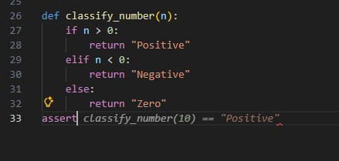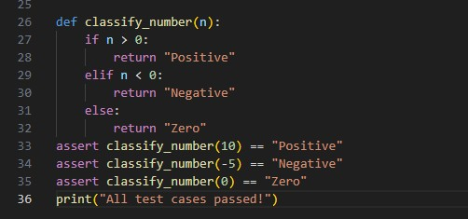

OUTPUT:

Task Description #3 (Anagram Checker – Apply AI for String Analysis)
- Task: Use AI to generate at least 3 assert test cases for is_anagram(str1, str2) and implement the function.
- Requirements:
  - Ignore case, spaces, and punctuation.
  - Handle edge cases (empty strings, identical words).
Example Assert Test Cases:
assert is_anagram("listen", "silent") == True assert is_anagram("hello", "world") == False assert is_anagram("Dormitory", "Dirty Room") == True
Expected Output #3:
- Function correctly identifying anagrams and passing all AI-generated tests.
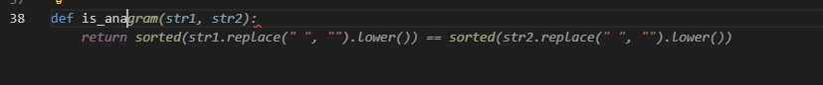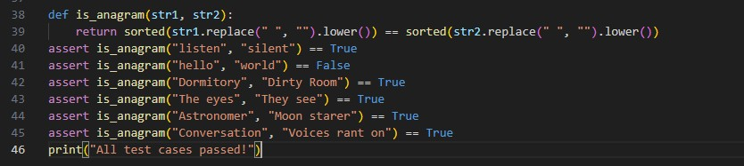
OUTPUT:

Task Description #4 (Inventory Class – Apply AI to Simulate Real-World Inventory System)
- Task: Ask AI to generate at least 3 assert-based tests for an Inventory class with stock management.
- Methods:
o add_item(name, quantity) o remove_item(name, quantity) o get_stock(name)
Example Assert Test Cases: inv = Inventory() inv.add_item("Pen", 10) assert inv.get_stock("Pen") == 10 inv.remove_item("Pen", 5) assert inv.get_stock("Pen") == 5 inv.add_item("Book", 3) assert inv.get_stock("Book") == 3
Expected Output #4:
- Fully functional class passing all assertions.

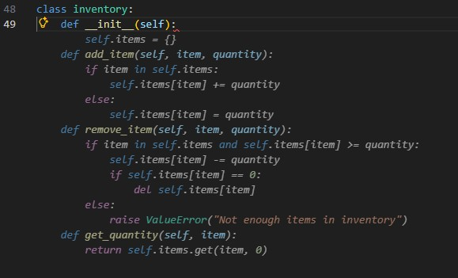
OUTPUT:
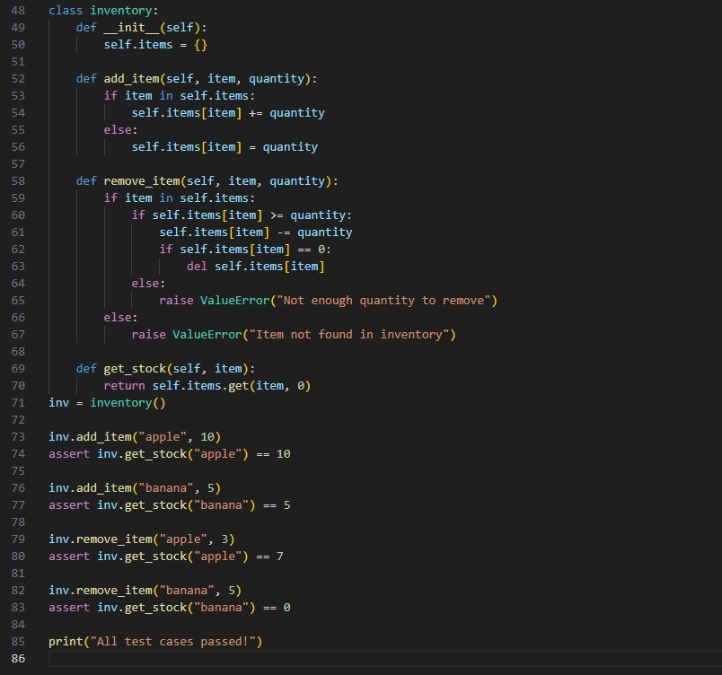
OUTPUT:

Task Description #5 (Date Validation & Formatting – Apply AI for Data Validation)
- Task: Use AI to generate at least 3 assert test cases for validate_and_format_date(date_str) to check and convert dates.
- Requirements:
  - Validate "MM/DD/YYYY" format. o Handle invalid dates.
  - Convert valid dates to "YYYY-MM-DD".
Example Assert Test Cases:
assert validate_and_format_date("10/15/2023") == "2023-10-15" assert validate_and_format_date("02/30/2023") == "Invalid Date" assert validate_and_format_date("01/01/2024") == "2024-01-01"
Expected Output #5:
- Function passes all AI-generated assertions and handles edge cases.
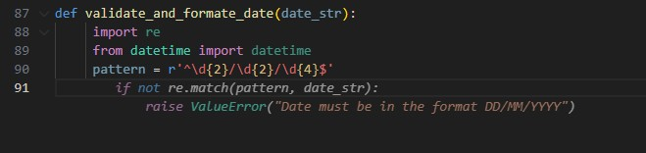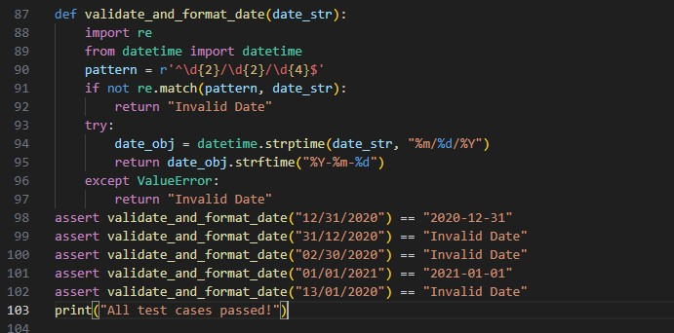
OUTPUT:

