**PIZZA SALES SQL QUERIES**

**1. Total Revenue:**

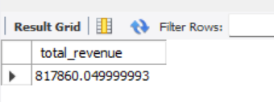

**2. Average Order Value**

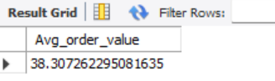

**3. Total Pizzas Sold**

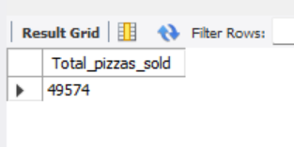

**4. Total Orders**

SELECT COUNT(DISTINCT order_id) as Total_orders from pizza_sales;



**5. Average Pizzas Per Order**

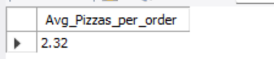

6. Daily Trend for Total Orders

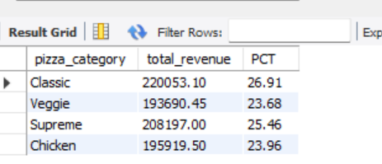

7. Monthly Trend for Orders

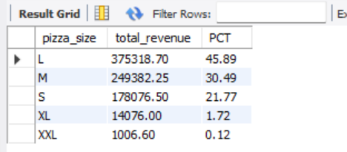

**8. % of Sales by Pizza Category**

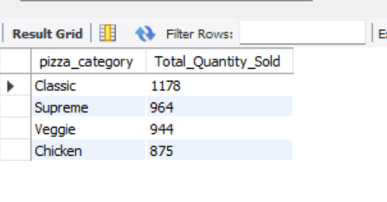

**9. % of Sales by Pizza Size**

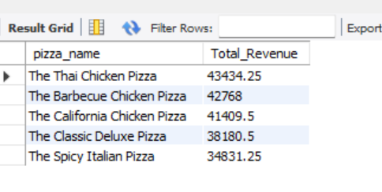

**10. Total Pizzas Sold by Pizza Category**

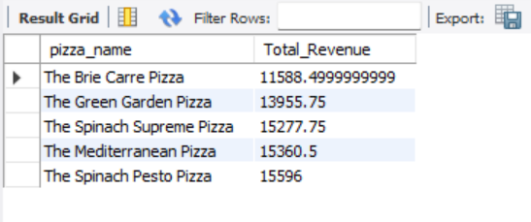

11. Top 5 Pizzas by Revenue

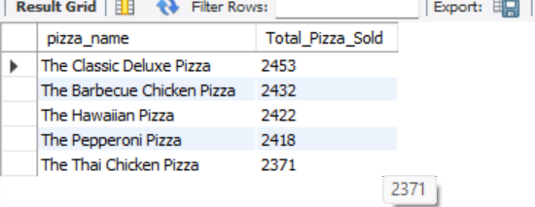

12. Bottom 5 Pizzas by Revenue

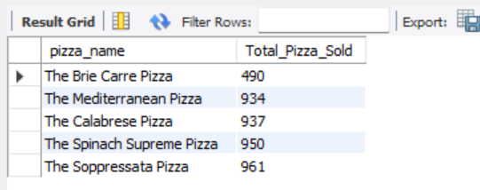

**13. Top 5 Pizzas by Quantity**

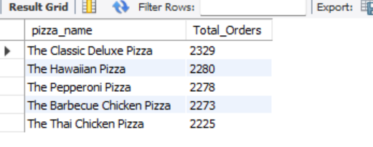

14. Bottom 5 Pizzas by Quantity

