**ezSPORTS SAGA**

**Group Project – SCS3117/ IS3013**

**Group Number: 09**

**B S T GUNARATHNA 14020248**

**Y N LIYANAGE 14020475**

**K I U MUNINDRADASA 14000997**

**T G N S PADMASIRI 14001071**

**S C M SENARATHNA 14001314**

**M M P THALAGAHAPITIYA 14001446**

**July 2017**

**DECLARATION**

We do hereby declare that the work reported in this report was exclusively carried out by us under the supervision of Dr. K L Jayarathna. It does not contain any material previously published or written by another person or our self and only it describes the results of our own independent work except where due reference has been made in the text.

Date: 27/07/2017

|  |  |
| --- | --- |
| **Name** | **Signature** |
| B S T Gunarathna |  |
| Y N Liyanage |  |
| K I U Munindradasa |  |
| T G N S Padmasiri |  |
| S C M Senarathna |  |
| M M P Thalagahapitiya |  |

I endorse the declaration by the candidates.

……………………………………. Date: ……………………………

Dr. K L Jayarathna

Supervisor

**Abstract**

This report contains details about the description and the implementation of the Group project which we carried out in the 3rd year semester – I.

As students in the University of Colombo, we have gone through several issues in taking details of achievements and participations of sports. This process currently takes a lot of time since they are still manually based. Also currently, students face some problems in doing reservations for the indoor gymnasium and the ground. People find it difficult to make reservations and find available dates. Also we have identified that there is a disturbance for examinations for nearer faculties when there is an event in the ground or the gymnasium as there is no proper coordination. Therefore, we came with his idea to eliminate all these issues.

The aim of this project is to develop a web based application that store details of the students who are engaged in sports in the University of Colombo. This helps in retrieving student details immediately when requested. Also ground and indoor gymnasium reservations can also be requested through the web based application. People can view the available and reserved dates and time through the calendar provided in the web based application. Therefore it gives an easy way to do the reservations. Also this provides a facility to faculty Deans / Directors to notify the Physical Department about the events or examinations that is going to take place through the web based application. It can help to eliminate disturbances for nearer faculty students. It also provides details about the sports and sports events that are held and participated in the University of Colombo.

This web based application helps to do the communication among the whole university effectively and efficiently avoiding collapsing of events.

**Acknowledgements**

We would like to extend our heartfelt gratitude to all the people who supported us in carrying out our project ezSports SAGA.

* First we would like to express our gratitude to our Supervisor Dr. K L Jayarathna, for the wonderful support and guidance given throughout the project. Proper guidance and advices helped a lot in figuring out our requirements, weaknesses and strengths.

* Then we would be much grateful for Mr. Ajantha Dahanayake and the staff of the Physical Education Department of the University of Colombo for providing us with the details to carry out the project and to clarify the requirements.
* We would also like to express our sincere gratitude to Mr. M.A.I.M Dharmadasa and Ms.M.G.A. Srimalee for their kind co-operation and encouragement as well as for providing us with necessary feedback throughout the project.
* Also, we express our gratitude to our families for the support and encouragement given throughout the project.
* At last, but not the least we would like to thank all our colleagues and everyone for the support, motivation and strength given in completing this project.

**Table of Content**

Declaration i

Abstract ii

Acknowledgements iii

Table of Contents iv

List of Figures v

List of Tables vi

List of Abbreviation vii

**List of figures**

# Introduction

# Project Introduction

This is a web based application which focuses on handling the UOC gymnasium and the ground reservation process, sports students’ details of the University of Colombo. Also, it provides opportunity to view the available date and time slots of ground and the indoor gymnasium for reservations for a particular event. Also, administration can access to students details as profits for their various document’s request easily. It also provides details about the sports and sports events held in the University of Colombo. The faculty Deans/Directors is provided with the opportunity to notify the admin about their faculty events (ex: Examinations) by this web based application ezSports SAGA.

We came up with this idea due to the difficulties we face in booking, or requesting documents regarding sports from the Physical Department of University of Colombo. In this system we first register the students who are participating in any kind of sport for the University of Colombo. Then we store all the data related to the student's participations, achievements and all the relevant details in the database. Therefore, when a student requests for a document related to his/ her sports (Eg: Enhancement credits), the administrators can easily view and prove the details and generate a report. In the current manual system this takes a lot of documentation and long time period. Sometimes wrong data can be given since there is no any proper way to prove.

Also, in this system we provide the opportunity to book the indoor gymnasium, Ground online. We provide a calendar for the viewers to find the events on a particular date, available time slots and dates for reservations. Therefore, people can suggest and decide their time and dates for the event and do bookings. Issuing passes for swimming is also can be requested through this system comforting the users.

This removes the paperwork and allows an efficient and effective process. This web based application allows new students to register (Name, Registration Number, Faculty, Sport), Edit personal details etc. It maintains a dynamic hierarchy for different users. Access rights will be different (Administrator, Employees, Students, Visitors). Therefore, even if the responsible persons are not available and also for past students, this system provides a chance to get the details needed without a hassle. For an example, past students who need to get their full report in sports in their University, they might face a challenge of changes in administration panel. This might get troubles of finding the past records of the particular student and his/her performances during university life. Our system stores data of each and every sports person in the system, allowing anyone to prove their participations and achievements.

Also, the fresher’s who are unaware about the sports opportunities of the university can be given awareness through this web based application. They also can get to know about the sports events such as Inter Faculty Meet, Fresher’s Meet, and Inter University Games (SLUG) etc. All this information is covered through his web based application.

Not only for the Fresher’s but also for the past students to get their full report in sports at any time where sometimes if the main Admin going to change so they are in a trouble of finding the past records of the particular student and his/her performances during the university life.

* **Goal**

The main goal of the project is to develop a web based application to handle all the documentation in an electronic way. This system will provide platform for an easy, less time consuming, user friendly and less complex approach.

* **Objectives**
  + To verify the Enhancement credit for the students and past students.
  + To provide easy method to do the bookings for the UoC ground and the indoor gymnasium.
  + To provide clear details for students about the sports and its events.
  + To identify necessary technologies to complete the task.
  + To get initial idea about how the Physical Department carry on their functions.

**1.2 Project Scope**

* **Main functionalities of the system:**

The proposed solution consists of registering students, booking indoor gymnasium and the ground, verifying student participation and achievements. Also it notifies the availability of the grounds and the details of the events that are already booked.

* **Users of the system:**
* Administrator
* Directors
* Students
* Employees
* Visitors

1. **System Analysis and Design**

After considering the above mentioned issues we face, we found that there is a potential for a web based application to manage sports. Therefore, we started through requirement gathering by interviewing the staff f the Physical Education Department of the University of Colombo, and students who are participating in sports. Then we discussed with our supervisor, mentors and team mates on how to carry out the project. Then we came up with the solution of ezSports SAGA, a web based application. Then we planned the developing according to the requirements and the time we have. Also we identified and designed on how the system should function, its functionalities, the actors of the system etc. After planning and understanding the system we designed the diagrams to carry out the further work simply.

**2.1 Requirement gathering techniques**

* + Frequent questioning with the students who engaged in sports.
  + Discussing the particular issue with the Director of Sports as well as the Advisory board.
  + Observation of the sport environment.
  + Inspection of Source documents-Co-operate plan, Manual document
  1. **Functional requirements of the project**
  + Report Generation
  + Player Categorization
  + Registering Students
  + Booking Indoor Gymnasium and the Ground
  + Verifying Student Participation
  + Verifying Student Achievement
  + Notifications on the availability of the Ground

**2.3 Nonfunctional requirements of the project**

* Security
  + - Authorization levels, usernames and passwords are used to upgrade the security
* Recoverability
  + - Ability to restore the deployment when a failure occurs
* Periodical backups
* Maintainability
  + - Fix errors successfully at given time
* Integrity
  + - The ability to perform its intended functions without any failures

**2.4 Use case Diagram**

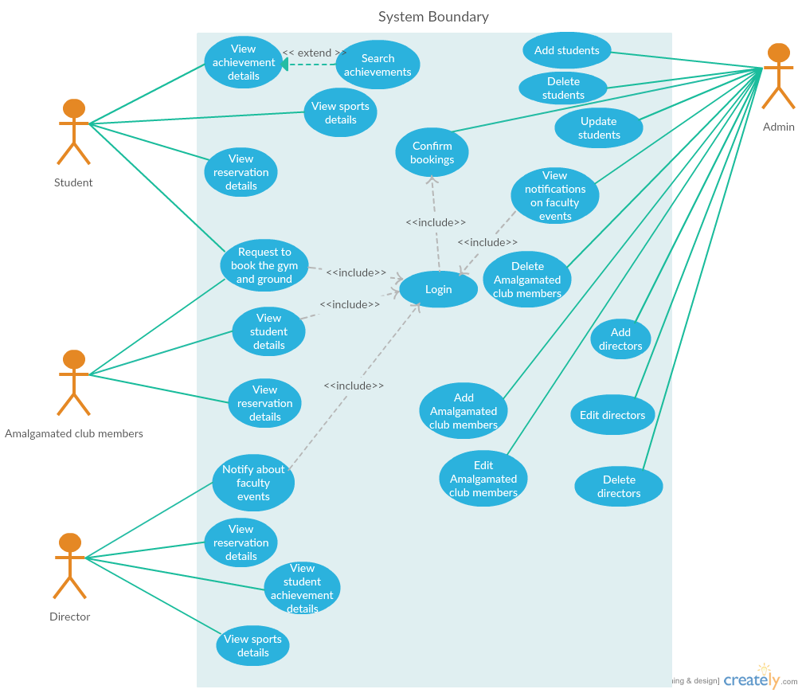

**2.5 Data Flow Diagram**

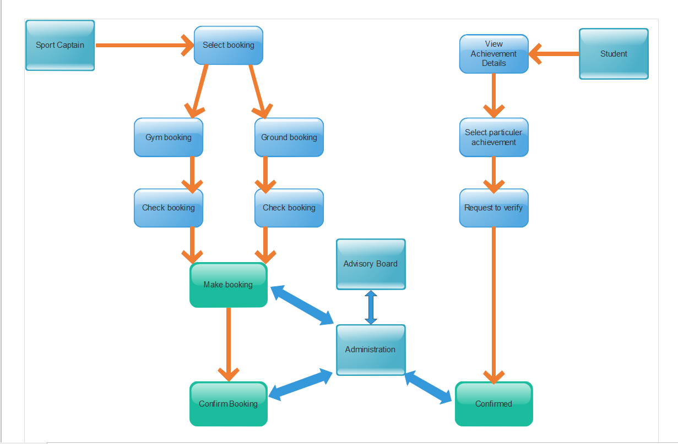

**2.6 System Architecture**

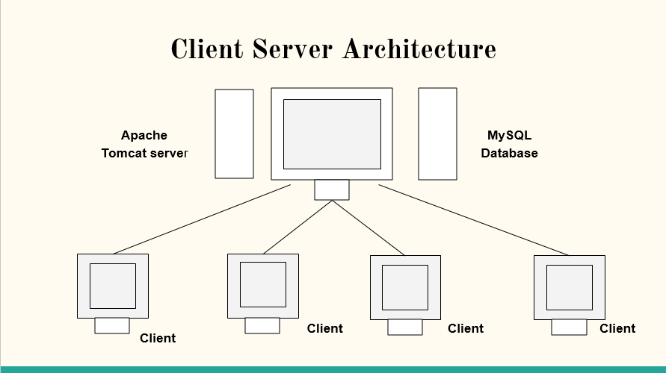

There are four users for the system as follows.

1. Administrator
2. Directors
3. Amalgamated club members
4. University Students

The server we are using is the Apache Tomcat server with a MySQL database connected.

**2.7 Class Diagram**

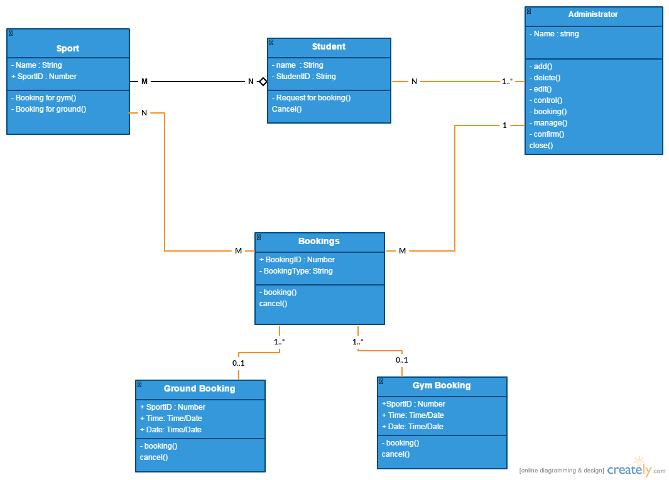

1. **System Development**

**3.1 The Project Plan**

Project work down is identified as below.

1. Problem definition and Identification

2. Requirement gathering

3. Project proposal completion

4. Project proposal presentation

5. Feasibility Study and use case modeling

6. Interim Presentation and reports submission

7. Studying on technologies

8. User interface designing

9. Prototyping

10. System development

11. Implementation

12. Testing

13. Feedback

14. Documentation

**3.2 Gant Chart**

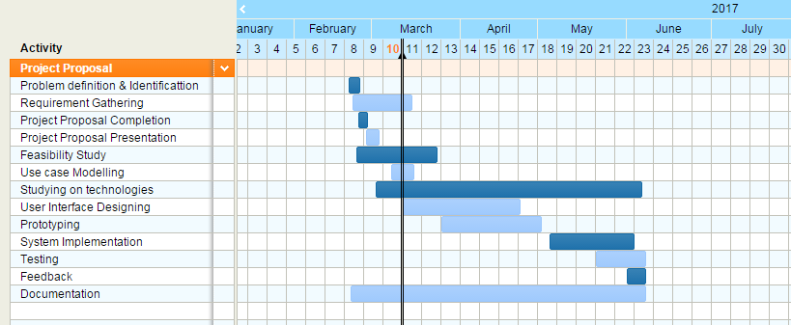

**3.3 Main deliverables of the system**

* + - Web based application

**3.4 Technologies Used**

* + - **To implement the web platform**
    - JavaEE
    - Apache Server
    - Netbeans IDE
    - Javascript
    - CSS3
    - HTML5
    - **To create database**
    - MYSQL
    - **To generate reports**
    - Jasper reports

1. **Testing and Evaluation**

**4.1 Assumptions**

* All the tests are done manually.
* Functionalities are implemented and available in the system prior to start of Functional Testing.
* Functional Specification document, Use case documents are available prior to start of testing.

**4.2 Risks**

|  |  |  |  |
| --- | --- | --- | --- |
| **#** | **Risk** | **Impact** | **Mitigation Plan** |
| 1 | Test planning and scheduling problems | Medium | Try to automate some testing processes rather than doing everything manually |
| 2 | New requirement may need to be added later and it may cause to change already existing test plan | High | Have a test plan that can allocate requirement changes |
| 3 | Scope of testing process is high | Low | Try to use minimum number of test cases that will cover almost all the functionalities |
| 4 | Sequence of code delivery doesn't suit the test schedule | High | Schedule the tests considering  project plan or schedule as well. |
| 5 | Developers delaying to deliver the build for testing | Medium | Conducting Risk Assessment review meeting with the development team. |

**4.3 Testing Types**

* Functional Testing
* Unit Testing
* GUI Testing
* Integration Testing

1. **Conclusion**

Our product ezSports SAGA, provides the facility to the user on retrieving relevant data easily and effectively when requested. It helps in making users aware about the sports events held in the university. Managing students achievement and participation data helps in getting clarifications and evidence easily and properly as well.