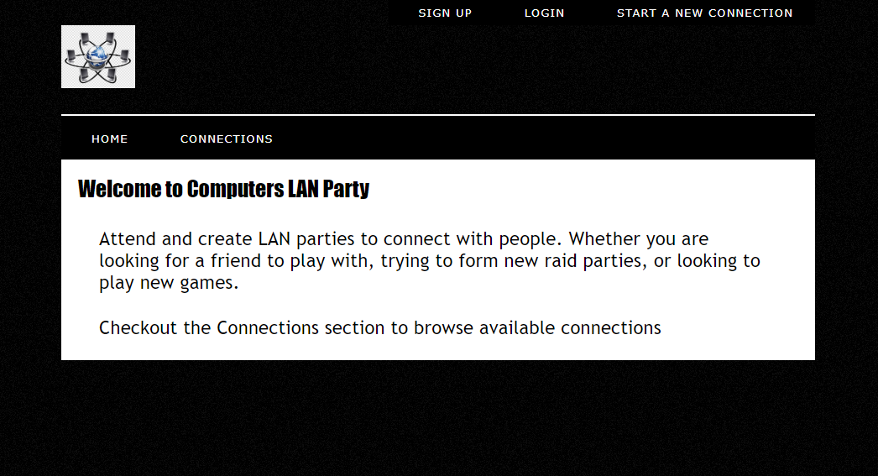

There were no additional features added to the project

Everything is complete

All of the easy parts was creating the basic look of the page with HTML and CSS. The challenging part was to make everything match and make sure that nothing was too out of place. I overcame this challenging by making small tweaks many times until I was happy with the page layout.