# CHAPTER 11

## Current Designs Excel Tutorials

**Using Excel to Make Decisions at Current Designs**

**Topic(s): Information Needs of Managers, Special-Purpose Reports, and Cost Classifications**

**Excel Functions and Tools: Cell Formatting Tools: Font Settings, Cell Styles, Alignment, Merge and Center, Row Height, Column Width, Cell Borders, Text Wrapping, Number Formatting**

This document provides instructions that explain how to use some of Excel’s® most common formatting features to create a report with a professional appearance for the Current Designs problem that appears in the Chapter 11 worksheet templates. A **What-if** question at the end of the solution will help you see how formatting changes can enhance the appearance of your worksheet. Download the Excel file containing the Chapter 11 Excel Templates from the Wiley resources. It includes an Excel Template to use to solve the Current Designs problem.

### Problem Statement

Mike Cichanowski founded Wenonah Canoe and later purchased Current Designs, a company that designs and manufactures kayaks. The kayak-manufacturing facility is located just a few minutes from the canoe company’s headquarters in Winona, Minnesota.

Current Designs makes kayaks using two different processes. The rotational molding process uses high temperature to melt polyethylene powder in a closed rotating metal mold to produce a complete kayak hull and deck in a single piece. These kayaks are less labor-intensive and less expensive for the company to produce and sell.

Its other kayaks use the vacuum-bagged composite lamination process (which we will refer to as the composite process). Layers of fiberglass or Kevlar® are carefully placed by hand in a mold and are bonded with resin. Then, a high-pressure vacuum is used to eliminate any excess resin that would otherwise add weight and reduce strength of the finished kayak. These kayaks require a great deal of skilled labor as each boat is individually finished. The exquisite finish of the vacuum-bagged composite kayaks gave rise to Current Designs’ tag line, “A work of art, made for life.”

Current Designs has the following managers:

Mike Cichanowski, CEO

Diane Buswell, Controller

Deb Welch, Purchasing Manager

Bill Johnson, Sales Manager

Dave Thill, Kayak Plant Manager

Rick Thrune, Production Manager for Composite Kayaks

The company’s accounting data for the most recent period is presented here.

|  |  |  | **Product Costs** | | |  |  |
| --- | --- | --- | --- | --- | --- | --- | --- |
|  |  |  | **Direct** | **Direct** | **Mfg.** | **Period** | **Total** |
| **Payee** | **Purpose** |  | **Materials** | **Labor** | **Overhead** | **Costs** | **Costs** |
| Winona Agency | Property insurance for the manufacturing plant | |  |  |  |  | $ 3,200 |
| Bill Johnson (sales manager) | Payroll check - payment to sales manager | |  |  |  |  | 1,700 |
| Xcel Energy | Electricity for manufacturing plant | |  |  |  |  | 450 |
| Winona Printing | Price lists for salespeople | |  |  |  |  | 85 |
| Jim Kaiser (sales representative) | Sales commissions | |  |  |  |  | 1,250 |
| Dave Thill (plant manager) | Payroll check - payment to plant manager | |  |  |  |  | 1,450 |
| Dana Schultz (kayak assembler) | Payroll check - payment to kayak assembler | |  |  |  |  | 760 |
| Composite One | Bagging film used when kayaks are assembled; it is discarded after use. | |  |  |  |  | 260 |
| Fastenal | Shop supplies - brooms, paper towels, etc. | |  |  |  |  | 890 |
| Ravago | Polyethylene powder which is the main ingredient for the rotational molded kayaks. | |  |  |  |  | 3,170 |
| Winona County | Property taxes on manufacturing plant | |  |  |  |  | 5,480 |
| North American Composites | Kevlar ® fabric for composite kayaks | |  |  |  |  | 4,930 |
| Waste Management | Trash disposal for the company office building | |  |  |  |  | 660 |
| None | Journal entry to record depreciation of manufacturing equipment | |  |  |  |  | 4,540 |

**Instructions**

1. What are the primary information needs of each manager?

b. Name one special-purpose management accounting report that could be designed for each manager. Include the name of the report, the information it would contain, and how frequently it should be issued.

  c. When Diane Buswell, controller for Current Designs, reviewed the accounting records for a recent period, she noted the cost items and amounts shown above (amounts are assumed). Enter the amount for each item in the appropriate cost category. Then sum the amounts in each cost category column.

### What-If? Question

Current Designs estimated its product costs for an order from Special Sports, which are provided below in the solution section. The sales manager wants a report of the product costs associate with an order received from Special Sports. Format the report to submit for the sales manager.

### Solution Tutorial

Follow the step-by-step directions to complete the solution and to properly format a report. Save your file frequently while working.

#### Part 1 a.

**Use sheet tab CD11 Part 1.**

**Step 1:** Open the worksheet template file in Microsoft Excel. Save the file on your computer’s desktop.

**Step 2:** In cells E71 through I76, indicate the primary accounting information needs of each of Current Designs’ managers. Compare your work to the solution that follows. If you are unsure of any answers, review the concepts in Chapter 11 of your textbook.

An illustration shows an Excel spreadsheet with two columns, and the column headers are: Managers, and Primary Information Needs. The data are as follows: 
Managers, Mike Cichanowski, C E O; Primary Information Needs, Mike Cichanowski, C E O, needs to know the overall financial picture of the company. He also needs to have a general picture of sales by territory and product line, and of cost per unit by product line;
Managers, Diane Buswell, Controller; Primary Information Needs, Diane Buswell, Controller, needs all accounting-related information;
Managers, Deb Welch, Purchasing Manager, Controller; Primary Information Needs, Deb Welch, Purchasing manager, needs to know the costs of the components for each product;
Managers, Bill Johnson, Sales Manager; Primary Information Needs, Bill Johnson, Sales Manager, needs to know sales by territory and product line;
Managers, Dave ThiII, Kayak Plant Manager; Primary Information Needs, Dave Thill, Kayak Plant Manager needs to know all the costs of producing each type of kayak;
Managers, Rick Thrune, Production Manager for Composite Kayaks; Primary Information Needs, Rick Thrune, Production Manager for Composite Kayaks, needs to know the costs related to the composite kayak production.

**Decision Analysis:** Managers need information that will help them make informed decisions, which includes information useful for planning, directing, and controlling. Managers at lower levels need details of specific products, while those at upper-levels need broader information.

#### Part 1 b.

**Step 3:** Apply cell formatting to the column headings that appear in cells B79 to H79.

**Hint:** Excel contains several predefined cell formats. Select cells B79 to J79. From the **Home** tab of the menu ribbon, click the pull down menu for the **Cell** **Styles** option in the **Styles** tab. The **Cell Styles** menu will appear. The last section contains the **Themed Cell Styles** options. Select **Accent1** and the heading columns in row 79 will be changed to dark blue shading and white font.

**An illustration shows a portion of an Excel spreadsheet menu ribbon with its various functions. A series of tabs are displayed on the top row with the Home tab enabled and its icons displayed. Immediately below the options wrap text, merge and center, and cell styles are selected. The data displayed are as follow: 
Good, bad, and Neural: Normal, Bad, Good, Neural;
Data and Model: Calculation, Check cell, Explanatory, Input, Linked Cell, Note, Output, and Warning Text;
Title and Headings: Heading 1, Heading 2, Heading 3, Heading 4, Title, Total;
Themed Cell Styles: 20% Accent, 20% Accent, 20% Accent, 20% Accent, 20% Accent, 20% Accent; 
Themed Cell Styles: 40% Accent, 40% Accent, 40% Accent, 40% Accent, 40% Accent, 40% Accent;
Themed Cell Styles: 60% Accent, 60% Accent, 60% Accent, 60% Accent, 60% Accent, 60% Accent;
Themed Cell Styles: Accent 1 (labeled Accent Style 1), Accent 2, Accent 3, Accent 4, Accent 5, Accent 6. The option cell styles, is labeled, Cell Style button. **

**Step 4:** In cells C80 to C85, indicate the name of a report that each manager may use to aid decision-making.

**Step 5:** In the merged cells for columns E through H in rows 80 through 85, indicate the information that would be contained in each report.

**Step 6:** In cells I80 to J85, indicate how frequently the reports you recommended should be issued. Compare your work to the solution that follows. If you are unsure of any answers, review the concepts in Chapter 11 in your textbook.

An illustration shows an Excel spread sheet with four columns, and the column headers are: Managers, Name of report, Information report would contain, and Frequently issued. The data are as follows: 
Managers, Mike Cichanowski; Name of report, Analysis of proposed new product line; Information report would contain, Projected revenues and expenses for a possible new product line; Frequently issued, As needed and requested;
Managers, Diane Buswell; Name of report, Company-wide budget analysis; Information report would contain, Revenues, expenses, and net income compared to the budgeted amounts for each; Frequently issued, Monthly;
Managers, Deb Welch; Name of report, Purchasing history; Information report would contain, List of items purchased and most recent cost for each item; Frequently issued, Monthly or available online;
Managers, Bill Johnson; Name of report, Sales Summary; Information report would contain, Sales by product line and by customer; Frequently issued, Monthly or weekly;
Managers, Dave Thill; Name of report, Cost of Production Report; Information report would contain, Direct materials, direct labor, and manufacturing overhead costs assigned to each product line; Frequently issued, Monthly or weekly;
Managers, Rick Thrune; Name of report, Cost of Production Report for Composite Kayaks; Information report would contain, Detailed direct material and direct labor costs for the composite kayaks; Frequently issued, Weekly. 

**Decision Analysis:** Managers use many reports to help with decision-making with each report providing information geared towards aiding a manager’s specific needs in his or her area of responsibility. Because there are many reports, your answers may differ from those given in the solution.

#### Part 1 c.

**Step 7:** Unformatted data has been provided in rows 88 through 104. To format the table:

1. Change the font size to 10 point.

**Hint:** Select cells B88 through I104. From the **Home** tab of the menu ribbon, click the arrow in the lower right corner of the **Font** tab. (If you are using a Mac computer, you may not see the **Font** tab label so simply select from the available fonts in the drop-down box just to the right of the **Cut, Copy** and **Format** icons.) The **Format Cells** dialog box will appear. In the **Size** list, select 10. In the **Font** list, you will see the font that is set as default in the program settings on your computer. The font set as default that appears in the **Format Cells** graphic that follows is **Liberation Sans**. You may select any font you like or keep the default font. In the **Font Style** list, select **Regular**. Select **OK** near the bottom right of the dialog box to close it.

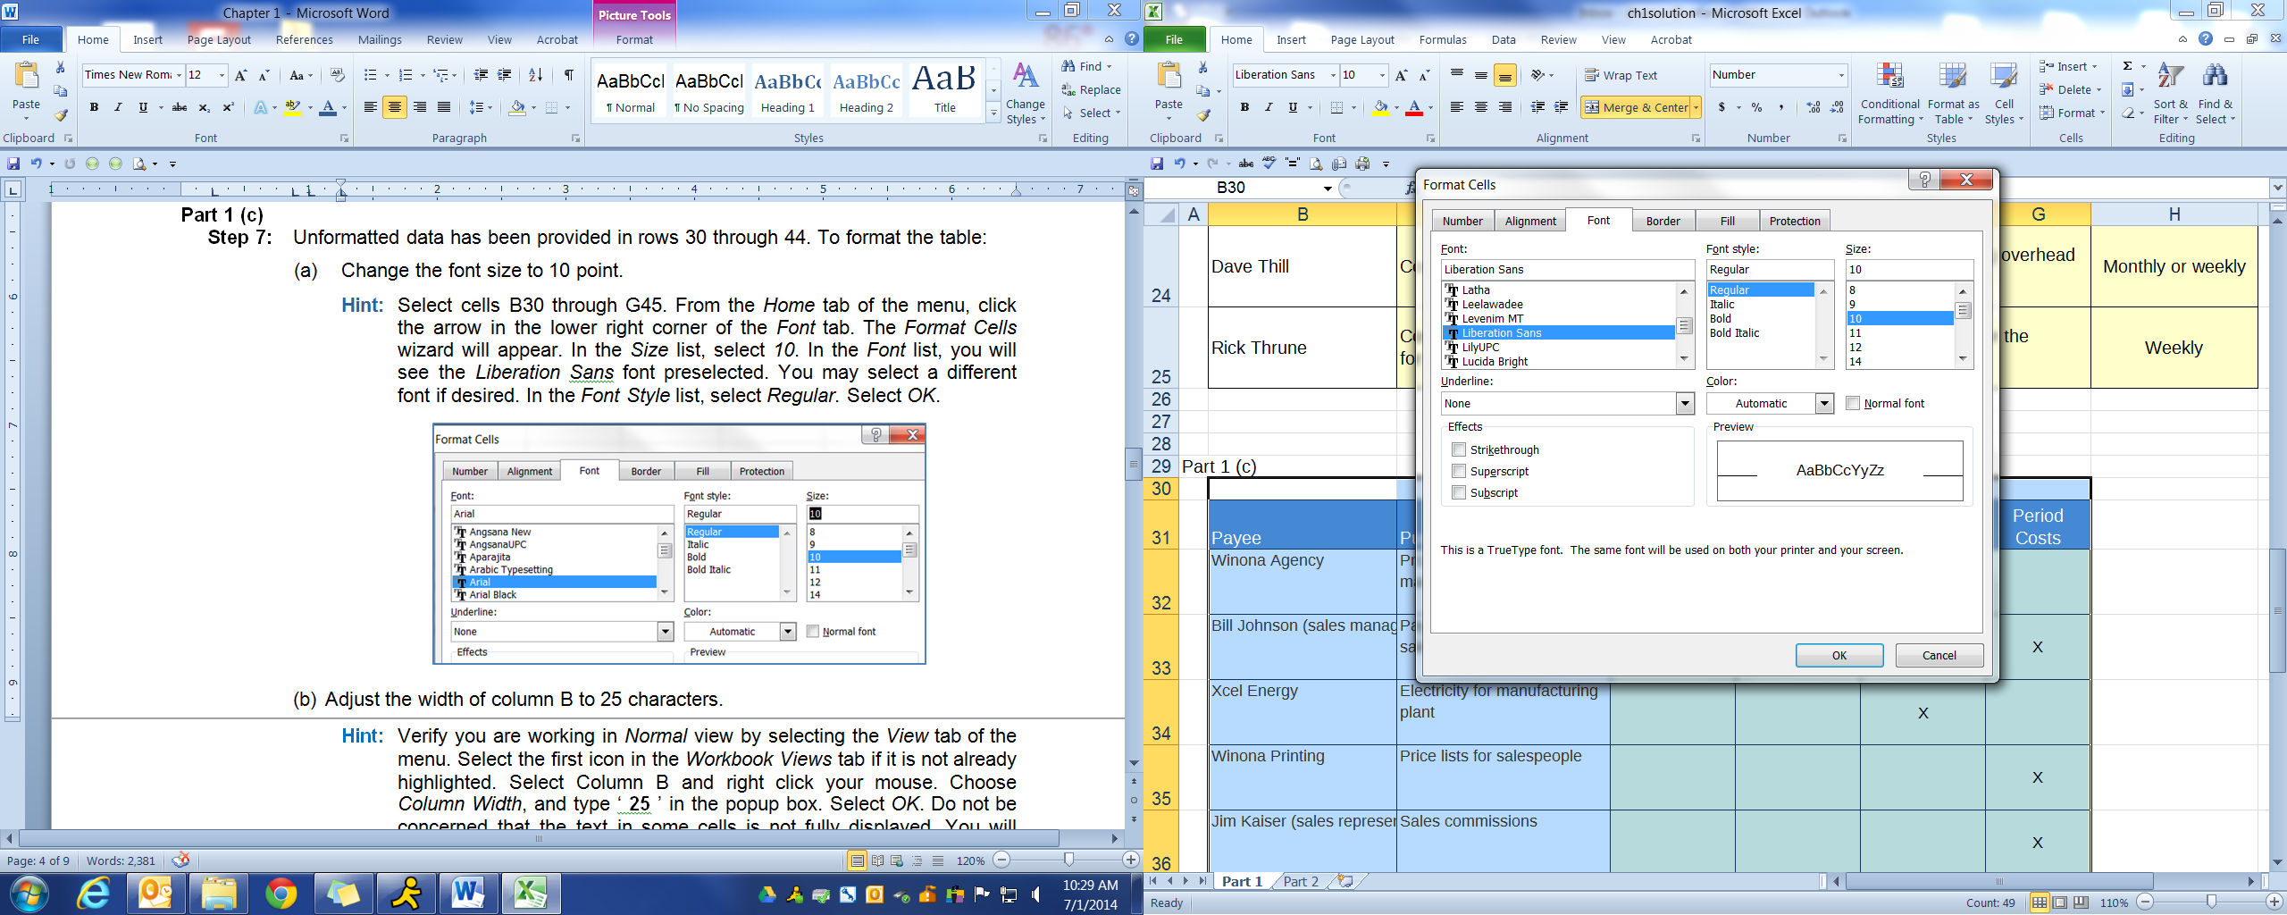

1. Adjust the width of column B to 12 characters.

**Hint:** Verify you are working in **Normal** view byselecting the **View** tab of the menu ribbon. Select the first icon labeled as **Normal** in the **Workbook Views** tab if it is not already highlighted.

Select column B and right click your mouse. Choose **Column Width** and type the number **12** in the popup box. Select **OK** to close the dialog box. Do not be concerned that the text in some cells is not fully displayed. You will adjust the text later.

1. Adjust the width of the following columns to the specified number of characters:

Columns E, F, G, and H 8.2 characters

**Hint:** Selecting columns E, F, G, and H together will allow you to set the column width for all four columns simultaneously. If your Excel settings do not allow the selection of multiple columns, select one column at a time to adjust the column widths.

1. Adjust the height of rows 90 through 103 to 40 characters.

**Hint:** Selecting rows 90 through 103 together will allow you to set the row height for all rows in your selection simultaneously. Any labels in these cells that are partially obscured will be corrected later.

Select rows by placing your cell pointer on row numbers 90 to 103 at the far left of the worksheet. Right click the mouse and select **Row Height** from the drop-down menu choices. When the **Row Height** dialog box displays, type 8.2 and click **OK** to close the dialog box.

1. Add borders to the table.

**Hint:** Select cells B89 through I103.Click the arrow to the right of the **Borders** button in the **Font** group of the **Home** menu ribbon to display the possible border selections. Select the **All Borders** option.

1. Merge and center cells E88, F88, and G88. Because direct materials, direct labor, and manufacturing overhead are all considered to be product costs, you are centering the **Product Costs** label over these three columns.

**Hint:** Select cells E88, F88, and G88.Click the **Merge & Center** button in the **Alignment** tab of the menu ribbon.

1. Add a border to the merged cell that occupies E88 through G88.

**Hint:** Select the merged cell which begins in E88 and click the arrow to the right of the **Borders** icon in the **Font** tab of the **Home** menu ribbon to display the possible border selections. Select the **Outside Borders** option.

1. Center the headings horizontally in cells C89 through I89.

**Hint:** Select cells C89 through I89. Click the **Center** button which appears in the **Alignment** tab of the **Home** menu ribbon.

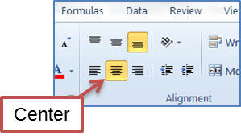

1. Align the text vertically at the bottom of cells B89 to I89. If the alignment default is already selected at the bottom of these cells, you may skip this step.

**Hint:** Select cells B89 to I89. Click the **Bottom Align** icon which appears in the **Alignment** tab of the **Home** menu ribbon.

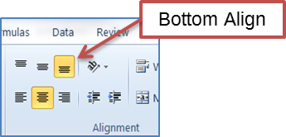

1. Wrap the text in cells E89 to I89.

**Hint:** Select cells E89 to I89. Click the **Wrap Text** icon which appears in the **Alignment** tab of the **Home** menu ribbon.

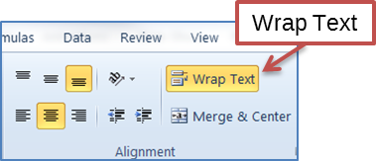

1. Wrap the text in cells C90 to C103.
2. Apply the **Accent1** cell style to the column headings that appear in cells E88 through G88 (previously merged) and cells B89 through I89.

**Hint:** Use the **Cell Styles** button in the **Styles** tab from the **Home** menu ribbon.

**Step 8:** Identify the appropriate classification for each cost that appears in rows 90 through 103 by typing the respective cost amount in the column of the respective classification. If you are unsure of any classifications, review Chapter 11 in your textbook.

**Step 9:** Add the amounts in each column and enter the totals in the respective columns of row 104. Compare your work to the solution that follows.

**An illustration shows an excel spread sheet with seven columns, and the column headers are: Payee; Purpose; Product Costs: Direct Materials, Direct Labor, Manufacturing Overhead, Period Costs; and Total Costs. The data are as follows: 
Payee, Winona Agency; Purpose, Property insurance for the manufacturing plant; Direct Materials, no data; Direct Labor, no data; Manufacturing Overhead, 3,200; Period Costs, no data; Total Costs, $3,200;
Payee, Bill Johnson (sales manager); Purpose, Payroll check - payment to sales manager; Direct Materials, no data; Direct Labor, no data; Manufacturing Overhead, no data; Period Costs, 1,700; Total Costs, 1,700;
Payee, Xcel Energy; Purpose, Electricity for manufacturing plant; Direct Materials, no data; Direct Labor, no data; Manufacturing Overhead, 450; Period Costs, no data; Total Costs, 450;
Payee, Winona Printing; Purpose, Price lists for salespeople; Direct Materials, no data; Direct Labor, no data; Manufacturing Overhead, no data; Period Costs, 85; Total Costs, 85;
Payee, Jim Kaiser (sales representative); Purpose, Sales commissions; Direct Materials, no data; Direct Labor, no data; Manufacturing Overhead, no data; Period Costs, 1,250; Total Costs, 1,250;
Payee, Dave Thill (plant manager); Purpose, Payroll check - payment to plant manager; Direct Materials, no data; Direct Labor, no data; Manufacturing Overhead, 1,450; Period Costs, no data; Total Costs, 1,450;
Payee, Dana Schultz (kayak assembler); Purpose, Payroll check - payment to kayak assembler; Direct Materials, no data; Direct Labor, 760; Manufacturing Overhead, no data; Period Costs, no data; Total Costs, 760;
Payee, Composite One; Purpose, Bagging film used when kayaks are assembled; it is discarded after use; Direct Materials, no data; Direct Labor, no data; Manufacturing Overhead, 260; Period Costs, no data; Total Costs, 260;
Payee, Fastenal; Purpose, Shop supplies - brooms, paper towels, et cetera; Direct Materials, no data; Direct Labor, no data; Manufacturing Overhead, 890; Period Costs, no data; Total Costs, 890;
Payee, Ravago; Purpose, Polyethylene powder which is the main ingredient for the rotational molded kayaks; Direct Materials, 3,170; Direct Labor, no data; Manufacturing Overhead, no data; Period Costs, no data; Total Costs, 3,170;
Payee, Winona County; Purpose, Property taxes on manufacturing plant; Direct Materials, no data; Direct Labor, no data; Manufacturing Overhead, 5,480; Period Costs, no data; Total Costs, 5,480;
Payee, North American Composites; Purpose, Kevlar, registered trademark symbol, fabric for composite kayaks; Direct Materials, 4,930; Direct Labor, no data; Manufacturing Overhead, no data; Period Costs, no data; Total Costs, 4,930;
Payee, Waste Management; Purpose, Trash disposal for the company office building; Direct Materials, no data; Direct Labor, no data; Manufacturing Overhead, no data; Period Costs, 660; Total Costs, 660;
Payee, None; Purpose, Journal entry to record depreciation of manufacturing equipment; Direct Materials, no data; Direct Labor, no data; Manufacturing Overhead, 4,540; Period Costs, no data; Total Costs, 4,540;
Payee, Totals; Purpose, no data; Direct Materials, $8,100; Direct Labor, $760; Manufacturing Overhead, $16,270; Period Costs, $3,695; Total Costs, $28,825.**

**Decision Analysis:** Product costs consist of all costs necessary to get the inventory (products) ready to sell. Product costs are a necessary and integral part of producing the finished product. They contain both direct and indirect costs. Direct materials and direct labor consist of materials that can be physically and directly associated with the finished product and employee efforts directly associated with producing products during the manufacturing process. Manufacturing overhead consists of indirect materials, indirect labor, and factory-related costs that are necessary for production but are not directly associated with specific products. All costs that are not product costs are period costs and are often called nonmanufacturing costs.

### What-if Solution

Excel contains a broad array of formats that can be used to suit the needs of the users. Perform the steps that follow to use numeric formatting and to make changes to the **what-if** formats to see the impact of the appearance of the table.

#### Part 2

**Use sheet tab CD11 Part 2.**

**Hint:** Refer back to Part 1 for directions if needed to perform the formatting steps in this section.

**Step 1:** The unformatted report appears in rows 76 through 87 of the worksheet. Set the size of the font in cells B76 through E87 to 12 point.

**Step 2:** Set the width of column E to 9.5 characters.

**Step 3:** Adjust the height of row 76 to 20 characters. Adjust the height of rows 77 through 87 to 17 characters.

**Step 4:** Merge and center the report heading over the four columns of the report (cells B76 through E76).

**Step 5:** Align the text vertically in the center of the row 76 merged cells.

**Step 6:** Apply the **Accent4** cell style to the row 76 merged cells.

**Step 7:** Place a bottom single border in cell E86.

**Step 8:** Place a bottom double border in cell E87.

**Step 9:** Assign **Accounting** number formatting to the numerical amounts in cells E77 through E87.

**Hint:** Select cells E77 through E87.Open the **Number** tab from the **Home** menu ribbon to display the **Format Cells** dialog box. Select **Accounting** from the **Category** field. Change the number of decimal places to 0 in the **Decimal places** field. The default setting for the *Symbol* field should display as *None*. Change the **Symbol** to **None** if any other appears. Click **OK**.

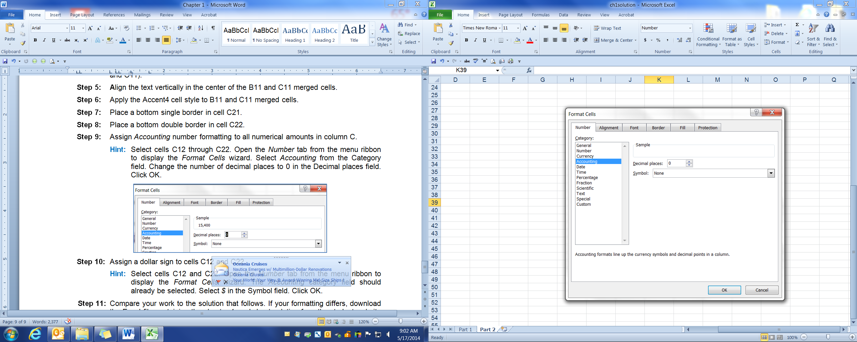

**Step 10:** Assign a dollar sign to cells E77 and E87.

**Hint:** Select cells E77 and E87.Open the **Number** tab from the *Home* menu ribbon to display the **Format Cells** dialog box. The **Accounting** category field should already be selected. Select **$** in the **Symbol** field. Click OK.

**Step 11:** Compare your work to the solution that follows.

An illustration shows an excel spread sheet titled, Product Costs for the Special Sports’ Order with two columns, the first column displaying account names, and the second column displaying their respective account names. The data are as follows: 
Direct materials used in production, $15,400; Direct labor, 11,200; Indirect materials, 1,200; Indirect labor, 4,300; Factory rent, 2,100; Equipment depreciation, 1,600; Factory manager's salary, 3,200; Factory utilities, 1,100; Property taxes on factory building, 700; Factory insurance, 900; Total product costs, $41,700.

You may want to try some other font styles and sizes, cell styles, cell alignments, and other formatting options to see how each change affects the appearance of your report.