# CHAPTER 12

## Current Designs Excel Tutorials

**Using Excel to Make Decisions at Current Designs**

**Topic(s):  Job Order Costing**

**Excel Functions and Tools:  Using Mathematical Formulas**

This document provides instructions that explain how to use mathematical formulas in a Microsoft Excel worksheet to solve the Current Designs problem that appears in the Chapter 12 worksheet template. A **What-If** scenario illustrated at the end of the solution will help you see how changes in one section of the worksheet can affect accounting information in other sections of the worksheet. Download the Excel file containing the Chapter 12 Excel Templates from the Wiley resources. It includes an Excel Template to use to solve the Current Designs problem.

### Problem Statement

Huegel Hollow Resort has ordered 20 rotomolded kayaks from Current Designs. Each kayak will be formed in the rotomolded oven, cooled, and then have the excess plastic trimmed away. Then, the hatches, seat, ropes, and bungees will be attached to the kayak.

Dave Thill, the kayak plant manager, knows that manufacturing each kayak requires 54 pounds of polyethylene powder and a finishing kit (rope, seat, hardware, etc.). The polyethylene powder used in these kayaks costs $1.50 per pound, and the finishing kits cost $170 each. Each kayak will use two kinds of labor: 2 hours of more-skilled type I labor from people who run the oven and trim the plastic, and 3 hours of less-skilled type II labor from people who attach the hatches and seat and other hardware. The type I employees are paid $15 per hour, and the type II employees are paid $12 per hour. For purposes of this problem, assume that overhead is applied to all jobs at a rate of 150% of direct labor costs.

The data for this problem are provided here.

| Number of kayaks ordered | | 20 |  |
| --- | --- | --- | --- |
| Resources required for each kayak | |  |  |
|  | Polyethylene powder | 54 | pounds |
|  | Finishing kit | 1 | each |
|  | Type I labor | 2 | hours |
|  | Type II labor | 3 | hours |
|  | Manufacturing overhead | 150% | of direct labor cost |
| Costs | |  |  |
|  | Polyethylene powder | $ 1.50 | per pound |
|  | Finishing kits | 170.00 | each |
|  | Type I labor rate | 15.00 | per hour |
|  | Type II labor rate | 12.00 | per hour |

**Instructions**

Determine the total cost of the Huegel Hollow order and the cost of each individual kayak in the order. Identify costs as direct materials, direct labor, or manufacturing overhead.

### What-If? Question

Perform what-if analysis to answer the following question:

Suppose Current Designs can purchase a higher quality type of polyethylene power at a cost of $1.65 per pound, which will enable to the company to reduce the number of hours of type I labor to 1 hour. What will be the new cost of each kayak?

### Solution Tutorial

Follow the steps below to learn how to use Excel’s mathematical operations and formulas to help you determine the cost of the Huegel Hollow Resort order for Current Designs. Save your file frequently while working.

#### Part 1

**Use sheet tab CD12 Part 1.**

**Step 1:** Open the worksheet template file in Microsoft Excel. Save the file on your computer’s desktop. The data area that appears in cells B22 through G34 contains the data provided by Current Designs.

**Step 2:** Type a mathematical formula into cell F46 that calculates the cost of the polyethylene powder.

**Hint:** All formulas begin with an “ = ” (equal sign) in Excel.

1. Place the cell pointer in cell F46 and press the “ = “ (equal sign) key.
2. Immediately select cell F25 which contains the number of pounds of powder needed for production.
3. Press the “ * “ (asterisk) key. This symbol is used to multiply in Excel.
4. Select cell F31 which contains the cost per pound of the powder
5. Press the **Enter** key.
6. Select cell F46. The formula bar which appears just below the menu ribbon at the top of the worksheet displays the formula for this cell. Verify the formula displays as shown below:

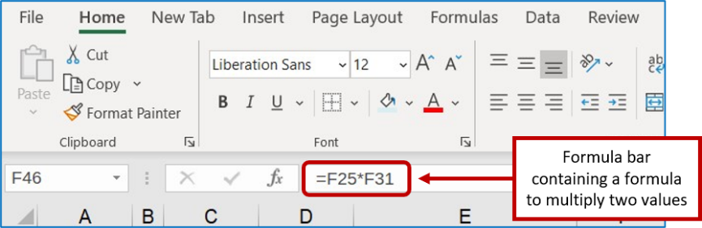

**Step 3:** Repeat step 2 to calculate each of the following costs, using the respective amounts from the data area:

1. Select cell F47 and enter the formula to calculate the cost of the finishing kit.
2. Select cell F50 and enter the formula to calculate the cost of the type I labor.
3. Select cell F51 and enter the formula to calculate the cost of the type II labor.
4. Select cell F53 and enter the formula to calculate the cost of the manufacturing overhead.

**Hint:** Because there are two components on direct labor, your formula will consist of three components. The “ + ” (plus sign) allows you to add individual numeric amounts.

1. Place your cell pointer in cell F53.
2. Type the ‘ = ‘ sign.
3. Type a left parentheses ‘ ( ‘ symbol.
4. Immediately select cell F50.
5. Type the ‘ + ‘ sign to add the labor amounts.
6. Immediately select cell F51.
7. Type a right parentheses ‘ ) ‘ symbol.
8. Immediately type a ‘ * ‘ symbol.
9. Immediately select cell F29 which contains the overhead rate.

**Step 4:** Add the manufacturing costs to determine the total cost of one kayak.

**Hint:** To add the costs:

1. Place your cell pointer in cell F55.
2. Press the “ = “ (equal sign) key.
3. Immediately select cell F46 which contains the cost of the powder.
4. Press the “ + ” (addition) key.
5. Immediately select cell F47 which contains the cost of the finishing kit.
6. Press the “ + ” (addition) key again and select cell F50.
7. Press the “ + ” (addition) key again and select cell F51.
8. Press the “ + ” (addition) key again and select cell F53.
9. Press the **Enter** key.
10. Select cell F55 to see the following formula displayed in the formula bar:

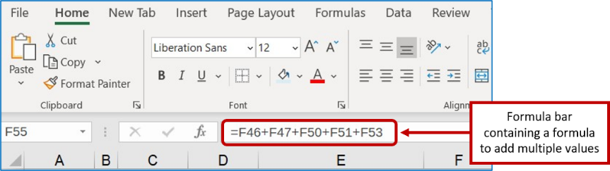

**Step 5:** Determine the cost of the Kayak order for Current Designs in cell F57.

**Hint:** Use Excel’s “ * ” symbol to multiply the number of kayaks ordered by the cost per kayak you calculated in F55. When you view the formula in the formula bar, it should display as: =F55*F22.

**Step 6:** Compare your work to the solution that follows.

**An illustration shows an Excel spreadsheet that displays the calculation of Cost for one kayak in 4 subsections. There are 2 columns displayed, the first displaying account names and the other displaying the respective amounts.
The first subsection, Direct materials, is displayed in the first column. The following account names are listed in this section slightly indented with the respective amounts listed in the numeric column: Polythene powder, $81; Finishing kit, 170.
The second subsection, Direct Labor, is displayed in the first column. The following account names are listed in this section slightly indented with the respective amounts listed in the numeric column: More-skilled, 30; Less-skilled, 36. 
The next line displays, Manufacturing overhead. Its total of 99 appears in the numeric column. Immediately below manufacturing overhead, Total cost of one kayak is displayed as $416. The last line displays Cost for order of 20 kayaks, with an amount of $8,320 displayed in the numeric column.**

### What-if Solution

Once worksheet formulas are set up in Excel, you can perform what-if analysis to see the costs change under different scenarios.

#### Part 2

**Use sheet tab CD12 What-if Part 2.**

**Step 1:** A blank worksheet named CD12 Part 2 What-if has been created for you. After completing part 1, copy the worksheet containing your solution and paste to this blank worksheet using the instructions in the Part 2 tutorial. To copy and paste:

1. On the worksheet that contains your solution, select the small triangle that appears to the left of the row A label and just above the label for row 1. You will see the entire worksheet dimmed to denote that the entire worksheet is selected.

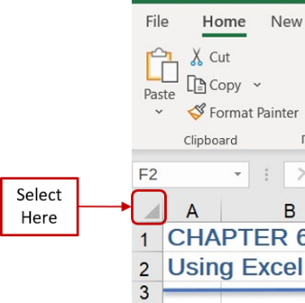

1. Right click your mouse to display a list of options. Select **Copy**.
2. Select the **CD12 Part 2 What-if** worksheet tab.
3. Place your cell pointer in the same location on this blank worksheet as you did to copy in step **a.** above—i.e., the triangle to the left of the column A label and to the right of the label for row 1. Right click your mouse and select the first icon under the **Paste** options, labeled as **Paste (P),** to paste the contents. The worksheet should look identical to your original worksheet.

**Step 2:** To determine the cost of each kayak if the company decides to use higher quality materials and has an increase in the number of labor hours, change these amounts in the Problem area of the worksheet to the following.

Cell F31: $1.65 per pound

Cell F27: 1 hour

**Step 3:** Verify your solution appears as presented below.

An illustration shows an Excel spreadsheet that displays the calculation of Cost for one kayak in 4 subsections. There are 2 columns displayed, the first displaying account names and the other displaying the respective amounts.
The first subsection, Direct Materials, is displayed in the first column. The following account names are listed in this section slightly indented with the respective amounts listed in the numeric column: Polythene powder, $89; Finishing kit, 170.
The second subsection, Direct Labor, is displayed in the first column. The following account names are listed in this section slightly indented with the respective amounts listed in the numeric column: More-skilled, 15; Less-skilled, 36. 
The next line displays, Manufacturing overhead. Its total of 77 appears in the numeric column. Immediately below manufacturing overhead, Total cost of one kayak is displayed as $387. The last line displays Cost for order of 25 kayaks, with an amount of $7,732 displayed in the numeric column. 

**Decision Analysis:** The total cost declined from $8,320 to $7,732 because of the two changes, a net cost savings of $588.

Effect of polyethylene powder cost increase:

The change in the polyethylene powder quality caused an increase in cost of $0.15 per pound. At 54 pounds, the net increase in the cost of the powder is $0.15 times 54 pounds, or $8.10 per kayak. This results in an increase of cost for the order equal to $162 ($8.10 times 20 kayaks).

Effect of direct labor cost reduction: The reduction of one hour of type 1 labor per kayak saved $15 per kayak, resulting in a savings of $300 ($15.00 times 20 kayaks).

Effect of manufacturing overhead cost reduction: Since manufacturing overhead is applied based on direct labor cost, there is a total savings due to the reduced labor cost of $450 (150% times the decline in labor cost from $30 to $15 per kayak times 20 kayaks).

The net cost savings of this **What-if** scenario is $588. You may want to try some alternative changes in costs or units to see how each change affects the unit cost and the total cost.