# CHAPTER 13

## Current Designs Excel Tutorials

**Using Excel**® **to Make Decisions at Current Designs**

**Topic(s):  Cost-Volume-Profit**

**Excel Functions and Tools:  Break-even Chart**

This document provides instructions that explain how to use chart tools in a Microsoft Excel worksheet as an aid in cost-volume-profit analysis and for the Current Designs problem that appears in the Chapter 13 worksheet template. A **What-if** question at the end of the solution will help you see how changes in variables in one section of the worksheet can affect accounting information in other sections of the worksheet. Download the Excel file containing the Chapter 13 Excel Templates from the Wiley resources. It includes an Excel Template to use to solve the Current Designs problem.

### Problem Statement

Bill Johnson, sales manager, and Diane Buswell, controller at Current Designs are beginning to analyze the cost considerations for one of the composite models of the kayak division. They have provided the following production and operational costs, selling price necessary to produce one composite kayak and the profit desired.

| Kevlar® | $ 250 | per kayak |
| --- | --- | --- |
| Resin and supplies | 100 | per kayak |
| Finishing kit (seat, rudder, ropes, etc.) | 170 | per kayak |
| Labor | 420 | per kayak |
| Selling and administrative expenses - variable | 400 | per kayak |
| Selling and administrative expenses - fixed | 119,700 | per year |
| Manufacturing overhead - fixed | 240,000 | per year |
| Selling price per unit | 2,000 | per kayak |
| Profit desired | 270,600 |  |
| Expected units to be sold | 1,000 | kayaks |

Bill and Diane have asked you to provide a cost-volume-profit analysis, to help them finalize the budget projections for the upcoming year. Bill has informed you that the selling price of the composite kayak will be $2,000.

### Instructions

a. Calculate variable cost per unit.

b. Determine the unit contribution margin.

c. Using the unit contribution margin, determine the break-even point in units for this product line.

d. Assume that Current Designs plans to earn $270,600 on this product line. Using the unit contribution margin, calculate the number of units that need to be sold to achieve this goal.

e. Based on the most recent sales forecast, Current Design plans to sell 1,000 units of this model. Using your results from part (c), calculate the margin of safety and the margin of safety ratio.

### What-if Question

Suppose Current Designs locates a supplier that can provide fast-dry resin. While the resin cost will increase by $20 per kayak for this fast-dry formula, the fixed manufacturing overhead costs will decline by $72,980 per year by eliminating the rental of a drying machine. Perform what-if analysis to determine how many units Current Designs will need to produce and sell if these changes occur. Illustrate this change with a break-even chart. Should Current Designs make the change?

### Solution Tutorial

Follow the following steps below to learn how to use chart tools in a Microsoft Excel® worksheet as an aid in cost-volume-profit analysis for Current Designs. Save your file frequently while working.

**Part 1 a.**

**Use sheet tab CD13 Part 1.**

**Step 1:** Open the worksheet template file in Microsoft Excel. Save the file on your computer’s desktop. Begin with the CD13 Part 1 Template worksheet.

**Step 2:** Cell-reference the names of the variable cost items from the data area into cells B52 through B56.

**Hint:** Labels are cell-referenced in the same manner as cell-referencing values.

1. Select cell B52 and press the ‘ **=** ’ (equal) symbol.
2. Immediately select cell B12.
3. Press the **Enter** key.

The Kevlar® label will appear in cell B52. Perform the same cell-referencing for the labels of the other variable costs.

**Step 3:** Cell reference the amounts from the data area for each of the variable cost amounts into cells E52 through E56.

**Step 4:** Use the **SUM** function in cell E57 to total the unit variable costs which appear in E52 through E56.

**Part 1 b.**

**Step 5:** Input a formula in cell D59 that cell-references the data area and to your solution in part (a) to calculate the unit contribution margin.

**Part 1 c.**

**Step 6:** Input a formula in cell D61 that cell references the data area and your answer to part b to calculate the breakeven point in units.

**Hint:** You will have two components to total fixed costs.

**Part 1 d.**

**Step 7:** Input a formula in cell D63 that cell-references the data area and your answer to part b to calculate the units to be sold to achieve the target net income.

**Step 8:** Verify that your work matches the solution that follows.

An illustration shows a partial Excel spreadsheet with four parts. Part A displays a calculation of Total variable costs, with the first column displaying account names and the second column displaying their respective amounts. The data are as follows, Kevlar, $250; Resin and supplies, 100; Finishing kit (seat, rudder, ropes, etc.), 170; Labor, 420; Selling and administrative expenses – variable, 400; and Total variable costs, $1,340.
Part B shows the Unit contribution margin, $660.
Part C shows the Break-even point, 545 units.
Part D shows the Units to achieve goal, 955 units.

**Part 1 e.**

Step 9: Input a formula to calculate actual (expected) sales in cell D65 that cell-references the selling price per unit from the data area and the expected units to be sold.

Step 10: Input a formula in cell D66 that cell references amounts from the data area and part (c) to calculate break-even sales.

Step 11: Input a formula in cell D67 that determines the margin of safety in dollars by cell-referencing the amounts in D65 and D66.

Step 12: Input a formula in cell D68 that determines the margin of safety ratio using amounts you calculated.

Step 13: Verify that your work matches the solution that follows.

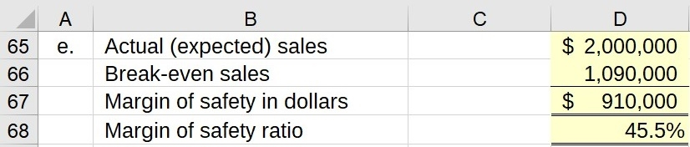

### What-if Solution

Once worksheets are set up in Excel, you can perform what-if analysis to see the change under difference scenarios. Because the data is linked to the chart, changes in any data item are automatically updated on the chart.

**Use sheet tab CD13 Part 2 What-if.**

You will use the CD13 Part 2 What-if worksheet to complete part 2.

**Step 1:** A blank worksheet named CD13 Part 2 What-if has been created for you. After completing part 1, copy the worksheet containing your solution and paste to the blank worksheet. To copy:

1. On the worksheet that contains your solution, select the small triangle that appears to the left of the row A label and just above the label for row 1. You will see the entire worksheet dimmed to denote that the entire worksheet is selected.

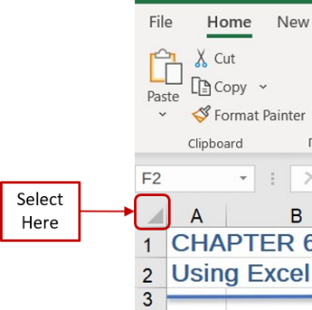

1. Right click your mouse to display a list of options. Select **Copy**.
2. Select the **CD13 Part 2 What-if** worksheet tab.
3. Place your cell pointer in the same location on this blank worksheet as you did to copy in step **a** above—i.e., the triangle to the left of the column A label and to the right of the label for row 1. Right click your mouse and select the first icon under the **Paste** options, labeled as **Paste (P),** to paste the contents. The worksheet should look identical to your original worksheet.

**Step 2:** Change the resin cost and the fixed manufacturing overhead costs in the data area.

**Hint:** When you view the solution area for part 1, you should see that the contribution margin per kayak decreases to $640 and the break-even point declines to 448 kayaks.

Step 3: A table has been set up in rows 73 to 76 to help you create a break-even chart. Input formulas by cell-referencing to the data area and previous calculations to complete the sales revenue and total fixed cost amounts in the data table in rows 74 and 75.

Step 4: Use formulas in columns C, D, and E in row 76 to calculate total costs for the three activity levels. This table represents the three amounts that are plotted on a breakeven chart costs at the three activity levels.

Step 5: Verify that your work matches the solution that follows.

An illustration shows an excel spread sheet with four columns where the first column displays account names and next three are numeric columns. The data are as follows,
Number of units: 0; 448; 1,000;
Sales revenue: no data; $896,000; $2,000,000;
Total fixed costs: 286,720; 286,720; 286,720;
Total costs: 286,720; 896,000; 1,646,720.

**Step 6:** Select cells B74 through E76.

**Step 7:** From the **Insert** menu ribbon, select the *Scatter* option from the **Charts**tab.

**Step 8:** Hover over each of the possible chart types and select the **Scatter with Straight Lines and Markers**option.

**Step 9:** Select the chart. Select the **Chart Design** tab and then **Switch Row/Column** icon. Click the **OK** icon to display the break-even chart.

Step 10: Assign an appropriate chart title. Grab any side of the chart with your cell pointer to stretch the chart to make it easier to view. Verify that your chart matches the solution that follows.

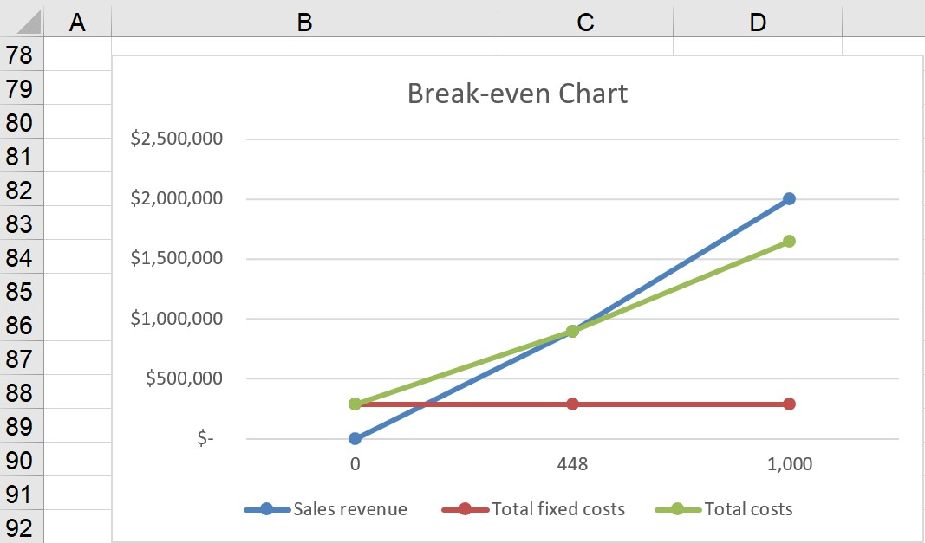

**Decision Analysis:** The intersection of the sales revenue and the total costs lines (i.e., the breakeven points) shifted down to 448 units, and approximately $896,000 in revenue dollars. Note that the break-even point has shifted to the left in the chart primarily due to the downward shift in total fixed costs. With the change in the type of resin, the company becomes profitable when it produces and sells 448 kayaks rather than 545 kayaks with the current operations. Buying the new fast-drying resin will produce a favorable outcome for the company.

Try some alternative changes in costs or selling price to see changes in the break-even point in units and revenue dollars as displayed on the break-even chart.