# CHAPTER 18

## Current Designs Excel Tutorials

**Using Excel® to Make Decisions at Current Designs**

**Topic(s):** **Planning for Capital Investment Decisions: Annual rate of return, Payback period, NPV, IRR**

**Excel® Functions and Tools: IRR function; NPV function**

This document provides instructions that explain how to use Excel’s IRR and NPV functions to solve the Current Designs problem that appears on the Chapter 18 worksheet template. A **What-if** question at the end of the solution will help you see how changes in one section of the worksheet can affect accounting information in other sections of the worksheet. Download the Excel file containing the Chapter 18 Excel Templates from the Wiley resources. It includes an Excel Template to use to solve the Current Designs problem.

### Problem Statement

A company that manufactures recreational pedal boats has approached Mike Cichanowski to ask if he would be interested in using Current Designs’ rotomold expertise and equipment to produce some of the pedal boat components. Mike is intrigued by the idea and thinks it would be an interesting way of complementing the present product line.

One of Mike’s hesitations about the proposal is that the pedal boats are a different shape than the kayaks that Current Designs produces. As a result, the company would need to buy an additional rotomold oven in order to produce the pedal boat components. This project clearly involves risks, and Mike wants to make sure that the returns justify the risks. In this case, since this is a new venture, Mike thinks that a 15% discount rate is appropriate to use to evaluate the project.

As an intern at Current Designs, Mike has asked you to prepare an initial evaluation of this proposal. To aid in your analysis, he has provided the following information and assumptions.

| Required rate of return | 15% |  |
| --- | --- | --- |
| Cost of new rotomold oven | $256,000 |  |
| Salvage value of new rotomold oven | $ 0 |  |
| Estimated useful life | 8 | years |
|  |  |  |
| Projected annual results for the project: |  |  |
| Sales |  | $220,000 |
| Less |  |  |
| Manufacturing costs | $140,000 |  |
| Depreciation | 32,000 |  |
| Shipping and administrative costs | 22,000 | 194,000 |
| Income before income taxes |  | 26,000 |
| Income tax expense |  | 10,800 |
| Net income |  | $ 15,200 |

### Instructions

1. Compute the annual rate of return.
2. Compute the payback period.
3. Compute the net present value using a discount rate of 9%. Should the proposal be accepted using this discount rate?
4. Compute the net present value using a discount rate of 15%. Should the proposal be accepted using this discount rate?

### What-If Question

Perform what-if analysis to answer the following:

What if Current Design's managers want to know the return the expected investment will provide? Use the IRR function to determine this rate. Input this rate into the NPV function to determine the new NPV. Explain the NPV using the IRR as the discount rate.

### Solution Tutorial

Follow the steps below to learn how to use Excel’s IRR and NPV functions to aid the evaluation of capital budgeting decisions for Current Designs’ managers. Save your file frequently while working.

#### Part 1 a.

**Use sheet tab CD18 Part 1.**

**Step 1:** Open the worksheet template file in Microsoft Excel. Save the file on your computer’s desktop. The data area which appears in rows 18 through 31 contains the data provided by Current Designs.

**Step 2:** In cell D52, input a cell reference to the data area to the expected net income.

**Step 3:** In cell D53, input a formula with cell references to the data area to calculate the average investment value of the rotomold oven.

**Step 4:** In cell D54, input a formula using cell references to the amounts in cells D52 and D53 to calculate the annual rate of return that the rotomold oven is expected to generate. Compare your work to the solution that follows.

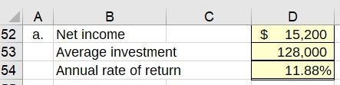

**Decision Analysis:** The accounting rate of return indicates the annual profitability of a capital expenditure. The rotomold oven is expected to generate an 11.88% return of profit during each of the 8 years of its expected life. This investment is unacceptable because it is expected to generate a return that is less than the designated required rate of return of 15%.

#### Part 1 b.

**Step 5:** In cell D57,input a cell reference to the data area to the cost of the investment.

**Step 6:** In cell E58,input a formula using cell references to the data area to the amount of net income and the non-cashflow amount to calculate the net annual cash flow.

**Step 7:** In cell D59, input a formula to amounts in this work area to calculate the payback periodof the rotomold oven un the data area. Compare your work to the solution that follows.

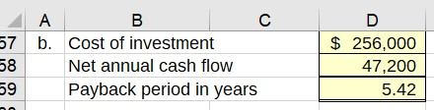

**Decision Analysis:** The amount of cash to be invested in the rotomold oven is expected to be recovered in 5.42 years. Given the oven is expected to be used by the company for 8 years and the cash can be recovered before the end of the useful life, the proposed acquisition is acceptable.

#### Part 1 c.

**Step 8:** To use NPV most efficiently, atable that displays the individual cash flows associated with the proposed acquisition of the oven has been set up.

1. In cell D63, input cell reference to part (b) for the net annual cash flow amount.
2. Because the annual operating cash flows are the same for each of the 8 years, use a cell reference in E63 that references the amount in cell D63. Use the Copy tool to copy the contents of cell E63 to cells F63 through K63.
3. In cell C65, use a cell reference to the data area for the cash flow of the proposed oven acquisition.

**Hint:** This is a cash outflow and is shown as a negative amount.

1. Use the SUM function or a cell reference in cells C67 to K67 to add the annual cash flows for each year.

**Hint:** If you use the SUM function (=SUM(C63:C65) in C67, you can easily select cell C67 and drag its contents to cells D67 through K67 to quickly place the total cash flows in those cells.

Compare your work to the solution that follows.

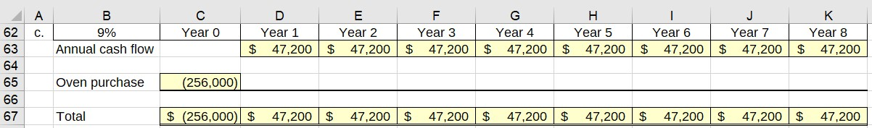

**Hint:** Placing all cash flow amounts in a single row simplifies inputting cash flows into the NPV function when all amounts are adjacent to each other.

**Step 9:** Use Excel’s NPV function to calculate the net present value of the proposed investment.

**Hint:** Excel’s NPV function uses discount factors built into the Excel program so that you can calculate NPV without using a table to obtain discount factors.

1. Select cell C69 and then select the **Formulas** menu option.
2. Click the **Financial**option from the**Function Library** group to display a drop down menu.
3. Scroll down and select the **NPV** option. The **NPV** **Functions** dialog box will appear.
4. Place your cell pointer in the **Rate** field, and immediately select cell B62 which contains the discount rate.
5. Place the cell pointer in the **Value1** field, and immediately select cells D67 to K67. Click **OK** and the total present value of the cash flows for years 1 through 8 will appear.

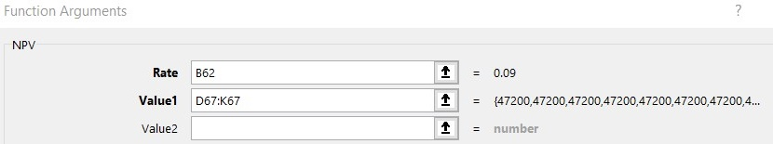

**Hint:** Be sure to select only *future* cash flows, i.e., years 1 through 8. The cash flow amount in cell C65 occurs on the acquisition date and is not part of the *future* cash flow amounts. As an option, you could have selected only the operating cash flow for year 1 in the Value1 field, then the cash flow for year 2 in the Value2 field, and so on, which is less efficient.

1. Because the **NPV** function allows only for the computation of future cash flows beginning in year 1, you must now factor in the initial cash flow (year 0). Select cell C69.
2. Place your cell pointer at the end of the NPV function in the formula bar. Type “ + ” (addition symbol) and immediately select cell C67. Press **OK**.
3. The **NPV** of $5,243.46 will appear in cell C39. Compare the formula in cell C41 to the solution that follows.

=NPV(B62,D67:K67)+C67

**Step 10:** In cell D71, select Yes or No from the drop-down list to indicate if the proposal should be accepted or not based on the NPV.

**Decision Analysis:** The net present value indicates that the purchase of the rotomold oven is expected to generate a cash return during each of the next 8 years that exceeds the minimum designated rate of return of 9%. This investment is acceptable.

#### Part 1 d.

**Step 11:** Repeat the NPV calculation in cell C74 using a required rate of return of 15%. You can use the cash flows on row 67.

**Step 12:** To repeat the NPV,

1. Select cell C74 and then select the **Formulas** menu option.
2. Click the **Financial**option from the**Function Library** group and select the **NPV** option.
3. In the **NPV** **Functions** dialog box in the **Rate** field, reference cell F18 which contains the 15% discount rate.
4. In the **Value1** field select cells D67 to K67. Click **OK** to display the NPV of the future cash flows.
5. Place your cell pointer at the end of the NPV function in the formula bar. Type “ + ” and immediately select cell C67. Press **OK**.

**Step 13:** In cell D76, select Yes or No from the drop-down list to indicate if the proposal should be accepted or not based on the NPV. Compare your work to the solution that follows.

"An illustration shows an Excel spreadsheet labeled part C and separately part D with the first column displaying line item labels and the next nine column displaying the years from zero to eight and the respective amounts. The discount rate is shown as 9%. For part C, the annual cash flow amounts for Years 1 through 8 are shown as $47,200. The oven purchase is shown in the Year 0 column as negative 256,000. The total for year 0 is negative $256,000, with the total for years 1 through 8 is $47,200. The NPV has been calculated as is shown as $5,243. Just below is a question that reads: Accept the Proposal?, followed by a cell with the answer, Yes.
In part D, the NPV has been calculated as negative $44,198. Just below is a question that reads: Accept the Proposal?, followed by a cell with the answer, No."


**Decision Analysis:** The net present value indicates that the purchase of the rotomold oven is expected to generate a cash return during each of the next 8 years that is less than the required rate of return of 15%. Why is there no difference in the IRR under the two interest rates? The IRR does not use the required rate of return in its calculates. It simply determines the rate of return the investment is expected to generate.

### What-if Solution

Once worksheet formulas are set up in Excel, you can perform additional analysis to see the impact of the change under different scenarios.

#### Part 2.

**Use sheet tab CD18 Part 2 What-if.**

**Step 1:** A blank worksheet named CD18 Part 2 What-if has been created for you. After completing part 1, copy the worksheet containing your solution and paste to the blank worksheet. To copy:

1. On the worksheet that contains your solution, select the small triangle that appears to the left of the row A label and just above the label for row 1. You will see the entire worksheet dimmed to denote that the entire worksheet is selected.

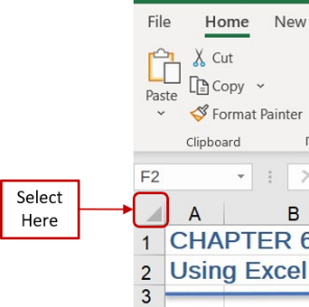

1. Right click your mouse to display a list of options. Select **Copy**.
2. Select the **CD18 Part 2 What-if** worksheet tab.
3. Place your cell pointer in the same location on this blank worksheet as you did to copy in step **a** above—i.e., the triangle to the left of the column A label and to the right of the label for row 1. Right click your mouse and select the first icon under the **Paste** options, labeled as **Paste (P),** to paste the contents. The worksheet should look identical to your original worksheet.

**Step 2:** Type the label IRR in cells E69 and E74.

**Step 3:** Change the formatting in cell F69 and F74 to percentage format with 4 decimals.

To change the formatting:

1. Select cells F69 and F74.
2. From the **Home** tab of the menu ribbon, click the small arrow at the bottom right of the **Number** group. The **Format Cells** dialog box will display.
3. Select **Percentage** from the **Category** field list.
4. In the **Decimal places** field to the right, type the number 4.

**Step 4:** Use Excel’s IRR function to calculate the rate of return the proposed investment is expected to generate.

**Hint:** Excel’s IRR function uses discount factors built into the Excel program that enable you to calculate IRR without using a table to obtain discount factors and without trial and error.

1. Select cell F69 and then select the **Formulas** menu ribbon.
2. Click the **Financial** option from the**Function Library** group to display a drop down menu.
3. Scroll down and select the **IRR** option. The **IRR Functions** dialog box will appear.
4. Place your cell pointer in the **Values** field, and immediately select cells C67 to K67.

**Hint:** The IRR function allows the input of the cash flow amounts for all years, including year 0, the year of expected acquisition.

1. Leave the **Guess** field blank, as it is used only if extremely large or small rates of return are expected. Click **OK** and the internal rate of return of all the cash flows for years 0 through 8 will appear as 9.55%.
2. Select cell C43 and place your mouse pointer in the formula bar. Your formula should appear as follows:

=IRR(C67:K67)

1. Repeat the steps to calculate the IRR in cell F74.
2. Compare the IRR amounts for the two discount rates.

**Decision Analysis:** Calculating IRR using the interest tables requires a trial and error approach which often takes consider time to approximate the return.Excel’s IRR function is not only exactly accurate, but it is much quicker. There is no difference in the IRR between the two discount rates because the IRR is based on the cash flows expected with the investment, which are the same regardless of what return management desires to generate.

**Step 5:** To change the NPV to reflect the discount rate used in the NPV for part d, select cell C74 and delete its contents.

**Step 6:** Use the NPV function again with the same operating cash flows in row 67 and the initial cash flow in cell C67. However, this time, use a cell reference to cell F74, which contains the IRR. The NPV should be zero in cell C74.

**Step 7:** Compare your work to the solution that follows.

**"An illustration shows an Excel spreadsheet labeled part C and separately part D with the first column displaying line item labels and the next nine column displaying the years from zero to eight and the respective amounts. The discount rate is shown as 9%. For part C, the annual cash flow amounts for Years 1 through 8 are shown as $47,200. The oven purchase is shown in the Year 0 column as negative 256,000. The total for year 0 is negative $256,000, with the total for years 1 through 8 is $47,200. The NPV has been calculated as is shown as $5,243. To the right of the NPV is a cell labeled as I R R with the amount of 9.5486% displayed. Just below is a question that reads: Accept the Proposal?, followed by a cell with the answer, Yes.
In part D, the NPV has been calculated as zero. To the right of the NPV is a cell labeled as I R R with the amount of 9.5486% displayed. Just below is a question that reads: Accept the Proposal?, followed by a cell with the answer, No."
**

**Decision Analysis:** The IRR indicates the return that the investment is expected to generate 9.5486% over each of the next 8 years. The IRR of 9.5486% is compared to the required rate of return. When the required of return is 15%, the investment is unacceptable. When the required rate of return is 9%, the investment is acceptable.

There are two concepts here to note. First, the IRR is the same regardless of whether the NPV is based upon 9% or 15%, as the required rate of return is not used in the computation of the IRR. Second, the internal rate of return is the rate at which the NPV is zero. Hence, when NPV is calculated using the IRR as the discount rate, the NPV is displayed as zero.

You may want to try some alternative discount rates, investment cost, or operating cash flows to see how each change affects the IRR and the NPV.