import java.util.Scanner;

class Shape{

protected String shapename;

public Shape(String shapename){

this.shapename=shapename;

}

double calculateArea() {

return 0;

}

}

class Rectangle extends Shape{

private int length;

private int breadth;

Rectangle(int length,int breadth){

super("Rectangle");

this.length=length;

this.breadth=breadth;

}

double calculateArea() {

double area=length\*breadth;

return area;

}

}

class Square extends Shape{

private int side;

public Square(int side){

super("Square");

this.side=side;

}

double calculateArea() {

double area=side\*side;

return area;

}

public int getSide() {

return side;

}

public void setSide(int side) {

this.side = side;

}

}

class Circle extends Shape{

private int radius;

Circle(int radius){

super("Circle");

this.radius=radius;

}

double calculateArea() {

double area=3.14\*radius\*radius;

return area;

}

}

public class Inheritance {

public static void main(String args[]) {

System.out.println("1.Rectangle\n2.Square\n3.Circle");

System.out.println("Area Calculator-----Choose Shape");

Scanner sc = new Scanner(System.in);

int option = sc.nextInt();

switch(option) {

case 1:

System.out.println("Enter Length and breadth:");

Rectangle r=new Rectangle(sc.nextInt(),sc.nextInt());

System.out.println("Area of Rectangle:"+r.calculateArea());

break;

case 2:

System.out.println("Enter Side of a Square:");

Square s=new Square(sc.nextInt());

System.out.println("Area of Square:"+s.calculateArea());

break;

case 3:

System.out.println("Enter Radius of Circle:");

Circle c=new Circle(sc.nextInt());

System.out.println("Area of Circle:"+c.calculateArea());

break;

default:

System.out.println("Exiting");

break;

}

}

}

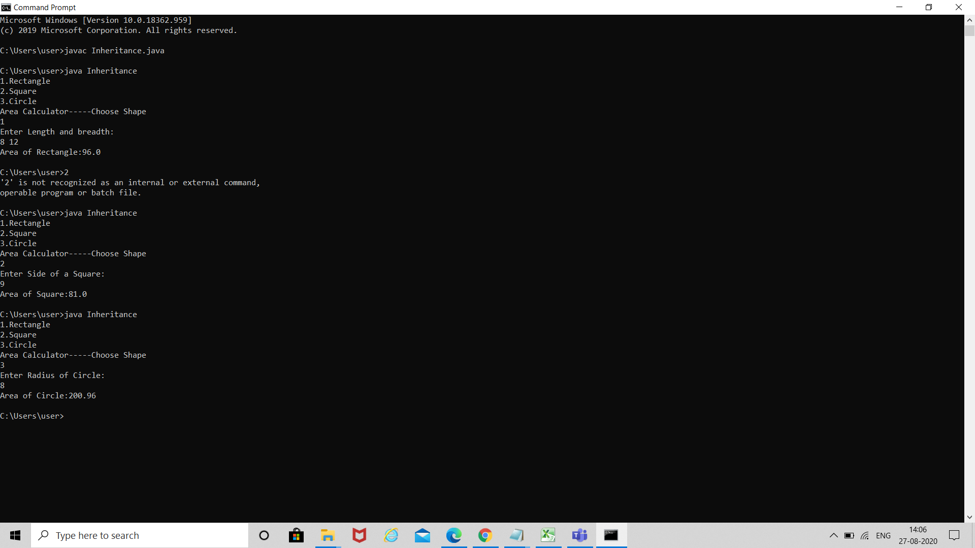v