1.1

A.

<!DOCTYPE html>

<html>

<head>

<title>Login page</title>

</head>

<body>

<center>

<h1>Login</h1>

<input type="Submit" value="Login"><br>

<br>

<a href="C:/Users/user/Documents/Login.html">login page</a>

</center>

</body>

</html>

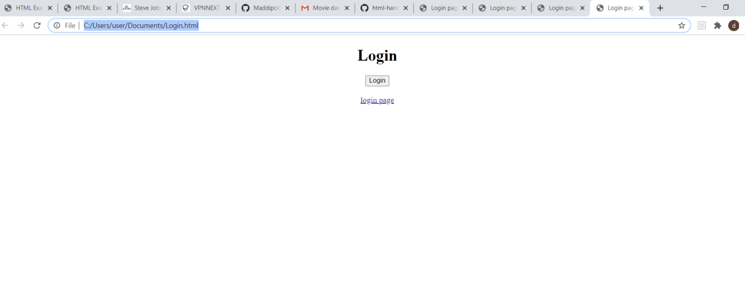

B.

<!DOCTYPE html>

<html>

<head>

<title>Address Book</title>

</head>

<body>

<center>

<h1>ADDRESS BOOK</h1>

<form>

Name : <input type="text" name=TextFIELD value=" "></br><br>

Address : <input type="textarea" name=Textarea value=" "></br><br>

City : <input type="text" name=TextFIELD value=" "></br><br>

Postalcode :<label for="Postalcode"></label>

<select id="Postalcode" name="code">

<option value=" salur ">535591</option>

<option value="mamidipalli">535593</option>

<option value="vizianagaram">535001</option>

<option value="visakhapatnam">535002</option>

</select></br>

TransportMode : <input type="radio" name = ".." value="Bus"> Bus </br>

<input type="radio" name = ".." value="Car"> Car </br>

<input type="radio" name = ".." value="Cycle"> Cycle </br>

<input type="radio" name = ".." value="Other"> Others </br>

Skillsets: <input type="checkbox" id=" " name=" " value=" ">

<label for="SkillSet">hardwork</label><br>

<input type="checkbox" id=" " name=" " value=" ">

<label for="Skillset2"> smart work</label><br>

<input type="checkbox" id=" " name=" " value=" ">

<label for="Skillset3"> IQ level</label><br><br>

Email : <input type="TextField" name=" "value=" "><br>

About Yourself : <input type="TextFiled" name=" " value=" "><br>

Register:

<a href="C:/Users/user/Documents/Addressbook.html">submit</a><br>

Reset : <input type="submit" value="Reset"><br>

<br>

Add new Address :<input type="submit" value="add address">

Deleting :<input type="submit" value="delete data">

updating : <input type="submit" value="Update date">

Searching for entries: <input type="submit" value="New Entries">

</center>

</form>

</body>

</html>

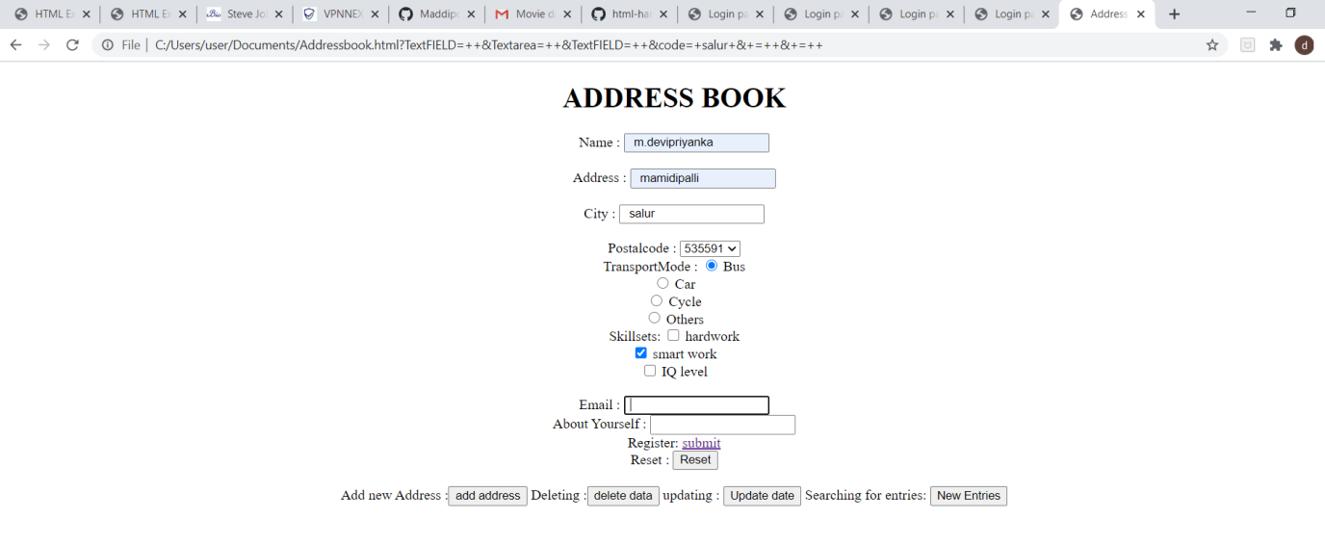

c.

<!DOCTYPE html>

<html>

<head>

<title>submission</title>

</head>

<body>

<center>

<form method="POST" action="1.1.html">

<p>"Your details are submitted.Thank you!"</p>

</center>

</body>

</html>