Student Name: Aayush Raj UID: 25MCI10066
Branch: M.C.A(Al & ML) Section/Group: 25MAM-1 A
Semester: 2nd Date of Performance:03/02/2026
Subject Name: TECHINCAL SKILLS Subject Code: 25CAP - 652

WORKSHEET 4
AIM: To understand and implement iterative control structures in PostgreSQL conceptually, including FOR loops, WHILE loops, and basic LOOP constructs, for repeated execution of database logic.

Tools Used: PostgreSQL

OBJECTIVES:
- To understand why iteration is required in database programming
- To learn the purpose and behavior of FOR, WHILE, and LOOP constructs
- To understand how repeated data processing is handled in databases
- To relate loop concepts to real-world batch processing scenarios
- To strengthen conceptual knowledge of procedural SQL used in enterprise systems
Given:
Practical / Experiment Steps

Step 1: FOR Loop – Simple Iteration
- The loop runs a fixed number of times
- Each iteration represents one execution cycle
- Useful for understanding basic loop behavior
Query:
DO $$
DECLARE
i INTEGER;
BEGIN
FOR i IN 1..5 LOOP
RAISE NOTICE 'Number is:- %',i;

END LOOP;
END $$;

Output:
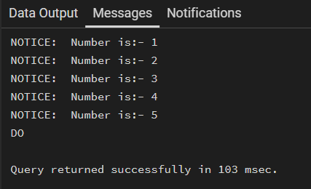

Step 2: FOR Loop with Query (Row-by-Row Processing)
- The loop processes database records one at a time
- Each iteration handles a single row
- Simulates cursor-based processing

Query:
CREATE TABLE employee (
emp_id INT,
emp_name VARCHAR(50),
salary INT
);

INSERT INTO employee VALUES
(1, 'Amit', 30000),
(2, 'Neha', 40000),
(3, 'Rahul', 35000);

DO $$
DECLARE
rec RECORD;
BEGIN
FOR rec IN SELECT * FROM employee LOOP
RAISE NOTICE 'ID: %, Name: %, Salary: %',
rec.emp_id, rec.emp_name, rec.salary;
END LOOP;
END $$;

Output:
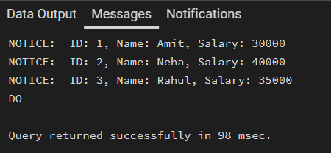
Step 3: WHILE Loop – Conditional Iteration
- The loop runs until a condition becomes false
- Execution depends entirely on the condition
- The condition is checked before every iteration
DO $$
DECLARE
sum INTEGER := 1;
BEGIN
WHILE sum <= 5 LOOP
RAISE NOTICE 'Sum is : %',sum;
sum := sum + 1;
END LOOP;

END $$;
Output:
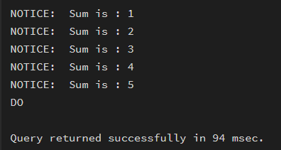

Step 4: LOOP with EXIT WHEN
- The loop does not stop automatically
- An explicit exit condition controls termination
- Gives flexibility in complex logic

Query:
DO $$
DECLARE
num INTEGER := 1;
BEGIN
LOOP
RAISE NOTICE 'Number: %', num;
num := num + 1;

EXIT WHEN num > 5;
END LOOP;
END $$;

Output:-
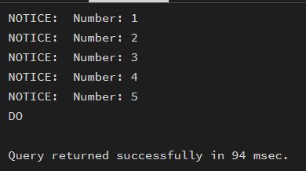

Step 5: Salary Increment Using FOR Loop
- Employee records are processed one by one
- Salary values are updated iteratively
- Represents real-world payroll processing
Query:
DO $$
DECLARE
rec RECORD;
BEGIN
FOR rec IN SELECT * FROM employee LOOP
UPDATE employee
SET salary = salary + 2000
WHERE emp_id = rec.emp_id;
END LOOP;
END $$;

SELECT * FROM employee;

Output:
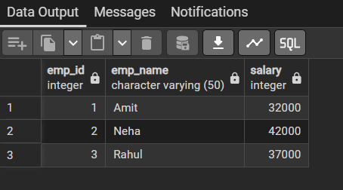
Step 6: Combining LOOP with IF Condition
- Loop processes each record
- Conditional logic classifies data during iteration
- Demonstrates decision-making inside loops

Query:
DO $$
DECLARE
rec RECORD;
BEGIN
FOR rec IN SELECT * FROM employee LOOP
IF rec.salary >= 40000 THEN
RAISE NOTICE '% is High Salary Employee', rec.emp_name;
ELSE
RAISE NOTICE '% is Normal Salary Employee', rec.emp_name;
END IF;
END LOOP;
END $$;

Output:
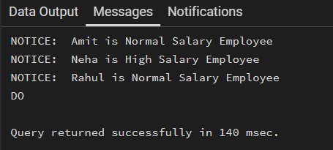

Learning Outcomes:
- Understand the need for iterative control structures in database programming.
- Explain the syntax and working of FOR, WHILE, and LOOP constructs in PostgreSQL.
- Implement range-based and query-based FOR loops using PL/pgSQL.
- Use WHILE loops for condition-controlled execution of SQL statements.
- Apply LOOP with EXIT conditions for flexible and custom termination logic.
- Perform row-by-row data processing inside PostgreSQL using procedural SQL.
- Integrate conditional statements (IF–ELSE) within loops for decision making.
- Understand how iterative logic is used in real-world database applications such as payroll processing, reporting, and batch operations.
- Gain foundational knowledge of PL/pgSQL used in enterprise-level database systems.

