
DEPARTMENT OF

University Institute Of Computing

Experiment 5

Student Name: Aayush Raj UID: 25MCI10066
Branch: MCA (AI & ML) Section/Group: 25MAM-1
Semester: 2nd Date of Performance:27/02/26
Subject Name: Technical Training Subject Code:25CAP-652

AIM:
To gain hands-on experience in creating and using cursors for row-by-row processing in a database, enabling sequential access and manipulation of query results for complex business logic. (Company Tags: Infosys, Wipro, TCS, Capgemini)

OBJECTIVE:
- Sequential Data Access: To understand how to fetch rows one by one from a result set using cursor mechanisms.
- Row-Level Manipulation: To perform specific operations or calculations on individual records that require conditional procedural logic.
- Resource Management: To learn the lifecycle of a cursor: Declaring, Opening, Fetching, and importantly, Closing and Deallocating to manage system memory.
- Exception Handling: To handle cursor-related errors and performance considerations during large-scale data iteration.

Implementation:

Step 1: Implementing a Simple Forward-Only Cursor
Creating a cursor to loop through an Employee table and print individual records.
-- Table Creation

CREATE TABLE Employee (
emp_id SERIAL PRIMARY KEY,
emp_name VARCHAR(100),
department VARCHAR(50),
salary NUMERIC(10,2)
);

-- Data Insertion

INSERT INTO Employee (emp_name, department, salary) VALUES
('Rahul', 'IT', 50000),
('Sneha', 'HR', 40000),
('Amit', 'Finance', 55000),
('Priya', 'IT', 60000);

-- Cursor Commands

CREATE OR REPLACE FUNCTION display_employees()
RETURNS VOID AS
$$
DECLARE
emp_record RECORD;
emp_cursor CURSOR FOR SELECT * FROM Employee;
BEGIN
OPEN emp_cursor;

LOOP
FETCH emp_cursor INTO emp_record;
EXIT WHEN NOT FOUND;

RAISE NOTICE 'ID: %, Name: %, Department: %, Salary: %',
emp_record.emp_id,
emp_record.emp_name,
emp_record.department,
emp_record.salary;
END LOOP;

CLOSE emp_cursor;
END;
$$
LANGUAGE plpgsql;

SELECT display_employees();

Output :-

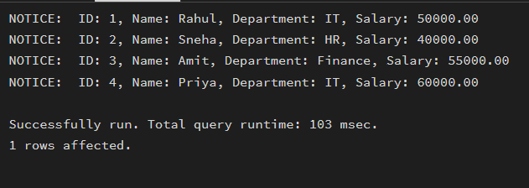

Step 2: Complex Row-by-Row Manipulation : -
Using a cursor to update salaries based on a dynamic "Experience-to-Performance" ratio logic.

ALTER TABLE Employee
ADD COLUMN experience INT,
ADD COLUMN performance_score INT;

UPDATE Employee SET experience = 5, performance_score = 8 WHERE emp_id = 1;
UPDATE Employee SET experience = 3, performance_score = 6 WHERE emp_id = 2;
UPDATE Employee SET experience = 7, performance_score = 9 WHERE emp_id = 3;
UPDATE Employee SET experience = 2, performance_score = 5 WHERE emp_id = 4;

CREATE OR REPLACE FUNCTION update_salary_by_ratio()
RETURNS VOID AS
$$
DECLARE
emp_rec RECORD;
exp_perf_ratio NUMERIC;
BEGIN
FOR emp_rec IN SELECT * FROM Employee
LOOP
-- Ratio calculate karo
exp_perf_ratio := emp_rec.performance_score::NUMERIC / emp_rec.experience;
IF exp_perf_ratio > 1.5 THEN
UPDATE Employee
SET salary = salary * 1.20
WHERE emp_id = emp_rec.emp_id;

ELSIF exp_perf_ratio BETWEEN 1 AND 1.5 THEN
UPDATE Employee
SET salary = salary * 1.10
WHERE emp_id = emp_rec.emp_id;

ELSE
UPDATE Employee
SET salary = salary * 1.05
WHERE emp_id = emp_rec.emp_id;
END IF;
RAISE NOTICE 'Updated Employee ID: %, Ratio: %',
emp_rec.emp_id, exp_perf_ratio;
END LOOP;
END;
$$
LANGUAGE plpgsql;

Output :-

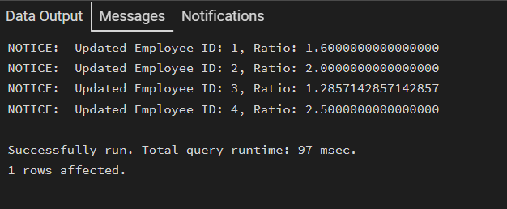

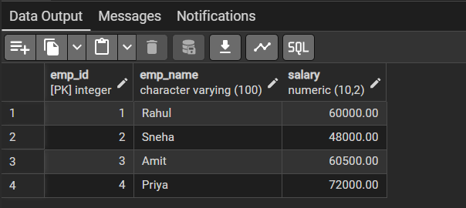
Step 3: Exception and Status Handling
Ensuring the cursor handles empty result sets or termination signals gracefully.

CREATE OR REPLACE FUNCTION safe_cursor_example()
RETURNS VOID AS
$$
DECLARE
emp_rec RECORD;
emp_cursor CURSOR FOR SELECT * FROM Employee;
BEGIN
OPEN emp_cursor;

LOOP
FETCH emp_cursor INTO emp_rec;
EXIT WHEN NOT FOUND; -- Handles empty set & termination safely
RAISE NOTICE 'Employee ID: %, Name: %',
emp_rec.emp_id,
emp_rec.emp_name;
END LOOP;

CLOSE emp_cursor;

RAISE NOTICE 'Cursor executed successfully.';
END;
$$
LANGUAGE plpgsql;

SELECT safe_cursor_example();

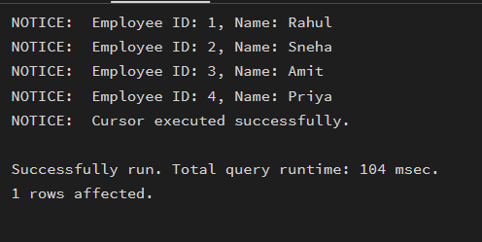

LEARNING OUTCOMES:

- Cursor Implementation: Students will be able to design, implement, and manage cursors to solve row-wise processing problems.

- Lifecycle Mastery: Students will demonstrate the correct syntax for declaring, opening, fetching, and closing cursors.

- Error Prevention: Students will understand how to properly handle row-by-row processing exceptions and prevent memory leaks via deallocation.

- Analytical Thinking: Students will be able to apply cursor-based logic to solve real-world scenarios like multi-level payroll adjustments or data migrations.

