Worksheet 1

Student Name:Aayush Raj UID:25MCI10066
Branch:MCA (AI&ML) Section/Group: 25MAM-1A
Semester:2nd Date of Performance:13/01/2026
Subject Name:- Technical Training Subject Code: 25CAP-652

1. Aim of the Session

To design and implement a sample database system using DDL, DML, and DCL commands for managing departments, employees, and projects, and to apply role-based access control for secure data handling.

2. Objective of the Session

After completing this practical, the student will be able to:
- Understand the use of DDL commands to create and modify database structures.
- Perform DML operations such as INSERT, UPDATE, DELETE, and SELECT.
- Implement relationships using primary and foreign keys.
- Apply DCL commands to manage roles and privileges.
- Analyze input and output of SQL queries in a real database environment.

3. Practical / Experiment Steps

Design the database schema for Department, Employee, and Project tables.

Create tables using appropriate constraints.

Insert sample records into tables.

Perform update and delete operations.

Retrieve data using SELECT queries.

Create a role and grant/revoke privileges.

Alter and drop database objects.

4. Procedure of the Practical

(i) Start the system and log in to the computer.

(ii) Open PostgreSQL software.

(iii) create database Experiment1;

(iv) Create tables using DDL commands.

-- Department table

CREATE TABLE Department (

dept_id SERIAL PRIMARY KEY,

dept_name VARCHAR(50) UNIQUE NOT NULL,

location VARCHAR(50) NOT NULL

);

-- Employee table

CREATE TABLE Employee (

emp_id SERIAL PRIMARY KEY,

emp_name VARCHAR(50) NOT NULL,

email VARCHAR(100) UNIQUE NOT NULL,

salary NUMERIC(10,2) CHECK (salary > 0),

dept_id INT NOT NULL,

CONSTRAINT fk_department

FOREIGN KEY (dept_id)

REFERENCES Department(dept_id)

ON DELETE RESTRICT);

-- Project table

CREATE TABLE Project (

project_id SERIAL PRIMARY KEY,

project_name VARCHAR(100) NOT NULL,

budget NUMERIC(12,2) CHECK (budget >= 1000),

dept_id INT,

CONSTRAINT fk_project_department

FOREIGN KEY (dept_id)

REFERENCES Department(dept_id)

ON DELETE SET NULL

);

INSERT INTO Department (dept_name, location)

VALUES

('HR', 'New York'),

('IT', 'Bangalore'),

('Finance', 'London');

INSERT INTO Employee (emp_name, email, salary, dept_id)

VALUES

('Aayush Raj', 'aayush@org.com', 60000, 2),

('Rahul Verma', 'rahul@org.com', 50000, 1),

('Sneha Sharma', 'sneha@org.com', 55000, 3);

INSERT INTO Project (project_name, budget, dept_id)

VALUES

('HR Management System', 50000, 1),

('Complaint Management System', 120000, 2),

('Accounting Automation', 80000, 3);

SELECT * FROM Department

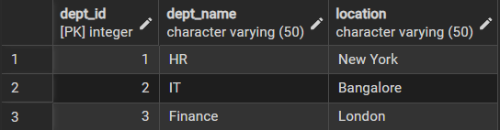

SELECT * FROM Employee

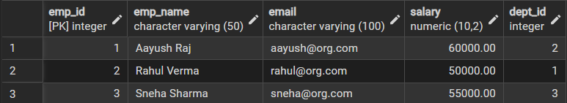

SELECT * FROM Project

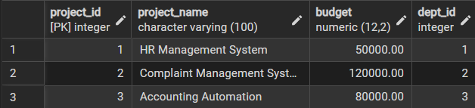

UPDATE Employee

SET salary = salary + 5000

WHERE emp_name = 'Rahul Verma';

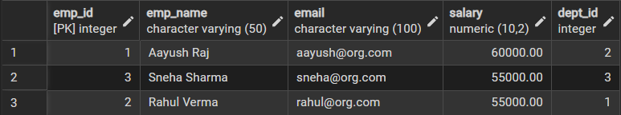

DELETE FROM Project

WHERE project_name = 'Accounting Automation';

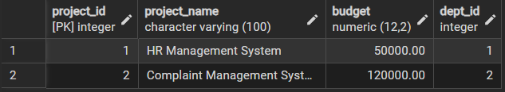

CREATE ROLE report_user LOGIN PASSWORD 'report123';

GRANT CONNECT ON DATABASE org_db TO report_user;

GRANT SELECT ON Department TO report_user;

GRANT SELECT ON Employee TO report_user;

GRANT SELECT ON Project TO report_user;

REVOKE CREATE ON SCHEMA public FROM report_user;

ALTER TABLE Employee

ADD COLUMN phone_number VARCHAR(15);

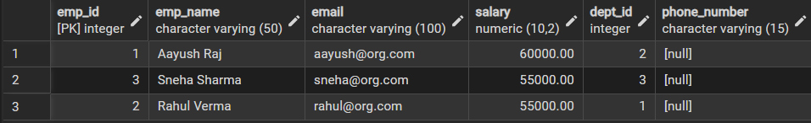

DROP TABLE Project;

Learning Outcomes
- Understood the basics of relational database design using tables, keys, and relationships.
- Learned to apply primary and foreign key constraints to maintain data integrity.
- Gained hands-on experience with INSERT, UPDATE, and DELETE operations.
- Understood role-based access control using GRANT and REVOKE.
- Learned how to create read-only users for secure data access.
- Practiced ALTER TABLE and DROP TABLE commands for schema management.

