**How to Select Option from DropDown using Selenium Webdriver**

In this tutorial, we will learn how to handle Drop Down and Multiple Select Operations.

**Select Methods**

The following are the most common methods used on drop-down elements.

|  |  |
| --- | --- |
| **Method** | **Description** |
| **selectByVisibleText()**and**deselectByVisibleText()** *Example:*[How to Select Option from DropDown using Selenium Webdriver](https://cdn.guru99.com/images/image017(3).png) | * Selects/deselects the option that displays the text matching the parameter. * **Parameter**: The exactly displayed text of a particular option |
| **selectByValue()** and**deselectByValue()** *Example:*[How to Select Option from DropDown using Selenium Webdriver](https://cdn.guru99.com/images/image018(3).png) | * Selects/deselects the option whose "value" attribute matches the specified parameter. * **Parameter**: value of the "value" attribute * Remember that not all drop-down options have the same text and "value", like in the example below.   [How to Select Option from DropDown using Selenium Webdriver](https://cdn.guru99.com/images/image019(2).png) |
| **selectByIndex()** and**deselectByIndex()** *Example:[How to Select Option from DropDown using Selenium Webdriver](https://cdn.guru99.com/images/image020(2).png)* | * Selects/deselects the option at the given index. * **Parameter**: the index of the option to be selected. |
| **isMultiple()** *Example:[How to Select Option from DropDown using Selenium Webdriver](https://cdn.guru99.com/images/image021(2).png)* | * Returns TRUE if the drop-down element allows multiple selections at a time; FALSE if otherwise. * **No parameters needed** |
| **deselectAll()** *Example:[How to Select Option from DropDown using Selenium Webdriver](https://cdn.guru99.com/images/image022(2).png)* | * Clears all selected entries. This is only valid when the drop-down element supports multiple selections. * **No parameters needed** |

**Drop-Down Box**

Before we can control drop-down boxes, we must do following two things:

1. Import the package **org.openqa.selenium.support.ui.Select**
2. Instantiate the drop-down box as a "Select" object in WebDriver

As an example, go to Mercury Tours' Registration page (<http://demo.guru99.com/test/newtours/register.php>) and notice the "Country" drop-down box there.

[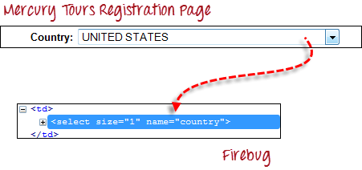](https://cdn.guru99.com/images/image011(3).png)

**Step 1**

Import the "Select" package.

[How to Select Option from DropDown using Selenium Webdriver](https://cdn.guru99.com/images/image012(1).png)

**Step 2**

Declare the drop-down element as an instance of the Select class. In the example below, we named this instance as "drpCountry".

[How to Select Option from DropDown using Selenium Webdriver](https://cdn.guru99.com/images/image013(3).png)

**Step 3**

We can now start controlling "drpCountry" by using any of the available Select methods. The sample code below will select the option "ANTARCTICA."

[How to Select Option from DropDown using Selenium Webdriver](https://cdn.guru99.com/images/image014(3).png)

**Selecting Items in a Multiple SELECT elements**

We can also use the **selectByVisibleText()** method in selecting multiple options in a multi SELECT element. As an example, we will take <http://jsbin.com/osebed/2> as the base URL. It contains a drop-down box that allows multiple selections at a time.

[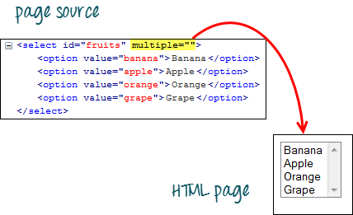](https://cdn.guru99.com/images/image015(3).png)

The code below will select the first two options using the selectByVisibleText() method.

[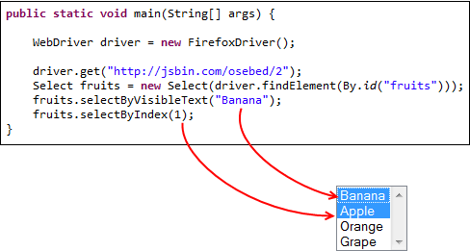](https://cdn.guru99.com/images/image016(3).png)

**Code**

**package newpackage;**

**import org.openqa.selenium.WebDriver;**

**import org.openqa.selenium.firefox.FirefoxDriver;**

**import org.openqa.selenium.support.ui.Select;**

**import org.openqa.selenium.By;**

**public class AccessDropDown {**

**public static void main(String[] args) {**

**System.setProperty("webdriver.firefox.marionette","C:\\geckodriver.exe");**

**String baseURL = "http://demo.guru99.com/test/newtours/register.php";**

**WebDriver driver = new FirefoxDriver();**

**driver.get(baseURL);**

**Select drpCountry = new Select(driver.findElement(By.name("country")));**

**drpCountry.selectByVisibleText("ANTARCTICA");**

**//Selecting Items in a Multiple SELECT elements**

**driver.get("http://jsbin.com/osebed/2");**

**Select fruits = new Select(driver.findElement(By.id("fruits")));**

**fruits.selectByVisibleText("Banana");**

**fruits.selectByIndex(1);**

**}**

**}**

**\*Note : Refer the Above images for Code Output .**