FIFA World Cup Data Analysis

**Low Level Design**

**Author: Syed Mujtaba**

**Index**

|  |  |  |
| --- | --- | --- |
| **Sl. No.** | **Title** | **Page no.** |
| 1 | Abstract | 3 |
| 2 | Given Tasks | 3 |
| 3 | Scope | 3 |
| 4 | Architecture | 4 |
| 5 | Data Description | 5 |
| 6 | Connect Data with Tableau & Deployment | 8 |

# Abstract

# With FIFA being in the blood as many people of the world. You are tasked to tell the story of unsung analysts who put great efforts to provide accurate data to answer every question of fans.

# The FIFA World Cup is a global football competition contested by the various football-playing nations of the world. It is contested every four years and is the most prestigious and important trophy in the sport of football.

# The World Cups dataset show all information about all the World Cups in the history, while the World Cup Matches dataset shows all the results from the matches contestedas part of the cups.

# Given Tasks

* **Task #1** - In a word document write the process and data added to the current dataset. In addition, mention the theme on which you will be creating the dashboard.
* **Task #2** - You can add your data as per your convenience.
* **Task #3** – Do the data preparation part.
* **Task #4** – Build the dashboards
* **Task #5** – Build a Storyline

# Scope

* My main theme is on Most Number of World cups won by the country throughout the FIFA history. I made three dashboards showing their visualizations. Dashboard shows the following data.
* Most no. of world cup winning team.
* Highest no. of runner up titles.
* Highest no. of third titles.
* Highest no. of fourth titles.
* Qualified teams as per year.
* Matches played as per year.
* Stadium with max no. of attendance.
* Matches with max no. of attendance.
* Total away team goals.
* Total home team goals.
* Matches outcome by home team and away team.
* My main theme is to create dashboards on Most world cup winning team with their highest number of wins and Runner up and make visualization the whole data.

# Architecture

* The architecture of entire project is shown below:

**X**

**MS**



**Tabelau Desktop, Client, Visualization.**

**Tableau Server**

* Our entire data source of csv file. This csv file was opened in python (Jupyter notebook).
* Then the data was analyzed using pandas, matplotlib, NumPy, plotly, cufflinks.
* I made many tables using the data with the help of pandas and converted this csv into excel file and did some more analysis in excel.
* Then I connected the data with tableau to make visualization out of it .
* Tableau server has various architectural components regarding to solve the query.
* The functionalities show the result according to query entered by the end user or client.
* Screen of Tableau desktop, client and various charts and dashboard (screen) of Tableau are present at client side.
* Client entered the query to show the graph, after selecting the data in form of rows and columns it will go inside the tableau server. In tableau server, it understands the query and generates the best recommended charts based on selected data and return it into the tableau screen.
* Based on recommended charts, client can make the visual aspect of the same.
* If client is not satisfied with the result, he/she has to select data accordingly otherwise make required changes to show the expected result.

# Data Description

* Data was given into three parts in excel file which are FIFA – WorldCupMatches, WorldCupPlayers, World Cups.
* WorldCupMatches include year, datetime, stage, stadium, city, home team, away team, win condition, attendance, half-time home goal, half-time away goal, referee, assistant1, assistant2, round id, match id, home team initials, away team initials
* WorldCupPlayers include round id, match id, team initials, coach name, lineup, shirt number, player name, position, event.
* World Cups includes year, country, winner, runner-up, third, fourth, goals scored, qualified teams, matches played, attendance.
* Glimpse of FIFA World Cup – Matches Info:

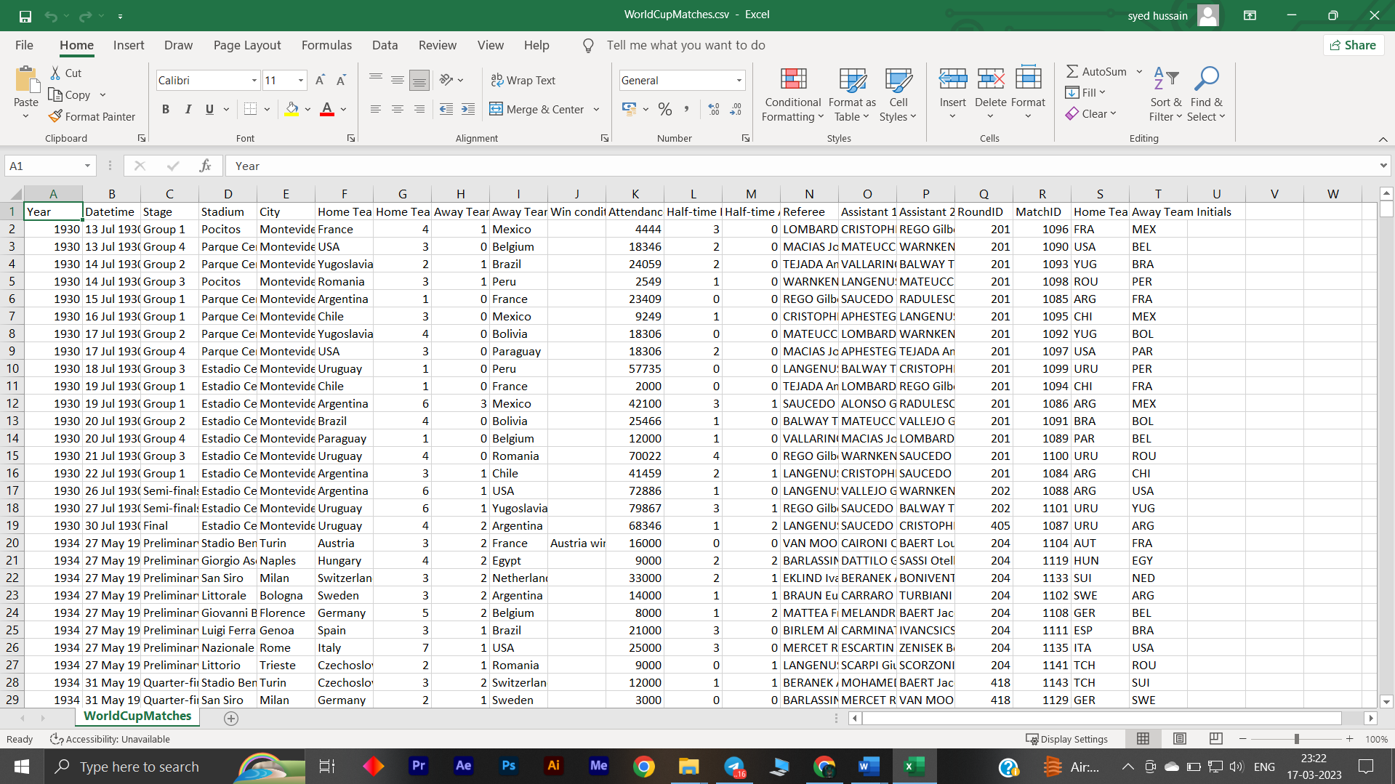

* Glimpse FIFA World Cup– players Info:

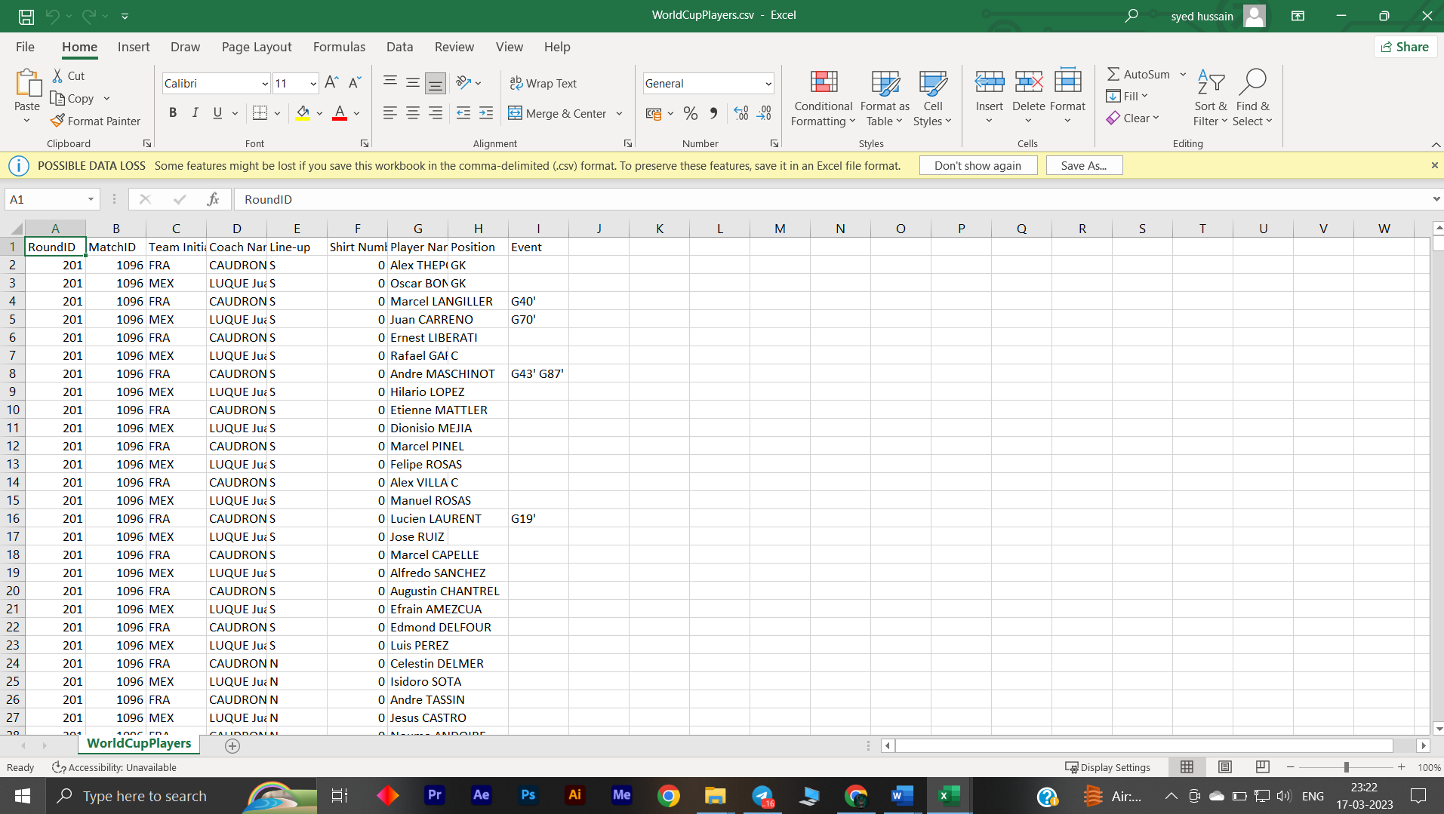

* Glimpse of FIFA World Cups Info:

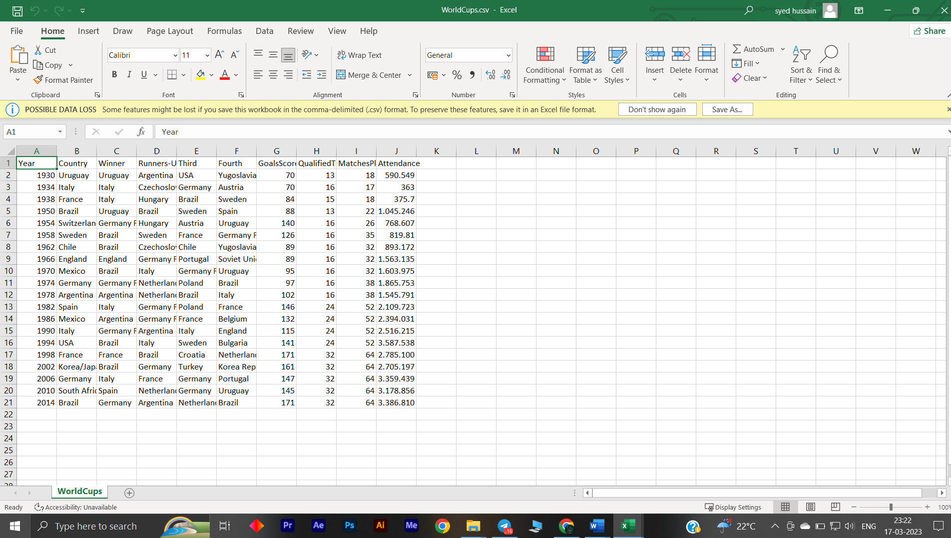

The Data includes following Attributes:

* year
* datetime
* stage
* stadium
* city
* home team
* away team
* win condition
* attendance
* half-time home goal
* half-time away goal
* referee
* assistant1
* assistant2
* round id
* match id
* home team
* initials
* away team initials

2nd table

* round id
* match id
* team initials
* coach name
* lineup
* shirt number
* player name
* position
* event

3rd table

* year
* country
* winner
* runner-up
* third, fourth
* goals scored
* qualified teams
* matches played
* attendance

# Connect Data with Tableau & Deployment

* First of all, open Tableau Public in your desktop. At first screen, it will ask you to connect your files from various sources like MS Excel, SQL Server, Tableau Server etc.
* First screen of Tableau looks like:

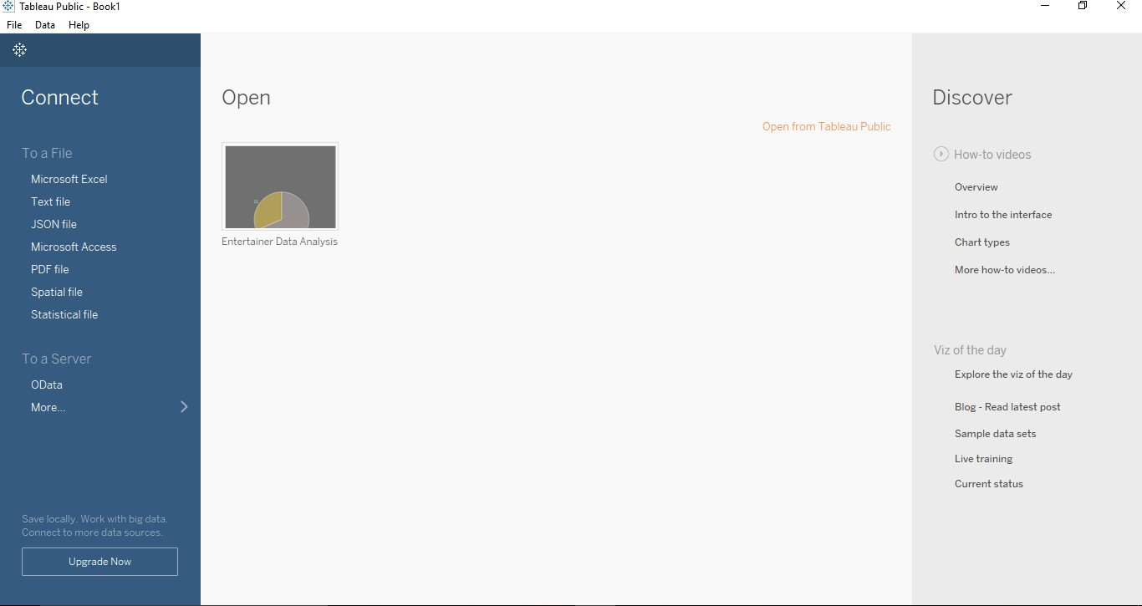

* Make sure internet connection is connected well while working with tableau, otherwise it will show the error.
* After completion of work, you can simply press ctrl + s or save it from file menu. It will let you to tableau public’s website and ask you for signing in. After sign-in, your work will be saved in tableau’s website. At there, all can see the work.