FIFA World Cup Data Analysis

**Wireframe**

**Homepage**

**As per the given problem statement, you have to mention a theme on which you will be creating the dashboard.**

**Theme: Top Team with FIFA World Cup Winners**

# Dashboard 1:

# 

→ Top Winning titles are shown in this dashboard.

→ Let’s see each and every chart.

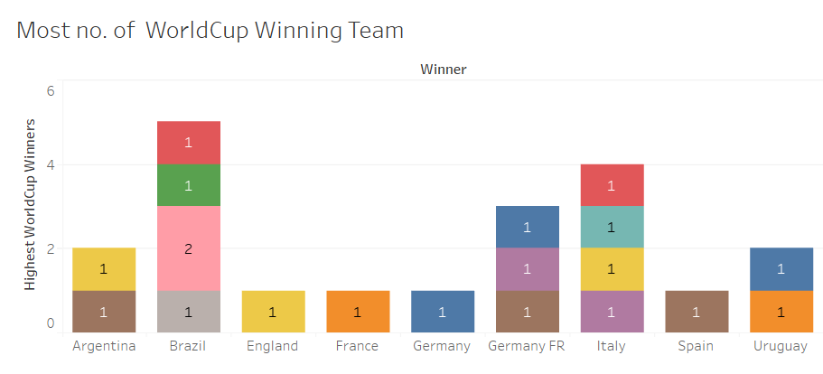

→ This Bar chart shows the most no. of World Cup Winning Team

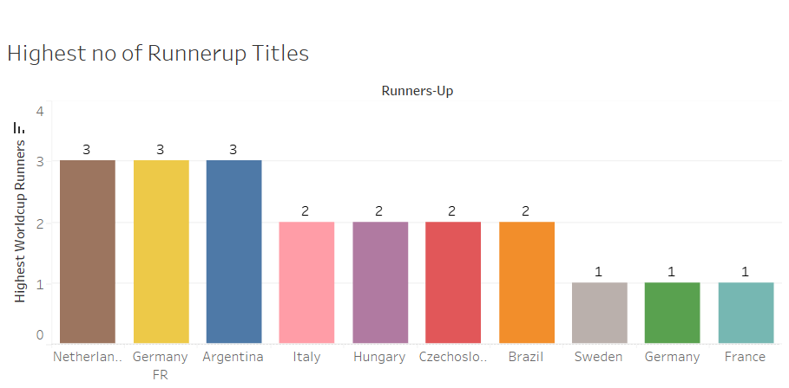

→ This Bar Chart shows the most no. of runner-up Team means the teams who got the most runner-up titles.

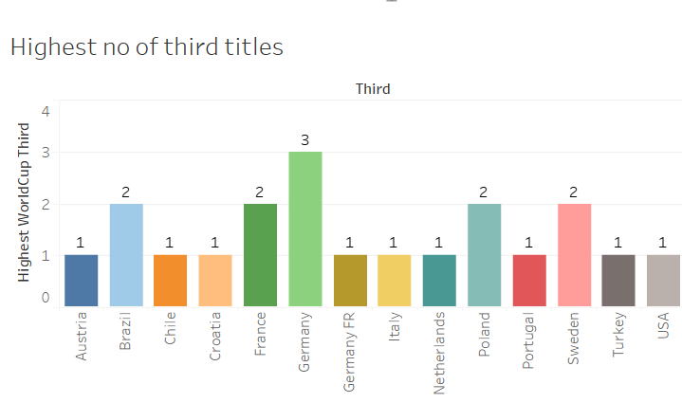

→ This Bar Chart shows the most no. of Third Team means the teams who got the most Third Titles.

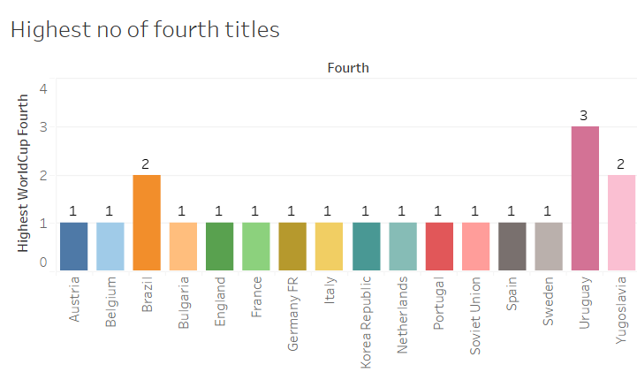

→ This Bar Chart shows the most no. of Fourth Team means the teams who got the most Fourth Titles.

**Dashboard 2:**

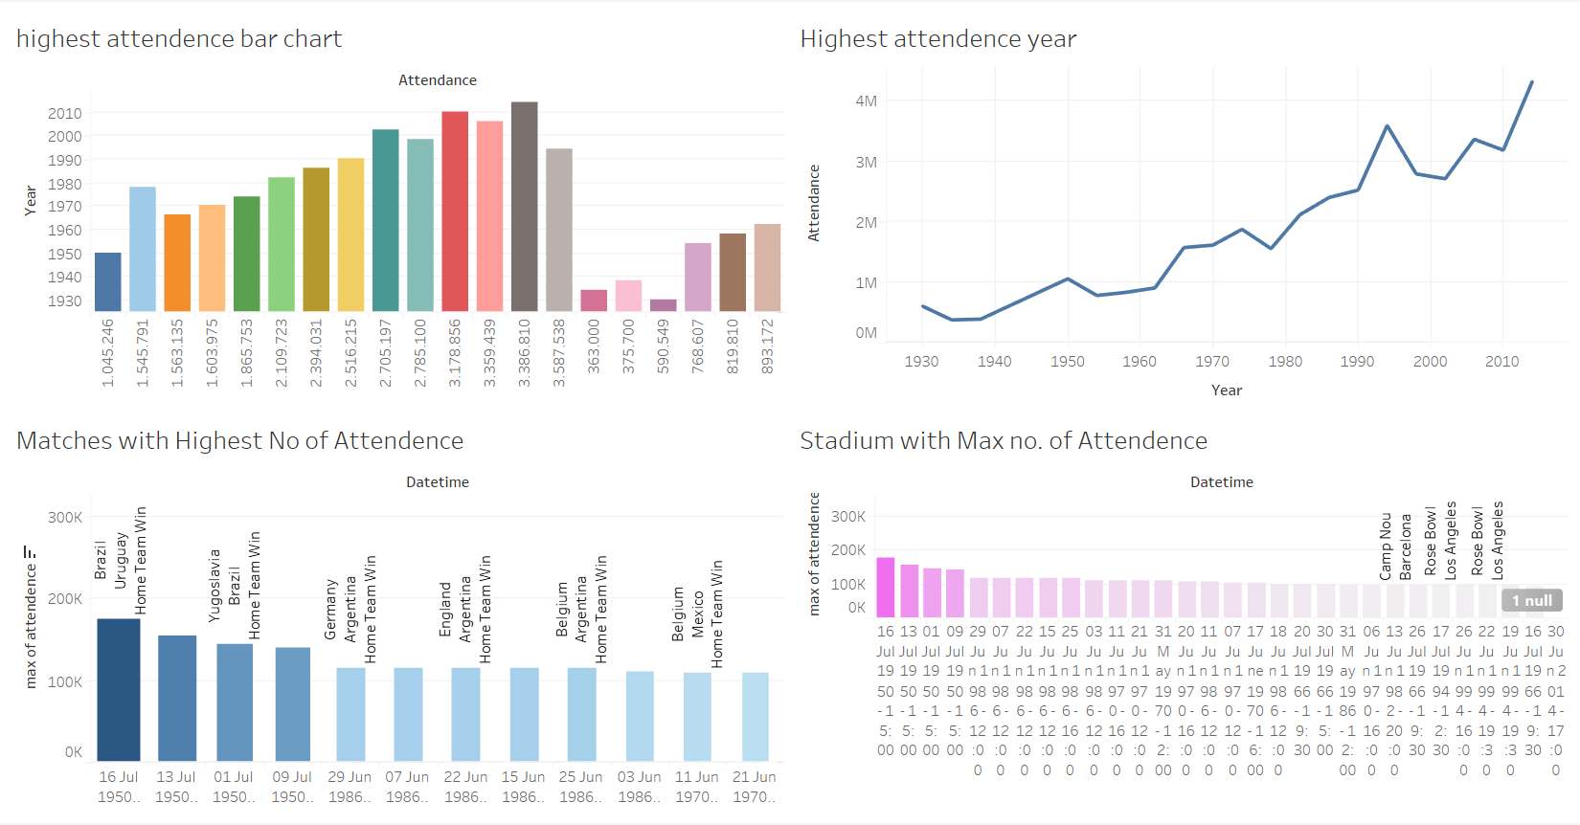

→ Dashboard 2 is about the Attendance of the matches and stadium

→ Let’s see each and every chart.

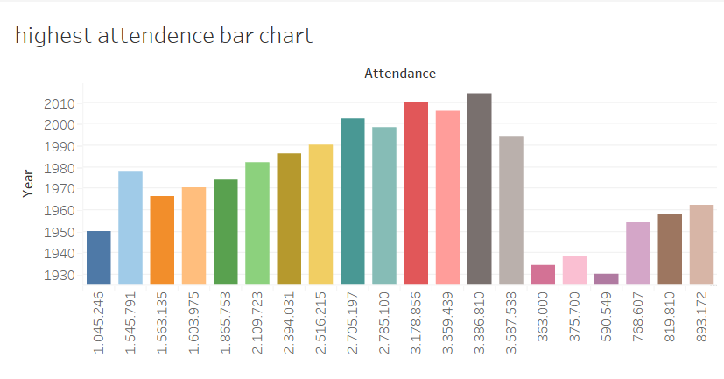

→ This bar chart shows the Attendance of the overall World Cup Years

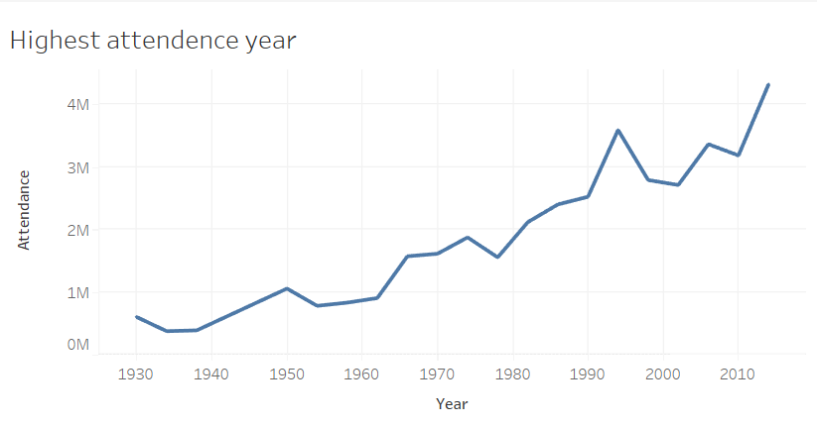

→ This Line Graph shows the Attendance of the overall World Cup Years.

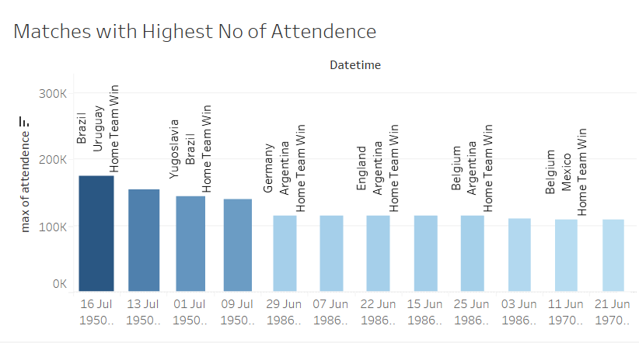

→ This Bar chart shows the Matches with Highest Attendance over the years.

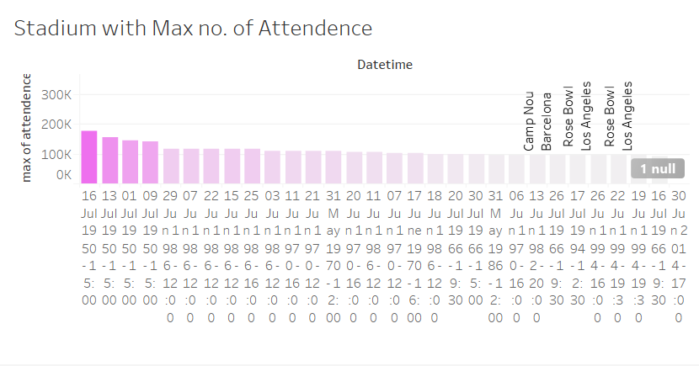

→ This Bar chart shows the Stadium with Highest Attendance over the years.

**Dashboard 3:**

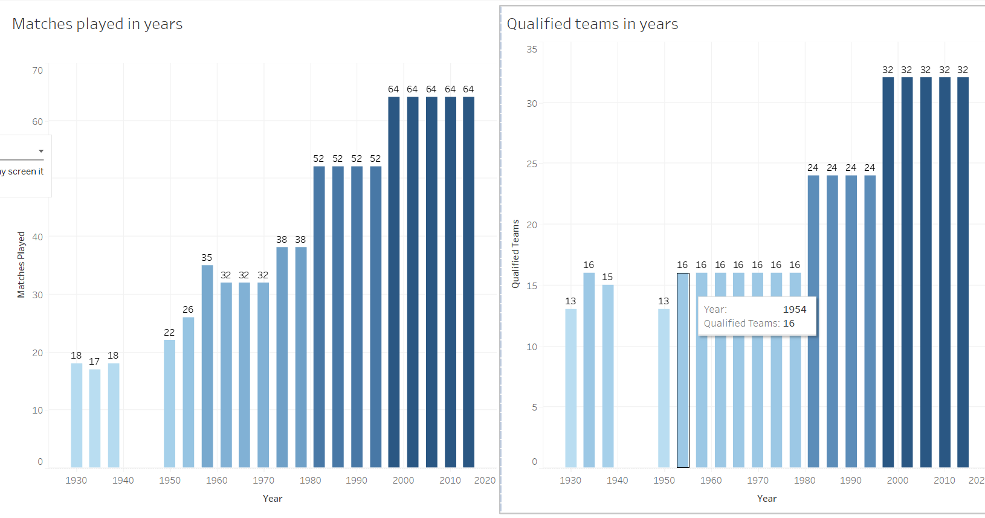

→ Dashboard 3 is about the Matches played in years and qualified team in year.

→ Let’s see each and every chart.

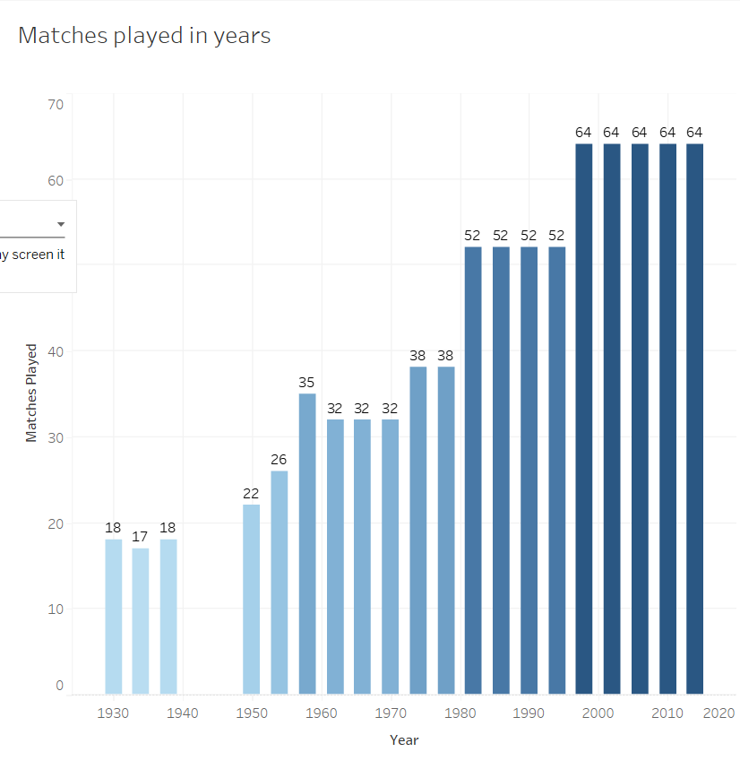

→ This Bar chart shows the matches played over the years.

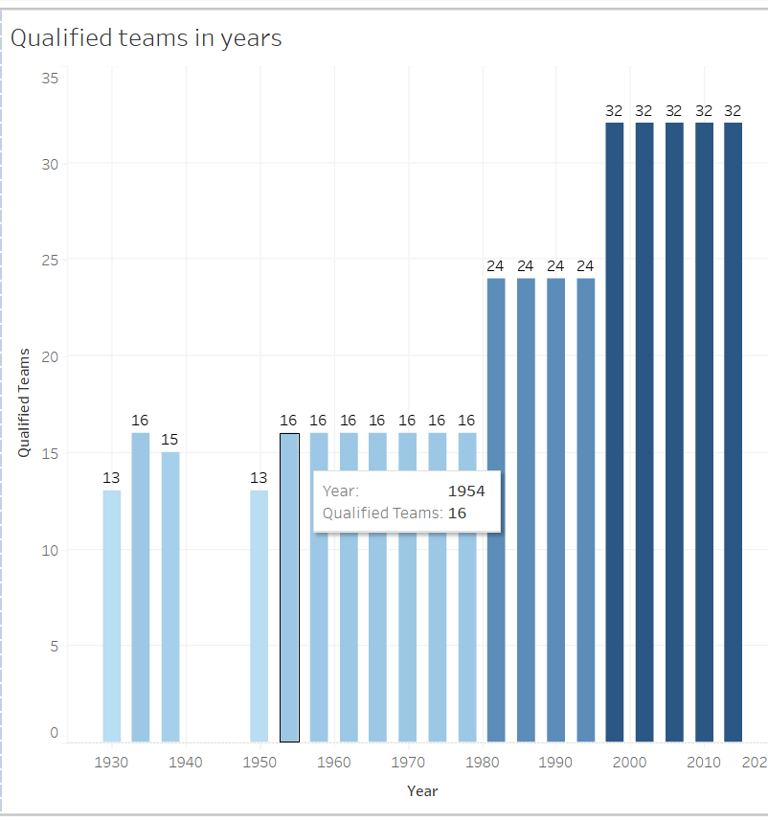

→ This Bar chart shows the Qualified Teams over the years.

**Dashboard 4:**

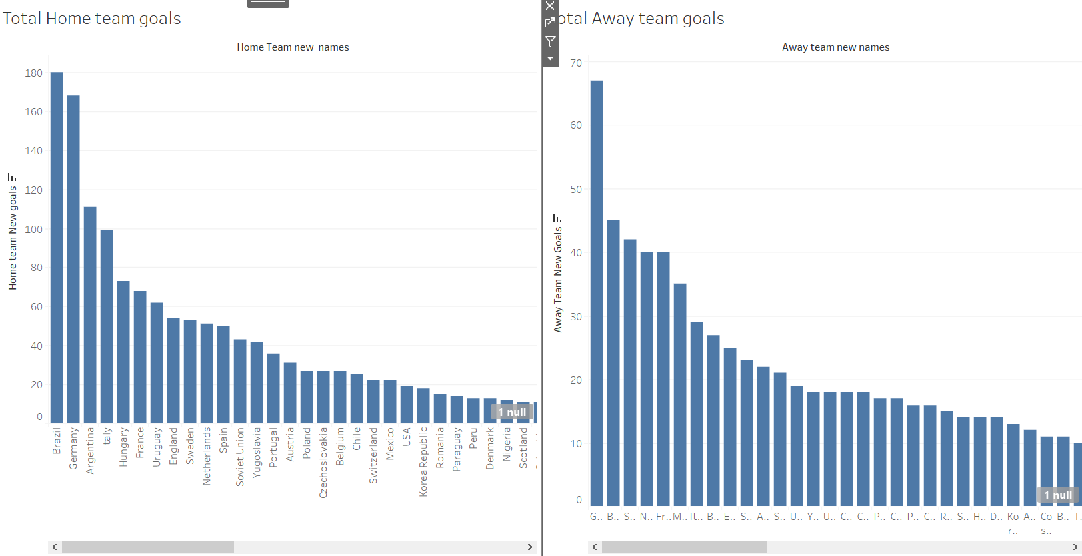

→ Dashboard 4 is about the goals of home team and away team which indicates about every team

→ Let’s see each and every chart.

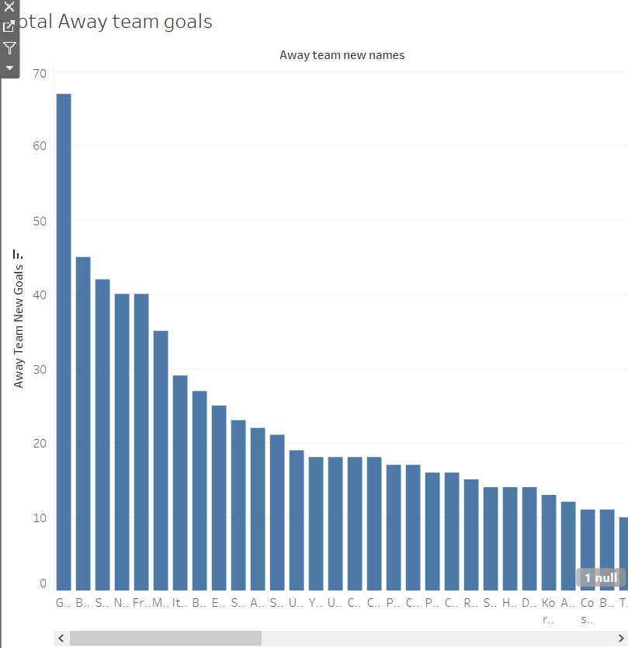

→ This Bar chart shows the total goals of each and every team when they were Away team.

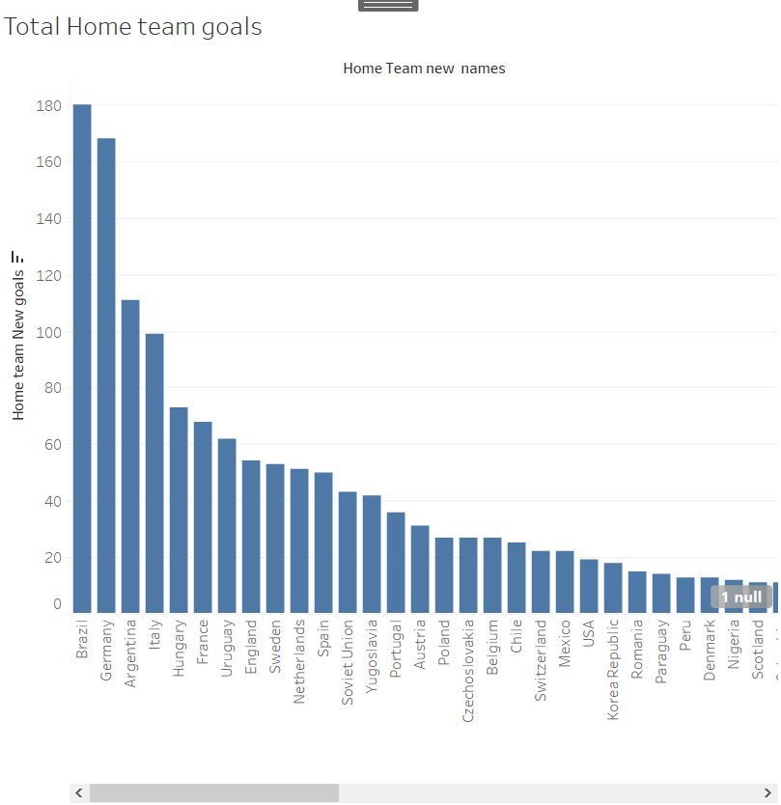

→ This Bar chart shows the total goals of each and every team when they were Home team.