**Shape Example Barbara Ericson** [**ericson@cc.gatech.edu**](mailto:ericson@cc.gatech.edu)

**Example of: Interface, Abstract class, Polymorphism, and a List**

Run the main in ShapePanel class. You can click on a button and then click and drag in the yellow area to draw that shape.

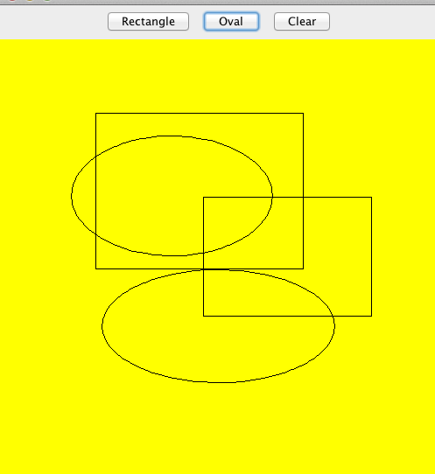

This example features the abstract class Shape. A shape has two points that define it so this is only good for the kinds of shapes that can be defined by two points. The ShapePanel has a ShapeComponent that is used to display the shapes and handle the user interface. The ShapeComponent keeps a list of shapes that it is displaying. The ShapeCanvas implements the ShapeInterface. The Shape class is abstract and has an abstract method draw since we need to know the type of shape in order to draw it. The Oval and Rectangle classes are subclasses of Shape and provide the code for the draw method.

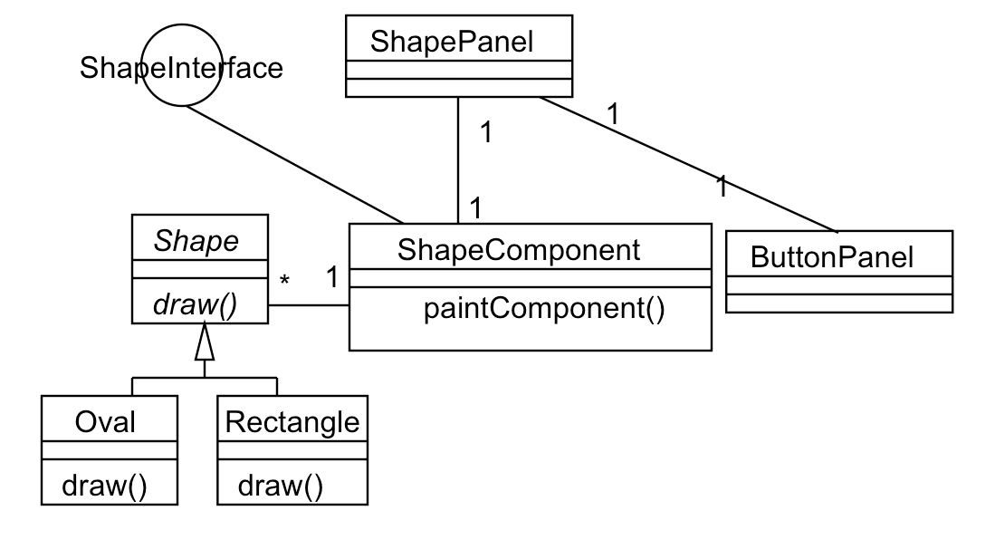

Try adding a Line class which also subclasses Shape. Add "Line" to the shapeNames field in the ButtonPanel.