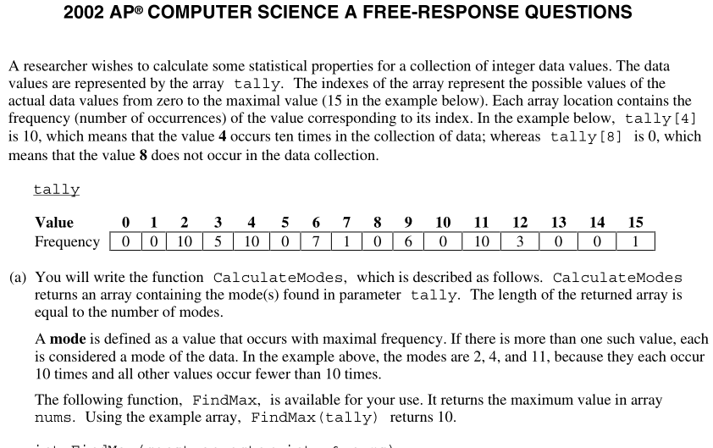

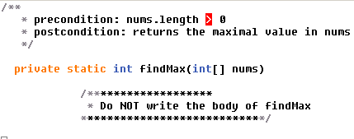

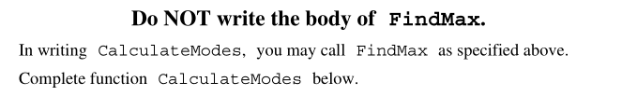

In writing calculateModes, you may call method findMax specified above.

Complete method calculateModes below.

/\*\*

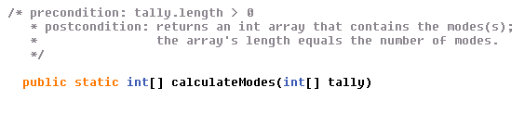

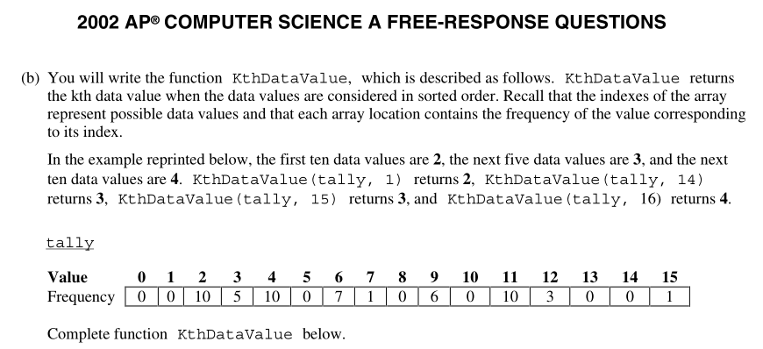Complete method kthDataValue below.

