**PROJECT REPORT**

**Abstract -**

As a fresher at IIITD did I find it difficult to find likeminded people to interact with and make study groups? Yes! So, what did I do about it? I decided to make an app to make sure no one else has to experience what I did. And while making it, why not make it accessible to professors and students both. This would help create a stronger and informal bond amongst the community. Our app ‘Quiwi’ provides a common platform to both students and professors to provide and access all sorts of services one can deliver, be it logo designing, web developing, video editing or research projects, TAship and what not. This idea of an integrated app would provide a platform for budding students to test out their skills in the real world and maybe earn their first salary by doing paid projects. All in all, this app is a win-win for all the stakeholders.

**Story board:**

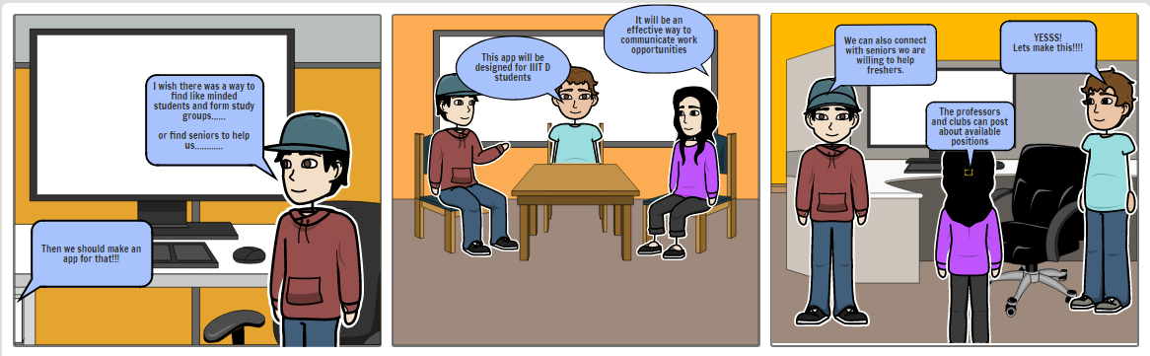

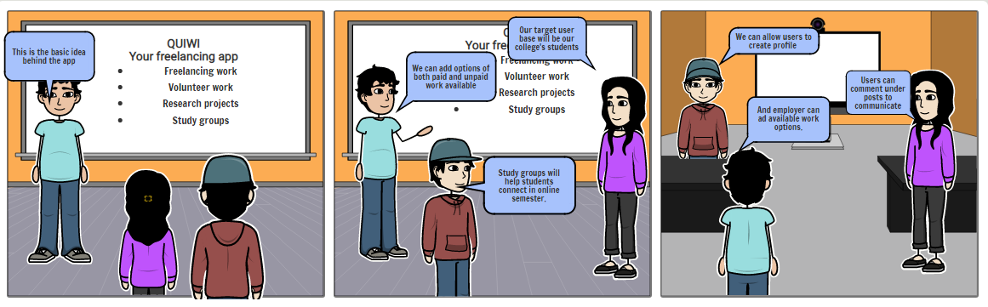

**INTRODUCTION -**

We decided to design this application to make it easier and convenient for students and faculty of our college to interact with each other for work related purposes.

This application will enable likeminded juniors to connect with each other and participate in study groups and for seniors to guide and help juniors. It will also allow professors to inform interested students about available research opportunities in the institute. Club coordinators and event organizers can also post about the details of work enabling interested students to connect with them. This application will allow employers from within the college and also outside to post about relevant freelance work opportunities for college students.

**Problem definition**: Lack of access to organized information about various kinds of work opportunities available in our institute.

The target user base of our application will comprise the following:

* Students of our college who are either looking for work or those who want to volunteer and help their fellow students.
* Professors who want to get students for research projects or other academic related work
* Employers inside and outside the college who have freelance work available for college going students

**Motivation:** As a fresher at IIITD I’ve felt the lack of lack of opportunities and platforms to meet likeminded people, make study groups, find guidance and test out skills in the real field. Many talented minds wish to showcase their talents and skills in multiple fields and the only opportunities they got to do so are club activities. The issue here is that we have a limited number of clubs which means not all talent goes noticed and the frequency of events is also dependent on a number of factors. Not only this, many people are afraid to ask their doubts in the class and don’t raise their hands if they can't understand something.  To tackle these issues, we came up with the idea of a freelancing app. Here, people can showcase their skills whenever they want and others can utilise those skills. Many children wish to help others and can do so by forming voluntary study groups making it a win-win situation for all the stakeholders.

**Existing challenges**: There is no such application designed for our institute yet and it thus all of the communication happens via email. This makes it very disorganized and hard to find relevant information about opportunities available in the institute. Moreover, there is no platform targeted towards making freelance work available to students here.

Due to the semester being online there is very little communication between seniors and Juniors and also between batch mates. This application will allow seniors to guide juniors in many ways and also allow likeminded students to participate in study groups. The professors can use this to inform about research opportunities, selection criteria and other parameters and interested students can inform them. The professors can simply click on the profile of the student and get all the relevant information about them to make the decision.  The profile will show the student's credentials, their cgpa, their past work experience, et cetera.

Employers can also use this to shortlist candidates depending on their challenges. This application will make all the information available at one place making it convenient for users. Right now, there are no such applications. There are separate applications for freelance work like "Upwork" and "Fiverr" but they are very large scale and only targeted towards paid work. Websites like "LinkedIn " are there which contain user information but they don't have any other features. We wanted to develop something which was just for IIIT D students.

The surveys we took to ask students also showed that they were interested in an application like this and thought it would be helpful.  Most of the responders said that they would be interested in using our application.

**The proposed solution**: Our application is called Quiwi. It is our local freelancing application and would have many features to enable the IIITD community to connect with each other in meaningful ways. Our application will have a sign-up page where users can make their account and then add all the relevant information to complete their profile. Our app would show the popular services and areas where work is available.  They can use filters to make sure they are surfing through the posts where they satisfy the given criteria. The posts will clearly mention what role/ position the employer/ professor is looking for and also include information about working hours, pay and criteria for shortlisting.

The application will show the opportunities for both employers and students, students can browse through available work and employers/professors can browse through the profiles of students. The students can add posts they are interested in to their wish list and contact the employer via email or comment on their post. The employers, professors and employee’s information will be easily available on their profile page. The students will be able to see what popular courses are in demand and search for roles they qualify for.

There will also be posts relating to volunteer work. This can either be in the form of seniors helping juniors or batch mates with course work or via some organization that has collaborated with the college. Interested students can apply for these positions. There will also be provision to allow likeminded students to form study groups, discuss questions and connect with each other. The professors looking for students interested in research or other activities can also post here. They can browse through the profiles of interested students to select the ones that fit the criteria best. The club coordinators can also use this to inform about their selection drive for the club. Event organizers can also connect with students and team up with the ones that are interested.  Moreover, information about extra-curricular activities or upcoming complications that are open to students for participation can be posted here.

Basically, this application will be a one stop place for information about various activities happening in our institute and everything will be organized in a proper manner making it very convenient to use. The posts would allow students, professors, employers and batch mates to communicate with each other whenever they need to find other people to do any kind of work. The profile of students and employers will give users more information about the person and make it easy to carry out the selection procedure.

**METHODOLOGY -**

**1.Problem Definition and Stakeholders -**Lack of access to organized information about various kinds of work opportunities available in our institute

The stakeholder of this project is the entire IIITD community, since this app can be used by students for forming groups etc and the professors too, can reach out to students for research projects and many other things. Even people outside IIITD can access this app to avail services of our students.

As of now, the only mode of communication in the community is e-mail. The reason this is not a very viable option is because everyone receives hundreds of mails every day and many mails go unnoticed.

Our app would use notifications whenever something new would be posted in the user’s interested categories. This way, their inbox would not fill with unnecessary emails and they would also remain updated.

Currently students interested in research are not able to know about the various opportunities available in the IIIT Delhi Labs so through our apps professor would be able to post research positions.

**2.Requirements Gathering :-** We decided to gather requirement and opinions of different kinds of user to check the feasibility and acceptability of the idea among the students .Along with it we also decided to find which features would the users prefer .We asked everyone for their suggestions or any additional ideas which we should incorporate .We decided to float a Google Form which acted like a survey for our freelancing App Quiwi .To make it relevant for our final product which is made for IIIT Delhi students we sent the form to only IIITD Students

We floated the following Google Form - <https://forms.gle/SPfRRL7VyeJ8AM9o7> to take the inputs from different kinds of users and know their opinion before moving ahead with the low fidelity and high-fidelity prototype. We gave a basic short description of our app before the survey to make user familiar with the idea before answering further questions.

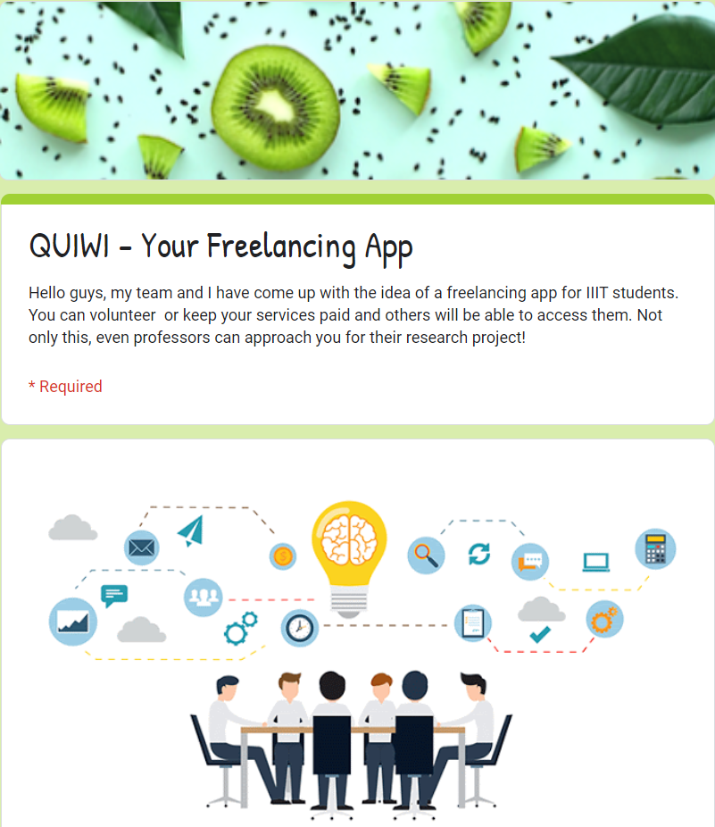

Understanding the importance of anonymity, we decided not to keep any field for the name and decided to keep only an email field so we can further update users about our product in the future if they are interested and that too was kept optional for privacy reasons.

In total we got 50 valuable responses from different kinds of users all of those helped us to proceed with our idea in a better way and we got to know which ideas would be important for our app and which areas we need to add and what our users expect from us .We kept the survey short and simple along with more emphasis on questions which are objective and hence can be quickly answered from what we learnt in Data Gathering chapter of the IHCI Course and different principles we learnt in the complete course.

The responses corresponding to different questions were as follows :-

1.The need of our product: This was asked to validate our idea. We gave the user to answer from 1 to 5 scale to get better understanding of public demand instead of Yes/No as a scale. The rating scale helps the user to give a relative answer as a user rating 3 in such answer may select the no option and it can give wrong perspective to our team in the other scale.

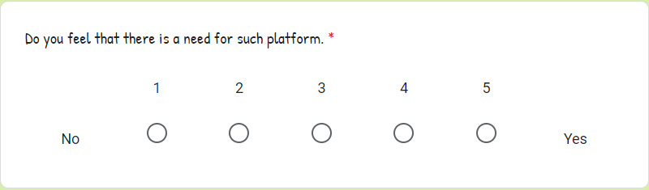**We got the following responses:-**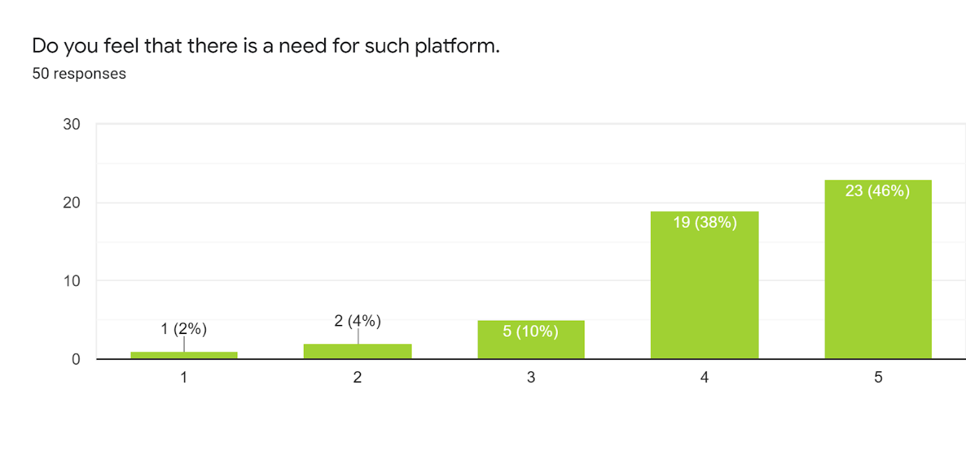

This indicates that most of the users feel that there is a good demand for such a platform. So, we decided to proceed with the same idea for our project.

2.Next we asked the users if such an opportunity is given to them to showcase their talent through our freelancing app will they use it. We gave options of Yes, No and Maybe. We added “Maybe” because sometimes the user can’t be sure before giving a concrete answer as currently, he has not used our final app or he is unsure about his future demands in the current scenario.

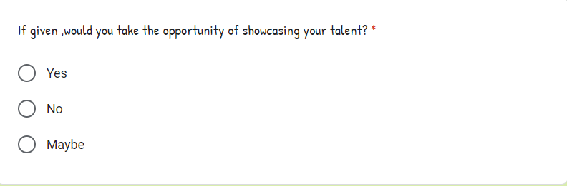

**Response -**

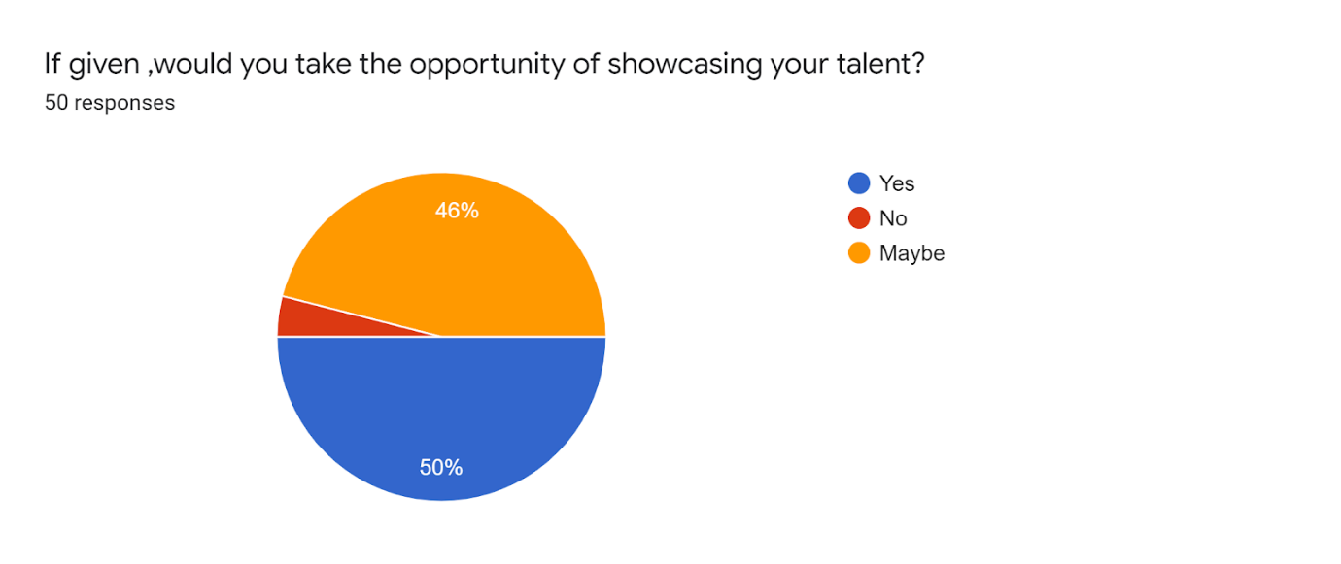

From the responses we received most of the people are ready and excited to showcase their talent on such a platform like Quiwi which is a positive indicator for our group as the interest to use such an app could be high as per the responses.

3.Next we asked the users about what kind of services will the users avail or offer out of the given services we have planned .We gave the users to tick multiple options in the form as they could possibly be interested in multiple services along with it we also gave the option for people to select other and mention any service which we might have missed in the problem definition and could possibly be included based on the popular demand .

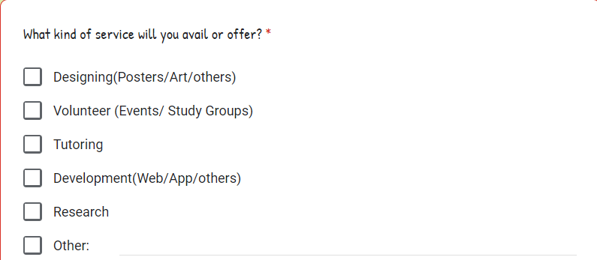

**Responses:-**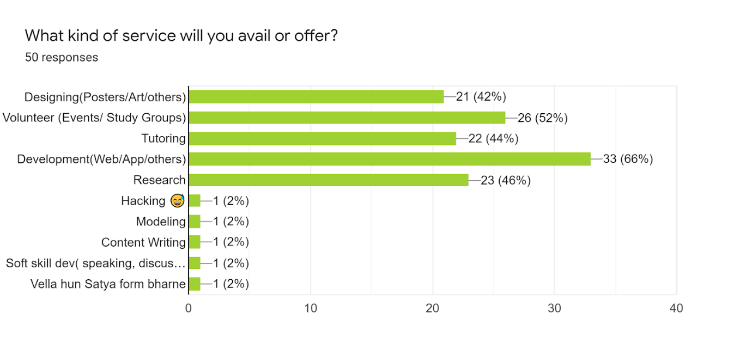

As we expected as IIIT Delhi is a computer science-based research institute we found that most of users are willing are interested in work related to Development and Coding along with many of the students are also interested in other fields relating to helping Juniors in academics or forming study groups to improve their academics which form a crucial part in IIIT Delhi. Some students provided us with new and unique things which we had not thought about earlier like soft skills development, hacking etc which we will try to incorporate in future if we receive more demand after our app achieves its initial target.

4.Next we asked our users about their interest in study groups which will help the students to find similarly interested students and we are planning to keep it as a coveted feature of our app. It would also help students to excel in academics.

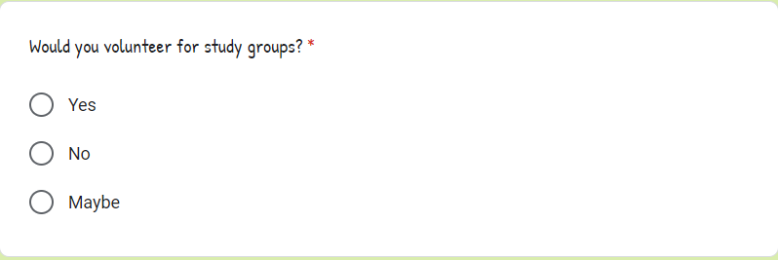

Response - 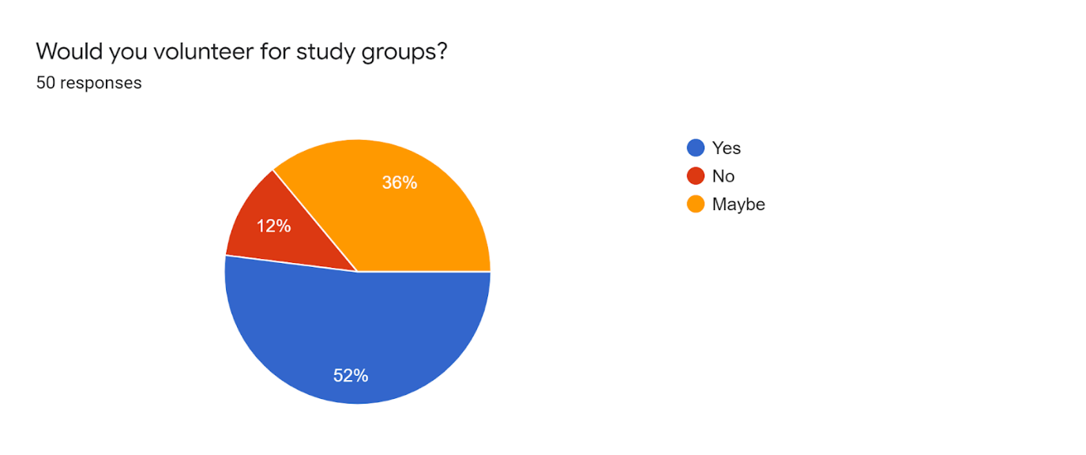

Again we received a good response from the targeted users which indicates that this feature will probably be a hit among the students as the majority of people are expected to use this feature in the app.

5.Next we asked people would they approach other people who are offering their services through this app and use their services to know how many students are willing to use services offered by the other students. We again put the same three options of Yes, No, Maybe.

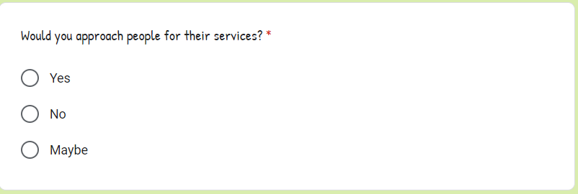

**Responses :-**

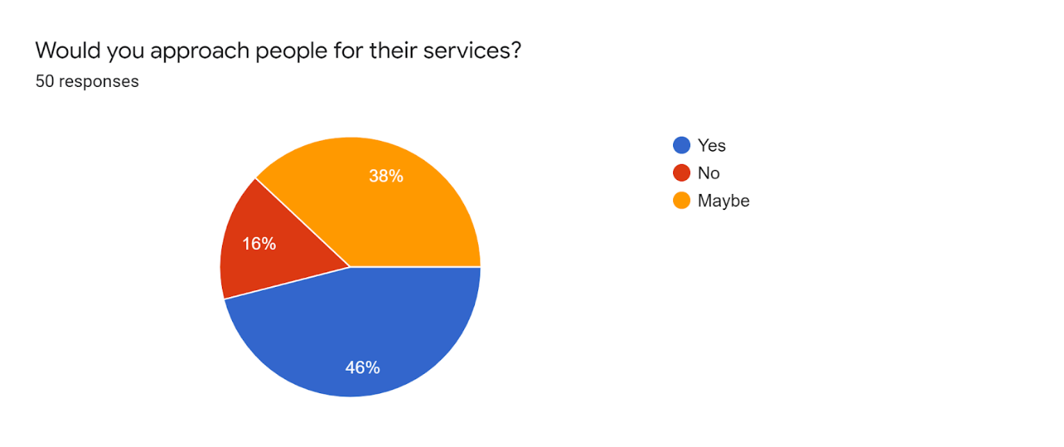

Again, we received positive responses from most of the students which indicates that besides employers or companies looking for services offered by students the students themselves will also use the services offered by other students which will probably increase the usage of apps by IIITD students.

6.Next we asked our final objective question that will you recommend this app to your friends to know is the idea good enough that popularity and advertising can happen directly through the students for increasing the popularity of the app.

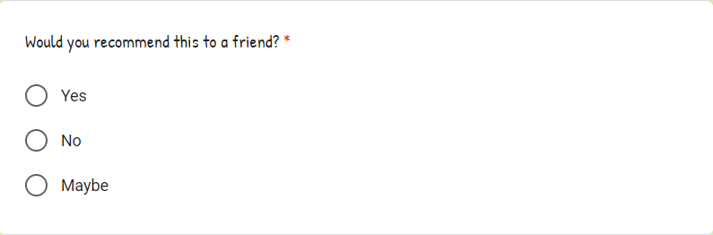

**Responses:-**

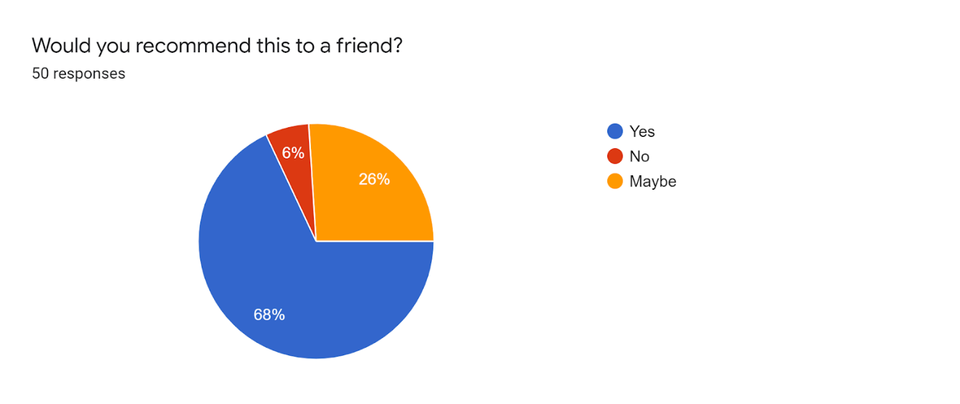The response received again is very positive for our team as this indicates that most of the users 68% liked the idea of this product and will themselves recommend it to their friends which can increase the number of users on our app and more options will be available for employers as well students.

7.The last question was kept as optional and in the end, we asked users about any additional suggestion or feedback regarding the idea to know if we are missing some feature or idea which we could incorporate or if any improvement in idea is required then also we can know it before starting with LO-FI and HI-FI Prototype.

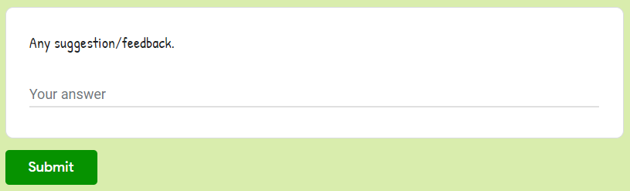

**In Response to this question we got the following:**

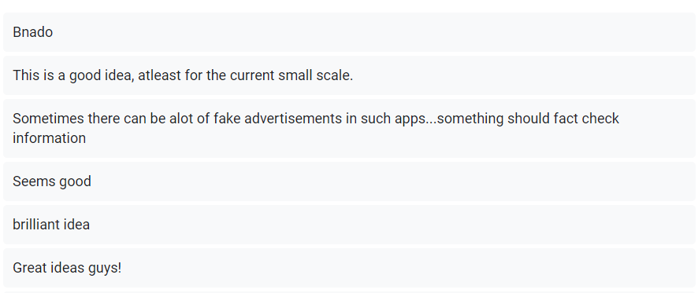

So the response here too is positive and most people really liked our idea and gave positive feedback for the same and encouraged us to go forward with the idea and make the product. One of the users gave feedback to make a mechanism to avoid fake advertisements in the app and we noted the same to keep in mind. Along with it we also conducted some informal unstructured interviews and conversations with our close friends through call and WhatsApp to now their opinion in detail and discussed the idea in detail with them.

**Overall summarizing the discovering requirement’s part, we received valuable feedback and found the opinion and suggestions for our idea and expected product from the target users along with desired requirements of the users. We analysed the feedback deeply to use it in further steps of development.**

**3.Ideation and Low-fi Prototyping:** Brainstorm and identify possible solutions to your

problem statement. Narrow down to one solution (give reasons why the chosen one was better

than the others) and create low fidelity prototypes for this solution.

For Ideation and Low-fi Prototyping we gathered in a google meet and we discussed about the problem statement and current problems which our product aims to solve .We tried to think what all could be there in the interface which provides solutions to the listed problems and we discussed the probable features and solutions to the listed problems one by one .We also involved the data collected in our ideathon process and analysed the demand of users and what they want from us ,what are the areas which could have more demand and which are the areas we are missing in our app which the user want .

So before starting with low fidelity we discussed all these things with our team step by step . The major problem was about the users not getting a platform to showcase their skills so corresponding to that we decided our app would need a very good profile page which would enable our users to present their skills in front of other people and the page should cover his past experiences,skills,qualifications,posts under the single page so the companies,professors or any other student can know about him from that page .So we arrived to the final profile page after coming up with different ideas from our members .We finally picked the best ideas of each members and combined them in a single one .

Next problem in the problem statement was about the interface between the employer and the student which will enable each other to list their services and approach each other for their services and along with it classification according to type of services ,money,type of work ,skills required and all .We discussed and found that for our app to sustain in long term we need some revenue model and we found that a very good revenue model would be to feature some services and students and show them on top of the desired page as featured service along with it we also decided to charge a small part from the companies outside IIITD a small amount around 1% if they employ any IIITD student from our app .The common interface for such a exchange portal among the students and employees was adapted from different rough models and ideas prepared from our users we also considered what our close friends suggested in unstructured interview .All of the members submitted rough paper sketches we picked the current one taking inspiration from different good part of each sketch and idea .We decided to create a popular service page which would on top tell the latest openings and coveted opportunities like some news and would support horizontal scrolling and below it we will have different categories which we have planned for the app .After that on the page of employee he would be able to see a list of probable candidates interested in doing a particular kind of work,the money they are charging along with their skills and profile .On the other hand we decided on similar page for the Student where he would be able to see the available opportunity according to the selected category and he would be able to see the positions for research,freelance work,study groups ,tutoring ,development .etc opportunities along with the money being offered .After clicking the profile of company he would be able to see the details ,eligibility and benefits for each opportunity posted along with option to wishlist and apply .

We decided on filter and sort options on each page taking inspiration from the popular apps in the industry which have such options and include relevant filters and sort according to our app .

We discussed the problem of emails and found that a notification page similar to what such platforms offer would be great asset and would be helpful for students to know current status ,see new posts from the topics they are following and help them track progress of their interaction with the companies .So we finally we decided on current notification page which looked minimalistic and matched all the expectations from the users which was contributed by one of our member .We tried to make navigation as easy as possible throughout our app.

We decided to keep the colour scheme in shades of green and designed our logo also as we are inspired from Kiwi fruit so we kept colour scheme green and named our product quiwi.

After deciding on these key areas in ideation we finally started making our final Low-Fi prototype using pen and paper and the first page of any app should be that of Login so we decided to create a interactive login page which enables user to sign in using different options beside his own quiwi account for flexibility .

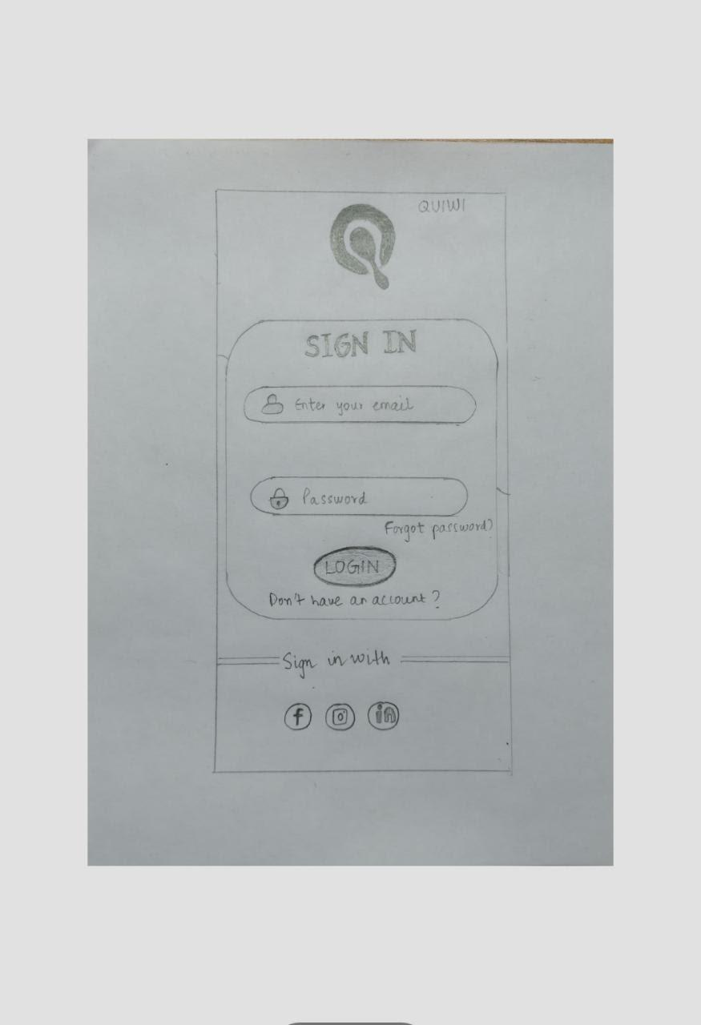

Next we decided after this login page the user would come to the popular service page for which we discussed about in the ideation stage because it was of utmost importance to our app and based on the discussion we came up with the following lo-fi prototype:-

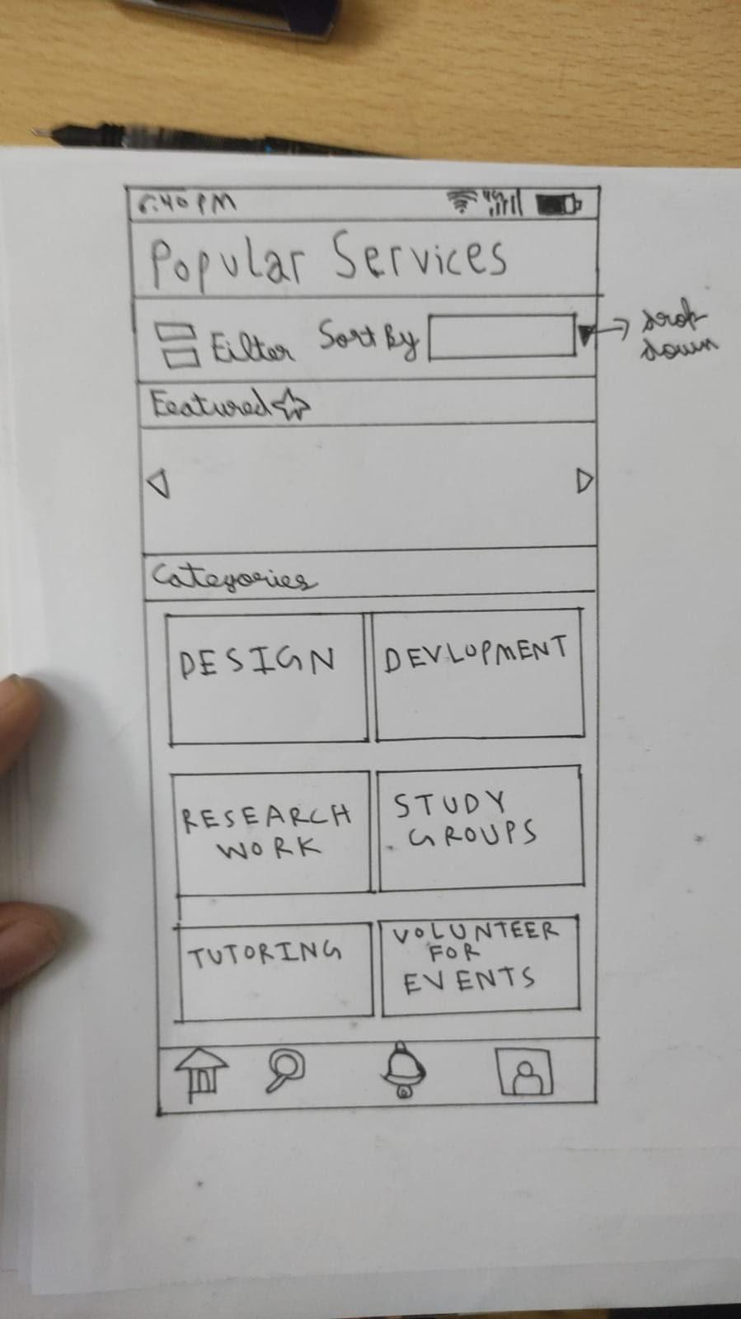

Then next task was to create the page for which we discussed above for the exchange of services offered by student and opportunities offered by clubs,professors,companies and other students .We came up with following prototype for the same :-

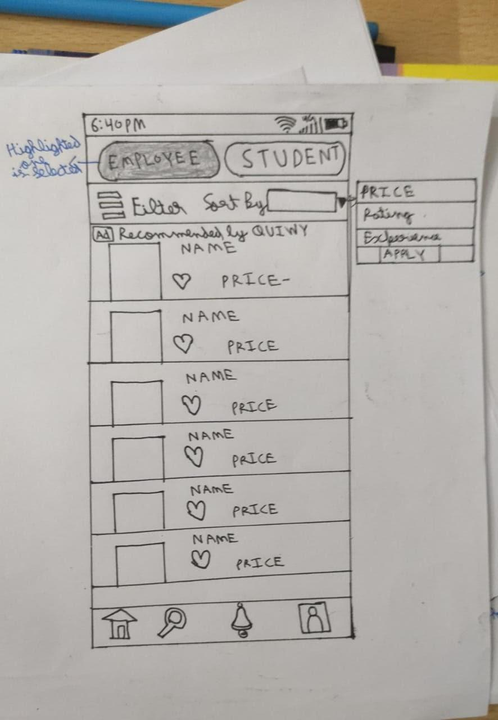

For the filter options in the same page after brief discussion we came up with the following rough sketch for the filter option on all these pages which incorporate the maximum required features according to the page it is being used over :-

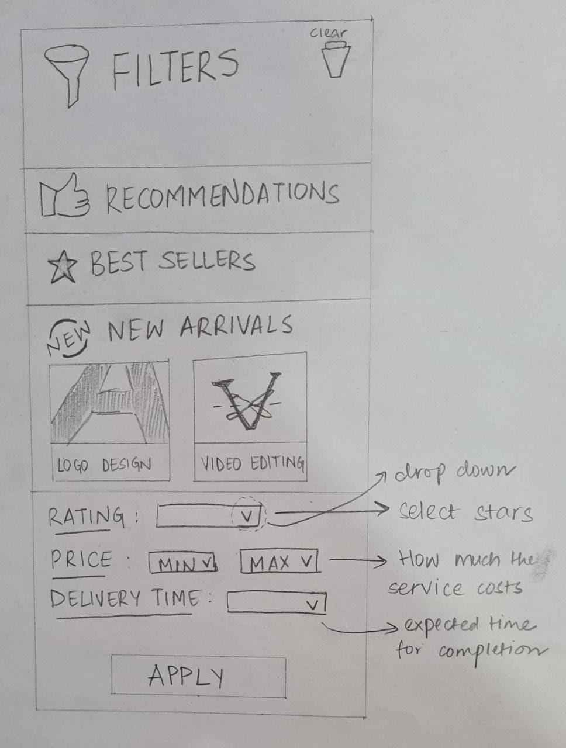

Next important part for our app was the notifications part and as discussed in the ideathon process we incorporated all ideas to create the solution of the problem of multiple emails and classified notification based on time and date also as following :-

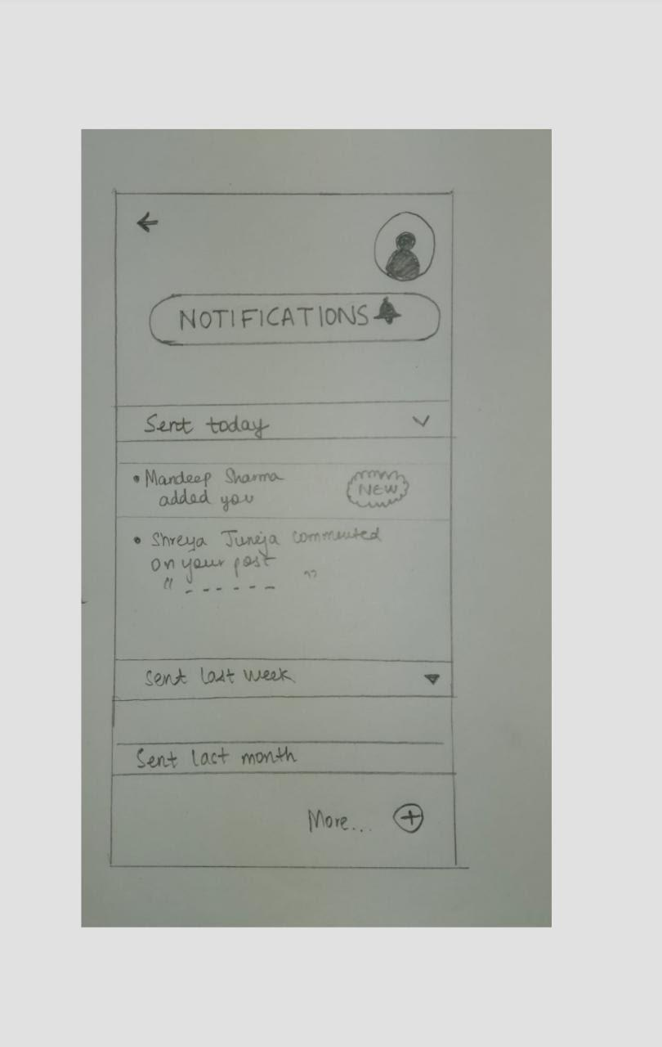

Next very important part was profile for which we had enough debate and discussion in the ideation part and finally taking inspiration from different rough sketches we came up with the following comprehensive profile page :-

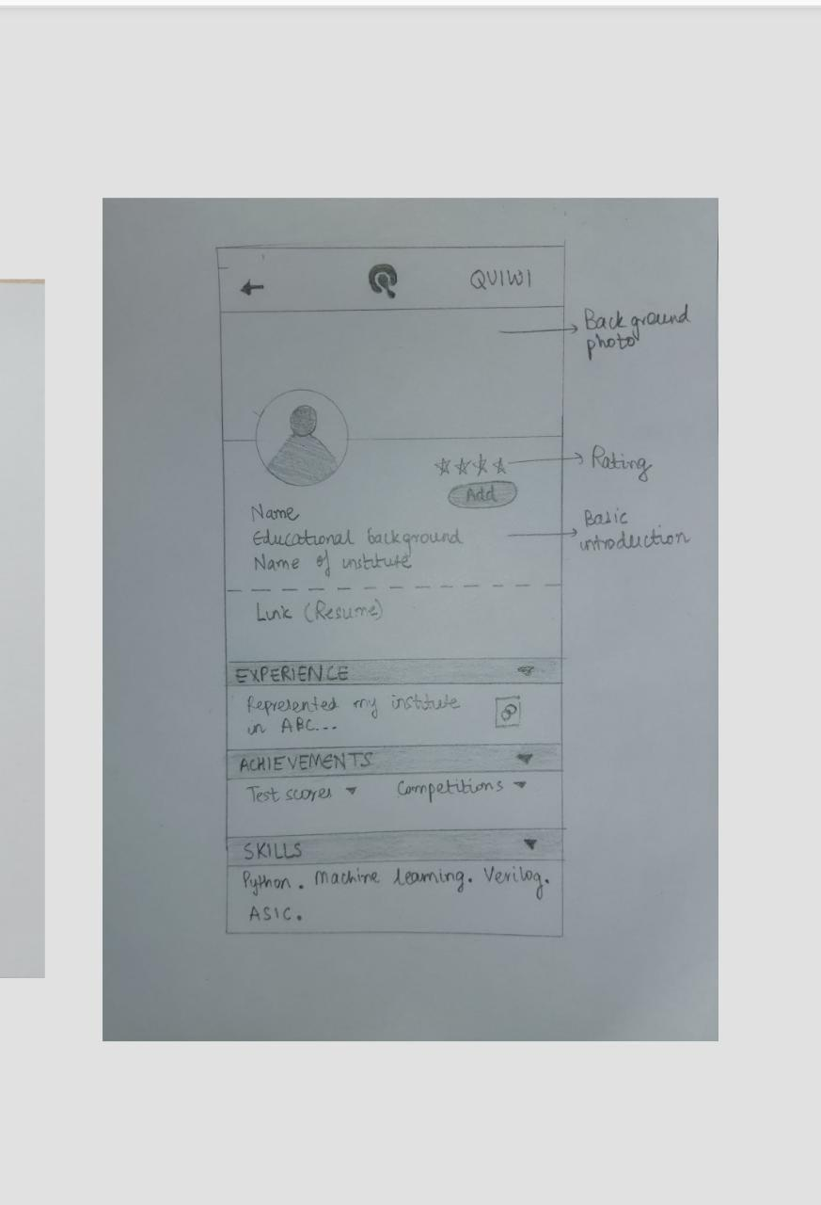

Along with it we also put a profile posts page where the user can post some importance related to his work or put a shoutout to his connections and friends or inform them about his achievements and his work .We came up the following page which will list all posts in the chronological order of time :-

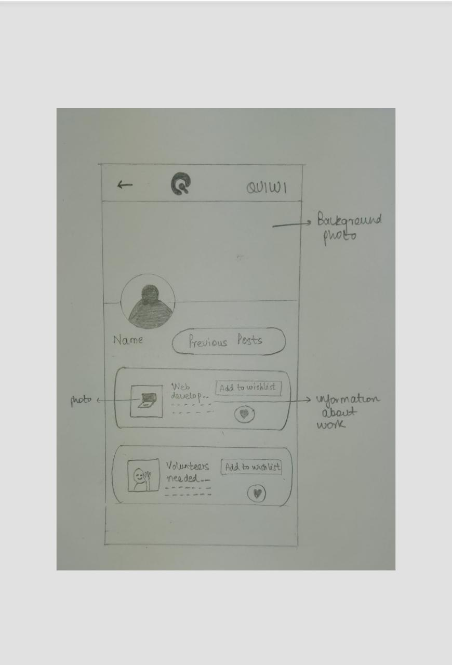

We decided what the basic structure of these posts could look like and created a low-fi prototype for the same inspired by an idea from one of our team members .

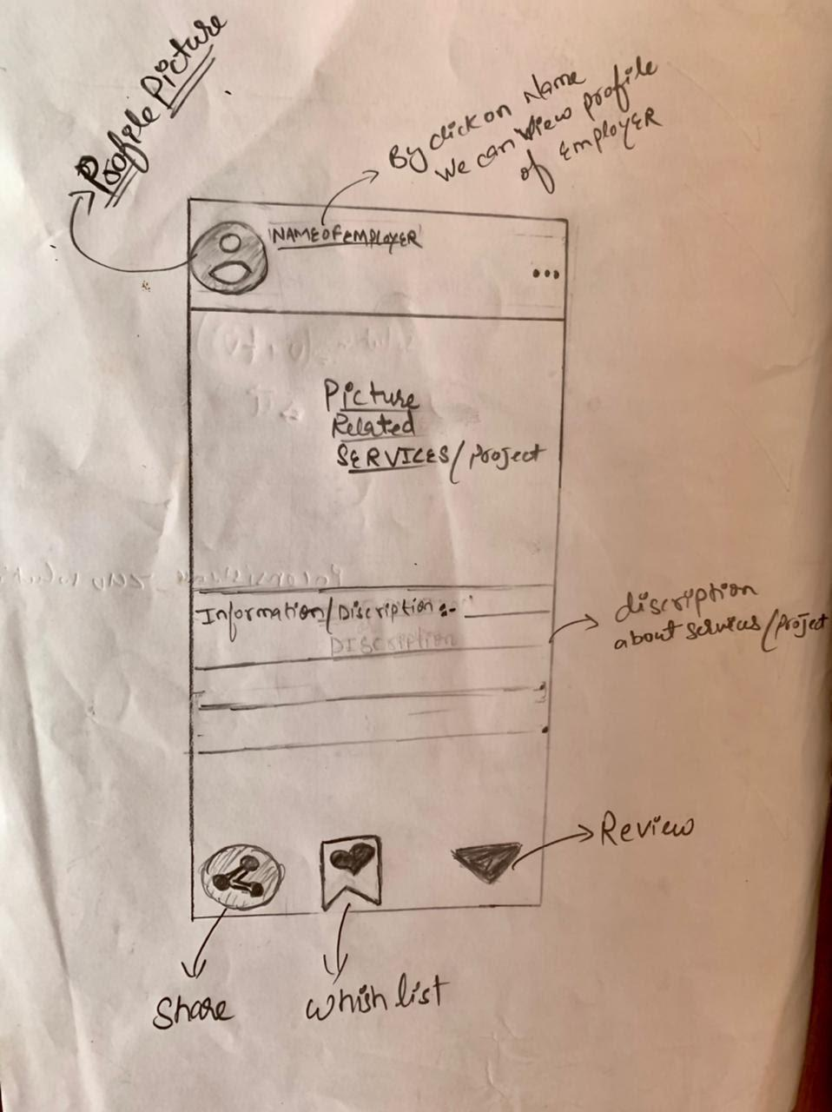

The last part which we decided upon in our app was regarding the setting page which will help users to set theme ,mode ,modify his profile ,ask for help ,contact the teams .etc we tried to include maximum things which setting page should have .We finally decided on the following low-fi prototype :-

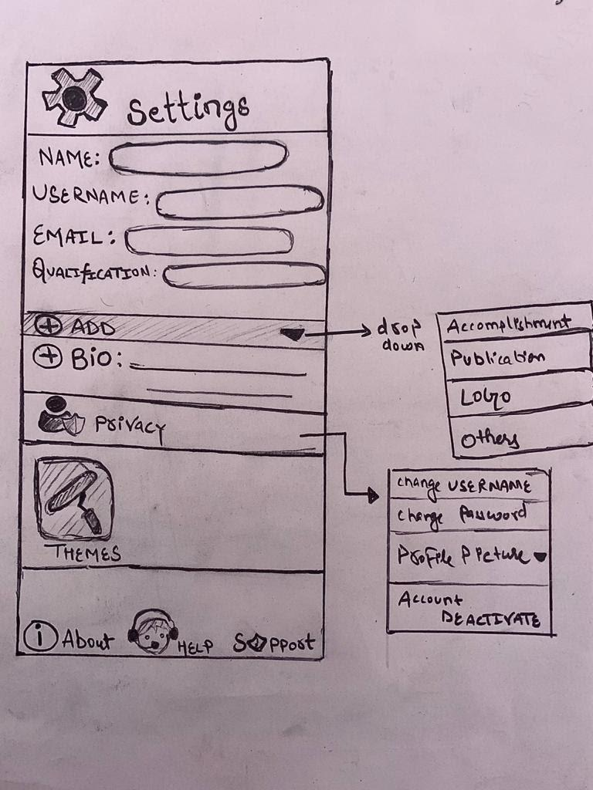

This was our part from the ideation and low-fidelity prototype and in this part we worked pretty as well as team and all the members contributed equally for the sketches and ideas of all the possible pages of our app.

**High fidelity prototyping:**After deciding the basic idea for interface and various pages, we developed our high fidelity prototype using the figma software. As we mentioned we decided to go with the green color scheme. We designed a very chic sign up page with options of logging in via email and also with other accounts like Facebook and LinkedIn.  After that the application will take the user to popular services page where they can see the trending and relevant posts. The user can choose to be either a student looking for work or be an employer/professor finding students to do the work. After selecting this option, the application will show us relevant posts and profiles.  We have added the option to filter out posts to make it easier to find the desired results. The user can filter out the results on the basis of pay,popularity,ratings and number of opportunities. We have also divided the posts into various categories like design,  development,  research to make it more organized. We have also provided a search bar to search for the desired results .After choosing a post the user can simply click it to get more details about that position/person. The post will show all the relevant information required to make the decision like the number of working hours, pay and criteria for shortlisting.  The user can contact the employer via their email which would be mentioned on the post or by leaving a comment under it.

A user will have a profile where their information like their credentials,  achievements,  past work experience and cgpa would be mentioned allowing employer to easily look at it. The user can put up their own posts which would be visible on the main feed and their dashboard. Any comments and likes on the users posts will be informed to them through notifications tab.We also have a settings page where the user can change their name, username, add or delete qualifications, et cetera

**Evaluation -** Once the prototype was complete, we selected a bunch of people to whom we sent an evaluation form to get an overview of the general response of the public towards our prototype. We decided the criteria for evaluation would be how well the user was satisfied by the implementation of usability goals . We had quite varied opinions on multiple subjects, and a lot of small things needed to be improved upon as per the feedback.

E.g. **–**

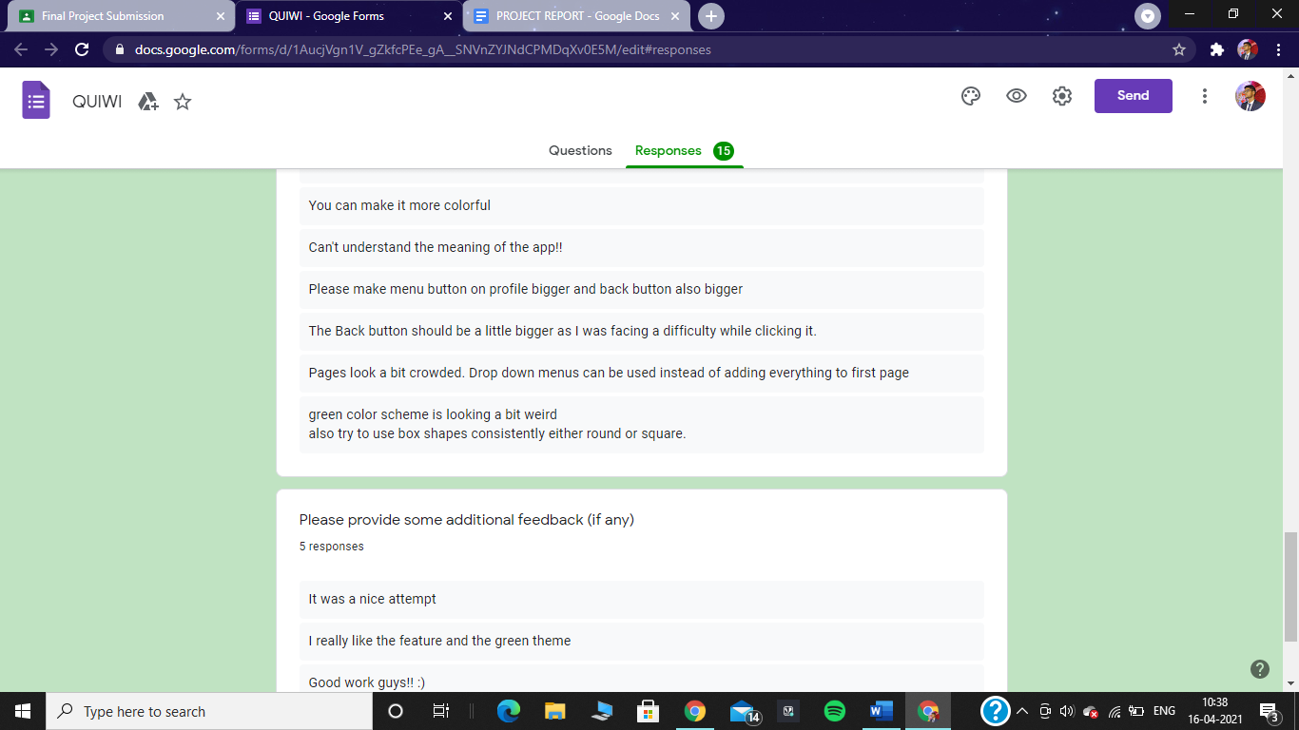

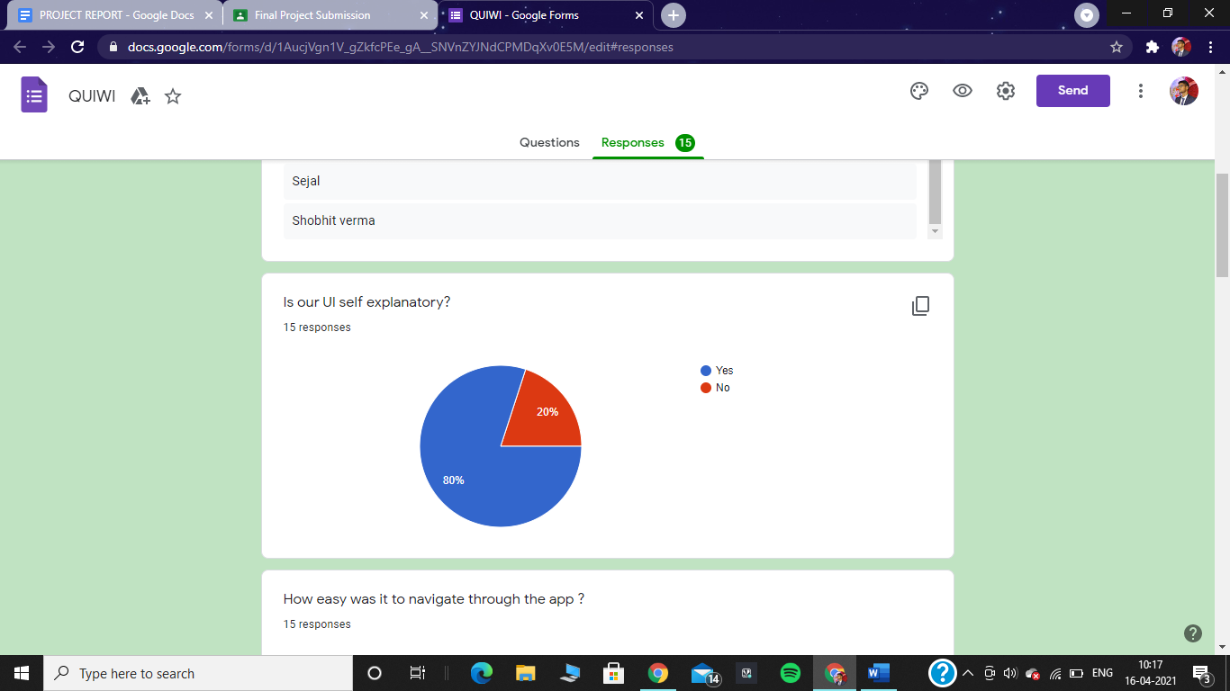

However, we were of the general opinion that the UI is quite nice and decided not to change anything about it. Next was navigation -

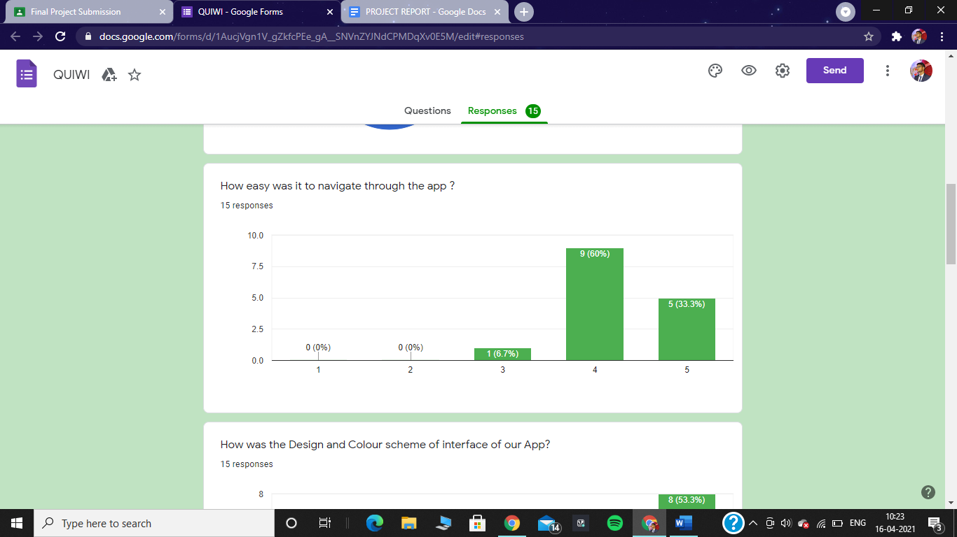

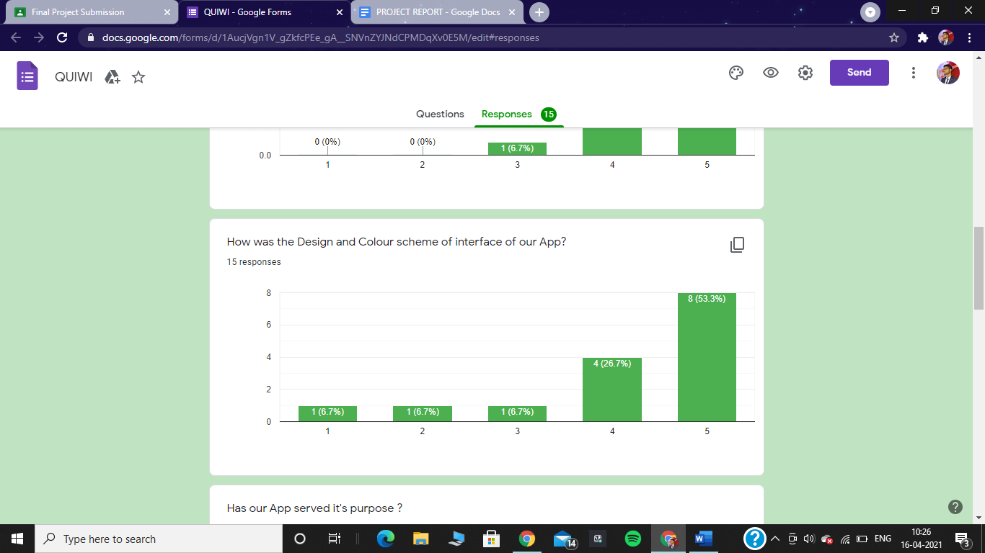

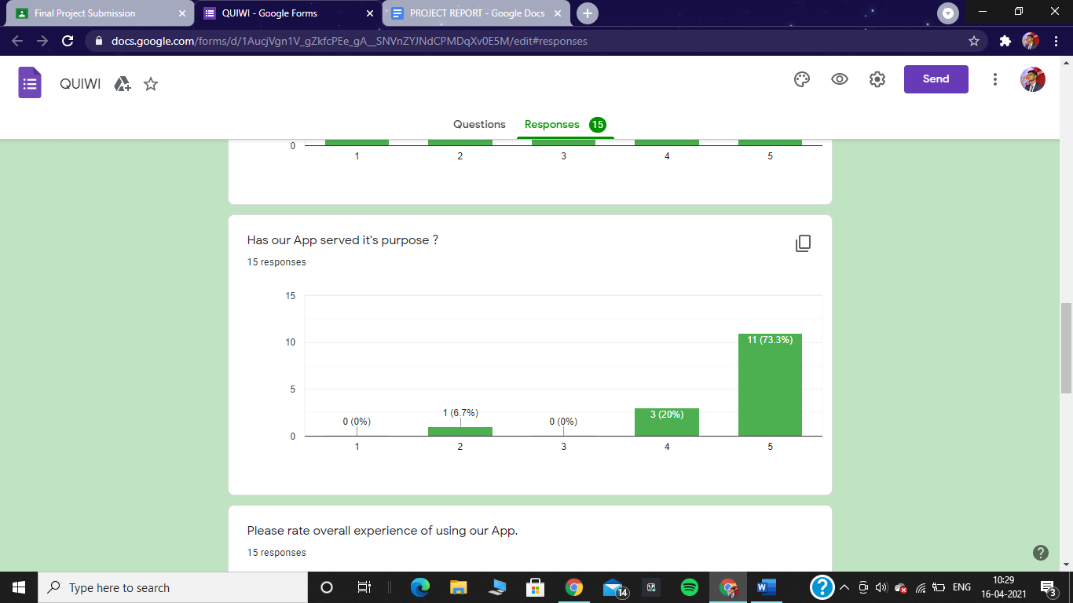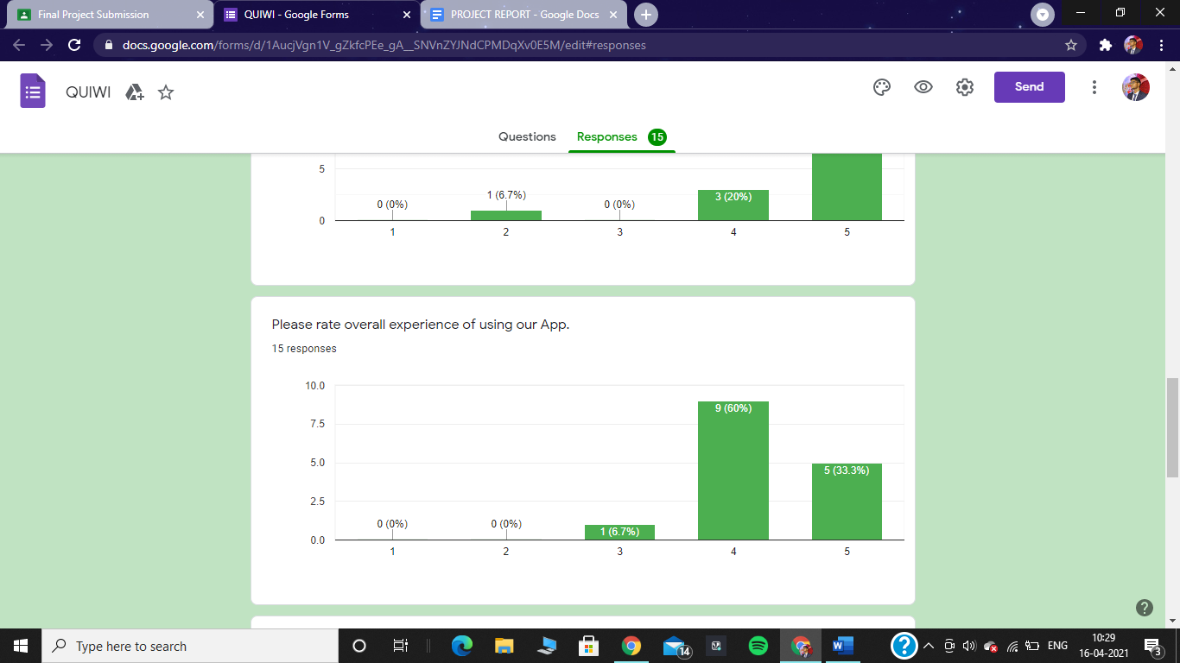

Looking at the results, we were quite happy since we were successful in implementing all the usability goals and keeping the users happy. Well, mostly happy. We did receive few comments about the lacking aspects of our design and decided to make the necessary changes. After the changes we reached out to our interview group for a follow up and they were happy with the changes.

Here are the feedbacks and suggestions received –

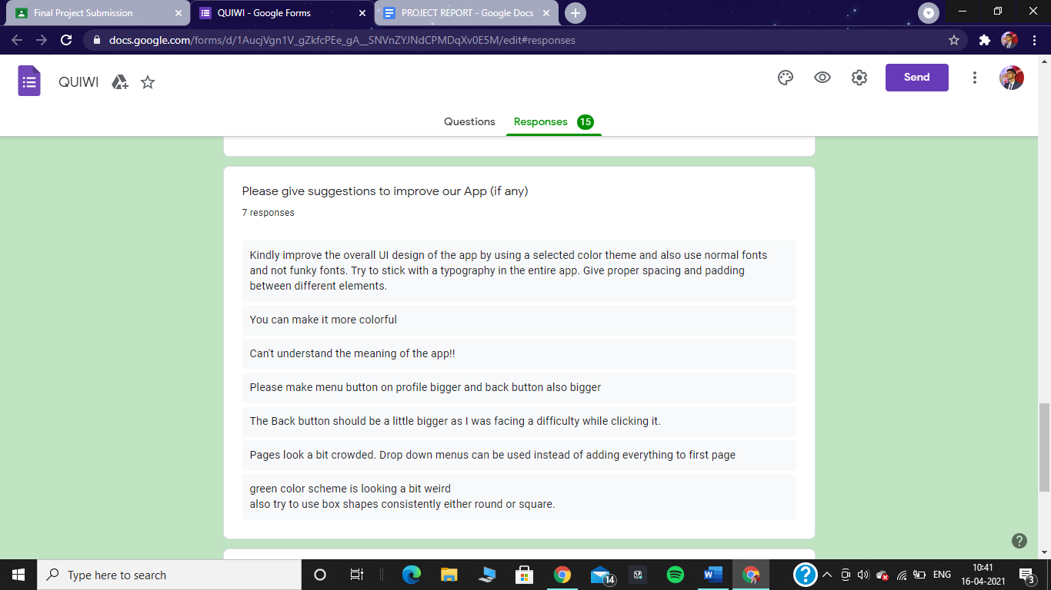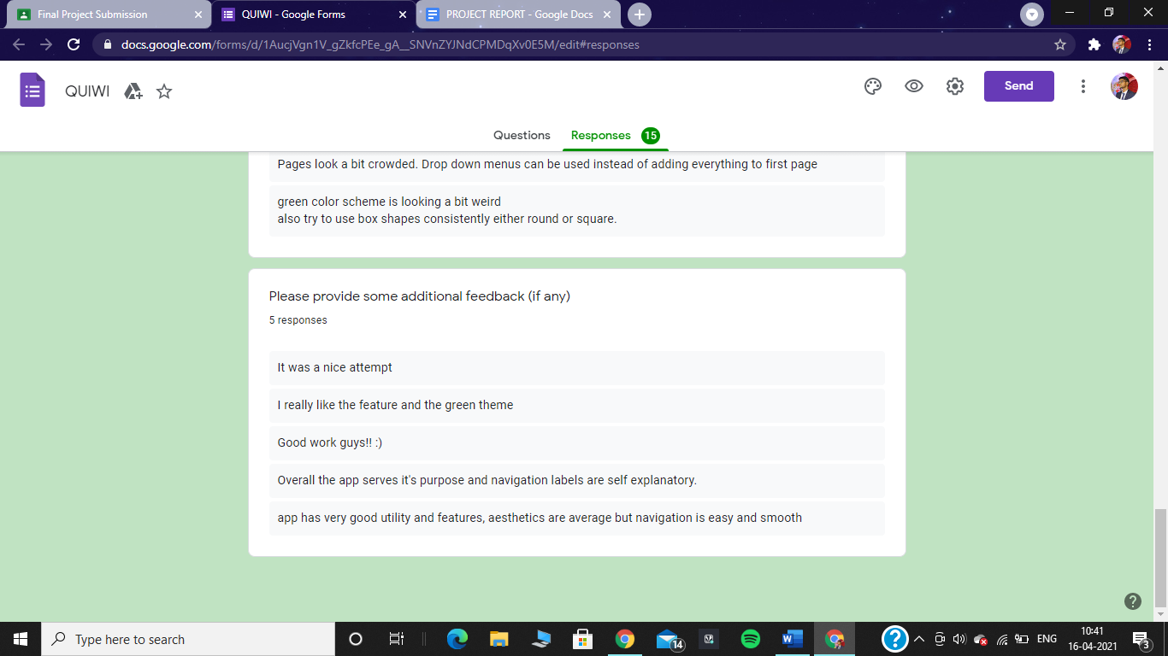

**Contribution of different members:-**

In short we can see every member had an equal contribution of 25% out of total of 100% .So four of us created this product equally .

**Details of Contribution:-**

In our team all of the members contributed equally towards the project and we distributed our work in the each phase and design and idea was finalized only after due discussion with our teammates in every step .First we organized regular google meets to come up with details of the idea and problem statement and everyone had contributed it in it .Then our group member Mohd Faizan created the google form and took the responsibility to send it among our groups and other members also gave their best to get more and more responses .He collected the data and analyzed it along with other members .In the next phase of low-fi prototyping we again contributed our part in the discussion equally and everyone made few of the prototypes and we fine picked among them or took the best out of each and came up with final one .Everyone had contributed almost equal lo-fi prototype as you can see from the different papers and handwritings .Our member Ishita had done quite good efforts in improving some of the prototypes.

After the low-fi prototype we decided that all the users will make the hi-fi prototype of the same part which they had made the low-fi prototype which has chosen according to the interest of each member .In Figma project all of our members contributed equally as well and we worked on a common colour scheme and theme in a single figma work space .After creating all the pages we had common opinion about the navigation,animations .etc and after discussion everyone interconnected our pages for smooth navigation .A major part in the interconnection and animations was done by Mudit and Pritish as they had good skills in this part while for the designing of hi-fi prototype everyone contributed equally .Next for the evaluation part again our team member faizan created a survey and form for evaluation and sent it to everyone to collect their feedback and analyzed their responses to get to final suggestions and improvements which we all did together as a team.In the project report we divided our work equally as well as with Ishita doing the Introduction part ,Mudit and Pritish doing the methodology part in the equal ratio and Faizan doing the conclusion and analysis part .It was not difficult to sum up our work in report as we have worked together for the project as a complete team .

**Analysis and future work:-**The term “freelance” dates back to the 1800s when a “freelance” referred to a medieval mercenary who would fight for whichever nation or person paid them the most. The term “lance” referred to the long weapon that knights on horseback used to knock opponents off of their horses.Over time, the term continued to mean “independent” so  freelancing means to work as an independent contractor than be independent contractor rather than be  employed by someone else.And with the rise of gig-economy people are talking about freelancing more than ever before . Union shows that 57 million american freelanced in 2019.And according to the same study, 53% of workers aged 18-22 are freelancing.And in our surveys 46% are going with the option yes there is necessary need for such type of platform and 38 percent of them are goes with it is good to have platform like this. Most of us want to earn what we learn and this is our app giving them the opportunity of earning with learning. And 50% of people want to showcase their talent and 46 percent may showcase their talent according to our survey report .

And from our survey 50 % of people want to work with people of the same interest.After getting that much positive response from our surveys so my team finally decided to make this app.

In our prototype we firstly provided a login and signup option so everyone can make their specific id .A person who sign in our app as a contractor they make their profile in which they add their qualification and  achievements. And they can make a post in which they give the description of work that they can freelance or they want to find a partner for any project or research . Companies and associations can also make posts related to any specific work which they want to freelance with proper cost and deadline details  and we provided categories option to make it simple to find a person from any specific category and we also recommend the most rated contractor and company . We gave the filter option also so the people get what they really want and anyone can comment on the posts so they can contact the post maker. The limitation of our proposed prototype is  that we didn't provide a way that only genuine people can make id in our freelancer app to avoid frauds and false claims . In  future we will definitely make our app more secure by making a verification page before their claims in  profile in which we take peoples documents of degree , achievements and authorised certificate of company and students id cards .And we will go to do work on increasing our target base user by adding schooling students also . and by adding more  categories like fashion which includes (fashion designer, makeup artist, hairstyler  etc), construction which includes (highway contractor ,builders , architecture, plumber blacksmith etc), travel(guide , driver, etc) these types of categories are really gonna help to increase our user in future.

**Conclusion:-** Firstly the future of freelancing in India is vibrant.because many individuals like to choose the  work according to their preference where they want, when they want and the work of their choice. Nowadays people are not wants to work under any boss because they are the boss of themself and the our app not only give them the opportunity of freelancing but with our app they  also find a partners for their project ,research,and for group study even though they can find  professors  who would like to help them in their research.And in our survey report we find that many of people wants that type of platform to showcase their talent  and explore themself beyond the limits  so that's why we came up  with idea of our app **QUIWI** in which individuals are not limited to only posting the work they want to do but they can find the opportunity offered by different  client and companies. We  know there are limitations in our app but this is only an app which  provides that kind of facility so in last i going to end this conclusion with our app slogan . **QUIWI**  YOUR FREELANCING APP.

**Links –**

Here are the links to the forms and prototypes –

1. Requirement Gathering Form – https://docs.google.com/forms/d/e/1FAIpQLScmRDsw8ttKTiK_ezHsBy3TM0JZaD-zdjVJKNRwjzUv1JbX8Q/viewform?usp=sf_link
2. Evaluation Form –https://docs.google.com/forms/d/e/1FAIpQLSc0irbPpt-Fws1Bco0nFbg-hsQTWBnJXL0VLZqf5yScguWkVg/viewform?usp=sf_link
3. Quiwi Prototype-https://www.figma.com/proto/quU9j3BNGfuyVYODHNj9DS/QUIWI?node-id=112%3A16&scaling=scale-down&page-id=0%3A1
4. Our Project Video - https://youtu.be/B0YDjcm0O5M

**References -**

<https://www.freelancer.in/>

For icons of basic things like Home,Back,Notifications we used extensions in figma font awesome icons,material icons

For images we used images of mostly our members and for companies we tried to keep maximum images from clubs and things related to IIIT Delhi and most of these images were picked from the IIITD website and we give them due credit for these images .

The design was totally our own and original.