APPLICATION OVERVIEW

Webinar Engagement and AI Analytics Platform
Application architecture, user experience, AI services, and analytics
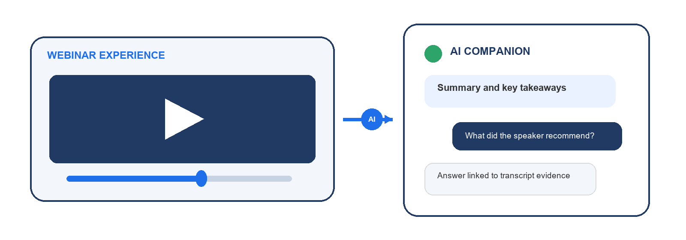
This application connects the complete webinar journey in one system: campaign discovery, lead registration, protected viewing, automatic transcription, AI assistance, and administrator reporting.
Visitors can find a session, register, watch securely, search the transcript, ask questions, and return to saved conversations. Administrators can see the same journey through registrations, consent, watch behavior, questions, transcript status, and filtered exports.
CAPTURE qualified registrations • ENGAGE video and AI • MEASURE behavior and questions
Prepared for Arkentech Publishing | October 2026

PRODUCT EXPERIENCE

From campaign card to business insight
Campaign context stays attached throughout the experience, so every registration, playback event, transcript passage, conversation, and report remains connected to the correct webinar.
01 Discover
Visitors explore campaign cards loaded from MySQL, search and filter the library, open a dynamic webinar landing page, and continue to related sessions in the same category.
02 Register
The form captures first name, last name, email, phone, company, job title, and country. Privacy acceptance is required; marketing and activity consent are separate optional choices.
03 Unlock
A successful registration grants access only to the selected webinar. PHP streams the private video with browser-friendly byte-range playback while the source file stays outside public access.
04 Engage
With activity consent enabled, the player records real playback behavior: starts, pauses, resumes, seeks, progress, completion, last position, and observed watch time.
05 Understand
Faster-Whisper turns the recording into timestamped text. The AI companion adds transcript search, downloads, section-based summaries, source links, and saved questions and answers.
06 Analyze
Administrators review leads, consent, watch behavior, transcript coverage, and chatbot activity, then apply filters and export the same result set as CSV.

SYSTEM ARCHITECTURE

A web application with dedicated AI services
The browser communicates with the PHP application. PHP controls database access, protected media, transcription jobs, model calls, and reporting, so infrastructure credentials never need to enter frontend code.
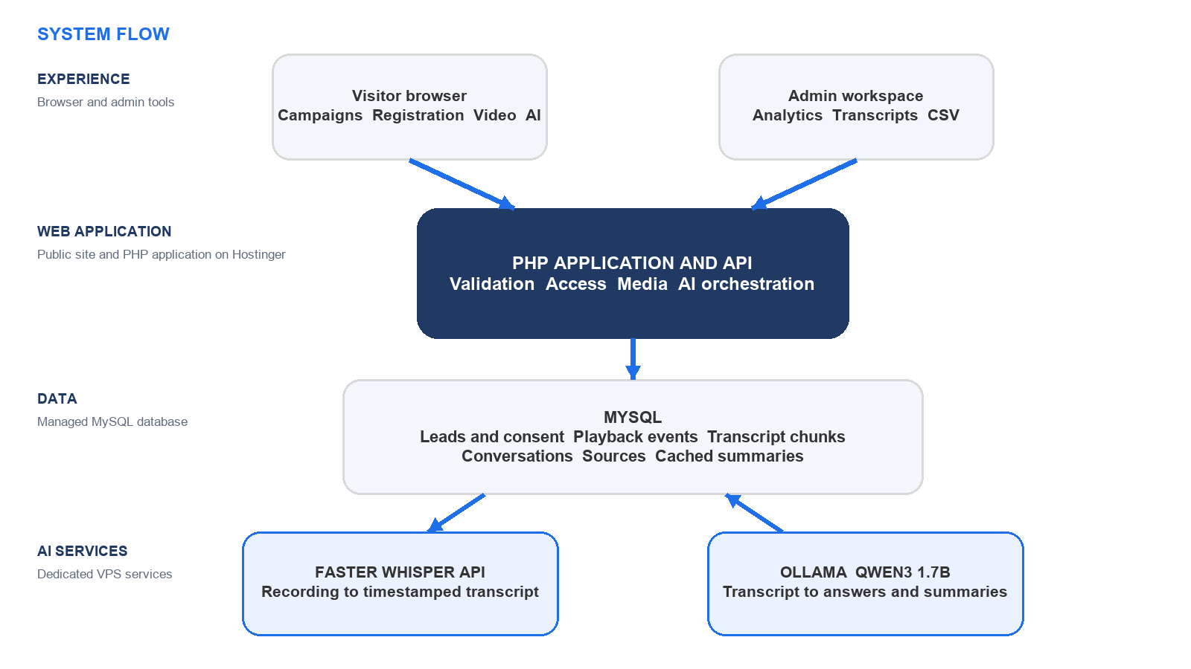
The website host coordinates user access, application data, speech processing, and language generation.
Current service placement
- Web application: Hostinger web hosting at arkentechpublishing.com/2026/october/Task/.
- Data: managed MySQL on the hosting platform.
- Speech processing: Faster-Whisper through the HTTPS API at transcribe.arkentechsolutions.com.
- Language generation: Ollama on a VPS serving qwen3:1.7b through server-to-server calls.

TECHNOLOGY STACK

A focused stack built for direct deployment
The production application needs no frontend framework or Node.js runtime. Standard browser technology, PHP, and MySQL handle the product experience, while speech and language models run as separate services.
Layer | Technology | Role in the platform
Viewer interface | HTML5, CSS3, vanilla JavaScript | Campaign library, registration, responsive landing pages, video controls, AI drawer, and admin interaction.
Application server | PHP API | Validation, registration, sessions, consent, protected streaming, transcript jobs, AI orchestration, analytics, and exports.
Data platform | MySQL or MariaDB | Twenty-one normalized tables for leads, registrations, consent, events, transcripts, conversations, summaries, and administration.
Media delivery | HTML5 video plus PHP streaming | Registration-scoped playback with seeking and HTTP byte-range support.
Speech intelligence | Faster-Whisper HTTPS API | Automatic language detection and timestamped speech-to-text processing.
Language intelligence | Ollama with qwen3:1.7b | Transcript-grounded answers, summaries, topics, takeaways, and explicitly stated actions.
Local development | XAMPP | Apache, PHP, and MySQL or MariaDB for the complete application workflow on Windows.
Production hosting | Hostinger web and database hosting plus VPS services | Public application hosting with separate model and transcription infrastructure.

Why this approach works
- Simple deployment: the web tier runs on standard PHP hosting and can be uploaded without a build pipeline.
- Clear ownership: application data stays in MySQL, while AI services can be upgraded independently.
- Graceful operation: transcript reading and saved history remain useful even when the language model is temporarily unavailable.

AI INTELLIGENCE LAYER

Two AI systems with separate responsibilities
Faster-Whisper listens to the recording and creates the transcript. Qwen reads selected transcript passages and turns them into answers and summaries. PHP sits between them, controls the workflow, and validates every saved result.
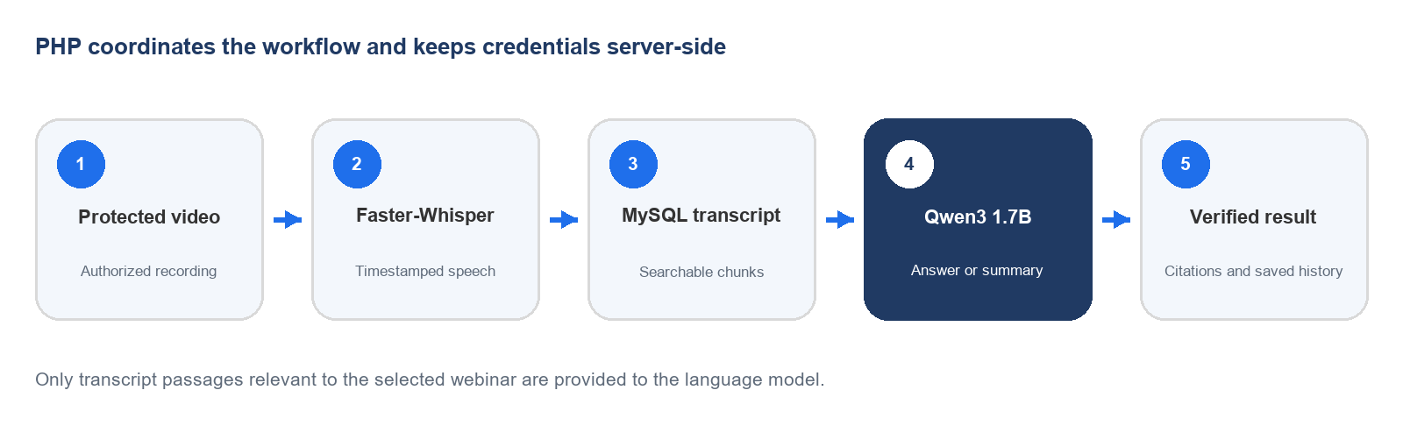
Component | Current runtime | Responsibility
Speech recognition | Remote Faster-Whisper API | Creates timestamped transcript segments from the authorized recording.
Retrieval | PHP lexical passage ranking | Selects relevant chunks from the chosen webinar; the application does not currently use a vector database.
Language model | Ollama with qwen3:1.7b | Returns structured answers and section-based summaries from supplied transcript evidence.
Evidence validation | PHP schema and quote checks | Rejects unsupported citations before an answer, source quote, or summary item is saved.

How grounded answers are produced
- The question is matched against transcript chunks from one webinar only.
- Relevant passages and bounded recent chat context are sent to Qwen; registration contact fields are excluded.
- The model returns structured JSON with an answer and exact source quotations.
- The server checks every chunk ID and quote. Invalid evidence is rejected and the response is not saved.
Hosted model profile: qwen3:1.7b, 8,192-token context, up to 1,200 output tokens, and deterministic temperature 0. The hosted Faster-Whisper model variant is managed by the transcription service and is not declared in this application. The local fallback uses Faster-Whisper 1.2.1 with the multilingual base model on CPU/INT8.

ADMINISTRATION AND ANALYTICS

See acquisition, attention, and content interest together
The private dashboard connects each registered viewer to observed playback and saved transcript conversations, giving teams a single place to understand reach, engagement, and audience questions.
Dashboard view | What it shows | Useful questions
Registrations | Contact details, webinar, registration date, consent choices, viewing-session count, and conversation count. | Who registered, for which session, and what permissions did they grant?
Video activity | Observed watch time, last position, furthest progress, status, and a chronological event timeline. | How long did people watch, where did they stop, and did they reach the end?
Chatbot activity | Conversation owner, webinar, questions, answers, model details, timestamps, and quoted transcript sources. | What did viewers want to understand, and which content supported each answer?

Dashboard capabilities
- Search by name, email, or company and filter by webinar or India Standard Time date range.
- Filter viewing sessions by status and open complete playback or conversation timelines.
- Refresh on demand or every 30 seconds while the dashboard remains open.
- Export the active filters to CSV, with server-side pagination and a 50,000-record safety limit.
- Manage transcripts through generation, status tracking, review, correction, replacement, download, and cancellation.

Core metrics
Registered users, registrations, consented registrations, viewing sessions, observed watch time, average progress, reached-end events, chatbot conversations, and saved questions are calculated directly from MySQL. Watch time counts sampled playing intervals and excludes pauses, buffering, and seek jumps.

TRUST AND OPERATIONS

Controlled access and explicit consent
The application treats registration data, media, transcripts, and AI conversations as connected but separately controlled records. Access checks and consent determine what each visitor can view and what activity the system may store.
Control | How it protects the application
Scoped registration | Video and transcript access are granted for the selected webinar, rather than across the entire library.
Separate consent | Privacy acceptance, marketing permission, and activity tracking are stored independently and can be updated.
Protected sessions | HttpOnly cookies, hashed tokens, CSRF checks, same-origin checks, and rate limits protect visitor and administrator actions.
Private assets | Video paths, SQL files, configuration, and server source stay outside direct public access; PHP performs authorized streaming.
Minimal AI context | Ollama receives the question, bounded chat context, and relevant transcript passages. Lead contact fields are not included.
Server-side credentials | Database and transcription credentials stay in protected PHP configuration and are never placed in HTML or JavaScript.
Data lifecycle | The default retention cleanup is 90 days, with associated activity removed through database relationships when registration data is deleted.

Deployment profile
The public application and MySQL database run on the website hosting platform. Faster-Whisper runs behind a separate HTTPS transcription API, while Ollama serves qwen3:1.7b from a VPS. Local development uses the same PHP and database workflow through XAMPP.
Production configuration keeps the transcription API key server-side and restricts the model endpoint to trusted traffic. When a transcript becomes ready, the application automatically unlocks transcript search, download, summaries, and chat for registered viewers.

Application outcome
The platform turns a webinar from a single viewing event into a measurable content asset. It captures qualified leads, protects recordings, makes spoken content searchable, answers questions with checked transcript evidence, and gives administrators a clear view from registration through conversation.

