**Housing price prediction without regularization.**

**Dataset Description:**

In this assignment, we had to predict housing price given on the dataset. Dataset contains 546 rows and 12 columns. Out of which 5 columns are categorical features

Categorical features have not been considered for predicting the housing price.

**Data Pre Processing:**

After removing categorical features our data will look like.

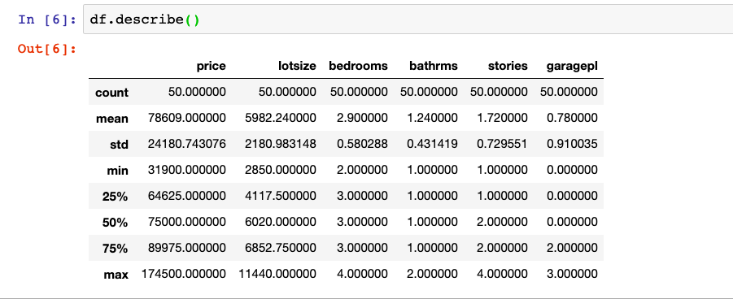

The normalization technique, I have used is mean shifting and variance scaling. In which we shift the mean and scale it by variance.

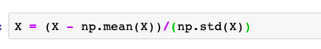

After normalization, I have added a bias term for the further calculation. Solution from normal equation gives us values of theta row vector.

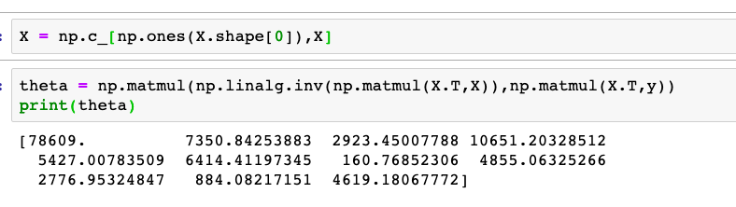

**Solution using gradient descent:**

It’s an iterative approach to minimize the cost function. In this algorithm we initialize the weights by random values and try to find the minima of the function by moving in a direction opposite to the gradient of the function. Below implementation of this algorithm has bene done by me.

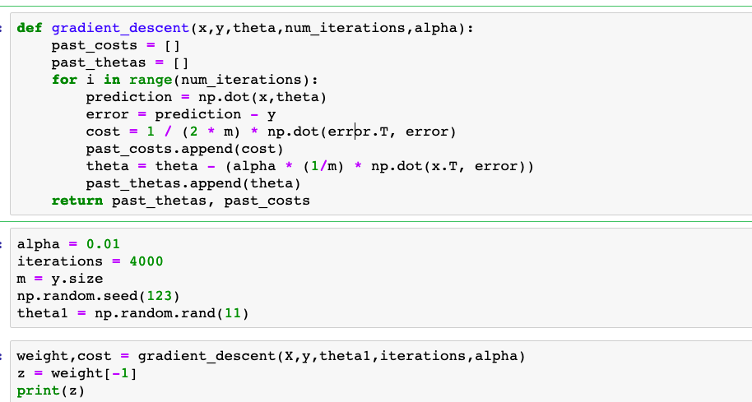

As we increase the number of iterations cost function decreases first and after some times, it becomes constant.

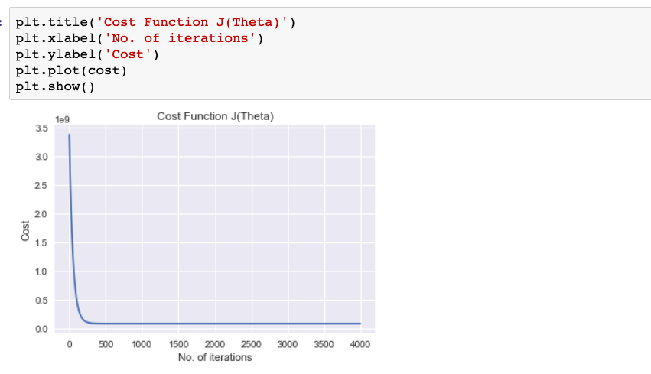

After this, we can take the dot product of theta with the feature vector and calculate the housing price.

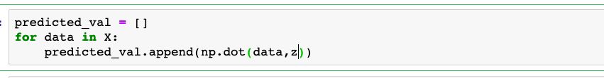

After calculating the predicted value, we can compare it with the actual value and calculate the mean squared error.

