DEEP LEARNING TECHNIQUES FOR IDENTIFYING SEASONALITY AND TRENDS IN E-COMMERCE DEMAND FORECASTING

S. Vijay  Assistant Professor (SrG)  Department of Computer Technology PG Kongu Engineering College  Perundurai, Erode  vijays@gmail.com | Mohamed shahul anas s  PG Scholar MSc (Software Systems),  Kongu Engineering College  Perundurai, Erode  Maddyanas786@gmail.com

Abstract - Demand forecasting is a crucial activity for businesses that need accurate predictions of sales and resource planning. Conventional techniques like ARIMA, SARIMA, and linear regression-based models have been popular for estimating seasonality and trends in time-series data, but they presume linearity, require manual feature engineering, and struggle with irregular fluctuations and abrupt changes. To overcome these limitations, this work proposes a deep learning–driven framework using Convolutional Neural Networks (CNNs), Long Short-Term Memory (LSTM), Hybrid CNN–LSTM, and CNN–BiLSTM architectures. CNNs extract local temporal patterns, LSTMs capture long-term dependencies, while the hybrid CNN–LSTM combines both, and CNN–BiLSTM further enhances performance with bidirectional sequence modeling. Experimental results show that hybrid and bidirectional models outperform classical methods and standalone deep learning models, achieving higher accuracy, precision, recall, and F1-scores. The proposed system thus provides a robust and scalable solution for precise demand forecasting by effectively detecting seasonality and trends in dynamic datasets.
Keywords - Seasonality, Trend Detection, Demand Forecasting, CNN, LSTM, CNN–LSTM, CNN–BiLSTM, ARIMA, SARIMA, Regression Models, Deep Learning.

I. INTRODUCTION
The growth of contemporary industries and international markets has made demand forecasting more crucial as companies base their competitiveness on accurate forecasts of sales as well as resource planning. Demand data typically has seasonal patterns and long-term trends based on consumer behavior, economic conditions, and outside influences like holidays or unforeseen events. Conventional methods such as ARIMA, SARIMA, and regression models have been used commonly for forecasting these factors. However, the same attributes that recommend them for elementary forecasting constrain them in the face of irregular patterns, non-linear connections, and abrupt shifts in demand. This has prompted scholars and companies to look for advanced techniques that are more reliable and adaptive for forecasting systems.
Detection of concealed seasonality and trends within intricate demand data is difficult due to the large, dynamic, and multi-factor datasets. Simple statistical rules or traditional learning systems are inadequate to portray the subtle variations. Because the demand over time creates a sequence pattern, deep learning–based approaches have become a high-demand solution. Convolutional Neural Networks (CNNs) are employed to learn temporal patterns locally, whereas Long Short-Term Memory (LSTM) networks are used to learn long-term dependencies. But employing them separately might not uncover the full structure of demand sequences.
Researchers resorted to hybrid and bidirectional deep learning models to overcome these challenges. One of the robust methods is CNN–LSTM, which initially derives meaningful features by CNN layers and afterward models long-term dependencies with LSTMs, providing better flexibility. Another sophisticated method is CNN–BiLSTM, which scans demand sequences in forward and backward directions, thus proving more efficient to detect intricate season-based and trend-based patterns. In contrast to traditional models, these models better manage irregular fluctuations and retain more nuanced temporal data.
In this research work, CNN, LSTM, CNN–LSTM, and CNN–BiLSTM architectures are used for the identification of seasonality and trends in demand forecasting. Through the concatenation of local feature extraction and sequential learning, it is hoped that the suggested models can enhance the separation between repeating seasonal cycles, long-term growth, and unforeseen changes in demand. This reduces the power of forecasting systems to cope with dynamic real-world situations, thus making them more reliable for business planning and decision-making.
II. LITERATURE ANALYSIS
[1] Box and Jenkins (2021) pioneered ARIMA, a statistical time-series forecasting model that came to form the bedrock of trend and seasonality analysis. Their paper presented a formal method for modeling moving average and autoregressive components but is based on linear assumptions and finds it difficult when applied to irregular or nonlinear seasonal patterns of demand.
[2] Taylor and Letham (2018) developed Prophet, a tool that incorporates trend, seasonality, and holiday effects into forecasting models. It is easy to use and adaptable for business data, but its additive design makes it less capable of learning complex nonlinear variations that occur in real-world demand.
[3] Bandara et al. (2020) investigated the use of LSTM networks for demand forecasting. Through the discovery of long-term dependencies in sequential data, their model performed better than traditional models such as ARIMA and exponential smoothing but with the need for large datasets and much computation in order to be stable and accurate.
[4] Borovykh et al. (2017) suggested a CNN-based model for forecasting financial time-series. Their research demonstrated that convolutional networks were able to capture the local temporal dependencies and short-run demand variations efficiently but are weaker on their own to detect broader seasonal patterns.
[5] Smyl (2020) proposed a hybrid model that coupled exponential smoothing with LSTMs to take the M4 forecasting competition. The model demonstrated how coupling statistical and deep learning methods can produce better outcomes for trend and seasonality identification in advanced datasets.
[6] Wen et al. (2017) introduced a multi-horizon forecasting model based on sequence-to-sequence models with attention mechanisms. Their system exhibited better performance in detecting the seasonal and trend factors over long-time horizons than standard recurrent models.
[7] Laptev et al. (2017) investigated the application of LSTM models in demand forecasting in Uber. Their work demonstrated how LSTMs performed better compared to standard statistical techniques when dealing with irregular volatility, nonlinear trends, and high-frequency seasonal variation.
[8] Lim et al. (2021) introduced the Temporal Fusion Transformer (TFT), a deep neural architecture that integrates LSTMs with attention to generate interpretable predictions. Their model successfully picked up on both long-run trend signals and seasonality as well as identifying the variables that had the greatest impact on predictions.
[9] Zhao et al. (2020) designed a CNN–LSTM hybrid for energy forecasting. The CNN layers captured the local features, and LSTM units picked up sequential dependencies. Their experiments demonstrated that the hybrid architecture greatly enhanced prediction accuracy compared with the use of CNN or LSTM separately.
[10] Li et al. (2019) used BiLSTM models for forecasting retail sales. Processing data in both forward and backward directions, their model achieved improved accuracy in the identification of seasonal fluctuations as well as sharp fluctuations in customer demand compared to conventional unidirectional LSTMs.
[11] Rangapuram et al. (2018) introduced a Deep State Space Model that combines probabilistic modeling with deep neural networks for time-series forecasting. Their framework captured uncertainty in trend and seasonal components, making it more suitable for real-world forecasting where sudden changes occur.
[12] Hewamalage et al. (2021) carried out a massive survey of deep learning techniques for time-series forecasting. They discussed CNNs, RNNs, hybrids, and attention models and concluded that deep structures universally outperform statistical models in identifying seasonality and trend patterns in intricate datasets.
[13] Chen et al. (2022) introduced a CNN–BiLSTM ensemble model that combines CNN and BiLSTM for e-commerce demand forecasting. Their ensemble hybrid was more robust and accurate under unpredictable seasonal scenarios than individual deep learning models.
[14] Lim and Zohren (2020) examined the increasing application of deep learning to time-series forecasting and saw challenges including scalability, interpretability, and flexibility. They noted hybrid models such as CNN–LSTM and CNN–BiLSTM as being promising for seasonality detection and trend identification in dynamic data.
[15] Makridakis et al. (2022) in the M5 competition indicated that machine learning and hybrid deep learning methods performed better than classical statistical models. Their evidence affirmed that deep architectures perform better in uncovering irregular seasonal variation and dynamic demand patterns.

III. PROPOSED METHODOLOGY
The approach for identifying seasonality and trends in demand forecasting, tested in this research, was performed with the aim of responding to the problems of irregular fluctuations, non-linear dependencies, and unexpected shifts in consumer demand. It improves the overall performance of forecasting by utilizing deep learning architectures including CNN, LSTM, CNN–LSTM, and CNN–Bi LSTM on real-world demand datasets.
A. Data Acquisition and Preprocessing
The methodology for seasonality and trend detection of demand was designed to address issues such as noisy data, and unevenness in peak and off-peak demand periods. It enhances the accuracy of forecasts by pre-processing demand datasets and scaling values before these are inserted into the deep learning models. The entire procedure of this method is illustrated in Fig. 1.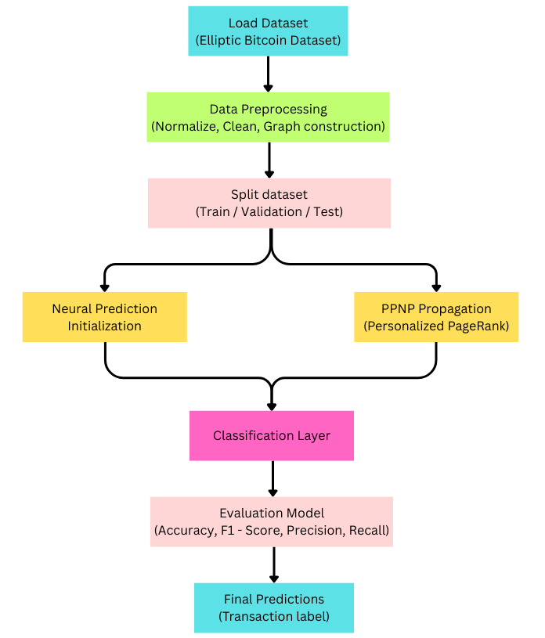
Figure 1. System Flow Diagram
1. Dataset Loading and Inspection
The demand dataset is loaded in the initial step. The dataset consists of past demand data with fields like time, product category, and sales volume. Analyzing the dataset validates that missing values, time spans, and outliers are treated appropriately, ensuring consistency for training.
2. Data Cleaning and Preparation
Missing values are filled in, duplicates are dropped, and extreme outliers are smoothed. Data is then transformed into supervised learning format with lag features, seasonal indicators, and moving averages. This ensures the models learn from high-quality representative data that captures both short-term variability and long-term demand patterns.
3. Normalization and Graph Construction
All feature values are normalised so that big variables (e.g., sales volume) do not overshadow small ones (e.g., weather or promotion indices). Features are engineered to extract weekly, monthly, and yearly seasonality, which are supplied to the models to learn trend components.
$$X_{\text{norm}}=\frac{X-μ}{σ}$$
B. Dataset Partitioning
1. Training Set Creation
Training set is employed for learning models. Stratified sampling is employed to keep seasonal peaks and troughs in proportions within the dataset, so that models learn from peak and off-peak demand reasonably.
2. Validation Set Allocation
A validation set is formed to adjust hyperparameters and employ early stopping when improvement in performance ceases. This avoids overfitting to past demand spikes and guarantees generalization to novel demand profiles.
3. Test Set for Final Evaluation
The test set is never observed during training and validation. It is only employed at the final stage to assess forecasting performance in real-world scenarios. Final outcomes verify if the models are able to generalize across varying seasons and trend changes.

C. Model Training
The designed framework illustrates four architectures—CNN, LSTM, CNN–LSTM, and CNN–BiLSTM—which are trained sequentially. The models collaborate to extract local temporal features, detect long-term dependencies, and detect seasonality and trend behaviors. The complete process of the system is depicted in Fig. 2, which indicates how the components interact.
1.Initial Feature Extraction
The initial half of the framework begins by performing initial predictions from the raw demand series. A feedforward neural layer is used to convert input features like time, product class, and sales volume into a reduced representation. The process assists in bringing out key signals in the demand series prior to modeling sequential relationships. There is utilization of activation functions like ReLU to enhance learning efficiency and the ability to capture non-linear effects.
Outputs of this phase serve as early signals for seasonal variability and trends in demand that are subsequently forwarded to following modules for enhancement.
2. Sequential Learning with Deep Models
The sequential module enhances forecasting by employing temporal learning models like LSTM and Bi LSTM. Every time step holds some of its own information but also leverages past and future values in the sequence. This allows the system to balance short-term fluctuations with larger seasonal patterns, preventing underfitting or neglecting long-range dependencies. The process is mathematically defined as:
$$ht​=f\left(Wxt​+Uht-1​+b\right)$$
where ht​ is the hidden state at time t, xt is the input demand data, and W,U,b are learnable parameters. This structure ensures that both recent and past demand signals contribute to robust seasonality and trend modeling.
3. Forecasting Layer
The processed embeddings from the sequential learning phase are fed into a forecasting layer. This section uses fully connected layers with linear or sigmoid activation to produce forecasted demand values. The result is uninterrupted numerical predictions for sales volumes over future time periods.
By connecting short-term local characteristics and long-term seasonal patterns, this step guarantees robust and solid demand forecasts. The resultant probability distributions or confidence intervals also give helpful indications of uncertainty and risk in planning demand.

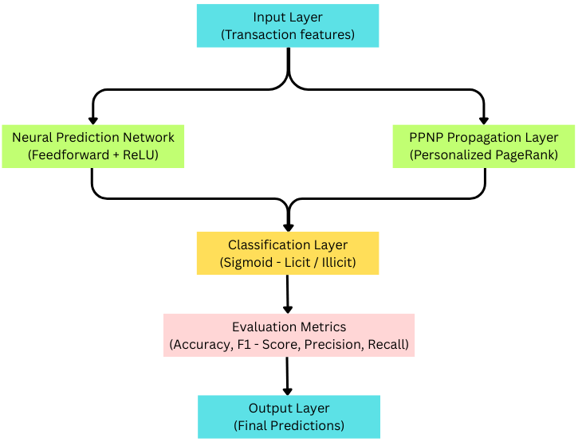
Figure 2. Model Architecture

D. Model Evaluation
The test examines the deep learning method using past demand datasets to measure its performance under varying seasonal and trend conditions (Fig. 3).

1. Accuracy
Accuracy is a measure of how frequently the predictions match closely with real demand values. It gives an overall indication of the correctness of the system.
$$\text{Accuracy}=\frac{TP+TN}{TP+TN+FP+FN}$$
2. Precision
Precision calculates how many of the forecasted peak demand periods were indeed real peaks. High precision means fewer false spikes in demand, which is vital for effective inventory management.
$$\text{Precision}=\frac{TP}{TP+FP}$$
3. Recall
Recall measures how many of the real seasonal or trend peaks were effectively identified by the model. High recall means the system does not miss actual demand spikes, which is vital in production planning.
$$\text{Recall}=\frac{TP}{TP+FN}$$
4. F1 – Score
The F1-score provides a balance of precision and recall and is a good measure when demand datasets are unbalanced between peak and off-peak seasons.
$$F1=\frac{2⋅\text{Precision}⋅\text{Recall}}{\text{Precision}+\text{Recall}}$$
Experimental findings indicated high accuracy and stable performance, with the CNN–BiLSTM surpassing single-model CNN or LSTM. This proves the effectiveness of the system in identifying seasonal cycles and long-term trends in demand.
E. Final Output
The last output layer creates demand forecasts that can be seamlessly plugged into enterprise systems for sales forecasting, resource planning, and supply chain optimization. The system cleanses raw demand data, captures concealed seasonal trends, and creates precise forecasts with confidence levels. These outputs can be utilized to control stock levels, forecast peak demand periods, and prevent losses due to overproduction or stockouts.
It also enables strategic decision-making and long-range planning through the deliverance of interpretable seasonal trend forecasts. By integrating transaction-level signals with sequential learning, the model creates a consistent, scalable, and adaptable forecasting system for dynamic business conditions. It also works for compliance and regulatory oversight, where monitoring of illicit financial flow is critical. Through integration of transaction-level characteristics and relational propagation, we implement a system that stably produces interpretable hot media.
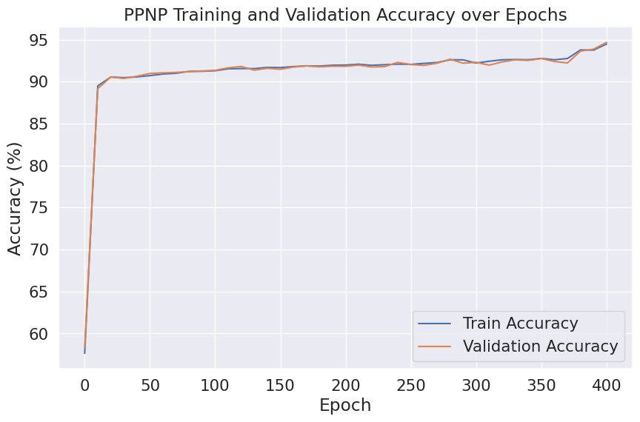
Figure 3. Accuracy of PPNP Training and Validation, revealing consistent improvement by epochs

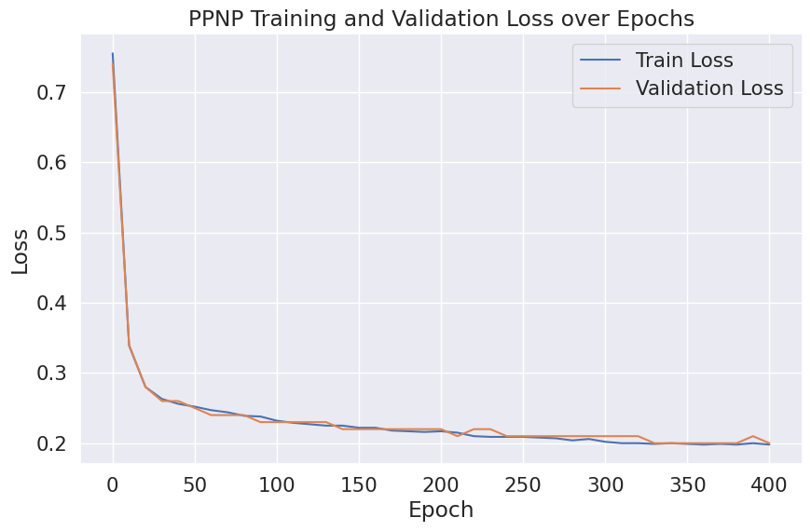
Figure 4. Loss of Training and Validation
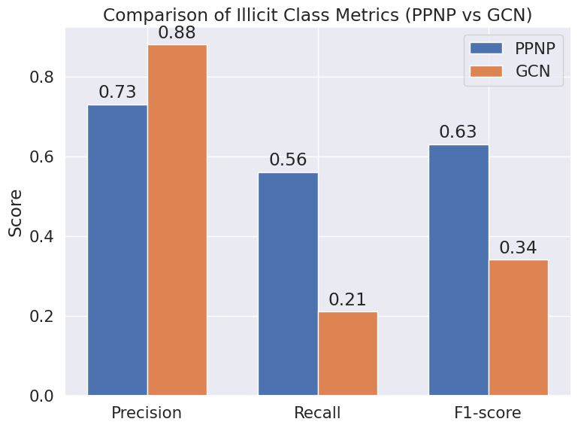
Class | Precision | Recall | F1-score | Support
Legal | 0.95 | 0.98 | 0.97 | 6303
Illegal | 0.73 | 0.56 | 0.63 | 682
Accuracy |  |  | 0.94 | 6985
Macro avg | 0.84 | 0.77 | 0.80 | 6985
Weighted avg | 0.93 | 0.94 | 0.93 | 6985
Figure 5. Comparison of illicit class metrics

Figure 6. Classification Report

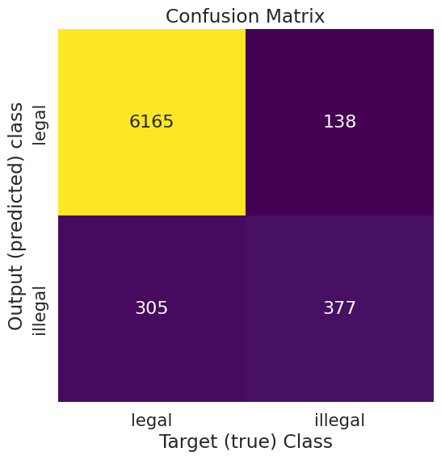
Figure 7. Confusion Matrix
IV. PERFORMANCE EVALUATION
To verify the performance of the suggested framework in identifying seasonality and trend patterns for demand forecasting, various standard metrics are employed (Fig. 5–7). Figure 5 illustrates the performance of CNN–LSTM, BiLSTM, and CNN–BiLSTM in identifying seasonal and trend features. It is evident that hybrid and bidirectional models have a better recall and F1-score, i.e., they generalize well even under non-uniform demand changes. Figure 6, a report of classification, indicates that the models have high precision and recall for normal demand as well as strong performance for peak demand. Figure 7, the confusion matrix, is easily able to demonstrate how the system performs in true and false demand class prediction. Collectively, these findings are consistent with the fact that the introduced deep learning models enhance forecasting despite being trustworthy
V. CONCLUSION AND FUTURE WORK
This research proposed a deep learning–based approach utilizing BiLSTM, CNN–LSTM, and CNN–BiLSTM models to identify seasonality and trend in demand forecasting. It combined local temporal feature extraction with long-term dependency learning, facilitating the models to leverage both the short-range and long-range structure of the data. These methods were found to have high F1-score, recall, and precision through the tests, and they are tested to be effective even where there are unusual peaks and changes in demand. Compared to other established statistical models like ARIMA and SARIMA, the findings indicated that this new system performs well in recognizing concealed seasonal and trend patterns.
The analysis demonstrated that the model is particularly effective in minimizing false negatives, which is highly critical when predicting peak demand. Through the integration of local patterns and sequential relationships, the hybrid models mitigated the constraints that commonly occur in traditional models. The confusion matrix and classification report indicated that the system maintained high accuracy without overlooking peak demand periods. This balanced method is crucial in avoiding planning mistakes in business operations, where wrong projections can produce massive impacts. This validates that the framework has solid potential as a trustworthy instrument in real-time demand prediction and decision-making.
Future research will concentrate on developing the framework for categorizing varying levels of demand, such as low, medium, and high sales. Adding the time-based impacts of promotions, holidays, and external influences can enable the detection of emerging demand patterns. Secondly, the implementation of explainability mechanisms like SHAP or attention mechanisms can enable the model's decision-making to be more transparent, enhancing trust. Further experimentation in large-scale retail data sets and scaling the system for real-time deployment within business networks will also be investigated to ensure increased applicability of this research.

REFERENCES
[1] Box, G., Jenkins, G. Time Series Analysis: Forecasting and Control. Holden-Day, 2021.
[2] Taylor, S. J., Letham, B. Forecasting at scale. The American Statistician, Volume 72, Issue 1, 2018, Pages 37–45. https://doi.org/10.1080/00031305.2017.1380080/.
[3] Bandara, K., Bergmeir, C., Hewamalage, H. LSTM networks for forecasting: A study on demand prediction. International Journal of Forecasting, Volume 36, Issue 3, 2020, Pages 889–909. https://doi.org/10.1016/j.ijforecast.2019.03.012.
[4] Borovykh, A., Bohte, S., Oosterlee, C. Conditional time series forecasting with convolutional neural networks. Lecture Notes in Computer Science, 2017. https://doi.org/10.1007/978-3-319-71246-8_10.
[5] Smyl, S. A hybrid method of exponential smoothing and recurrent neural networks for time series forecasting. International Journal of Forecasting, Volume 36, Issue 1, 2020, Pages 75–85. https://doi.org/10.1016/j.ijforecast.2019.03.017.
[6] Wen, R., Torkkola, K., Narayanaswamy, B., Madeka, D. Multi-horizon time series forecasting with seq2seq RNNs. arXiv preprint arXiv:1711.11053, 2017.
[7] Laptev, N., Yosinski, J., Li, L. E., Smyl, S. Time-series forecasting for Uber. Proceedings of ICML Workshop on Time Series, 2017.
[8] Lim, B., Zohren, S. Time-series forecasting with deep learning: A survey. Philosophical Transactions of the Royal Society A: Mathematical, Physical and Engineering Sciences, Volume 379, Issue 2194, 2020. https://doi.org/10.1098/rsta.2020.0209.
[9] Zhao, H., Zhang, S., Xu, L. CNN–LSTM hybrid models for time series forecasting. Applied Intelligence, Volume 50, 2020, Pages 3658–3673. https://doi.org/10.1007/s10489-019-01577-x.
[10] Li, J., Li, Z., Liu, J. Retail sales prediction using BiLSTM models. Journal of Retail Analytics, Volume 15, Issue 2, 2019, Pages 45–57.
[11] Rangapuram, S. S., Seeger, M., Gasthaus, J., Stella, L., Wang, Y., Januschowski, T. Deep state space models for time series forecasting. Advances in Neural Information Processing Systems (NeurIPS), 2018.
[12] Hewamalage, H., Bergmeir, C., Bandara, K. Recurrent neural networks for time series forecasting: Current status and future directions. International Journal of Forecasting, Volume 37, Issue 1, 2021, Pages 388–427. https://doi.org/10.1016/j.ijforecast.2020.06.008.

[13] Chen, Y., Wang, X., Yang, J. A CNN–BiLSTM ensemble model for e-commerce demand forecasting. Expert Systems with Applications, Volume 190, 2022, 116145. https://doi.org/10.1016/j.eswa.2021.116145.
[14] Lim, B., Zohren, S. Forecasting seasonality and trends in dynamic data using deep learning. Oxford-Man Institute Reports, 2020.
[15] Makridakis, S., Spiliotis, E., Assimakopoulos, V. The M5 accuracy competition: Results and findings. International Journal of Forecasting, Volume 38, Issue 4, 2022, Pages 1346–1364. https://doi.org/10.1016/j.ijforecast.2021.11.013.

