SIMATS ENGINEERING
ASSESSMENT TOOL 3

COURSE CODE: ITA 0605 COURSE NAME: MACHINE LEARNING

COURSE OUTCOME COVERED

CO1: Learning Problems, Perspectives and Issues, Concept Learning, Version Spaces & Candidate Elimination, Inductive Bias, Decision Tree Learning, Representation & Heuristic Search (BL1, BL2)

Assessment Tool Weightage: 40%

QUESTIONS: 15 Total Marks: 30

Annexure C

Analytical Assignments with SDGs

Code of Conduct:

I Mathiprakash E – 192312085 certify that this submission is my original work and that I have adhered to the guidelines specified for this assessment.
I understand that any violation of academic integrity rules will result in disciplinary action.


Signature of the student:

Name: Mathiprakash E
Reg no. 192312085
ITA0605 – MACHINE LEARNING
CO-1 – ASSESMENT TOOL-3 – Analytical Assignments with SDGs
34. Explain Wildlife Monitoring Using Machine Learning
- Introduction
Wildlife monitoring is the systematic observation and analysis of wild animals, their population, movement, behaviour, and habitat conditions. Traditionally, wildlife monitoring is performed by forest officers, researchers, camera traps, GPS devices, and field surveys. However, monitoring large forest areas manually is difficult, expensive, and time-consuming.
Machine Learning (ML) can automate this process by learning patterns from wildlife images, videos, sounds, and sensor data. It can identify animal species, count animals, detect their movements, and identify changes in wildlife populations.
Machine Learning-based wildlife monitoring therefore provides a faster and more scalable method for biodiversity conservation and ecosystem protection.
This problem is directly related to SDG 15 – Life on Land, which focuses on protecting terrestrial ecosystems, forests, biodiversity, and wildlife
- Problem Statement
The main problem in wildlife monitoring is the difficulty of continuously observing animals across large and remote forest areas.
Traditional methods face several challenges:
- Large forest areas are difficult to monitor manually.
- Wildlife may be active mainly at night.
- Rare and endangered animals are difficult to observe.
- Manual counting can be inaccurate.
- Continuous monitoring requires large human resources.
- Illegal hunting and changes in animal movement may go unnoticed.
- Large quantities of camera-trap images are difficult to analyse manually.

Proposed Solution
A Machine Learning-based wildlife monitoring system can automatically analyse data collected from camera traps and other sensors to:
- Detect animals.
- Identify their species.
- Count individual animals where possible.
- Monitor animal movement.
- Identify rare or endangered species.
- Analyse population trends.
- Generate useful information for wildlife conservation.
- Objectives
The major objectives of the proposed system are:
- To automatically detect wildlife from collected data.
- To classify animals according to their species.
- To reduce the manual effort required for wildlife surveys.
- To monitor wildlife populations over time.
- To identify endangered and rare species.
- To analyse animal movement and habitat usage.
- To provide data-driven information for forest and wildlife authorities.
- To support biodiversity conservation under SDG 15 – Life on Land.
- Background Study
Wildlife researchers commonly use camera traps, acoustic sensors, GPS devices, and other monitoring equipment to collect information from natural habitats.
A camera trap may capture thousands of photographs over a period of several weeks. Analysing every image manually is difficult. Machine Learning can process these images and learn visual patterns associated with different animal species.
For example, a trained model could distinguish between:
Animal | Possible Visual Features
Tiger | Stripes, body shape, facial pattern
Elephant | Large body, trunk, ears
Deer | Antlers, body shape, colour
Leopard | Spots, body structure
Bear | Body size, fur characteristics

The model learns these patterns from previously labelled training data and uses them to classify new images.

- Machine Learning Problem
Wildlife monitoring can be formulated as a classification and prediction problem.

Input
The system can receive:
- Camera-trap images
- Wildlife videos
- Animal sounds
- GPS/location information
- Date and time
- Environmental conditions
- Sensor readings

Features
Useful features may include:
- Animal body shape
- Size
- Colour
- Fur or skin patterns
- Spots or stripes
- Facial characteristics
- Movement patterns
- Sound characteristics
- Location
- Time of observation

Target Output
The ML system can produce:
- Animal species
- Number of animals detected
- Presence or absence of a species
- Location of detection
- Activity pattern
- Population trend
Thus, the system learns a relationship between the observed wildlife data and the corresponding animal class or monitoring result.

- Data Collection
The first stage is collecting suitable wildlife data.

Sources of Data
Data can be obtained from:
- Camera traps installed in forests
- Wildlife monitoring stations
- Acoustic sensors
- GPS tracking devices
- Forest surveys
- Historical wildlife records
- Publicly available wildlife image datasets
For image-based monitoring, each image should ideally contain a label identifying the animal species.

Example Dataset
Image | Species | Location | Time
Image 1 | Tiger | Forest A | Night
Image 2 | Deer | Forest B | Morning
Image 3 | Elephant | Forest A | Evening
Image 4 | Leopard | Forest C | Night

A sufficiently large and representative dataset is important because the model's performance depends heavily on the quality of the training data.
- Data Preprocessing
Raw wildlife data may contain irrelevant, duplicated, or poor-quality observations. Therefore, preprocessing is required.

Important preprocessing steps
- Remove duplicate images
- Remove corrupted files
- Handle missing data
- Resize images
- Normalize image values
- Remove irrelevant images
- Label the wildlife species
- Split the dataset into training and testing data
For example:
Dataset → Cleaning → Labelling → Training Set + Testing Set
The preprocessing stage improves the quality and consistency of the data supplied to the ML model.
- Data Representation
Wildlife images can be represented using numerical features extracted from the images.
For example:
Image → Pixel Values → Feature Extraction → Numerical Representation
The extracted features may represent:
- Shape
- Texture
- Colour
- Edges
- Patterns
- Body structure
For audio-based monitoring, features such as frequency and sound patterns can be extracted.
The numerical representation is then provided to the Machine Learning algorithm.
- Suitable Machine Learning Approach
According to the assignment requirements, suitable approaches can include Concept Learning, Decision Tree, Version Space, or Heuristic Search.
For wildlife monitoring, a Decision Tree-based classification approach can be explained effectively.
Decision Tree
A Decision Tree makes decisions by asking a sequence of questions about the input features.
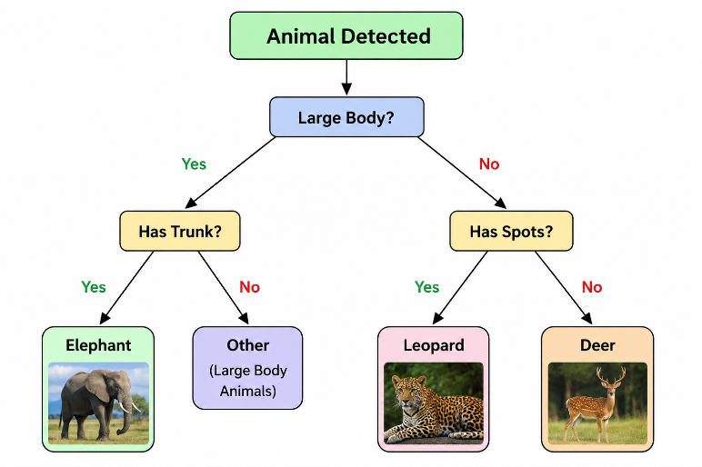
For example:
The tree starts at the root node, evaluates features, and follows branches until it reaches a leaf node, which represents the predicted species.
- Working of the Proposed System
The overall workflow can be represented as:
Wildlife Habitat
↓
Camera Traps /
Sensors / GPS
↓
Data Collection
↓
Data Preprocessing
↓
Feature Extraction
↓
ML Model Training
↓
Animal Detection
↓
Species Classification
↓
Population & Movement
Analysis
↓
Conservation Action

Step 1: Data Collection
Camera traps and sensors continuously collect information from the forest.

Step 2: Preprocessing
Unwanted, duplicate, or poor-quality observations are removed.

Step 3: Feature Extraction
Important characteristics such as colour, shape, texture, patterns, and movement are extracted.

Step 4: Model Training
The labelled dataset is provided to the Machine Learning algorithm.

Step 5: Animal Classification
When a new image is received, the trained model predicts the species.

Step 6: Monitoring
The system records:
- Species detected
- Number of observations
- Location
- Time
- Frequency of occurrence

Step 7: Analysis
The collected results are analysed to identify population and behavioural trends.

Step 8: Conservation Decision
Forest authorities and researchers can use the information for conservation planning.

- Concept Learning in Wildlife Monitoring
Wildlife monitoring can also be viewed as a concept learning problem.
The ML system learns a concept such as:
“Is the animal in the image a tiger?”
The training examples contain positive and negative examples.
Positive examples
Images containing tigers.
Negative examples
Images containing deer, elephants, leopards, or other objects.
The system learns patterns that distinguish the target species from other species.
This learned concept can then be applied to previously unseen wildlife images.
- Inductive Bias
Machine Learning systems use assumptions about the data when generalizing from training examples.
For wildlife monitoring, an algorithm may assume that:
- Animals belonging to the same species have similar visual characteristics.
- Similar patterns can be used to classify animals.
- Training examples represent the species adequately.
These assumptions are known as inductive bias.
A good dataset is therefore essential because an unsuitable dataset can cause incorrect generalization.
- Version Space Concept
The Version Space represents the set of all hypotheses that are consistent with the available training examples.
For example, suppose the system is learning to identify tigers.
Initially, many possible rules may exist:
- Large animal
- Striped animal
- Orange-coloured animal
- Large striped animal
- Orange animal with black stripes
As positive and negative examples are provided, inconsistent hypotheses are removed.
Eventually, the remaining hypotheses form the version space that is consistent with the observed examples.
This concept illustrates how Machine Learning can progressively narrow down possible rules for wildlife classification.
- Analysis of Wildlife Monitoring Data
After classification, the collected data can be analysed to understand wildlife patterns.
For example, the system can calculate:
- Number of animals detected per day
- Number of species detected
- Species distribution
- Detection frequency
- Seasonal changes
- Location-wise animal presence
- Day/night activity

Example
Suppose camera traps produce the following observations:
Species | Number of Observations
Deer | 420
Elephant | 180
Tiger | 45
Leopard | 30

This information can help researchers understand the relative occurrence of different species in the monitored region.

- Visualization and Interpretation
Visualization makes wildlife monitoring results easier to understand.
Example 1: Species Distribution
A bar graph can show the number of observations for each species.
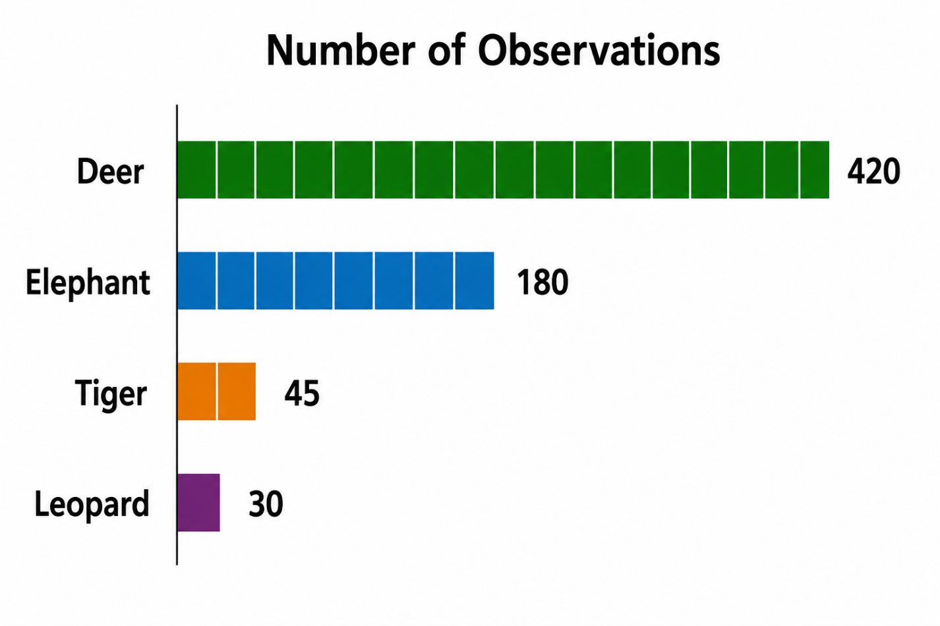

Example 2: Time-Based Monitoring
A line graph can represent the number of animal detections over different months.
This can help identify:
- Increasing populations
- Decreasing populations
- Seasonal migration
- Changes in animal activity

Example 3: Location-Based Monitoring
A map can display areas where particular species are frequently detected.
This helps identify important wildlife habitats and movement zones.
- Expected Outcomes
The proposed ML-based system is expected to provide:
- Automatic species identification
- Faster wildlife monitoring
- Reduced manual analysis
- Improved biodiversity assessment
- Identification of endangered species
- Population trend analysis
- Animal movement monitoring
- Better conservation planning
The system can convert large quantities of raw monitoring data into useful information for researchers and conservation authorities.

- Advantages

1. Reduces Human Effort
Thousands of images can be analysed automatically instead of manually.

2. Continuous Monitoring
Camera traps and sensors can collect information continuously.

3. Large Area Coverage
ML can help process information collected from multiple monitoring locations.

4. Faster Detection
Animals can be identified soon after images are captured.

5. Endangered Species Protection
Rare species can be monitored more effectively.

6. Data-Driven Conservation
Conservation decisions can be based on observed data rather than only manual surveys.

7. Long-Term Analysis
Historical data can be analyzed to identify population and habitat trends.
- Limitations and Challenges
Despite its advantages, ML-based wildlife monitoring has several challenges.
1. Limited Training Data
Rare species may have very few available images.
2. Poor Image Quality
Darkness, rain, fog, vegetation, and camera movement can affect image quality.
3. Similar Species
Some animals have similar physical characteristics, making classification difficult.
4. Environmental Variations
The appearance of animals can change depending on lighting, season, age, and environment.
5. Infrastructure Cost
Installing and maintaining cameras and sensors over large forest areas can be expensive.
6. False Predictions
The ML model may sometimes incorrectly identify an animal.
7. Data Management
Large numbers of images and videos require considerable storage and processing resources.

- Practical Applications
Machine Learning-based wildlife monitoring can be used for:
- Endangered species monitoring
- Population estimation
- Forest biodiversity assessment
- Animal migration monitoring
- Habitat analysis
- Illegal hunting detection
- Wildlife corridor monitoring
- Human-wildlife conflict analysis
- Protected-area management
- Conservation research
For example, repeated detection of an endangered species in a particular region can indicate that the region is important for conservation.
- Relation to SDG 15 – Life on Land
Question 34 is specifically associated with SDG 15 – Life on Land in the given PDF.
SDG 15 aims to protect, restore, and sustainably manage terrestrial ecosystems and halt biodiversity loss.
Wildlife monitoring contributes to this goal by:
Machine Learning → Wildlife Detection → Biodiversity Monitoring → Conservation Planning → Protection of Ecosystems
For example, if ML analysis shows that the population of a particular endangered species is decreasing, conservation authorities can investigate the causes and introduce appropriate protection measures.
Therefore, ML acts as a technological support system for biodiversity conservation and sustainable management of terrestrial ecosystems.

- Conclusion
Machine Learning provides an effective approach for modern wildlife monitoring. By analysing camera-trap images, videos, sounds, and sensor data, ML can automatically identify species, monitor populations, and analyse wildlife movement.
The use of concept learning, decision-tree classification, feature extraction, and data analysis allows large amounts of wildlife information to be converted into useful conservation knowledge. Although challenges such as limited datasets, poor image quality, false predictions, and infrastructure costs exist, proper data collection and model validation can improve the reliability of the system.
Most importantly, ML-based wildlife monitoring supports SDG 15 – Life on Land by helping conserve biodiversity, protect endangered species, monitor ecosystems, and support sustainable management of terrestrial environments. The assignment specifically identifies wildlife monitoring as an SDG 15 application.

