1 安装docker

Yum install docker

设置 daemon 略

2 安装 etcd

yum install etcd -y

systemctl start etcd

systemctl enable etcd

etcdctl -C http://localhost:2379 cluster-health

看看是不是health

3 安装flannel

yum install flannel -y

进入 /etc/sysconfig/flanneld

更改FLANNEL_ETCD_ENDPOINTS="http://127.0.0.1:2379 --iface=eth0"

增加网段命令 etcdctl mk /atomic.io/network/config '{ "Network": "10.0.0.0/16" }'

4 安装k8s

yum install kubernetes -y

安装好后，编辑文件 /etc/kubernetes/apiserver，将 KUBE_ADMISSION_CONTROL 后面的 ServiceAccount 去掉

5 启动以下命令

systemctl enable flanneld

systemctl start flanneld

service docker restart

systemctl restart kube-apiserver

systemctl restart kube-controller-manager

systemctl restart kube-scheduler

systemctl enable flanneld

systemctl start flanneld

service docker restart

systemctl restart kubelet

systemctl restart kube-proxy

6 检验k8s node

Kubectl get node

看看有没有

NAME STATUS AGE

127.0.0.1 Ready 33m

使用kubectl run nginx --image=nginx --port=80 --replicas=1

成功后进入

Kubectl get pods 看看

NAME READY STATUS RESTARTS AGE

nginx-3449338310-sn1cj 1/1 Running 0 21m

如果为pending 则可能 flannel 没配好，查看docker 和 k8s 的网络

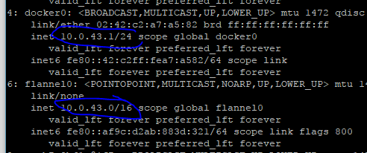

如果为container activing 则需要

用命令 kubectl describe pod 检查，如发现 xxxxxx redhat xxxxx

需要如下操作：

安装

 yum install *rhsm* -y

然后去pull redhat pod-infrastructure 镜像，一定要先安装 rhsm 否则pull不了！

docker pull registry.access.redhat.com/rhel7/pod-infrastructure:latest

最后成功