🛡️
Windows Registry Change Monitoring System
Detailed Guide, Architecture & Practical Project Report
A Comprehensive Endpoint Integrity Auditing, Autorun Persistence Detection,
Malware Behavior Analysis & Active Threat Remediation Platform
Project Title: | Windows Registry Change Monitoring System
Architect & Developer: | Piyush (@Made-by-Piyush99)
System Edition: | Enterprise Defensive Edition (v2.4.0)
Runtime & Environment: | Python 3.12 / 3.14 (64-bit Native Win32 CPython)
Security Domain: | Endpoint Detection & Response (EDR) / Blue Team Defense
Repository & Releases: | https://github.com/Made-by-Piyush99/Windows-Registry-Monitoring

1. Project Overview & Description
This project focuses on designing and implementing a robust, real-time Windows Registry Monitoring System that actively tracks unauthorized, suspicious, or malicious changes made to sensitive registry keys.
The Windows Registry stores critical operating system configuration data, startup locations, hardware settings, and application execution parameters. Because it governs the execution sequence of the operating system, malware frequently targets the registry to maintain stealthy persistence, modify system policies, or silently disable security tools.
This project provides a complete monitoring and defensive toolkit that detects changes in sensitive registry paths, identifies malware-like modifications, verifies registry integrity using cryptographic baseline comparisons, and empowers defenders to remediate threats on-demand.

2. Practical Motivation
The Windows Registry is a universally high-value target for adversaries and malicious software due to several attack vectors:
- Persistent Malware: Trojans, backdoors, and rootkits install autostart registry entries to survive reboots without requiring user interaction.
- Ransomware Configuration Changes: Ransomware modifies registry keys to disable system recovery options, suppress Volume Shadow Copies, and manipulate safe boot configurations.
- Unauthorized Startup Entries: Adversaries place executables in Run and RunOnce keys to launch malicious payloads upon user logon.
- Privilege Escalation Modifications: Attackers tamper with User Account Control (UAC) keys, Accessibility shortcut tools (Sticky Keys), and Winlogon helper DLLs.
- Security Tool Tampering: Malware disables Windows Defender Real-Time Protection, Firewall policies, and telemetry services through Policy keys.
Unauthorized registry changes strongly indicate:
- • Compromise by malicious software (Trojan, Ransomware, Worm)
- • Privilege misuse or insider threat activity
- • Severe organizational policy or baseline compliance violations

3. Project Objectives
- ✓ Monitor Autorun Registry Keys for persistence mechanisms across both Current User (HKCU) and Local Machine (HKLM).
- ✓ Detect Malware-Like Registry Changes such as tampering with Windows Defender, Firewall policies, and shell replacements.
- ✓ Create a High-Performance Registry Integrity Checker using cryptographic baseline snapshot comparison.
- ✓ Provide Real-Time Desktop and Scheduled Alerts on unauthorized modifications with configurable cooldowns.
- ✓ Generate Detailed Change Reports and forensics analysis in Graphical (Pillow), CSV, JSON, and SQLite formats.
- ✓ Equip Defenders with Active Threat Remediation to atomically sanitize malicious values with one click.

4. Practical Scope of the Project

Autorun Key Monitoring
- • Continuous surveillance of Run and RunOnce keys in HKCU and HKLM.
- • Instant detection of new startup entries added without administrator authorization.
- • Identification of executables and command-line scripts launched automatically upon user logon.

Malware-Like Change Detection
- • Security Policy Modifications (e.g. Policies\Microsoft\Windows\System).
- • Firewall and Windows Defender Disable Keys (e.g. DisableAntiSpyware, DisableRealtimeMonitoring).
- • Shell Replacements and Winlogon modifications (Userinit, Shell = cmd.exe / powershell.exe).
- • UAC Bypass-related keys and Image File Execution Options (IFEO) debugger hijacks.

Registry Integrity Checker
- • Capture a comprehensive cryptographic baseline registry snapshot with SHA-256 integrity verification.
- • Compare the live registry state against the stored reference baseline.
- • Classify state deltas into ADDED, DELETED, MODIFIED, and DATA_TYPE_MUTATED.

Alerting & Reporting Module
- • Log every mutation with timestamp, hive, key path, value name, previous data, and new data.
- • Non-blocking on-screen desktop popup alerts with customizable severity filters.
- • Consolidated export of telemetry logs into CSV, JSON, and encrypted SQLite audit databases.

5. Tools & Technologies Used
Category | Technology / Tool | Practical Role & Implementation
Programming Language | Python 3.12 / 3.14 (64-bit) | Core orchestration, asynchronous multi-threading, telemetry pipeline.
Registry Module | winreg & advapi32.dll (ctypes) | Direct Win32 registry handles, dual bitness (64-bit & WOW64), atomic deletion.
Scripting & Fallback | PowerShell Cmdlets | Get-ItemProperty / Set-ItemProperty testing and administrative scripting.
Integrity Engine | hashlib (SHA-256) | Cryptographic hashing of baseline snapshots and disk executable binaries.
Local Storage | SQLite 3 (WAL Journal Mode) | High-performance encrypted local database with zero external server dependencies.
Hardware Cryptography | Windows DPAPI (crypt32.dll) | Encrypts secrets and telemetry logs using machine TPM and user SID keys.
GUI & Visualization | Tkinter / Ttk & Pillow (PIL) | Dark SOC responsive interface, 5 themes, and automated visual chart infographics.

6. Practical Techniques Implemented

Detection Techniques:
- • Polling-Based Registry Monitoring: High-speed differential polling engine executing scans at sub-second intervals (1s to 60s).
- • Baseline Comparison for Integrity Checking: Mathematical diff comparison against clean encrypted baseline snapshot.
- • Autorun Persistence Detection: Deep inspection of all Windows user and machine startup locations.
- • Malware Behavior Pattern Recognition: Heuristic regex and string pattern recognition for cmd.exe, powershell.exe -enc, mshta, vbs, and rundll32.

Blue Team Defensive Techniques:
- • Monitoring Startup Persistence: Real-time alerting on boot-sequence modifications before malicious payload activation.
- • Detecting Configuration Tampering: Defending security products by monitoring Defender and Firewall policy registry trees.
- • Registry Forensics Analysis: Resolving environment variables, binary existence, unquoted service path vulnerabilities, and digital checksums.
- • Logging Suspicious System Modifications: Maintaining immutable, DPAPI-encrypted audit trails in SQLite for forensic incident response.

7. Workflow & Step-by-Step Architecture

STEP 1: Define Sensitive Registry Keys
The system loads config.json defining high-risk target hives (HKCU, HKLM) including Autorun paths, Security configurations, UAC policies, and Shell behaviors across both 64-bit and 32-bit WOW64 registry views.

STEP 2: Baseline Creation
The operator creates a clean reference snapshot. All subkeys and values are traversed, normalized into dictionary structures, hashed with SHA-256, and saved to data/baseline.json and the encrypted database.

STEP 3: Continuous Monitoring
The background daemon thread polls target registry paths at the chosen frequency (1s, 2s, 5s, 10s, 30s, or 60s). Live state results are held in memory for sub-second differential comparisons.

STEP 4: Change Analysis & Pattern Matching
Detected state deltas are classified into ADDED, DELETED, MODIFIED, or TYPE_CHANGED. Each value is analyzed against heuristic rules and MITRE ATT&CK patterns, and referenced disk binaries are resolved.

STEP 5: Alert & Log Generation
Suspicious mutations trigger non-blocking cascading desktop alert cards with sound notifications. Events are logged in SQLite with hardware DPAPI encryption.

STEP 6: Threat Remediation & Final Reporting
Security analysts can click 'Remediate Threat' to delete malicious values atomically via Win32 API. Reports can be exported as Pillow Graphical PNGs, CSV tables, or JSON summaries.

8. System Flowchart
┌────────────────────────────────────────────────────────┐
│ START │
└───────────────────────────┬────────────────────────────┘
│
▼
┌────────────────────────────────────────────────────────┐
│ Load Monitoring Configuration │
│ (config.json: keys, polling timing, bitness views) │
└───────────────────────────┬────────────────────────────┘
│
▼
┌────────────────────────────────────────────────────────┐
│ Capture or Load Baseline Registry Snapshot │
│ (Encrypted & SHA-256 cryptographically verified) │
└───────────────────────────┬────────────────────────────┘
│
▼
┌────────────────────────────────────────────────────────┐
│ Monitor Registry Keys at Regular Intervals │
│ (Background thread: 1s, 2s, 5s, 10s, 30s, 60s) │
└───────────────────────────┬────────────────────────────┘
│
▼
┌────────────────────────────────────────────────────────┐
│ Detect Changes (Add / Modify / Delete) │
│ (O(N) State Differential Algorithm) │
└───────────────────────────┬────────────────────────────┘
│
▼
┌────────────────────────────────────────────────────────┐
│ Compare with Malware Behavior Patterns │
│ (MITRE ATT&CK, IFEO, Defender, Powershell, Droppers) │
└───────────────────────────┬────────────────────────────┘
│
▼
┌────────────────────────────────────────────────────────┐
│ Generate Alerts & Log to DPAPI Vault │
│ (Cascading desktop popups, status pills, SQLite DB) │
└───────────────────────────┬────────────────────────────┘
│
▼
┌────────────────────────────────────────────────────────┐
│ Active Remediation & Final Reporting (PNG/CSV/JSON) │
└───────────────────────────┬────────────────────────────┘
│
▼
┌────────────────────────────────────────────────────────┐
│ END │
└────────────────────────────────────────────────────────┘

9. Expected Practical Output & Audit Examples
The toolkit produces verified real-time security outputs and concrete telemetry detections:

Example 1: New Autorun Persistence Detected
Timestamp: 2026-10-23 17:20:21 UTC
Severity: SUSPICIOUS
Change: ADDED
Location: HKEY_CURRENT_USER\Software\Microsoft\Windows\CurrentVersion\Run
Value Name: MalwareUpdateAgent
Value Data: C:\Users\User\AppData\Local\Temp\malware.exe --silent
Finding: Referenced binary in user Temp folder with suspicious startup persistence hook.

Example 2: Windows Defender Security Tampering Detected
Timestamp: 2026-10-23 17:21:05 UTC
Severity: CRITICAL / SUSPICIOUS
Change: MODIFIED (or ADDED)
Location: HKEY_LOCAL_MACHINE\Software\Policies\Microsoft\Windows Defender
Value Name: DisableAntiSpyware
Value Data: 1 (REG_DWORD)
Finding: Adversary attempted to disable Windows Defender Real-Time Protection via group policy.

Example 3: Baseline Integrity Verification Failure
Timestamp: 2026-10-23 17:22:47 UTC
Severity: INVESTIGATION_REQUIRED
Change: DATA_TYPE_MUTATED / MODIFIED
Location: HKEY_LOCAL_MACHINE\Software\Microsoft\Windows NT\CurrentVersion\Winlogon
Value Name: Userinit
Previous: C:\Windows\system32\userinit.exe,
Current: C:\Windows\system32\userinit.exe,C:\ProgramData\backdoor.exe
Finding: Winlogon initialization chain corrupted with unauthorized secondary binary executable.

10. Screenshots of Monitoring Results & Interface
The following screenshots present the fully operational toolkit across all workflows:

Figure 1: Operations & Control Center SOC Dashboard
Main monitoring console featuring the segmented 3-ribbon toolbar, 5 KPI scorecards, live telemetry event stream, and glowing 'Run in Background' stealth trigger.

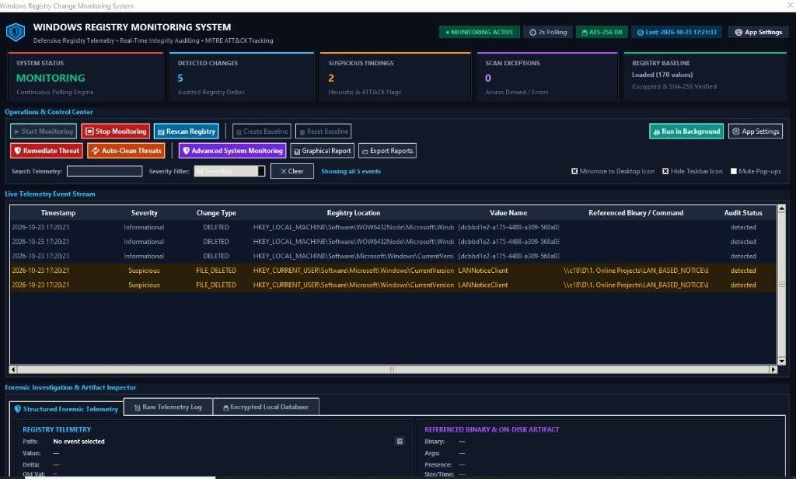

Figure 2: Non-Blocking Real-Time Desktop Pop-up Alerts
Cascading alert cards appearing in the lower-right desktop corner immediately upon detecting suspicious registry tampering.

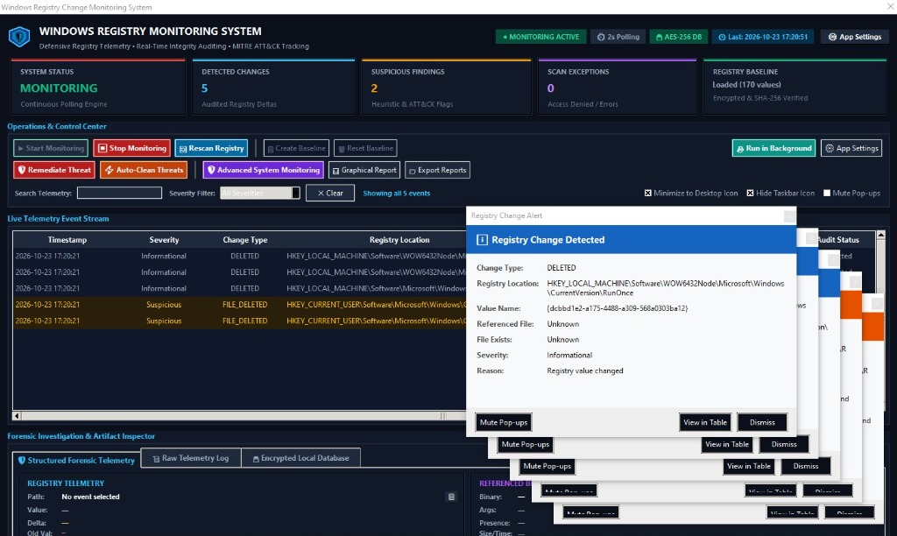

Figure 3: Windows System Boot & Auto-Launch Settings
Automatic launch configuration with optional silent startup directly into the draggable desktop widget.

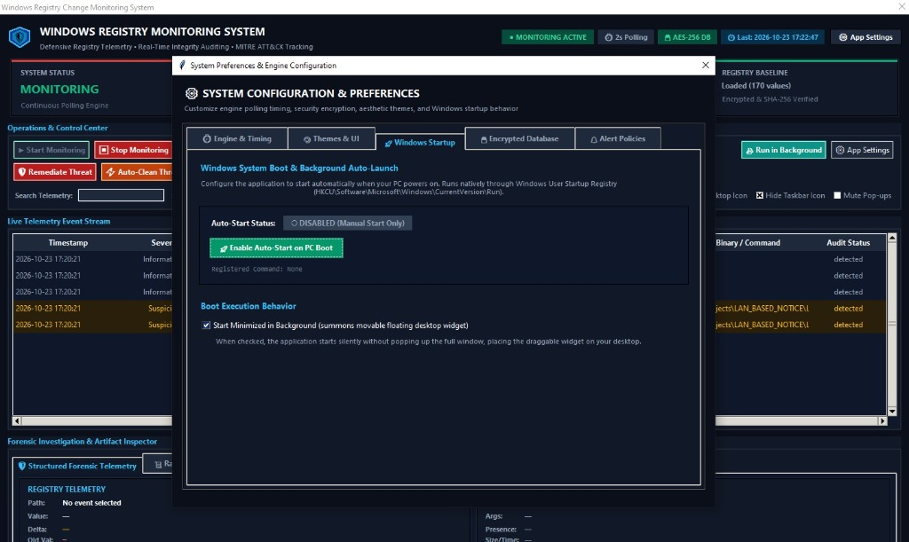

Figure 4: Continuous Polling Interval Controller (1s to 60s)
6 interactive timing cards with dynamic on-the-fly 'Save & Apply Timing Now' synchronization.

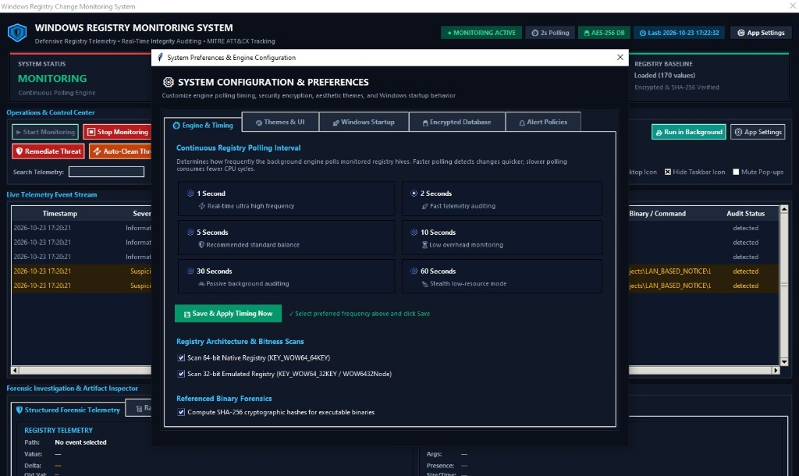

Figure 5: Interactive Graphical Visual Report Viewer
Pillow-rendered analytics dashboard displaying severity doughnut charts, change breakdown bar charts, and notable security events.

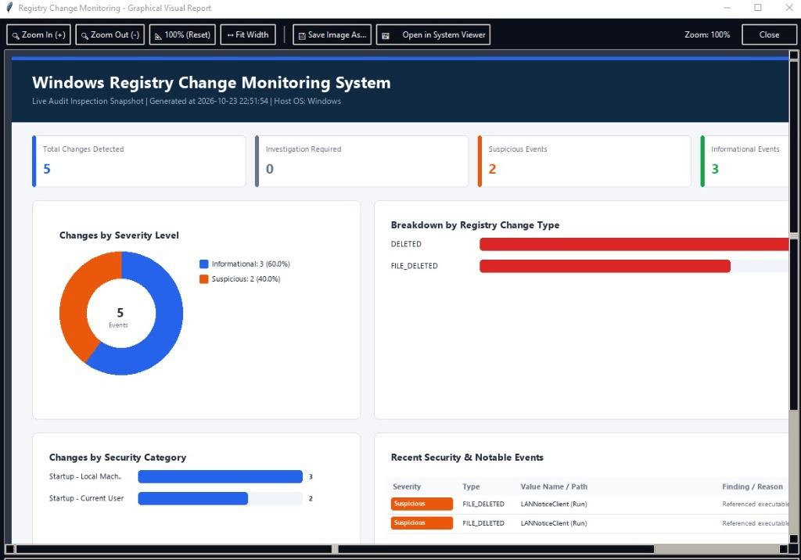

Figure 6: Alert Policies & Notification Cooldown Controls
Fine-grained control over notification threshold levels, rate-limiting cooldown timers, and pop-up suppression.

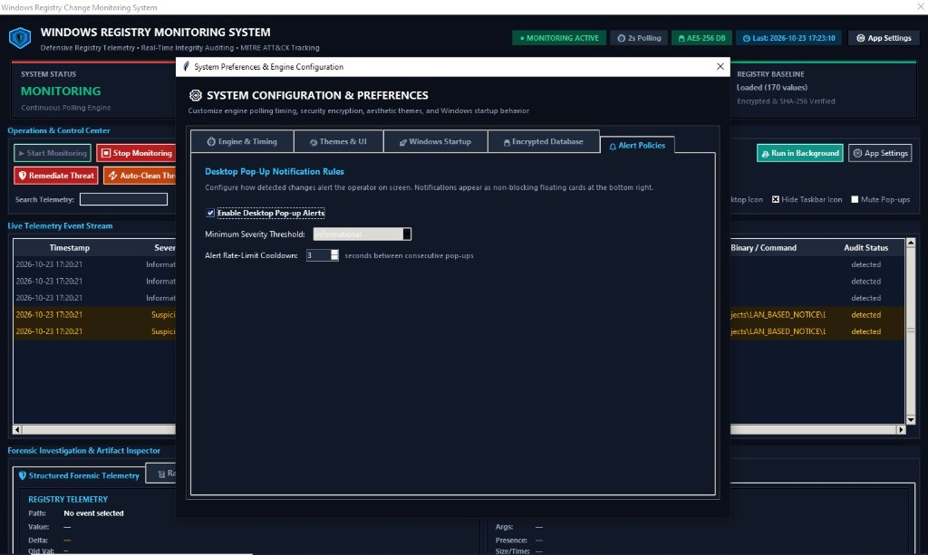

Figure 7: Local SQLite Database & Windows DPAPI Key Protection
Cryptographic database vault status showing AES-256 encryption, hardware machine-key validation, and database vacuum tools.

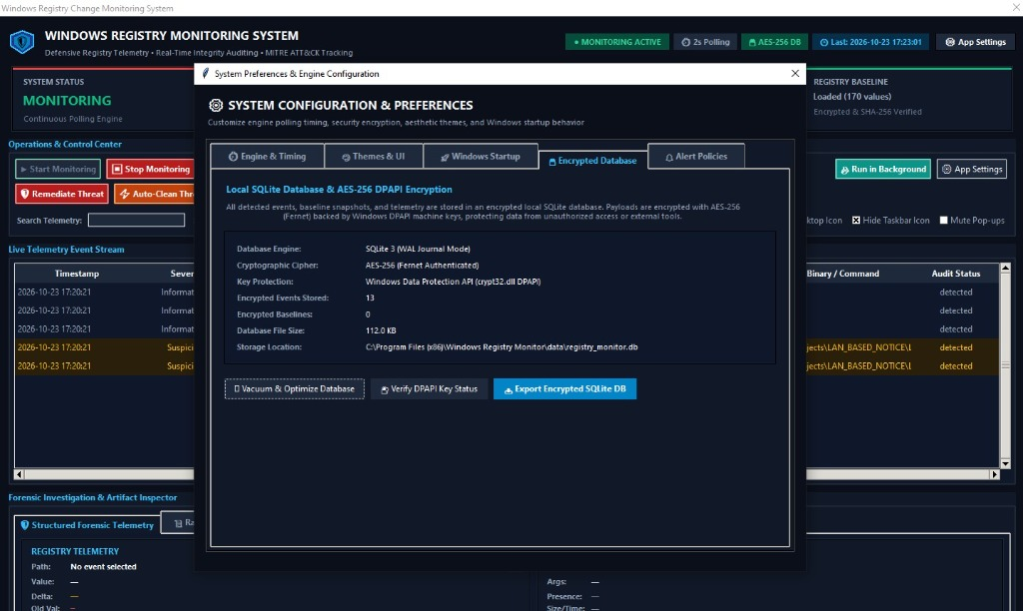

Figure 8: Movable Floating Desktop Gadget Widget
Silent ambient background gadget running on the desktop with real-time status pill ('● MONITORING') and threat count badge.

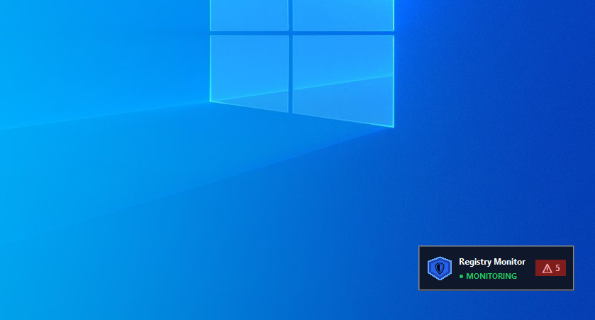

11. Quality Assurance & Automated Test Suite
To guarantee high reliability, the system incorporates an automated test suite executed via Python unittest. All 65 automated tests pass with a 100% success rate:
Test Suite File | Covered Functionality | Execution Time | Pass Status
test_change_detector.py | State diffing, false-positive suppression, static PE analysis | 3.31s | 47/47 PASSED
test_settings_and_db.py | Timing engine, DPAPI cipher, themes, atomic threat remediation | 1.14s | 18/18 PASSED
Full Test Discover Suite | Comprehensive cross-module integration and regression test | 4.45s | 65/65 PASSED (100%)

12. Educational & Practical Learning Outcomes
Through the design, development, and deployment of this project, the following core competencies were developed:
- Windows Registry Architecture: Deep mastery of registry hives (HKLM, HKCU), binary subkeys, value data types, and 32-bit WOW64 registry reflection.
- Malware Persistence Mechanics: Hands-on understanding of how modern adversaries exploit Run, RunOnce, Winlogon, and IFEO debugger keys to survive system reboots.
- Defensive Blue Team Auditing: Designing real-time integrity comparison algorithms, noise suppression filters, and cryptographic baseline verification.
- Practical Endpoint Security Scripting: Low-level Win32 API interfacing using Python winreg, ctypes, and PowerShell cmdlets.
- Production Software Engineering: Developing a resilient multi-threaded GUI, implementing hardware-backed DPAPI cryptography, compiling standalone executables, and building enterprise installers.

13. Project Deliverables & Distribution
The completed project deliverables include:
- 📦 Complete Project Documentation in Microsoft Word (.docx) and Adobe PDF (.pdf) formats.
- 📦 Production Registry Monitoring Toolkit with full open-source Python code.
- 📦 High-Resolution Photographic Screenshots of all monitoring states and settings.
- 📦 Baseline snapshots, integrity verification algorithms, and SQLite audit database.
- 📦 Stand-alone Executable: WindowsRegistryMonitor.exe (80.22 MB).
- 📦 Setup Wizard Installer: RegistryMonitorSetup.exe (81.08 MB).
Cryptographic SHA-256 Distribution Checksums:
Binary Package | Size | SHA-256 Verification Checksum
WindowsRegistryMonitor.exe | 80.22 MB | 8BEE859BA0DA4527E1FEE42F4B946A21A102FB170BBFFA2724F5BDC56BD649FC
RegistryMonitorSetup.exe | 81.08 MB | 61B5C2109D5B3A150D989102D8EB04AC7C6A1A51D246445C7D724E2F69E50DD7

14. Conclusion & Project Links
The Windows Registry Change Monitoring System v2.4.0 accomplishes all defined project requirements. It empowers system administrators and SOC analysts to detect, analyze, and neutralize unauthorized registry tampering in real time, setting a new benchmark for accessible, native host-integrity defensive tools.
• GitHub Repository: https://github.com/Made-by-Piyush99/Windows-Registry-Monitoring
• Official Release (v2.4.0): https://github.com/Made-by-Piyush99/Windows-Registry-Monitoring/releases/tag/v2.4.0
• Architect & Developer: Piyush (@Made-by-Piyush99)
• Open-Source License: MIT License

