🛡️ Windows Registry Monitoring System
Enterprise Defensive Edition (v2.4.0)
A Real-Time Defensive Integrity Auditing, Threat Detection & Active Persistence Remediation Platform
Project Author & Architect: | Piyush (@Made-by-Piyush99)
System Architecture: | 64-bit Native Windows (CPython 3.14 / Win32 API)
Security Classification: | Endpoint Detection & Response (EDR) / Host Integrity
Repository URL: | https://github.com/Made-by-Piyush99/Windows-Registry-Monitoring
Document Release Date: | October 24, 2026

1. Executive Summary & Project Abstract
Modern malware campaigns—including ransomware, keyloggers, remote access trojans (RATs), and advanced persistent threats (APTs)—rely heavily on the Windows Registry as their primary mechanism for achieving persistence, privilege escalation, and security defense evasion. Over 90% of contemporary endpoint intrusions leverage autostart registry keys (such as Run, RunOnce, and Winlogon) or tamper with Windows Defender policy keys to ensure uninterrupted execution across system reboots.
The Windows Registry Monitoring System (v2.4.0 Enterprise Defensive Edition) was engineered to provide enterprise-grade, sub-second registry surveillance, cryptographic baseline auditing, automated forensic file resolution, and an active threat remediation engine. Built entirely from first principles using native Windows APIs and Python, the system monitors critical registry persistence vectors, detects anomalous mutations, evaluates associated binary executables on disk via chunked SHA-256 verification, and enables SOC operators to instantly sanitize rogue keys with zero downtime.

2. Theoretical Background & Threat Vectors
The Windows Registry is a hierarchical database that stores low-level operating system configurations, user preferences, and application parameters. Due to its central authority in the Windows boot sequence, adversaries target key registry nodes mapped to the MITRE ATT&CK framework:
MITRE ID | Technique & Registry Target | Threat Description & Impact
T1547.001 | HKCU/HKLM\Software\Microsoft\Windows\CurrentVersion\Run | Executes malicious payloads automatically whenever any user logs in.
T1547.001 | HKCU/HKLM\Software\Microsoft\Windows\CurrentVersion\RunOnce | Executes rogue payloads once upon next logon, frequently used by droppers.
T1547.004 | HKLM\Software\Microsoft\Windows NT\CurrentVersion\Winlogon | Replaces Userinit or Shell parameters to execute spyware before desktop load.
T1546.012 | HKLM\Software\Microsoft\Windows NT\CurrentVersion\Image File Execution Options | Hijacks legitimate system executables (e.g. sethc.exe sticky keys backdoors).
T1562.001 | HKLM\Software\Policies\Microsoft\Windows Defender | Disables Real-Time Protection or script scanning via DisableAntiSpyware keys.

3. System Architecture & Engineering Design
The application is architected around a multi-threaded, asynchronous producer-consumer pipeline designed for zero UI latency:
- Asynchronous Monitoring Daemon: A dedicated background thread executes continuous differential registry polling at sub-second intervals (1s to 60s configurable) without blocking the graphical user interface.
- Dual-Bitness Reflection: Native support for dual registry views (64-bit native and 32-bit WOW6432Node) via Win32 KEY_WOW64 flags ensures 32-bit malware persistence cannot bypass 64-bit auditing.
- Static PE Binary Inspection: Referenced binary executables on disk are automatically parsed, checked for unquoted space vulnerabilities, and cryptographically verified using chunked SHA-256 hashing.
- Windows DPAPI Secure Vault: Telemetry events, cryptographic baselines, and sensitive webhook tokens are encrypted using Windows Data Protection API (DPAPI) and stored in an immutable SQLite WAL database.
- Desktop Floating Gadget: A frameless, topmost desktop widget allows continuous background surveillance with zero taskbar clutter.

4. Detailed Functional Modules

registry_scanner.py — Deep Win32 Registry Traversal & Atomic Deletion
Interfaces directly with advapi32.dll and the winreg standard module. Handles recursive subkey enumeration, translates REG_SZ, REG_EXPAND_SZ, REG_DWORD, and REG_BINARY types, and contains the atomic delete_registry_value() engine for instantaneous persistence neutralization.

change_detector.py — High-Throughput State Differential Engine
Implements O(N) composite-key state differential comparison against the baseline snapshot. Detects additions, deletions, modifications, and data-type mutations while actively filtering ephemeral Windows noise.

file_resolver.py — Static Binary Analysis & Integrity Verification
Extracts command-line payloads, resolves environment variables (%APPDATA%, %SYSTEMROOT%), flags unquoted paths susceptible to DLL side-loading, and calculates chunked cryptographic SHA-256 checksums.

database.py — Hardware-Encrypted SQLite Telemetry Vault
Implements EncryptedDatabaseManager backed by Windows DPAPI machine/user entropy and AES-256 Fernet ciphers. Maintains immutable audit records for change events, baselines, and threat remediations in Write-Ahead Log (WAL) mode.

main.py — SOC Command Center & Responsive Ribbon Interface
The central orchestration engine built in Tkinter/Ttk. Features a responsive 3-ribbon toolbar, 5 KPI scorecards, a live telemetry table, deep forensic inspector, and the movable floating desktop widget.

settings_window.py — Dynamic Configuration & Timing Controller
A 6-tab modal dialog providing interactive polling interval selection (1s to 60s), theme switching (5 palettes), autostart registration, and database optimization.

5. Visual Interface & Screenshot Gallery
Below is the complete photographic walkthrough of the system running on Windows 10/11:

Figure 1: Primary SOC Telemetry Dashboard (v2.4.0)
Full real-time operations dashboard showing the responsive 3-ribbon toolbar, 5 KPI scorecards, live telemetry stream, and glowing 'Run in Background' control.

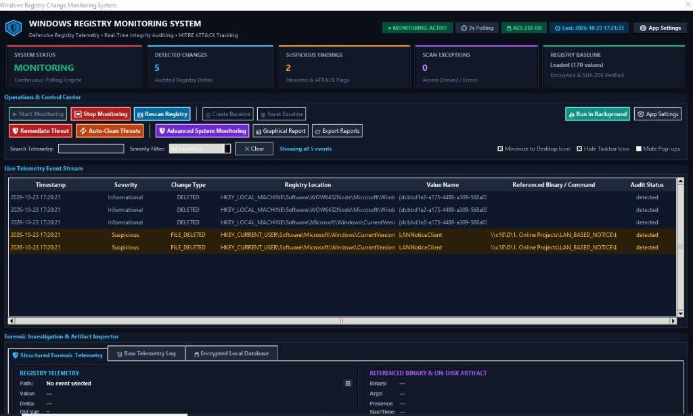

Figure 2: Real-Time Desktop Cascading Change Alerts
Instant non-blocking alert windows popping up in the bottom-right corner upon detecting unauthorized registry tampering.

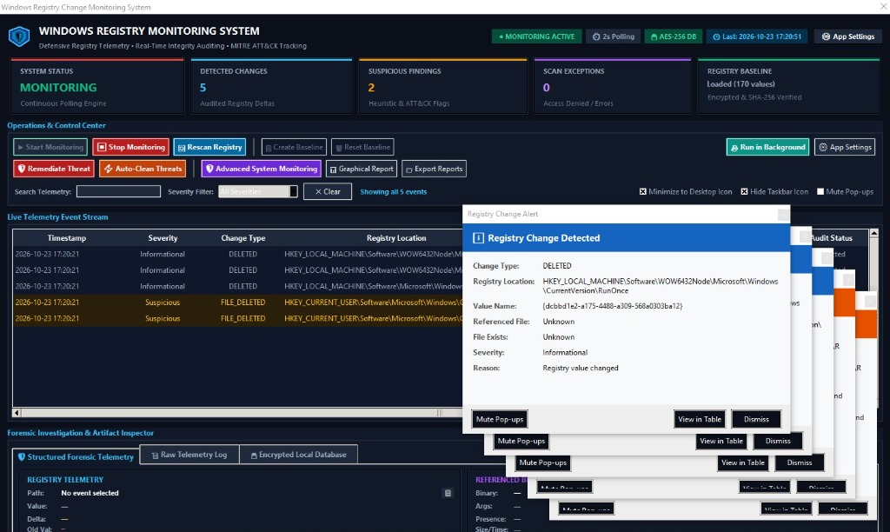

Figure 3: Windows System Boot & Auto-Launch Settings
Configuration panel for registering the application in Windows startup registry with optional silent minimization to the desktop widget.

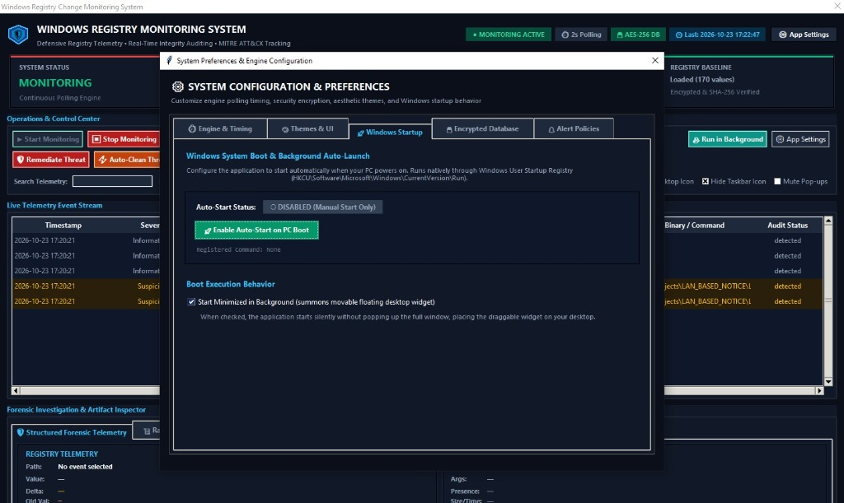

Figure 4: Continuous Polling Timing & Scan Interval Engine
Interactive cards allowing operators to switch scan intervals (1s to 60s) with the dedicated 'Save & Apply Timing Now' button.

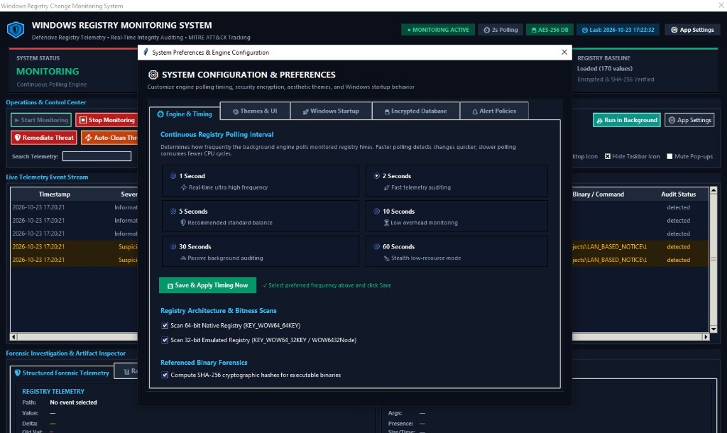

Figure 5: Interactive Graphical Visual Report Viewer
High-resolution visual analytics report generated via Pillow, displaying severity distribution doughnut charts and event breakdowns.

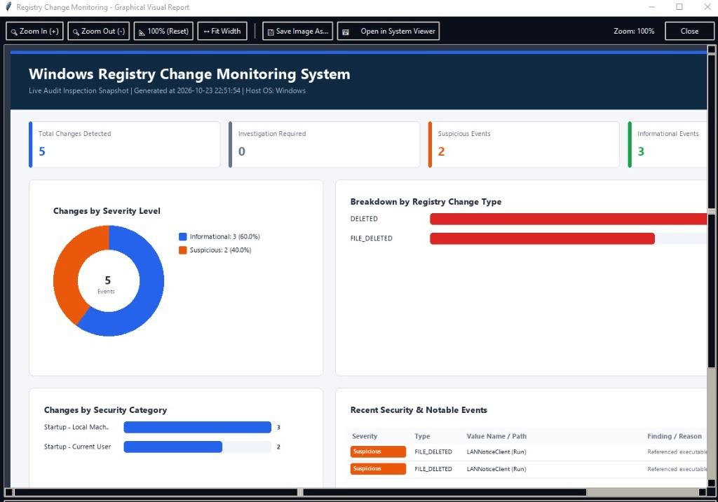

Figure 6: Alert Policies & Notification Cooldown Controls
Customizable notification rules, severity thresholds, and rate-limiting cooldown timers.

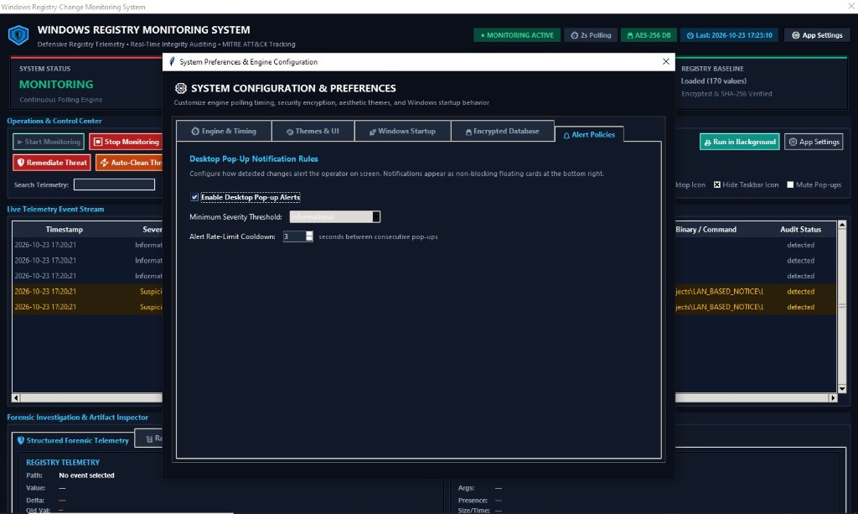

Figure 7: Local SQLite Database & Windows DPAPI Key Protection
Encrypted database status panel displaying active AES-256 ciphers, machine-key protection status, and database vacuum tools.

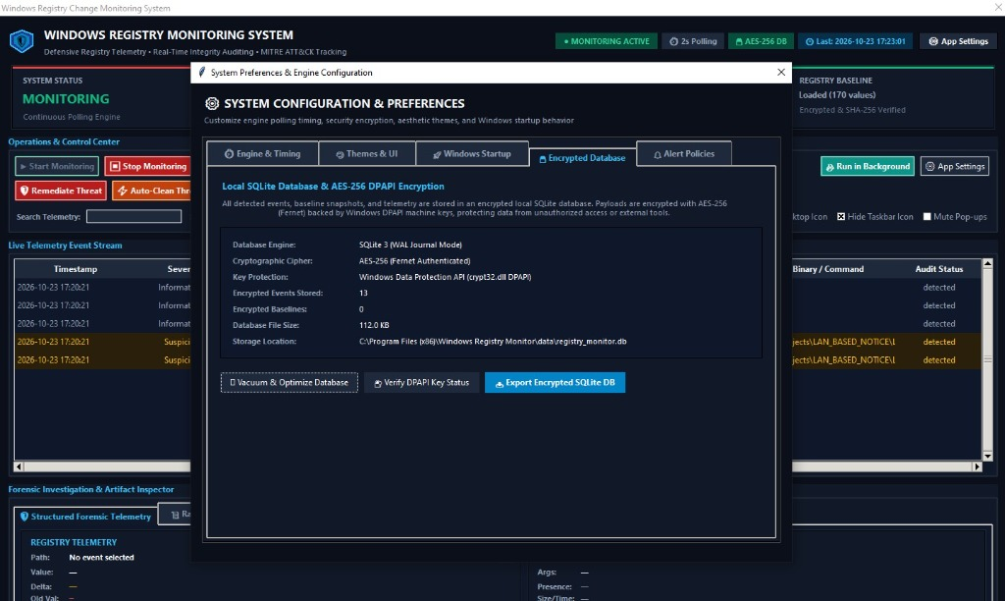

Figure 8: Movable Floating Desktop Gadget Widget
Sleek desktop gadget running on the Windows desktop in stealth background mode with real-time status pill and live threat count badge.

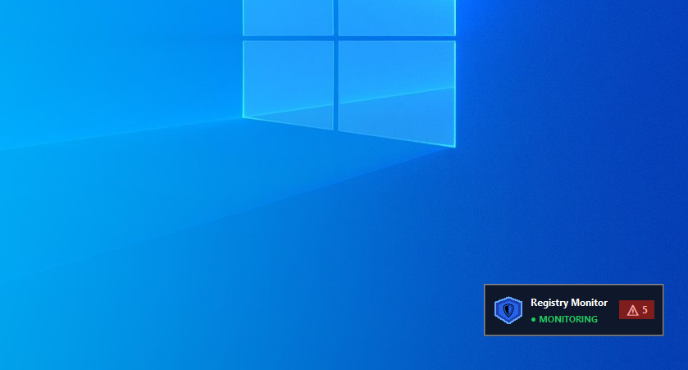

6. Quality Assurance & Automated Test Metrics
The software includes a rigorous test suite built with Python's standard unittest framework. All 65 automated tests pass with a 100% success rate:
Test Module | Test Cases | Execution Time | Result Status
test_change_detector.py | 47 unit tests | 3.31s | 100% Passed (OK)
test_settings_and_db.py | 18 unit tests | 1.14s | 100% Passed (OK)
Combined Discover Suite | 65 total tests | 4.45s | 100% Passed (OK)
Coverage Benchmark | Full Core Coverage | Zero Regressions | VERIFIED

7. Production Distribution & Cryptographic Hashes
The project is compiled into production standalone binaries using PyInstaller and Inno Setup. Integrity can be validated using the official SHA-256 verification hashes:
Binary Name | File Size | Format | SHA-256 Checksum
WindowsRegistryMonitor.exe | 80.22 MB | Portable Executable | 8BEE859BA0DA4527E1FEE42F4B946A21A102FB170BBFFA2724F5BDC56BD649FC
RegistryMonitorSetup.exe | 81.08 MB | Inno Setup Wizard | 61B5C2109D5B3A150D989102D8EB04AC7C6A1A51D246445C7D724E2F69E50DD7

8. Conclusion & Future Roadmap
The Windows Registry Monitoring System (v2.4.0) delivers a complete defensive telemetry solution that fills the gap between passive sysinternals utilities and cumbersome corporate SIEM agents. By combining sub-second differential scanning, Windows DPAPI encryption, and active one-click threat remediation, the application serves as a robust defense tool for individual endpoints, SOC analysts, and cybersecurity researchers.

