Changing Com Port Through Device manager

- First open the “start menu” at the bottom left of your desktop screen then type in “device manager” and double click to open.
- Next you will come to a screen like the one below. Find the “Ports” drop down and click it to see the ports connected. In our case we are looking for the “USB Serial device” or anything named “arduino”. We can see it is using “com3”
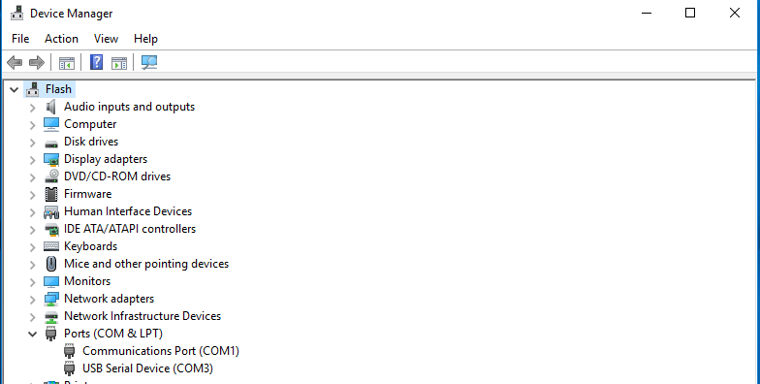
3. Next let us Right click the “USB serial device” and click on “properties”. The screen below is what you will see. Once we are on the properties screen to find the “port settings” tab at the top.
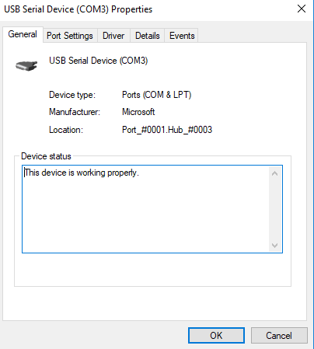

    - Once we are in the “port settings” tab we want to go to the “advanced” tab and open that. When in the “advanced” tab you can see the option to change the “com port number” to the needed port. All done!

